Introduction:
In this presentation there will be an introduction on M&S, what CRM is and how it effects organisations. There will reasons why M&S use CRM where it will include, McKinsey framework, Porters strategy and marketing mix. It will conclude with SWOT on M&S and recommendations how they can improve themselves.
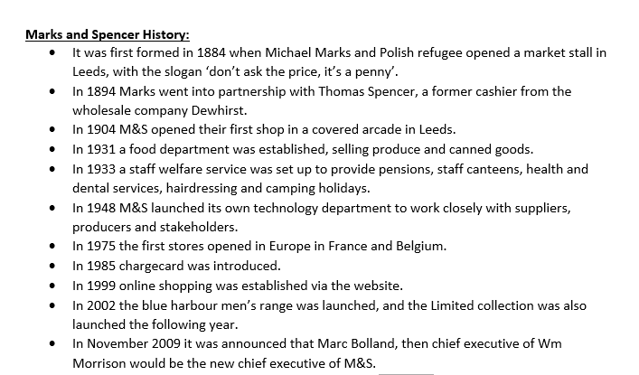
(marksandspencer.com, 2019)

M&S Market share by value;

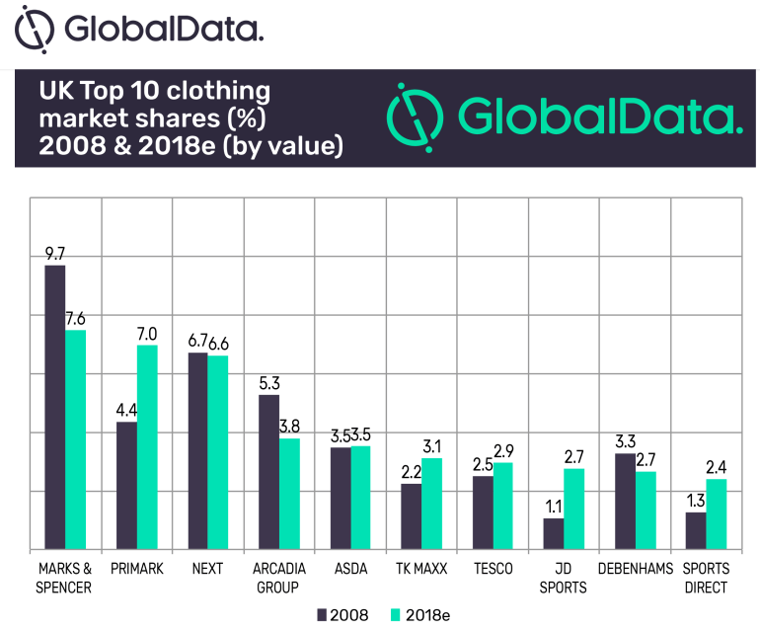
According to Global Data, (2018), M&S had a drop with 2.1% in 10-year time. In order to increase their market share they can improve their growth by focusing on the 4-marketing mix.
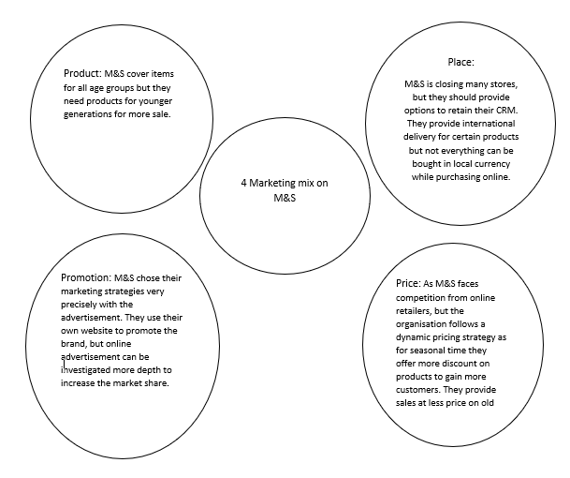 (mbaskool.com, 2018).
Porters Generic Strategies:
According to Rodrigo (2012), marks and spencer use Porters 5 forces of model which is shown below;
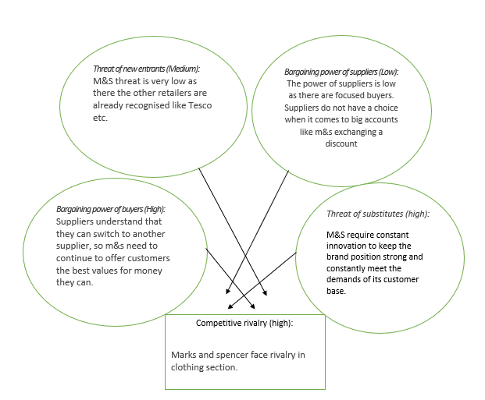

Task 1
What is CRM?
According to Armour, (2018) a CRM system refers to business system which are designed to manage customers interaction. It is used by sales people and features in sales force automation.
According to Josh, (2010) the main feature of CRM is to build a strong sense of trust and respect between the organisation and mainly the stakeholders, the customers and plan to increase sales from recalling customers rather than regularly penetrating the same market again and again.
Task 2:
Benefits of operating a CRM system in organisations:
According to learning centre (2019), having a CRM have advantages, for example;
- Cross-team collaboration
- Increased productivity
- Increased customer satisfaction and maintenance.

Benefits of operating CRM system in Tesco:
According to expertmarket.com (2019) the many benefits Tesco achieved from CRM system. Loyalty cards and comment cards are the most popular which lets Tesco gain more satisfied customers.

Drawbacks of operating a CRM system in organisations:
There are potential problems of implementing CRM which are:
- Cost
- Lack of leadership
- Poor communication. (NIbusinessinfo.co.uk, 2019).

Drawback of operating CRM in Woolworth:
According to assignmentfirm.com (2019), Woolworth has different loyalty schemes, yet their CRM system was not effective enough at retaining their customer to achieve their long-term loyalty.

Task 6:

- Strength:
M&S inspire employees to take decisions at the right time focusing on customer needs. Campaigns like ‘spend it well’ and ‘doing the right thing’ is some of the techniques which help build a long-lasting customer relationship. (swotandpestle.com, 2018).
- Weakness:
M&S focus with working class people on the clothing sector mainly and they have not taken any approach on younger generation which is making them not gain as much customers. To overcome this, they need to complete the goal in their plan A.
- Opportunities:
New and improved website for M&S can be a great way in which can attract more new customers especially those who are overseas. (Bunce, 2010)
- Threats:
M&S have UK suppliers only which cause them to sell their products in a high cost rate. To overcome this M&S need to expand their suppliers internationally.

Recommendations/Conclusion:
- Opportunities for M&S is how they take customers views and demands on boards
- Be more innovative with their CRM system so they can stand out in the retail industry.
- M&S need to engage and provide customers with a commitment plan and get the customers more involved.
- To avoid loss they need an exit plan
- M&S can gain more customers by having a Unique selling point.

Reference list:
(2014) Woolworth using CRM, Available at: https://assignmentfirm.com/sample-assignment/literature-review-customer-relationship-management.php (Accessed: 13th February 2019).
(2018) Global Data, Available at: https://www.globaldata.com/ms-lose-decades-long-status-number-one-clothing-retailer-primark/ (Accessed: 10th February 2019).
(2018) Marks & Spencer Marketing Mix Strategy, Available at: https://www.mbaskool.com/marketing-mix/services/17122-marks-and-spencer.html (Accessed: 10th February 2019).
(2018) Marks and Spencer SWOT, Available at: https://www.swotandpestle.com/marks-and-spencer/ (Accessed: 18th February 2019).
(2018) Marks and Spencer's short history, Available at: https://marksintime.marksandspencer.com/download?id=996 (Accessed: 6th February 2019).
(2019) Potential drawbacks of CRM, Available at: https://www.nibusinessinfo.co.uk/content/potential-drawbacks-crm-systems (Accessed: 12th February 2019).
(2019) Tesco CRM System, Available at: https://www.expertmarket.co.uk/crm-systems/tesco-crm-case-study (Accessed: 12th February 2019).
(2019) What is CRM? - Customer Relationship Management, Available at: https://www.salesforce.com/uk/learning-centre/crm/what-is-crm/ (Accessed: 12th February 2019).
Armour, H. (2018) Customer Relationship Management, Available at: https://www.reallysimplesystems.com/blog/customer-relationship-management/ (Accessed: 10th February 2019).
Bunce, E. (2010) A Case Study Analysis Report of Marks and Spencer, Available at: https://issuu.com/emmabunce/docs/m_s_case_study (Accessed: 18th February 2019).
Cottrell, S. (2015) Skills for success, career planning, 3rd edn., United Kingdom, Basingstoke: Palgrave Macmillan.
Josh, A. (2010) Marks and Spencer’s - Customer Relationship Management, Available at: https://manifestedmarketing.wordpress.com/2010/07/23/marks-and-spencers-customer-relationship-marketing/ (Accessed: 12th February 2019).
Maund, A. (2018) BA in Leadership and Management skills for the workplace, 1st edn., British Library: Sage Publications.
Rodrigo (2012) Strategic Analysis of Marks and Spencer’s Plc (M&S), Available at: https://writepass.com/journal/2012/12/ms-and-modifies-its-business-strategies/ (Accessed: 9th February 2019).

