For this project, me and my group was given the opportunity to create a short 3D animation from scratch using Maya. During our very first meeting, which took place during the last week of January we discussed all the roles that will have to be considered when making an animation video/movie (Industry style). After the roles were listed we began to allocate each group member to a role, I was allocated to the following roles; Thumbnails, Character Modelling, Animatics and Lighting (Editing was allocated to me later on the project). I was allocated to roles in the pre-production and production stage of the project. After all the roles were given, we started to think of a story. Everyone’s ideas were shared during the meeting, after a lot of discussion I shared a good story idea to my group which they enjoyed. However, my story needed further development so we all contributed various ideas that would help the story develop. The story was developed further, and a script was created a week later by Ben.
Once the Script was complete we began the pre-production stage. After I had received and read the script I began to create the thumbnails on Adobe Photoshop. The thumbnails were completed within a week and they were successfully uploaded onto Trello so that Jordan (in-charge of storyboards) can access them and start creating the storyboards. I thought being in-charge of the thumbnails was beneficial because I was able to develop my thumbnail skills, techniques and drawing skills. I was also able to use some of the Photoshop and drawing techniques that I have acquired from my other projects. I thought my thumbnails could have been better if I had obtained further time to give all the thumbnails colour, this would have been ideal so that when others see the thumbnails they can clearly understand the story from just looking at the thumbnails.
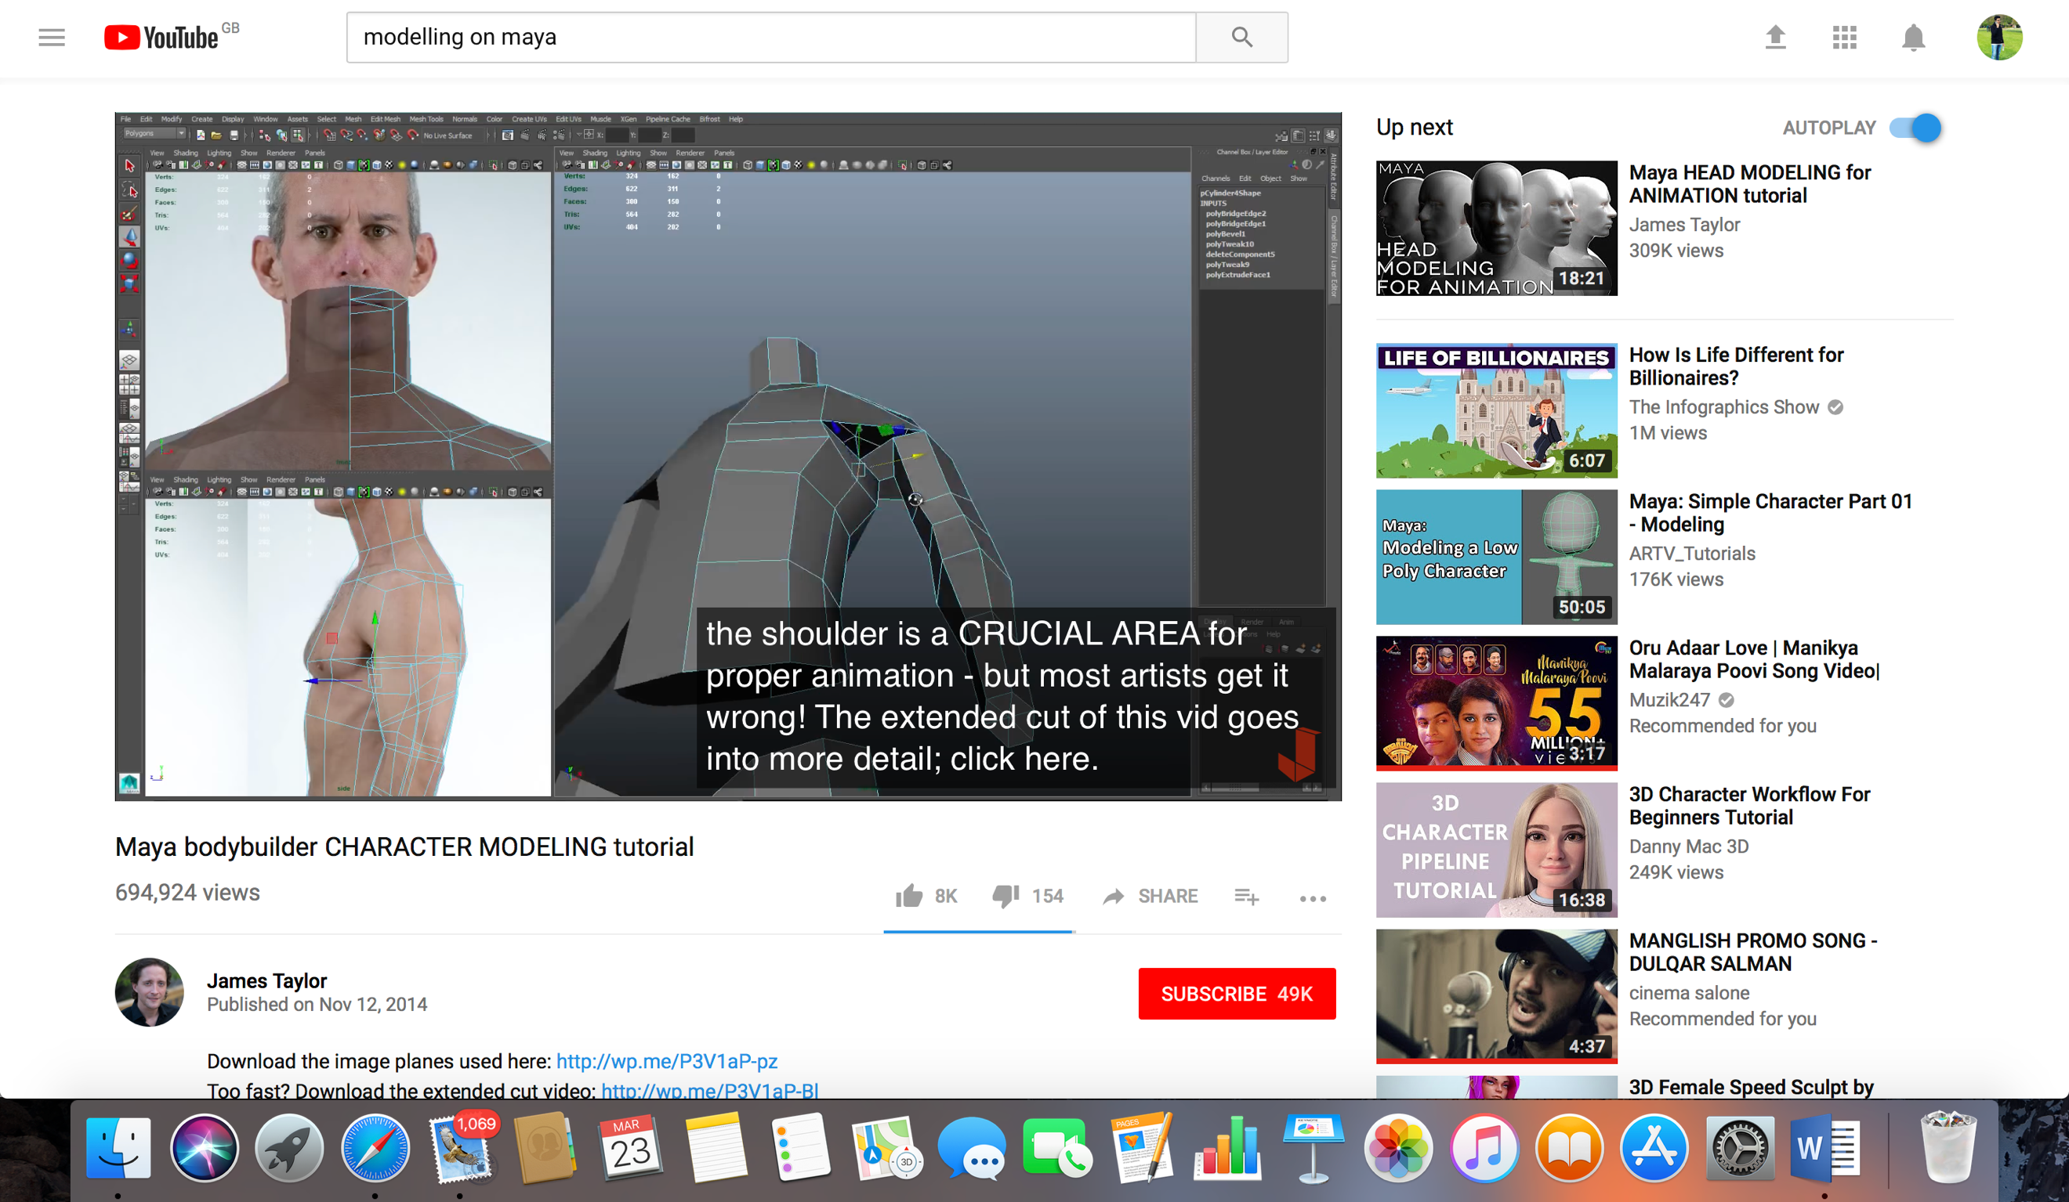
My next allocated role for this project was creating the character models, I was responsible for modelling the two children from our story and Dafydd was responsible for the two gladiator versions of the children. I decided to only model two characters rather than four characters because I had no previous knowledge on character modeling, so with this in mind we all discussed that Dafydd should help me by modelling the other two characters. Dafydd was chosen because amongst the group he had more experience and knowledge on modelling characters. Having someone who had further experience at modelling was beneficial because If I was responsible at modelling all four characters then the modelling stage would have not been completed within the given deadline. Since I had no previous experience or knowledge on modelling on Maya or Zbrush, I decided that I would watch tutorial videos on YouTube before I start creating the models. The image to the right is a screenshot of one the tutorials I used to get further education on modeling on Maya, this video was called ‘Maya Bodybuider Character Modeling Tutorial’. The tutorials I used were very helpful and useful because when I was modelling the two characters I was able to refer to the tutorials for help. Both characters were modelled on Maya and then I added the smooth feature to the characters body to give them a human like body.
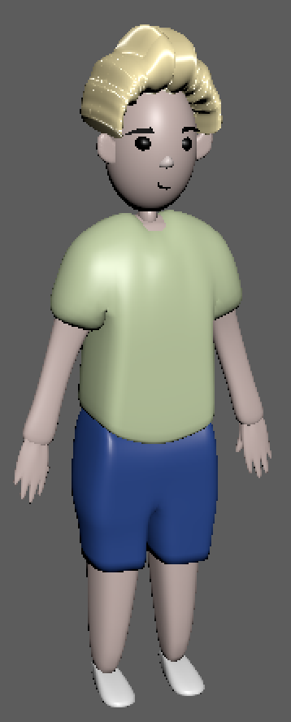
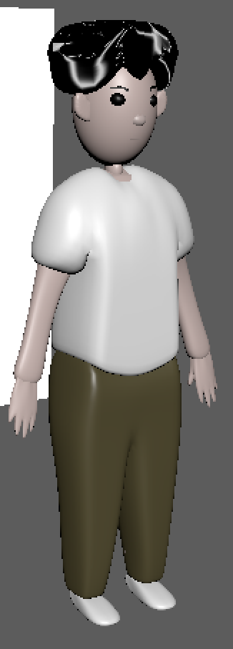
Both characters took me 2 weeks to model, the images below are screenshots of both the characters that I had modelled for the very first time. I thought the Modelling stage has taught me various skills and techniques which I can hopefully use in my future projects. This has also enabled me to obtain further experience at modelling. My Maya skills were also developed massively through this role. I also received good feedback and valid criticisms from my group, I can use them to develop and improve my modelling skills/techniques. If I could make improvements to the modelling stage, I wish I had extra time to make them more human like than the current Lego style look. When I displayed my character models to my group they all gave me good feedback and criticism, such as the fact that my models were very similar to the concept art created by Jordan. However, they suggested that my models didn’t seem correct in the living room environment. After we imported my models onto the living room scene, even I came to the same conclusion that the models were not meant for the living room environment. After a discussion on this topic as a group we decided that I should use Dafydd’s 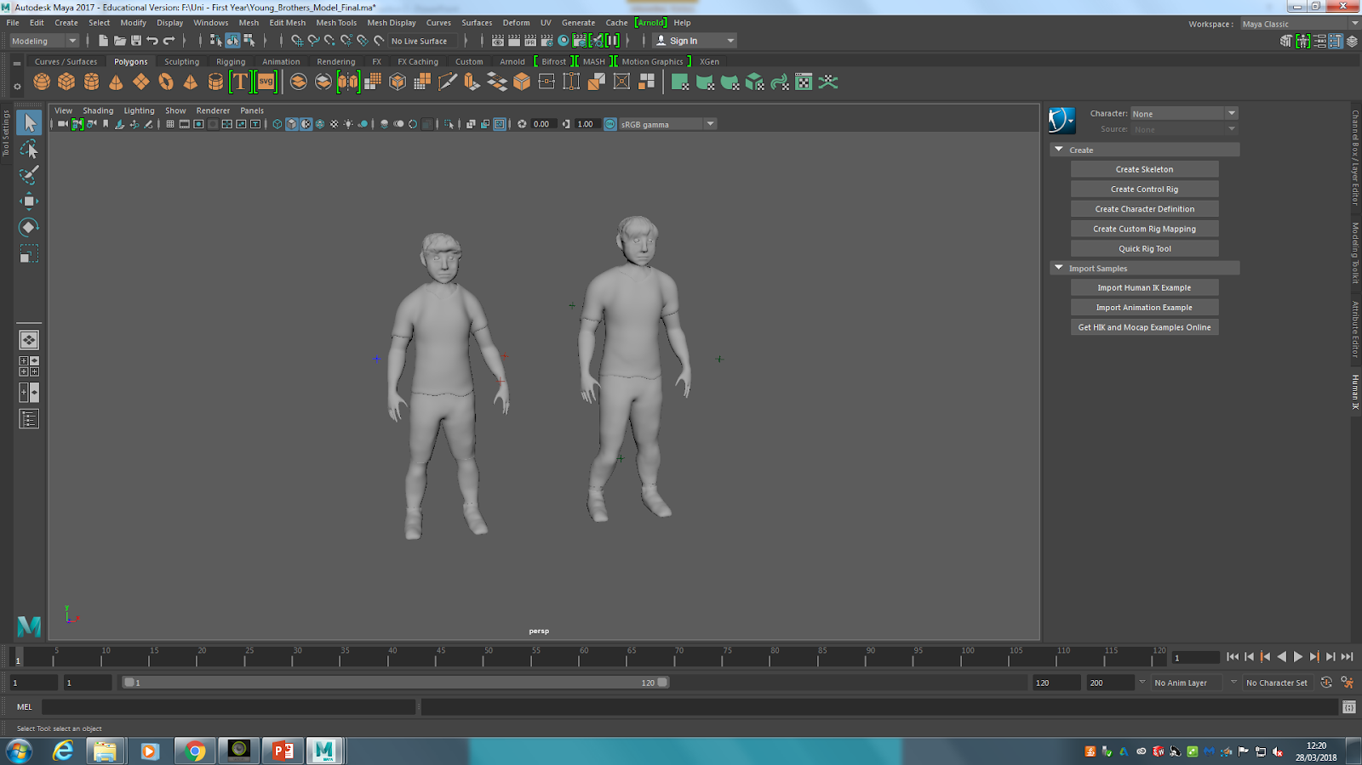gladiator models and make them into the two brothers. To do this
Dafydd showed me how to change the gladiators to look more like kids and then I did the same to the other model. He made the younger brother and I made the older one. The final brother models were completed using Maya and Zbrush.
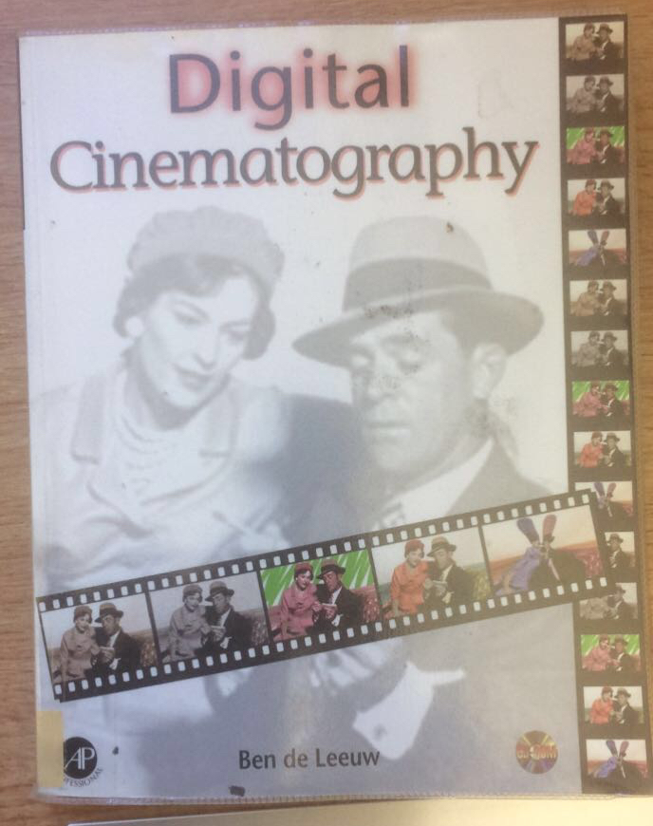
My next role was to create the animatic video. To work out the animatic video length I had to work with Ben, he was in-charge of the animations. We worked out that the completed animation will be around 40 seconds long, so the animatic was changed to 40 seconds. When creating the animatics I used Ben’s help with adding effects because I had no previous experience with Adobe After effects. I thought the animatic looked good, however the Leica reel looked a bit quick. If I could improve then I would have worked with Ben again to get the speed correct on the Leica reel. My final two roles were lighting and editing (another role that was given to me during the pre-production stage), I was able to complete both roles to the best standard using my previous experience and knowledge. Editing was done the day before the deadline of this project; Ben and I carefully edited the animation and added the sounds that were given to us. Further knowledge for this was identified from a book I obtained called, ‘Digital Cinematography’.
As a group I thought there were certain aspects that needed improvements, such as planning and communication. Communication was a big area; an example would have to be when I forgot to get a file from Ben and due to this I wasn’t able to show my group the animatic when Ben was absent. Another area was the absence of a certain group member, this caused many issues such as pre-production stage being delayed. The absence of a team member also meant that their roles had to be allocated to others who already had many other roles to do.

Bibliography:

Taylor, James (2014). Maya Bodybuilder Character Modeling Tutorial. [Video] Available at: https://www.youtube.com/watch?v=spi4lGxnMZg. [Accessed 7 February. 2018].

Artv_Tutorials (2016). Maya: Simple Character Part 01-Modeling. [Video] Available at: https://www.youtube.com/watch?v=xzmg0grXHyE. [Accessed 7 February. 2018].
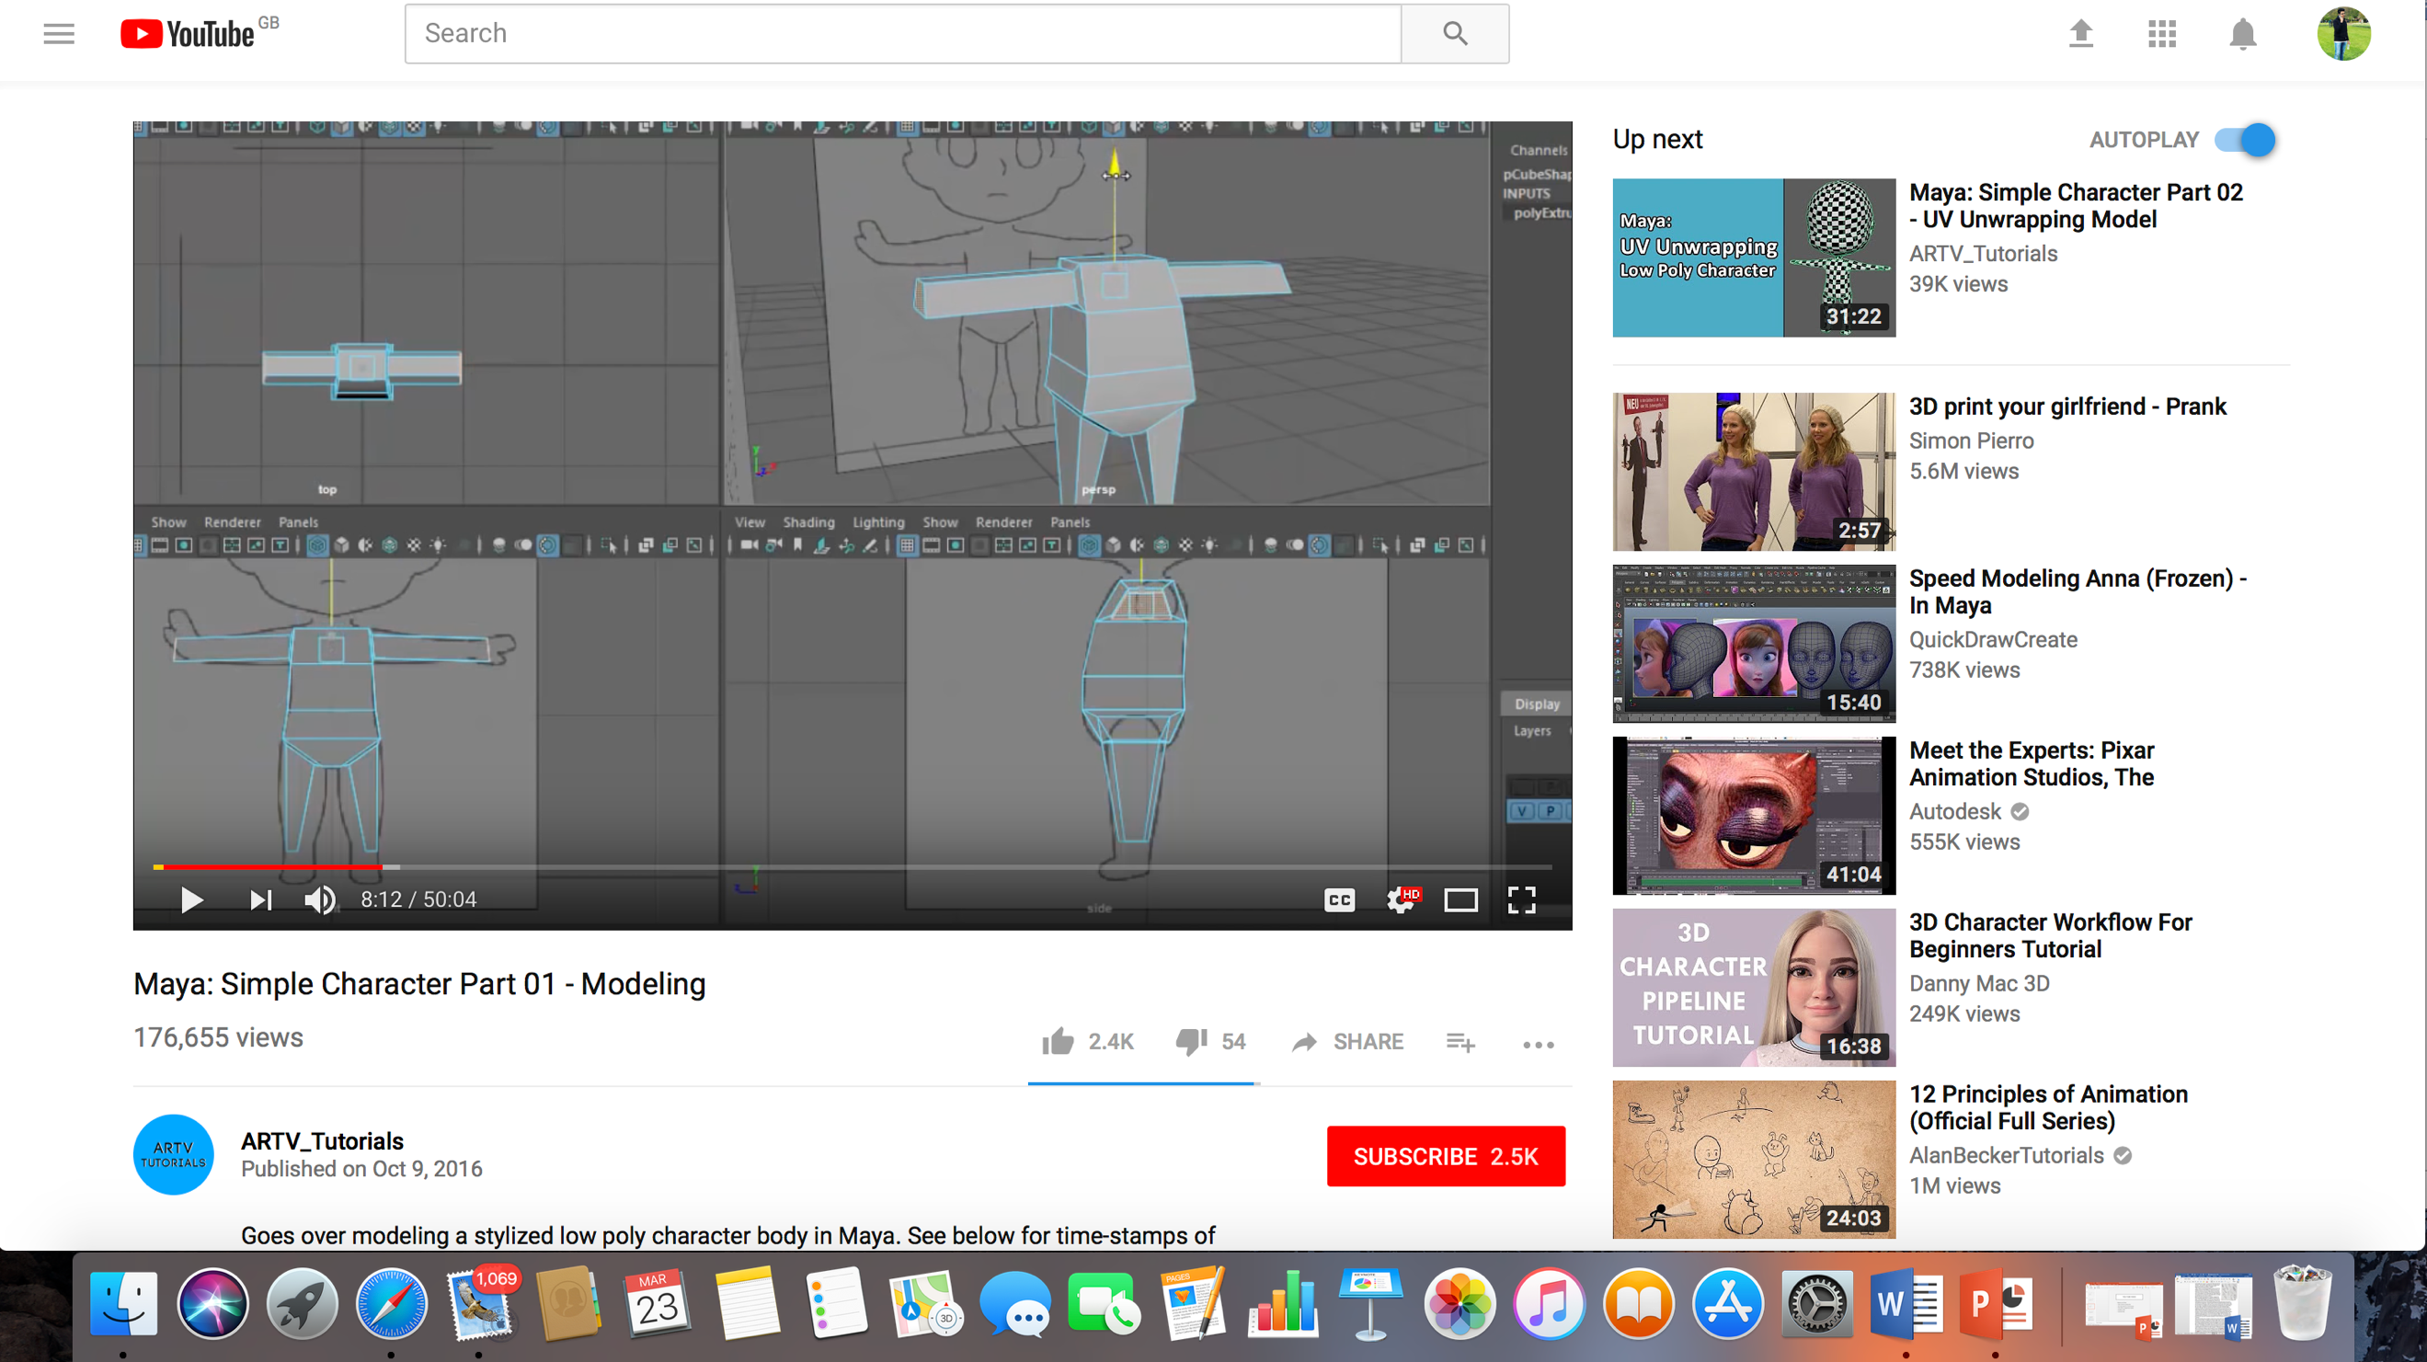

Leeuw, Ben De. (1997) Digital Cinematography: Lighting and Photography. Publisher: Morgan Kaufmann.

