TITLE PAGE

Name - Shzanur Rahman

Student I.D number- 1815228

Programme - BA (Hons) Management and Leadership – Skills for the Workplace

Module - Managing Projects in the Workplace

Module code - BMSW5104

Assignment title - Project Management Plan

Lecturer – Vajira Balasuriya

TABLE OF CONTENTS

- TITLE PAGE
- TABLE OF CONTENTS
- INTRODUCTION
- BUDGETING
- MEHNDI
- WEDDING
- CONCLUSION
- REFERENCE LIST

INTRODUCTION

On this assignment I will be organising a wedding from the side of the groom, I will be covering a number of areas, one of which is to work closely with the family and remain within their budget, and another part will be delegating a handful of family members and friends of the groom to assist with the events and planning.
“A distinctive feature of most Indian weddings is the barCt, the procession from the groom's house to the home of the bride. This procession is frequently accompanied by lights, fireworks, music, and dance” Booth, G.D., 1990

PREPARATION – Firstly I will put in place the groundwork for the wedding I am planning, this will include numerous things which I shall section into primary priorities and then secondary prioritiePlanning a wedding is a large job for any 1 person, therefore I shall include a few people to delegate responsibilities, this will not only help me to unload some of the work, but also to receive the opinions of others to ensure all angles are covered, this will be 2-3 family members or close friends of the groom/bride.

IMPLEMENTATION – Once all ideas, plans and decisions have been confirmed, it will then be time to execute everything to as close to perfection. This will include such things as, designing the theme of colour, including the clothing, furniture and decorations. Booking the correct machines, lighting, vendors and focusing on keeping to the correct timeline for the event(s)

PILOTING - In this section, it is important to test all things where possible, this ranges from seating arrangements, entry and exit places, also tasting of the food, cake and rehearsing the ceremonies and the end of the event

LIVE – Now it’s time to put all the practice, rehearsals and plans into place for the real days of events. This must be done precisely as there is no second chance, however as with anything, some things will not go as intended, so we must be ready to improvise and continue as best possible.

RESPONSE – After all events are complete, it’s very important as the event organiser to receive feedback and comments from not only the direct grooms and brides families, but also from the guests, all the staff and my colleagues who helped conduct the wedding planning.
“The wedding-planning industry began in the United States around the late 1970s and early 1980s. This was a period of unprecedented marriage Blakely / Busy Brides and the Business of Family Life 643 Downloaded from jfi.sagepub.com at PENNSYLVANIA STATE UNIV on March 5, 2016 rates, with the bulk of the baby boom generation in its prime matrimonial years” Blakely, K., 2008
BUDGETING

Budgeting for a wedding is the most important part, as this will help us to calculate exactly how much we can spend on each of the required sectors.
“Event budgeting is a critical component of event financial management. Budgeting provides detailed information of how funds should be allocated for the elements of an event” Park, H. and Olson, E., 2020

- VENUES – the first on my to do list is acquiring the correct venues, as we are having 2 main events which will require ideal locations and will be of most costly for this wedding. We must take into consideration many things, the location for the mehndi must be close to the grooms home, also we have to calculate how many guests we are expecting, typically for a mehndi it will be no more than 250 people, including the family of the groom, the cost of hiring a small hall for the times between 6pm – 11pm will be £500, this will include the seating and stage for use. The wedding hall will be a more complex issue, as the location must be close to the brides home, also we will need to calculate how many guests we are expecting, from both sides typically in an Asian wedding you can expect between 600-800 guests, typically a hall of this capacity will give a package which includes, the seating, stage, food, drinks and cake the cost of all put together is usually between £10,000 - £12,000

“Meanwhile, the National Wedding Survey claims that the average cost of a UK wedding
in 2019 was an eye- watering, Instagram-fuelled, £31,974” Pywell, S., 2020

- FOOD & DRINKS– as the food will be provided by the wedding hall, the only cost for food will be for the mehndi, as we are expecting a maximum of 250 people, we will use a local takeaway service to accommodate us, this will be worked out at a maximum cost of £500, this will be a bulk order of starters, rice and 3 – 4 curries, including vegetarian dishes, chicken, meat and fish, the takeaway will provide a selection of side dishes, usually dhall as a goodwill gesture, to save some money we will buy a variety of drinks from a local supermarket, this will be fizzy drinks, water and juice, the cost of which should be no more than £100

- CLOTHES – in an Asian wedding it is customary for the groom to purchase not only his own attires, but also to pay for the brides clothing, so for the groom we will need to purchase 2 separate event attires, 1 for the mehndi and one for the wedding, both will be custom made and ordered, the typical cost for this will be around the £1000 mark, for the bride we will be simply paying as the bride will herself choose her attires for both events, for the bride the cost is always significantly more, ranging from £2,500 - £4,000

“The recent changes in wedding attire and ceremonies are associated with the word modern. With its connection to Islam, the trend of wearing modern-style veils and Muslim clothing is perceived as better suited to the lifestyles of middle class urban Muslims”

- TRANSPORT – transport is a very important part of the event days, firstly we will need to hire a vehicle for the groom to go to the wedding hall, wait there and then return with the bride, also we will need at least 2 limousines for the family members of the groom to go to the venue and come back with, also we will need to book at least 1 coach for guests to be taken to the wedding and back, we will only need hired vehicles with drivers for the wedding day as for the mehndi, we will be using our personal cars, the typical cost for all these are in the region of £2,500 - £3,000 “Chauffeurs can be hired on an ad hoc basis to drive a wedding vehicle, drive your bosses’ car when the chauffeur is sick or even to valet cars during a car launch event or any big event. A minimum charge of 5 hours is required”
BUSES, M. and VAN, L., PASSENGER VEHICLES, 2019
- VIDEO & PHOTOGRAPHY – this is a service which is a priority, there are many companies offering this at similar prices, but it’s important to acquire a reliable service and people who have enough experience and good reviews, cost varies at the package that’s wanted, the starting price for 2 day events are £2,000 - £3,000

“Memory is ephemeral and fragile, but through the carefully curated wedding film others may bear witness to idealized forms ‘for generations to come” Wade, M. and Walsh, M.J., 2019

MEHENDI

“Throughout the world, the marks and assimilation of traditional sociocultural values into popular, mainstream culture have become the new norm: from wedding ceremonial tradition, such as mehndi and bindi” Clinics in Dermatology Volume 38, Issue 3, May–June 2020

Mehendi night is common in Asian weddings, this is an event which takes place 1 or 2 nights before the wedding ceremony, it is a gathering of the groom and brides family separately, it is almost as similar to a stag/hen night, except in an Asian setting this is a very much family atmosphere, as I am covering the grooms side I shall plan this accordingly.
The first thing I will do is calculate how many people we will be hosting for this night, I will work closely with the family members of the grooms to ensure we are both in the know of how many invitations have been sent out for this event, also we need to have a precise number of people attending, with or without children. I will then need to acquire the correct venue for this event, this must be close to home of the groom, also have appropriate parking facilities, easily accessible for people with disabilities and children.
Next I will be delegating the people who are working closely with me from the groom’s side to choose and purchase the colour theme for this event, generally in Asian weddings the direct family of each side chooses the same matching colour of clothes to match the theme of each event, this will be decided by the family members on what colour they would like, we will then need to take measurements of each person, this will be done at the shop where the family members have chosen their desired colour, material and design of the outfits. The groom’s outfits will ultimately be chosen by himself, but we will be accompanying him to various stores so he can find the perfect ones.
“Henna-night is a very old ritual, with a history that some believe goes back to the time of prophet Muhammad. Ustuner, T., Ger, G. and Holt, D.B., 2000
As this event will be held in the evening, between 6pm – 12pm it is essential to accommodate the guests with food, drinks and refreshments, I will be using a local takeaway to have fresh food ordered ready to arrive no later than 8pm, we will be having a few variety of things such as, starters, mains and certain snacks and sweets, to accommodate guests of all ages. Vegetarian dishes will be on the menu as well as chicken and meat so everyone has choices, we will be buying packs of plastic recyclable cups, plates and cutlery to serve guests with.
Before the night of the mehndi arrives I will need to pre order many items, such as, the cake, fruits, drinks, decorations, henna and some other miscellaneous items, I will attempt to use the same shop to order all these items from, this has advantages such as, the store being happier as we are spending more, items to arrive together with little inconvenience, also we should receive a better deal as we are ordering a package of items, the cake will be custom designed, this again will be done with the help of our select few people.
The night of the mehndi is very much an intimate family and friends event, we will do our best to create an atmosphere where everyone feels included and important, this isn’t always easy as there will be many people with families, but as the event is roughly a 5 hour event, we will do our best to ensure all guests feel included and a part of every ceremony.
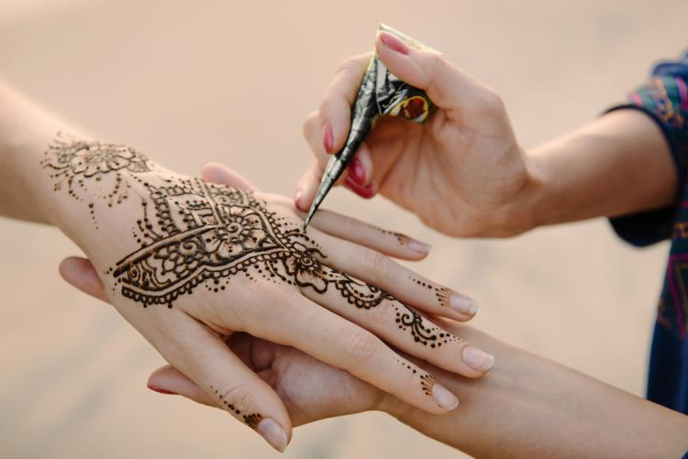
“From wedding stationary services, to the florists and photographers, many wedding suppliers are small, locally run and independently owned businesses. Often, they rely on a busy wedding season to stay afloat” Surplice, P., 2020

WEDDING

“The period between the engagement and the marriage is one of great excitement and anticipation for both the bride and groom to be. It is marked with a lot of fun-filled activities, with both families getting to together to plan the wedding, to shop, and getting to bond” Gullapalli, S. and Sagi, A.R., 2009
As I am the planner of this wedding on behalf of the groom, we will need to follow certain traditions that are common in an Asian wedding. Firstly we will have already had the grooms outfit booked and delivered to his home, this is usually custom made to fit. Transport is essential for this day, depending on where the bride is we will have booked 1 vehicle for the groom to go to the venue where the bride resides, the venue itself will be in the same city or nearby to the bride as is customary, the groom will be accompanied by some of his family members in his ride, this is usually his younger brothers/sisters. Other transport will also have been booked for family and guests, this will be 1 or 2 limousines depending on the number of family members, and there will also be a coach booked for guests who do not wish to drive.
Once we arrive at the venue, it is very important we conduct all relevant scenes within the event, as we will be on a time limit from the venue.
Upon arrival the bride and her family will enter the hall first, the groom will then enter with his family and guests, where the bride shall be placed in a different room in privacy, once the groom is in, on stage and seated we can begin the first and most important section of the wedding, “the nikkah” this is in simple terms, the vows and “I do” part, in our wedding, which is a Muslim ceremony it is conducted slightly differently, some members of the grooms family will accompany the “imam” which is a man from the mosque that is qualified to perform this part, to go firstly to the bride to ask her if she accepts this groom as her husband, once the bride has accepted, the imam will then come to the groom and do the same, once this is completed a short prayer will take place, the bride will then be accompanied on stage by her family members, they will walk up the aisle and the bride will then be left to join the stage with her newly wedded husband, now the food can be served. After this the bride and groom will together cut the cake and share with family members. “The Muslim marriages don’t seem to be a holy observance; rather they’re sure by contracts. Splendidly referred to as Nikah” Bhatia, P. and Agarwal, P, 2017
This is one of the most important parts of the wedding as in an Asian atmosphere it is very important to ensure all guests are catered for with little to no problems, first the starters will be served, along with water and drinks, the bride and groom will have a separate table for themselves along with a few family members alongside them. Once the mains and deserts have been served and finished, it will be time for the photoshoots, in an Asian wedding it is very important to allow both sides of the family to get on the stage and take photos with the groom and bride, firstly the bride’s family will be on, then each member of the family will be on with their own partner and children, then the grooms family will do the same, after this, both sides of the family are to be on stage together to create a full family picture. After this it is now time to allow guests to get on stage to take pictures with the new couple, this is a long process as there are many guests and everyone wants to have their own moment, I will be on the stage with a microphone, calling out each family to come up on stage, this must be done sensitively as we don’t want to miss anyone out, but we also must be weary of time as usually in an Asian wedding, we’ll have around 6 hours to complete all sections.
Once all pictures have been completed, it will now be time for the bride and groom to exit together, this is an emotional and important part of the event, the bride’s family must be together as one with the bride and walk her and the groom off to the transport waiting to see them off. “It expects bridal photographs to conform to a certain formulaic pattern—with the bride and groom in elaborate costumes and flawless hairdos, the bride with thick make-up, carefully prepared background scenery either in a studio or at a scenic site, and photography by professional photographers” Chan, S.C. and Ximin, X., 2007
Once the groom and bride arrive at the home of the groom, as is customary, my work as the event organizer is complete, now it is over to the families to continue with their own proceedings, however, there are certain things I will need to keep track of, such as the wedding photos and videos, usually these will be edited and be ready in 4 – 6 months after the wedding.
The wedding event is a very sacred and important event in which both the groom and brides families are under a lot of pressure to make sure all guests are served to the highest standard possible, as in an Asian culture, the wedding is a reflection on the families as to how welcoming they are, how hospitable we can be to the guests. Again we will need to make sure all guests are made to feel welcome and entertained, as there will be roughly 800 people, this will be quite challenging, but we will be working as a team to make sure nobody misses out on food, greeting the bride and groom on stage and generally enjoying the day.
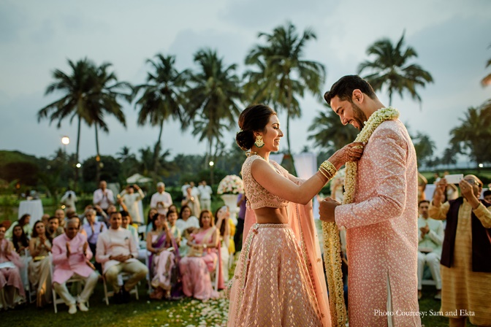
CONCLUSION

To conclude this project management plan, I have used personal experience and also research to plan this wedding, it is a very difficult job as one must be able to accommodate everyone, keeping families, friends and guests universally content is an impossible expectation, but the best planners will use all their experience and know how to do this as best as possible. I have kept family members close throughout the planning as it’s important to get a variety of opinions, also these people will have better knowledge of what would work best in certain situations. “Many people engage in the wedding planning industry because they have visions for weddings” Huang, H.C., Hou, C.I. and Hong, Y.S., 2017
As a wedding planner, I have learnt the importance of forming a team within a team, for example I am the paid planner, but it is vital for me to keep a handful of people who are family members of the groom to help organise everything, they have helped me to understand what their family needs and requires, certain things which I would not have guessed, also the family members were a direct bridge for me and the family of the bride on certain situations where it was necessary to know if the opposite family were happy with certain decisions. “The Internet plays an important role in this service industry. Thus, it will be a wise choice to make the information centre easily available via cyberspace” Por, L.Y., Boey, R.F., Ang, T.F. and Liew, C.S., 2008
I have done my best to keep the cost of the wedding as low as possible, whilst keeping the quality of products high, this of course is difficult as prices are almost the same at most places of food and services, so it is important to negotiate and get the best deal possible. I’ve also learnt that budgeting for a wedding can be quite challenging as the families understandably want to keep the cost as low as possible but do not want to compromise on the quality of the products, so it was very important for me and my team to spend time into looking around multiple stores and wedding services to compare not only the prices, but also the quality, and then to competently negotiate the best prices possible. “As the types of wedding ceremonies become diversified, and consumers’ needs become more selective, greater importance is given to wedding planners’ roles in the wedding industry, and consumers require differentiated types of wedding service” Kim, H.J. and Yu, J., 2018
Receiving feedback from both families, the bride and groom and the guests is something I actively pushed for, this was done by constantly asking people if they are ok, if everything is up to the expected standard and where needed going the extra mile to ensure quality and timekeeping
Finally, and most importantly the bride and groom, I have learnt that the most important people are these 2 people as it is their day, that will last a lifetime, I have tried to ensure the couple are happy with all decisions and preparations, whilst also trying my best for them to be comfortable in all the events.

REFERENCES

Bhatia, P. and Agarwal, P., MUSLIM MARRIAGE LAW: FORMALITIES OF A LEGITIMATE WEDDING.
Blakely, K., 2008. Busy brides and the business of family life: The wedding-planning industry and the commodity frontier. Journal of Family Issues, 29(5), pp.639-662.
Booth, G.D., 1990. Brass bands: tradition, change, and the mass media in Indian wedding music. Ethnomusicology, 34(2), pp.245-262.
BUSES, M. and VAN, L., PASSENGER VEHICLES. 2019
Chan, S.C. and Ximin, X., 2007. Wedding photographs and the bridal gaze in Singapore. New Zealand Journal of Asian Studies, 9(2), p.87.
Clinics in Dermatology Volume 38, Issue 3, May–June 2020
Gullapalli, S. and Sagi, A.R., 2009. Indian Wedding Traditions. Valuable International Perspectives.
Huang, H.C., Hou, C.I. and Hong, Y.S., 2017. Analysis of importance of the professional abilities required by personnel in wedding planner services. International Journal of Organizational Innovation (Online), 9(4), pp.157-170.
Kim, H.J. and Yu, J., 2018. Ethnographic study of the selection attributes for wedding planner. The Research Journal of the Costume Culture, 26(2), pp.217-232.
Park, H. and Olson, E., 2020. Financial Management: The Case of a Wedding.
Por, L.Y., Boey, R.F., Ang, T.F. and Liew, C.S., 2008. An interactive web-based wedding planner with comparative analysis decision support system. Journal Wseas Transaction On Information Science And Application, 5(3), pp.211-220.
Pywell, S., 2020. 2+ 2=£ 127, if you're lucky. Law Society Gazette.
SHIOYA, M., The Wedding Ceremony as an Expression of Modern Muslim Identity—A Case Study of Central Java.
Surplice, P., 2020. Future of the Wedding industry: Is the party over?.
Ustuner, T., Ger, G. and Holt, D.B., 2000. Consuming ritual: Reframing the Turkish henna-night ceremony. Advances in Consumer Research, 27(1), pp.209-214.
Wade, M. and Walsh, M.J., 2019. ‘Their time and their story’: Inscribing belonging through life narratives and role expectations in wedding videography. In Social Beings, Future Belongings (pp. 26-42). Routledge.

