

University of Wales Trinity Saint David
School of Engineering

Engine Performance Characteristics
Vehicle Technology (M4X00394)

Ross Bendon
1901002
06/01/2020

Contents
1. Introduction 3
2. Methodology and Equipment 4
2.1 Equipment 4
2.2 Methodology 5
3. Results 8
4. Analysis 10
5. Conclusion 16
6. Evaluation 17
7. References 18

Figure 1 - Engine Dynamometer Setup 4
Figure 2 - Dynamometer Calibration Calculations 6
Figure 3 – Torque 11
Figure 4 - Brake Power 11
Figure 5 - Horsepower and Torque Combined 12
Figure 6 - Comparison Graph (Automobile-Catalog.com) 13
Figure 7 – SFC 14

Table 1 - Collected Results 8
Table 2 - Calculations 10

Introduction
This report will investigate the characteristics of an engine by testing its performance on the W230 engine dynamometer. By collecting the raw data from the dynamometer, calculations can then be performed to advance the information and knowledge about the characteristics of that engine, using this information graphs can then be created to recognise trends and compared to other studies to identify if the engine is running to it’s full potential. The engine dynamometer is designed to measure the torque and rotational speed of the engine but can also be used in emissions testing by putting an engine through a typical drive cycle simulating real life road driving conditions.

Methodology and Equipment

Equipment
- Schenck W230 Dynamometer
- Honda D16V1 Engine
- Microsoft Excel
- Calibration Arms
- 20kg weight
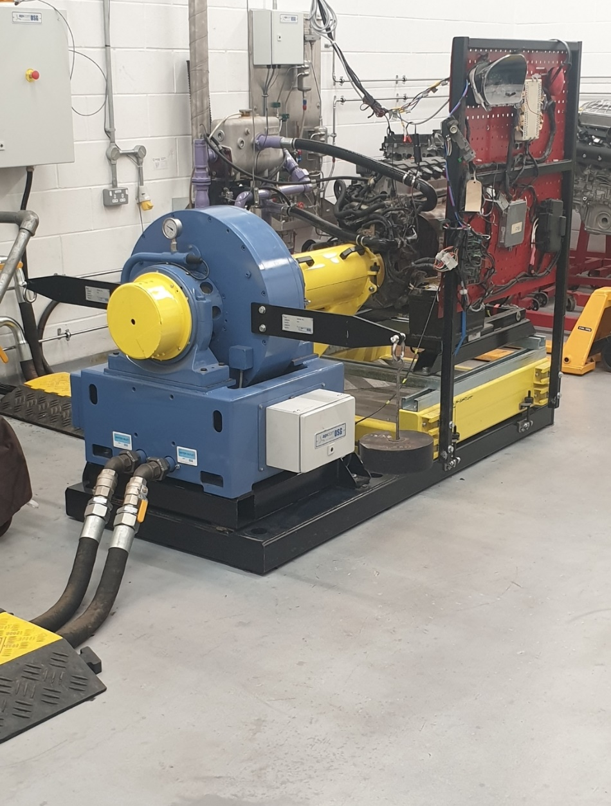
Figure 1 - Engine Dynamometer Setup

Methodology
Firstly, to check the dynamometer was calibrated correctly, the calibration arms were fitted to the pendulum housing and a load was applied to the end of one of the arms creating a turning force. The distance of the arm was 0.815776m and the load applied was 20.45kg (including the hook to attach the weight) therefore using the force of gravity and the equation T=D.mg the figure comes out to be 163.66Nm which is comparable to the 166.5Nm figure given as the session started, by reversing the equation with this equation T/Dg=m, this gave the mass of 20.8kg then subtracting the mass of the hanger left 20.3kg which isn’t far off the mass of the weight used however the weight is old and worn so some material has been lost due to corrosion and erosion.
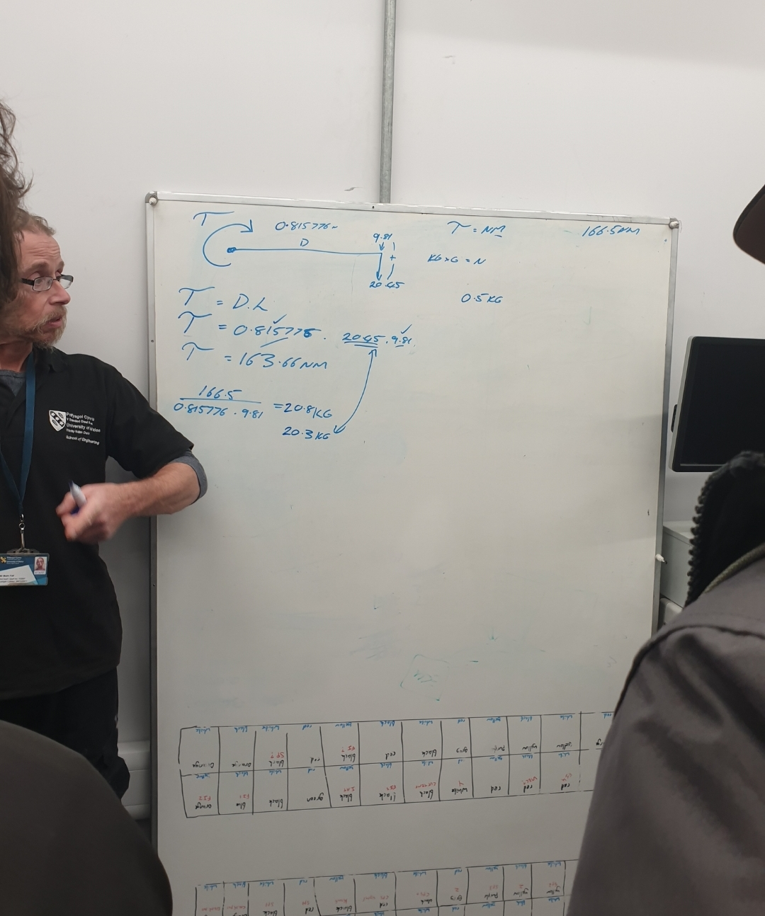
Figure 2 - Dynamometer Calibration Calculations
To collect data, a sweep test was used which means the engine will start at a chosen speed (1000rpm) and end at a specified speed (5500rpm) at a continuous pace however recording data every 50rpm so giving 90 sets of data to work with for further calculations. The test takes place with the throttle 100% open however takes longer than expected if a car were to rev because of the load being applied by the dynamometer which also stops the engine from stalling. The reading that were able to be taken were; load (N), dyno/engine speed (rpm), fuel flow (l/min) and the lambda value.
Other additional information was also recorded to help with calculations such as:
- Ambient Temperature - 25°C
- Barometric Pressure – 1.02785 Bar
- Humidity – 31.38%

Results
Table 1 - Collected Results
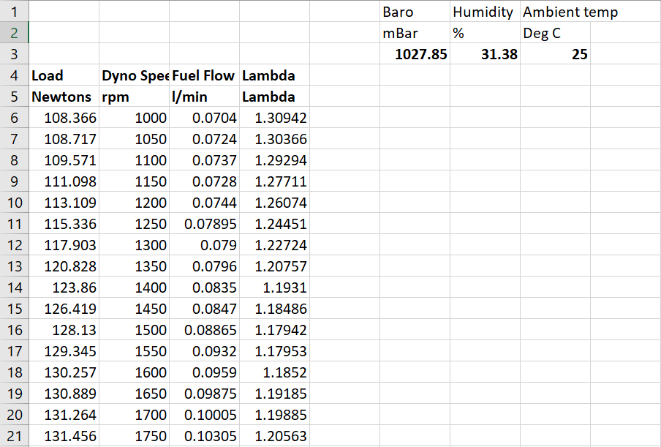



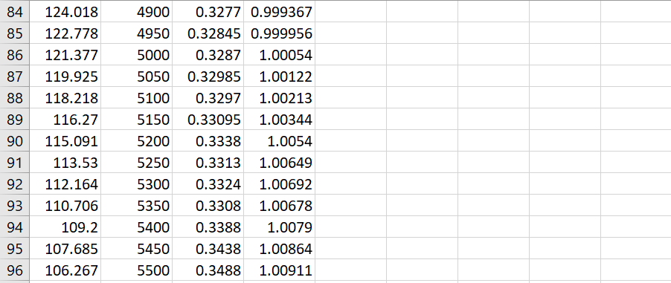

Analysis
After collecting the results, a separate spreadsheet was produced to perform calculations so that the questions asked were able to be answered, multiple formulas were used to answer these questions and create the spreadsheet.
Table 2 - Calculations
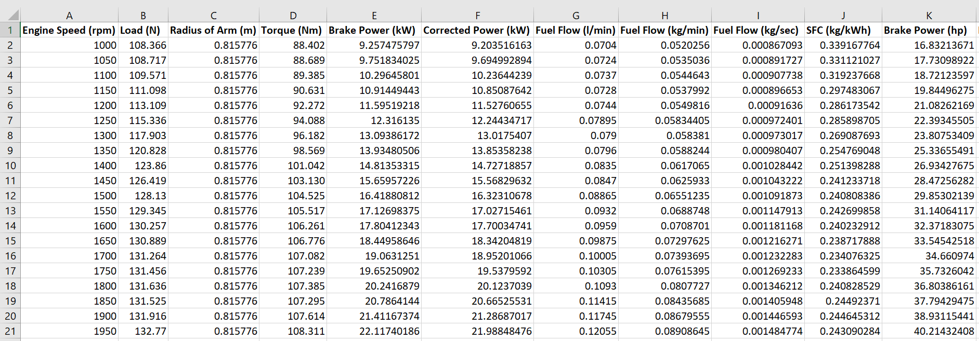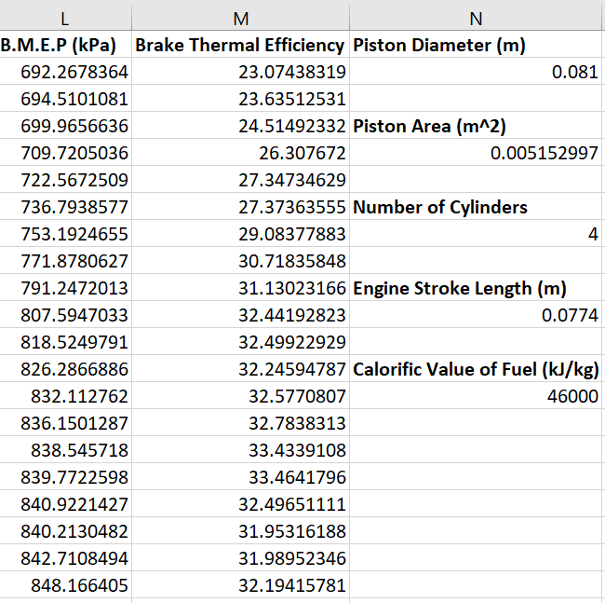
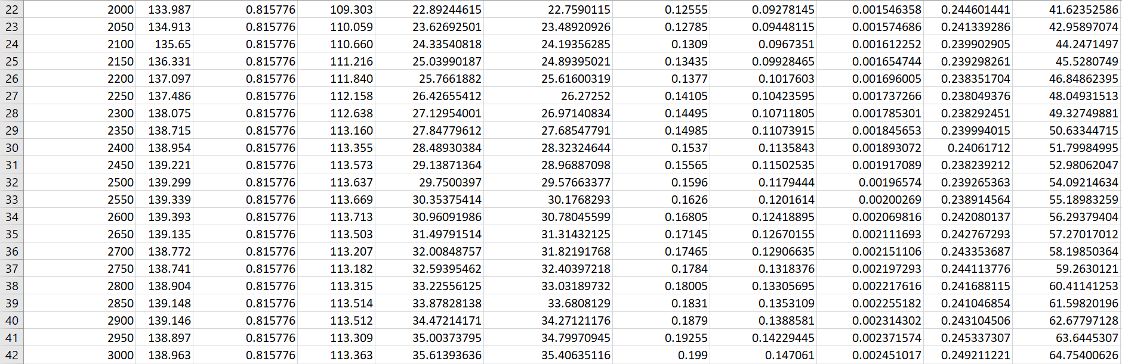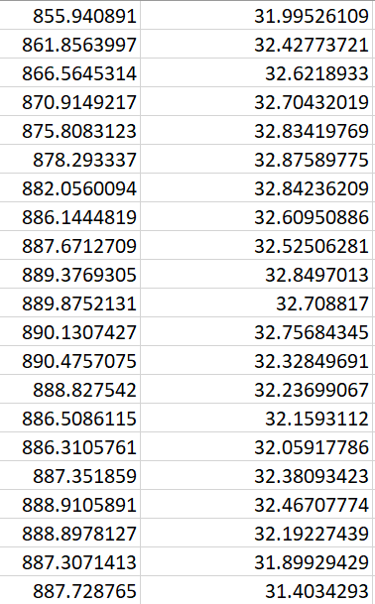
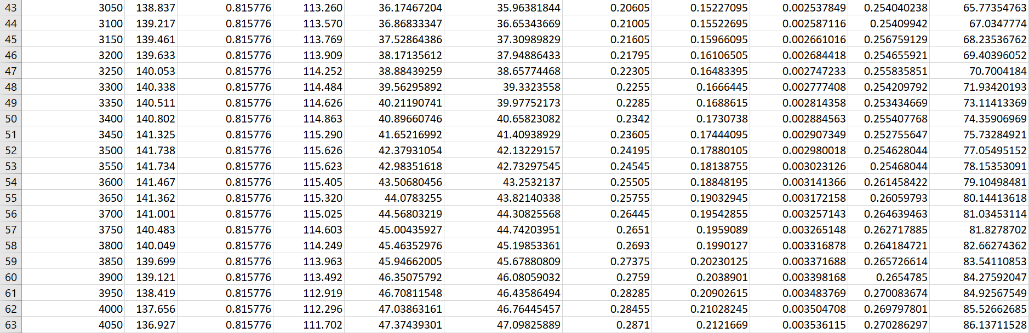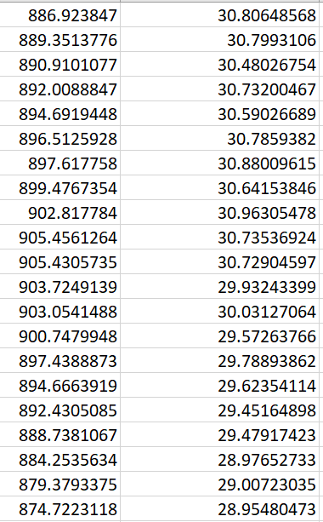
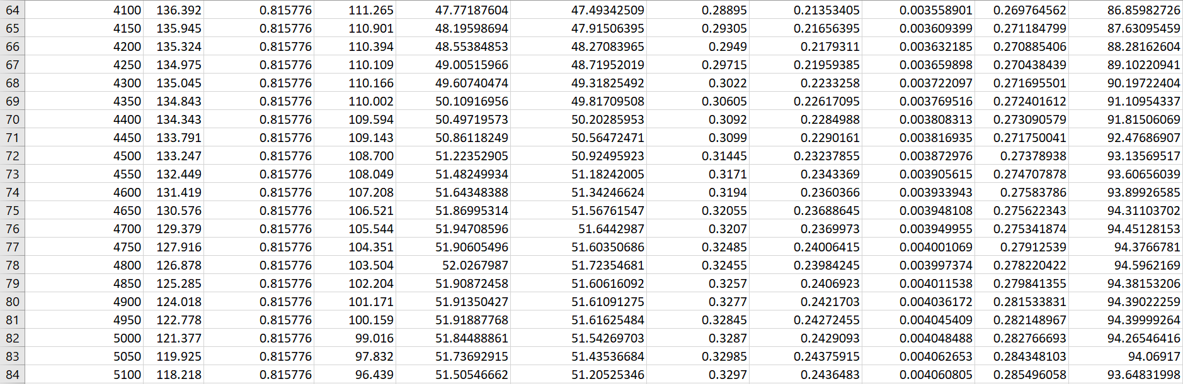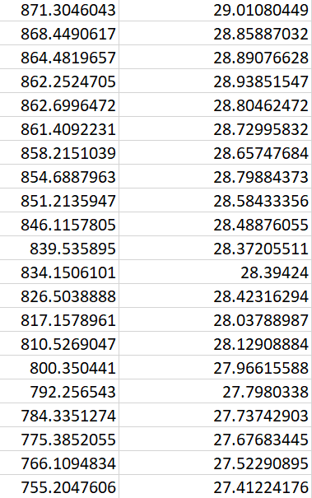
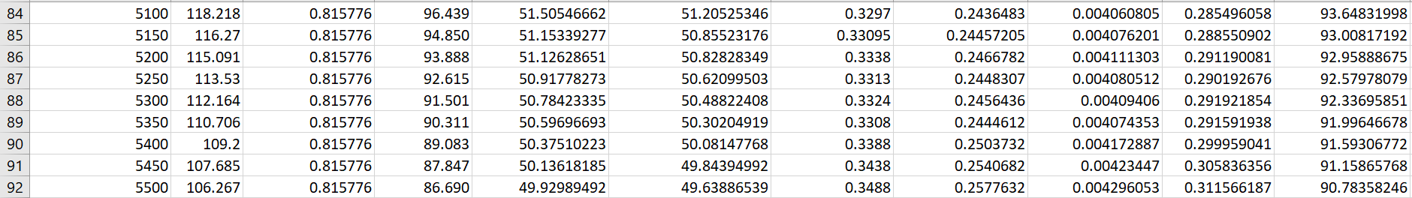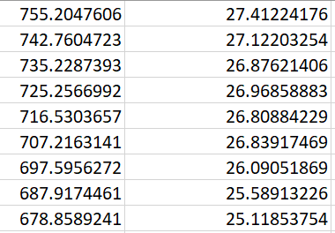
The table above presents the calculations that were completed in order to improve the knowledge of the engine. To find the torque T=WR was used where the load was multiplied by the radius of the arm, a graph was then created comparing the torque (T) against the engine speed (rpm)
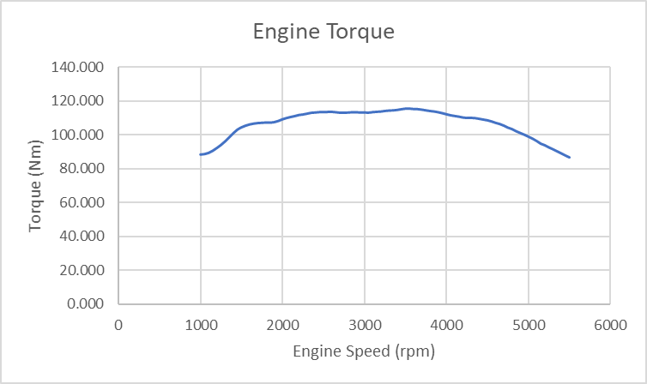
Figure 3 – Torque
Figure 3 shows that the torque figure starts off at a decent figure, which helps the car move from a standing start and at lower speeds which is especially useful for heavier vehicles or towing vehicles such as vans or lorries the line then starts to plateau at around 3000rpm which is just before the peak of around 3500rpm as the D16V1 is an economy engine therefore would not need a higher rpm for the peak for around-town driving or motorway cruising to be as fuel efficient as possible.
The brake power (BP) was then able to be calculated by using the formula $BP=\frac{2πNT}{60}$ which uses the torque (T) and engine speed (N), the graph shown in Figure 4 below shows a much more linear line with positive correlation compared to the torque graph, this is because as the rpm increases the combustions are occurring more frequently therefore producing more power, however does drop off at the top end due to the torque decrease.
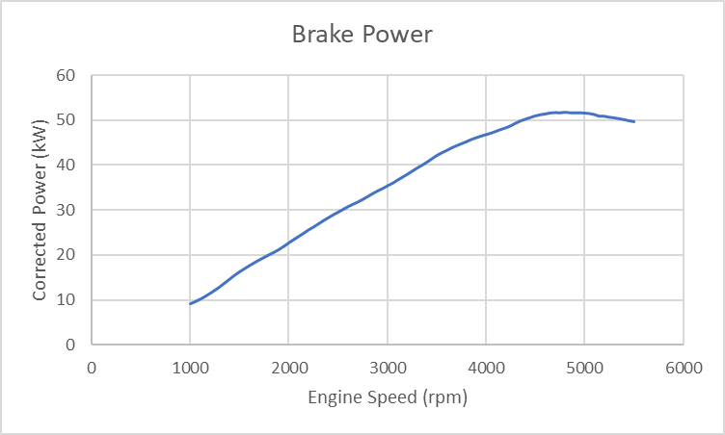
Figure 4 - Brake Power
As shown, the power increase is at a steady rate and by working out the horsepower using $HP=\frac{TN}{5252}$ , A full dyno graph can be created:
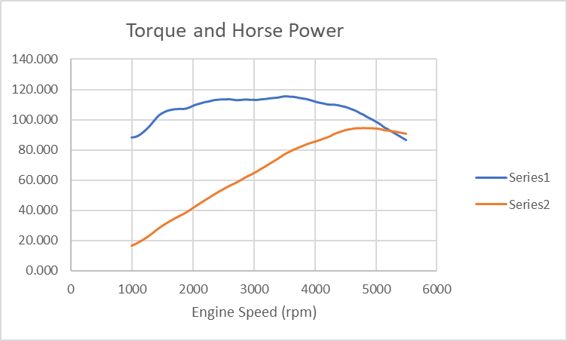
Figure 5 - Horsepower and Torque Combined
The horsepower was calculated because of the unobtainable graph in Watts or Kilowatts.
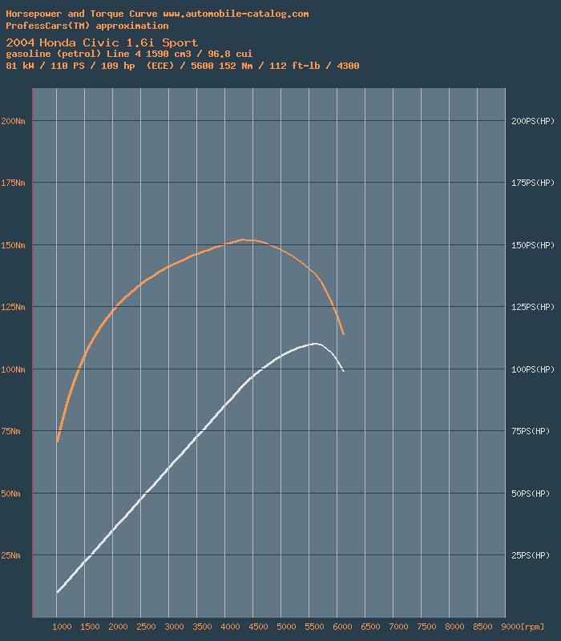
Figure 6 - Comparison Graph (Automobile-Catalog.com)
Although the original graph only has recorded data up to 5500rpm, comparisons can still be drawn from it, the original shows the torque as being roughly 90Nm however Figure 6 shows it being lower at just under 75Nm. The horsepower curve shows a similarity in shape but the original starts to drop off sooner and the torque curve shows a shallower quadratic line than the researched graph (Automobile-Catalog).
The brake power earlier calculated is not completely accurate however due to the altitude and ambient temperature at the time of testing, to solve this another equation was used; $Corrected Power=BP\frac{1.01325}{1.02785}\sqrt{\frac{298}{293}}$ , 1.02785bar was the recorded pressure in the room and 298K was the ambient temperature, due to these changes the corrected power (kW) was marginally smaller than the recorded brake power.
Next calculated was the specific fuel consumption (kg/kWh) which is used to measure an engines efficiency to produce power as the amount of fuel need (in kilograms) to generate a Kilowatt of energy in one hour. $SFC=\frac{Flow Rate x Specific Gravity of Fuel x 60}{Corrected Brake Power}$ was used to accomplish these figures as the results of the fuel flow rate were recorded in litres per minute and the specific gravity of fuel that was used was 0.739 (Quora, 2017) which is a ratio between the density of the fuel compared to water, water’s value being 1.
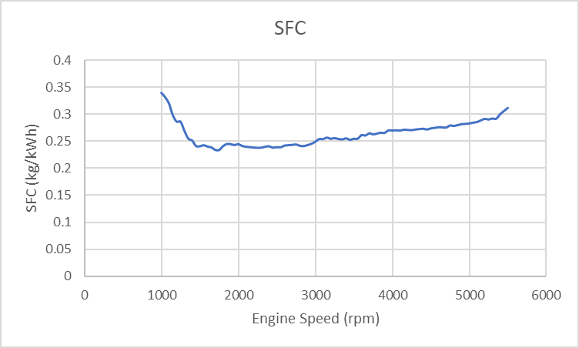
Figure 7 – SFC
The graph shows that the engine has a high consumption rate at very low rpms due to engine lugging where the engine has to work harder as the throttle is completely open, as the engine is being overworked the temperature increases therefore working less efficiently possibly causing uneven combustion within the chambers. Also, from viewing the lambda value, it shows that the AFR (air:fuel ratio) is very lean with values of around 1.3, as the revs increase to roughly 1700rpm is where the engine becomes most efficient as it is the lowest SFC. As expected, the line then gradually increases because as the rpms increase, more fuel is needed to mix with the increased volumes of air coming in from the intake. In a basic sense, more fuel is needed as the engine is rotating faster.
The bore size was taken from the engine manual provided, 0.081m so the piston area could then be determined as $A=\frac{πd^{2}}{4}$ being the total area on top of the piston.
Brake Mean Effective Pressure being the next calculation by using $BMEP=\frac{60\left(2\right)BP}{LANn}$ which is the mean pressure during the stroke after frictional loss. L being the engine stroke length also given in the manual provided (0.0774m), A being the piston area (0.005152997m²), N is the engine speed (rpm) and n is the number of cylinders in the engine (4). Typical values for a naturally aspirated spark-ignition engine are to be seen around 850-1050kPa (liquisearch.com) and the values recorded range from 700kPa (in the extremely low and high rev ranges) to 900kPa (standard rev range) so the BMEP is as it should be.
Brake thermal efficiency is the measurement of the engine’s ability to convert the energy from the fuel/combustion into mechanical energy, there are lots of ways for energy to be lost in a combustion engine such as heat and sound as well as the fuel providing energy for other areas of the car such as the alternator and air conditioning. The calorific value of fuel was researched and found as the value of 46000kJ/kg (World Nuclear Association, August 2018) by also using the SFC earlier made $η_{t}=\frac{3600(1000)}{SFC x Calorific Value of Fuel}$ gives the brake thermal efficiency, according to the hand out typical values are of 20-30% for a spark-ignited engine and the figures in the spreadsheet are from 23-32.8%

Conclusion
Overall, the results collected match up well to values researched online and show that the engine is in a healthy working order, the sweep test provided a good set of results that were accurate and contained enough raw data to complete the necessary calculations to create the graphs.

Evaluation
I think the dynamometer session went well, we were able to gather a large set of data and the excel spreadsheet worked well in terms of all the formulas performing as they were intended to. To improve the results collected, the sweep test could have been completed multiple times with figures averaged. The early rpm results could also be skewed due to the engine not being at prime operating temperature. Some of my references could have been from more reliable websites such as the Quora reference when researching the specific gravity of fuel as that is an open website where anyone can submit answers so may not be 100% accurate.

References
Quora – What is the specific gravity of petrol? (Available at https://www.quora.com/What-is-the-specific-gravity-of-petrol) Accessed on 30th December 2019
Automobile-Catalog, 2020 (Available at https://www.automobile-catalog.com/curve/2004/1134425/honda_civic_1_6i_sport.html) Accessed on 7th January 2020
Liquisearch.com - Mean Effective Pressure - BMEP Typical Values (Available at https://www.liquisearch.com/mean_effective_pressure/bmep_typical_values) Accessed on 6th January 2020
World Nuclear Association – Heat Values of Various Fuels (August 2018) (Available at https://world-nuclear.org/information-library/facts-and-figures/heat-values-of-various-fuels.aspx) Accessed on 30th December 2019

