A critical analysis of architecture post 1945 – The Sydney Opera House

Intro
The Sydney Opera House stands as possibly one of the most recognisable examples of contemporary architecture across the world. Some may even agree that this iconic building can be considered the ‘face’ of Australia. The Opera House was officially recognised as a UNESCO World Heritage Site in 2007 for its creative ingenuity and its daring engineering feats. While having encountered much controversy and experiencing the architect leave mid-project, the Sydney Opera House now serves as a focal point for artistic and cultural expression within Australia and stands as an example of innovative design and construction, with the project seeing the development of new construction methods and materials. (UNESCO World Heritage Centre, 2013)

This essay delves into the history, design principles, and engineering challenges of the construction of Australia’s biggest tourist attraction and most prominent piece of architecture.

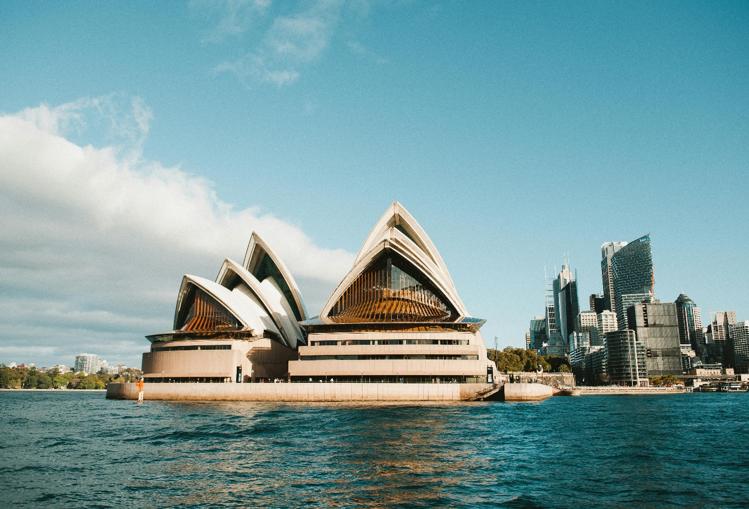

Figure 1 – A view of The Sydney Opera House from the harbour

Why was it built?
During the late 1940s, the Sydney Conservatorium of Music began looking for a new theatrical venue to provide a home for performing arts in Australia. The venue was to include a large hall capable of seating 3,000-3,500 people with an adjacent smaller hall with a capacity of 1,200, each able to accommodate the necessary acoustics to host various performances. Along with the performance halls, additional surrounding facilities were required, such as a restaurant to seat approximately 250 people, and necessary foyer and public areas. (Sydney Opera House – Jørn Utzon, no date)
An international competition for the design of the new venue was held in 1956 and the judging commenced at the start of the following year, where almost 230 designs were submitted. It was announced that the winning design was that of 38-year-old Jørn Utzon, an unheard-of Danish Architect. After winning the project, he was employed to overlook the construction of the new opera house. He moved his office to Sydney and construction of the new venue began in 1959, this would become his first major project outside of Denmark.
The Sydney Opera House is situated on Bennelong Point, a headland that protrudes out into the Sydney harbour in New South Wales, Australia. Its waterfront location allows for spectacular views of the harbour, the Sydney Harbour Bridge, and the Sydney City skyline.

Site history
Bennelong Point, originally known as ‘Tubowgale’ by the aboriginal people was an area rich in natural resources such as fish, mussels, oysters, and various edible plants. (Tubowgule, no date) The area was used as a dumping site for discarded bones and shells by the aboriginal people. When the British arrived to colonise the area in 1788, Tubowgale was used to store their horses and cattle, leading it to be known as ‘Cattle Point’. The current name of the site, Bennelong Point was derived from Wollarawarre Bennelong, an aboriginal man who served as an interpreter between the local Eora people and the British settlers. (Australian Museum, 2021)

Performance Spaces
The Sydney Opera House is about more than just opera, behind its iconic exterior is a multi-venue performing arts centre and cultural hub of various functions.
The building features the Concert Hall, The Joan Sutherland Opera Theatre, Drama Theatre, various other smaller performance spaces, backstage facilities and rehearsal rooms, as well as its restaurants, bars, and exhibition spaces, providing an immersive and engaging experience for both tourists and locals.
The main concert hall, the largest interior space within the design is capable of seating over 2600 people and hosts a variety of musical events. It features a swooping vaulted ceiling and tiered seating arrangements that extend outward from the central stage, allowing for unobstructed views of the performances. Along the side walls are raised boxes that provide more ‘premium’ and exclusive experiences of the performance. (Venue hire: Concert Hall, no date)
The concert hall is home to the Grand Organ, the world’s largest mechanical pipe organ of its kind, consisting of more than 10,000 pipes and weighing around 35 tonnes (Discover the Sydney Opera House’s 7 Performance Spaces, no date)

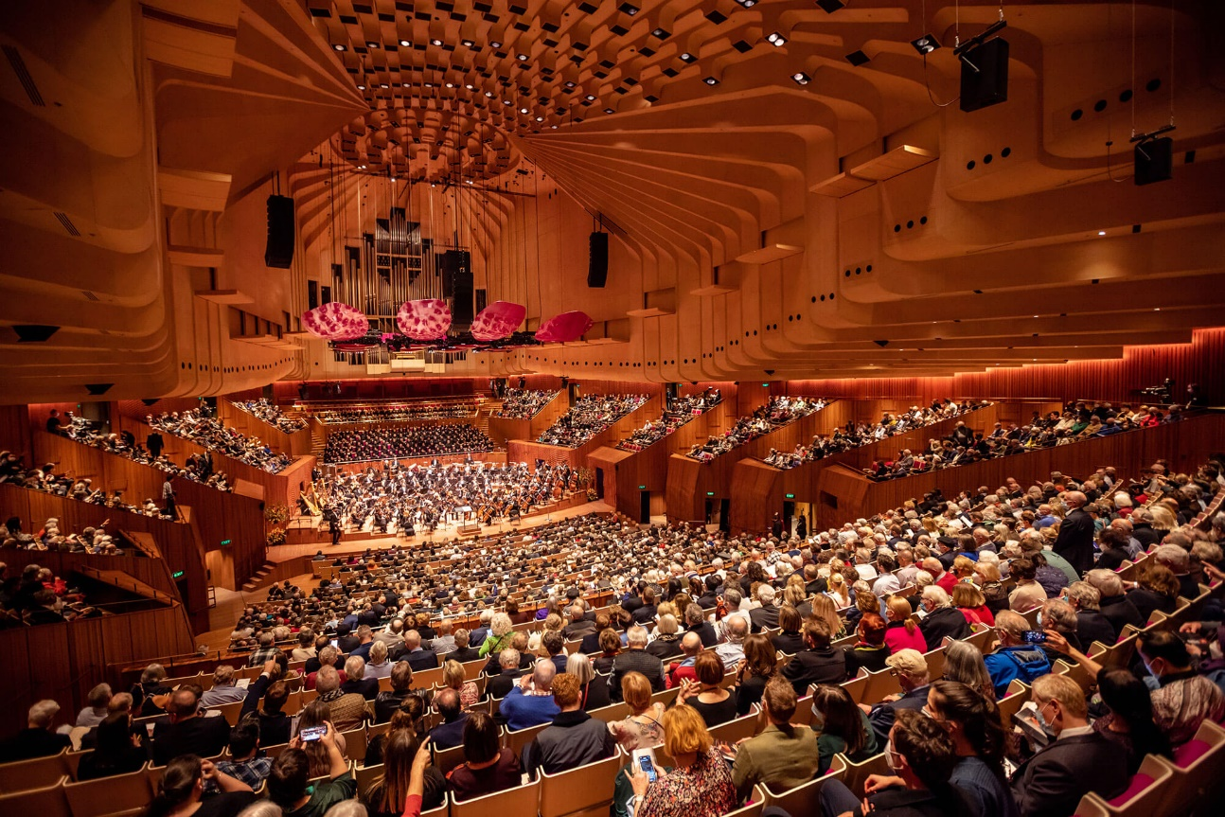
Figure 2 - The interior of the concert hall

Throughout the hall, acoustic reflectors are strategically placed to enhance the natural acoustics of the space. These reflectors help to distribute sound evenly, ensuring acoustic clarity and precision. The interior of the Concert Hall features warm, natural materials such as Australian white birch timber, which adds to the visual and acoustic warmth of the space. (Fromonot, 1998)

The Joan Sutherland Theatre, named after the renowned soprano from Sydney, seats over 1500 people and is predominately used for opera and ballet performances. It boasts state-of-the-art technical capabilities for high-quality productions. Its features include an extensive fly system and flexible staging configuration, allowing for it to host the various performances effectively. (Sydney Opera House Technical and Production Information The Joan Sutherland Theatre, no date) The adjustable walls of the proscenium arches, motorized stage lifts, and advanced lighting and sound systems provide flexibility for creative expression and technical precision. Backstage facilities, including dressing rooms, rehearsal spaces, and storage areas, cater to the needs of performers and production crews. The theatre's tiered seating, arranged in a horseshoe shape around the stage, offers an intimate and immersive experience for the audience. Additionally, the orchestra pit can accommodate up to 70 musicians.

The Design
The main elements of the design are undoubtedly the 3 separate groups of massive interlocking ‘shells’ that make up the roof of the opera house. These shells, also commonly referred to as ‘sails’ resemble the billowing sails of a boat or the rolling waves of the sea, recognising the surrounding context of Sydney Harbour. This iconic roof gives the opera house its distinctive profile and contributes to its status as one of the most recognizable architectural landmarks in the world. The ‘shells’ are covered with over a million glossy and matte light-coloured tiles that not only create a visual contrast between the blue skies and the waters of Sydney Harbour, but also serve as a dynamic backdrop for projection displays.
The project demonstrates a strategic juxtaposition of weight and lightness, where the ethereal shells seem to organically grow from a large concrete mass. This concrete mass serves as a podium, elevating the opera house up over the busy harbour. Utzon was inspired by the platforms of Yucatan, specifically those in Uxmal and Chichen-Itza where the Mayan temples were elevated above the dense jungle canopy, transforming the perception of the landscape to offer a sense of openness amidst the natural confines and providing worshippers with a physically closer connection to the gods. (‘Platforms and Plateaus. Ideas of a Danish Architect’, no date)
The podium, clad in vertical granite panels stands as a monumental element within the design, not only playing a role in its aesthetics by giving a ‘visually supportive base’ to the seemingly lightweight appearance of the shells, but also its functionality; it contains all the support facilities, rehearsal spaces, offices, and other rooms off-limits to the public. (Stevenson, 2007) This underground network of infrastructure ensures the seamless operation of the opera house while preserving the pure, ethereal appearance of the shell elements above. Utzon viewed the podium as a method of completely separating primary and secondary functions. Above, the spectators view the final, polished works of art, and below is where all the preparations occur. (Fromonot, 1998)
The Sydney Opera House's fluid, organic shapes contrast sharply with the angular buildings and geometric lines of the surrounding harbour and cityscape. Situated on Bennelong Point in Sydney Harbour, the Opera House's unique design stands out amidst the rigid structures, creating a captivating visual contrast that highlights its architectural significance and cultural prominence in the city.

Challenges and Construction
The construction of the Sydney Opera House was no straightforward task. Construction of the opera house was ordered to commence on the 2nd March 1959 by the head of the New South Wales government, Joseph Cahill before the designs were finalised as he strongly believed in the success of this project and he feared that funding would be withdrawn over the controversy the project faced. (Sydney Opera House, n.d.)
The plan was to divide the construction into three separate stages; the large concrete platform, the curved ‘shells’ that made up the roof, and then finally the interior spaces and furnishings. (Fromonot, 1998) The initial predicted completion date was set at 1963 but as we will discover, this would turn out to be a severe underestimate.
The first major issue arose rather quickly, as the site had not been thoroughly surveyed, it was discovered that the ground at Bennelong Point was unsuitable, it was saturated with water and was too unstable to build on, rendering it unsuitable for bearing the weight of the opera house. To make the ground usable, steel-cased concrete shafts of almost a meter in diameter were inserted deep into the ground around the perimeter of the site and large quantities of concrete were poured beneath the proposed base of the buildings to strengthen the unstable ground. (Fromonot, 1998) This would result in a drastic increase in costs for the client.
The concrete base was completed in February 1963, this marked a significant milestone in the project’s development, establishing it as one of the largest concrete structures in the southern hemisphere at the time. (Sydney Opera House, n.d.) However, the consequences of the premature start of the construction were mounting up, the next issue was the construction of the ‘shells’, the defining element of the opera house. Up to this point, the engineers had still not found a solution to constructing the shells. From the beginning of the design process, up until 1963, the design team explored and ultimately rejected twelve different variations of the shell-like roof structure. Eventually, Utzon had a breakthrough in solving the construction challenge of the shell roof. He recognised that the curvature of each individual shell could be derived from a single, theoretical sphere, meaning that each shell would share a common curvature, this allowed for all of the concrete ribs that would serve as the underlying structure of the unusual shell shapes to be cast in the same shape mould and then transported to site to be assembled in sections to create shapes that appear different but are in fact segments of the same shape. These series of ribs help distribute the load evenly throughout the structure and allow for large, open interior spaces without the need for interior columns, providing flexibility with the functionality of the floor plan. (Fromonot, 1998) It is said that Utzon demonstrated this theory to his design team by taking the peel of an orange and cutting it into segments of different sizes, and although each segment could vary in size and shape, the curve of each would be identical. This was dubbed the ‘Spherical Solution’ (Sydney Opera House, n.d.)
The project of the Sydney Opera House saw the use of many innovative construction materials and techniques, notably, its modular construction approach. The use of prefabricated concrete segments allowed for efficient assembly on-site, reducing construction time and costs. These chevron-shaped segments make up the whole of the shells and consist of a mosaic of ceramic tiles. This process allowed for these segments to be easily lifted into place by crane, rather than individually tiling the exterior. Each segment was meticulously engineered to fit together seamlessly, creating the illusion of a single cohesive structure despite its complex geometric composition. (Fromonot, 1998) Almost 2,200 of these pre-cast segments, each with a weight of approximately 15 tonnes were used in the construction of the iconic roof. (National Museum of Australia, 2019)
The project was also the first to implement the use of computer technology. Precise data such as angles and dimensions was collected after the end of each day of construction to be inputted into a computer at New South Wales University where it was able to model the complex forces exerted on the roof and provide mathematical solutions to the design team for the next day.
The Sydney Opera House project experienced its share of controversy as soaring costs and delays sparked public outrage and political debate. In May 1965, Davis Hughes assumed the role of Minister for Public Works, bringing a new perspective and approach to the management of the Opera House project. Hughes, dissatisfied with what he perceived as Utzon's disorganized management, intervened by halting funding for the project, leaving Utzon owed over $100,000 in fees and unable to pay his staff. This ultimately forced Utzon to resign, which was swiftly accepted by the minister. Protests erupted in Sydney as architects, artists, and unionists demanded Utzon's reinstatement. Utzon returned to Denmark shortly after, never to return to Sydney. (National Museum of Australia, 2019)

Following Utzon’s resignation, the government brought in Peter Hall, the architect who would take over Utzon’s work. (Fromonot, 1998) With the project now in its third stage focusing on interiors and acoustic design, significant alterations were made to Utzon’s original plans. Hall changed the plan for the concert hall from dual purpose to single purpose, now specifically for concerts.
The Sydney Opera House finally opened on 20 October 1973, a decade behind schedule and significantly over budget at $102 million, (Fromonot, 1998) fourteen times the initial estimate. Despite the controversy and setbacks, the Opera House stands as one of the greatest architectural achievements of the 20th century, serving as an iconic symbol of Australia, instantly recognizable and synonymous with both Sydney and the nation.

Conclusion

In conclusion, The Sydney Opera House stands not only as an architectural marvel but also as a testament to human perseverance and ingenuity. Despite facing numerous challenges during construction, including budget overruns and technical complexities, the project persevered with innovative design solutions, daring engineering feats, and the dedication of many individuals. This iconic structure became a testament to human creativity and determination and emerged as a symbol of artistic and cultural expression, not just for Sydney or Australia, but for the world.
The Sydney Opera House has had a profound impact on the cultural and economic landscape of Sydney and Australia. It serves as a vibrant cultural hub, hosting a diverse array of performances, events, and festivals that attract millions of visitors annually. Its sweeping silhouette against the backdrop of Sydney Harbour has become synonymous with the nation's identity, representing a harmonious blend of artistic expression, natural beauty, and multiculturalism.
The economic benefits stemming from tourism and cultural activities contribute significantly to the local and national economy, while also fostering a sense of community and pride among Australians. As an iconic symbol and tourist attraction, the Sydney Opera House continues to captivate the imagination of people around the world. Its inclusion as a UNESCO World Heritage Site in 2007 further solidifies its status as a global treasure, recognizing its cultural and historical significance. The Opera House has played host to numerous historic events, including the Crowded House concert in 1996, which drew over 100,000 people to its iconic grounds. The Sydney Opera House represents a groundbreaking achievement in architectural design and engineering. Its unique form and structural ingenuity continue to inspire architects and engineers, serving as a beacon of innovation in the field of architecture.

Reference List

Discover the Sydney Opera House’s 7 Performance Spaces (no date) Google Arts & Culture. Available at: https://artsandculture.google.com/story/discover-the-sydney-opera-house-39-s-7-performance-spaces/FAWhXxJfzdxTdQ?hl=en.
Françoise Fromonot (1998) Jørn Utzon. Gingko PressInc.
Google Arts & Culture. (n.d.). The Surprising Story of the Sydney Opera House’s Construction. [online] Available at: https://artsandculture.google.com/story/the-surprising-story-of-the-sydney-opera-house-39-s-construction/CAVhiDXG4On-xA?hl=en.
National Museum of Australia. (2019). Sydney Opera House | National Museum of Australia. Nma.gov.au. [online] Available at: https://www.nma.gov.au/defining-moments/resources/sydney-opera-house.
‘Platforms and Plateaus. Ideas of a Danish Architect’ (no date) Transfer. Available at: https://www.transfer-arch.com/monograph/platforms-and-plateaus/.
Stevenson, N. (2007) Architecture explained : [the world’s greatest buildings explored and explained]. New York: Dk Publishing.
Sydney Opera House (no date) Jørn Utzon, Sydney Opera House. Available at: https://www.sydneyoperahouse.com/our-story/jorn-utzon.
Sydney Opera House Technical and Production Information The Joan Sutherland Theatre (no date). Available at: https://www.sydneyoperahouse.com/sites/default/files/collaborodam_assets/soh-venue-technical-specifications-jst-v2022.03.pdf.
Sydney Opera House. (n.d.). Construction begins. [online] Available at: https://www.sydneyoperahouse.com/our-story/construction-begins.
Tubowgule (no date) Sydney Opera House. Available at: https://www.sydneyoperahouse.com/our-story/tubowgule.
UNESCO World Heritage Centre (2013) Sydney Opera House, Unesco.org. Available at: https://whc.unesco.org/en/list/166/.
Venue hire: Concert Hall (no date) Sydney Opera House. Available at: https://www.sydneyoperahouse.com/hire-a-venue/stage-a-performance/venues/concert-hall.

Images:

Figure 1 - Bernard Codillo, R. (2023). A view of the Sydney Opera House from the harbour
Figure 2 - Boud, D. (2023). The interior of the concert hall

