Understanding and Engaging in the Customer Experience
(BMSW5103)


Lecturer; Maria Heffernan

By Badsa Miah ID:1815821 Date:25/2/2022

EXECUTIVE SUMMARY

EXECUTIVE SUMMARY 2
1.0 INTRODUCTION 4
2.0 FINDINGS 5
3.0 CONCLUSION 6
4.0 APPENDICES 7
BIBLIOGRAPHY 8

INTRODUCTION

This report is for the chief executive of marketing at Tesco. The CEO and his team are currently researching the influence of ethical trading and sustainability practices and policies on the organisation's customer relationship management performance. The researcher has been asked to contribute to the following
A) Ethical policies and practices
B) Sustainability policies and practices
C) Influences of segmentation and the loyalty ladder
This report will analyse the customer’s experience of an organisation and evaluate the benefits of maintaining a good customer relationship and it will be showing the evidence in this report about Tesco.

2.0 FINDINGS
2.1
Tesco Plc provides food, non-food, and other retailing services. Its retail formats include fresh fruit, wines and spirits, in-store bakery, ready-meals, and sandwiches. In the UK, Tesco Finest and Tesco Value are food brands. Internet groceries and Tesco Direct are two of the company's online operations. Through its subsidiary Tesco Bank, the firm offers retail banking, insurance, and MasterCard and Visa credit card transactions in the UK. The Telecoms division sells mobile phones, including the latest smartphones, through Tesco Mobile. In the United Kingdom, Tesco provides retailing and related services. Jack Cohen created the firm in 1919 and it is based in Cheshunt, UK. (Tesco, 2022)
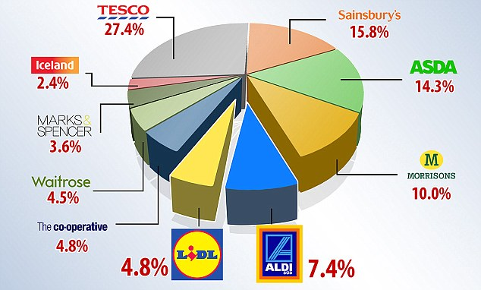
Share price
303.40p
+3.40p +1.13%
28 January 2022 at close
What is CRM?
CRM has grown in importance as a marketing tool in recent years. The retail business has experienced tremendous growth in sales and profit maximisation as a result of CRM's supportive duties. Customer service management is critical to the success of any business. In recent years, as competition has become more stiff than ever, businesses have had to focus on surviving and growing their presence. Major retailers compete to retain existing customers and gain new ones. This has resulted in the emergence of novel customer service concepts and approaches. Relationship management techniques Changes to customer relationship management (CRM) To establish a stronger reputation and facilitate data collection, this study utilised two big UK retailers: Tesco and Sainsbury's. Additionally, these two shops are regarded as pioneers in terms of using modern CRM frameworks. Both shops have expanded their activities as well. activities taken both within and beyond the United Kingdom A strong customer relationship is critical in today's changing business realities. This is one of the reasons CRM is regarded as a critical business tool in the modern-day. arena. Even better business and market planning are contingent upon improved understanding of customer and retailer success.
Ethical practices
Tesco's uses this to ensure the security of people's personal data under the data protection act. They obtained this in order to save data on your personal information, such as your billing address, email address, phone number, and date of birth. While Tesco's personal data is secure, it is vulnerable to hacking because it is stored on the internet. Personal data is handled by every member of staff at Tesco's. Ascertain that personal information is gathered, sorted, processed, and distributed appropriately by the corporate organisation. This contains information about an employee, a prospective customer, a customer, and a supplier. And anybody may make a formal request to access the data stored on them to ensure that it is current and correct. Breaching the confidences of customers or employees by selling or purchasing personal data is a serious offence punishable by an infinite fine.
Tesco has drafted a privacy statement that complies with the law, therefore avoiding legal action and a negative reputation. It safeguards the customer's data from being shared or sold to organisations with whom they do not wish to share it.
Examples of ethical workplace behaviours include adhering to the company's regulations, communicating effectively, accepting responsibility, accountability, professionalism, trust, and mutual respect for co-workers. These examples of ethical behaviour promote maximum productivity output at work, and TESCOS has a reputation for excellence in the workplace by providing the highest level of pleasure to its employees and customers in a variety of ways that contribute to the business's success. (Ethical Practice and the Role of People Professionals | Factsheets | CIPD, 2022)
Tesco’s policy is very strict regards to the information they gather of employees in the workplace and how they take customers’ private and confidential information which is very vital to the organization of Tesco because the business’s reputation will go downhill, and the company will face penalties and be fined if they don’t have the correct policies and practices in place. (Tesco,2022)
There are two major components to ethics: descriptive ethics, which includes ethical conduct that attracts consumers, and normative ethics, which includes how the organization portrays itself through a goal statement and ethical beliefs.
According to Schroeder (2002), there are three types of ethical business: those that seek to increase profit but also give charity from that profit, those that seek to incorporate social values into daily operations, and those that manufacture ethical products and services. However, this is something that is implemented by leaders who have developed ethical business and are the primary decision-makers (Schroeder cited in Campbell and Kitson,2008).
The researcher discovered two ethical tests: the golden rule test, which requires putting oneself in the shoes of others when it comes to being treated equitably, and the front-page ethical test, which requires the company to be unethical when it is poorly published on the first page.

Gellerman 1986) argues that the four most important rationalisations managers use to justify unethical behaviour are the belief that any activity falls within ethical legal criteria and is therefore not illegal, the belief that the activity is in the best interests of the individual or corporation, the expectation that the activity will somehow take on responsibility and will never be discovered or publicised, and finally, the belief that the activity benefits the firm, the organisation, or even the individual involved. (Gellerman cited in Campbell and Kitson,2008).

Retailers sell products and services to private customers or businesses, who make purchases through single transactions or subscriptions. Most retail activities are still carried out in physical stores, which sell general merchandise or specialize in specific products.
In recent years, the retail industry has faced a multitude of changes. While digital technology adoption has brought innovation, specific retail formats such as convenience and franchise stores are growing significantly faster than others. The retail market for fast-moving consumer goods is highly affected by the rise of e-commerce and shifts in consumer behaviour, such as increasing demand for multiple delivery and collection options. Meanwhile, the retail supply chain is becoming more complex, as brick-and-mortar stores are only one of many shopping touchpoints.
As one of several recent macro-trends, consumers expect retailers to run more sustainable businesses and reduce their impact on the environment. Jason Tarry, Tesco UK and ROI CEO said: “We’ve been using rail to transport our goods since 2008 and this new service reflects our continuing commitment to rail which has clear advantages for our business, our customers and the planet. Our rail service will be an important part of our efforts to deliver a fantastic Christmas for our customers but the journey doesn’t stop here as we continue to increase the number of containers we transport by rail as part of our commitment to reach net zero emissions in our operations by 2035.”

Chris Connelly, NTS Deputy CEO and Rail Director, said: “This is fantastic news, not only for DRS and Tesco but also for the environment. This is an example of how rail can play an integral part in the race to net zero. Each train will remove around 40 lorries from Britain’s roads and save 9,000 tonnes of CO2e, and we’re running two trains a day, seven days a week. We’re thrilled to be working with Tesco on this new service, helping them drive down their carbon footprint as they deliver for their customers throughout the UK.”
However Tesco and other supermarkets came under bad ethical practices In 2007, Tesco was placed under investigation by the UK Office of Fair Trading (OFT) for acting as part of a cartel of five supermarkets (Safeway, Tesco, Asda, Morrisons and Sainsburys) and a number of dairy companies to fix the price of milk, butter and cheese. In December 2007 Asda, Sainsbury’s and the former Safeway admitted that they acted covertly against the interests of consumers while publicly claiming that they were supporting 5,000 farmers recovering from the foot-and-mouth crisis. They were fined a total of £116 million. (Tesco, 2022) Tesco has improved its ethical processes by changing its behaviour.

Influences of segmentation and the loyalty ladder
The loyalty ladder is a relationship marketing concept in which consumers go through relationship tiers, beginning as prospects (those who want to purchase but have not yet done so) and ending as advocates (intensely loyal brand champions). Typically, the loyalty ladder looks something like this:
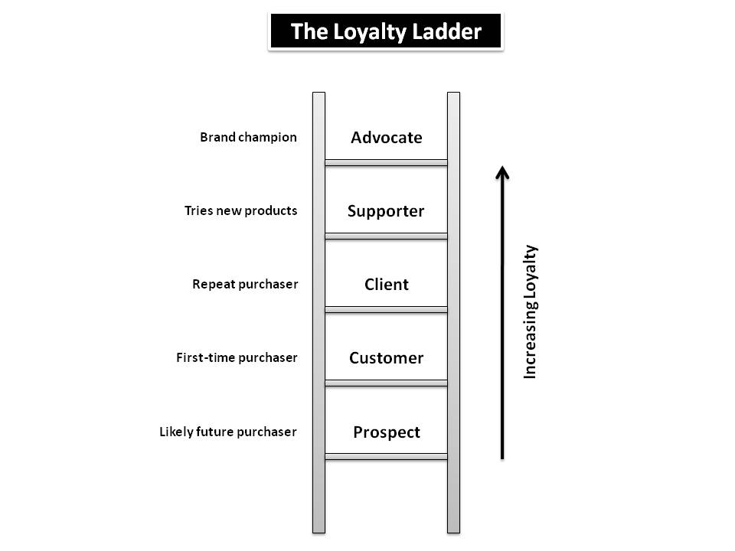

(The Loyalty Ladder: A Sideways Look | Eight Leaves | Data Analytics & Software Development, 2022)

Tesco and Sainsbury's Recent Customer Relationship Management Trends: Tesco and Sainsbury's have both been using customer relationship management tactics continuously. According to Tesco (2021), as a very effective instrument for customer service Relationship Management; over 150,000 Tesco customers receive magazines every month.
Having the most recent and exclusive offerings. These publications include advertising, stories, and the newest news. The latest news about our goods and services. Tesco Clubcard is a loyalty program that was launched in 1997. introduced to keep and earn the consumers' loyalty. Customer service techniques that are effective Additionally, relationship management has been expanded globally, with more than 8. Tesco contacted millions of consumers via the CRM solutions it has implemented. To remain in www.tesco.com, which was launched in 2000, keeps in touch with present and new clients. Each of these efforts are having a favourable effect on the decision-making process of customers. On the other hand, According to Sainsbury's (2012), the supermarket chain has steadily encouraged consumers to purchase online. as well as in-store. As with Tesco, Sainsbury's has sent magazines to its customers and the Nectar Card was introduced. Sainsbury's has made data collection a priority. customer encounters. This can become an essential component in formulating the most advantageous marketing methods that work.
Tesco's is one of the most well-known grocery stores in the world. They have built their reputation by increasing product loyalty and meeting the needs of external customers. For example, their unique selling point is to offer club cards to customers. This has become their method of communicating with customers in order to convey the benefits of brand loyalty and relationship building. Tesco's has continually introduced innovative ways to exceed customer expectations, and they have done it in a manner that distinguishes them from other food retailers. They introduce something fresh to entice clients to purchase their goods through the use of discounts and coupons. This is how to establish a positive reputation: by delivering something distinctive that appeals to customers, by analysing what customers want to buy, and by assisting customers in developing trust in order to acquire items.
Increased consumer goodwill aids in the retention of existing customers, since they see a benefit from purchasing at Tesco's. The club card fosters confidence in Tesco's and the United Kingdom; sales were enhanced by 4.5 percent volume growth. The club card is utilised for marketing reasons and is a customer service effort. The benefits of this are that they will gain loyal consumers, and that they will maintain a consistent level of service. Additionally, this will build trust among those who already have club cards, and will help spread the word about why they enjoy using club cards. Revenue begins to grow when a business develops pricing strategies to increase awareness. Posting it on social media platforms will increase awareness and, potentially, profit. When Tesco's advertises, it will be seen not only on television commercials, but also on the website for those who shop online and those who deliver goods. (Tesco,2022)

- Enhancing the reputation of business and brand – trust and confidence in business and brand leading to the potential expansion into new product ranges/services
- Increased customer retention
Pestle analyses showed there are 2 major influencers which is economical and political factors that Tesco’s affect their behaviour and it is vital to follow government guidelines to ensure safety of customers such as the pandemic queuing system that was implemented.
The economical factor of Tesco’s was on a strain due to restricting volumes of customers shopping in store lead to less revenue and it affected sales and deliveries were congested due to high impact which caused issues.

3.0 CONCLUSION
The researcher has found the information on sustainability policies and ethical policies of Tesco’s to be good ethical practice and procedures Tesco’s have in place to govern its operation CRM system has shown its core practises in place by engaging with customers and how they can engage in customer experience and how they collect their data and cookies.

RECOMMENDATION
More training for the employee on procedures and policies how it relates to customer experience.

4.0 APPENDICES

4.1 Pestle

Political Factors
Since the retailing company operates worldwide, global political factors greatly influence the performance of Tesco. These include, tax rates, acts of legislation and of course, the stability of the country it operates in. Due to ongoing financial instability in the world, many governments encourage retailers to create jobs for the domestic population. As Tesco plays its part in creating employment opportunities, it also, in turn, increases the demand for its products and diversifies its workforce.
Economic Factors
These factors are the main point of concern for Tesco, as they are most likely to leverage costs, demand, profits and prices. Therefore, the company should be aware of any changes in policies, such as changes in taxation or any other factors which could affect the accessibility of finance. It is important to mention that although the business is growing internationally, the company is still quite dependent on the UK market where it has a market share of around 30%.

With that said, internationalization and diversification have been two key strategies pursued by the company over the years, and a major reason for its success. Furthermore, due to decline in disposable income levels and household incomes, Tesco, has shifted most of its focus towards advertising its value brands rather than the more luxurious items.
Social Factors
Due to a variety of social changes, trends indicate that customers in the UK have moved towards bulk shopping and one-stop shopping. Therefore, Tesco has increased the number of non-food items offered for sale. The type of goods and services demanded by consumers is mostly influenced by their beliefs and attitudes which, in turn, are influenced by social conditioning. Because customers are becoming more aware of health issues, due to which their approach towards foods is changing constantly, Tesco is adapting to these changes by accommodating the demand for organic products.
Technological Factors
The advancements in technology have brought various new opportunities for Tesco. Two of the most distinct ones include, firstly, the development and introduction of online shopping with facilities for home delivery. Secondly, self-service checkout points have provided convenience and ease for customers, which in turn have reduced labour costs. Furthermore, Tesco has also invested a significant amount on energy efficiency projects to fulfil its long-term objective to reduce its carbon footprint.
Environmental Factors
With increased pressure on companies to address environmental issues and to adopt ways of operations which what would benefit society, Tesco is clearly committed to reducing its carbon footprint by 50% by 2020. Also, Tesco is minimizing the waste produced in their stores by increasing social conscience in customers.

Legislative Factors
Government policies and legislations also directly impact the performance of Tesco. For example, the Food Retailing Commission (FRC) in 2004 suggested a Code of Practice should be introduced which would ban many current practices, such as changing prices without notice or demanding payments from suppliers. To facilitate these policies, Tesco provides its customers price reductions on the fuel they purchase, in accordance to the amount spent on their grocery stores. Also, there are several promotion offers where prices are lowered. (Contributor, 2022)

(Tesco SWOT & PESTLE Analysis | SWOT & PESTLE, 2022)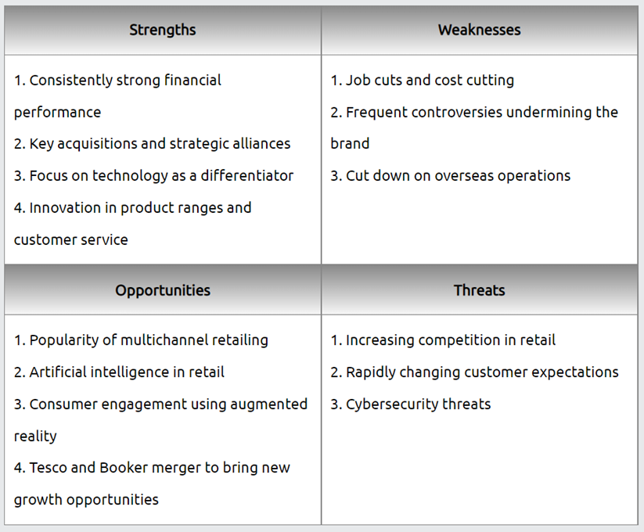

BIBLIOGRAPHY

CompaniesHistory.com - The largest companies and brands in the world. 2022. Tesco. [Available at: https://www.companieshistory.com/tesco/
[Accessed 29 January 2022].
Salesforce.com. 2022. What is CRM?. Available at: https://www.salesforce.com/uk/learning-centre/crm/what-is-crm/#:~:text=CRM%20stands%20for%20Customer%20Relationship%20Management.
[Accessed 25 February 2022].
CIPD. 2022. Ethical Practice and the Role of People Professionals | Factsheets | CIPD. Available at: https://www.cipd.co.uk/knowledge/culture/ethics/role-hr-factsheet#gref
[Accessed 25 February 2022].
Tescos,2022. Available at: https://www.tescoplc.com/about/how-we-do-business/ethics-and-compliance-policies/ [Accessed 25 February 2022].
Eightleaves.com. 2022. The Loyalty Ladder: A Sideways Look | Eight Leaves | Data Analytics & Software Development. Available at: https://www.eightleaves.com/2010/04/the-loyalty-ladder-a-sideways-look [Accessed 25 February 2022].
SWOT & PESTLE.com. 2022. Tesco SWOT & PESTLE Analysis | SWOT & PESTLE. Available at: https://www.swotandpestle.com/tesco/
[Accessed 25 February 2022].
Contributor, P., 2022. PESTLE Analysis for Tesco discusses its Business Environment. PESTLE Analysis. Available at: https://pestleanalysis.com/pestle-analysis-tesco/
[Accessed 25 February 2022].
Campbell, R, Kitson, A. (2008). The Ethical Organisation. Palgrave. Macmillan
2022. Available at: https://secure.tesco.com/clubcard/
[Accessed 25 February 2022].
Harvard Business Review. 2022. Why “Good” Managers Make Bad Ethical Choices. Available at: https://hbr.org/1986/07/why-good-managers-make-bad-ethical-choices
[Accessed 25 February 2022].

