2022
Learning & Reflection
THE Sports development entrepreneur bMSM6008
Self & Peer Review
Section 1 Self Analysis

The questionnaire statements are focused on your preferences so there are no right or wrong answers. For each statement, circle one of the numbers on the 4-point Likert scale. Personal reviews should consider the reflective
process (e.g. Gibbs Cycle) and consider the available literature in setting future action plans. Evidence of contribution should be included in the appendix. This should include photographic, scanned or screen shot evidence of tasks,
meetings and activities. A list of references can also be included at the rear, to complement any citations to literature made during the completion of this report card.

Entrepreneurial Intention

Intention

 | Not like me at all |  | Somewhat like me |  | Exactly like me
I am ready to do anything to be an entrepreneur | 1 | 2 | 3 | 4 | 5
My professional goal is to become an entrepreneur. | 1 | 2 | 3 | 4 | 5
I am determined to create a business in the future. | 1 | 2 | 3 | 4 | 5
I have very seriously thought about starting a firm | 1 | 2 | 3 | 4 | 5
I have got the intention to start a firm one day | 1 | 2 | 3 | 4 | 5
intend to start a firm within five years of graduation | 1 | 2 | 3 | 4 | 5
I see the possibility of starting a business as a potential opportunity to pursue | 1 | 2 | 3 | 4 | 5
If I do not start my own business, I may be missing a great opportunity | 1 | 2 | 3 | 4 | 5
Overall I would label the option of starting a business as something positive | 1 | 2 | 3 | 4 | 5

Please describe in our own words how the Module learning has affected your entrepreneurial intentions.

The moThrough out the course of my studies, I have come to understand that starting a Sports Travel
package agency is more than just a business idea and has opened my eyes to the business world.
The business planning module has taught me the importance of a well-structured business plan.
It has guided me in defining clear objectives, devising effective strategies, and planning for
potential challenges.
The modules on marketing have broadened my perspective on how to effectively promote my services.
From traditional marketing techniques to digital marketing strategies, I've gained valuable.
insights into reaching my target audience.
It has showed me that running a business can become very complex and very challenging. However, also
very rewarding at times. It has showed me that one must take risks and not to be scared about
failing numerous times. It is something that I would consider further into the future.

Contribution Summary
Please use the space below to outline your contribution for the entire duration of the module, from the initial
opportunity recognition and ideation phases, through to the business pitch and business planning, and eventual submission of the business plan and promotional resources.
You are encouraged to use the appendices section to evidence your contribution via photographic, scanned or
screen shot evidence of tasks, meetings and activities.

My contribution to this business contained a variety of things that we kept in and ones that we got rid of. My main idea that we pitched was having insurance on package bundles. I believed by having this that customers would be more open to working with us as it gives them a sense of comfort and trust. By implementing insurance customer satisfaction rates will rise, creating a much better review on websites, allowing further customer growth.
I also took lead into pitching the overview of the company as the business idea came from myself. I was the one to suggest it making me the lead role of producing an image whilst pitching our ideas.

Identifying Ideas and Opportunities – Self-appraisal

 | Not like me at all |  | Somewhat like me |  | Exactly like me
I am excellent at finding new opportunities to generate value for others. | 1 | 2 | 3 | 4 | 5
I am excellent at recognising new opportunities to address problems and challenges. | 1 | 2 | 3 | 4 | 5
I am excellent at seizing and shaping opportunities to respond to challenges and create value for others. | 1 | 2 | 3 | 4 | 5

Creativity

 | Not like me at all |  | Somewhat like me |  | Exactly like me
I am excellent at developing multiple ideas that create value for others. | 1 | 2 | 3 | 4 | 5
I am excellent at testing and refining ideas that create value for others. | 1 | 2 | 3 | 4 | 5
I am excellent at transforming ideas into solutions that create value for others. | 1 | 2 | 3 | 4 | 5

Vision

 | Not like me at all |  | Somewhat like me |  | Exactly like me
I am excellent at imagining a desirable future. | 1 | 2 | 3 | 4 | 5
I am excellent at building an inspiring vision that engages others. | 1 | 2 | 3 | 4 | 5
I am excellent at using my vision of the future to guide strategic decision-making. | 1 | 2 | 3 | 4 | 5

Valuing Ideas

 | Not like me at all |  | Somewhat like me |  | Exactly like me
I am excellent at understanding and appreciating the value of my ideas. | 1 | 2 | 3 | 4 | 5
I understand that ideas can have different types of value, which can be used in different ways. | 1 | 2 | 3 | 4 | 5
I am excellent at developing strategies to make the most of the value generated by ideas. | 1 | 2 | 3 | 4 | 5

Ethical & Sustainable Decision Making
 | Not like me at all |  | Somewhat like me |  | Exactly like me
I can recognise the impact of my choices and behaviours. | 1 | 2 | 3 | 4 | 5
I consistently consider ethical and sustainable principles when making decisions. | 1 | 2 | 3 | 4 | 5
I am excellent at making sure that ethical and sustainability goals are considered and met. | 1 | 2 | 3 | 4 | 5

Identifying Ideas and Opportunities – Self-reflection

Step 1 : Description of Process

As a group we decided to run with the suggestion of putting together a Sports Travel package Agency as it allows
us to engage in all types of sport.
as pure sports enthusiasts we love the idea that we can become big contributes to sports worldwide.
We strongly believe that this business idea would be very effective as the opposition in the market isn’t
Very high. There are not thousands of companies like us so it allowed us to strive to be the best.

Step 2: Personal Contribution to the Process

I suggested the idea of offering different package bundles. (ie, gold, silver, bronze). I thought this was a
brilliant idea to expand the business into different categories, eventually growing the customer rate as
It allowed people with different budgets to buy from us. It allowed us to grow as a company as it gives customers a wider range of variety.

Step 3: What I have learned

I have learnt that when creating a business, you need to keep a close eye out on your competitors as you always want to keep one up on them. Keep price ranges the same and add more value into packages
That other companies don’t do. For example, adding merchandise into a package seems more appealing to
Customers at first glance. This is also more appealing for family’s with kids.

Step 4: Personal Action Plan (based on experience and self-reflection).

My action plan is primarily based on growth for the business and expand on more sports.
I aim to expand more on women’s football packages as that aspect of sport is ascending rapidly.
Also a big aim for us as a company is to expand on E-sports tournaments / events. This would really boost our revenue as E-sports is growing day by day.
By adding E-sports bundles into our company it allows more parents and kids to buy from us. Creating
A wider range of customers across the board.

Mobilising and Managing Resources – Self-appraisal

 | Not like me at all |  | Somewhat like me |  | Exactly like me
I am confident in my ability to generate ideas and value for others. | 1 | 2 | 3 | 4 | 5
I am excellent at making the most of my strengths and weaknesses. | 1 | 2 | 3 | 4 | 5
I am excellent at compensating for my weaknesses by teaming up with others and by further developing my strengths. | 1 | 2 | 3 | 4 | 5

Motivation and Perseverance

 | Not like me at all |  | Somewhat like me |  | Exactly like me
I want to follow my passions and create value for others. | 1 | 2 | 3 | 4 | 5
I am willing to put effort and resources into following their passion and create value for others. | 1 | 2 | 3 | 4 | 5
I am excellent at staying focused on my passion and can keep creating value despite any setbacks. | 1 | 2 | 3 | 4 | 5

Mobilising Resources

 | Not like me at all |  | Somewhat like me |  | Exactly like me
I am excellent at finding and using resources responsibly. | 1 | 2 | 3 | 4 | 5
I am excellent at gathering and managing different types of resources. | 1 | 2 | 3 | 4 | 5
I am excellent at defining strategies to mobilise the resources needed to generate value for others. | 1 | 2 | 3 | 4 | 5

Financial & Economic Literacy

 | Not like me at all |  | Somewhat like me |  | Exactly like me
I am excellent at drawing up a budget for a simple activity. | 1 | 2 | 3 | 4 | 5
I am excellent at finding funding options and managing a budget for a new value-creating activity. | 1 | 2 | 3 | 4 | 5
I am excellent at making a plan for the financial sustainability of a new value-creating activity. | 1 | 2 | 3 | 4 | 5

Mobilising others
 | Not like me at all |  | Somewhat like me |  | Exactly like me
I am excellent at communicating my ideas clearly and with enthusiasm. | 1 | 2 | 3 | 4 | 5
I am excellent at persuading, involving and inspiring others. | 1 | 2 | 3 | 4 | 5
I am excellent at inspiring others and getting them on board for new ideas. | 1 | 2 | 3 | 4 | 5
Mobilising and Managing Resources – Self-reflection

Step 1 : Description of Process

The first process was creating a vision and a pathway for what sports we would get packages together.
For and what accommodation would be best suitable for customers.

Step 2: Personal Contribution to the Process

I believe I inspired the other boys to take the business worldwide and cover all aspects of the packages,
I.e., merchandise and food include.

Step 3: What I have learned

I have learnt that creating different ideas as a group allows yourself to see other people’s perspective
On ideas that I may have created. This also gives me a wider range of thoughts to piece together, to
Then decide what is more suitable for the business.

Step 4: Personal Action Plan (based on experience and self-reflection).

Our action plan for mobilising and managing resources is to carry on what we’ve been doing which is
Increase customer satisfaction rates but also to keep flowing in brand new ideas to also expand the business even bigger.

Turning Ideas into Action – Self-appraisal

 | Not like me at all |  | Somewhat like me |  | Exactly like me
I am interested in solving problems that affect my chosen industry/communities. | 1 | 2 | 3 | 4 | 5
I am excellent at initiating new value-creating activities. | 1 | 2 | 3 | 4 | 5
I am excellent at looking for opportunities to take the initiative to add or create value. | 1 | 2 | 3 | 4 | 5

Planning & Management

 | Not like me at all |  | Somewhat like me |  | Exactly like me
I am excellent at defining goals for a simple value-creating activity. | 1 | 2 | 3 | 4 | 5
I am excellent at creating an action plan, which identifies the priorities and milestones for the achievement of my goals. | 1 | 2 | 3 | 4 | 5
I am excellent at refining priorities and plans to adjust to changing circumstances. | 1 | 2 | 3 | 4 | 5

Coping with Uncertainty and Risk

 | Not like me at all |  | Somewhat like me |  | Exactly like me
I am not afraid of making mistakes while trying new things. | 1 | 2 | 3 | 4 | 5
I am excellent at evaluating the benefits and risks of alternative options and can make effective choices. | 1 | 2 | 3 | 4 | 5
I am excellent at weighing-up risks and making decisions despite uncertainty and ambiguity. | 1 | 2 | 3 | 4 | 5

Working with others

 | Not like me at all |  | Somewhat like me |  | Exactly like me
I am excellent at working in a team. | 1 | 2 | 3 | 4 | 5
I am excellent at working with a wide range of individuals and groups. | 1 | 2 | 3 | 4 | 5
I am excellent at building a new team and networking | 1 | 2 | 3 | 4 | 5

Learning Through Experience
 | Not like me at all |  | Somewhat like me |  | Exactly like me
I am excellent at recognising what I have learnt by taking part in activities. | 1 | 2 | 3 | 4 | 5
I am excellent at reflection and judging my achievements and failures, and can learn from these. | 1 | 2 | 3 | 4 | 5
I am excellent at improving my abilities by building on their previous experiences and interactions with others. | 1 | 2 | 3 | 4 | 5
Turning Ideas into Action – Self-reflection

Step 1: Description of Process

Creating the idea of adding merchandise into packages

Step 2: Personal Contribution to the Process

I believed this would be an eye catchy process to add as customers would be more inclined to accept
A more expensive package.

Step 3: What I have learned

I have learnt that adding merchandise allows family’s to be more inclined to buying with us as it can be
Seen as very exciting to give the kids a surprise when they get to the venues. Also merchandise can be expensive at sports grounds / events. We sell them for much cheaper allowing customer satisfaction rates and reviews to rise.

Step 4: Personal Action Plan (based on experience and Self Reflection below).

Our action plan is to carry on adding different merchandise into packages (not only jerseys), But items
Such as souvenirs, glasses, hats, tracksuits.
We would also love to create our own TFS merchandise to help promote the company when customers are away on their adventures.

Section 2: Individual Peer Review Reports for Team Members

There are six categories to assess your peers for the group work and presentations. For each item, rate each person in your group using the 4-point scale given. Please think hard and honestly, about each of the categories and how each group member performed - different people will have different strengths and will have made different contributions. Space for comments has been provided to explain your ratings allowing the marker to understand your views.

Please do your evaluations independently – do not share or discuss your scoring or come to a decision based on a group opinion. I want a rating from each of you, based on your perceptions and experiences.
Complete one form for each of your group members with their name on each form.

Peer Review

Name of Team Member: Callum Collins

Scoring:
For each assessment criteria, award each member of your group a score using this scale.
0 – No help at all to the group in this respect
1 – Not as good as most of the group in this respect
2 – About average for the group in this respect
3 – Better than most of the group in this respect

Assessment Criteria | Score | Example/Explanation
Group Participation: Attends meetings regularly and on time. | 0 | He did not attend any meeting throughout the process
Time Management & Responsibility: Accepts fair share of work and reliably completes it by the required time. | 0 | No responsibility shown towards the team.
Adaptability: Displays or tries to develop a wide range of skills in service of the project, readily accepts changed approach or constructive criticism. | 0 | N/A
Creativity/Originality: Problem-solves when faced with impasses or challenges, originates new ideas, initiates team decisions. | 0 | N/A
Communication Skills: Effective in discussions, good listener, capable presenter, proficient at diagramming, representing, and documenting work. | 0 | N/A
General Team Skills: Positive attitude, encourages and motivates team, supports team decisions, helps team reach consensus, helps resolve conflicts in the group. | 0 | Negative attitude to working as a team.
(adapted from Goldfinch, 1994; Lejk & Wyvill, 2001)

Peer Review

Name of Team Member: Callum Andrews

Scoring:
For each assessment criteria, award each member of your group a score using this scale.
0 – No help at all to the group in this respect
1 – Not as good as most of the group in this respect
2 – About average for the group in this respect
3 – Better than most of the group in this respect

Assessment Criteria | Score | Example/Explanation
Group Participation: Attends meetings regularly and on time. | 3 | Attended all meetings when asked by the team.
Time Management & Responsibility: Accepts fair share of work and reliably completes it by the required time. | 3 | Very good time management and responsible for task.
Adaptability: Displays or tries to develop a wide range of skills in service of the project, readily accepts changed approach or constructive criticism. | 3 | He developed a wide range of ideas that was well presented to the group.
Creativity/Originality: Problem-solves when faced with impasses or challenges, originates new ideas, initiates team decisions. | 3 | He had a hard challenge to face when reading up about competitors on the market. I believe he came up with very good ideas when thinking of how to one up them.
Communication Skills: Effective in discussions, good listener, capable presenter, proficient at diagramming, representing, and documenting work. | 3 | Very effective in discussion as he listens wisely and takes notes on board
General Team Skills: Positive attitude, encourages and motivates team, supports team decisions, helps team reach consensus, helps resolve conflicts in the group. | 3 | A very positive learning individual, he helped the team out a lot and contributed massively to help resolve conflict.
(adapted from Goldfinch, 1994; Lejk & Wyvill, 2001)

Peer Review

Name of Team Member: Myles Perkins

Scoring:
For each assessment criteria, award each member of your group a score using this scale.
0 – No help at all to the group in this respect
1 – Not as good as most of the group in this respect
2 – About average for the group in this respect
3 – Better than most of the group in this respect

Assessment Criteria | Score | Example/Explanation
Group Participation: Attends meetings regularly and on time. | 3 | Attended all meetings when asked by the team.
Time Management & Responsibility: Accepts fair share of work and reliably completes it by the required time. | 3 | Good time management, responsible for all task and completed all work on time when asked
Adaptability: Displays or tries to develop a wide range of skills in service of the project, readily accepts changed approach or constructive criticism. | 3 | Very adaptable when given unfamiliar roles in the business. He developed a wide range of skills and offered a good service to the customers.
Creativity/Originality: Problem-solves when faced with impasses or challenges, originates new ideas, initiates team decisions. | 3 | Myles was very creative when thinking of new ideas and faced challenges very well. He also initiated most group meetings which was very responsible from him
Communication Skills: Effective in discussions, good listener, capable presenter, proficient at diagramming, representing, and documenting work. | 3 | Very effective in discussion as he listens wisely and takes notes on board. Represented the company well and helped with admissions sides of things
General Team Skills: Positive attitude, encourages and motivates team, supports team decisions, helps team reach consensus, helps resolve conflicts in the group. | 3 | A very positive learning individual, he helped the team out a lot and contributed massively to help resolve conflict
(adapted from Goldfinch, 1994; Lejk & Wyvill, 2001)

Peer Review

Name of Team Member:

Scoring:
For each assessment criteria, award each member of your group a score using this scale.
0 – No help at all to the group in this respect
1 – Not as good as most of the group in this respect
2 – About average for the group in this respect
3 – Better than most of the group in this respect

Assessment Criteria | Score | Example/Explanation
Group Participation: Attends meetings regularly and on time.
Time Management & Responsibility: Accepts fair share of work and reliably completes it by the required time.
Adaptability: Displays or tries to develop a wide range of skills in service of the project, readily accepts changed approach or constructive criticism.
Creativity/Originality: Problem-solves when faced with impasses or challenges, originates new ideas, initiates team decisions.
Communication Skills: Effective in discussions, good listener, capable presenter, proficient at diagramming, representing, and documenting work.
General Team Skills: Positive attitude, encourages and motivates team, supports team decisions, helps team reach consensus, helps resolve conflicts in the group.
(adapted from Goldfinch, 1994; Lejk & Wyvill, 2001)

References

Appendices
Use the appendices to include evidence of your contribution to the group. This should include photographic,
scanned or screen shot evidence of tasks, meetings and activities.

(section1 – contribution summary evidence)
2 screenshots of evidence that I came up with ideas when pitching our business idea.
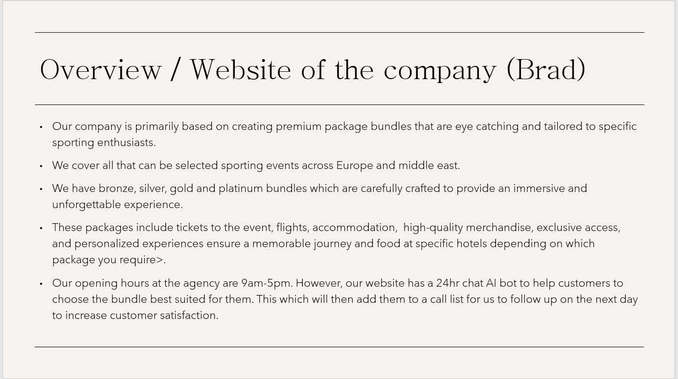
Overview of the business pitch created by me.

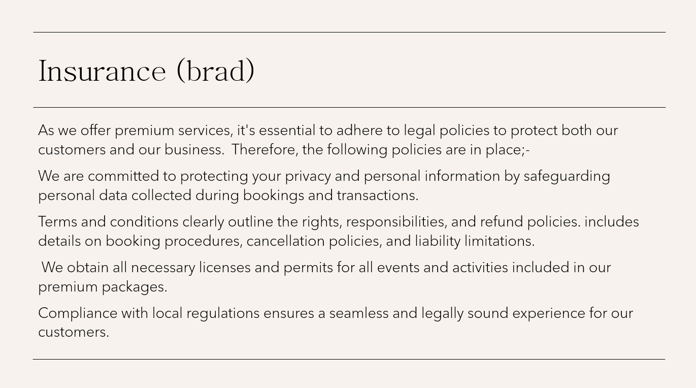
Insurances created and fostered by me.

