Marketing Essentials

Student’s Name: Elena Daniela Gavril
Student’s ID: 2207241
Module: Marketing Essentials ( BMIH4005)
Lecturer : Ruth Taylor Davies

Table of Contents
Introduction 3
Situation Analysis 4
The SWOT analysis of Premier Inn Hotel 4
The PESTEL analysis of Premier Inn Hotel 5
Porter’s Five Forces Analysis 6
Segmentation and Targeting 6
Collaborators 6
Objectives 6
Strategy 7
Creating Customer Value & Engagement Premier Inn Hotel 7
Tactics 8
Marketing Mix of Premier Inn Hotel 8
Action 9
Gantt Chart 9
Effective Use of Digital Marketing in Premier Inn Hotel 9
Control 10
Conclusion 11
References 12

Introduction
Premier Inn Hotel first opened its doors in 1987, and today it operates in over 80 countries with close to 72,000 guest rooms in its 800 hotels (Galindo Henríquez, 2018). It is virtually completely global, but it is headquartered in Dunstable. The target audience consists of both vacationers and business travellers, therefore services like breakfast in bed, activity packages, and meeting rooms will be offered, as will be delivery of these items. Around 4.1% of the overall UK hotel market is growing because to its presence (Walters, 2020). Here, there are numerous openings for the hotel industry to bring in new clients and increase profits. Following the Covid-19 outbreak, there are challenges for the hotel industry in terms of both customer retention and acquisition. The purpose of this study is to provide a marketing strategy for the hotel in question.

Situation Analysis

The SWOT analysis of Premier Inn Hotel
An understanding of a company's strengths, weaknesses, opportunities, and threats can be gained through the use of a SWOT analysis (Faizal S, 2018). In order to conduct an analysis of these elements, the Premier Inn Hotel is also required to apply the aforementioned instruments. The microenvironment of The Premier Inn Hotel consists of many different parties, including customers, staff, suppliers, and intermediaries.
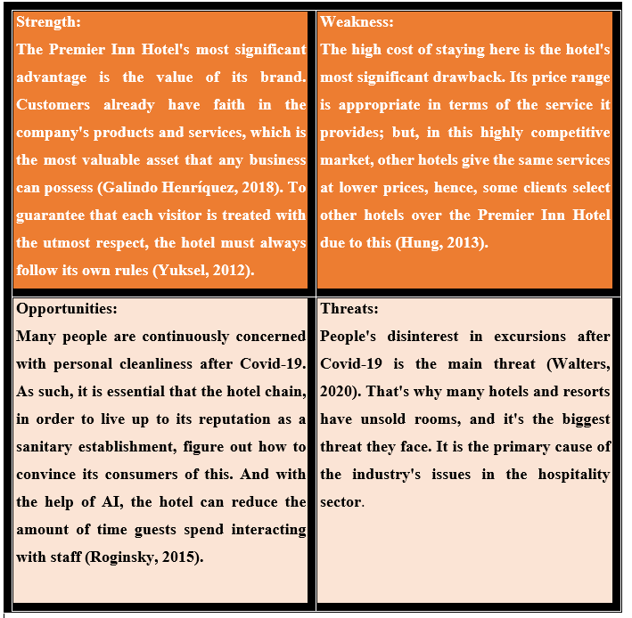
Figure 1: The SWOT Analysis of Premier Inn Hotel (Faizal S, 2018).

The PESTEL analysis of Premier Inn Hotel
The elements of a PESTEL Analysis include the political, economic, social, technological, and environmental and legal (Kampanje, 2014). Premier Inn Hotel also relies heavily on these macroenvironments in order to successfully attract new customers.
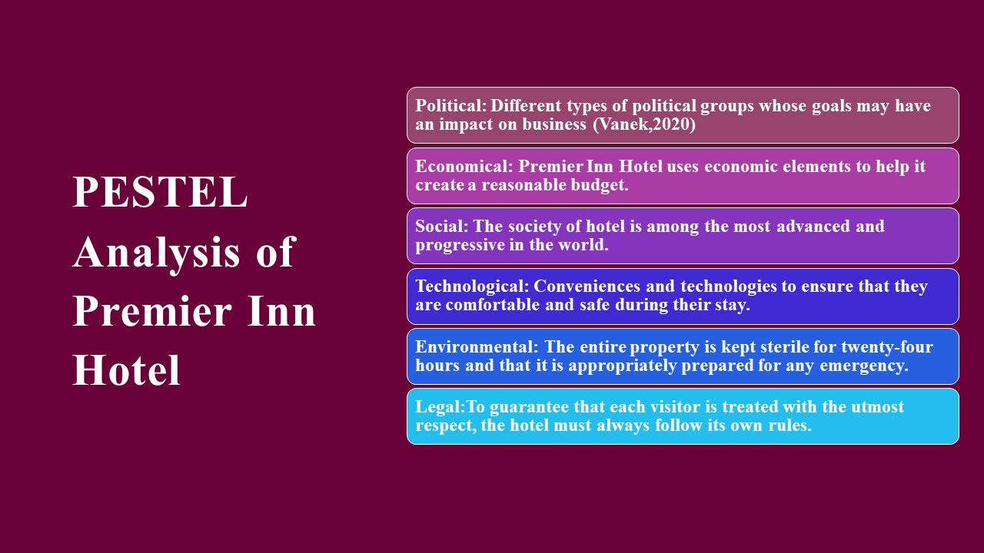
Figure 2: The PESTEL Analysis of Premier Inn Hotel (Kampanje, 2014).

Porter’s Five Forces Analysis
Porter’s five forces model in the marketing plan of Premier Inn Hotel in Dunstable has been shown below.
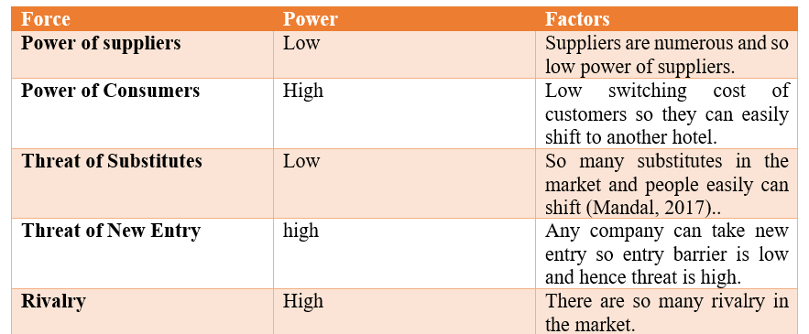
Figure 3: The Porter’s Five Forces Model in Premier Inn Hotel (Gordon, 2012).

Segmentation and Targeting
Segmentation: The hotel business has been segmented for the young people and older people. Most of the young come here to seek for adventure and older people come to spend their leisure time peacefully (Yuksel, 2012).
Targeting: The main target of the Premier Inn Hotel is the young aged people who spend a lot of time and money travelling and spending nights in the hotel.

Collaborators
The company is a franchisee business and previously it was run as a partnership business. However, the company is now planning to collaborate with large hotels to enhance its business worldwide.

Objectives
The objective of this marketing plan is to attract new customers to the Premier Inn Hotel.

Strategy
Bowman’s strategy clock is used to determine the perceived customer value in case of the price of a product or service (Walters, 2020). However, Premier Inn Hotel should use Bowman’s strategy clock while determining the price of the services provided as it has a major significant impact on the company’s revenue.
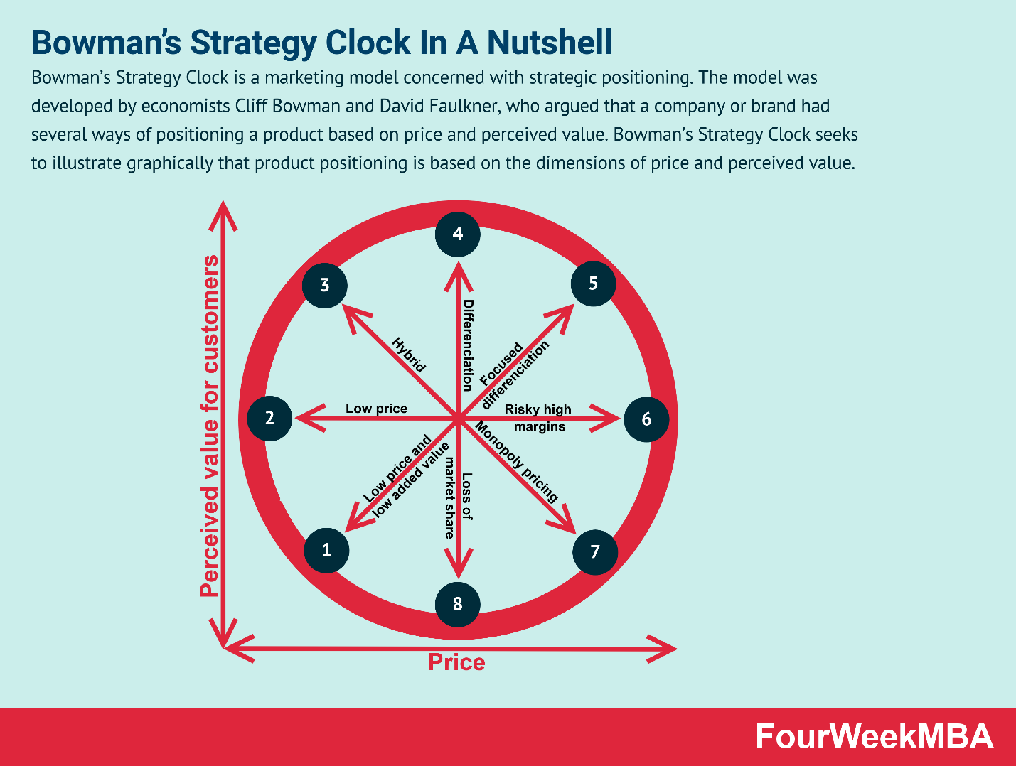
Figure 4: The Bowman’s Strategy Clock in Premier Inn Hotel (Walters, 2020).

Creating Customer Value & Engagement Premier Inn Hotel
It's universally agreed that after Covid-19, people are more cautious about their cleanliness. Guests looking for a place to stay for a holiday or business trip will first check the hotel's cleanliness and security measures before considering the resort's amenities (Walters, 2020). To ensure that its guests have a pleasant and worry-free stay, Premier Inn Hotel routinely disinfects all public spaces. The guest only needs to arrive, check in at the front desk, and head up to his room using his mobile device as the key when the reservation has been confirmed (Vaněk, 2020). So, he may rest certain that his hands will not come into contact with any keys, ensuring their cleanliness and his own. To add to that, Premier Inn may deploy robots to provide service to its guests in a way that is both safe and friendly.
For its advertising needs, the Premier Inn Hotel may turn to both traditional and modern media, both online and offline (Mandal, 2017). For no cost, it can use social media like Facebook, Instagram, and LinkedIn, and for a fee, it can employ techniques like commercial production, paid to advertise, and influencer promotion. Search engine optimization (SEO), electronic mail marketing (email marketing), video marketing, and other forms of digital promotion may all be employed.

Tactics

Marketing Mix of Premier Inn Hotel
A marketing mix is a collection of promotional strategies used to increase awareness of a company's goods and services among a specific demographic (Dominici, 2021). It is sometimes referred to as the "4Ps." Product, price, place, and promotion are the "4Ps" in this case.
Product: The hotel industry is service based. Since consumers rent hotel rooms and other facilities for their stays rather than buying them outright, the hotel industry must rely on service sales rather than property sales (Gordon, 2012). The hotel's product includes rooms, restaurants, an indoor pool, toiletries, and everything else. People stay at the Premier Inn Hotel because of the hotel's five-star service and not because of the hotel's products.
Price: Most guests at Premier Inn Hotel prefer quality over quantity because they are not bound financially. Premier Inn Hotel mostly caters to tourists from abroad rather than locals. Room rates at Premier Inn Hotels begin at about $900 per night (Hart, 2018). There is a lot of rivalry in this sector, thus the prices here tend to fluctuate.
Place: There are 800 different locations, making convenient placement the hotel's greatest strength. Its convenient location makes it a popular destination for tourists, students, and business travellers alike. Customers can find the store's location with the use of Google Maps, the website, or other sources.
Promotion: In terms of hotels, the Premier Inn Hotel is well-established and well-liked. It uses social media to advertise the extreme cleanliness of its facilities and the cutting-edge technology it employs to ensure that its clients are never exposed to any germs (Risteska, 2019).

Action
The action of marketing plan has been monitored through the use of a Gantt chart in the Premier Inn Hotel in Dunstable. The following part shows a Gantt chart for this marketing plan.

Gantt Chart
Gantt chart is used for any kind of planning activities and it helps providing the duration of a task to be completed (Maleki, 2016). However, this Gantt chart has been prepared to monitor the marketing plan over the years from November 2022 to November 2023.
Figure 5: The Gantt chart of the marketing plan in Premier Inn Hotel (Maleki, 2016).

Effective Use of Digital Marketing in Premier Inn Hotel
A successful marketing campaign in the modern era of advanced digital technology is impossible without some form of digital marketing (Connor, 2015). When compared to traditional methods of advertising, digital marketing is more effective at reaching its intended audience. Premier Inn Hotel can use social media as their primary method of advertising. Because so many of your potential consumers are already there, social media like Facebook, Instagram, and YouTube are excellent places to spread the word about your brand. In addition, it needs to emphasize search engine optimization (SEO) marketing, which will make this hotel's name appear at the top of search results. Email marketing is one of the most powerful marketing tactics nowadays, and content marketing can be helpful for its marketing operations as well (Mandal, 2017). Customers will be more engaged if the message is engaging to them. Hotel marketing efforts post-Covid-19 epidemic should centre on reassuring potential guests about the hotel's commitment to cleanliness, infrastructure improvement, guest safety, and the use of cutting-edge technology. The Premier Inn Hotel can easily reach both new and returning clients using these mediums.

Control
The control activites have been monitored through the Uning Selling Point (UPS). In every target point there is unique selling point wheret this marketing activites have been monitored so that everything is going well in the company’s promotional activities (Mandal, 2017).. The benefit of unique selling point is that customers get better service and they can get the service easily. The disadvantages of this unique selling method is that company needs huge cash in the establishment of unique selling point. The company will measure success through the enhancement of the business activites and providing better service to its customers. If new customers come to this hotel and the revenue margin increases then the marketing plan will be recognised as successful.

Conclusion
The success of this marketing plan hinges on successfully putting into action all of the strategies and plans that have been outlined. The hotel will have a hard time regaining its good reputation if its guests are worried about cleanliness or safety (Hart, 2018). After Covid-19, everyone desires a secure setting, thus extra financial outlay is welcomed. One of the greatest challenges is convincing them that the Premier Inn Hotel has taken adequate precautions to ensure the cleanliness of their facilities and is using cutting-edge technology to improve their infrastructure as a whole. In order to identify what areas, need the most attention and what features should be expanded further, Premier Inn Hotel needs to study market trends and learn about the preferences of its clientele. To stay ahead of the competition and attract new clients, Premier Inn Hotel needs to have a firm grasp of the state of the market and a sense of what lies ahead.

References
Connor, M. (2015). Creating Customer Value in a Digitally Transformed Future. Journal of Creating Value, 1(2), pp.204–213. doi:10.1177/2394964315569631.
Dominici, G. (2021). From Marketing Mix to e-Marketing Mix: a literature overview and classification. International Journal of Business and Management, 4(9). doi:10.5539/ijbm.v4n9p17.
Faizal S, M. (2018). A SWOT analysis of human resource management in Tamil Nadu hotel industry. Journal of Management Research and Analysis, 5(4), pp.373–375. doi:10.18231/2394-2770.2018.0059.
Galindo Henríquez, F.A. (2018). Destination marketing essentials. Turismo y Sociedad, 23, pp.279–282. doi:10.18601/01207555.n23.15.
Gordon, R. (2012). Re-thinking and re-tooling the social marketing mix. Australasian Marketing Journal (AMJ), 20(2), pp.122–126. doi:10.1016/j.ausmj.2011.10.005.
Hart, L.C. (2018). Essentials of Successful Marketing: A Case History in Manufacturer-Distributor Collaboration. Journal of Marketing, 13(2), p.195. doi:10.2307/1246829.
Hung, K. (2013). Understanding China’s Hotel Industry: A SWOT Analysis 中国酒店业的SWOT分析. Journal of China Tourism Research, 9(1), pp.81–93. doi:10.1080/19388160.2013.756771.
Kampanje, B. (2014). PESTEL analysis of Premier Inn Hotel. African Journal of Economic and Management Studies, 5(1). doi:10.1108/ajems-01-2013-0002.
Maleki, M. (2016). Are Macro and Micro Environment Affecting Management of Fresh Water Resources? A Case from Iran with PESTLE Analysis. Materia Socio Medica, 28(4), p.307. doi:10.5455/msm.2016.28.307-313.
Mandal, P. (2017). Understanding Digital Marketing Strategy. International Journal of Scientific Research and Management, 5(6). doi:10.18535/ijsrm/v5i6.11.
Risteska, J. (2019). PROMOTIONAL ACTIVITIES AS A MARKETING TOOL FOR TOURISM DEVELOPMENT. Knowledge International Journal, 31(1), pp.305–310. doi:10.35120/kij3101305r.
Roginsky, R.J. (2015). A Critical Analysis of Hotel-Impact Issues. Cornell Hotel and Restaurant Administration Quarterly, 36(4), pp.18–26. doi:10.1177/001088049503600416.
Vaněk, M. (2020). Evaluation methods of swot analysis. GeoScience Engineering, 58(2), pp.23–31.
Walters, C.G. (2020). Essentials of Marketing Management. Journal of Marketing, 34(4), p.108. doi:10.2307/1250721.
Yuksel, I. (2012). Developing a Multi-Criteria Decision Making Model for PESTEL Analysis. International Journal of Business and Management, 7(24), pp.52–66.



