ACCA4023 Assessment 1
Module Name: Introduction to Web and database concepts
Module code: ACCA4023
Student name: ALPHUS NFORMI NGWANI
Student ID: 2517800
Group: 2
Lecturer’s name: Dr Anum Paracha
Contents
Introduction: 2
Task 1: 3
Scenario Analysis: 3
2 Entity-Relationship Diagram (ERD): 5
3 Data Structure Development: 21
4 Normalization Compliance: 23
5 Sample Data Population:…………………………………………………………………………………………..24
6 Query Development, 27
Forms and Reports (MediLink Pharmacy Database) 31
7 Validation And Testing; 33
Reflection (MediLink Pharmacy Database Project) 34
Conclusion: 34
References : 35

Introduction:
In this assessment I will be discussing about MediLink Pharmacy that is going to consists of 2 main tasks, task 1 that is going to consist of Scenario analysis, Scenario analysis is a strategic planning and risk management process that examines potential future events by modelling various, often, best-case, worst-case, and base-case scenarios. It helps organizations and individuals evaluate how various variables—such as economic shifts or, say, supply chain disruptions—could impact future outcomes, allowing for more informed, proactive decision-making. Entity-Relationship Diagram (ERD), An Entity-Relationship (ER) diagram is a visual, structured blueprint of a database that maps out entities (nouns/tables), their attributes (descriptive facts), and how they relate to one another (verbs/connections). Used primarily in software engineering and database design, ERDs help visualize complex data structures, reduce data redundancy, and guide database optimization. Data Structure Development, Data structure development is the process of defining, designing, and implementing specific data organization and storage formats within a computer's memory so that data can be accessed, managed, and processed efficiently by programs. The goal is to optimize how data is handled, balancing between speed (time complexity) and memory usage (space complexity) for a given set of operations. Normalisation Compliance, Normalisation compliance, or data normalization, is the process of structuring data within a database or system to reduce redundancy, eliminate data anomalies, and improve data integrity. It involves organizing data—such as customer names, addresses, or product records—into a standardized format, typically by splitting large, complex tables into smaller, related tables. Sample Data Population, A population is the entire group of individuals, objects, or events researchers want to study, while a sample is a smaller, representative subset of that population chosen for data collection and analysis. Sampling enables inferential statistics to draw conclusions about the whole without surveying every member. Query Development, Query development is the process of designing, writing, and refining Structured Query Language (SQL) code to extract, manipulate, or analyse data from databases. It involves defining specific criteria to retrieve, update, or summarize information, enabling developers and analysts to turn raw data into actionable insights. Validation Testing, Validation testing is the final, dynamic process of confirming that a developed product, system, or software fulfils user needs and actual operational requirements. It determines if the "right thing" was built by testing the functional system—often via user acceptance (UAT), alpha/beta, or functional testing—to ensure it meets business goals. Task 2 will be about work written element

Task 1:

Scenario Analysis: Scenario analysis is a strategic planning and risk management process that examines potential future events by modelling various, often, best-case, worst-case, and base-case scenarios. It helps organizations and individuals evaluate how various variables—such as economic shifts or, say, supply chain disruptions—could impact future outcomes, allowing for more informed, proactive decision-making. [1]
The main entities in the Medi link Pharmacy database are Customer, Medicine, Supplier, Prescription, PrescriptionDetails, SalesTransaction,SaleDetails.
-Customer: The Customer entity stores details of people who buys medicines or receive prescriptions from the pharmacy. Key Attributes are CustomerID (PrimaryKey) – Unique identifier for each customer, FirstName, LastName, DateOfBirth, Address, PhoneNumber, Email
Relationship: A Customer can have various Prescriptions (1:M relationship).
A Customer can make various Sales Transactions (1:M relationship).
This entity helps the pharmacy maintain correct patient records and track purchase history.
- Medicine: The Medicine entity have information about the medicines available in the pharmacy inventory.
Key Attributes are MedicineID (Primary Key) – Unique identifier for each medicine,MedicineName,Category,
DosageForm (tablet, syrup, capsule, etc.),Price,StockQuantity,ExpiryDate,SupplierID (Foreign Key)
Relationship: A Supplier can supply many Medicines (1:M relationship).
A Medicine can appear in many Prescriptions (M:N relationship via PrescriptionDetails).
A Medicine can appear in many Sales Transactions (M:N relationship via SalesDetails).
This entity supports inventory tracking, pricing, and stock control.
-Supplier: The Supplier entity keeps all the records about the companies that supply medicines to MediLink Pharmacy.
Key Attributes are SupplierID (Primary Key) – Unique identifier for each supplier,SupplierName,ContactPerson,PhoneNumber,Email,Address.
Relationship: A Supplier can supply different Medicines (1:M relationship).
Each Medicine is supplied by one Supplier.
This entity allows the pharmacy to manage supplier relationships and monitor medicine sources.
-Prescription: The Prescription entity records prescriptions issued by doctors for customers.
Key Attributes are PrescriptionID (Primary Key) – Unique identifier for each prescription,CustomerID (Foreign Key),
DoctorName,PrescriptionDate,Notes
Relationship: A Customer can have many Prescriptions (1:M relationship). A Prescription can contain multiple Medicines (M:N relationship through PrescriptionDetails).
This entity ensures that prescriptions are properly recorded for medical and regulatory compliance.
-PrescriptionDetails (PrescriptionItems): This is a junction entity used to connect Prescriptions and Medicines, because one prescription can contain multiple medicines and one medicine can appear in many prescriptions.
Key Attributes are PrescriptionDetailID (Primary Key),PrescriptionID (Foreign Key),MedicineID (Foreign Key),Quantity,DosageInstructions
Relationship:Links Prescription and Medicine in a many-to-many relationship.
This entity allows the system to record exact medicines and quantities prescribed.
-SalesTransaction:The SalesTransaction entity records each sale made in the pharmacy.
Key Attributes are TransactionID (Primary Key) – Unique identifier for each sale,CustomerID (Foreign Key),TransactionDate,TotalAmount,
PaymentMethod.
Relationship: A Customer can make many Transactions (1:M relationship).
A Transaction can include multiple Medicines (M:N relationship via SalesDetails).
This entity helps the pharmacy track revenue and monitor sales activity.
-SalesDetails (TransactionItems):This entity records all the medicines sold to everybody in each transaction.
Key Attributes are SalesDetailID (Primary Key),TransactionID (Foreign Key),MedicineID (Foreign Key),Quantity,
UnitPrice
Relationship: Resolves the many-to-many relationship between SalesTransaction and Medicine.
This entity provides detailed sales records and supports accurate reporting and stock updates.
2 Entity-Relationship Diagram (ERD): An Entity-Relationship (ER) diagram is a visual, structured blueprint of a database that maps out entities (nouns/tables), their attributes (descriptive facts), and how they relate to one another (verbs/connections). Used primarily in software engineering and database design, ERDs help visualize complex data structures, reduce data redundancy, and guide database optimization. [2]

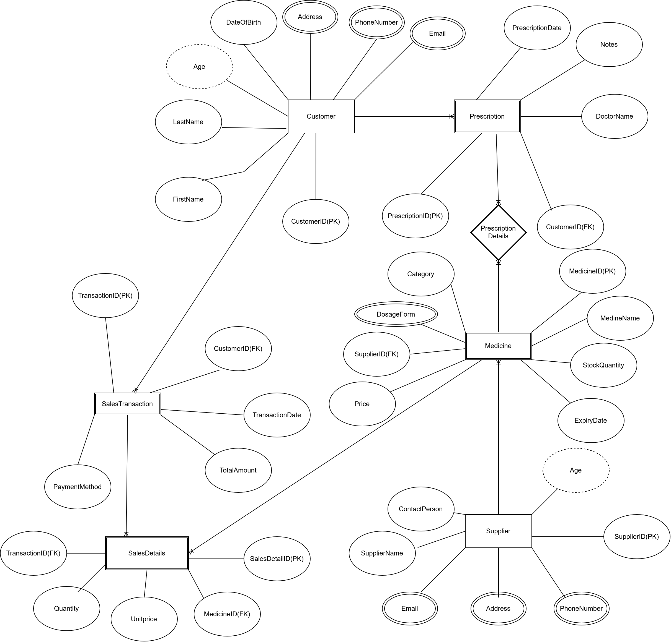
The above ERD shows the data of MediLink Pharmacy which is made of parent and child entity. The regular entity which is a parent entities are the Customer and the supplier entity and the weak or child entity are the Medicine and the prescription entity. Each of the entity have their attributes which consist of atomic, composite, multivalued, complex, and derived attributes. They are also related as a customer can have one-many relationship(1:M) meaning that a single customer can have so many different prescriptions, the Prescription entity is having many – many relationship (M:N) with the Medicine entity as so many prescriptions can have different medicines and many medicines have different prescriptions, also a supplier entity is having one- many relationship to medicine entity as a singly supplier can supply different medicines to MediLink Pharmacy. We also have SalesTransaction entity and SalesDetails entity.

Customer Table
Open Microsoft Access in a blank data as below
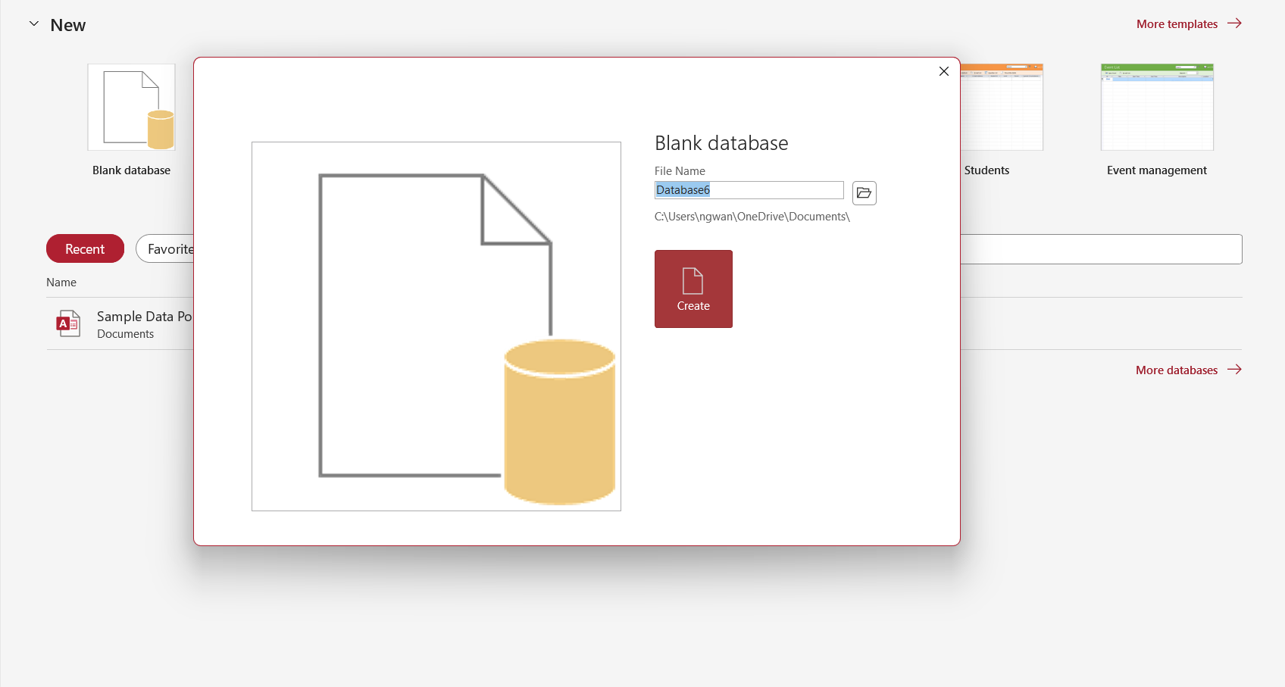
Enter the name of the data you are about to create as below ,
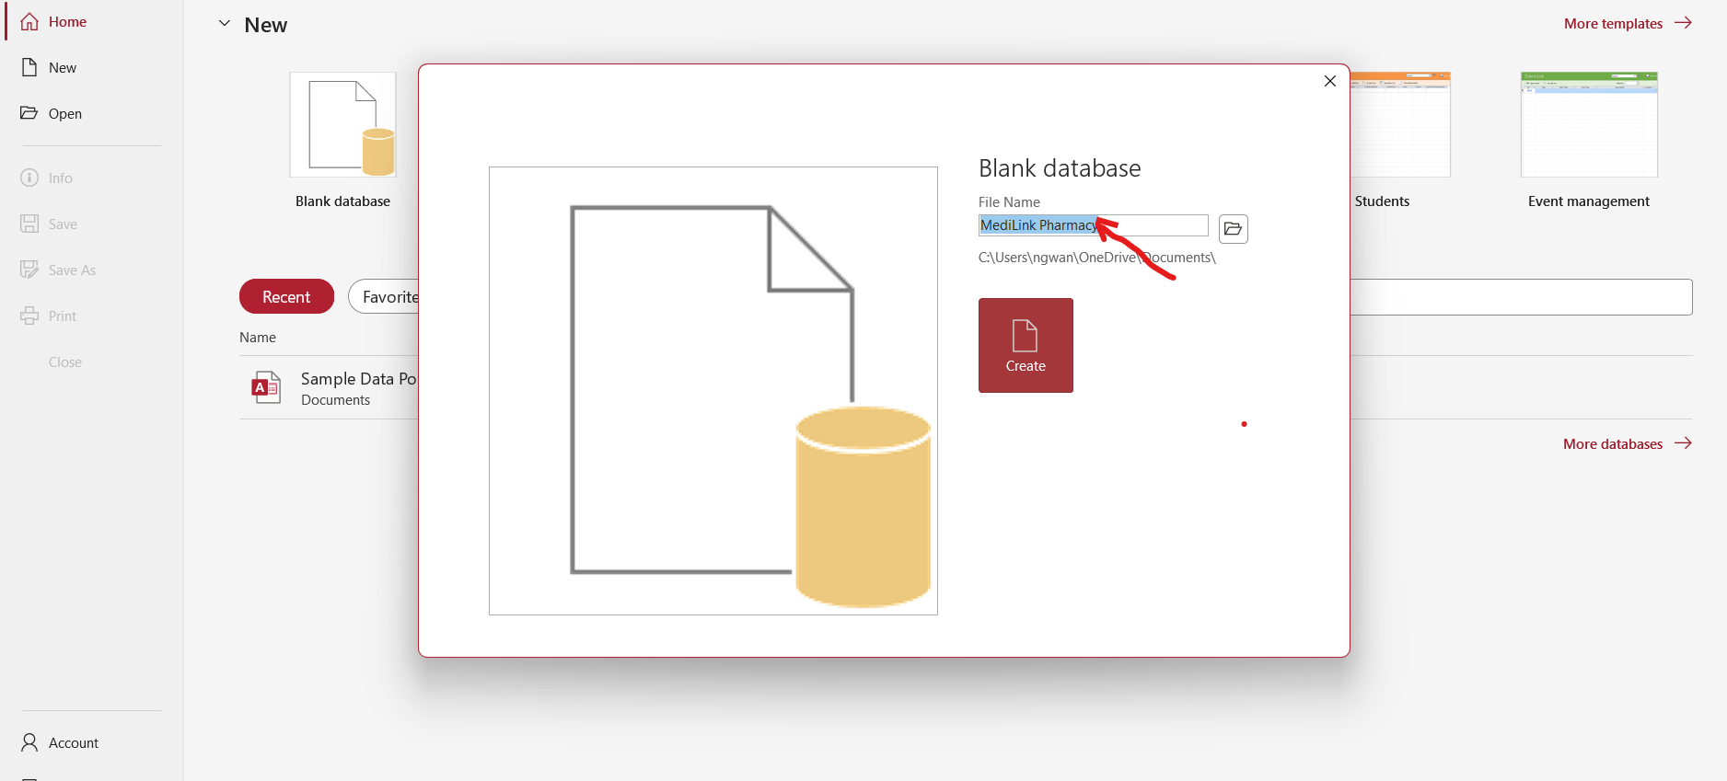

It will open with an empty data
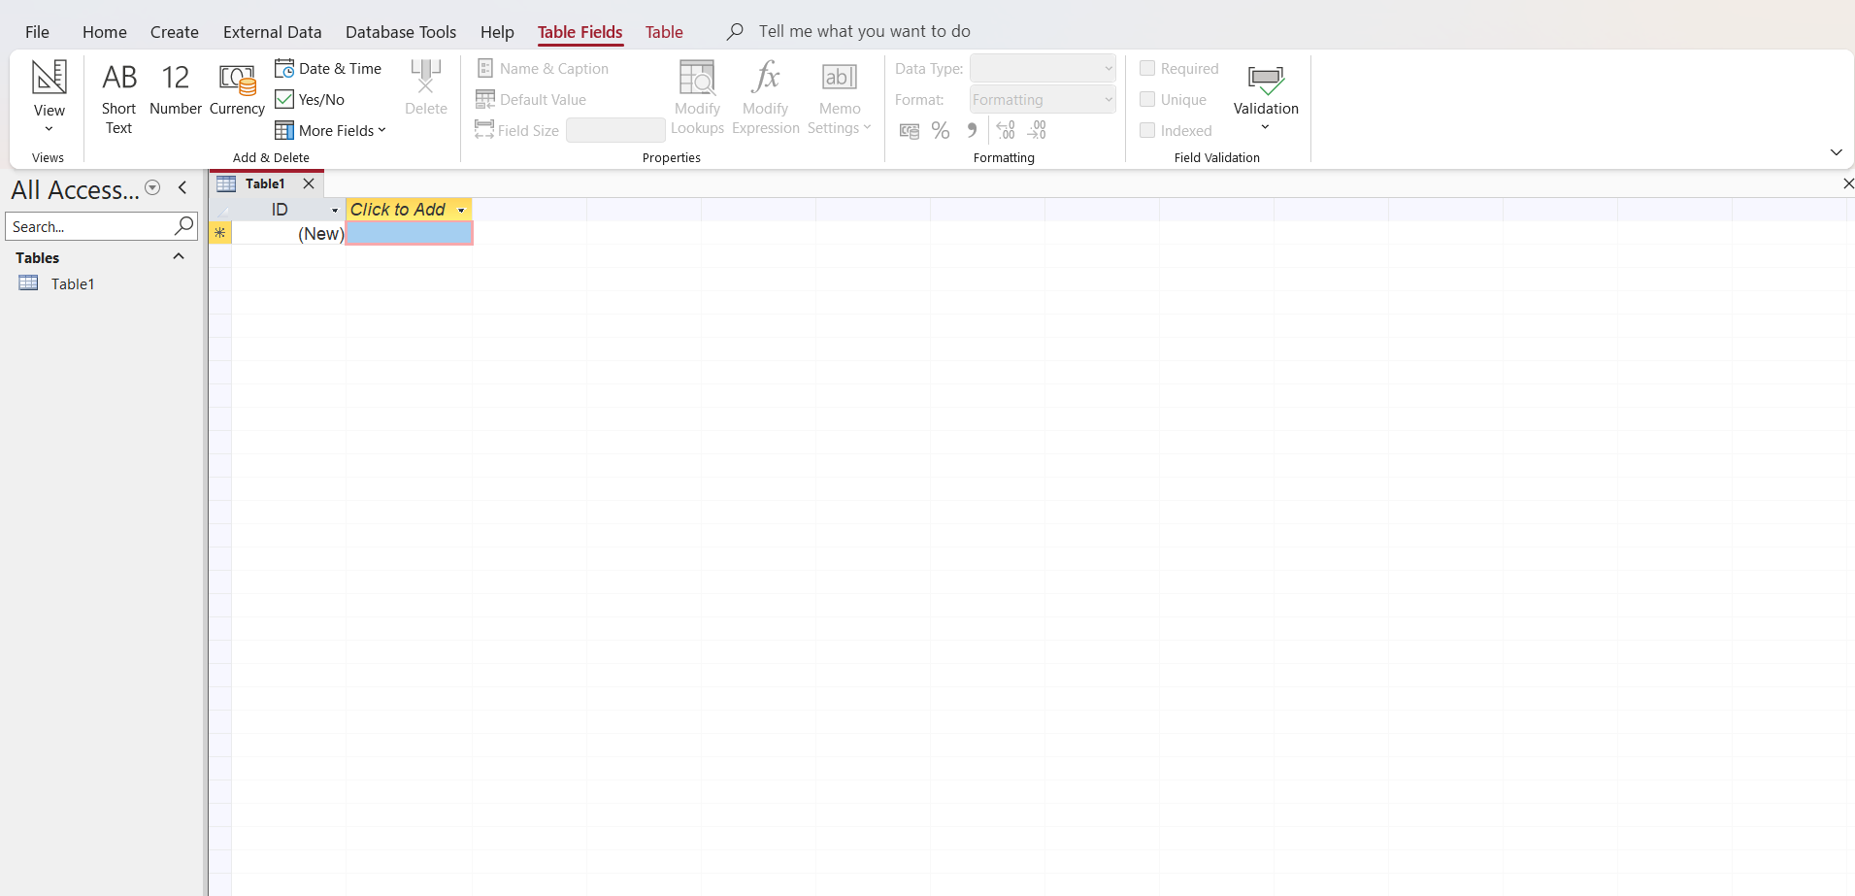
You go to create on the blank table on the top and click to create a data in the blank table
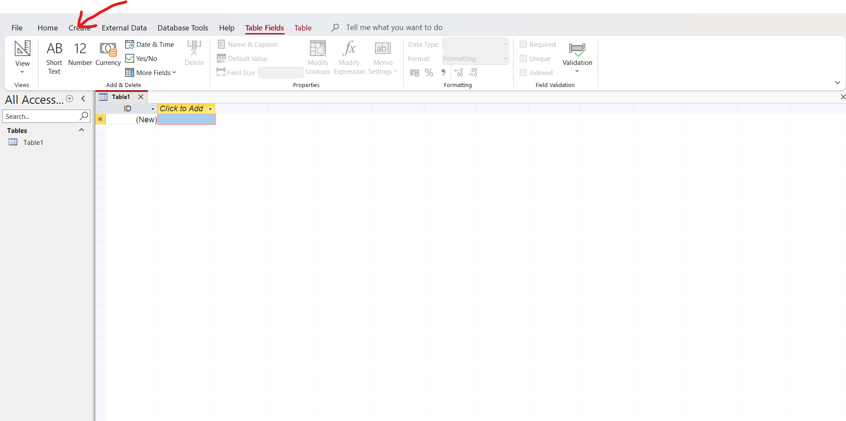
Open and go to table then click on the table
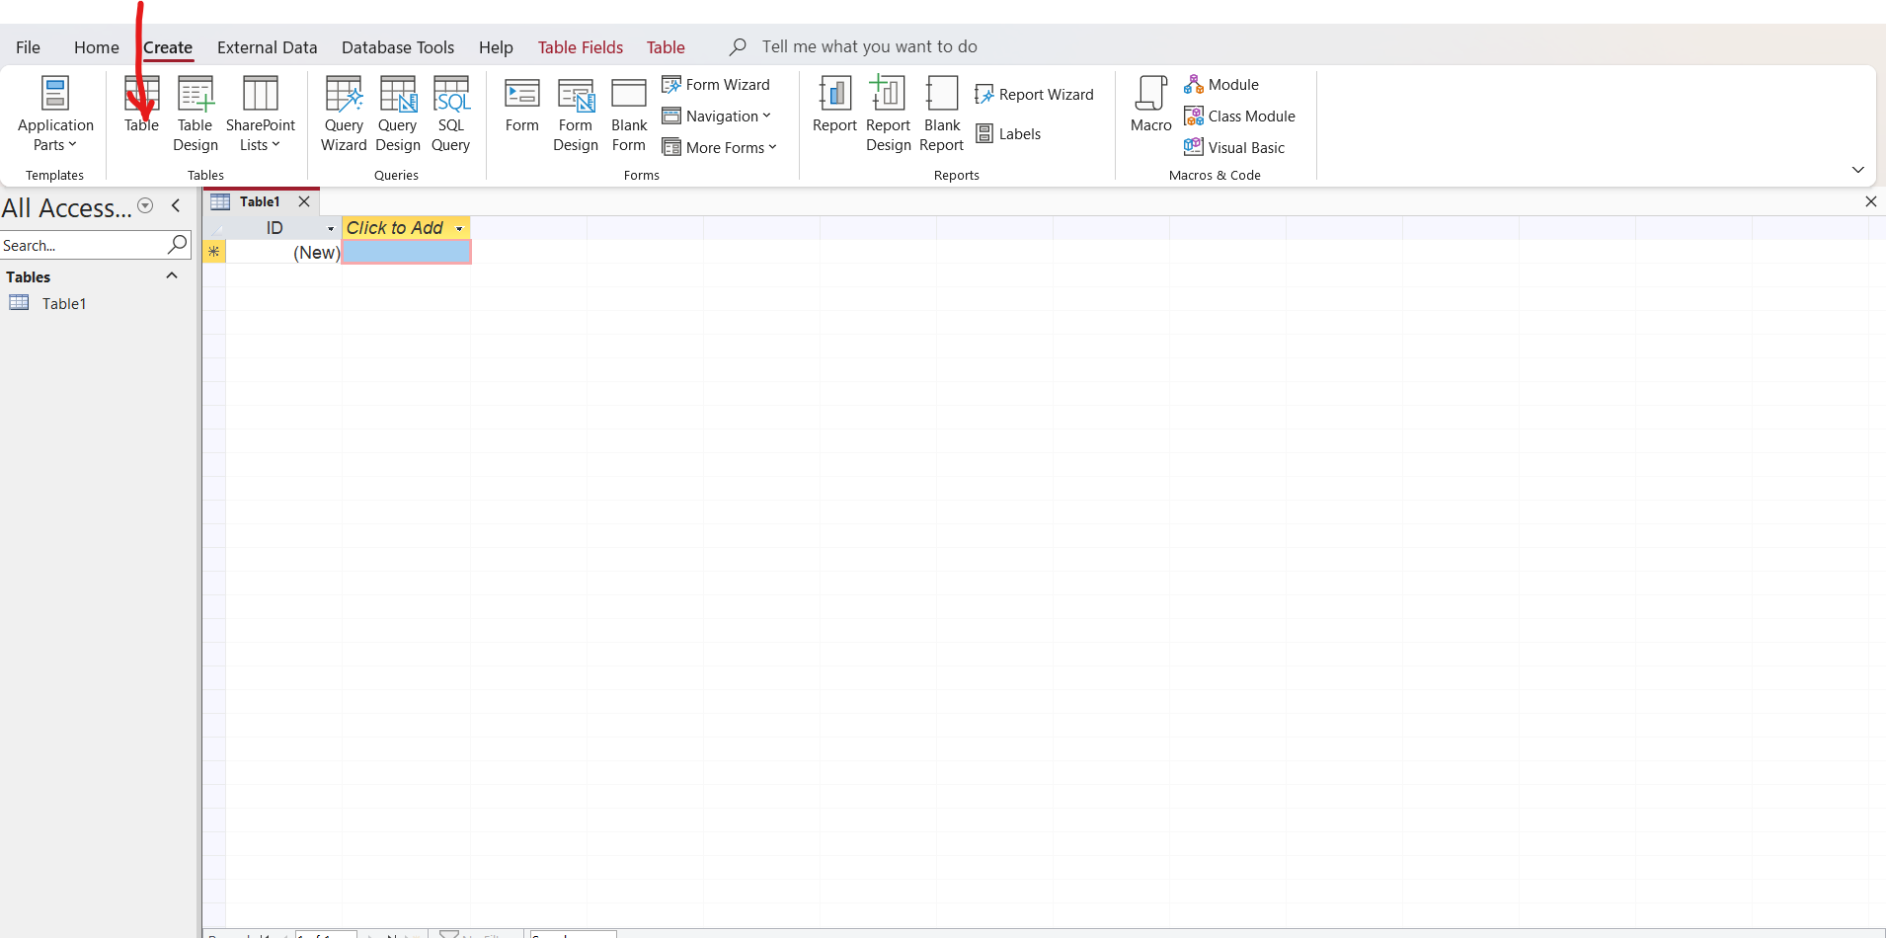
Right click on the ID field and go to rename to change the field name to Customer ID
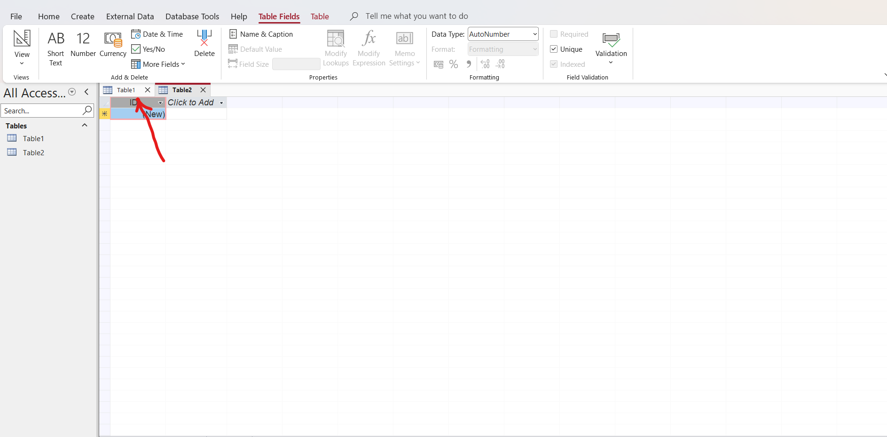
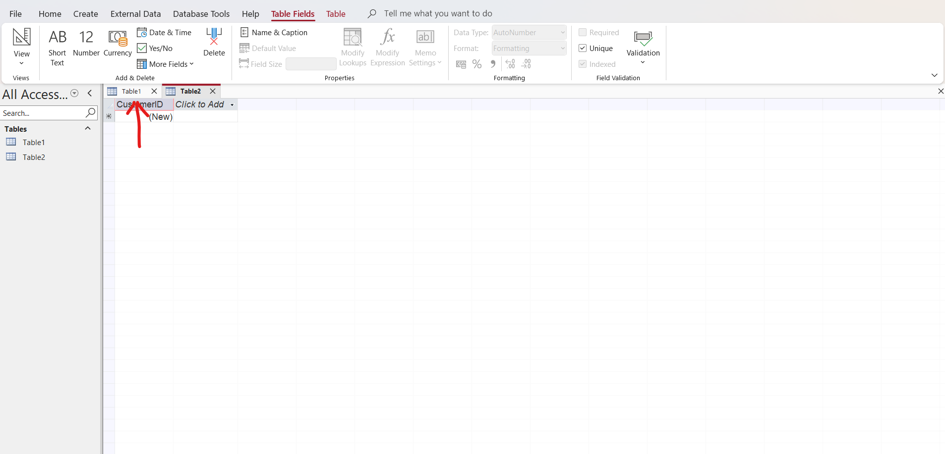

Click to add and add other fields up to the level of the fields you want to work with.
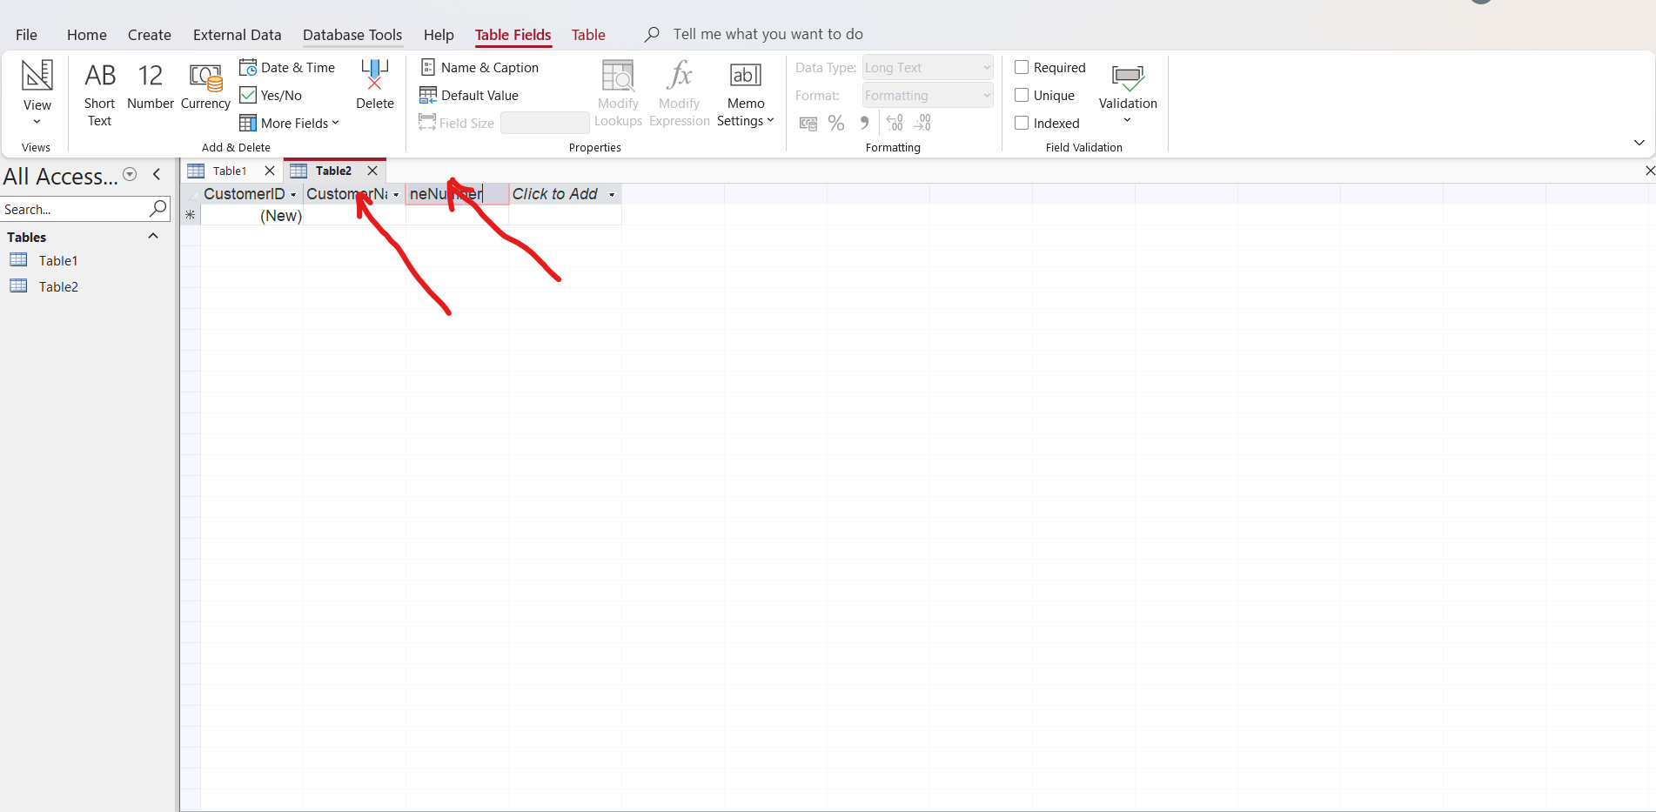
Insert the data you want to work with in all the fields as below;
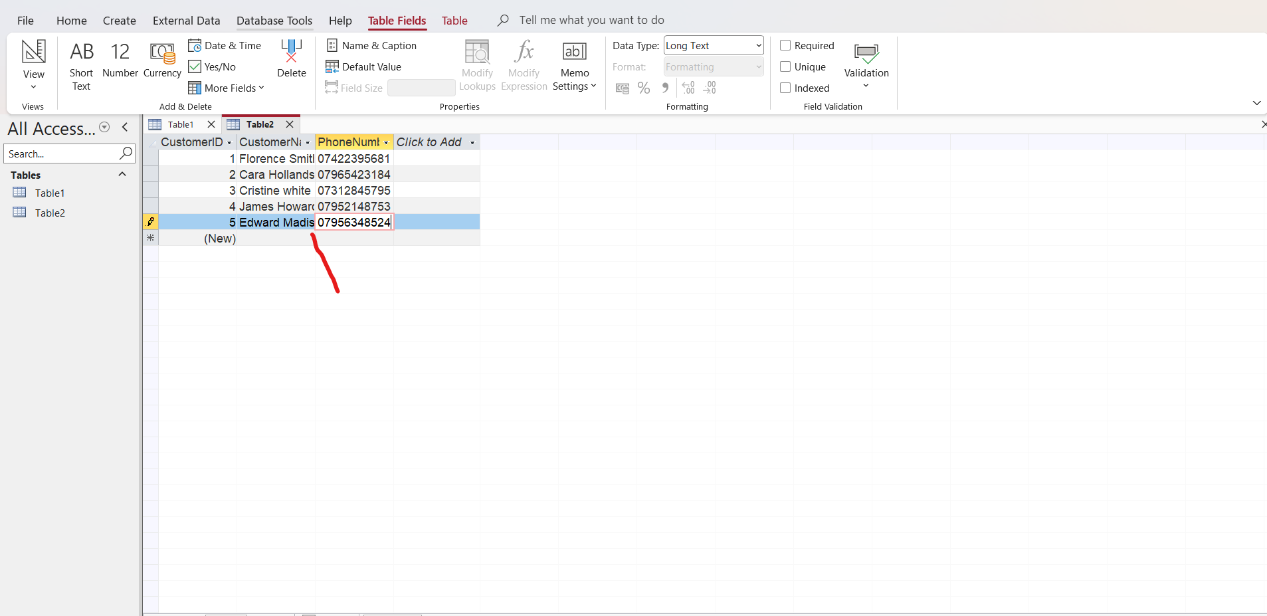
Press CTRL S to save it as customer Table.
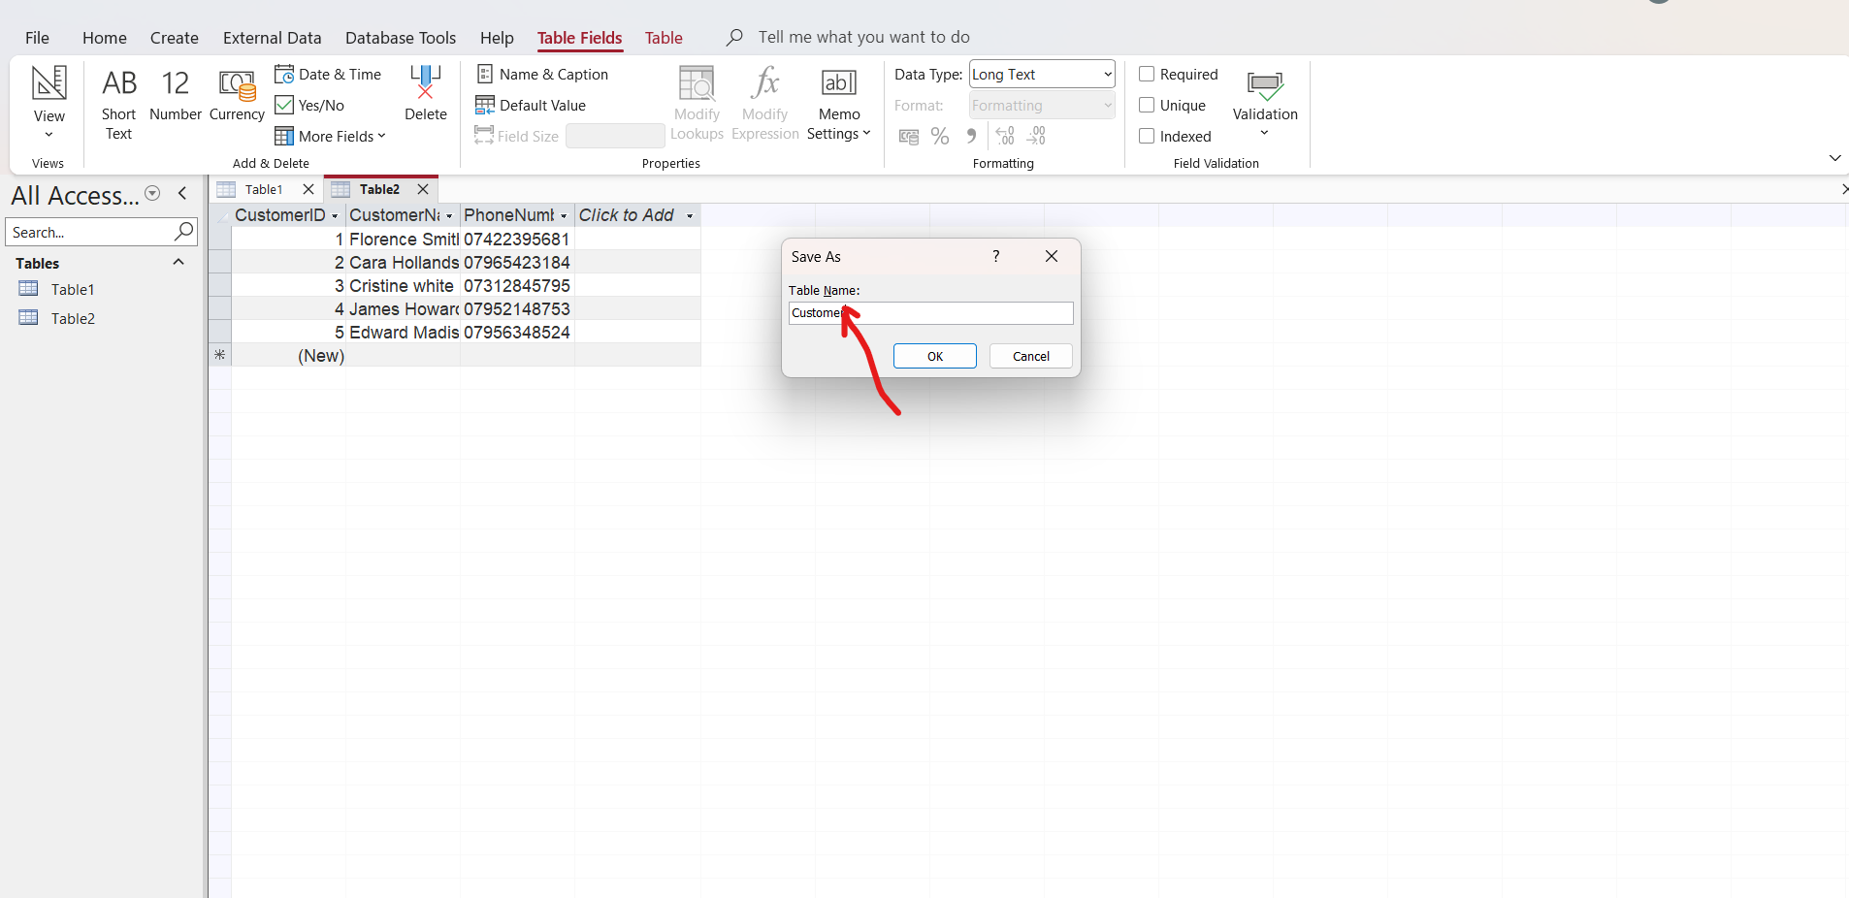
It will create a customer table on left.
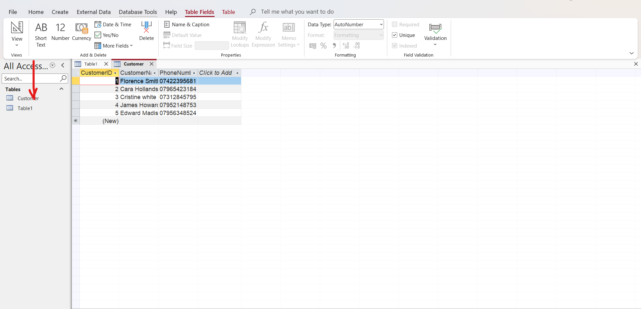

Prescription Table
Go to create or design view and click on table to open a new table
Right click on ID field and go to Rename and write it as Prescription ID
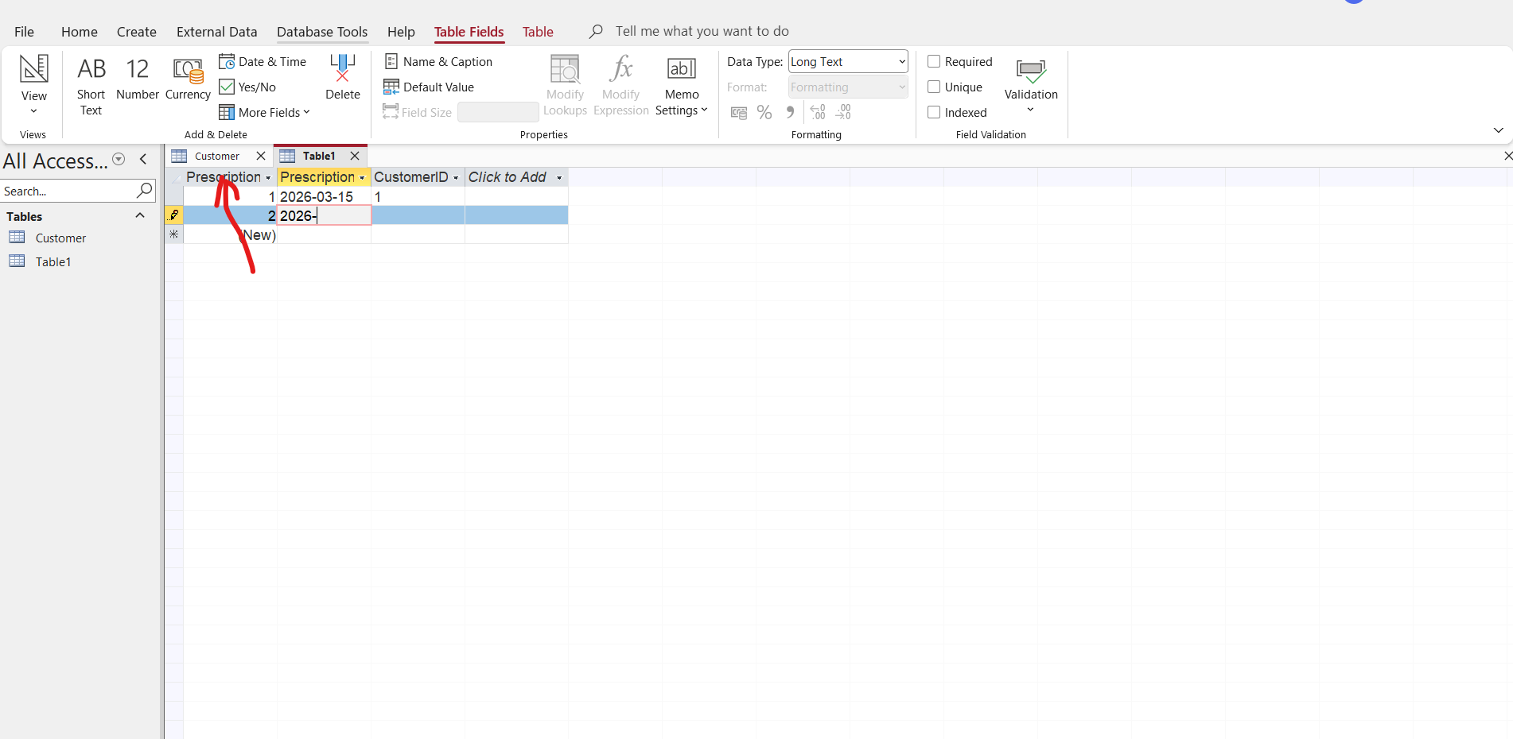
Click to add and add the fields you want to work with and a CustomerID is coming in the other field now as a foreign key in this prescription Table.
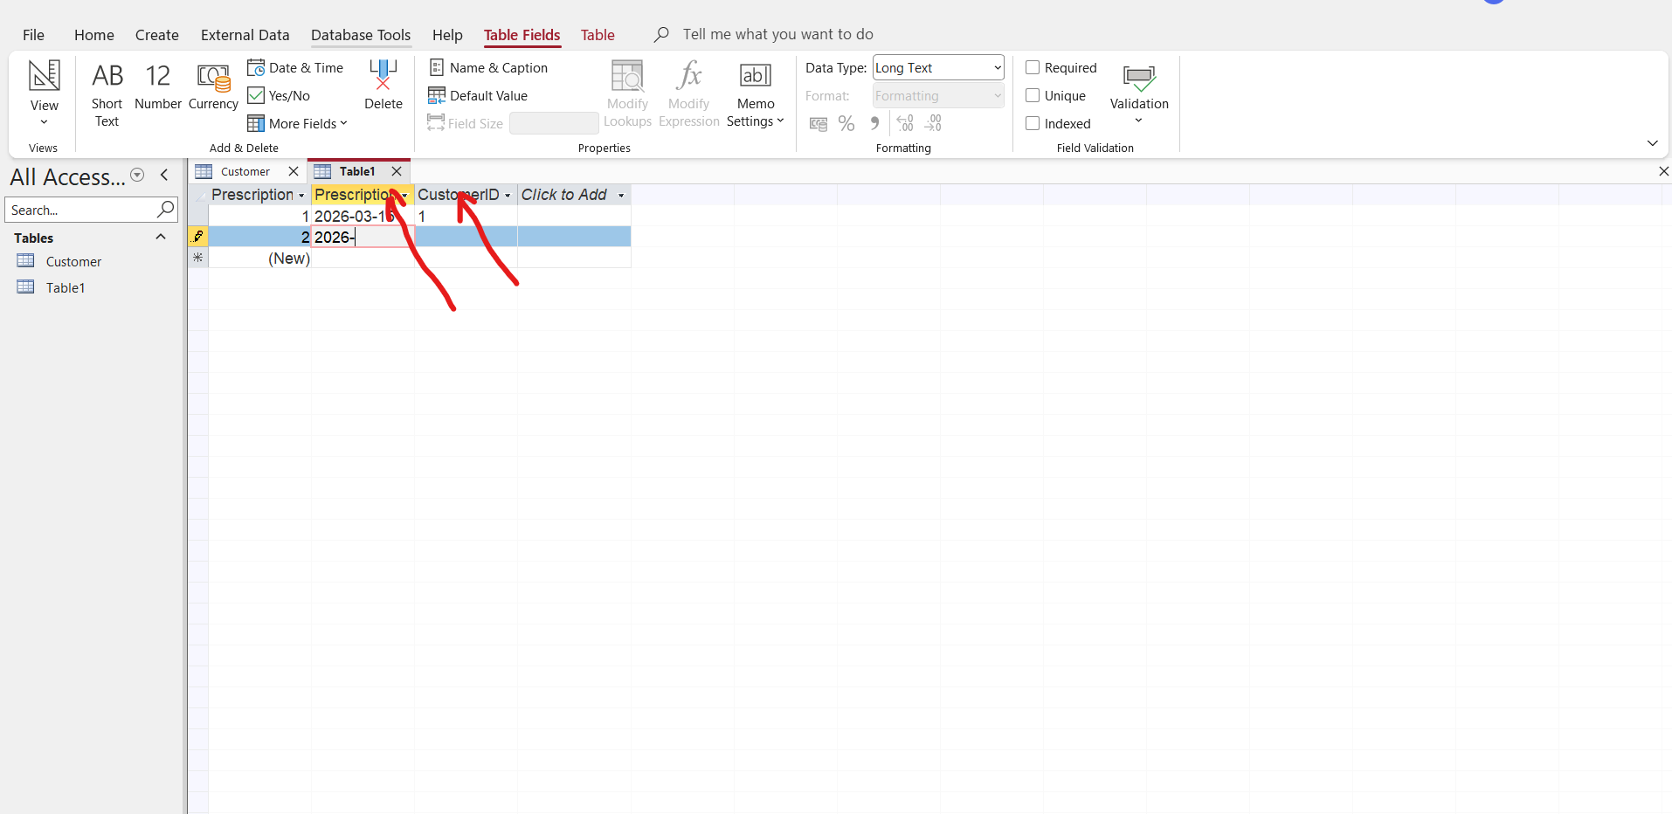
Put the data in the fields created
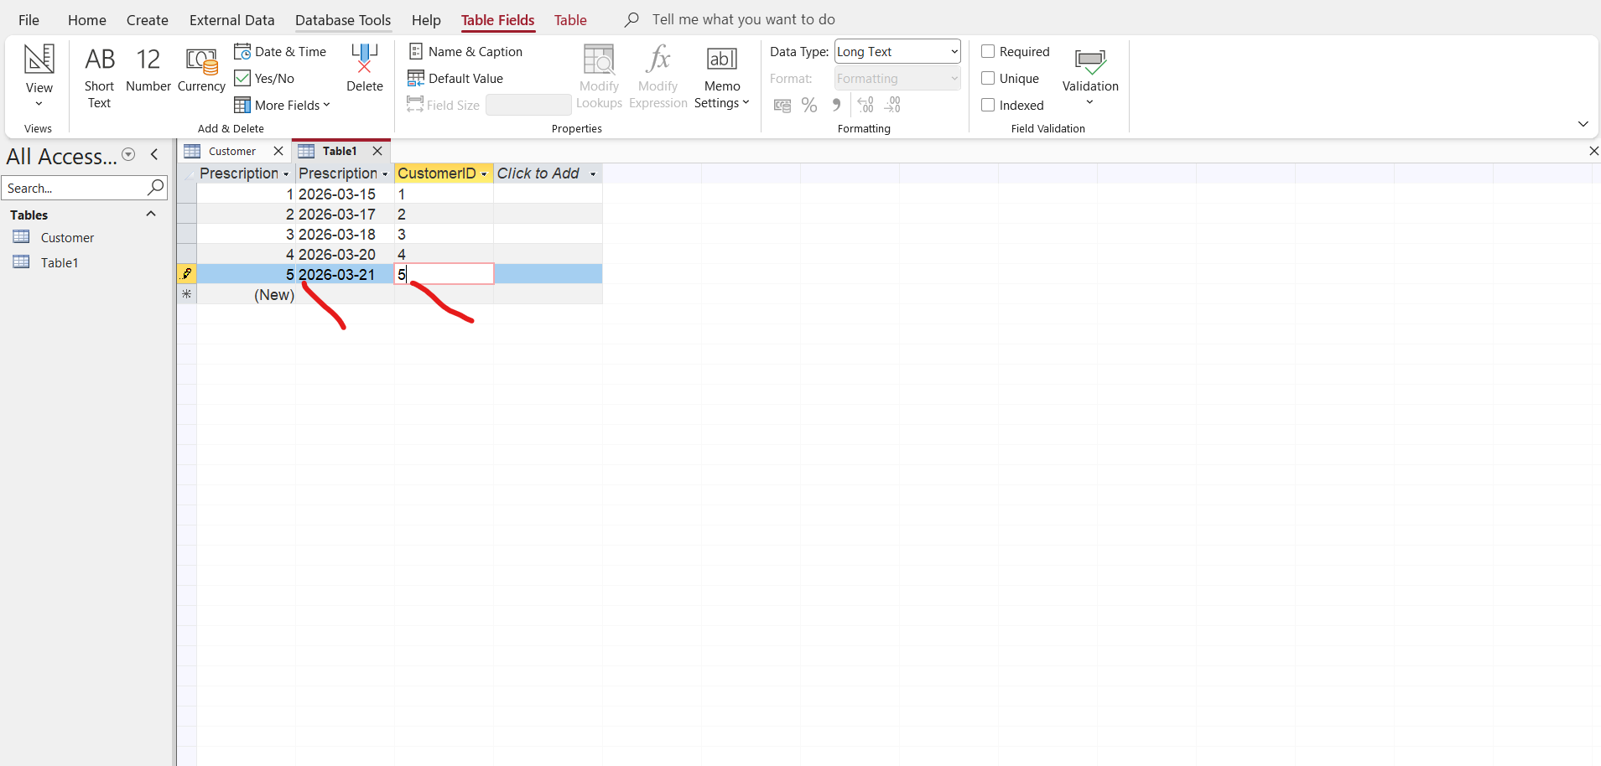
Go to save or press CTRL S to save as prescription

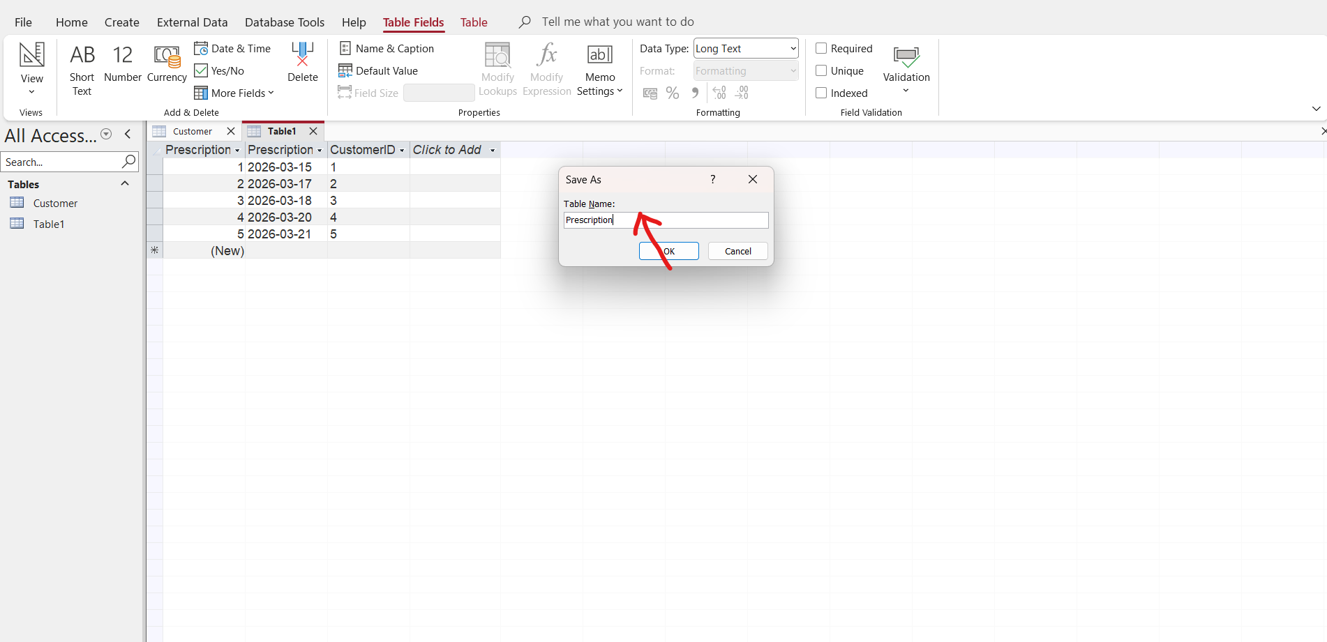
When you press enter a prescription table is created on the left side of the data you have created
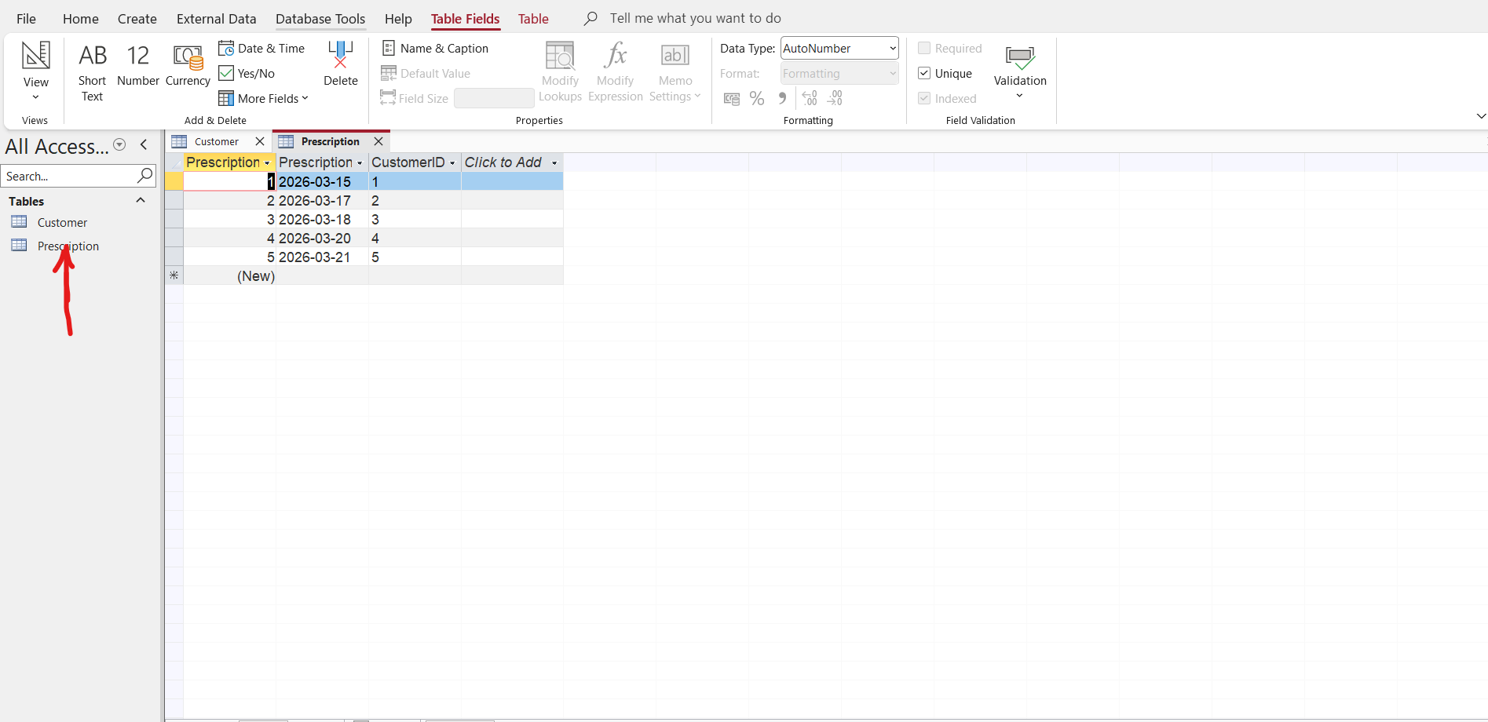

Medicine Table
Click on create and to table
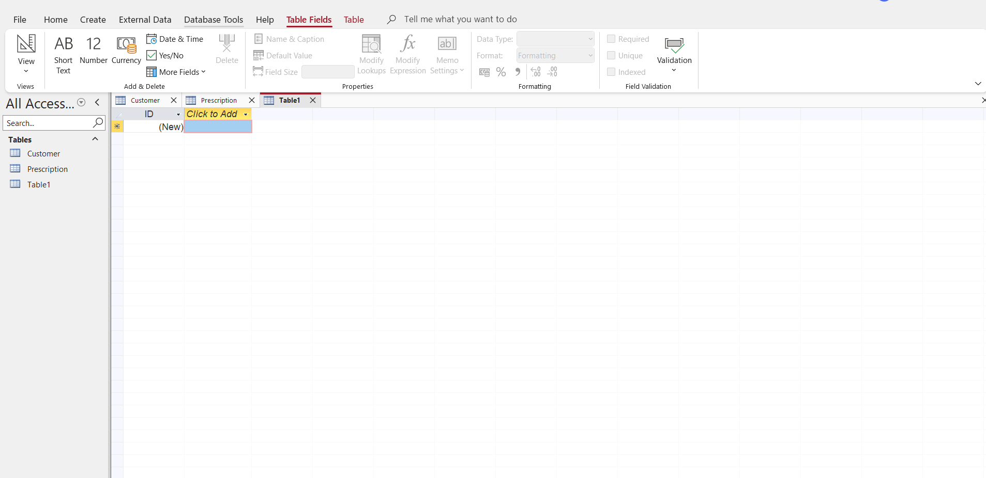
Go to ID field right click and select rename to call it Medicine ID
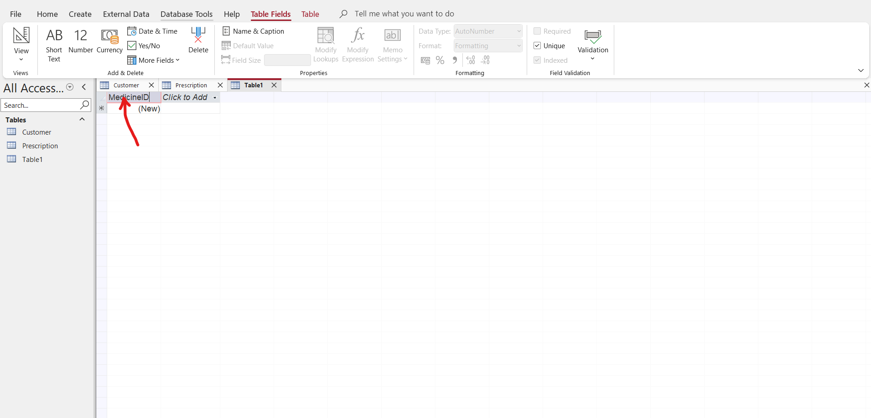
Click to Add and add your required fields and add supplier ID in one of the fields as a foreign key in this medicine table
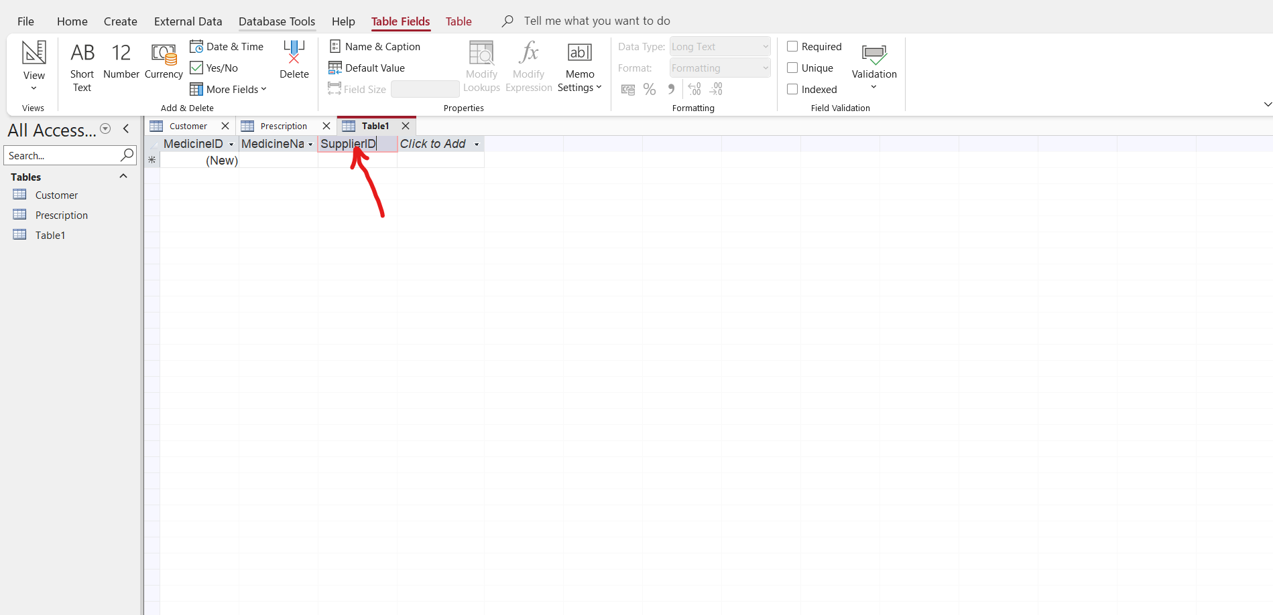
Insert the data in the medicine table as below
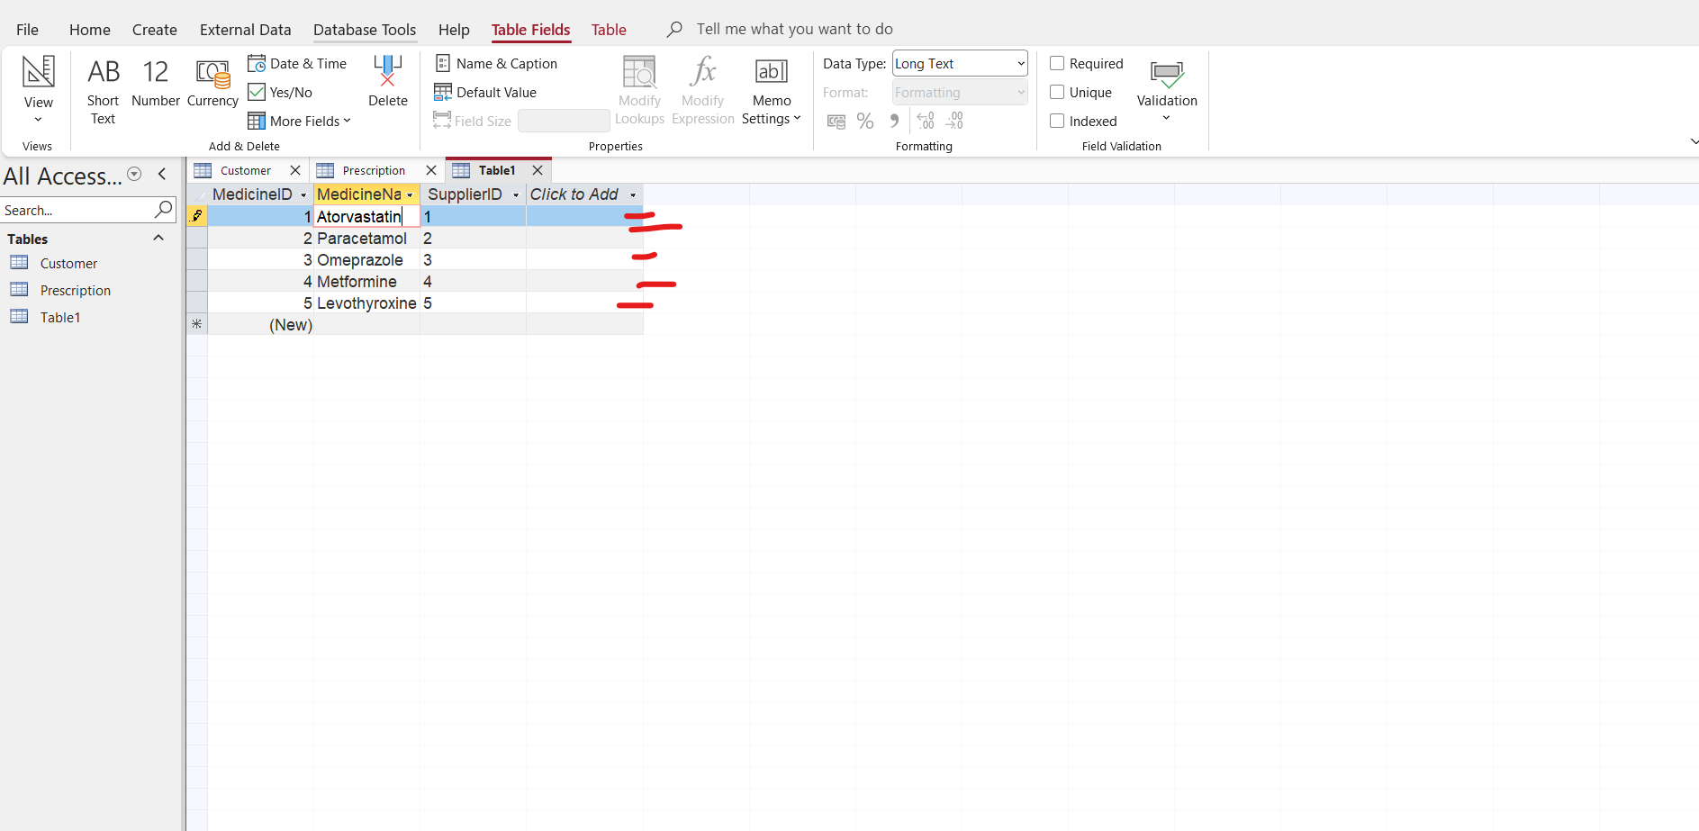
Press CTRL S to save as Medicine
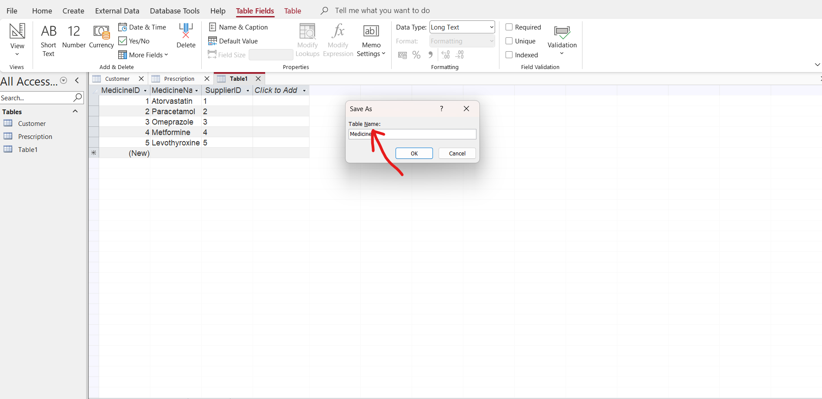
When you press enter it is going to create a medicine table on the left side
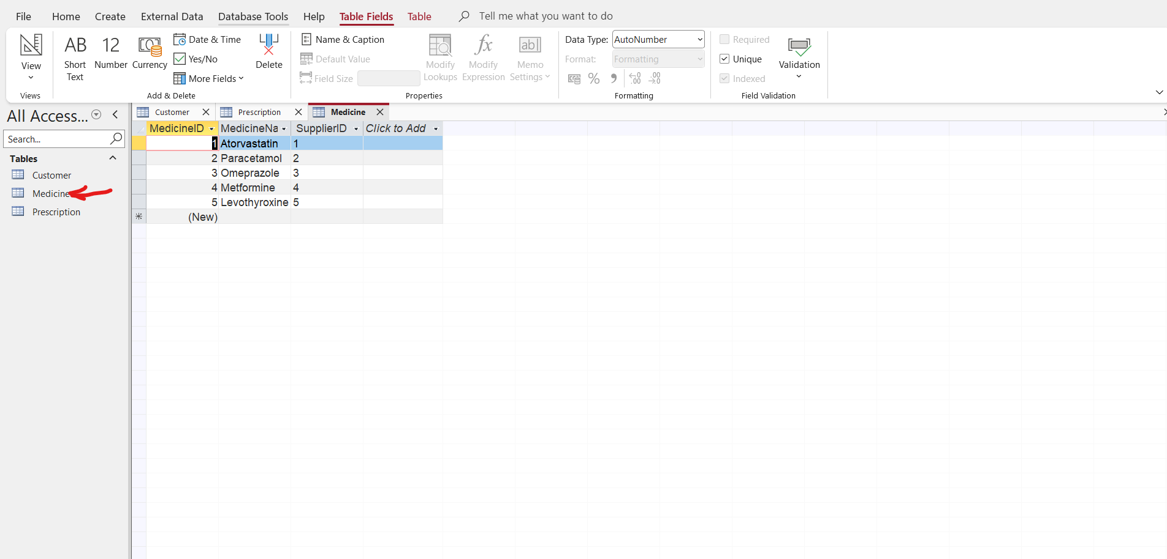
Supplier Table
Go to create and click on Table
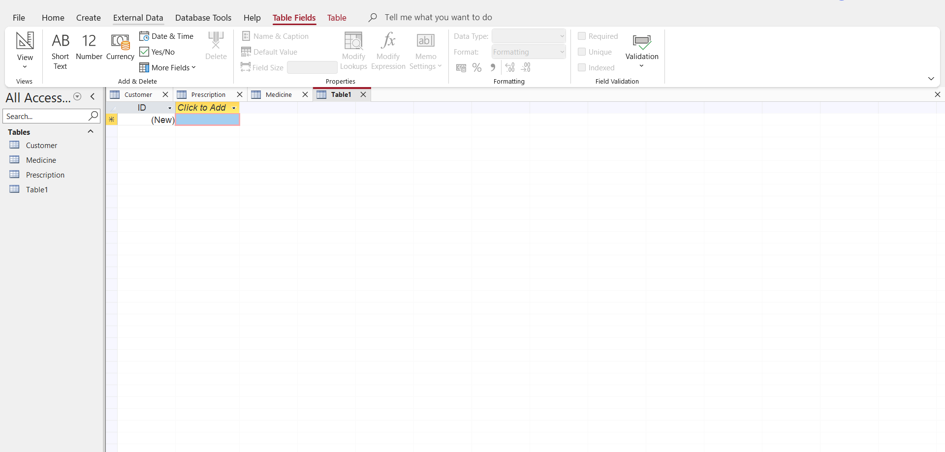
Right click on the ID field and select rename to change it into SupplierID
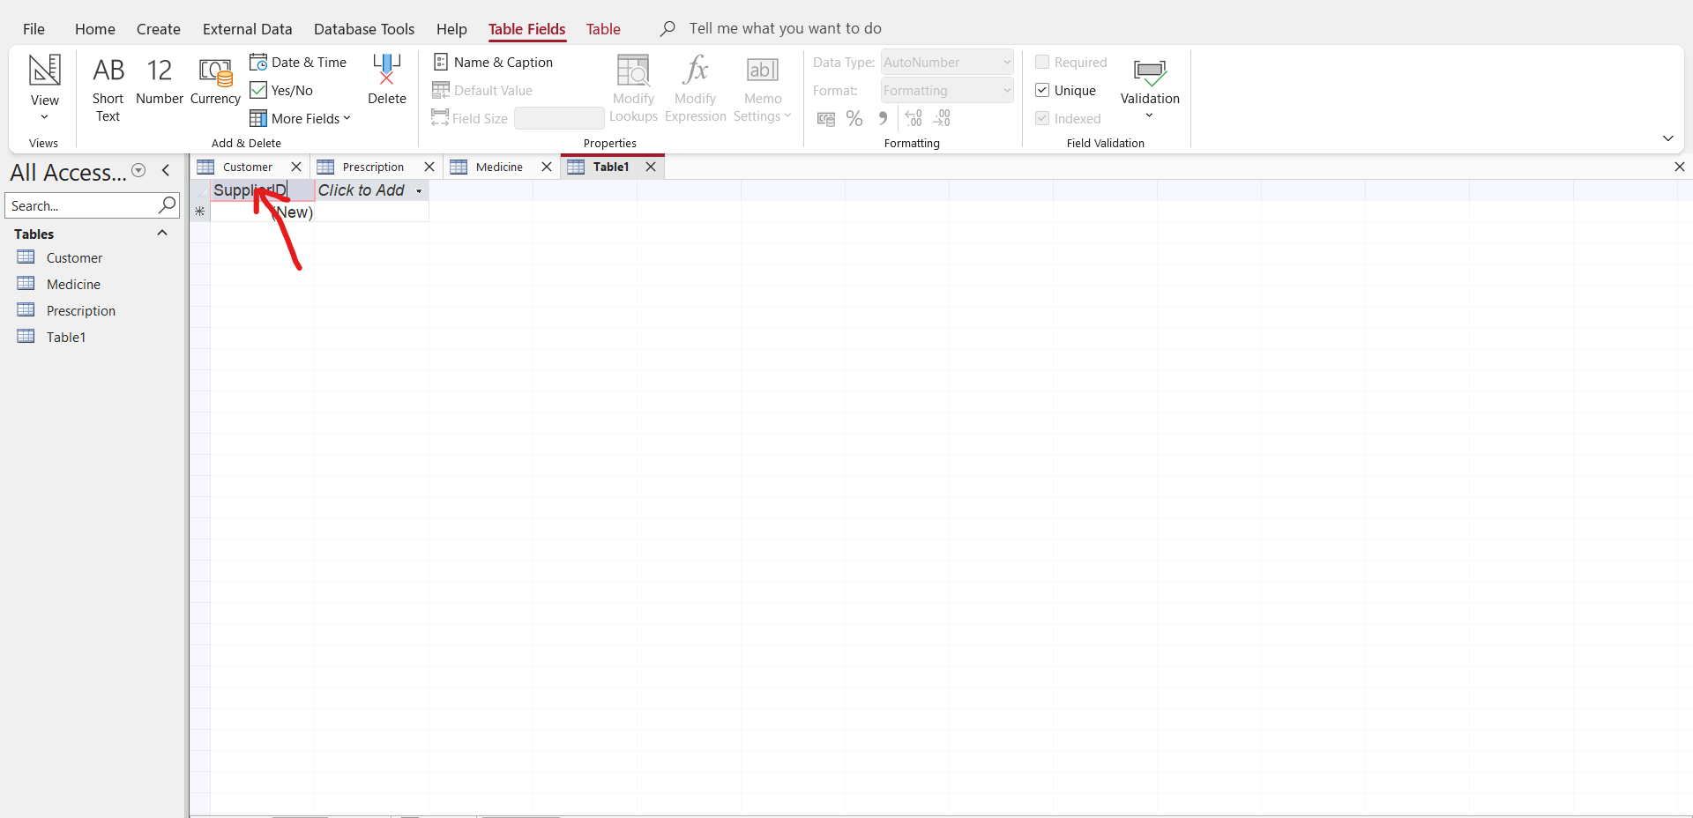
Click to Add and add the other fields require and enter the data required
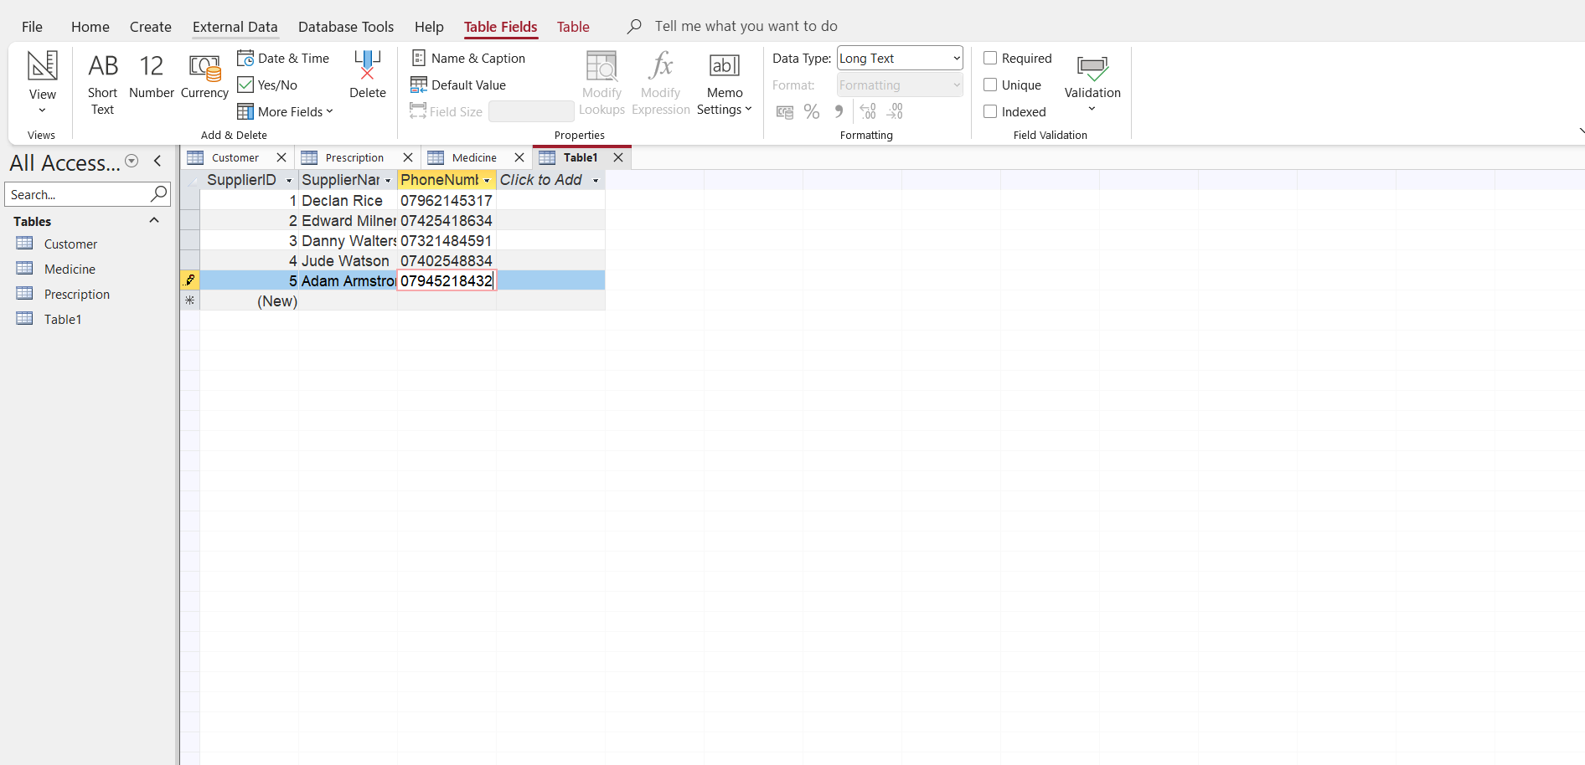
Press CTRL S to save the data as supplier
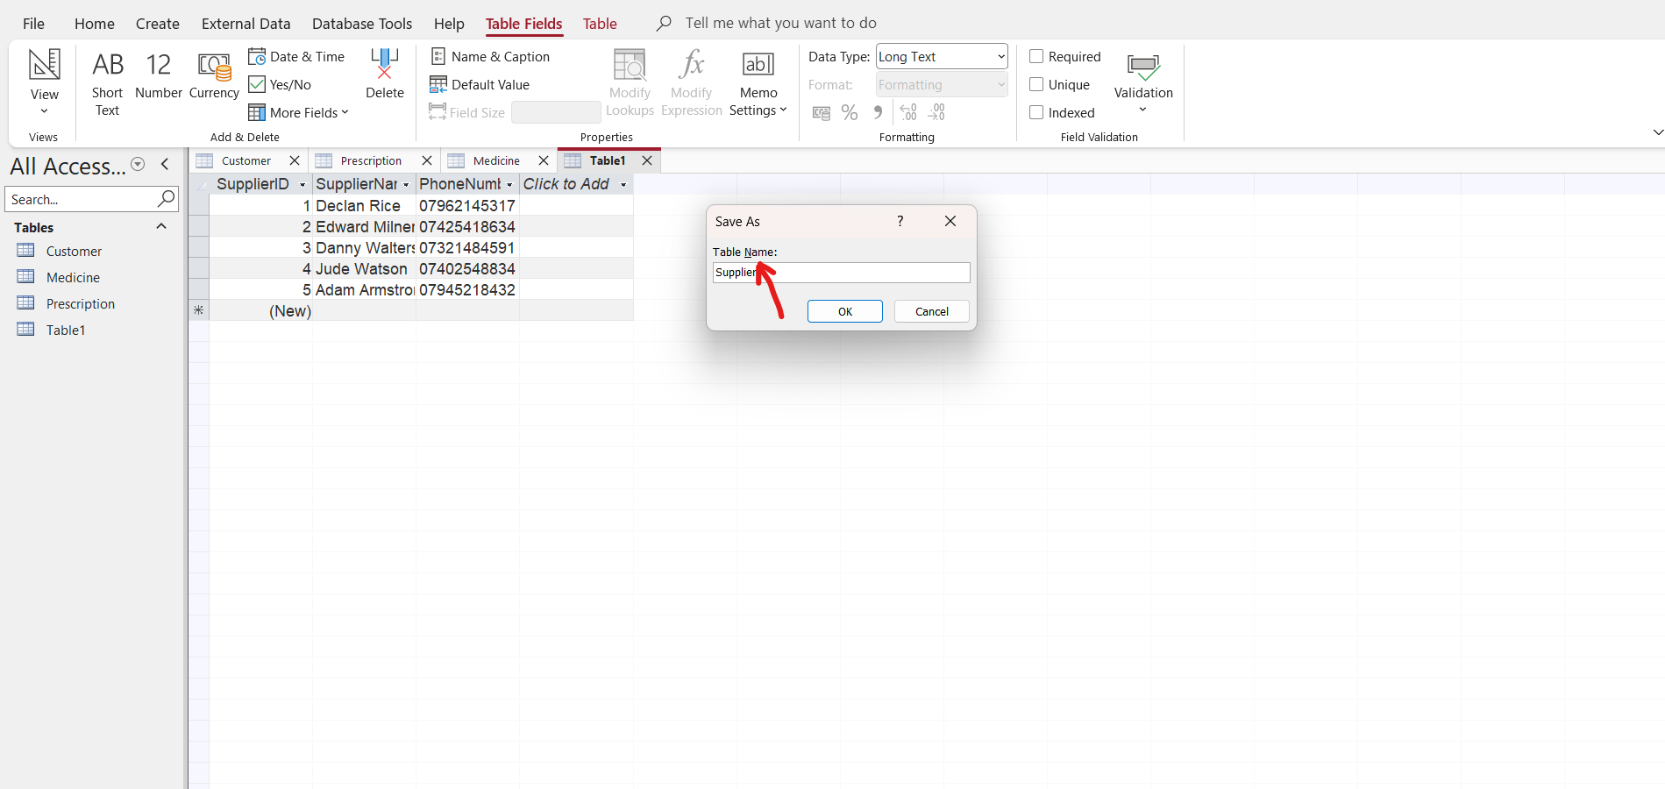
Press enter and it will create a supplier table on the left
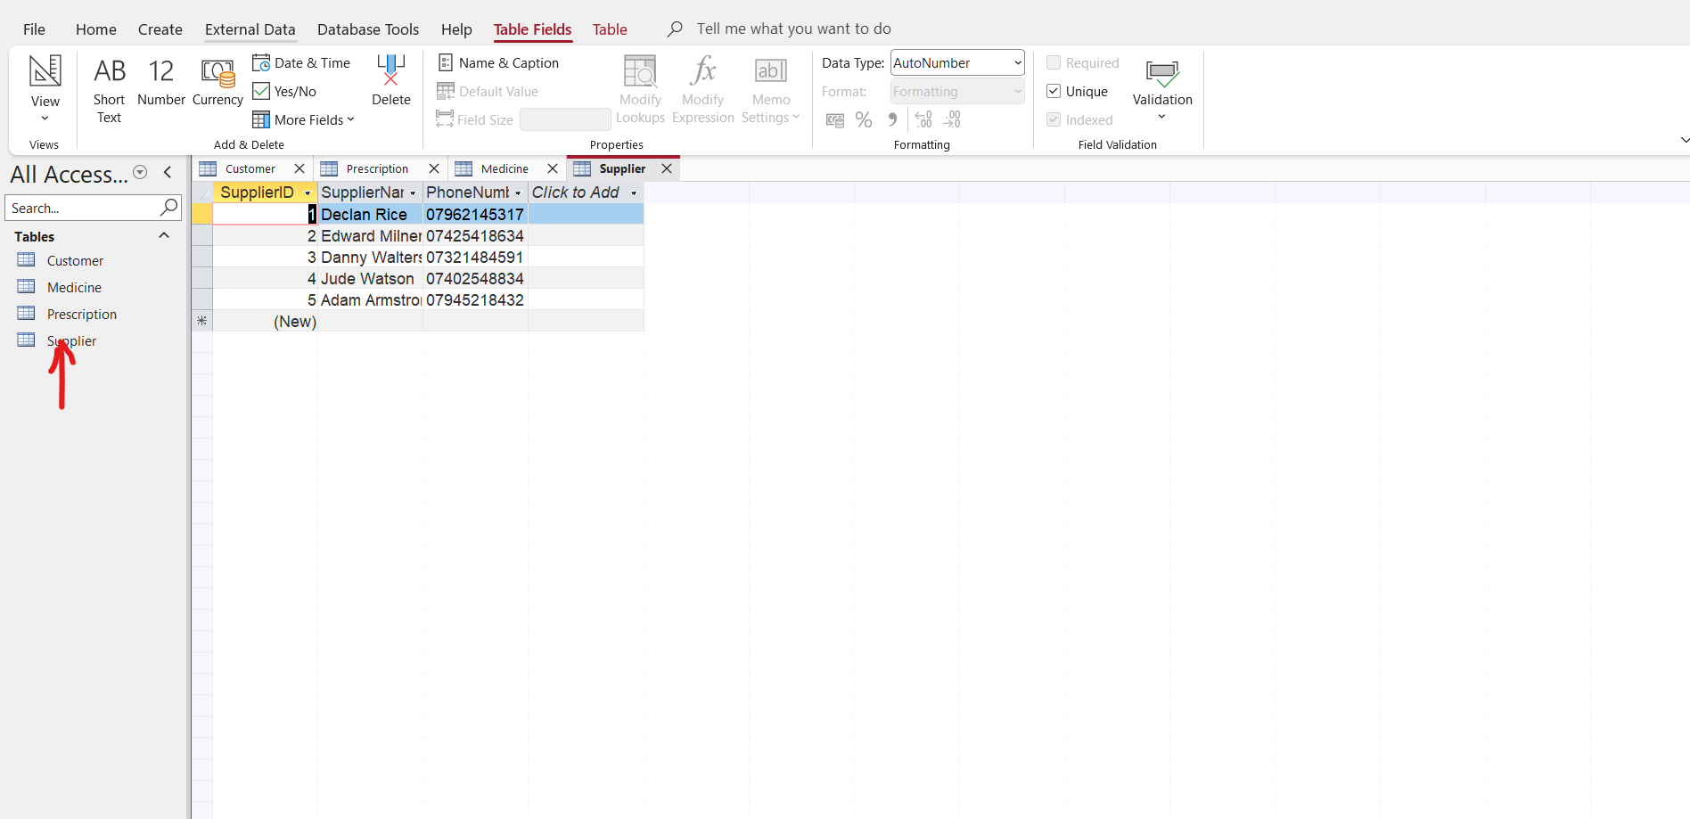

PrescriptionDetails
Go to create and click on table
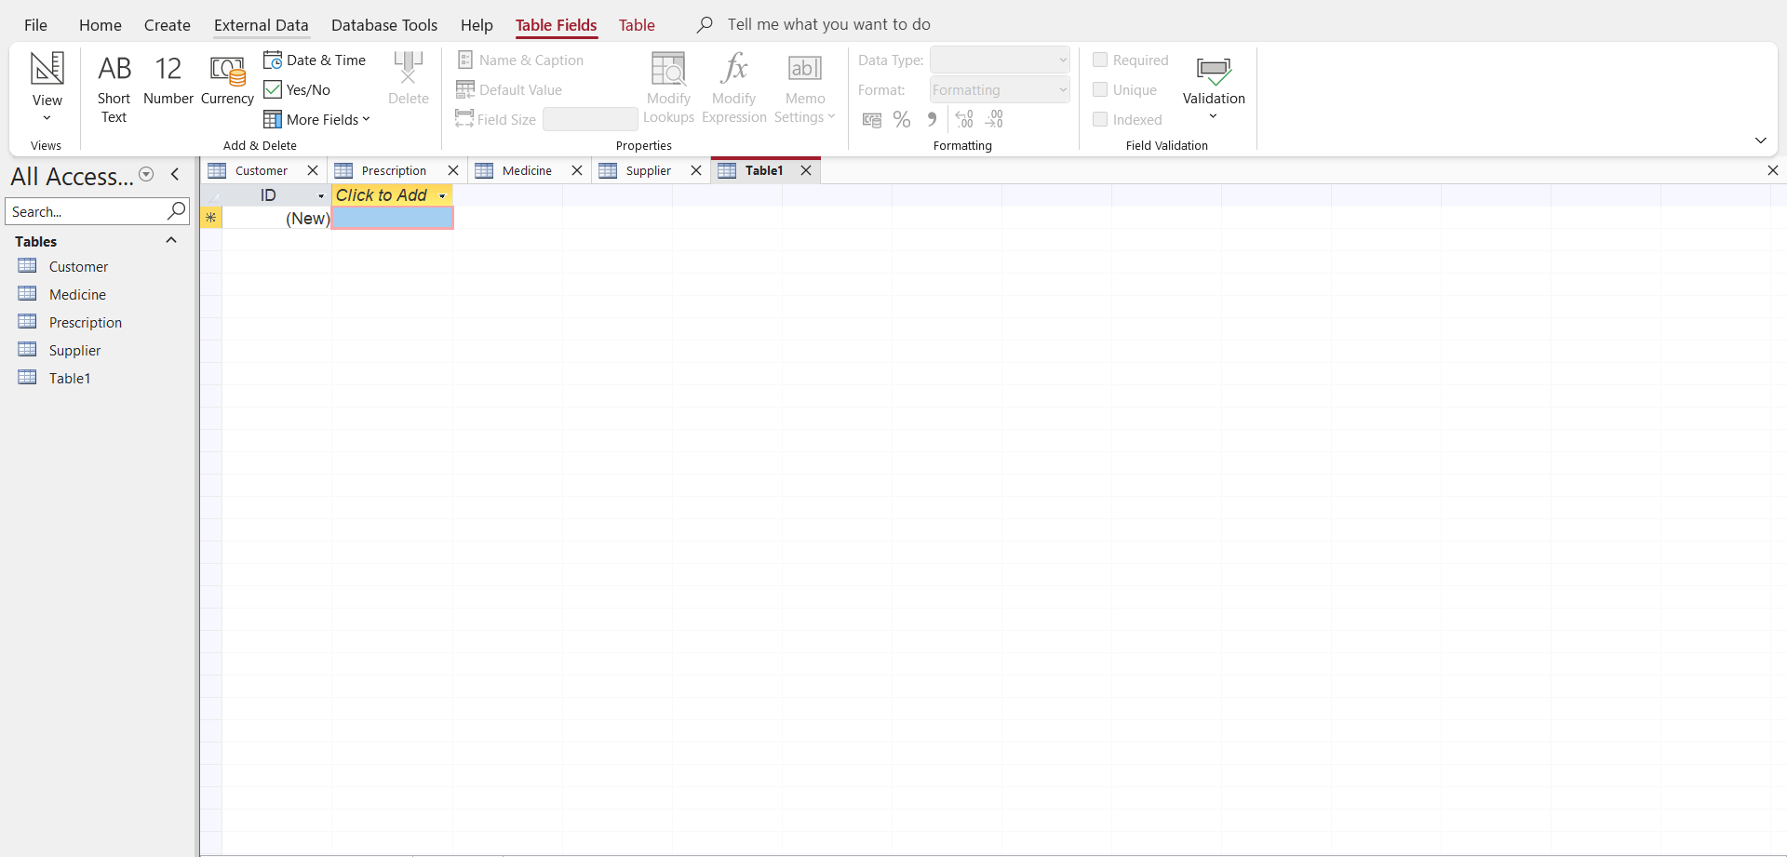
Right click on ID and select rename to change it into PrescriptionDetailsID
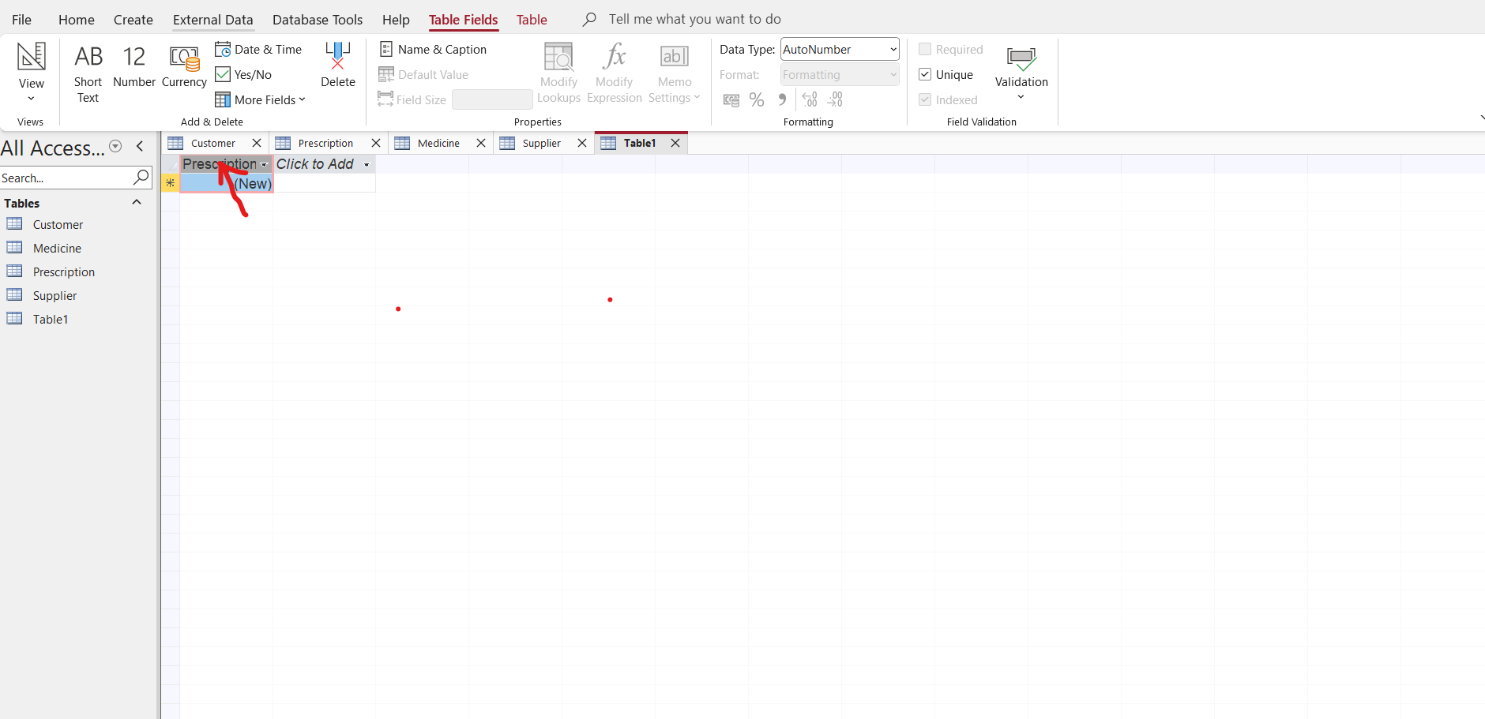
Click to Add PrescriptionID and MedicineID as foreign keys
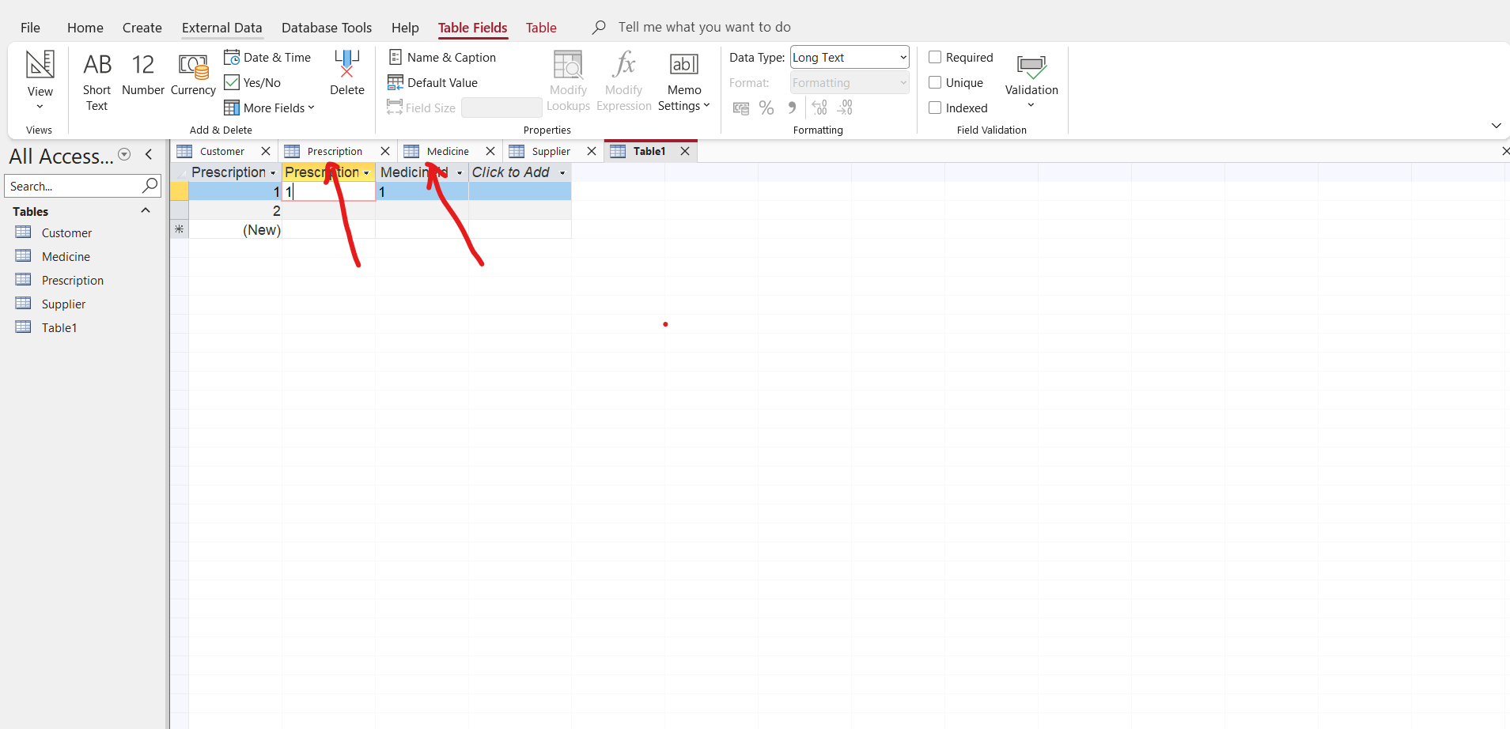
Insert the data require
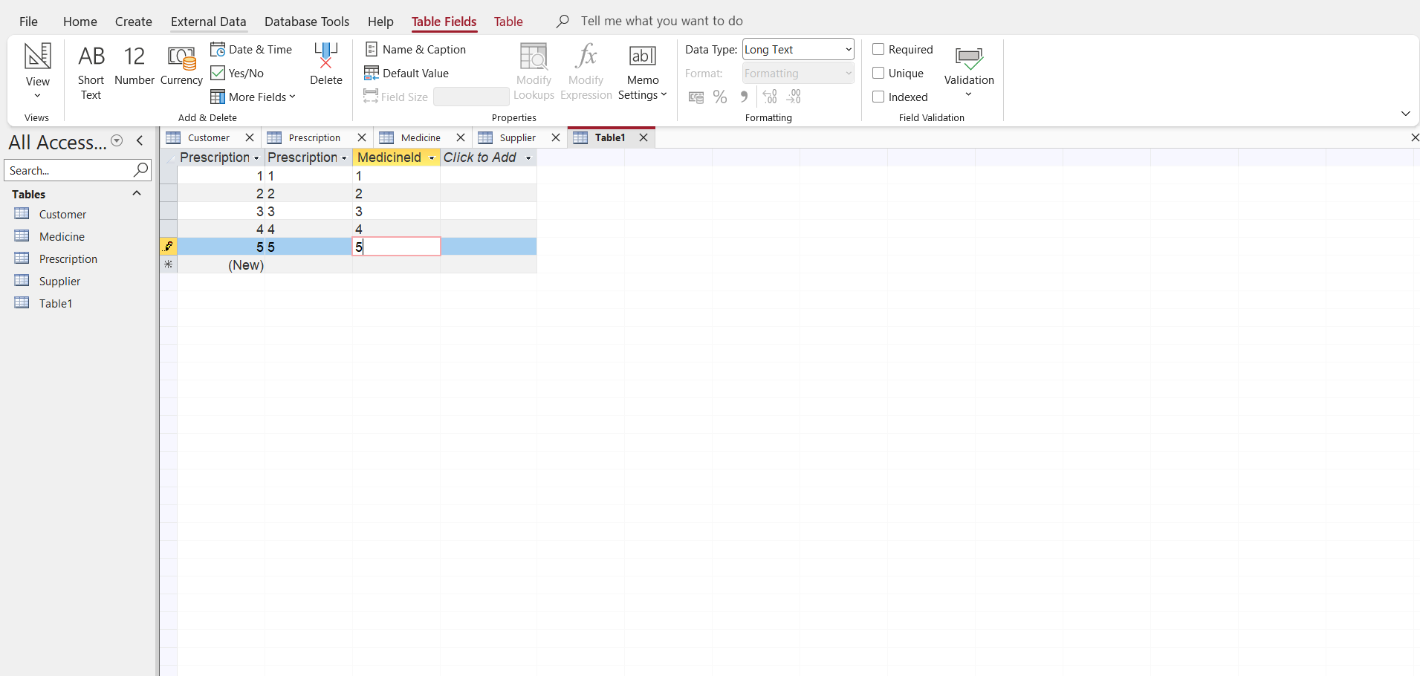
Press CTRL S and save the table as prescriptionDetails
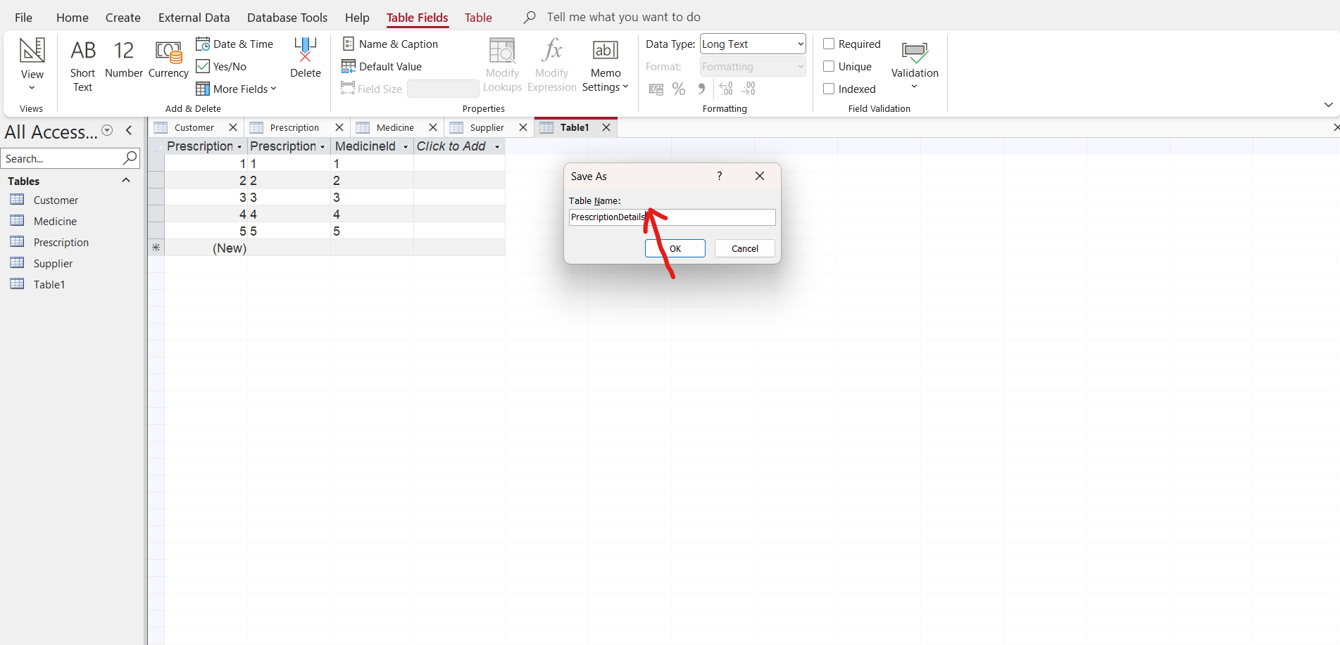
Press enter and a prescriptionDetails table is going to be created on the left side
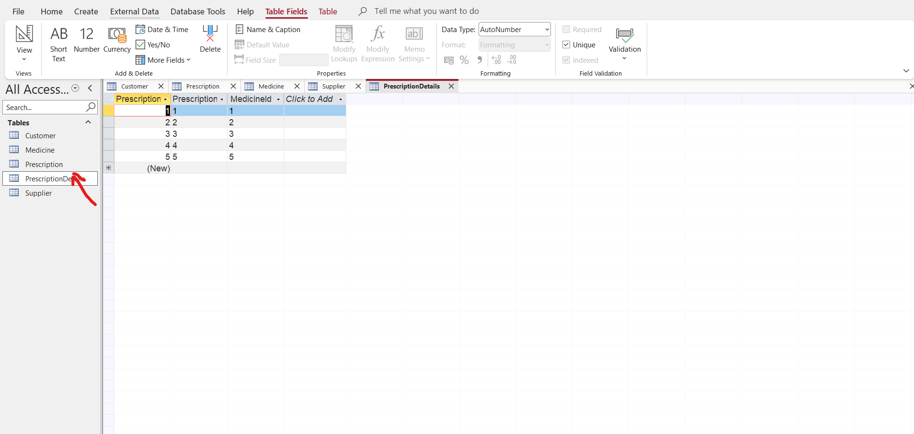
SalesTransaction
Go to create and click on table
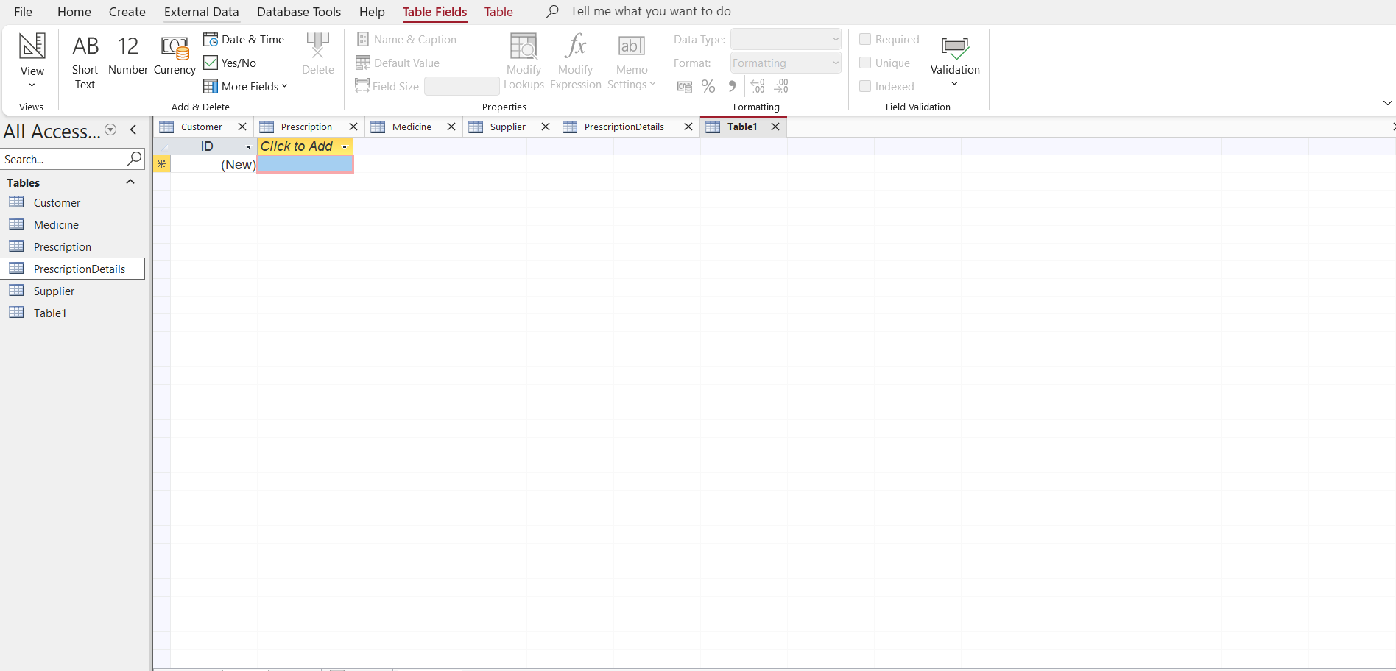
Right click on ID and select rename to change it to salestransactionID
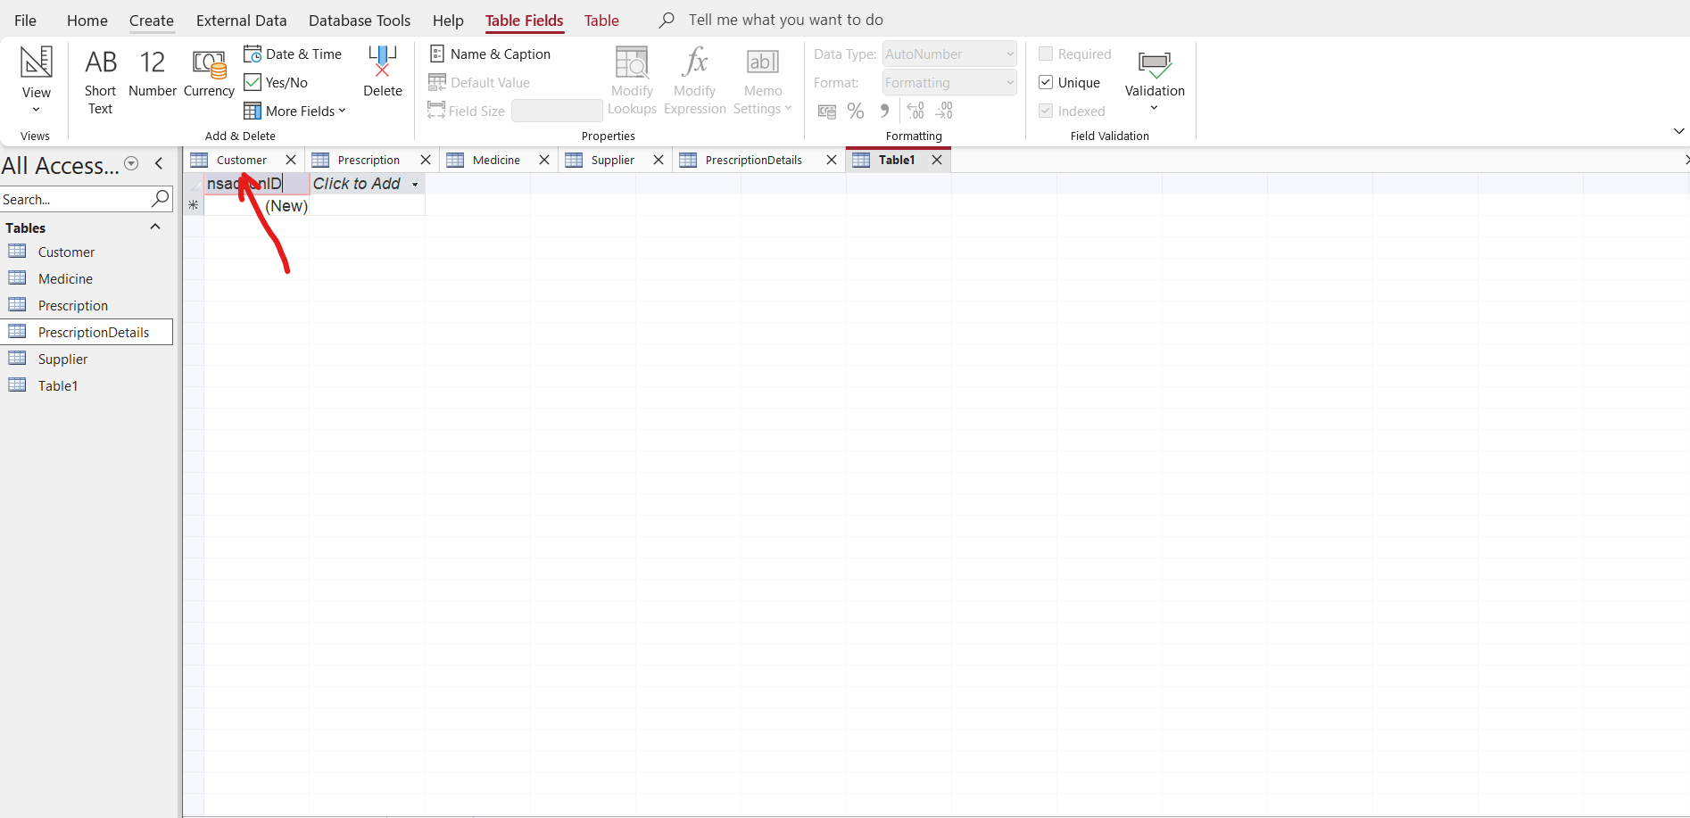
Click to Add and add CustomerID which is a foreign key and TransactionDate and put in the data as below
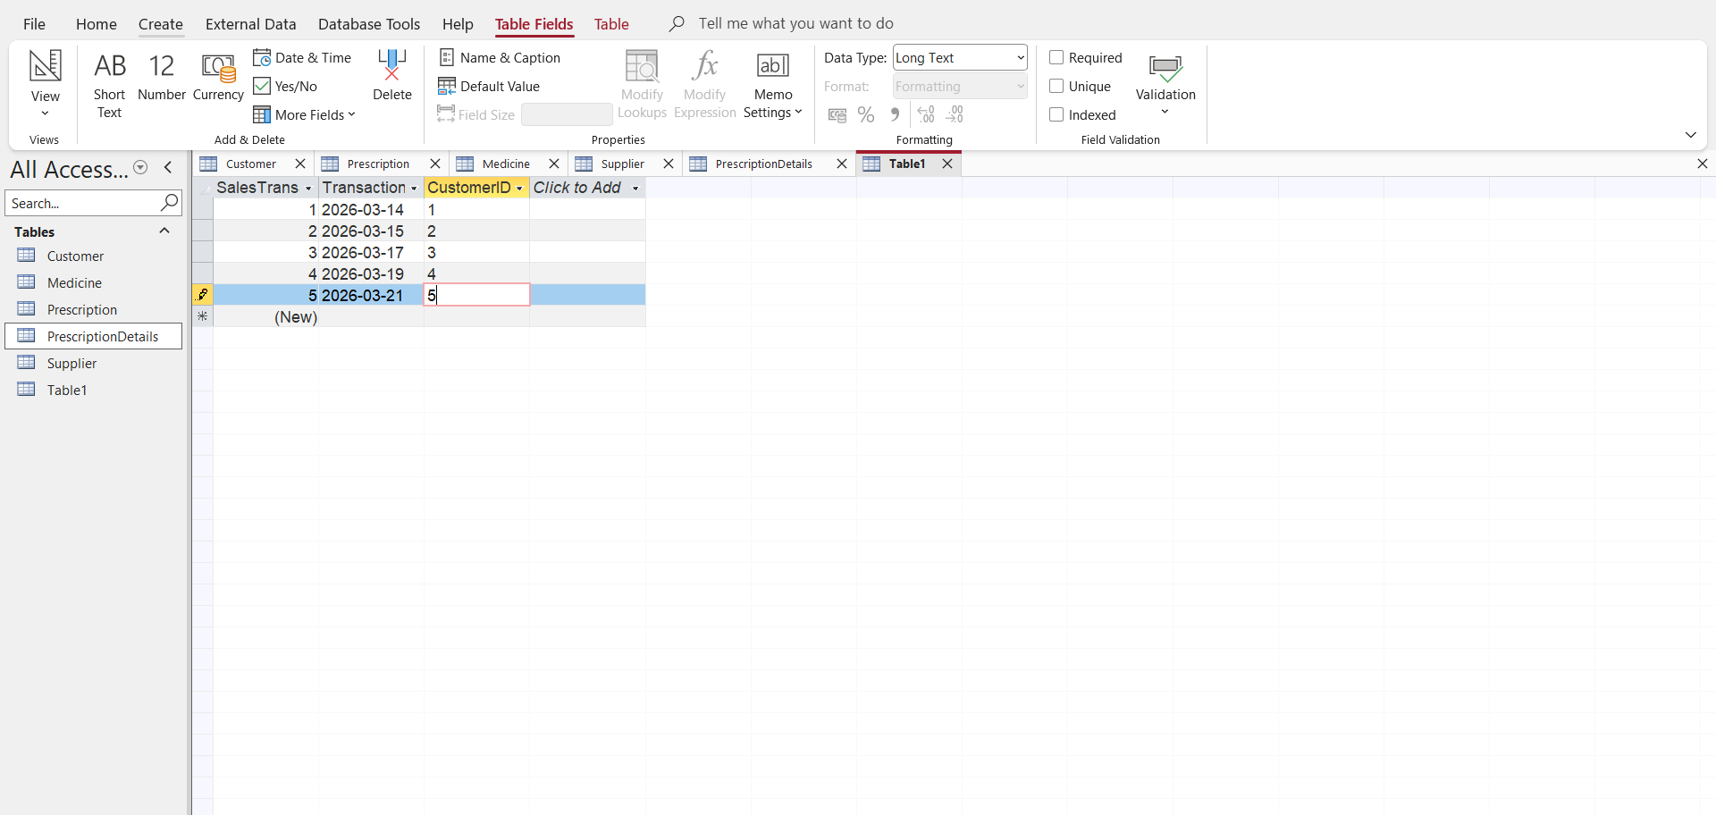
Then press CTRL S and save it as SalesTransaction
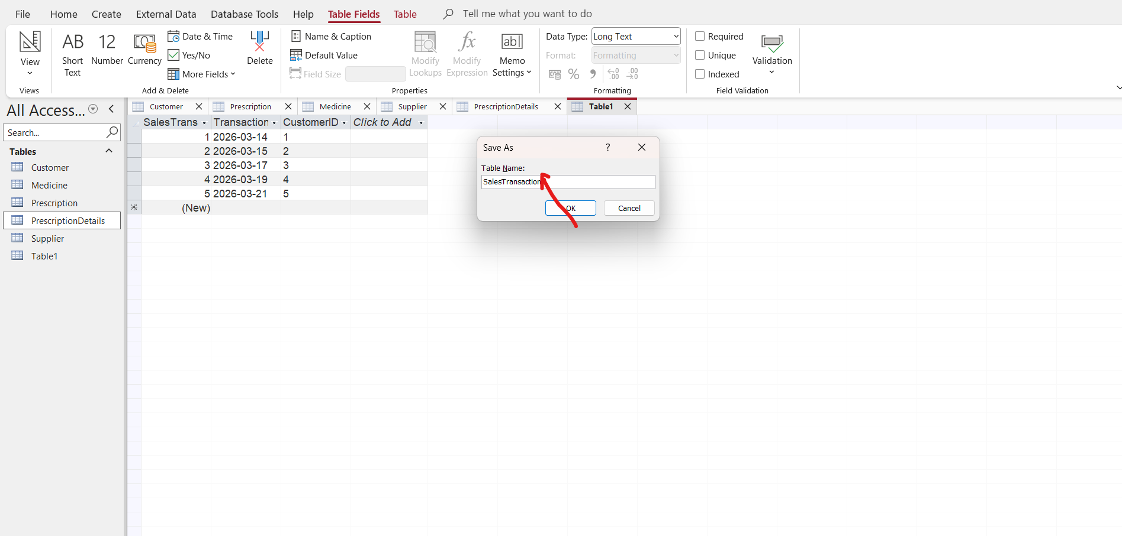
Press enter and a salesTransaction table is going to be created on the left side
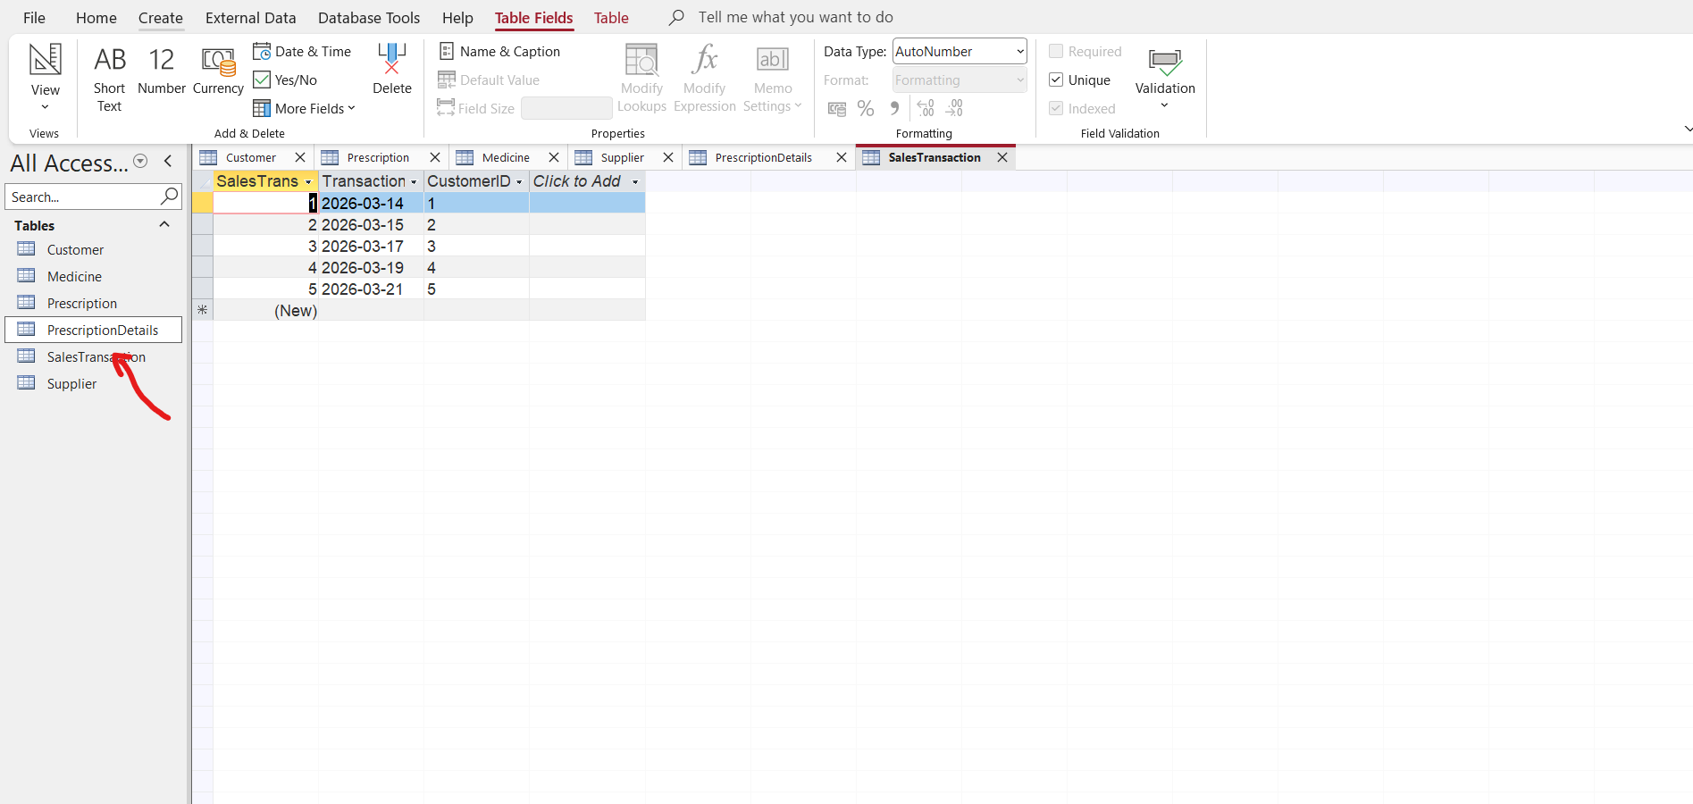

SalesDetails
Go to create and click on Table
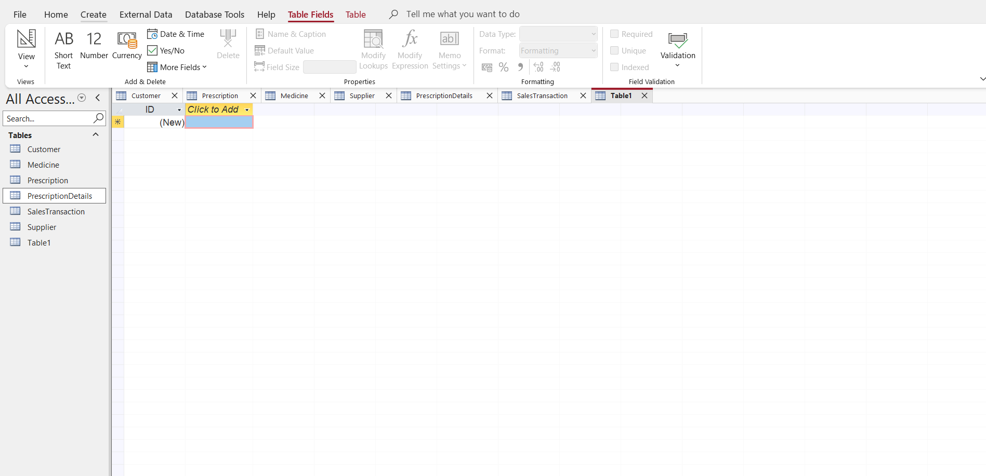
Right click on ID and select rename to change it into SalesDetailID
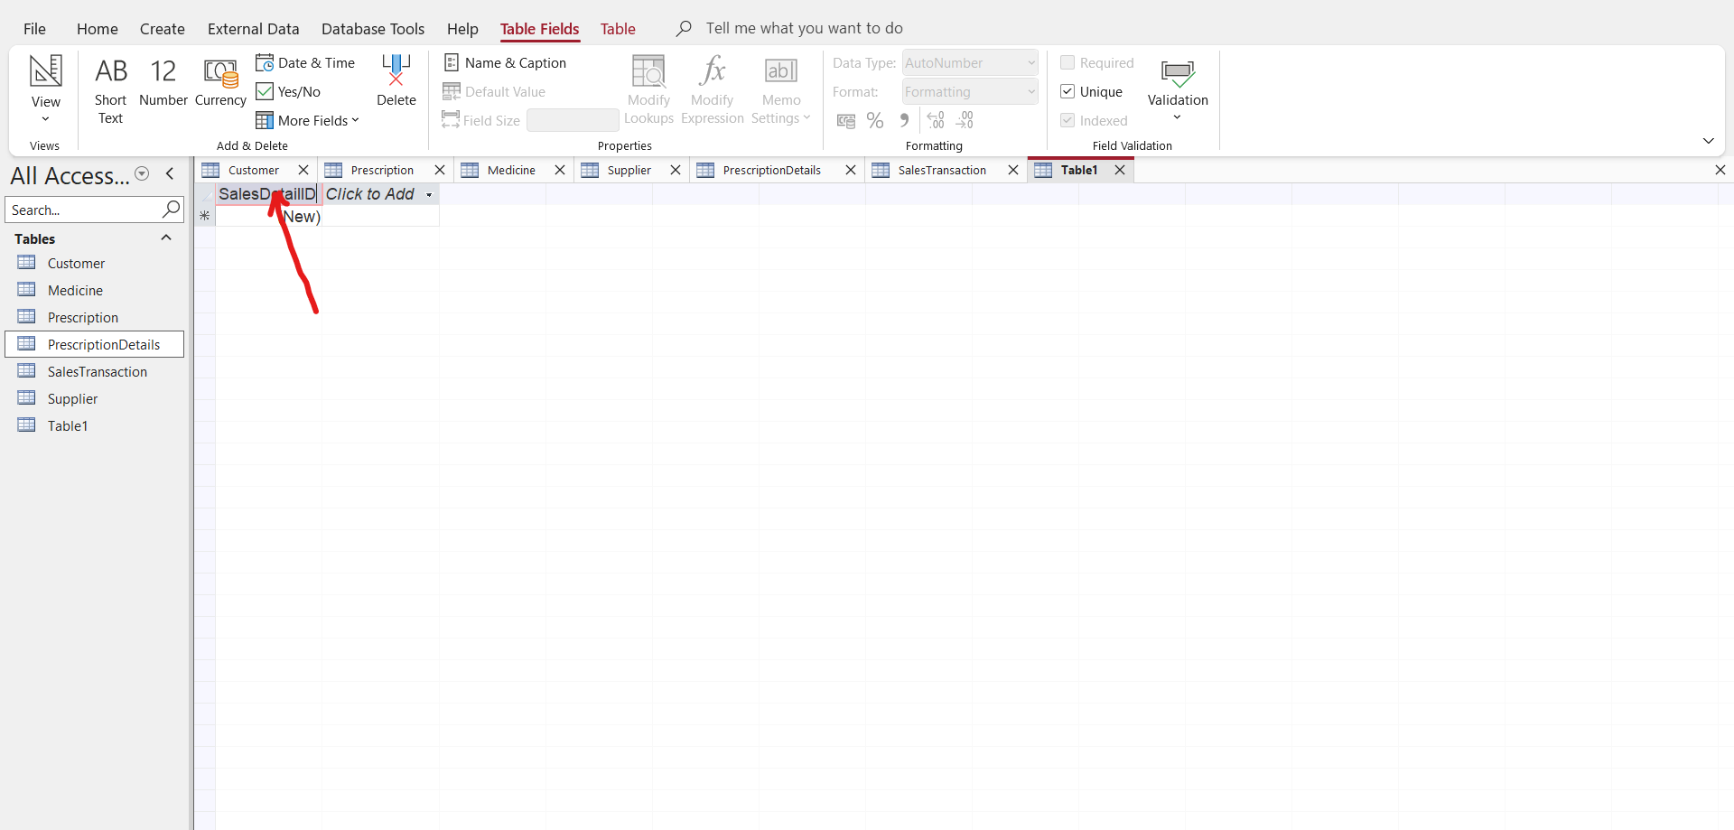
Click to Add and TransactionID and MedicineID as foreign keys
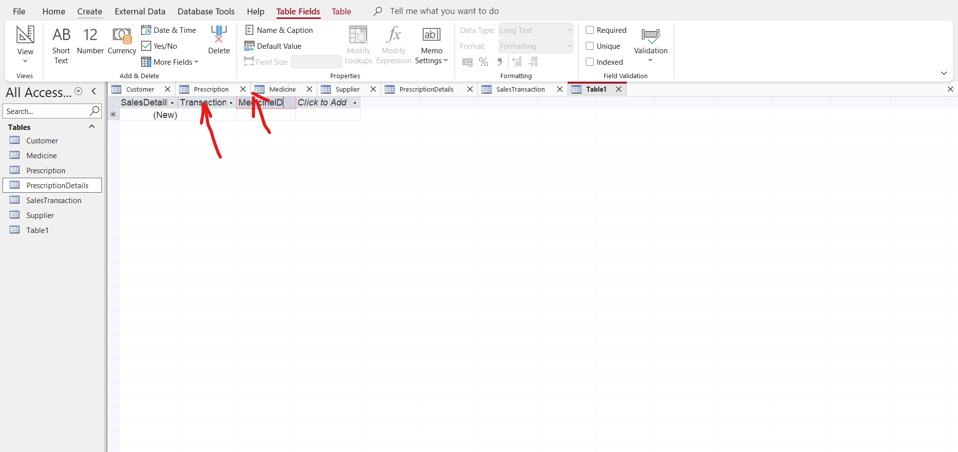
Put in the data in the table
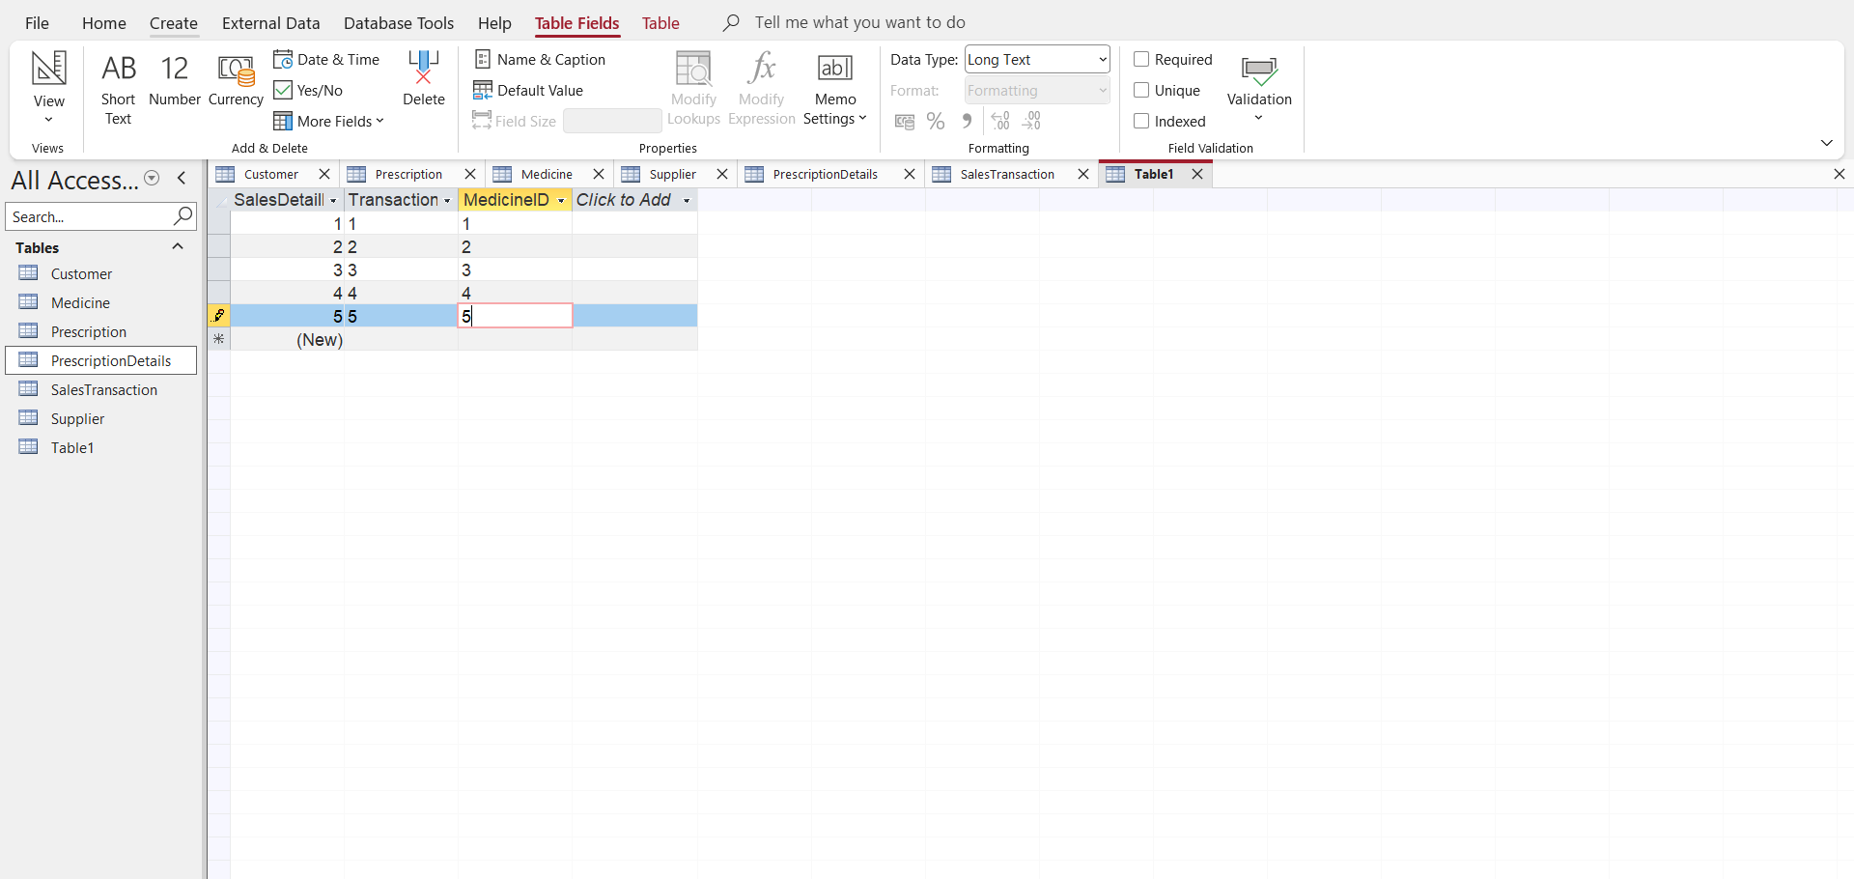

Press CTRL S to save it as SalesDetails
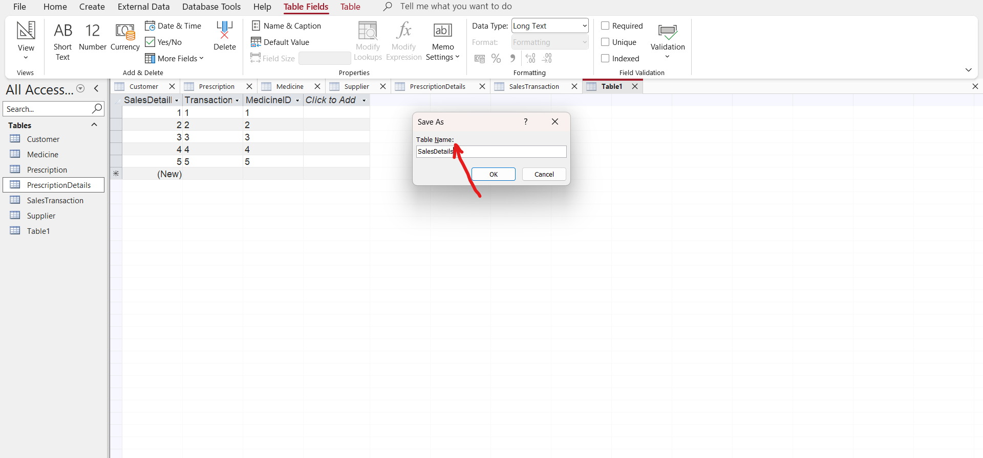
Press enter and a table of SalesDetails is created on the left side
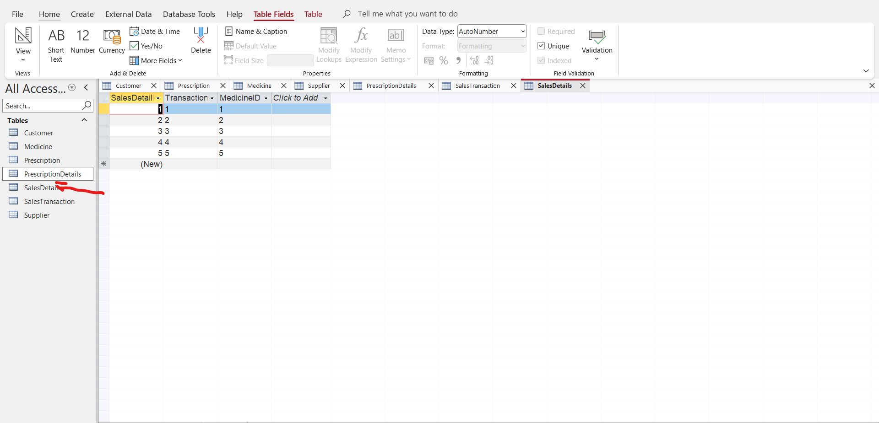

Now you go to Database tools and open your tables as below and start to link the tables that are related
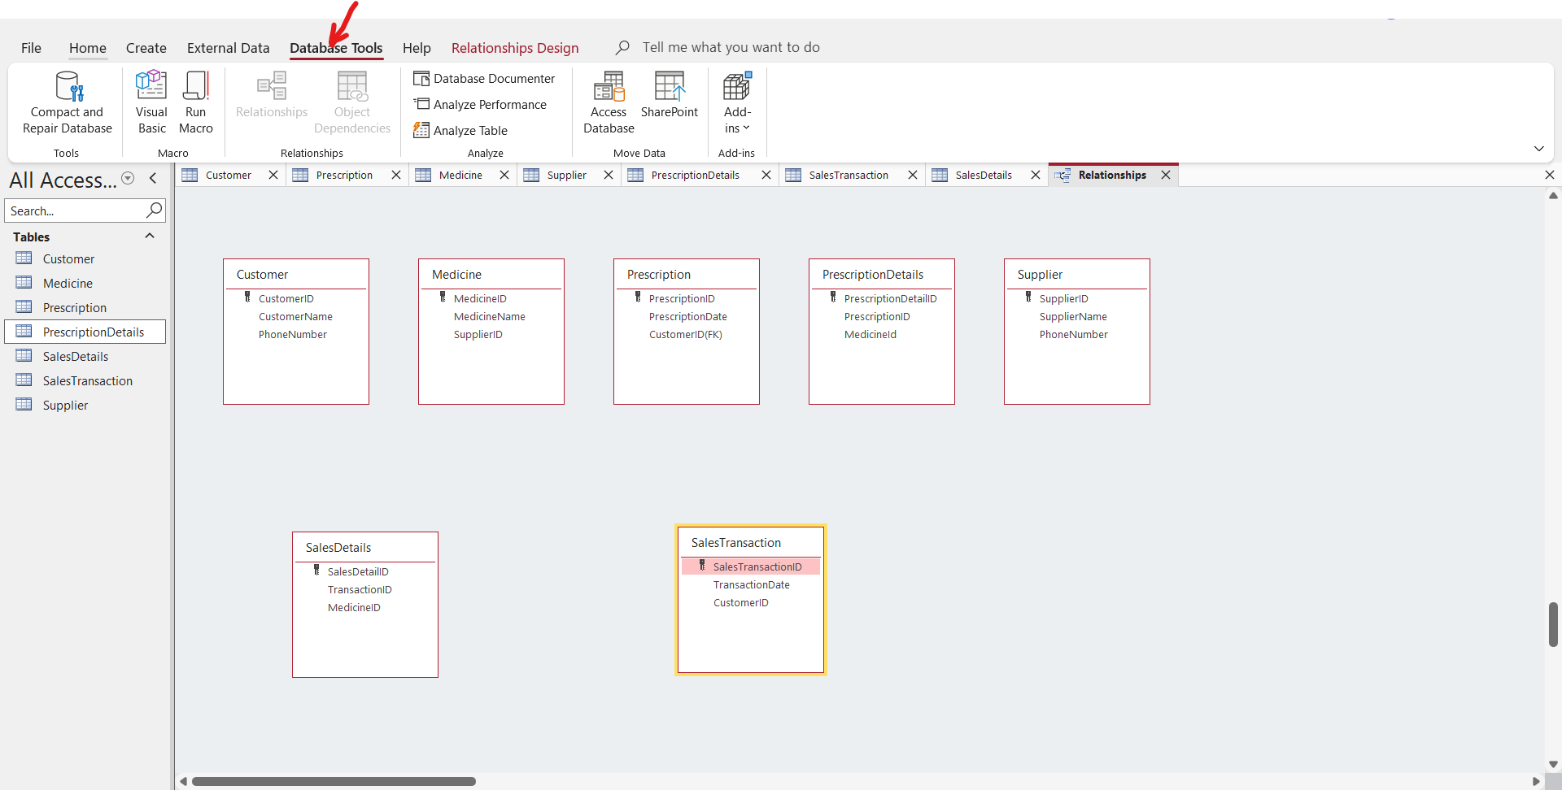
Then you start dragging the tables that are related and be linking them
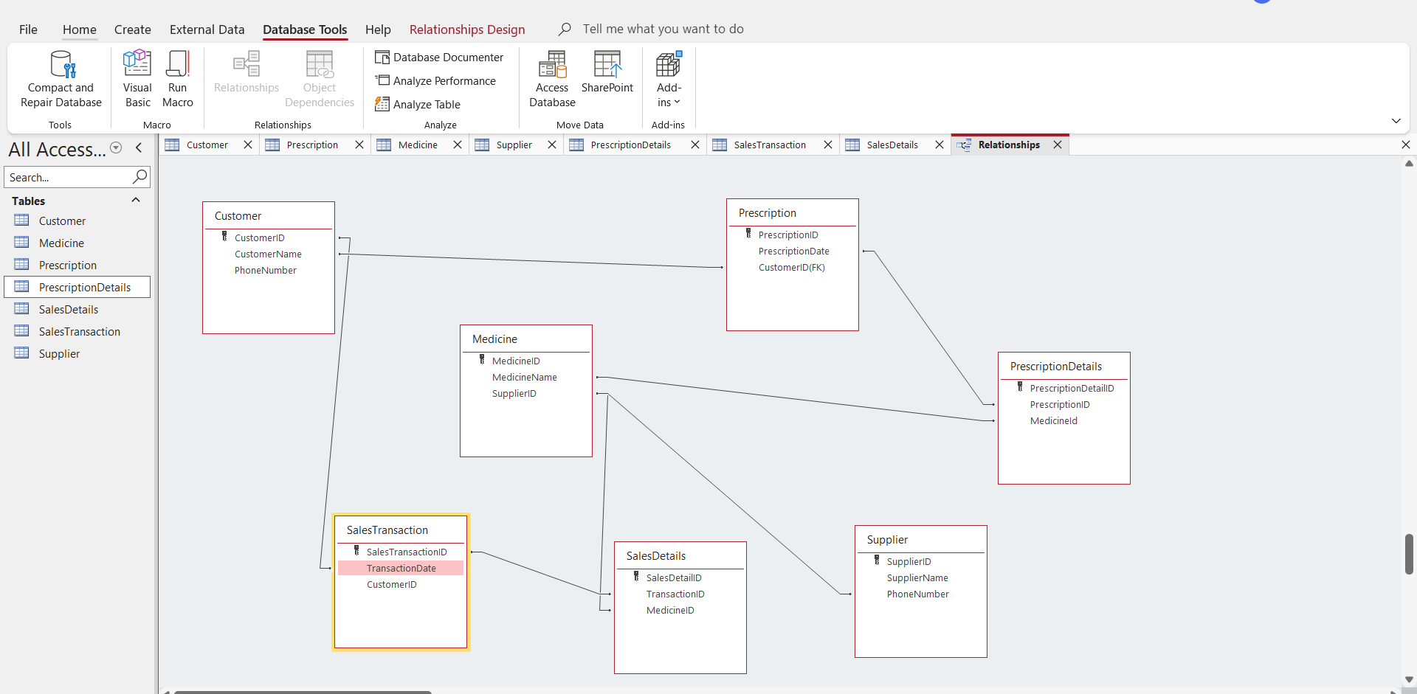

3 Data Structure Development: Data structure development is the process of defining, designing, and implementing specific data organization and storage formats within a computer's memory so that data can be accessed, managed, and processed efficiently by programs. The goal is to optimize how data is handled, balancing between speed (time complexity) and memory usage (space complexity) for a given set of operations. [3]
Entity | Attributes |  |  | Primary key
Customer | CustomerID,CustomerName,DateOfBirth,PhoneNumber,Address,Email,Age |  |  | CustomerID
Supplier | SupplierID,SupplierName,PhoneNumber,Address,Email |  |  | SupplierID
Medicine  Prescription  Precriptiondetails | MedicineID,MedicineName,Category,DosageForm,Price,ExpiryDate  PrescriptionID,PrescriptionDate,Notes  PrescriptionDetailID,PrescriptionID(FK),MedicineID(FK) |  |  | MedicineID  PrescriptionID  PrescriptiondetailID

A primary key is not supposed to be Null
A primary key is not supposed to be duplicated it must be unique
A foreign key FK must exist as Primary key in another table
A Customer can make various prescriptions that is 1:M Relationship
A Supplier can supply so many medicines to the pharmacy that is 1:M relationship
A medicine can appear into various prescriptions that is M:N relationship
A prescription can have on one prescription detail that is 1:1 relationship
Customer table Medicine Table Prescription Table Supllier Table
CustomerID (PK) MedicineID(PK) PrescriptionID(PK) SupplierID(PK)
CustomerName MedicineName PrescriptionDate SupplierName
Address Price CustomerID(FK) PhoneNumber
Email ExpiryDate MedicineID(Fk) Address
The PK are unique and a customer can make various prescriptions that is 1:M relationship and the customer ID will be the foreign key
Prescription Table
PrescriptionID(PK)
PrescriptionDate
CustomerID(FK)

Weak Entities or child entity are Medicine and Prescription
Medicine Table Prescription Table
MedicineID(PK) PrescriptionID(PK)
MedicineName PrescriptionDate
SupplierID(FK) CustomerID(FK)
The value of the foreign key use is not Null in total participation
The value of the foreign key can be Null in partial participation

4 Normalization Compliance: Normalisation compliance, or data normalization, is the process of structuring data within a database or system to reduce redundancy, eliminate data anomalies, and improve data integrity. It involves organizing data—such as customer names, addresses, or product records—into a standardized format, typically by splitting large, complex tables into smaller, related tables. [4]

1NF Rule
-No repeating groups
-All fields contain atomic values
-Each record has a primary key
Compliance in MediLink
-Each table has a primary key
-Fields stores single values for example no multiply medicine in one field.
-Repeating data is moved to separate tables for example multiple medicines per prescription-----PrescriptionDetails
Example
PrescriptionDetails
PrescriptionID MedicineID Quantity

2NF Rule
-Must be in 1NF
-No partial dependency
-Relevant mainly for tables with composite keys
Compliance in MediLink
Tables like SalesDetails and PrescriptionDetails
-Composite logic:(SaleID + MedicineID)
-All attributes depend on the full key

3NF Rule
-Must be in 2NF
-No Transitive dependency
Customer Table Medicine Table Prescription Table Supplier Table
CustomerID MedicineID PrescriptionID SupplierID
CustomerName MedicineName PrescriptionDate SupplierName

1NF= Fully compliant
2NF=Fully compliant
3NF=compliant

5 Sample Data Population: A population is the entire group of individuals, objects, or events researchers want to study, while a sample is a smaller, representative subset of that population chosen for data collection and analysis. Sampling enables inferential statistics to draw conclusions about the whole without surveying every member. [5]
Riders Table: Open the Microsoft Access app and choose blank data, then create a data name of which data you want to work on and then click enter and a blank data table is going to show as below
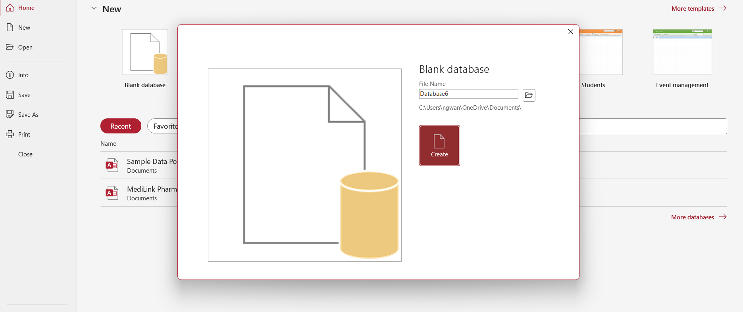

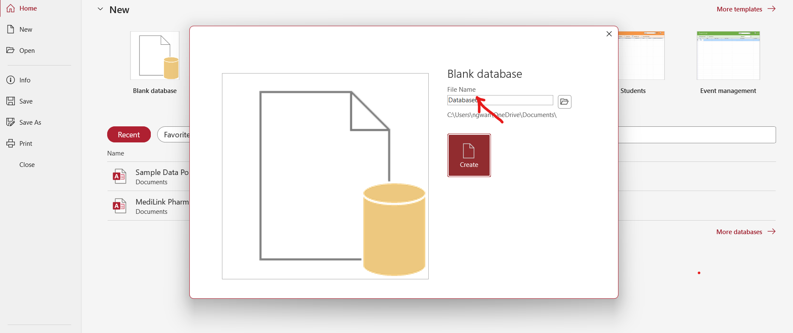
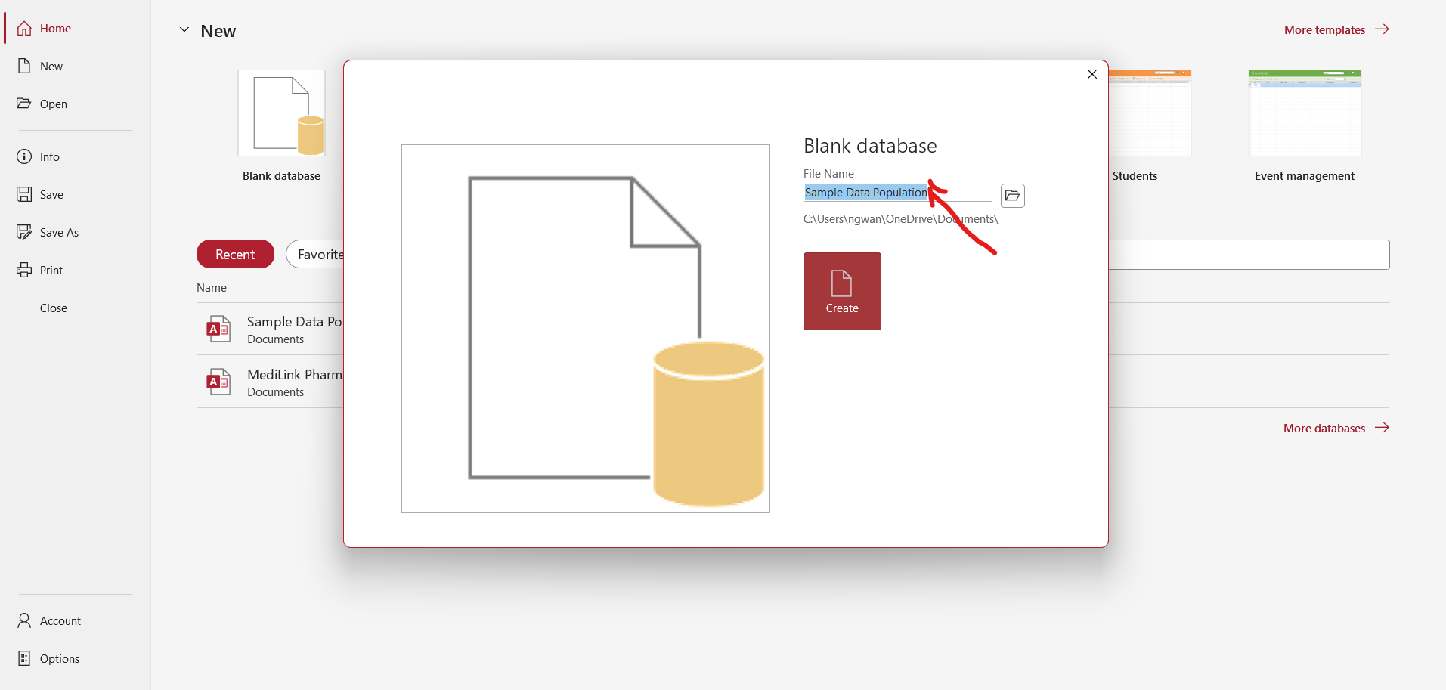
From here right click on the ID field and select rename to change to the field to riders ID and then click to Add and add the fields you are required to work with and once all this is done you can the put in the data you are working with when you are done inserting the data you press CTRL S to save it as riders table and then press enter and a riders table will be created on the left side as below
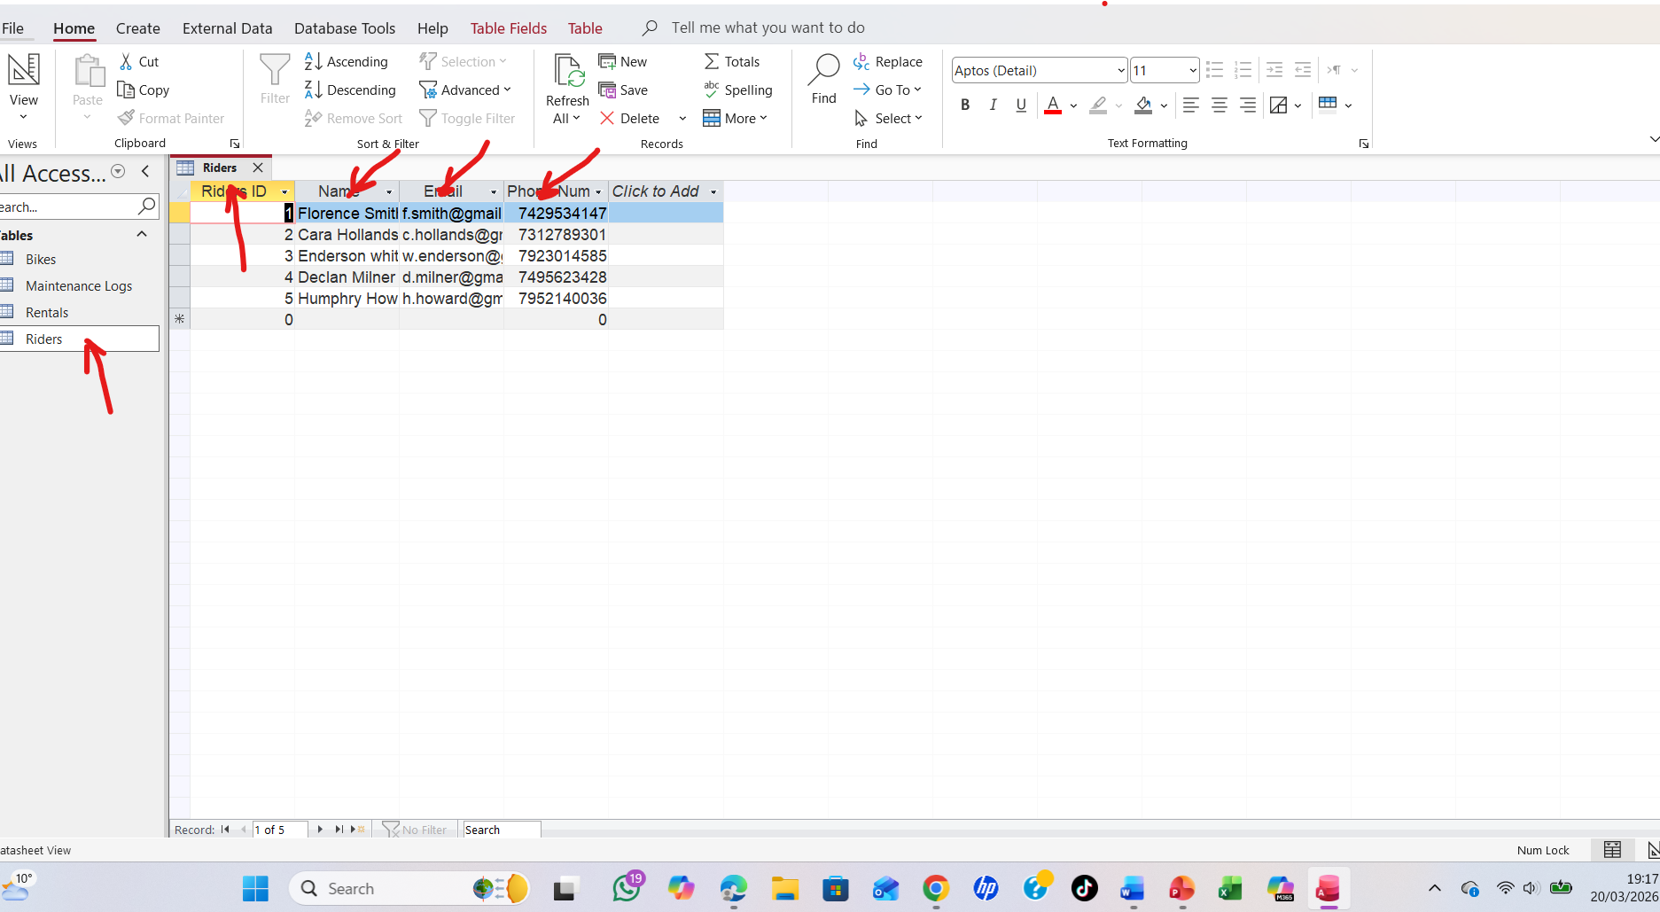

Bikes Table : Go to create then choose table and a new blank data is going to appear and you go to the field ID right click it and select rename to change the name of the field to Bikes ID and then click to Add and add the fields required and when you are done insert the data you want to work with. Once you are done inserting the data you then press CTRL S to save the data as Bikes and a bikes table is going to appear on the left side as below.
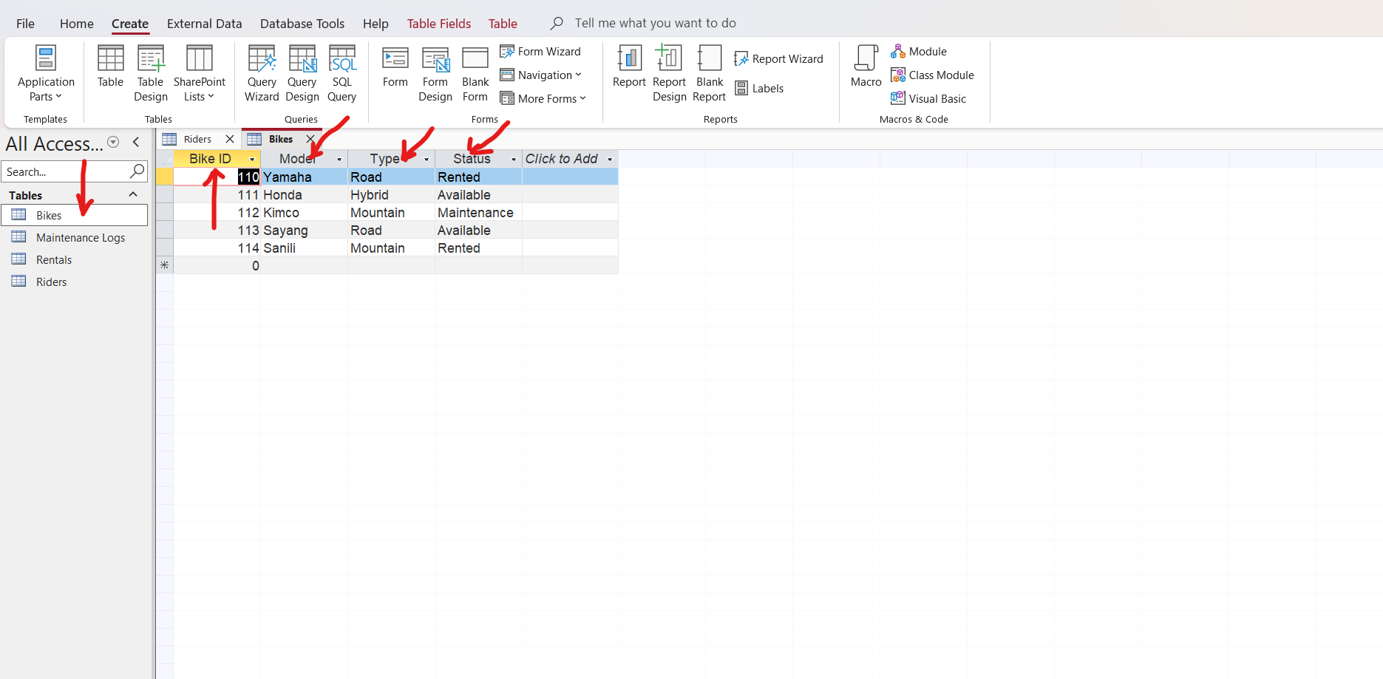
Rentals Table; Go to create then choose table and a new blank data is going to appear and you go to the field ID right click it and select rename to change the name of the field to Rentals ID and then click to Add and add the Bikes ID and Riders ID on this table as foreign keys and when you are done insert the data you want to work with. Once you are done inserting the data you then press CTRL S to save the data as Rentals and a Rentals table is going to appear on the left side as below.

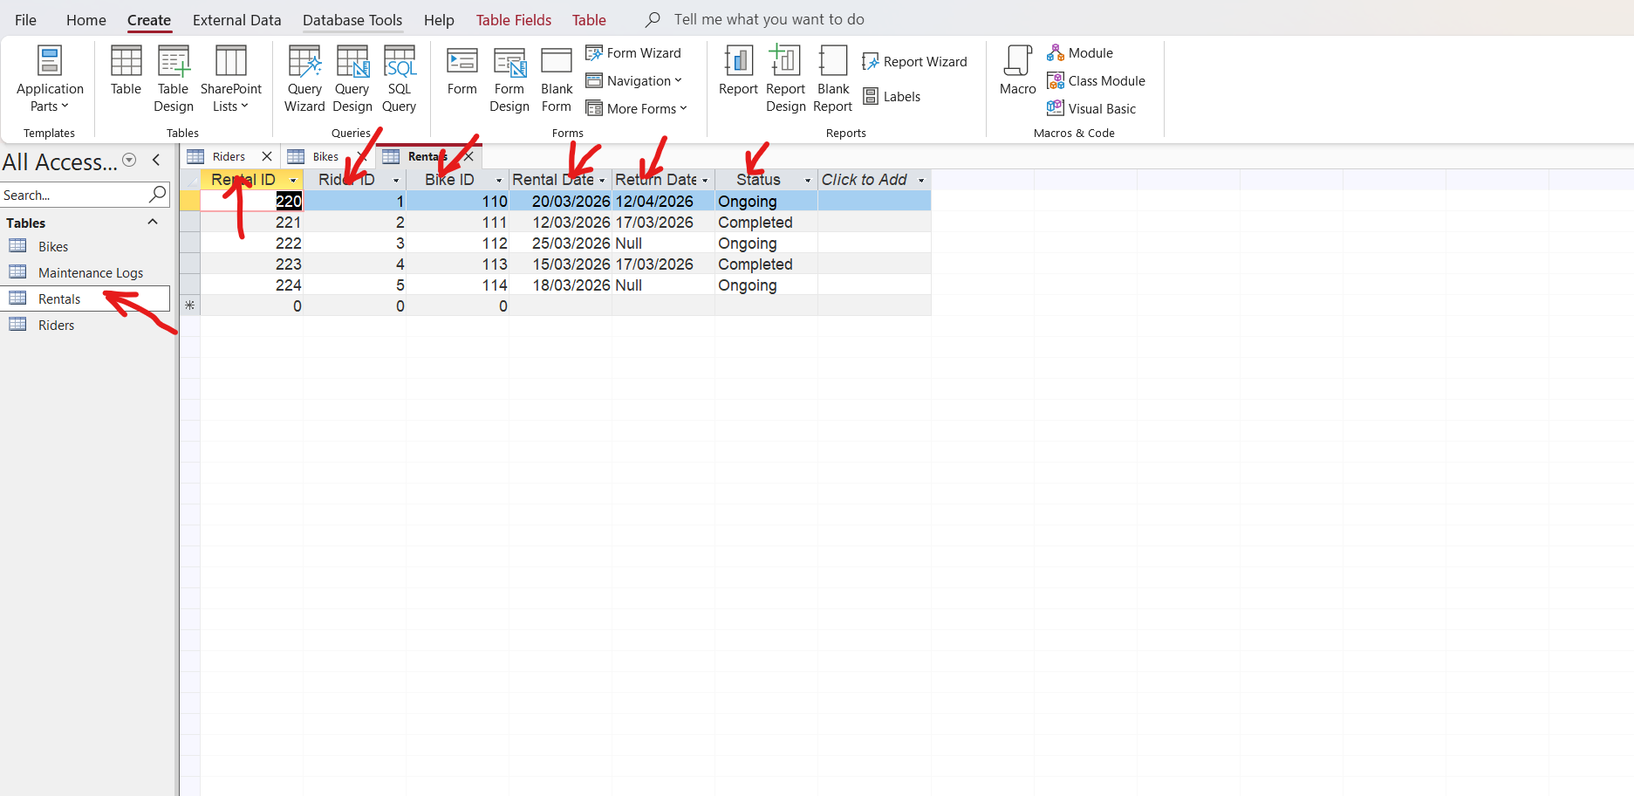
Maintenance Logs; Go to create then choose table and a new blank data is going to appear and you go to the field ID right click it and select rename to change the name of the field to MaintenanceLogs ID and then click to Add and add the Bikes ID on this table as foreign key and when you are done insert the data you want to work with. Once you are done inserting the data you then press CTRL S to save the data as MaintenanceLogs and a MaintenanceLogs table is going to appear on the left side as below.
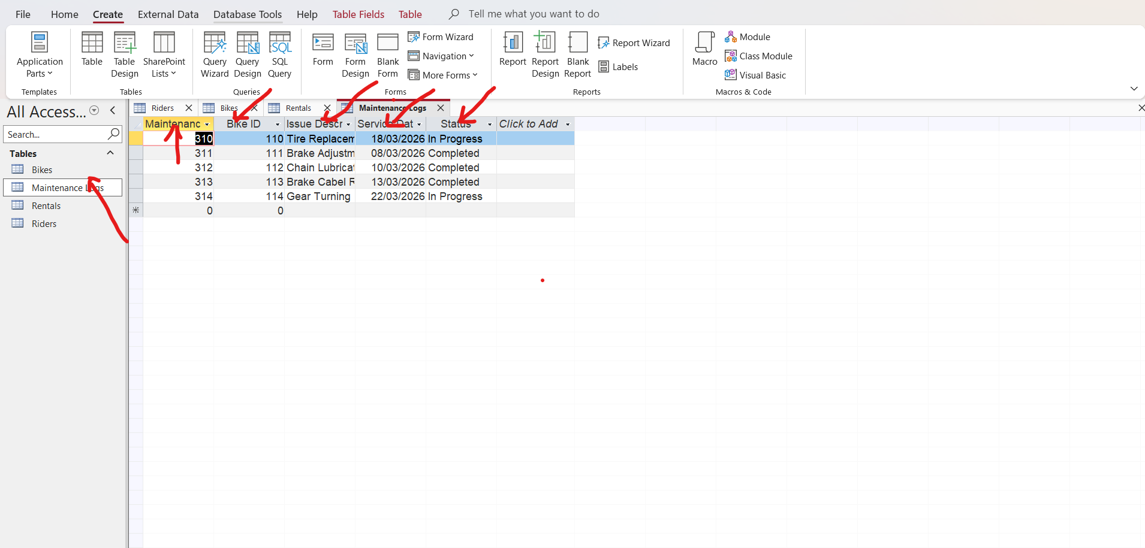

6 Query Development, Query development is the process of designing, writing, and refining Structured Query Language (SQL) code to extract, manipulate, or analyse data from databases. It involves defining specific criteria to retrieve, update, or summarize information, enabling developers and analysts to turn raw data into actionable insights. [6]
1; Available bikes for new rentals; lists of bikes ready to be rented
Go to create and select SQL and a new and blank table is going to appear with the name Query 1 as below
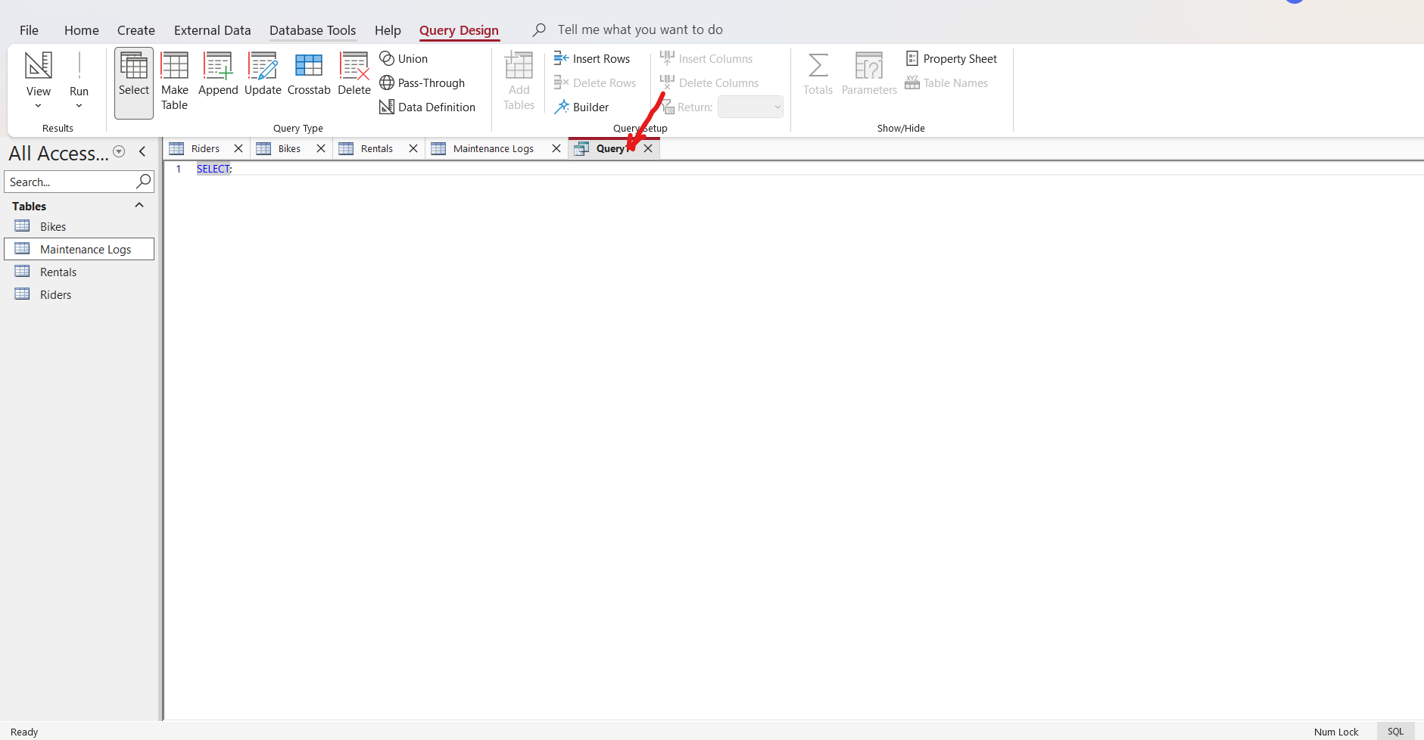
Go to select and enter the query command you want to carry out
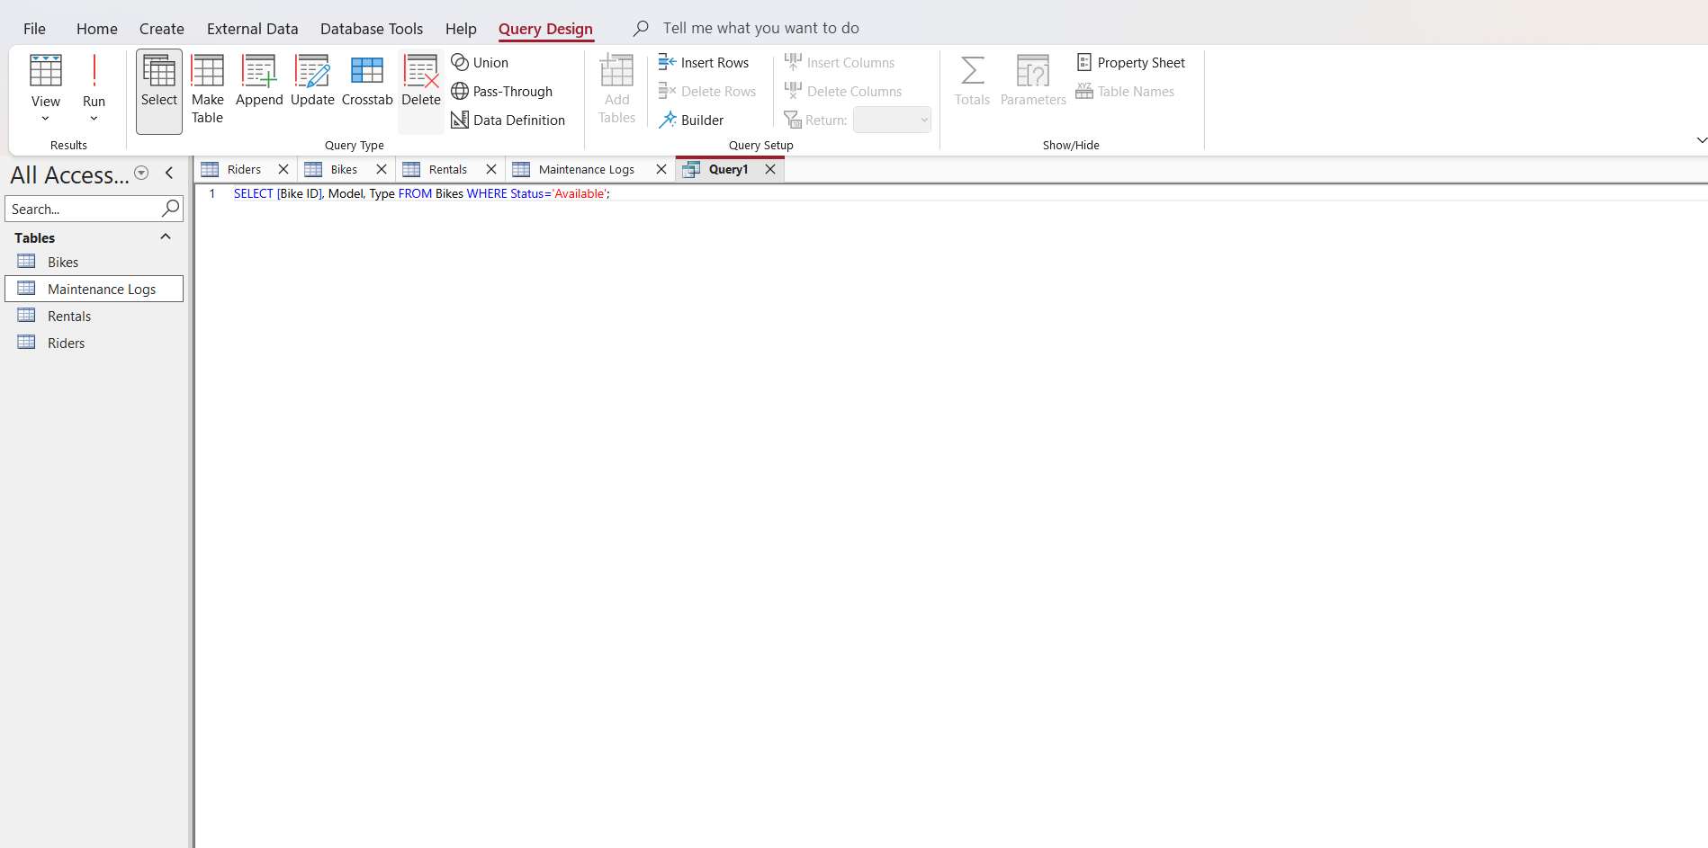
Then go to the top left and run it
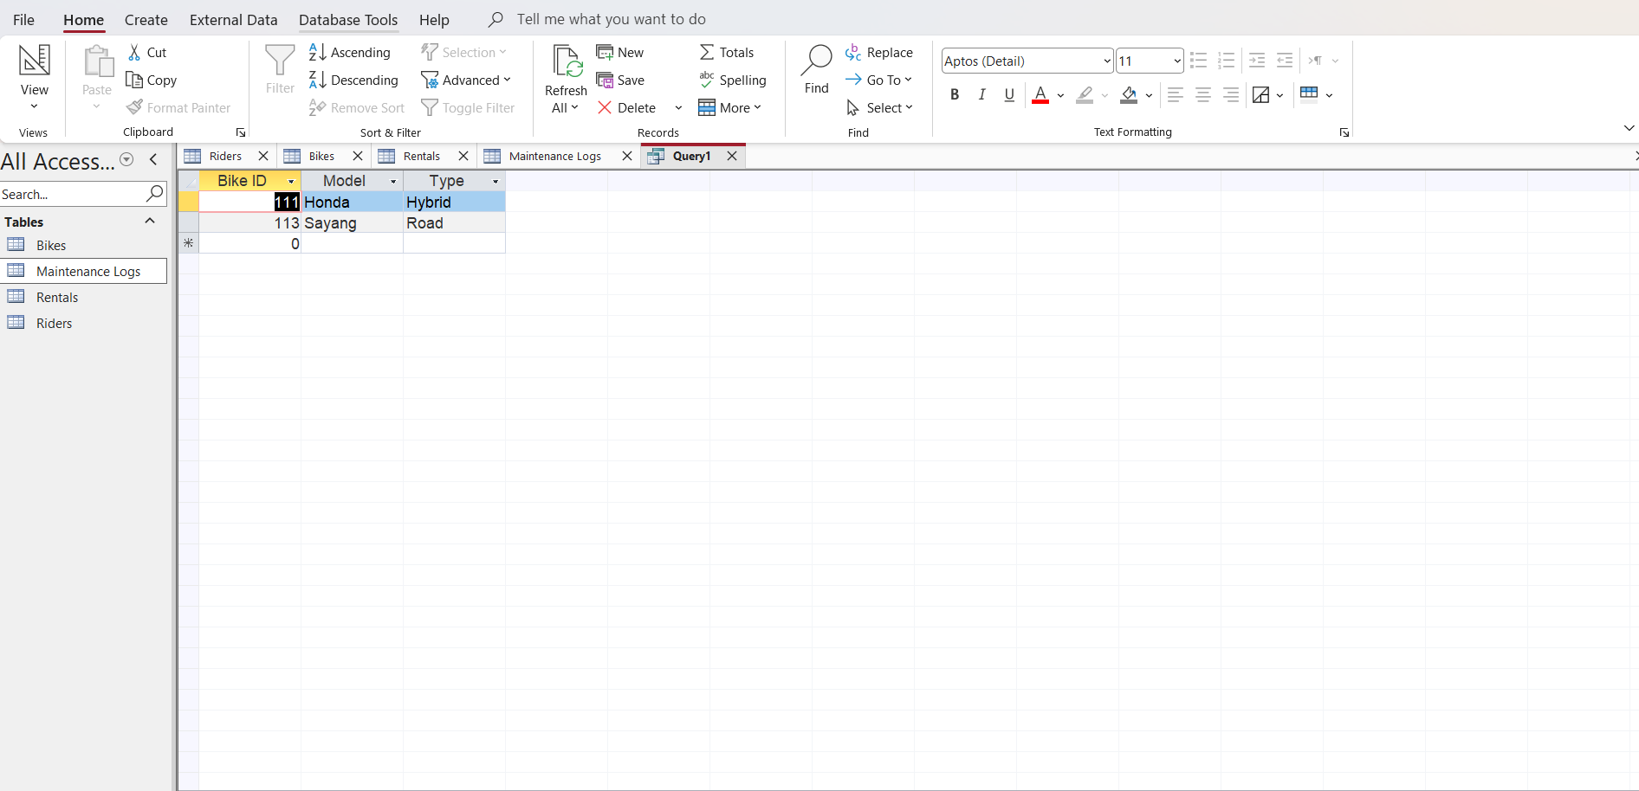
2 Bikes currently under maintenance, Go to create and select SQL and a new blank data table is going to open by name Query 2 as below

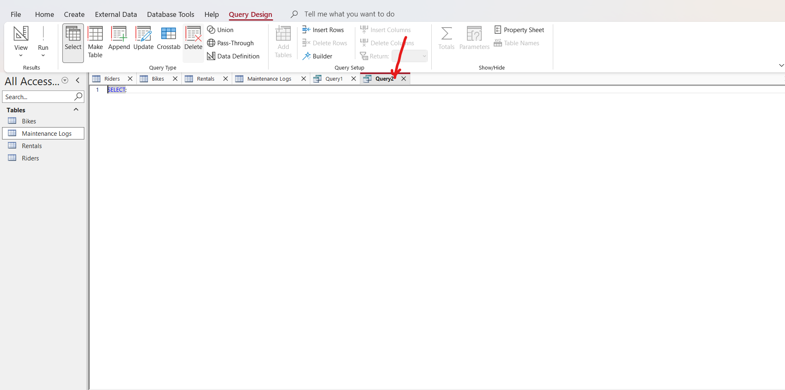
Put the command you want to run as below
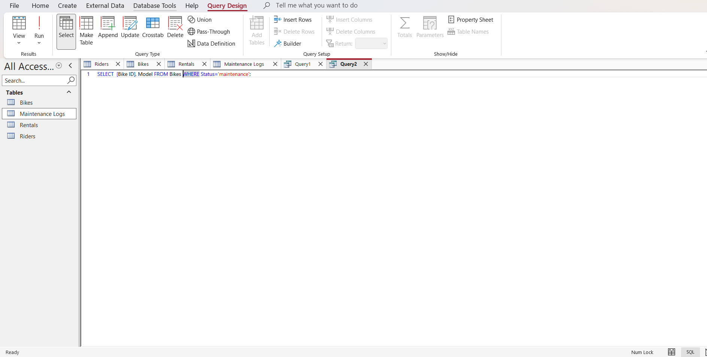
After putting the command go to the top left and run it
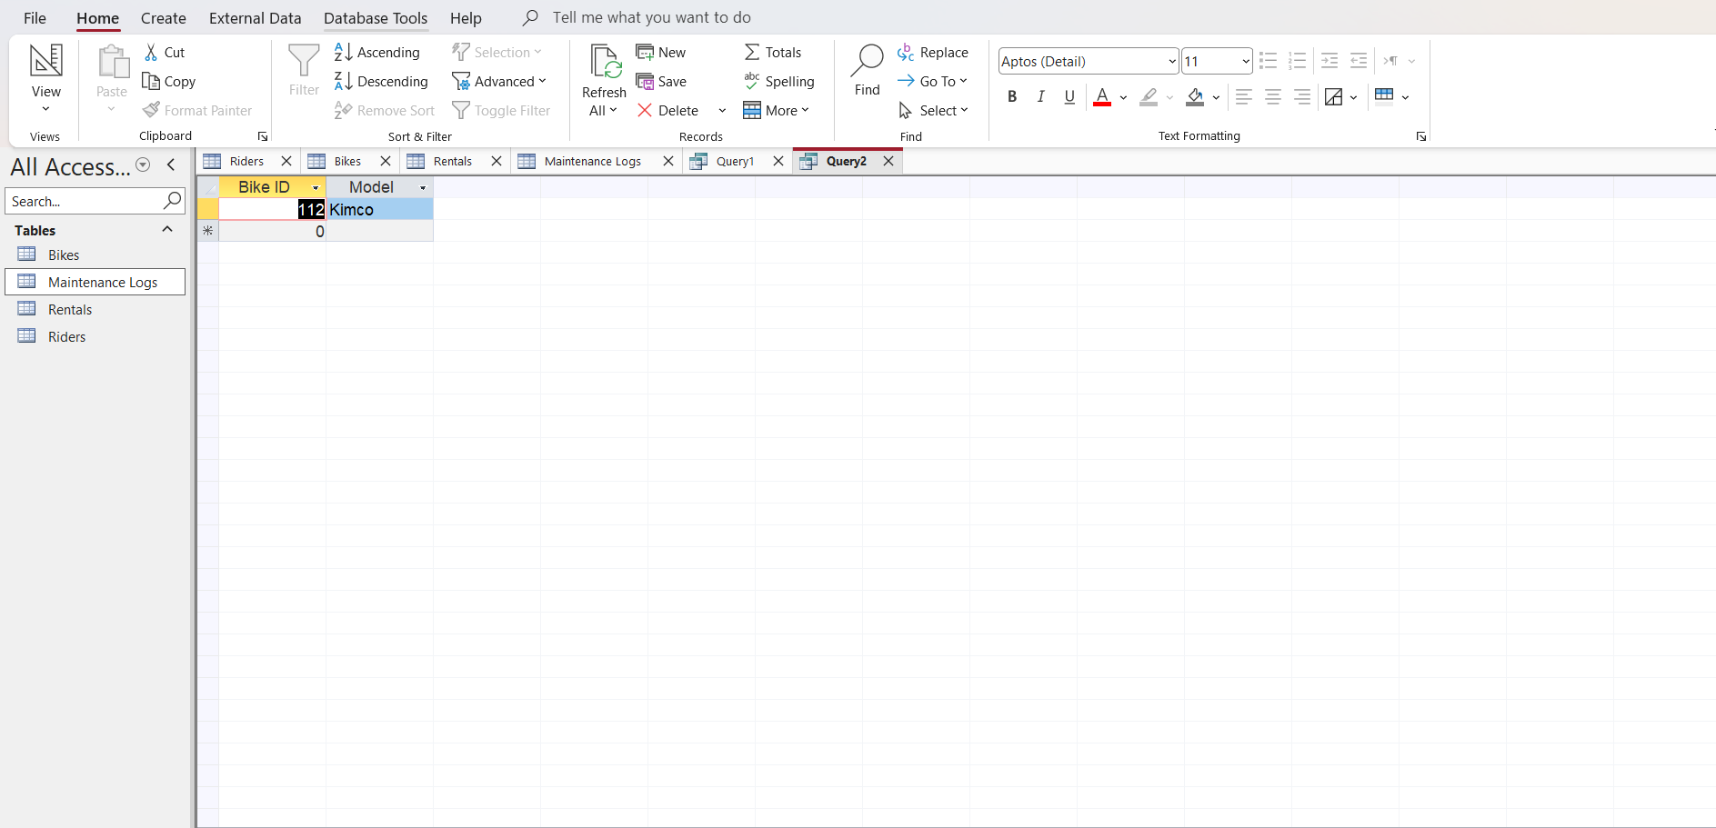
3 Rentals Within a Date Range go to create and take SQL and a blank data table is going to be created by name Query 3
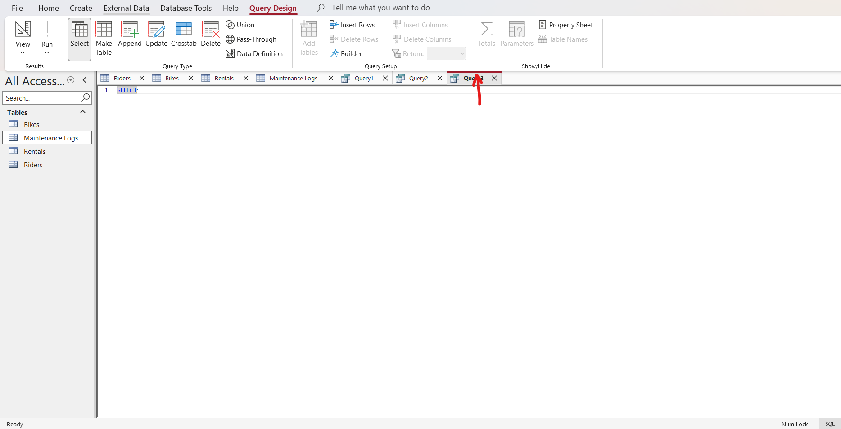
Put in the command you want the query to run
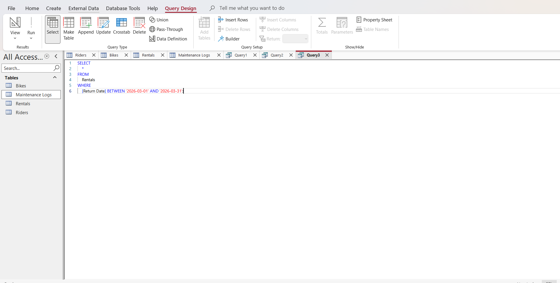
Select all from Riders table
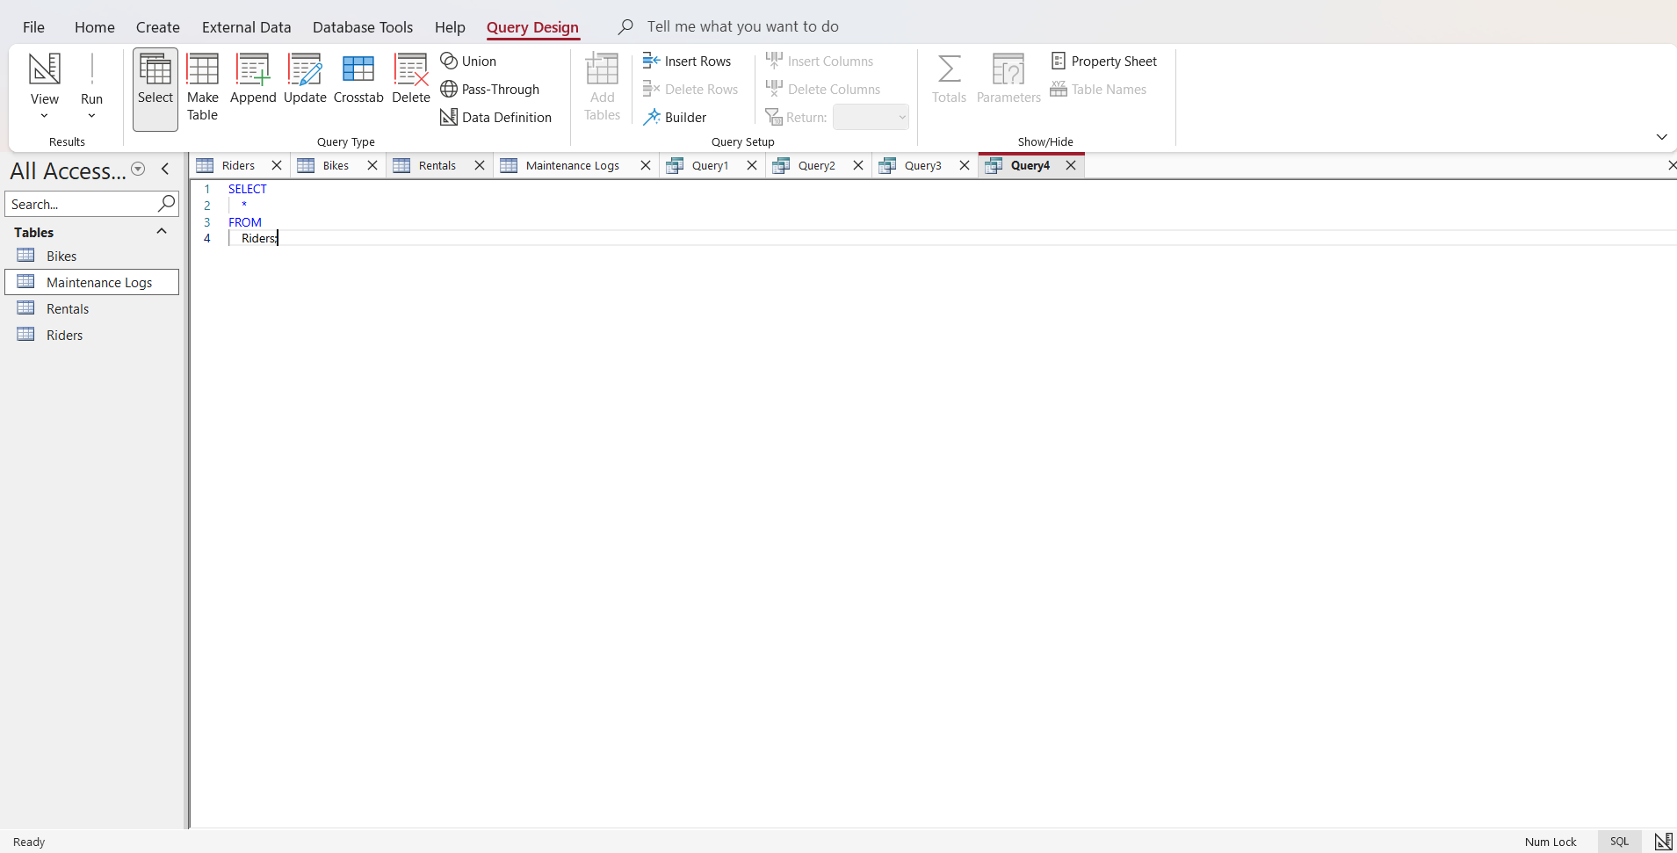
Run the command
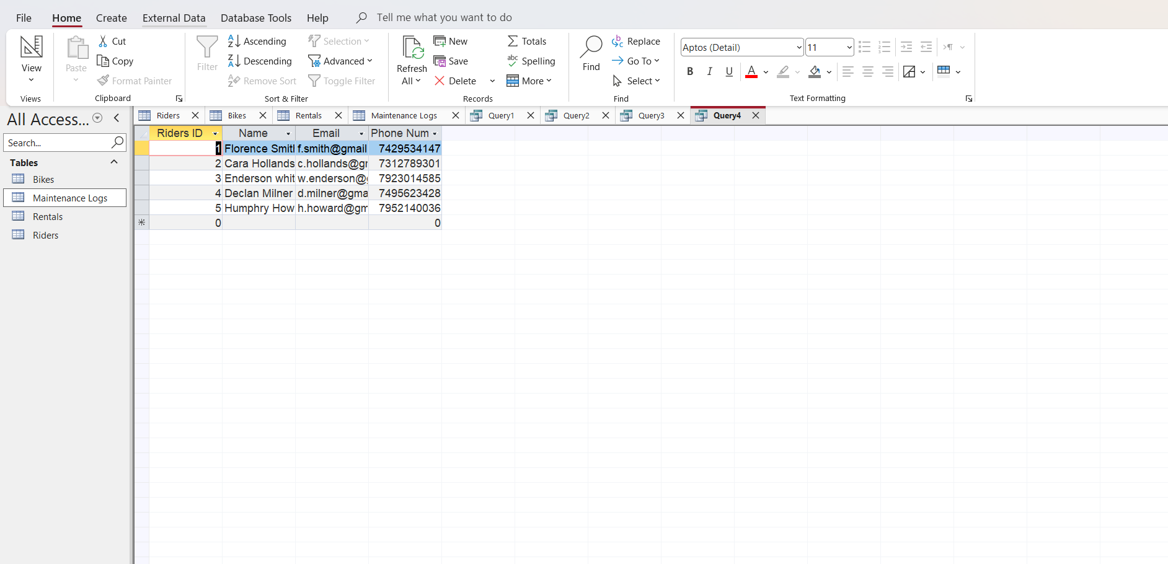

Forms and Reports (MediLink Pharmacy Database)
Forms: Forms in Microsoft Access will be used to provide a user-friendly interface for entering, updating, and viewing data in the system. They help reduce errors and make the system easy for pharmacy staff to use.
Key Forms to Design
1. Medicine Entry Form
Used to add and update medicine records
Includes fields like Medicine Name, Category, Price, Stock Quantity, Expiry Date
Supplier selected via a dropdown list
2. Supplier Form
Stores supplier details
Allows adding, editing, and viewing supplier information
3. Customer Registration Form
Captures customer details such as name, phone number, and address
Ensures accurate record-keeping
4. Prescription Form
Records prescriptions issued to customers
Includes:
Customer selection
Doctor name
Date issued
Uses a sub-form to add multiple medicines per prescription
5. Sales Transaction Form
Used at the point of sale
Includes:
Customer selection
Date of sale
Subform for adding multiple medicines purchased
Automatically calculates total cost
Benefits of Forms
Easy and quick data entry
Reduces typing errors through dropdowns and validation
Improves efficiency for pharmacy staff
Provides a clean and structured interface.
Reports:
Reports in Microsoft Access will be used to present data in a structured, readable format for decision-making and record-keeping.
Key Reports to Generate
1. Stock Report
Shows current inventory levels of all medicines
Helps monitor stock availability
2. Low Stock Report
Displays medicines below a certain stock level
Helps in timely reordering
3. Sales Report
Summarizes daily, weekly, or monthly sales
Includes total revenue and number of transactions
4. Expiry Report
Lists medicines nearing expiry
Helps prevent losses and ensures safety
5. Prescription Report
Shows customer prescription history
Useful for regulatory compliance and audits
6. Supplier Report
Displays supplier details and supplied medicines
Benefits of Reports
Provides clear insights for management
Supports decision-making (stock control, sales trends)
Helps meet legal and regulatory requirements. Easy to print and share.
7 Validation And Testing; It is the final, dynamic process of confirming that a developed product, system, or software fulfils user needs and actual operational requirements. It determines if the "right thing" was built by testing the functional system—often via user acceptance (UAT), alpha/beta, or functional testing—to ensure it meets business goals. [7]
-Purpose; The purpose of validation and testing is to make sure that the bike rental database system meets all functional requirements and works correctly. Testing verifies that data is stored, retrieved, and managed accurately while maintaining integrity.
-Testing Methodology; The system was tested using,
SQL queries to validate data operations
Test cases based on functional requirements
Expected vs actual results comparison
Each feature of the system (riders, bikes, rentals, and maintenance logs) was tested individually and in relation to other tables.
Reflection:

Reflection (MediLink Pharmacy Database Project)
The building up of the MediLink Pharmacy database using Microsoft Access has been a very important experience that enhanced my knowledge of database design, implementation, and management. Within this project, I was able to apply theoretical knowledge to a real-world scenario, which helped me appreciate the importance of well-structured data systems in improving business operations.
The essential strength of my work was the design of a relational database structure. By forming separate tables for medicines, suppliers, customers, prescriptions, and sales, and merging them using relationships, I ensured data consistency and minimized redundancy. Bringing in referential integrity further improved the reliability of the system.
One important achievement was the development of user-friendly forms. These forms made it easier to enter and manage data efficiently, reducing the likelihood of human error. Additionally, I made various reports, such as stock reports and sales summaries, which provide useful insights for decision-making and help the pharmacy maintain proper records.
However, i went through some difficult moments also during the project. Designing relationships, especially handling many-to-many relationships (e.g., prescriptions and medicines), required careful planning. I also faced difficulties in setting appropriate validation rules to ensure data accuracy without making the system too restrictive.
In terms of growing up my knowledge, I would enhance the system by adding more advanced features such as automated alerts for low stock and expiring medicines, a user login system for better security, and possibly integrating barcode scanning for faster sales processing. If i had enough time available, I would also test the system with a larger dataset to see how it works.
Moreover, this project has improved my skills in database design, problem-solving, and critical thinking. It has also shown me how database systems can significantly improve efficiency, accuracy, and service delivery in a business like MediLink Pharmacy.
Conclusion: In this my work I have made the introduction and the MediLink Pharmacy, done the scenario analysis, draw an Entity Relationship Diagram(ERD), made a Data Structure Development, looked at Normalisation Compliance, made Sample Data Population, run some Structured Query Language (SQL) or done Query Development, made my Validation and Testing of my work and finally made the References of my work. So with all these I can deduced that the database of MediLink Pharmacy was a success.

References :
[1] | P. Schoemaker, “Scenario Planning: A tool for strategic thinking,” 1995.
[2] | P. Chen, “The Entity-Relationship Model,” 1976.
[3] | C. e. a. Thomas H, Introduction to Algorithms, Cambridge: MIT Press, 2009.
[4] | E. F. Codd, “A Relational Model of Data,” 1970.
[5] | A. Bryman, Social Research Methods, Oxford: Oxford University Press, 2016.
[6] | Oracle, SQL Language Reference.
[7] | I. Organisation, ISO/IEC25010, Geneva: ISO, 2011.

