Student Name: Delwar Hussain
Student ID: 1813780
Module: Developing Workplace critical Thinking.
Module Code: BMSW5101
Lecturers Name: Dr Obinna Nkwocha
Assignment Title: How individuals’ beliefs attitudes and values impact on workplace behaviour.



Contents
Introduction 3
What is the (Equity Theory of Motivation) 4
Who developed the theory? 4
Views and critics of this theory 6
Critically discuss how useful is this theory in a workplace 7
Comparison of other motivational theories to Equity of motivation 9
Maslow’s hierarchy of needs 9
Herzberg’s Hygiene factors 10
Referencing 12

Part B task 1

Introduction
The module developing workplace critical thinking, I will be writing a report on the appointed topic to me (Equity theory of motivation). This report will give a brief description of who developed the theory how it acme about how it is used in the workplace it will also explain advantages and disadvantages of this theory in the work place. This report will be split into 2 sections first section is where I will be critically evaluating the management theory (Equity theory of motivation) and the usefulness of this theory in the modern day workplace. The second section is reflective writing on how this module has affected and developed the way of my thinking skills.

What is the (Equity Theory of Motivation)
The definition of the Equity theory of Motivation "is a process that represents a person's willingness, determination, and the extent an individual will go to accomplishing an objective". Equity theory defines if an individual is going to work hard or not is dependent upon the rewards and likely outcomes. Robbins and Judge (2007, p. 186)
The equity theory of motivation describes the human behaviour in a relationship between the employee’s perceptions of how fairly is he being treated and how hard he is motivated to work. There are five categories that and employee can fall into which will describe how committed and motivated they are towards their job.
The figure below shows the three situations of the equity theory.
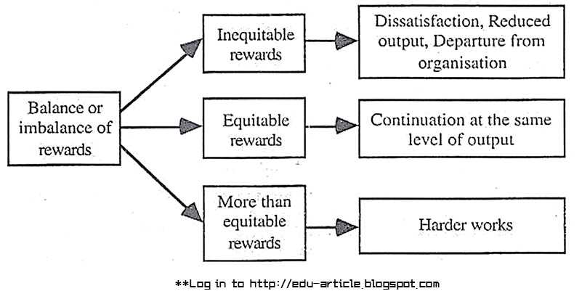
Figure 1
Source: edu- articles

Who developed the theory?
The Equity theory was developed by a behavioural psychologist called John Stacey Adams in 1963, around the same time of other theorist like Maslow’s hierarchy of needs and Herzberg’s two-factor theory. Adams theory was developed around the individual’s assessment and perception of the relationship between their work and their employer.
The Theory was developed on the beliefs of the employees how and why they become motivated or de-motivated with their job and their employers. If the employees feel like their input (levels of one’s work) is far greater than the output (rewards) they receive, it will de-motivate them and cause them to reduce effort levels, and they might become disgruntled or even descriptive causing tension or lower levels of efficiency for the employer.
Inputs: Inputs are all the skill, education, experience, effort, loyalty, commitment, employees believe they bring or contribute to the job, they believe they should be rewarded accordingly.

Outcomes: The outcomes that are expected by the employees from their employer are rewards they get from doing their jobs it includes things like- direct pay and bonuses, fringe benefit, job security, social rewards and psychological..
Equity: Employees will stay motivated to continue to contribute act about the same level if they perceive equity.
The theory expresses that "a person who sees that she or he is being dealt with unreasonably compared to others will be propelled to act in manners that decrease the perceived perception inequity”(Campling,Poole,Wiesner,Schermerhorn,2006,p. 394).

To use Adams Equity theory it is important to consider the factors that will help the employees strive to improve their job satisfaction, motivation levels. To do this Employers must find ways to the balance and imbalances employees have currently in the inputs and Outputs.
Inputs includes like:
- The effort that is given by the employee
- The skill and ability that the employee has
- How adaptable and flexible they are
- Team work and Acceptance of others
- How much Determination and enthusiasm they show
- Personal sacrifice the will make to move forward.
Outputs include things like:
- What kind of financial rewards will be given (such as salary, benefits, perks).
- Intangibles, things like: job security, recognition, responsibility, Praise, sense of achievement and advancement.
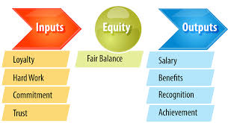
Figure 2
Source: management books
As many of the points can’t be compared, Adams equity theory argues that the employer should find a fair balance between the employees input and give in return a fair output and employees should be content with the outputs if they perceive it to be in Balance and fair.

Views and critics of this theory
There are many problems with the equity theory of motivation. I will write about the 3 main problems.
The first concern is that its one-dimensional theory and justice is primarily decided on a merit principle rather than multidimensional.
The second problem is that various workers view inputs and outputs as personal values. For example, two workers with similar experience and qualifications doing the same job for the same pay can have very different views of the fairness of the deal, meaning two people's thoughts are not exactly the same.
The third problem is that equity theory appears to exaggerate in social partnerships the value of justice. Among those who affect social understanding and actions, concern for justice is only one motivating force, and it can sometimes be a weaker force than others. Any of these issues with equity theory are shared by other approaches to the study of justice in social exchange.

Critically discuss how useful is this theory in a workplace
An example is when an employee with several years of experience with and organisation may be disappointed to find out that a new person a graduate hired is higher than his or her current earnings at a salary level, causing levels of motivation to fall.
Reasons why?
Employees allow parallels relative to those of others between their work inputs and performance. A state of equity is said to exist if we consider our ratio to be equal to that of the related others we equate ourselves with. Our condition we consider as equal. We feel equity stress when we see the ratio as unequal.
Four comparisons are available that an employee may use:
- Self-inside: The perspective of an employee inside his or her current company in a different role.
- Self-outside: The interactions of an employee outside his or her present organisation in a circumstance or role.
- Other-inside: Another person or group of people within the company of the employee.
- Other-outside: Another person or group of people outside the company of the employee.
- The knowledge the employee holds about referents, as well as the attractiveness of the referent, will influence the referent an employee selects. There are four variables: gender, tenure period, position in the organisational, and the amount of education or experience. Same-sex comparisons are preferred by men and women. This also indicates that it could be due to the comparative norm they use if females are tolerant of lower pay. Employees in non-sex-segregate jobs will make more comparisons than employees that are in a job that is either dominated by male or female.
- Employees with a short term contracts tend to have no data on those in their current organisations.
- For example employees with a long term contracts rely more heavily on colleagues.
- Employees at the upper level appear to be more cosmopolitan and have stronger data on people in other organisations. Their decisions are made on outside comparisons.

5. If workers have reasons to believe that they perceive an inequity, they may be expected to make one of six decisions:
- Change their inputs.
- Change their outcomes
- Distort self-perceptions.
- Distort others' views.
- Select a different referent
- Leave the job.
Not all employees are equity-sensitive.
Employees also tend to pursue equity in the allocation of other corporate benefits. Recent research has been aimed at expanding what equity or justice entails.
Equity theory has traditionally concentrated on distributive justice or the perceived fairness of the sum and distribution of incentives among individuals.
It should be considered as procedural justice, the supposed fairness of the process used to determine the distribution of rewards.
Distributive justice has a greater impact than procedural justice on employee satisfaction,
Employees are likely to regard their employers and the company as optimistic by raising the sense of procedural fairness, even though they are unhappy with salaries, promotions, and other personal performance.
Equity theory shows that motivation is greatly affected by relative incentives as well as absolute rewards for most workers, but some key issues are still unclear.
Equity is known as fairness to one’s eyes for example if 2 employees are doing the same job and they both put in the same effort levels but one of the employee get paid more than the other. The one getting less money will deem it to be fair if he puts in less effort.

5 critically discuss how useful is this theory in a workplace
6 give practical examples of how it is being used in the workplace and pros and cons

Comparison of other motivational theories to Equity of motivation
The following information that I will be providing is from another assignment that I have done for motivational theories in the (Developing relationships and workplace achievements) Module.
Other theories or motivation are:

Maslow’s hierarchy of needs
What does Maslow’s hierarch of needs mean?
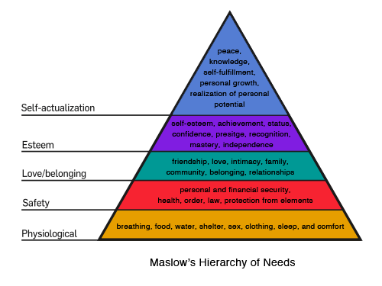
Figure 3 Maslow’s Hierarchy of needs
Source: (McLeod 2018)

The theory of Maslow is all about the individual's needs and desires in the workplace. The theory is composed of five layers of the human needs model. Before the person can step up, the need must be met at the lower levels. (McLeod 2018)

Biological and physiological needs
As seen in the diagram above, these are the basic needs that everybody needs to survive.
Safety needs
These are the criteria that offer you a sense of security, protection from components, security, order, law, peace, freedom from fear.

Belongingness and Love needs
The third level of human needs is psychological and includes feelings of belonging to a workplace or community or culture. The third level of human needs is social. The need for interpersonal connections motivates behaviour
Esteem needs
Esteem can come in the form of accomplishment, rank, reputation, recognition, mastery, freedom and obligation.
Self-actualisation needs
They will come from the realization of personal potential, personal growth and peak experiences of peace, knowledge, self-fulfilment, and lead to being more than we are.
This idea is all about a person's needs and desires. It determines what a person needs to live, what they need to have as fundamentals before they begin to explore their needs for esteem and self-actualization where they begin to search for future growth and development within the organization.

Herzberg’s Hygiene factors

The motivational principle of Herzberg hygiene is divided into two variables. He worked closely with the philosophy of Maslow and argued that there were some directives that could be enforced by an organisation that would explicitly inspire workers to work harder and more effectively (Motivational factor). There were however, variables that would de-motivate workers if they did not have access to them. Employers would have to inspire the workers themselves to work harder. (Factors of Hygiene) (Tutor2u 2020).

Figure 2: Herzberg’s motivation Theory
Motivational factors
Motivational variables are factors such as how exciting the work is and how much potential it offers for increased transparency, appreciation and promotion. There are variables that are related to the work itself.

Hygiene factors

Hygiene factors are things that 'surround the job' instead of the job itself. For example a reasonable level of pay and safe working conditions however these factors will not make him work hard they will be just doing it for the sake of pay. (Hussain 2020)

In this theory there are 2 motivational factors one is all external to the employee these are that surround the job like safe working environment, levels of pay and the other is recognition promotion extra responsibilities which are linked directly to the job. According to Herzberg the employee falls into one of those factors and gets motivated accordingly.

Recommendation
Key findings are employees look for fairness in their workplace and seek the equity that justifies their effort.
You can identify equity theory in the workplace easily by just listening to the phrases used workers when they talk about other colleagues receiving more money or other financial gains when doing the same job as them like:
“So and so gets paid more than me but does less work”
“This place will fall apart if it wasn’t because of me”
“How is it fair that the new guy get 200 pounds more than me?”
As you can see in each of the above examples someone is comparing their own compensation and effort against someone else. As a manager it is important to remember some key points that people measure the total inputs against the total outputs, for example single parents might prefer flexible working hours in return for lower pay as it might suit their needs more. However it’s not the same in all cases it all depends on how the manager understands the situation and make it relatively fair. So long as the employee perceives that their treatment is fair the commitment and the motivation will be present.

Part B Task 2

Introduction
This section of the report I will be doing reflective writing on what I have learnt from this module, if critical thinking has changed my way of thinking and how will I be using the knowledge that I have gained from this module.
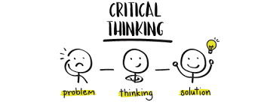

What is critical thinking?

This module has taught me that critical thinking is all about asking questions. The right questions that help you understand the meaning of claims and arguments. Learning the critical thinking skills such as listening, understanding, communicating makes it easier for you to assess evidence, evaluate arguments and adapt your thinking so you can engage in different situations.

Critical thinking sometimes involves you to step back from a situation so you can look at it from all angles, which in turn will give you a wider picture before making judgement or making decisions. You would need to identify the key points, analysing the sources of information and looking at different types the evidence before coming to a conclusion.
Critical thinking isn’t actually about being critical of something and finding flows in something. To become a true critical thinker you need to be creative, reflective and adaptable so you can evaluate any evidence to decide what is relevant, accurate and if you have the correct amount of information to make a decision for by yourself on the topic. (Macat 2020)
How I intend to use critical thinking that I gained from this module in the future is by not just making decisions straight away, I will think about things before making any decisions on anything. My critical think skill that I have learnt has opened my eyes to the way of thinking and question things that may look right to me. I have even started looking at labels of products now when it comes to comparing products before purchasing. When it comes to arguments I have started to listen to both sides of the story and now also started to ask for evidence to collaborate the stories to work out the solution.
I have also started to think why business put things on offer and weather purchasing the item be worthwhile or a waste of money. I have started asking question such as is this item going to be discontinued, or when is the next update to his item coming out. I think now I have started question everything.

Referencing
- Robbins,S. P. and Judge,T. A. ,(2007). Organizational Behaviour. (12th ed.)
- Campling,Poole,Wiesner,Schermerhorn,2006,p. 394).,Human Behavior
- .Okpara, J.O. (2006). Gender and the relationship between perceived fairness in pay, promotion, and job pay, promotion, and job satisfaction in a sub '' Saharan African economy. Woman in Management Review
- Campling,J.,Poole,D.,Wiesner,R. and Schermerhorn,J.R., (2006). Management. (2nd ed).
- What is equity theory? https://www.mindtools.com/pages/article/newLD
- https://www.yourcoach.be/en/employee-motivation-theories/stacey-adams-equity-theory.php
- Maslows theory (2018) https://canadacollege.edu/dreamers/docs/Maslows-Hierarchy-of-Needs.pdf
- McLeod, S., 2007. Maslow's hierarchy of needs. Simply psychology, 1, pp.1-8.
- Huitt, W., 2007. Maslow's hierarchy of needs. Educational psychology interactive, 23.
- Critical thinking, 2020 https://www.macat.com/critical-thinking
- What is critical think. https://www.criticalthinking.org/pages/defining-critical-thinking
- Huseman, R.C. and Hatfield, J.D., 1990. Equity theory and the managerial matrix. Training & Development Journal, 44(4), pp.98-103.
- Definition of equity theory, https://www.yourcoach.be/en/employee-motivation-theories/stacey-adams-equity-theory.php

