Abstract
Module: Electrical Machines
Lecturer: Steve Mosey
Stator Modelling Part 1
NAME: Nathan Davies
Student NUMBER: 1706135
Within this report is documentation of models created within FEMM which a Finite element method program is as well as the results attained by conducting various calculation on the created model. Using the specific tools found within the FEMM program results for the total flux was found with is being around 0.000255409 Weber’s, as well as the flux found within the rotor at various angles and the total flux leakage with in the model. One of the main conclusions is that this exercise has taught valuable skills in the creation and solving of flux equations using a FEM program
Introduction
Motors
As is so often the case with invention, the credit for development of the electric motor belongs to more than one individual [1]. It was with the discovery of electromagnetism in the year 1820 by Hans Oersted's with the additional research by William Sturgeon, Joseph Henry, Andre Marie Ampere, Michael Faraday, Thomas Davenport and a few others [1].
Using a broad definition of what a motor is by saying that it is an apparatus in which it converts electrical energy into a form of motion [1]. Most sources found will cite that Faraday is the one who created the first electrical motor in 1821, these devices where useful as being demonstration tools of the method but that is all [1].
As well as the normal dc motor there are a few different types of electric motors, some of these being induction motors and synchronous motors. An induction motor uses shorted wire loops on a rotating armature and obtain their torque currents induced in these loops by the changing magnetic fields produced in the stator coils [2]. This induction motor must attain a rotating magnetic field to continuously produce torque on the armature coils [2]. A synchronous electric motor operates by switching states, the rotation of the shaft is synchronised with the frequency of the supply current [3]. Synchronous motors contain multiphase ac electromagnets on the stator which create magnetic fields which rotate with the oscillating line current [3].
Magnetics in electric motors
Electric motors work on the principle of using magnets and magnetism to create motion within the motor [4]. The fundamental law of how magnets work is that opposite polls attract and like polls repel, within an electric motor this is the basic principle of how motion Is created by attraction and repulsion of magnets connected onto the stator and rotor [4]. But instead of normal magnets electric magnets are used so there can be controlled easily. Because the rotor is always spinning this influences the magnetic field turning it into a rotating magnetic field, this introduces a new problem in the form of back emf, this acts against the voltage applied to the motor and reduces the current flowing through the coils of the motor [4].
FEM / FEA
Finite element method or finite element analysis is a computer-based process used for modelling complex products and systems [6]. These simulations take place within a virtual environment for solving complex performance issues [5]. FEM works by breaking down large structures into smaller section, were each section will represent a material property [5].

The problem
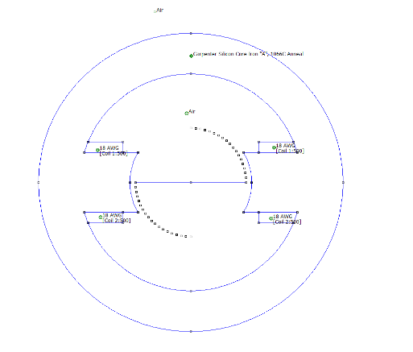
The specific problem faced within this assignment is to create a model of an electric motor within a program called FEMM (Finite Element Magnetics Method). Once this model is created, various results are to be recorded to figure out how effective the motor is in Flux leakage across the stator, Flux cutting across the rotor at various angles to simulate the rotor spinning and to calculate the results for flux leakage with in the model.
Method
The way this assignment was tackled, was to first create a motor model inside of a program called FEMM (Finite Element Method Magnetics). This model can be seen on the right in figure 1. This was created with specific dimensions that were given. These measurements include an outside stator diameter of 100mm, an inside stator diameter of 80mm, a pole face radius and width of 22mm and 20mm respectively. The coils found on ether side of the poles had a vertical size of 15mm and a horizontal size of 24.5mm. These coils also were wound 500 times and had a coil current of 1A.
Figure 1 DC stator circuit
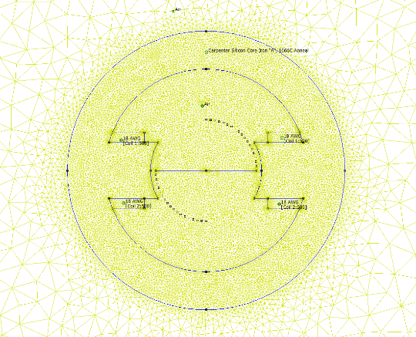
For this assignment a few results were needed to be recorded. These results include an estimate total flux being created in the stator, flux leakage factor for the design and an estimate of flux cutting the rotor coil at different angles.
To find out these results a mesh was needed first so the flux density within the model could be calculated by the application the mesh created can be seen in figure 2 on the right. Within the stator block, coil and the gap in the middle materials are defined, these materials determine how the meshes interact with each other.
Figure 2 Mesh created for the design
To find out the estimated total flux the contour tool was used to cover the gap over the stator this Is used to show the field properties for the specific area that the line covers, an example of this can be seen bellow in figure 3. To find the flux cutting through the rotor a similar method to finding the estimated flux in the stator was used. One difference was that the individual points for measuring had to be calculated then added onto the model. Once the mesh was recreated and the flux density was calculated then the contour tool could be used again to connect each point one at a time to find out the flux. Some examples of this can be found bellow in figure 4 and figure 5.
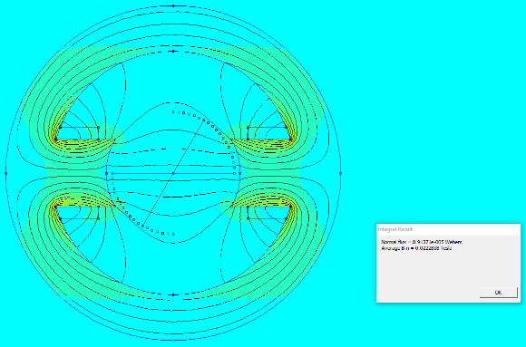
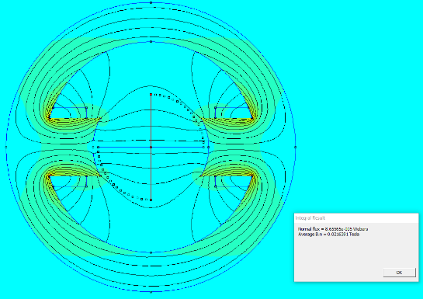
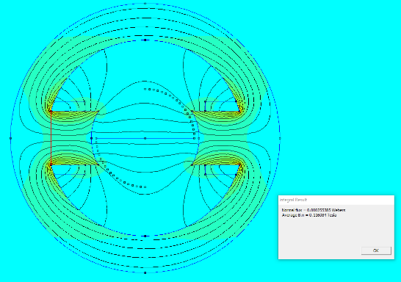

Figure 3 Flux across the stator
Figure 4 Flux within the rotor
Figure 5 Flux within the rotor

The final results that need to be found is the flux leakage within the model. To calculate these results the equation $\frac{Useful Flux}{Total Flux}$. Where the useful flux is the flux within the rotor at different angles and the total flux is the flux created by the stator.
Results
Total flux
Found in table 1 bellow is the result recorded for the flux created by the stator, this table also shows the value for the average magnetic induction passing through the stator.
Flux being created in the stator circuit

flux across gap (Weber) | Average B.n (Tesla)
0.000255409 | 0.116095

Flux vs angle
Found in the table 2 found below is the results for the flux cutting through the rotor at different angles, this table also shows the average magnetic induction at each angle created by the rotor.
Flux (Weber) | Average B.n (Tesla)
8.66E-05 | 0.0216443
8.67E-05 | 0.0216696
8.69E-05 | 0.0217329
8.74E-05 | 0.0218391
8.79E-05 | 0.0219827
8.85E-05 | 0.0221368
8.92E-05 | 0.0222906
8.96E-05 | 0.0224082
8.98E-05 | 0.0224347
8.91E-05 | 0.0222684
8.70E-05 | 0.0217504
8.22E-05 | 0.0205389
7.18E-05 | 0.0179509
5.72E-05 | 0.0143099
4.35E-05 | 0.0108854
3.15E-05 | 0.00786996
2.05E-05 | 0.00512065
1.01E-05 | 0.00252197
-1.53E-08 | -3.82E-06

Flux leakage factor
Found in the table3 bellow is the results for the flux leakage calculated within this specific model, specifics on how these results where calculated can be found in the next section.
Flux leakage (Weber)
2.950E+00
2.947E+00
2.938E+00
2.924E+00
2.905E+00
2.884E+00
2.864E+00
2.850E+00
2.845E+00
2.867E+00
2.936E+00
3.109E+00
3.557E+00
4.462E+00
5.866E+00
8.113E+00
1.247E+01
2.532E+01
-1.670E+04

Discussion
Within this section will be a discussion on the trends found within each table of results recorded and specifics on any anomalies found within any of the tables. For the sake of making the results easier to explain the tables for Flux vs angle and flux leakage have been made into tables.
Figure 6 found on the left is the graph produced by the flux vs angle table, as can be seen within the graph the flux stays level until around half way through the graph were the flux begins to decrease at a constant rate. There appears to be no visible anomalies found within this graph
Figure 6 Flux vs Angle graph
Figure 7 found on the right represents the graph produced by the flux leakage table. These results first needed to be calculated by using the equation $\frac{Useful Flux}{Total Flux}$, where the useful flux equals the results found in the flux vs angle graph and the total flux is equal to the total flux running through the stator.
As can be seen in figure 7 the flux leakage within the motor is around 0, Until the last result where it plummets down to the negatives. Looking at this graph the results appear to be normal with no visible anomalies showing.
Figure 7 Flux leakage graph

Conclusion
During this assignment a set of specific skills were learned to aid in the creation and solving of FEM models on the program FEMM. As seen throughout the report the set task where completed with clear results being obtained. This assignment as been very useful for gaining new skills into FEM modelling and calculating flux leakage within an electric motor.
References

References

[1] | "The Development of the Electric Motor," Sparkmuseum, [Online]. Available: http://www.sparkmuseum.com/MOTORS.HTM.
[2] | R. Nave, "Induction Motors," HyoerPhysics, [Online]. Available: http://hyperphysics.phy-astr.gsu.edu/hbase/magnetic/indmot.html.
[3] | Wikipedia, "Synchronous motors," Wikipedia, [Online]. Available: https://en.wikipedia.org/wiki/Synchronous_motor.
[4] | M. Brian, "How electric motors work," HowStuffWorks, [Online]. Available: https://electronics.howstuffworks.com/motor7.htm.
[5] | A. L. Andrew Duffy, "Back emf in elctric motors," BU Physics, [Online]. Available: http://physics.bu.edu/~duffy/sc545_notes04/back_emf.html.

