
Applied Industrial Placement (SPORT)
M5X02295
Placement Portfolio Template

TASK A – (Reflective Learning Log 1 - 500 words – First Experience of Placement)
Recommend to link the reflective experience to two different key themes.
Camp America -My first experience of placement has been exciting and overwhelming and have learnt a lot about myself and how to deal with different situations when coaching and looking after different age groups and genders. When I arrived at camp we were greeted by the returning members of staff and were given bunks where we were staying, the first week of camp was staff education week, this is where I learnt all the important information about the safety of the camp and the rules to what are aloud in camp and which are not. ‘Most importantly we learnt how to look after the children before they arrived and how to deal with different situations around camp. The first week of camp was an introduction of what to expect for the weeks to come. I learnt how to be completely independent, become more confident and meet new cultures from all over the world. this gave me an insight to what other people couch like and how different people learn and teach in different ways. Having this first week experience allowed me to be myself and teach the way I do at home as well as learning different techniques and games in my area.

Having my placement in another country and not knowing anyone at first was a shock and was nervous what to expect and how the job would become not knowing anyone, this new experience was an exciting due to meeting new people and learning how to adapt myself to different cultures and how people deal with different situations, for example. during the first couple of days I met a few girls which I became close with, however everyone gets a different group so I had to make new friends again which was continuing to happen which was hard and tiring. During the first week I have really enjoying getting to know all of the staff and learning different ways of teaching especially in tennis.

My most memorable experience from the beginning of my placement, is connecting with different people from all over the world, and learning how to adapt to each individual and there cultures, having to be aware what you can and cant say to different people due to different situations, I have also learnt a lot about myself and how I can take control of a situation whether it being with a child or another staff member, on the other hand there have been difficult times during my first week, for example being away from home for a long period of time, and having to learn a whole new job became challenging, however I am enjoying and learning something new everyday.

( Swansea lawn squash and racket club)
During the 2 weeks I spent coaching tennis I was preparing myself for the next step that was coming up. (camp america). My head coach taught me a lot about how to coach a range of age groups and the different levels of coaching needed to be addressed, having these two weeks to practice aloud me to be come more confident and get more knowledge of games that I could take with me to camp.

TASK A – (Reflective Learning Log 2 - 500 words – Mid Point Experience)
(Camp America)

Once settled into camp I was ready to start coaching the children and learn each of there personalities. This was a challenge for myself and the rest of the girls in my bunk, this was due to having to look after each child everyday all day and night. Due to the change in job and surroundings I found myself becoming exhausted and out of energy, this was natural for all the staff as its a busy job but also enjoyable which is the reason I started to really enjoy myself.
A typical day in camp was a 7.30 start where we would have to get ourselves up out of bed as well as the 14 other girls we had to look after, there age group ranged between 8-10, this was challenging as it was an age I hadn't worked with before, but was excited to see how I would be with a new age group. once they were up we would go for breakfast and get reading for the first activity. As i was a tennis specialist, I would be at the tennis courts coaching different ages, boys and girls, this would be for 6 periods which allowed me to coach different age groups throughout the day. During the night we would have night activity, then we would out the children to bed, and do the same the next day.
While coaching tennis I was taught a lot of new games and coaching techniques which was one of the main reasons I wanted to come to camp. getting more knowledge for tennis coaching was an exciting experience for me which I looked forward to everyday. Having professional coaches to help me build my tennis coaching and confidence was an amazing experience for me that I was to carry on throughout the summer.
My main challenge during the middle of my experience was being moved groups due to circumstances with other staff, I was moved groups/bunks as they were short staffed. this meant I had to get to know a whole new group of girls. This was a hard time for me as my group for before were very upset and I had to change the way I was counselling as the age group I was moved to were a couple years younger. This experience for me was hard, however I got to come across different challenges and I'm happy that it happened.
Having an impact on a child’s life everyday is rewarding and I'm enjoying growing as a person everyday.

( Swansea Lawn Squash and Tennis club)
As I became comfortable with coaching at my local club, I had the chance to become more independent whilst coaching, having this skill allowed me to get better control and a closer bond with the children I was coaching. Having more control over a group of children helps get them to respect you and listen to what you are telling them to improve them as a tennis player. Having a range of different age groups in one session was a challenge as the participants were at different levels of tennis, however finding a happy medium level of tennis for all age groups worked well.

Recommend to link the reflective experience to two different key themes.

(Camp America)
After being at camp for a couple of weeks I have started to settle in and enjoying dealing with new situations everyday. due to my camp having strict rules and regulations they have to stand by, some people at the camp left or got fired. This was due to breaking the rules or not enjoying, this changed things for myself in camp as I was moved age group to help another bunk. This meant me leaving the girls I already had bonded with and starting all over again with a new lot of girls. It was extremely challenging and I found it hard for a couple of days, however the girls were so welcoming and I've fitted straight in with them. Due to this hard time for me in camp, I was recognised for doing what I did and doing it so well, and got a community service award during Friday night services which brightened up my week. Having this experience at this time made me realise how much you can get a bond with each child even if its only a short amount of time and the impact you have on them which is really rewarding.

My main focus whilst coming to camp was to build up my confidence while coaching, even though its only week a month I feel that I have grown as an individual during the time I'm coaching, I'm learning new games and coaching techniques everyday and becoming a much more comfortable tennis coach, having the opportunity to coach all age groups is giving me a range of knowledge depending on the age group. Having this range of age groups allows to due use different ways of coaching, for example controlling a group is much more challenging when they are younger compared to an older group who will listen but don’t always want to get involved.

As this experience has become a full 24/7 job it has allowed me to be tested and rewarded in more than one area which is tennis. We have a period of the day which is called rest hour and night duty, if you are on duty for that day you will cover these areas for your bunk. In my opinion it is the hardest part of the day. The reason for this is that you have to take care of 14 children on your own and keep them busy in the bunk for 1 hour, this is where most fallings out and arguing happens, I have learnt so much about children and how to deal with these types of situations that after the first couple weeks I knew what to do, but at the beginning it was hard to get them to respect you as they don’t know you. Its the same with dinner time as they do not want to go to sleep and it can take up to 2 hours until they are all sleeping. As every individual child is different you have to get to know there personalities and find ways to get them to go to sleep which I found extremely challenging.

(Swansea Lawn squash and racket club)
I am so glad I had practice coaching at my local club before coming to America, having this small group of children to build my confidence and knowledge of tennis helped me understand the different ways to approach situations whilst on the tennis court. Getting to learn games and organising a court got me prepared for my next step.
TASK A – (Reflective Learning Log 3 - 500 words – Mid Point Experience)
Recommend to link the reflective experience to two different key themes.

Continued Professional Development post placement (250 words - Link to pre placement module)
Global cultural Environment
During my time in placement, I have noticed a large difference in the culture in America compared to the UK. ‘During the past three decades sport has assumed an ever greater role within the globalisation process and in the regeneration of national, regional and local identities in the postcolonial and global age.’(Stephen Essex et al. 2010). In America sport is massively driven in every aspect in camp, and there passion for sport is outstanding. ‘With much of global culture displayed by the media, events, particularly significant sporting ones such as the Olympic Games or the soccer World Cup, have become highly sought after commodities as developed countries, and increasingly some leading developing countries, move towards event-driven economies.’ (Stephen Essex et al. 2010).

‘Culture in sport traditionally refers to the values, ceremonies and way of life characteristic of a given group and the place of sport within that way of life. Like the concept of society, the notion of culture is widely used in the sociological, anthropological and historical study of sport.’(Jarvie, 2012). For example, from my placement being in America I noticed that basket ball in a sport they are mostly focused on and is most popular, However the camp I am with make sure every child has the opportunity to try out new sports and get out of the devision of cultural inclusion.
References from TASK A (10+ references)
- .Tandfonline.com. (2018). [online] Available at: https://www.tandfonline.com/doi/abs/10.1080/014365904200281302 [Accessed 11 Jul. 2018].

- .Jarvie, G. (2012). Sport, culture and society.

- .The UK's leading Sports Psychology Website. (2018). Sports Psychology – Leadership and the role of a leader in sports. [online] Available at: https://believeperform.com/coaching/leadership-and-the-role-of-a-leader-in-sports/ [Accessed 11 Jul. 2018].

- .

- .

- .

- .

- .
- .

- .
TASK A – (Reflective Learning Log 4 - 500 words – Near end of Experience)
Recommend to link the reflective experience to two different key themes.
(Camp America)
My overall experience has been overwhelming, I have learnt so much about myself and how rewarding a job can become, seeing children improve in not just tennis but overall from becoming more organised, learning better manners and respecting you, has had a massive impact on me and the way I now see the importance of becoming a leader for a group of children. ‘Leadership maybe considered as a behavioural process that influences individuals and groups towards set goals. As such, a leader has the dual function of ensuring player satisfaction while steering the individual or group to success.’. Being a role model for hundreds of children is more than what I had ever expected during this experience.
I have learnt to adapt myself to an american culture and become a teacher, role model and most importantly a friend, to all my staff colleagues and children for the past 8 weeks of camp.
Being at trails end camp gives you the opportunity to be yourself and be rewarded everyday for even the small things, especially being a tennis coach, when you see that the person you have been giving an extra tennis lesson to for the whole camp, who at first couldn't hit the ball to now where she can play a full point with serves is the most rewarding part of this job. You also learn to be patient and listen to what every child has to say or how they are feeling, 90% the children will not listen to anything you are saying, for example getting them to line up to raise the flag in the morning, something that should be a routine everyday is still a challenge for us staff, but the days where they do listen and do small things without you even asking, is worth all the patience there is on all the other days.
I honestly wouldn't change anything I have done during my time at camp as I have learnt from all my mistakes and taken them each week to improve the way I coach and handle difficult situations with the children in my bunk. If i have the opportunity to come back next year and do it all again I defiantly would as there isn't any other job where you can have an amazing time and still learn so much in a 2 month time slot, My time in America has gone so quickly due to having an amazing experience and appreciating everyday as it comes. Im looking forward to getting home and taking forward all that I have learnt at camp and using it to complete my degree and becoming a more confident person and tennis coach.
( Swansea Lawn squash and tennis club)
Having a short two weeks in my local tennis club, gave me the opportunity to bring back all my coaching techniques in preparation for America, my head coach was reassuring me throughout whats best to do in difficult situations and how I can adapt to different age groups this helped me massively with the bigger step ahead.

TASK A – (Add 250 words on link to future Continued Professional Development and Reference list based on total referenced material in Task B.
TASK B – (Picture Board – 5 pics (40MB upload limit to Turnitin) (Experience, Roles, Improvements)

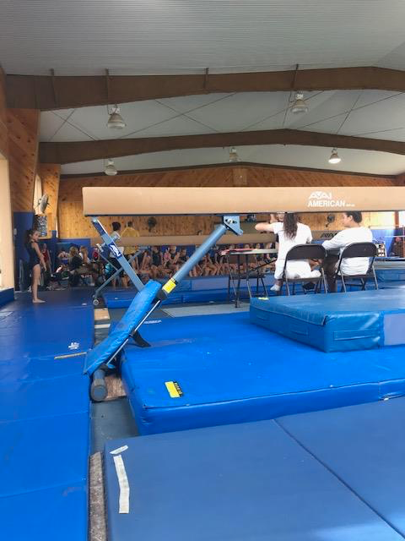
TASK B – (Picture Board Cont.–5 pics (40MB upload limit to Turnitin) (Experience, Roles, Improvements)
Picture Text (Paragraph)

During my time in Camp I was able to work in different areas throughout my time here, We had many evening activities where we would have different events, this is where we would dress up in different outfits, and put on a show.
When I wasn't at my specialty area I helped out down the lake, this would be making sure the children were safe on the Aqua Park, as well as putting life jackets away and handing out towels.
Being a tennis instructor I was on the tennis court coaching for 6 hours of the day, this would be with different age groups, boys and girls. I would sometimes have extra tennis as well, this is where I would take an individual lesson to a player who is looking to compete or learn more about the sport.
Once a week we get a staff evening event once all the children in bed, the picture in the blue tops is where we played a staff hockey game, this was really enjoyable and was a nice way to socialise with staff members that we might not get a chance to see a lot of the time.
When I'm not at my specialty area you go around with your bunk group and help out the other staff in your bunk, this way its easier to get a closer bond with your group and gain respect and responsibility for each child. I enjoying getting the chance to try out different sports with my group also.
During the week there are tennis matches and tournament that we have to attend too, this can be at the camp or even at another camp, I had the chance to visit 5 different camps and take 7 girls as a team to play matches at all age groups boys and girls.
Whilst being in the bunk, I was with 14 girls and 4 staff members including myself. This from the whole experience was defiantly the hardest part of my placement, I had to clean up the mess everyday, get them ready for activities and get them to bed.
When it was to rain at camp, I helped out in gymnastics and got the chance to go to a gym meet in another camp, It was really interesting to be able to see how another sport works during a competition and getting to know other girls around camp also.
Once a week we were aloud a day off where we would visit different parts of america, we got to go for food and shopping, and buses would be arranged for us, so we were able to do so.

TASK C Evidence – Employer Report (Signed),
NOTE – This will be compared against the report sent to the University.
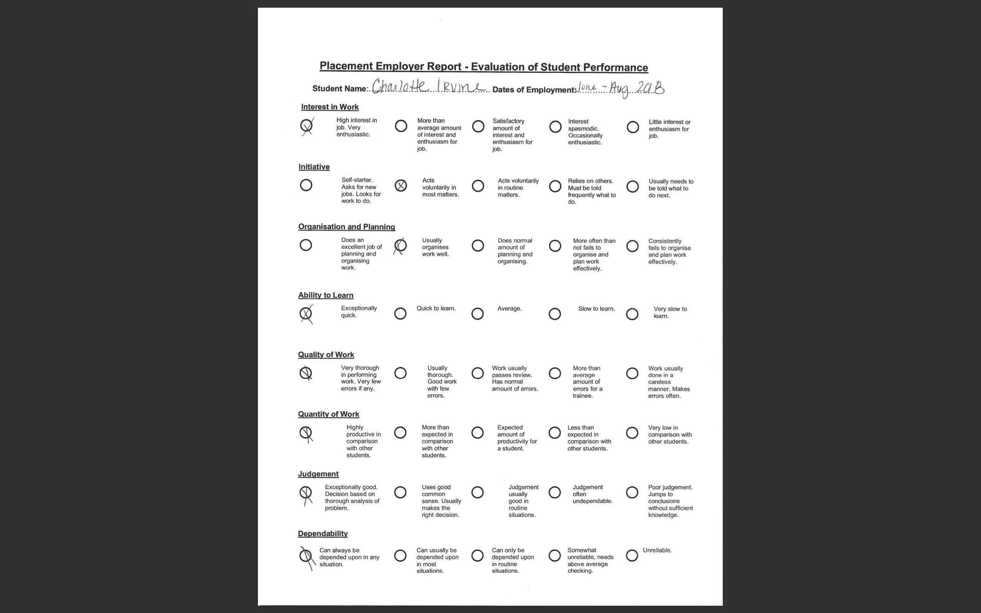

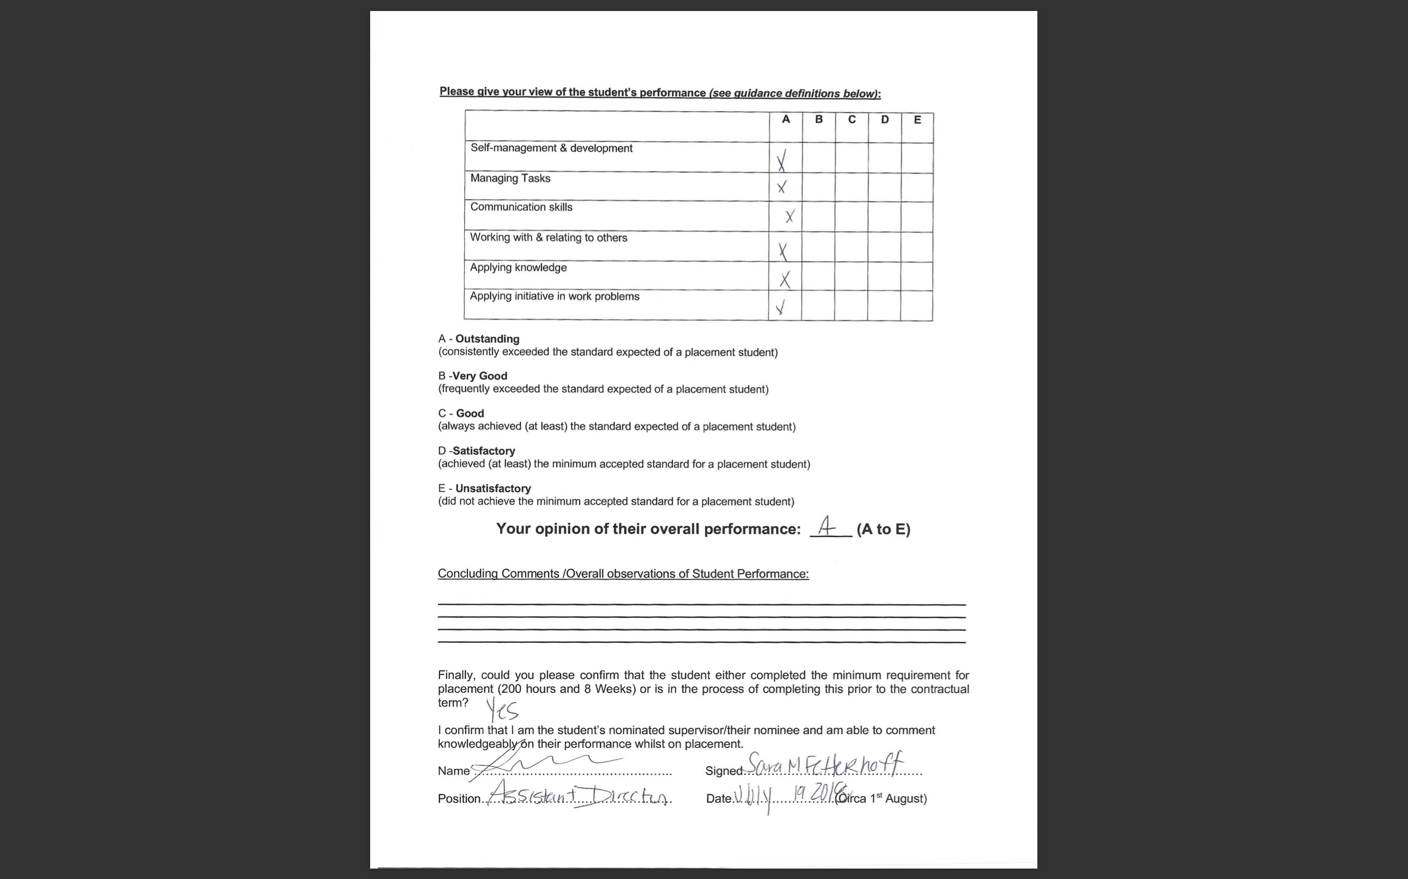
NOTE – You will need to complete additional copies if you have more than one provider.

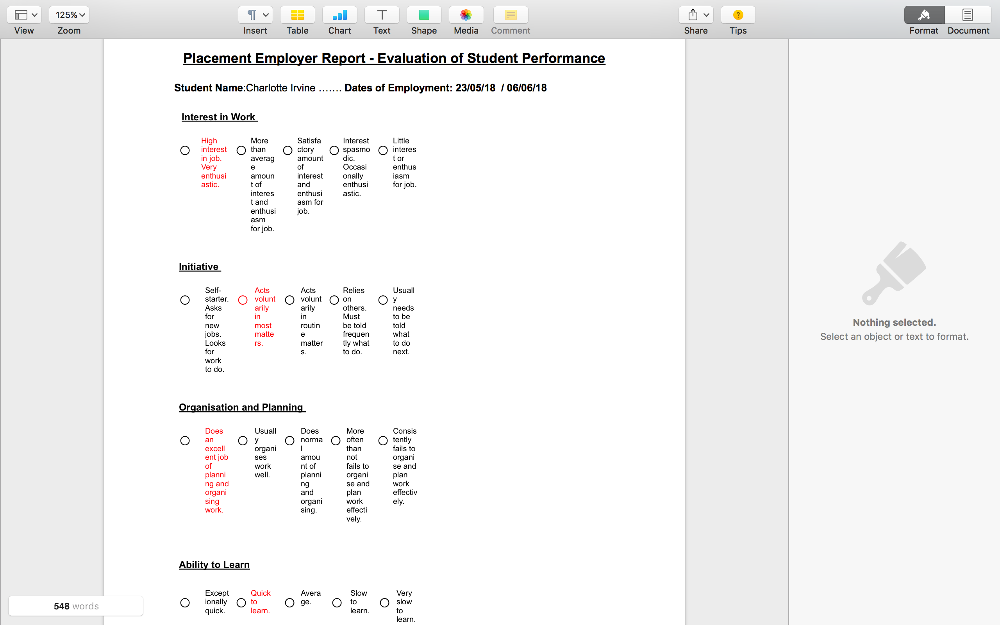
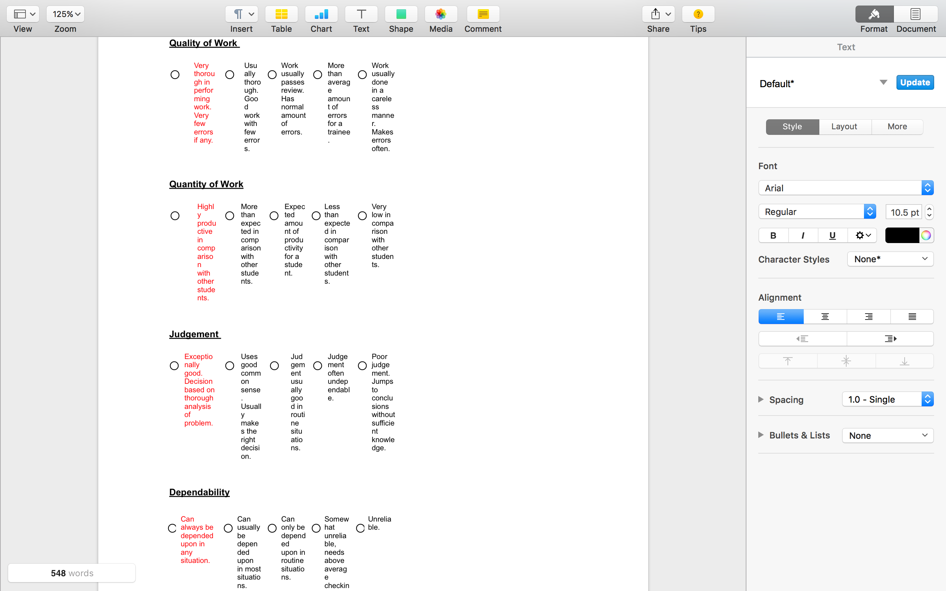

TASK C Continued Evidence – Employer Report (Signed),
NOTE – This will be compared against the report sent to the University.

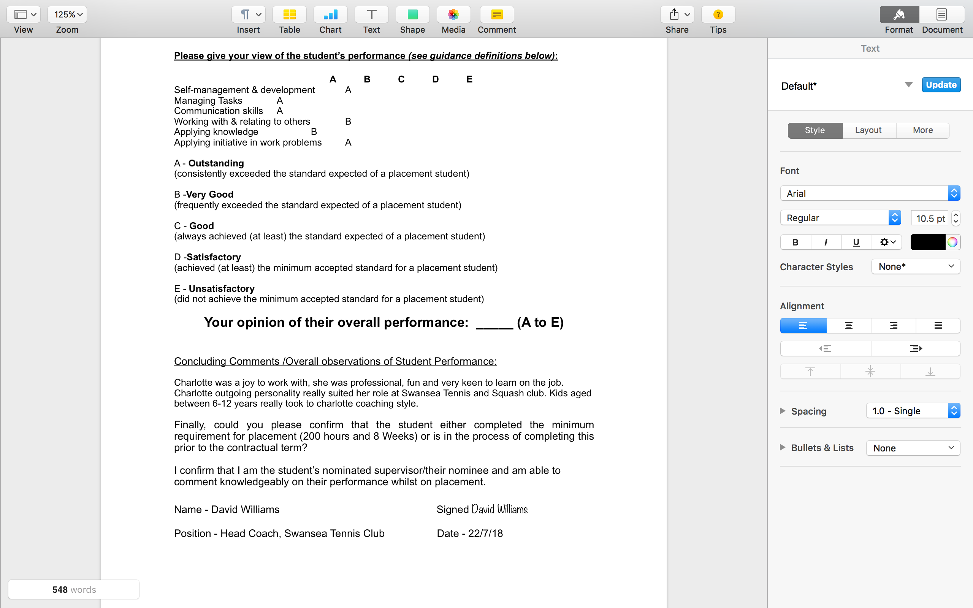

TASK C Evidence – Ethics Form – Signed by Organisation and Lecturer
NOTE – You will need to complete additional copies if you have more than one provider.
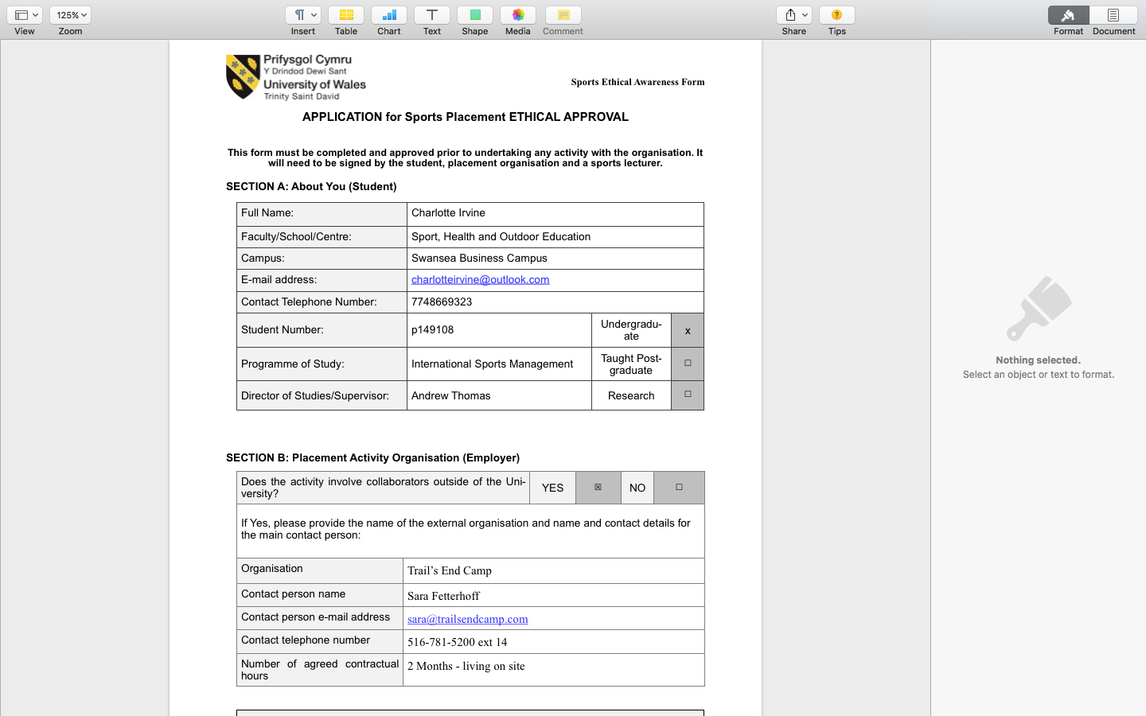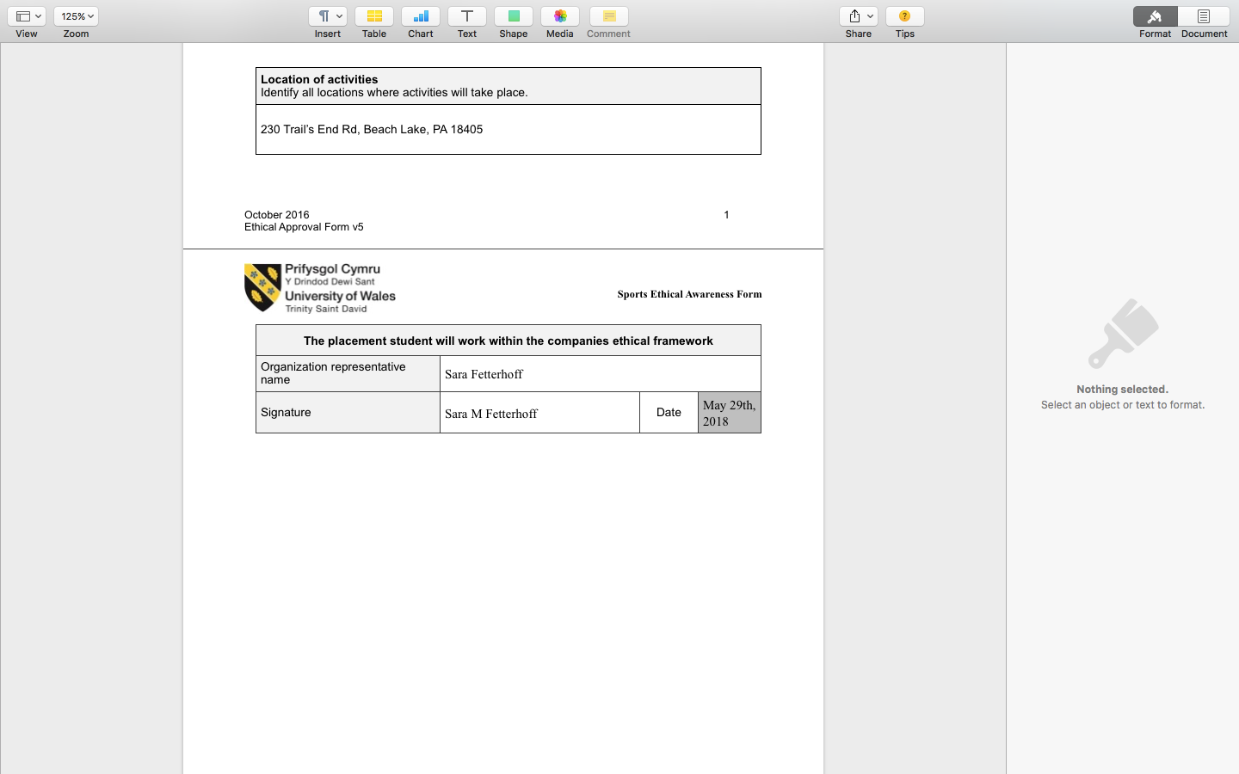

TASK C Evidence – Ethics Form Continued
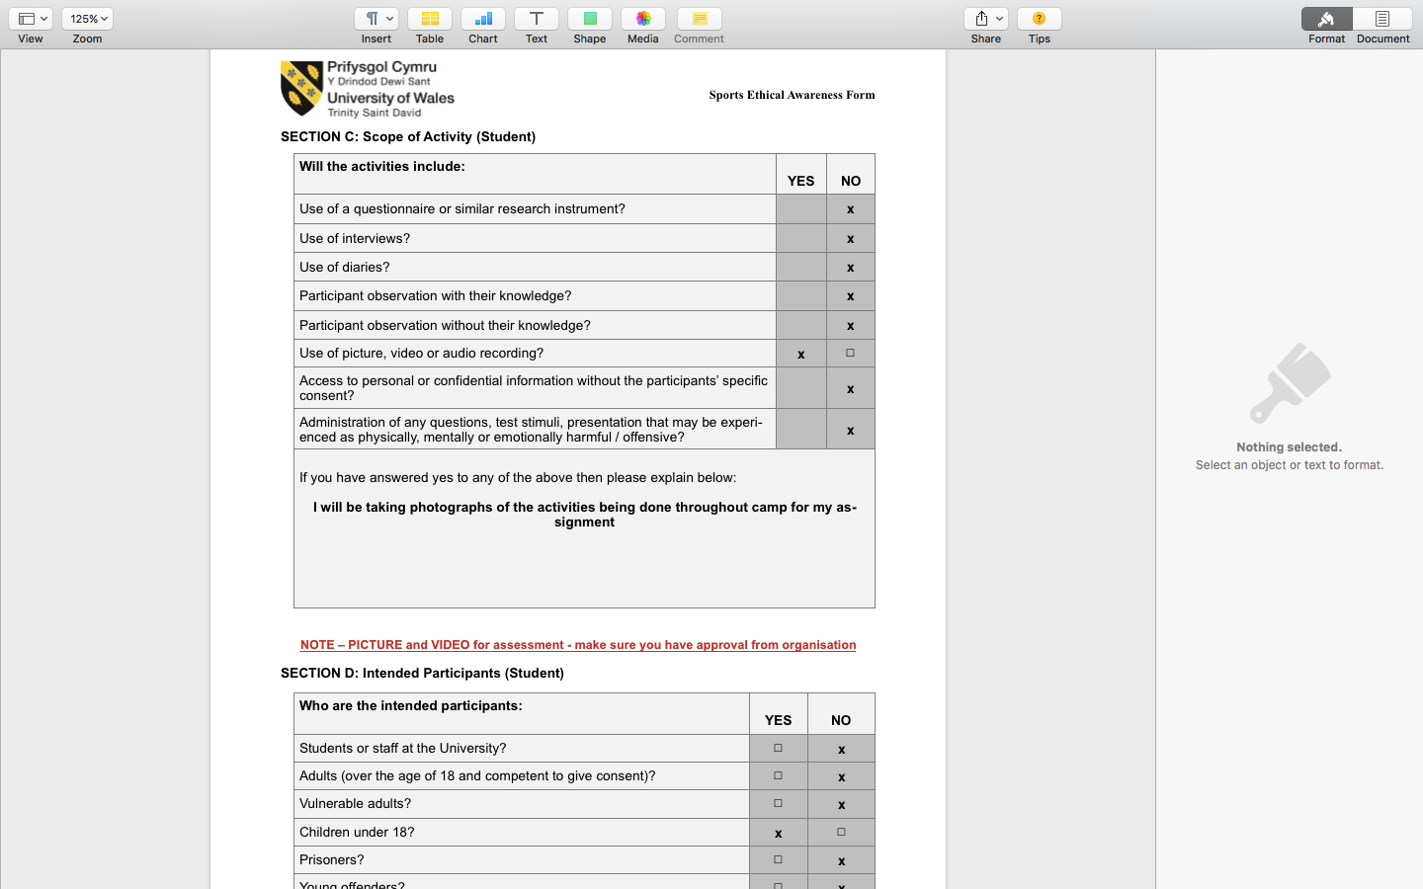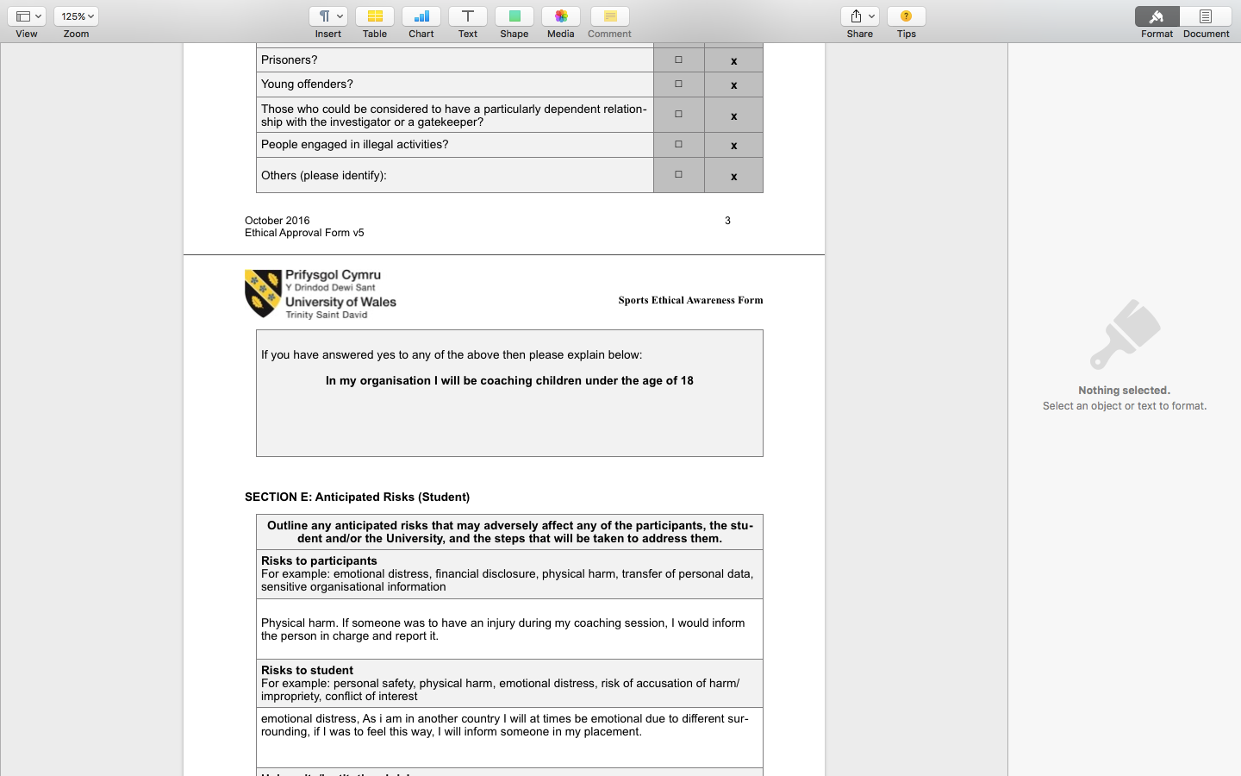

TASK C Evidence – Ethics Form Continued
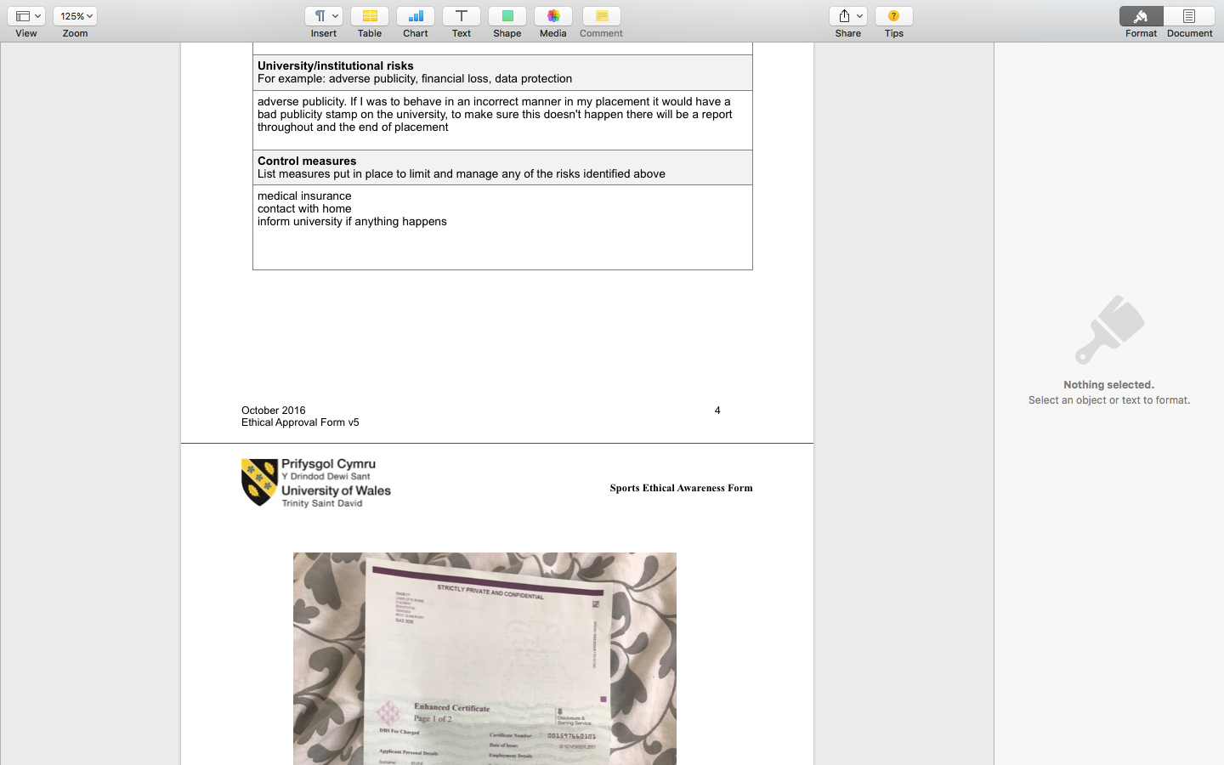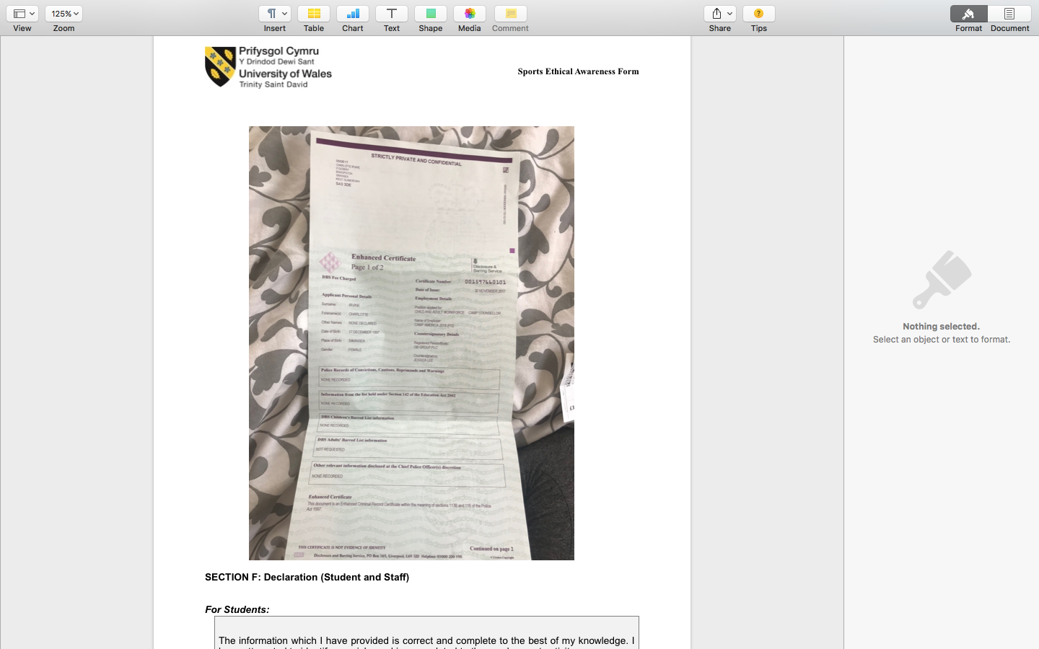

TASK C Evidence – Ethics Form Continued
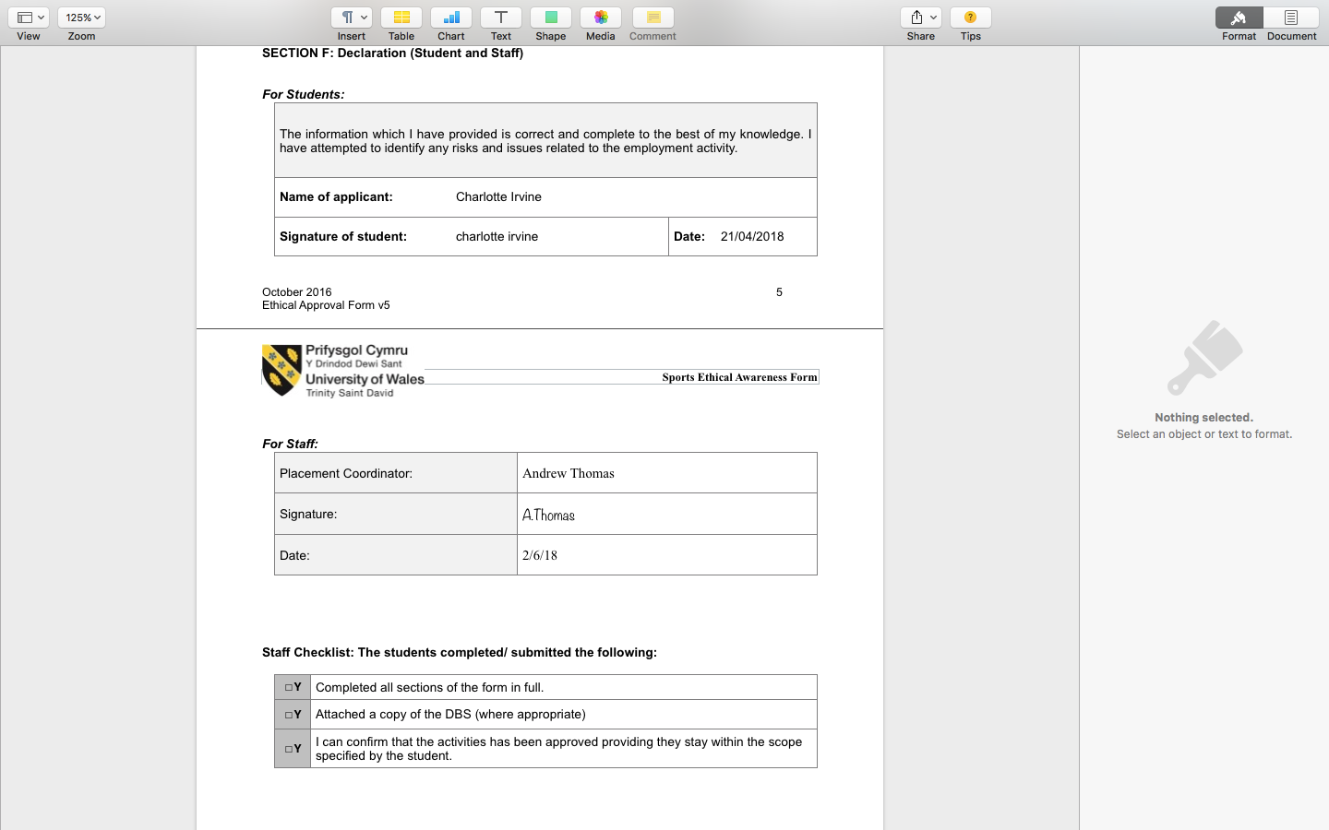

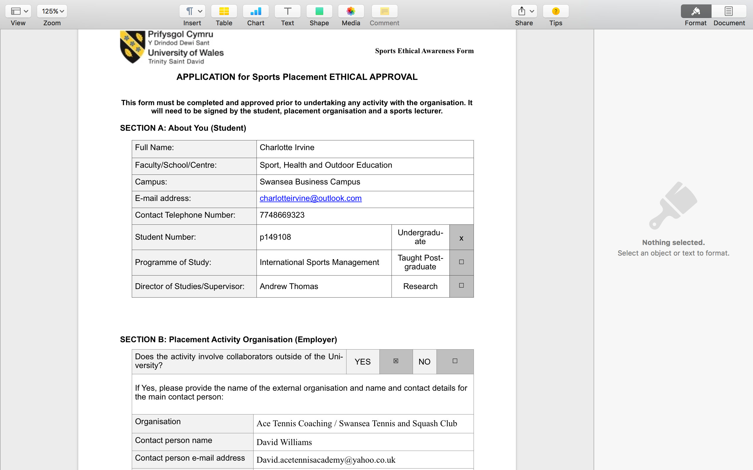

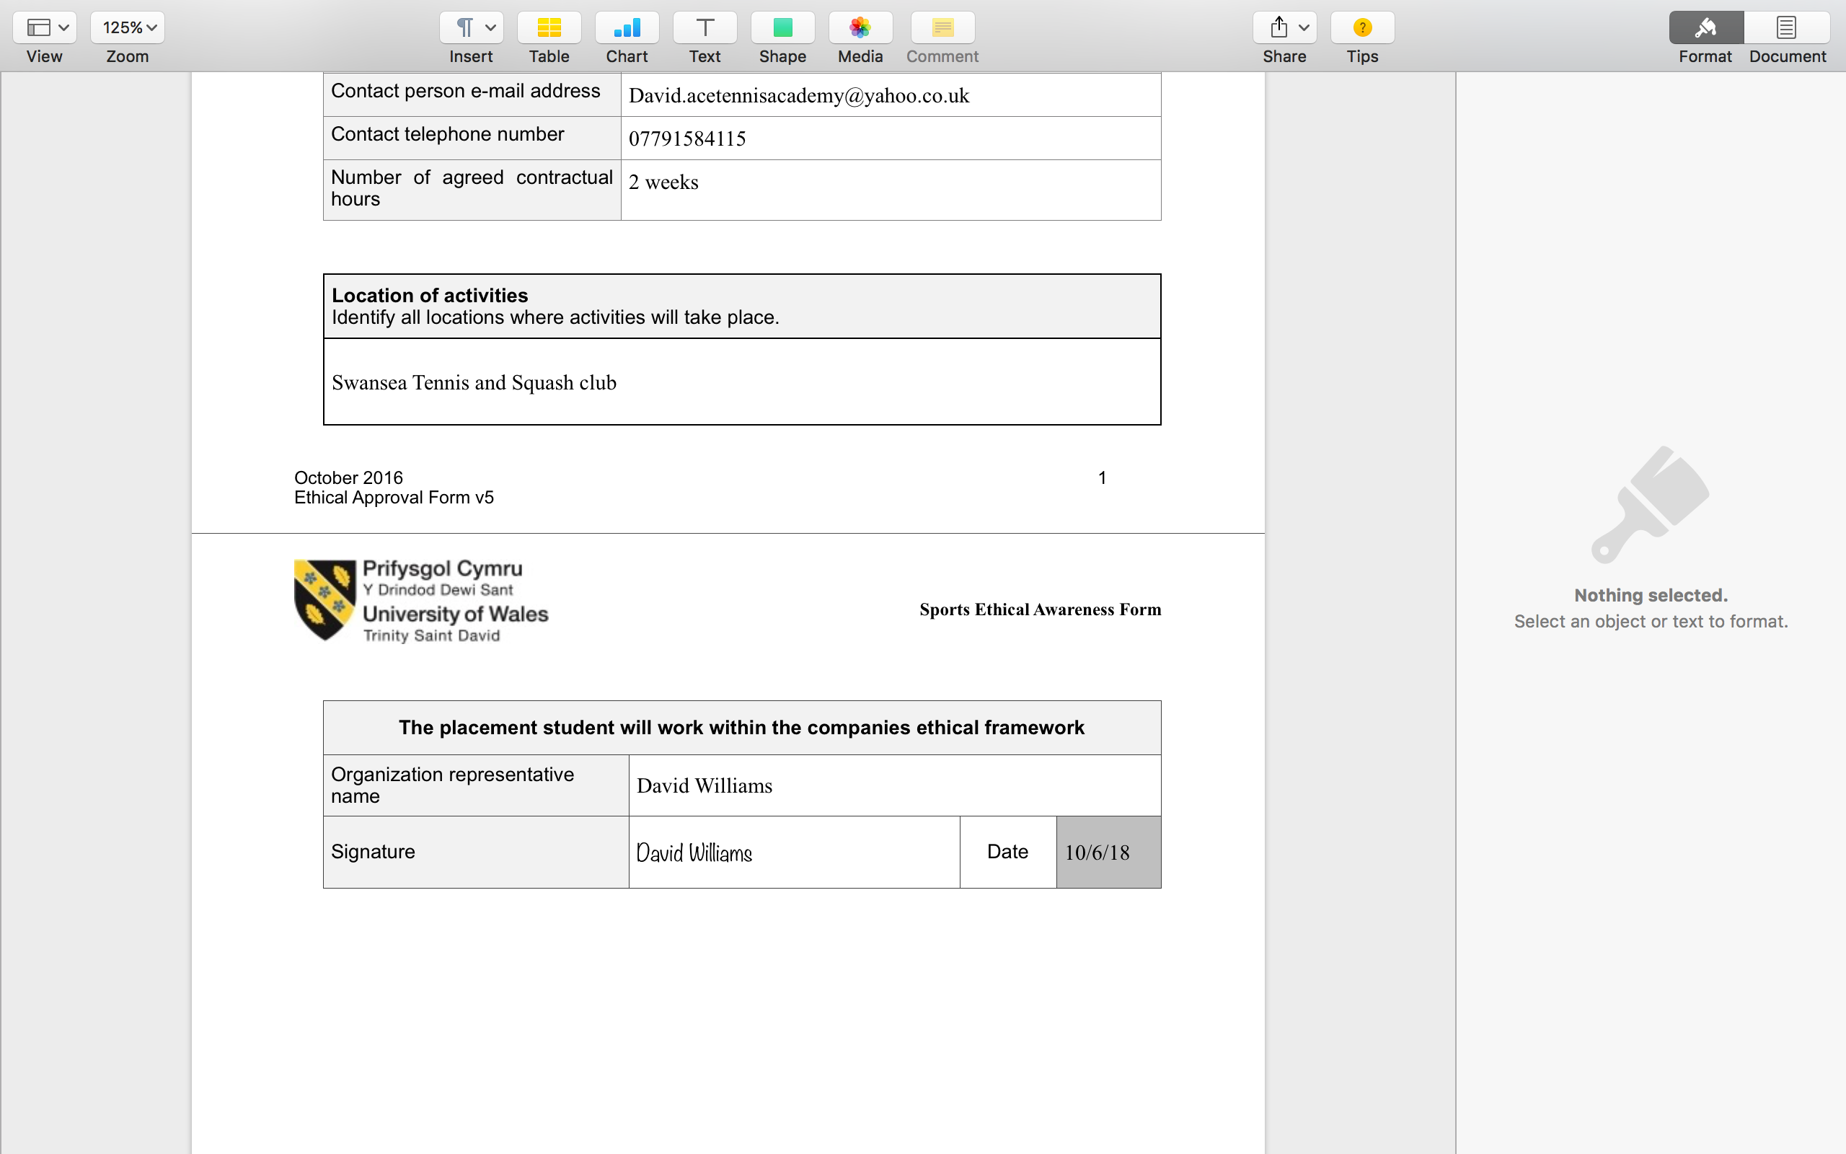
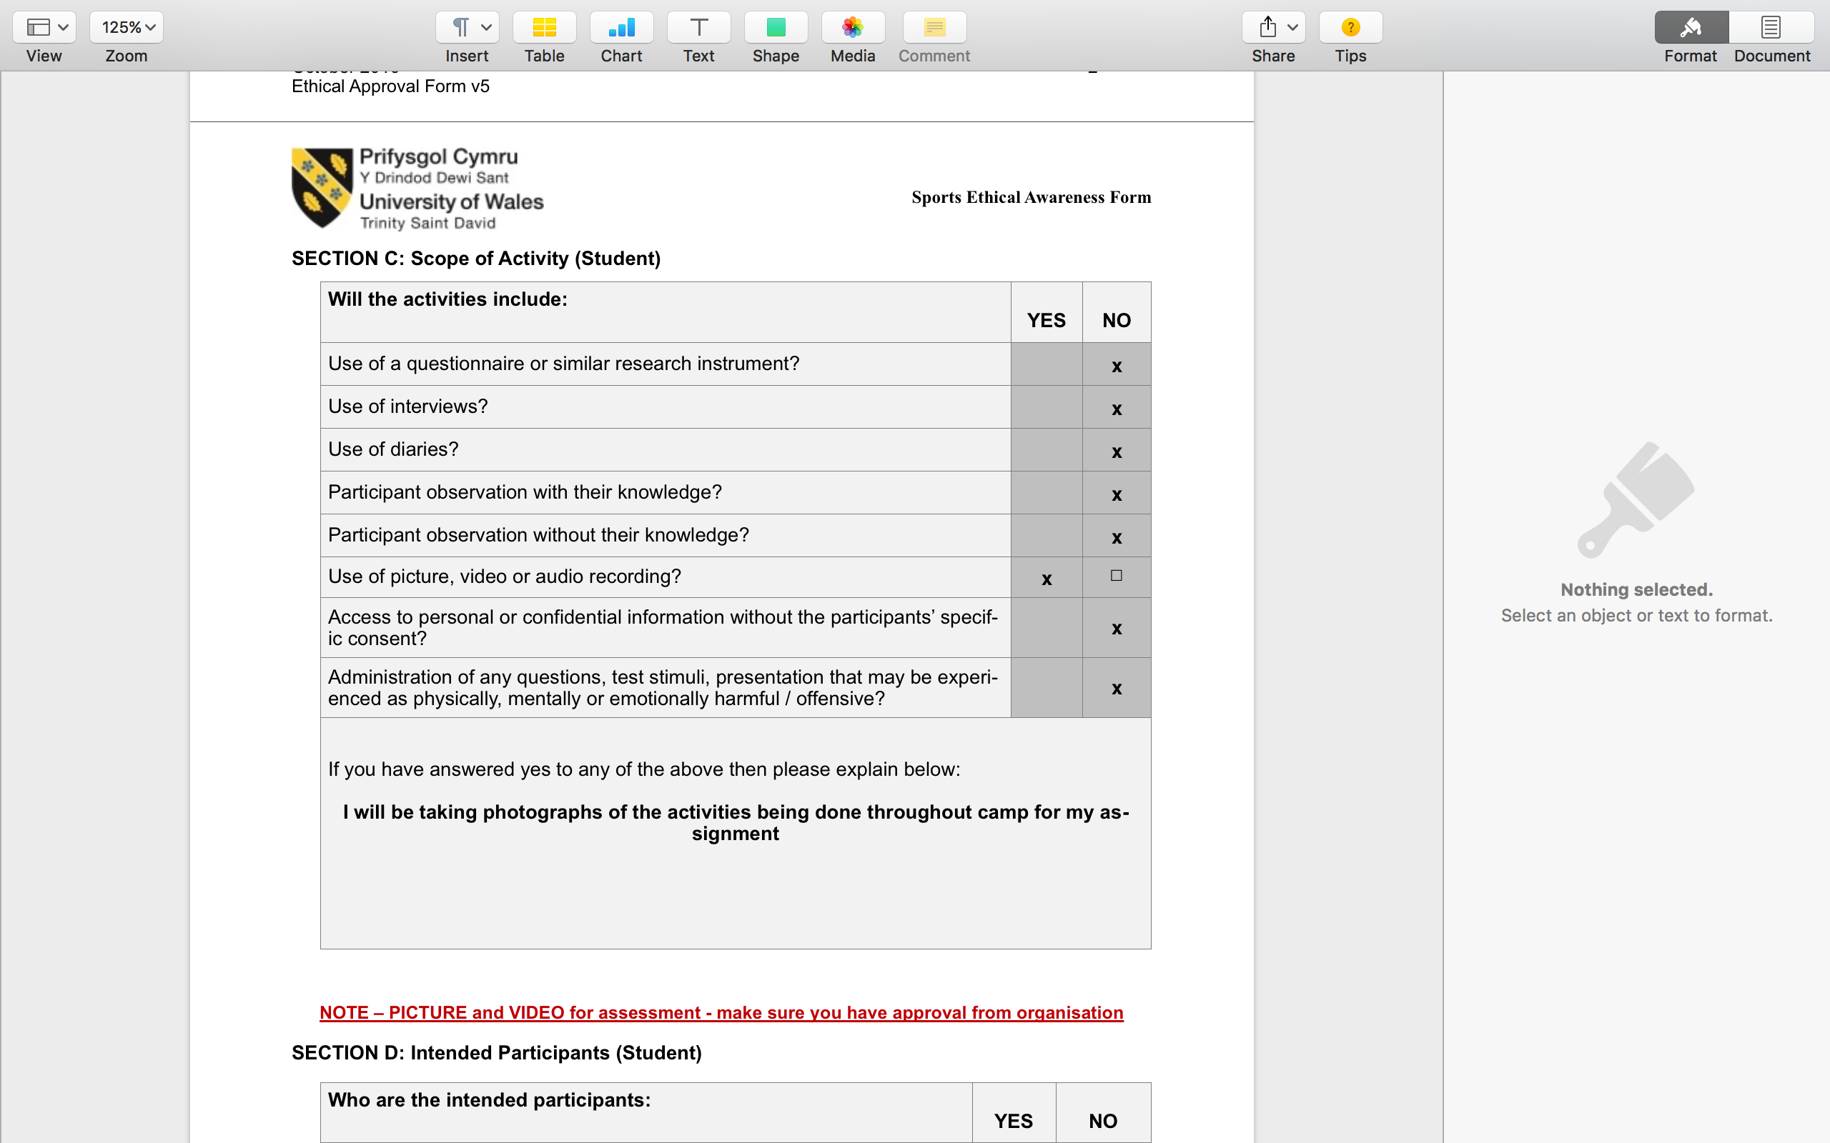

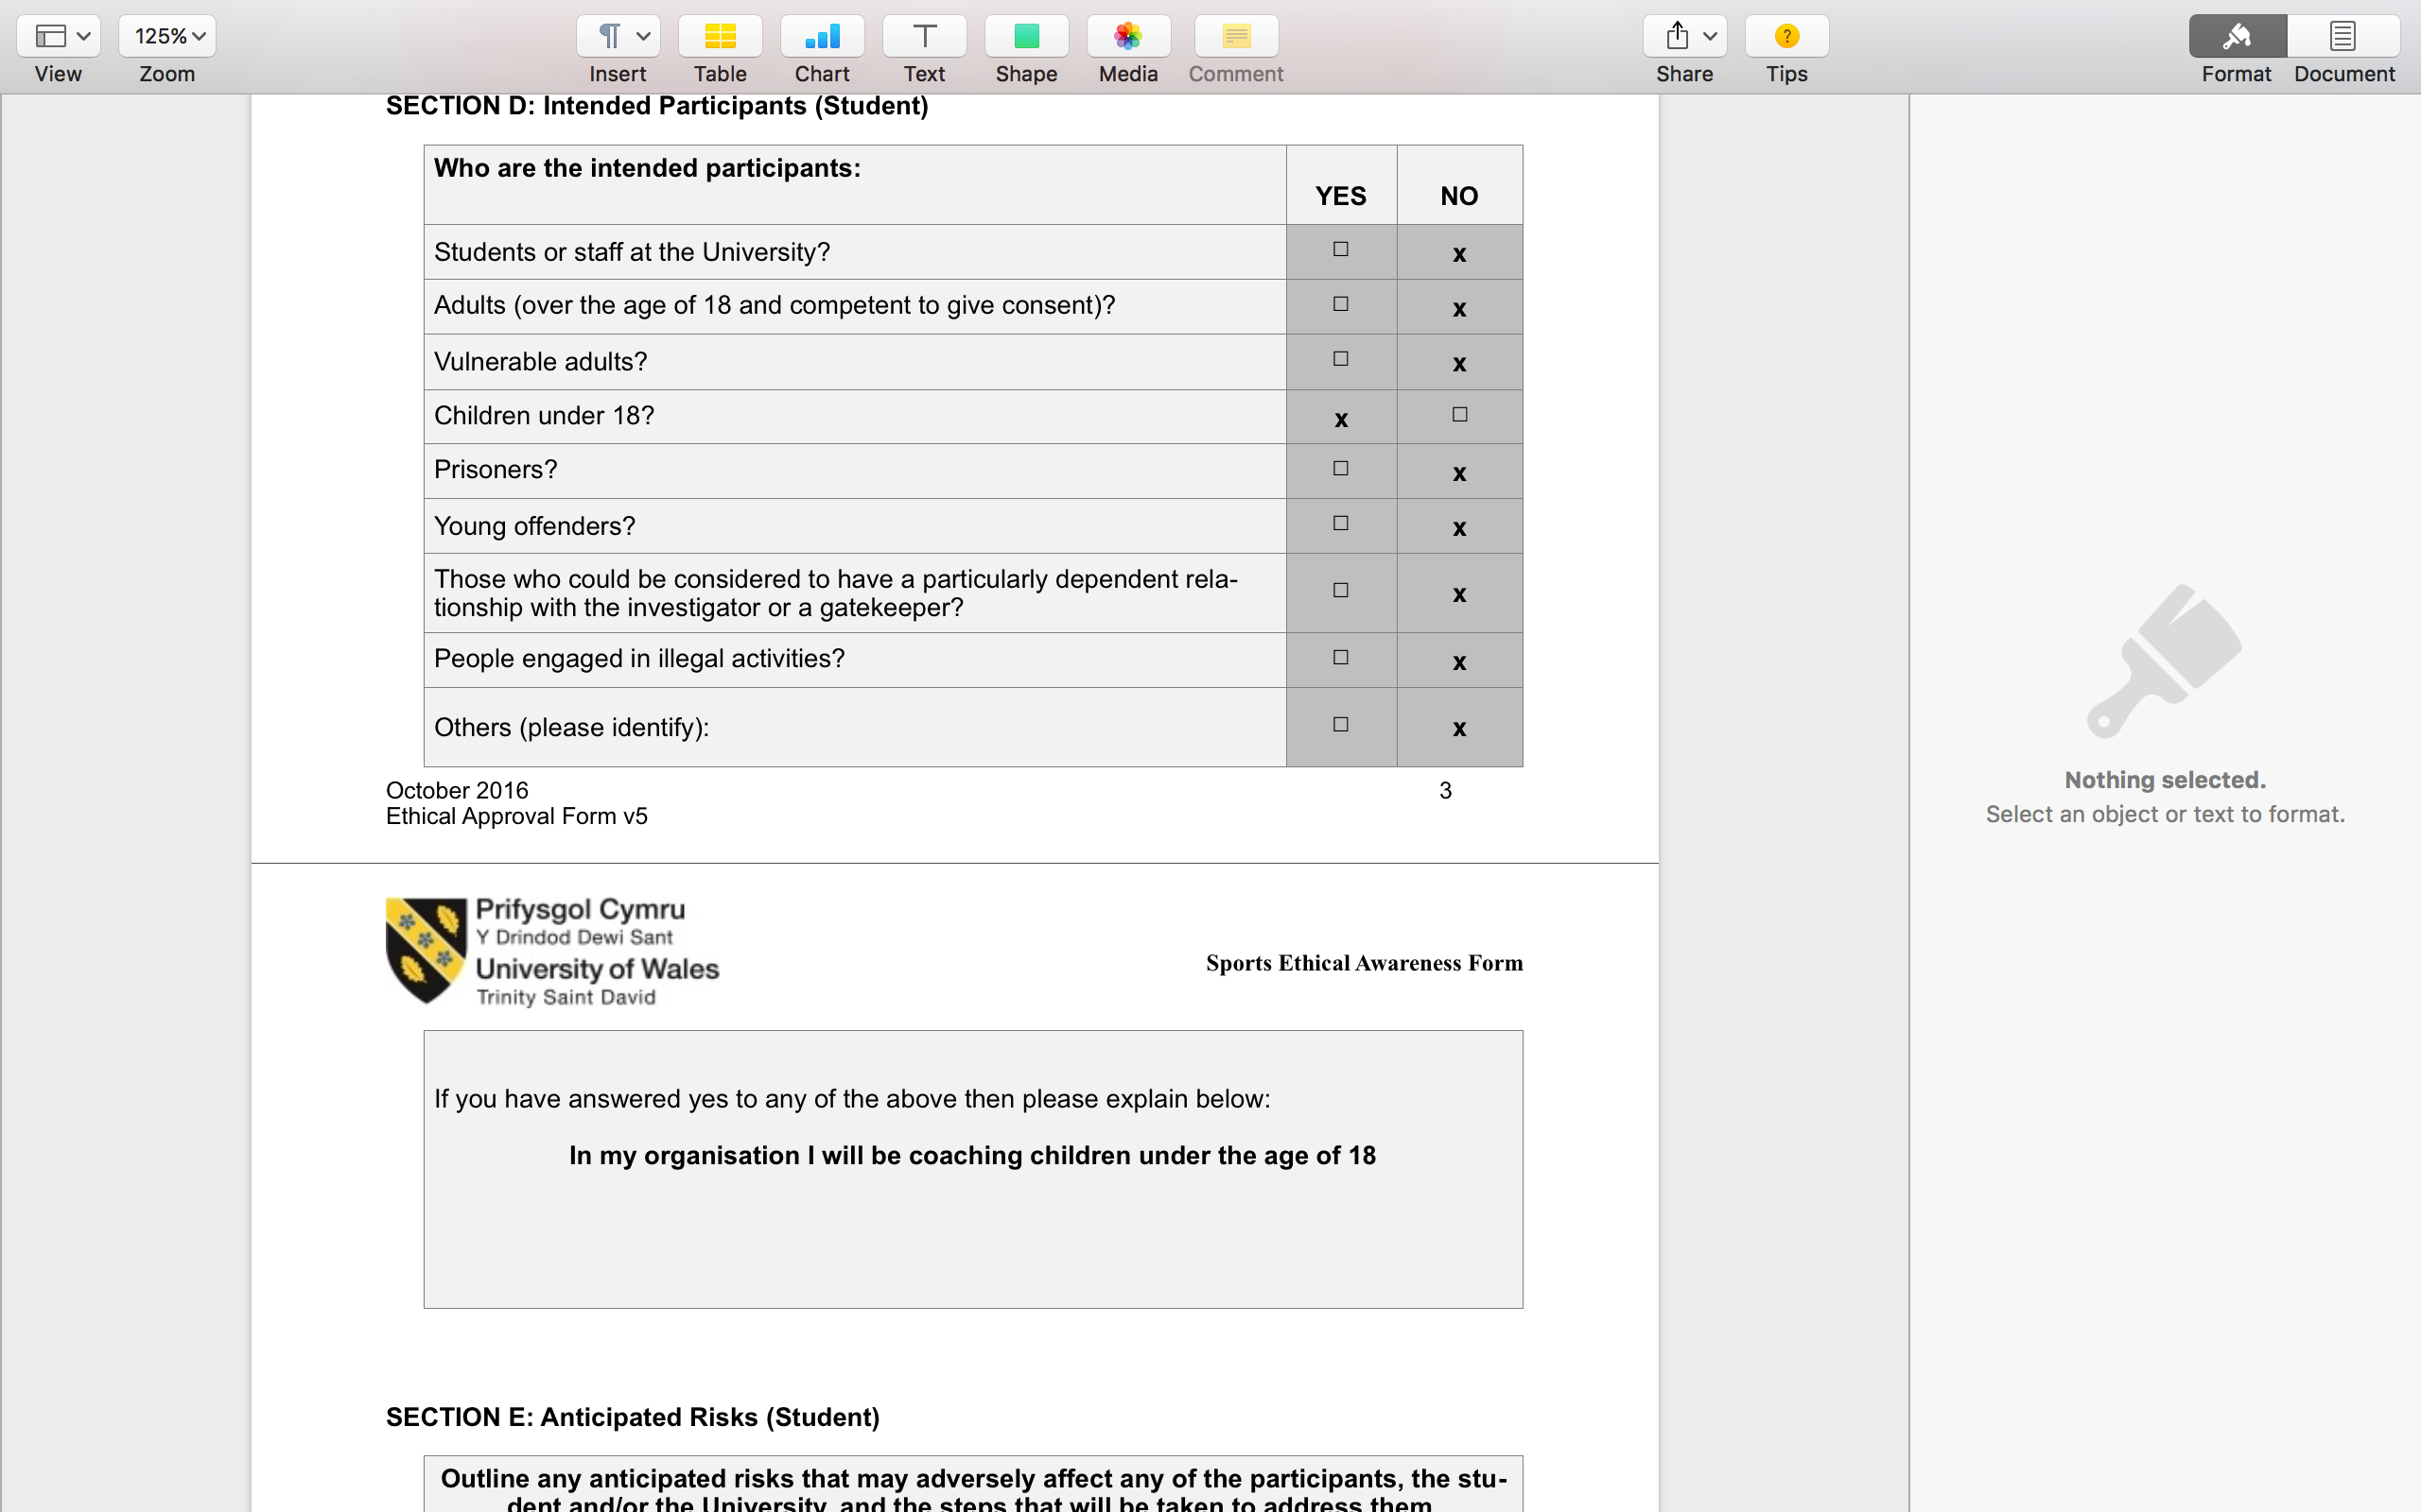
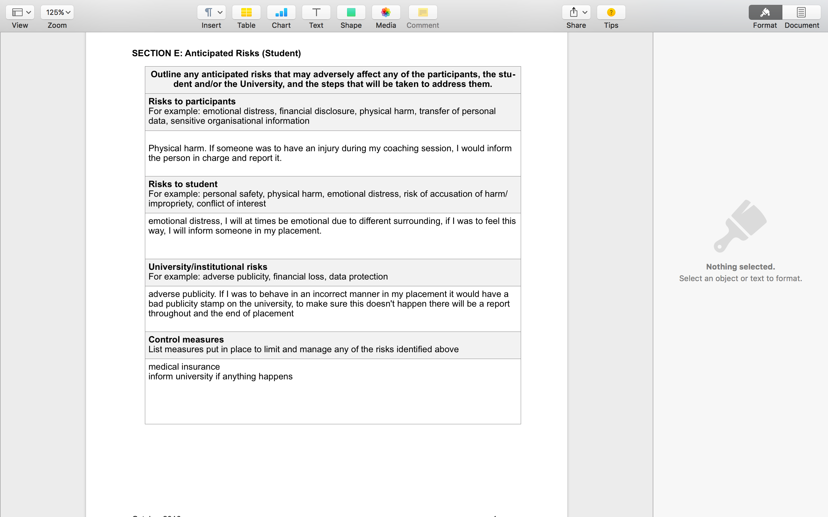

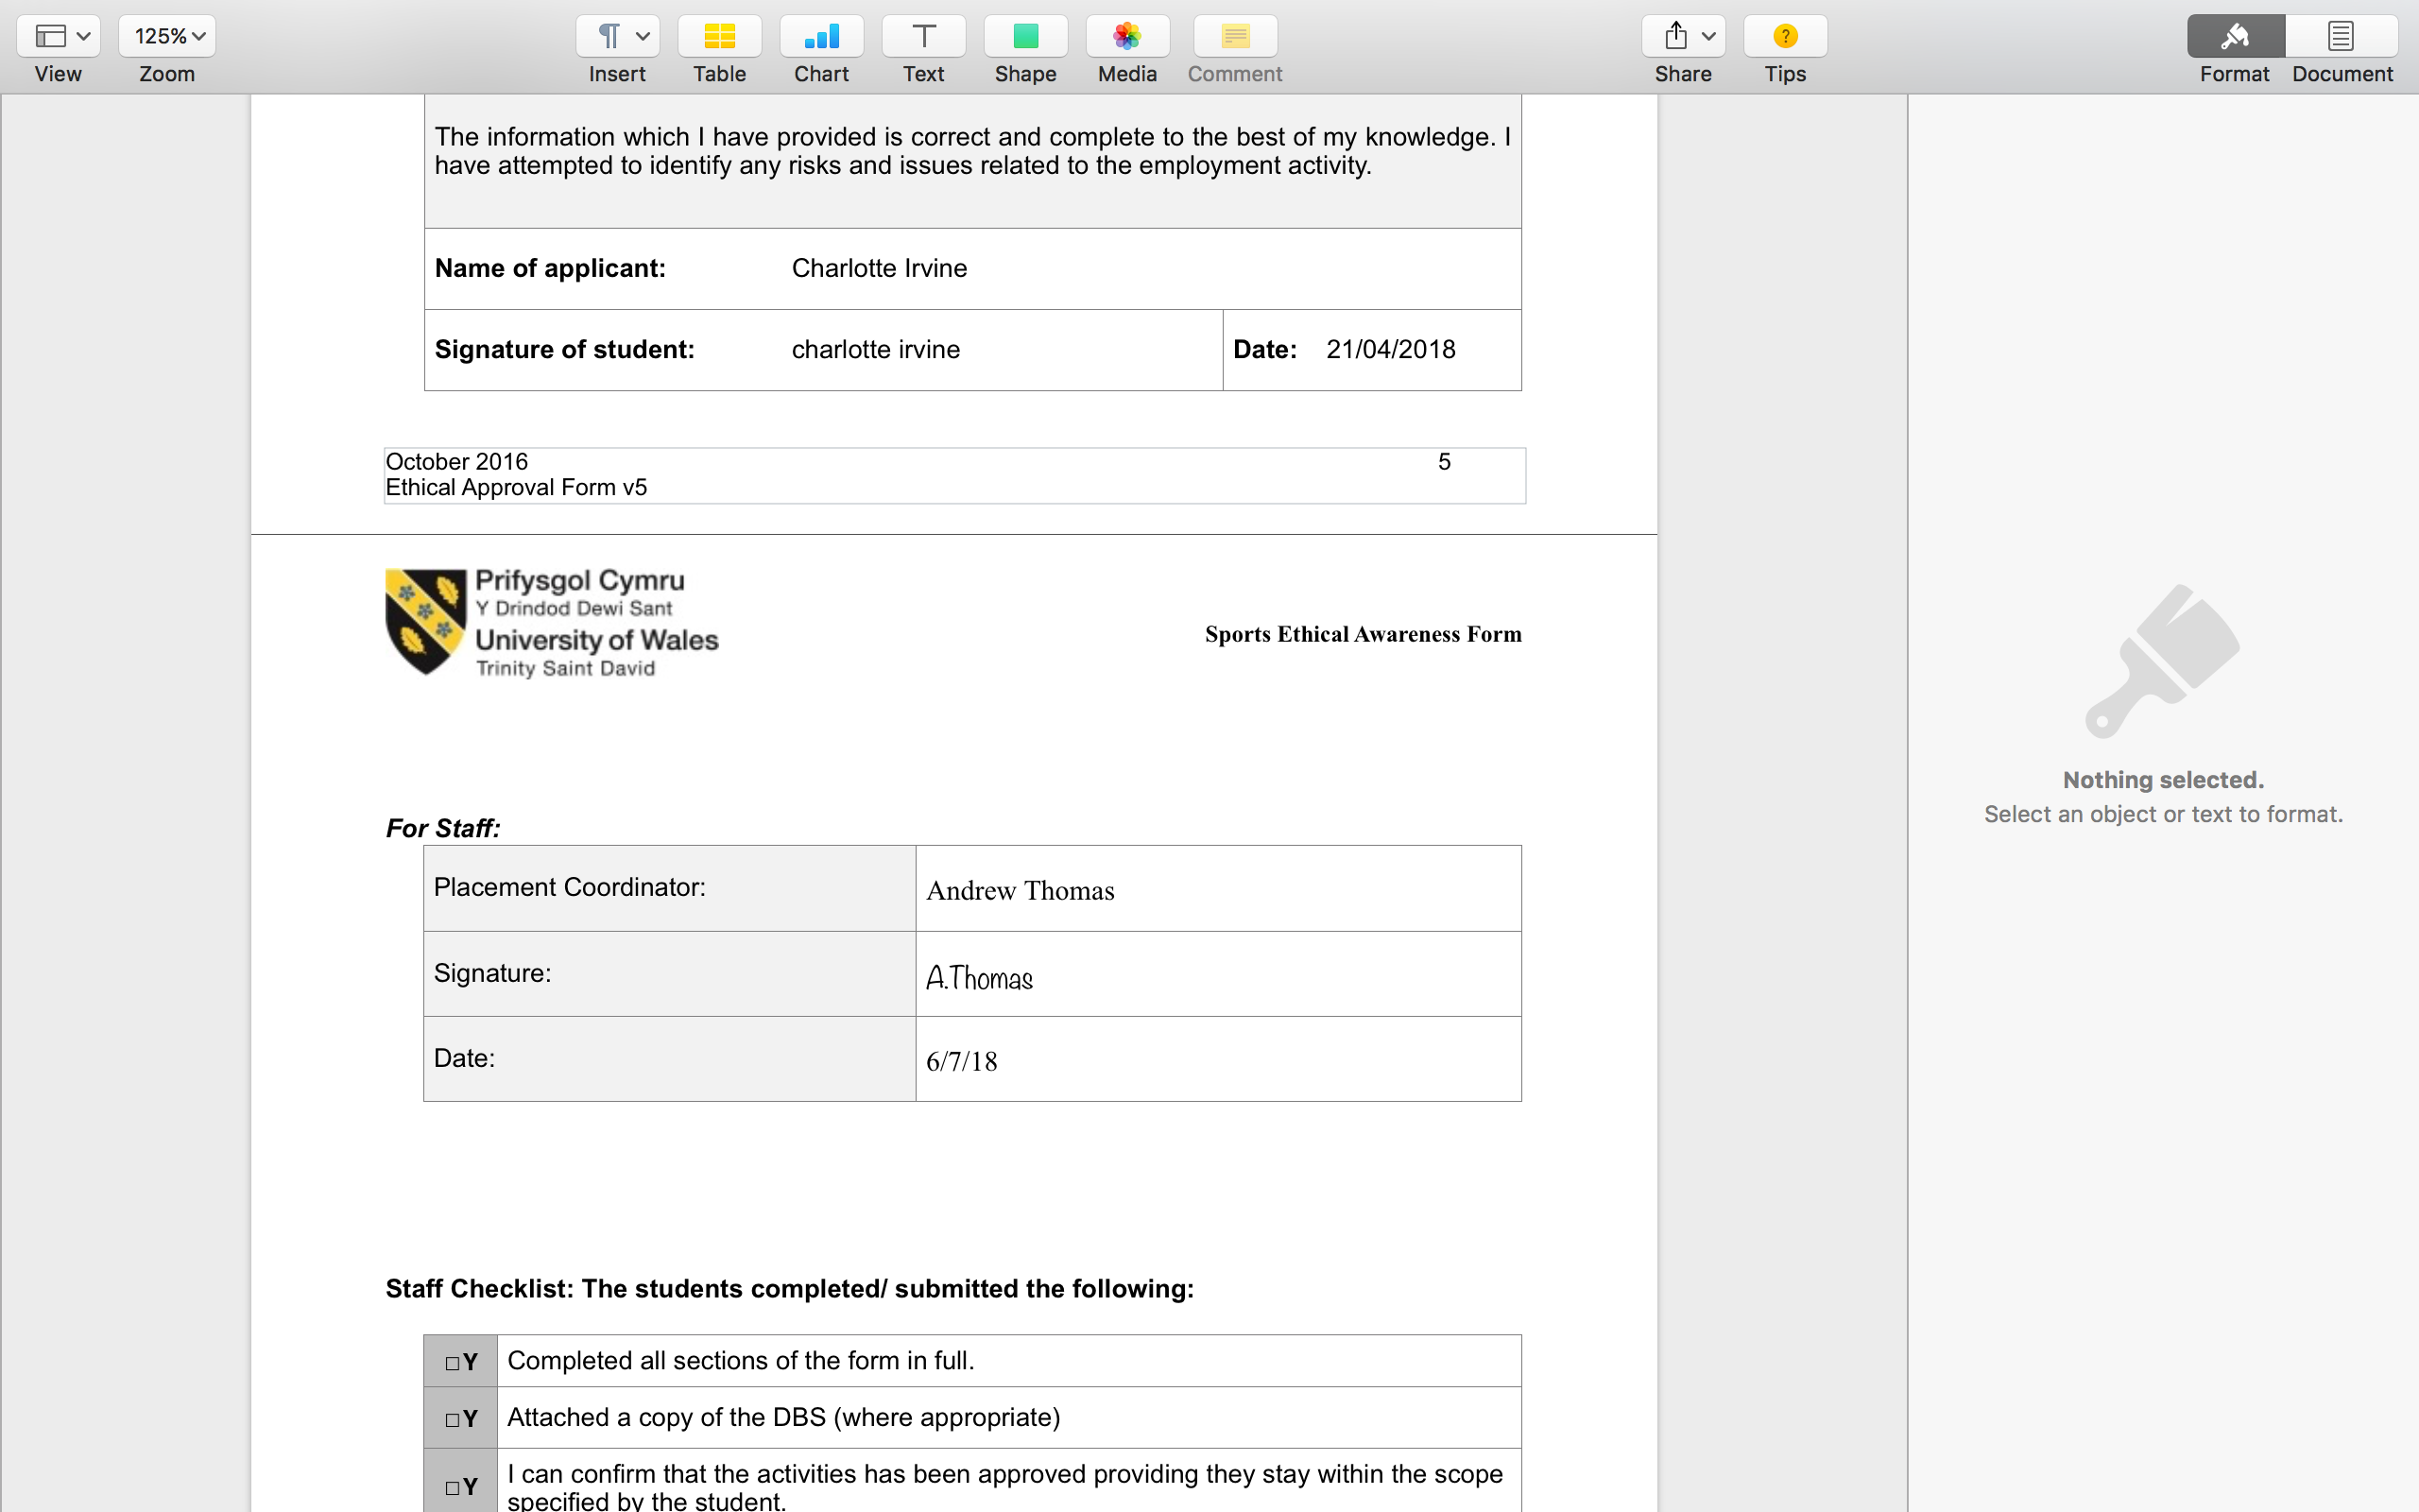
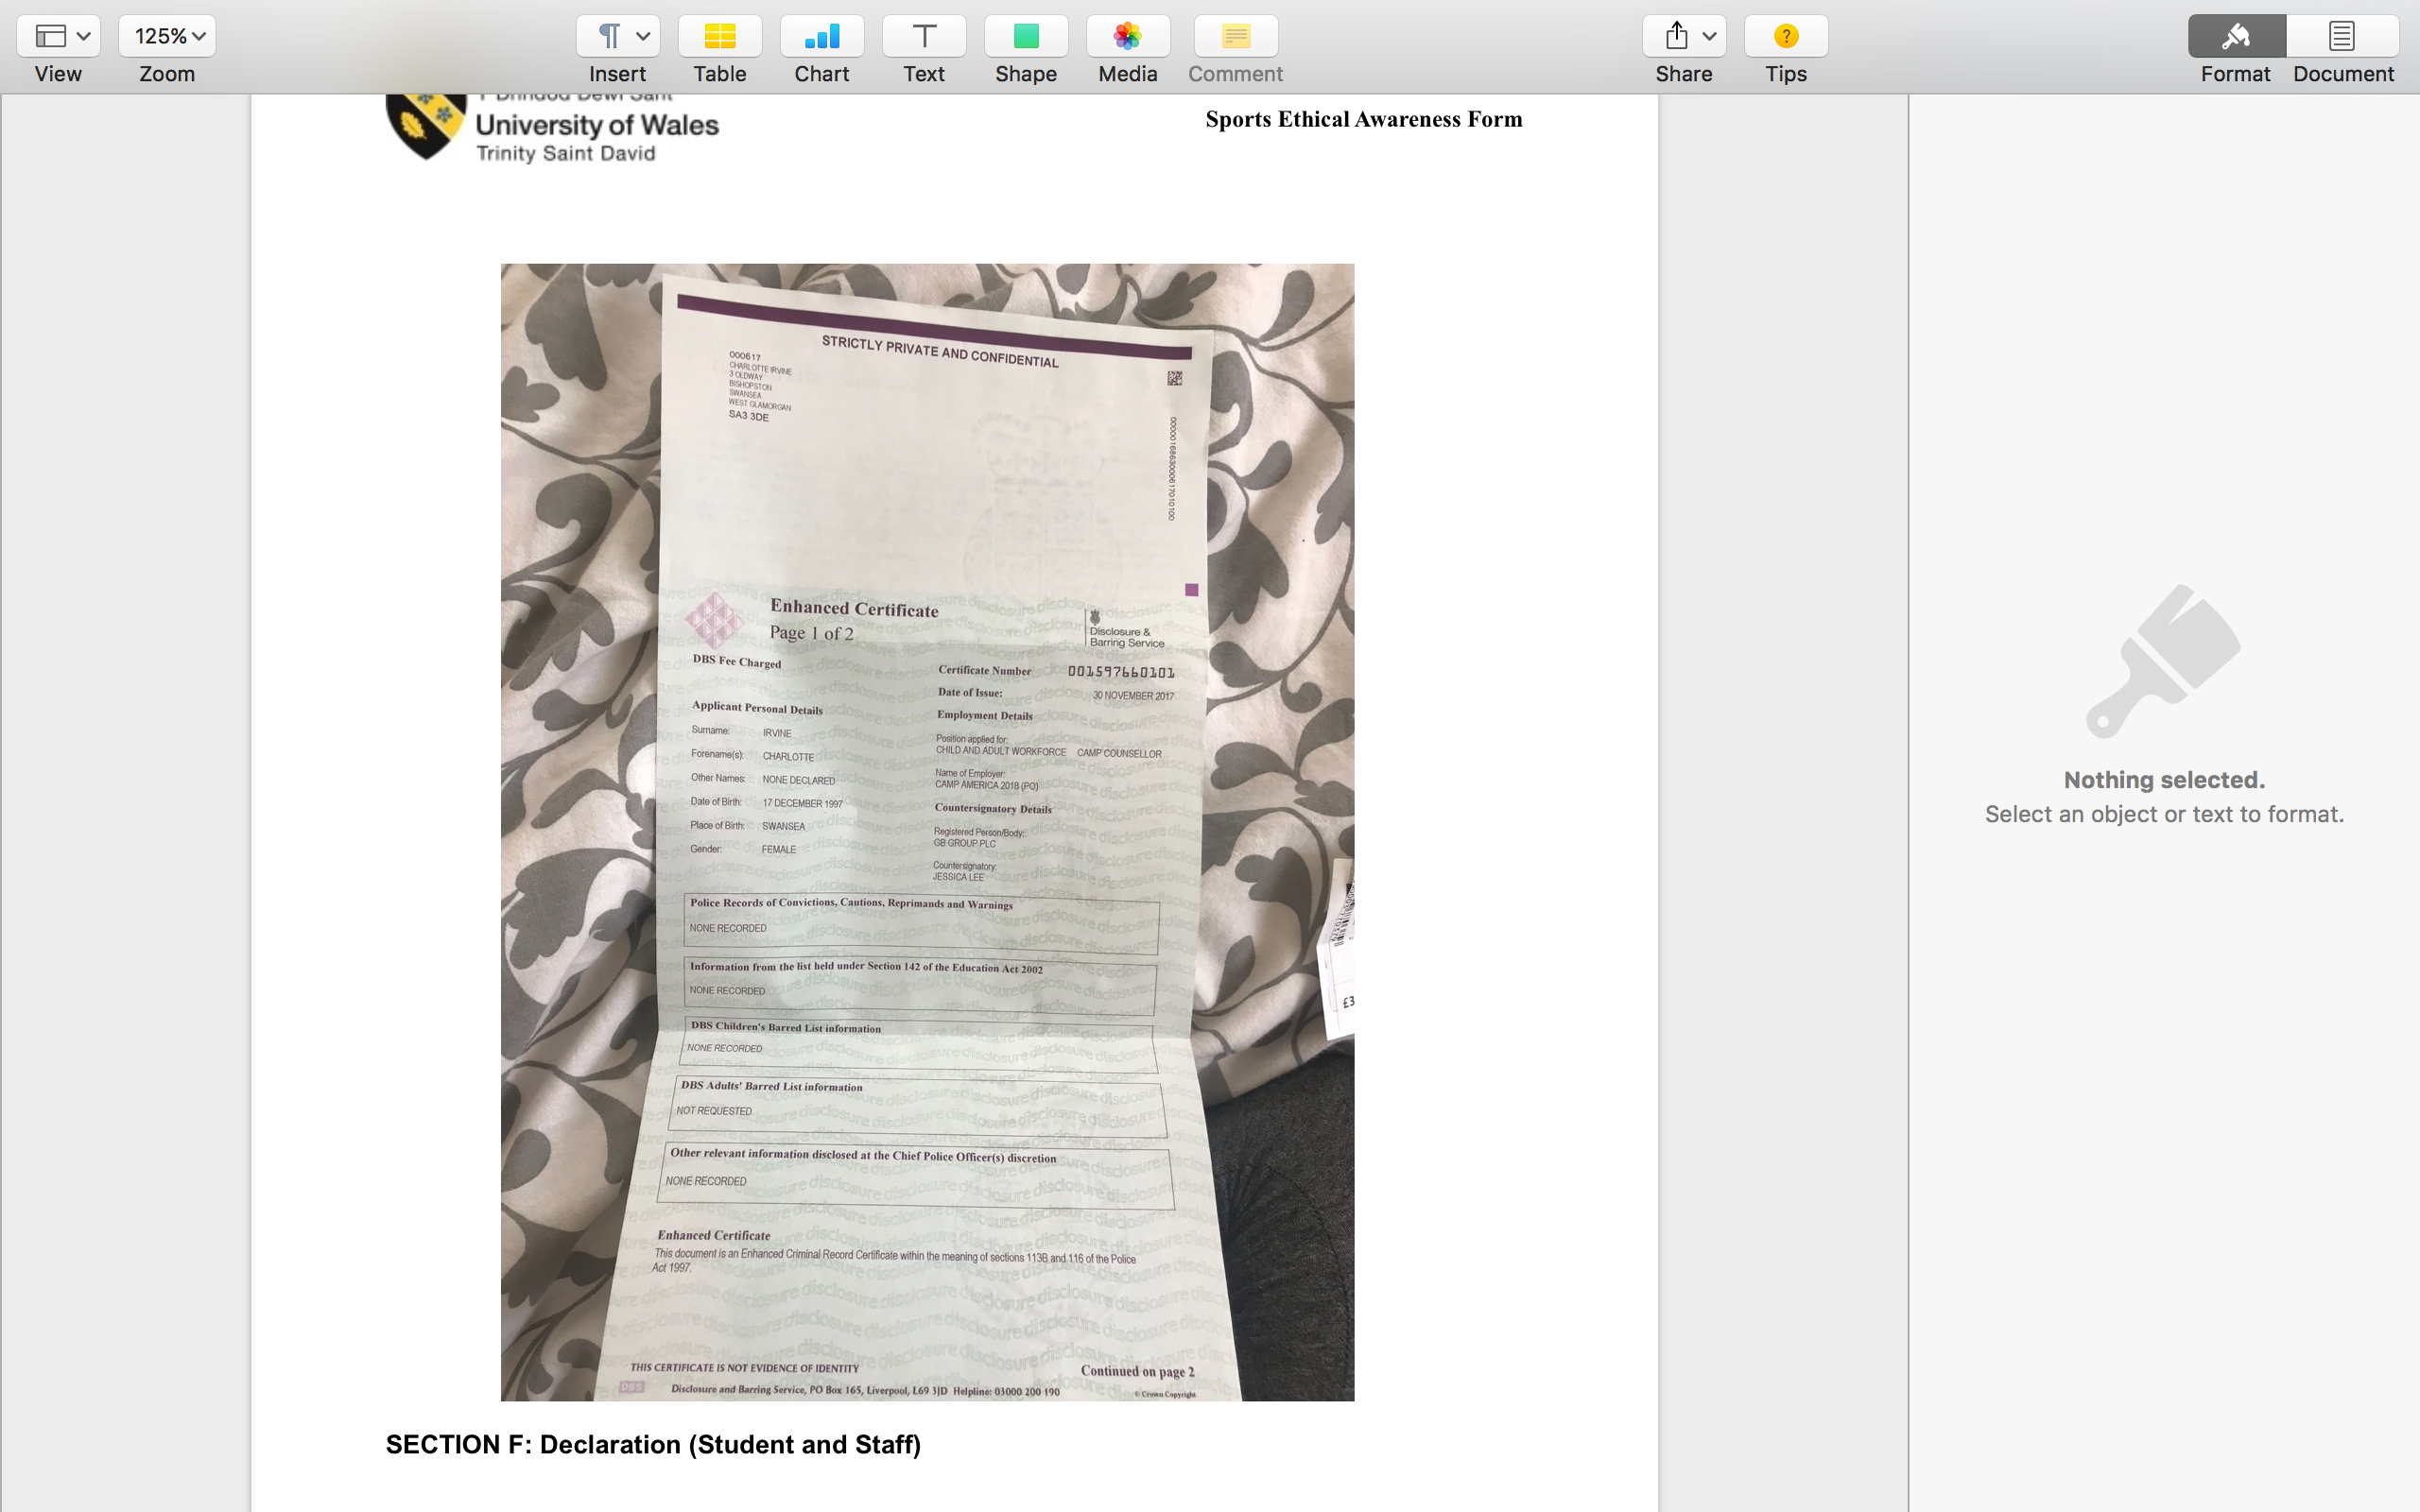

TASK C Evidence – Post Placement Review and Feedback
Dear Participant

Many thanks for your involvement in the work placement. I hope that you had a positive experience. The University of Wales Trinity Saint David reviews the provision annually for enhancement purposes and so we would be pleased to hear your feedback on any aspect of the placement.

Yours sincerely

Andrew Thomas, Placement Coordinator Sports Management Portfolio

Name of provider’s organisation:
Camp America- Trails End Camp

Name of student:
Charlotte Irvine

What were the positive aspects?

Were there any problems?

Do you have any recommendations for enhancement for the future?

Signed:

Name in block capitals:
Position (please tick one): ☐ Placement Provider
X Student
☐ Placement Tutor Date:

TASK C Evidence – Student Placement Induction Checklist

Health check forms

STUDENT CONFIRMATION

I confirm that I have been provided with an appropriate induction as specified above:


NOTE – If this is not completed please ask your supervisor on the placement to complete ASAP. However, please inform the placement coordinator at the earliest possible opportunity if this procedure does not take place
UWTSD SPORT
Placement

Student Name
Name – Charlotte Irvine
P Number – p149108
Report
Title –
Word Count –
References (Total) –
Job Title –
Organisation
Name –
Address –
Email –
Telephone Number –
Line Manager
Name –
Position –
Email –
Telephone Number –

