
OME – Systems Engineering, Systems Thinking Design Report (ACDA5021)

23/04/2026

Nathan Rowe - 1910544
Declaration
I declare that this report is the product of my own work and is not being submitted for any other degree etc.

Contents
1 Introduction 1
2 Systems Engineering Approach and Toolset 1
3 Customer Requirements 1
3.1 Explicit Customer Requirements 1
3.2 Derived Safety Requirements 2
4 Critical System Functionality 2
5 Concept and Design Choices 2
5.1 Concept Exploration Using SE Tools 2
5.2 Safety‑Driven Design Choices 2
6 Identifying Failure Modes 3
7 Identifying Critical Design Features 3
8 Manufacturing 3
9 Identifying Critical Processes 3
9.1 Process Control Measures 4
10 Disposal 4
11 Conclusion 4

References

[1] | D. Holley, “Design Brief,” [Online]. [Accessed 2026].
[2] | T. Kletz, What Went Wrong? Case Studies of Process Plant Disasters, 2009.
[3] | J. Oxley, Safe Handling of Explosives, in Explosive Effects and Applications, 1998.
[4] | HSE, Reducing Risks, Protecting People, 2001.

Introduction
This report describes the application of established Systems Engineering (SE) tools to the development of a conceptual solution for a mine-detection, clearing, and marking system, intended to enable the safe passage of medical supply convoys through a mined route in desert terrain. The work was undertaken as part of a multidisciplinary team, with the author fulfilling the role of Safety Lead.
The operational scenario presented a complex combination of constraints and requirements. A humanitarian medical convoy must traverse a mined area located within a steep‑walled pass, where diversion is impractical, aerial support is prohibited due to a persistent MANPAD threat, and ground mobility is limited to light vehicles such as Land Rovers and Hilux pickups. The convoy must pass quickly, with minimal delay, and the cleared route must remain safe for subsequent civilian traffic with no specialist support available.
The Safety Lead role was responsible for ensuring that hazards associated with detection, clearance, marking, manufacture, and end‑of‑life disposal were identified, assessed, and mitigated to a level that could be justified as As Low As Reasonably Practicable (ALARP). This required early integration of safety considerations into the design process using SE tools, so that safety informed concept selection and design decisions could be made.
This report explains how the SE toolset was used to support the design process through identification of key customer requirements, critical system functionality, concept derivation, potential failure modes, critical design features, manufacturing considerations, process controls, and disposal. All discussion is framed from the Safety Lead perspective.

Systems Engineering Approach and Toolset
A structured SE approach using the supplied toolset as shown in [Figure 1] and was adopted to manage the full design lifecycle of the product.
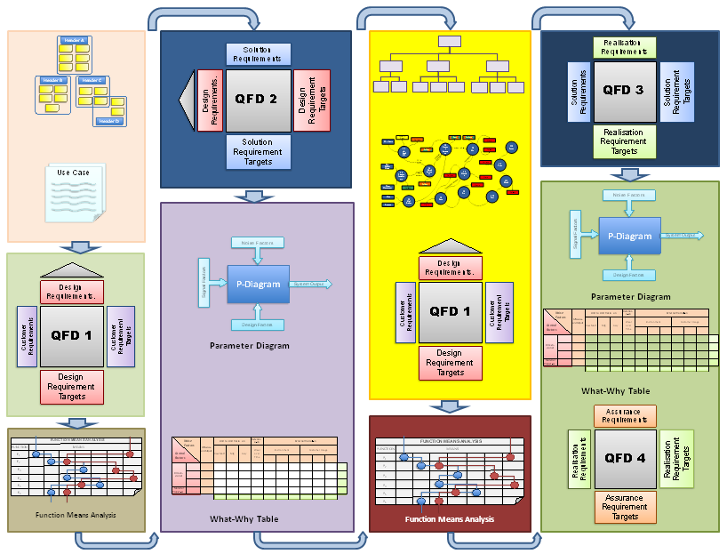
Figure 1 - Systems Engineering Toolset
The tool enabled the following:
- Stakeholder and customer requirements analysis
- Creation of safety requirements
- Functional decomposition and functional flow
- Concept generation
- Design comparisons and selection
- Hazard identification and qualitative risk assessment
- Identification of safety‑critical features
- Lifecycle safety consideration
The SE framework enabled traceability between hazards, requirements, functions, and design decisions. For a system operating near civilians and humanitarian convoys, this traceability was essential for achieving justified risk reduction instead of relying on assumptions.

Customer Requirements

Explicit Requirements
From the operation brief, the following explicit customer requirements were identified:
- Enable safe passage of light civilian vehicles through a mined route
- Operate within steep-walled desert terrain where diversion is not feasible
- Avoid use of helicopters or aerial systems
- Be transportable and deployable using light vehicles only
- Clear and mark a route rapidly to minimise time on operation
- Leave the route safe for subsequent non‑specialist civilian use
These requirements defined the operational envelope but did not state the safety constraints required to achieve them.

Derived Safety Requirements
Using SE requirements analysis, the Safety Lead derived additional safety requirements, including:
- Minimal use and carriage of energetic materials at forward locations
- Tolerance to small‑arms fire and fragmentation without inadvertent hazardous effects
- Fail‑safe behaviour in the event of mechanical or system malfunction
- Minimised exposure of personnel to mined areas during detection and clearance
- Avoidance of residual unexploded or hidden hazards following clearance
These derived safety requirements became constraints on concept development and ruled out several existing mine‑clearance approaches at an early stage.

Critical System Functionality
Functional decomposition was used to identify what the system must do before determining how it might be implemented. From a safety perspective, the following critical system functions were identified:
- Detect potential mine threats within the route corridor
- Neutralise or remove hazards sufficiently to allow safe vehicle passage
- Mark cleared routes clearly and unambiguously
- Maintain system stability and control on uneven terrain
- Prevent unintended hazardous initiation or escalation
- Transition to a safe state following failure
Separating function from implementation allowed the team to explore concepts without prematurely committing to unsafe or impractical solutions. This functional analysis was particularly important in avoiding reliance on methods unsuitable for light‑vehicle deployment or contested environments.

Concept and Design Choices

Concept Exploration Using SE Tools
A range of mine clearance methods were considered at a high level, informed by historical and current approaches. These included mechanically aggressive systems, energetically assisted clearance, and non‑intrusive detection‑led approaches.
Using systems‑engineering trade‑off analysis, each concept was assessed against safety, deployability, manufacturability, speed, and lifecycle risk. Concepts requiring heavy vehicles, extensive logistical support, or large quantities of energetic material were rejected early due to incompatibility with safety requirements and operational constraints.

Safety‑Driven Design Choices
From the Safety Lead perspective, concept selection prioritised:
- Reduced reliance on high‑energy clearance methods
- Solutions compatible with light‑vehicle transport and operation
- Concepts that limited secondary hazards such as fragmentation, blast, or residual unexploded material
- Predictable and repeatable behaviour, even if peak clearance rate was reduced
The selected concept represented a balance between rapid clearance and controlled risk, demonstrating how safety considerations influenced architecture rather than constraining it after the fact.

Identifying Failure Modes
Structured hazard identification techniques were applied across all lifecycle phases. Key potential failure modes included:
- False negatives during detection leading to uncleared hazards
- Mechanical failure resulting in loss of vehicle control in confined terrain
- Inadvertent activation due to environmental factors
- Misinterpretation or loss of route marking
- System immobilisation causing obstruction within the pass
Each failure mode was assessed qualitatively in terms of severity and likelihood. High‑consequence, low‑tolerance failures were targeted for design‑level mitigation rather than procedural reliance.

Identifying Critical Design Features
From the hazard and failure analysis, several safety‑critical design features were identified, including:
- Features ensuring stability and control on uneven or confined terrain
- Detection system performance thresholds tied to safe clearance assumptions
- Marking methods resistant to environmental degradation
- Physical separation and shielding of hazardous elements
- Design features enforcing safe states under fault conditions
The systems‑engineering process ensured these features were explicitly recognised and treated as safety‑critical, with implications for verification and manufacturing control.

Manufacturing
Although the design remained conceptual, manufacturing considerations were integrated early. From a safety standpoint, this was particularly important, as hazards often arise during manufacture and assembly rather than operational use.
Anticipated manufacturing considerations included:
- Fabrication of modular, lightweight subassemblies
- Integration of detection and marking systems
- Assembly sequences minimising human exposure to potential hazards
- Compatibility of materials under desert environmental conditions
Designs requiring complex or tightly controlled manufacturing environments were deprioritised in favour of robust, repeatable processes.

Identifying Critical Processes
Critical process steps were identified where variation or error could significantly increase risk. These included:
- Final system assembly and verification
- Integration of detection components
- Calibration and functional verification
- Packaging and transport preparation

Process Control Measures
Recognition of these steps informed both design simplification and identification of necessary process controls.
Applying the hierarchy of risk controls, the Safety Lead promoted:
- Inherent safety through design simplification
- Engineering controls to limit hazardous exposure
- Environmental and quality controls during manufacture
- Procedural controls only where design mitigation was not feasible
Residual risks were explicitly acknowledged, documented, and assigned ownership, supporting a defensible ALARP position consistent with safety-engineering best practice.

Disposal
End‑of‑life considerations were addressed as part of the overall system lifecycle. Disposal and removal from service were recognised as hazard‑bearing phases.
Safety‑driven design decisions reduced end‑of‑life risk by:
- Minimising hazardous materials within the system
- Enabling disassembly without specialist equipment
- Avoiding creation of long‑term residual hazards in cleared areas
This was critical given the humanitarian context and the likelihood of continued civilian interaction with the environment.

Conclusion
The application of a structured systems‑engineering toolset enabled the development of a portable mine detection, clearing, and marking system concept that balanced operational urgency with safety and lifecycle responsibility. From the Safety Lead perspective, the SE framework ensured that hazards were identified early, design decisions were informed by risk, and safety considerations were embedded into requirements, functions, and concept selection.
The approach demonstrated that safety is not a constraint on effectiveness, but a critical enabler of robust, deployable solutions in constrained humanitarian operations. Continued use of this integrated systems‑engineering approach is recommended for future concept refinement and qualification phases.

