
University of Wales Trinity Saint David, London

Assessment Title: Strategic Analysis of the Macro Marketing Environment and Organisational Responses in the Global AI Accelerator Industry: A Pioneer–Follower Comparison of Nvidia and AMD

Programme: Master of Business Administration
Module: Marketing Management (LCMB7024)
Lecturer: Dr Tushara Balendran
Student Name: Kamran Akhtar
Student ID: 2433466

Word Count: 2703
Submission Date: 20th November, 2025

Table of Contents
1. Introduction 1
2. Critical Analysis Of The Macro Marketing Environment 3
2.1 Overview of the Macro Marketing Environment 3
2.2 Selection of Two External Macro Marketing Actors 4
2.3 Critical Analysis of Each Actor 4
2.3.1 Technological Actor Analysis 4
2.3.2 Geopolitical & Regulatory Actor Analysis 6
3. Strategic Responses Of Pioneering & Follower Firms 8
3.1 Pioneering Organisations’ Strategic Responses: Nvidia 8
Ansoff’s Growth Matrix 9
Porter’s Generic Strategies 9
First-Mover Advantage Theory 10
Critical Evaluation 10
3.2 Follower Organisations’ Strategic Responses: AMD 11
Ansoff’s Growth Matrix 11
Porter’s Generic Strategies 12
Follower Strategy Theory 12
Critical Evaluation 12
4. Conclusion 13
Reference List 1

Table of Tables
Table 1: Comparative Strategic Advantages of Nvidia and AMD 10
Table 2: AMD’s Strategic Gaps vs Pioneer Capabilities 13
Table of Figures

Figure 1: Global AI Accelerator Market Forecast, 2025–2034 (USD Billion); Source: Market.us (2024). 1
Figure 2: Nvidia H100 GPU Shipments by Major Customers, 2023; Source: Omdia Research (cited in Gandhi, 2024). 2
Figure 3: Nvidia Stock Price Surge (2023–2025); Source: Statista (2025). 3
Figure 4: Nvidia vs AMD Data Centre Revenue (Quarterly); Source: bl0797 (2024), Reddit r/AMD_Stock. 5
Figure 5: Global AI Chip Market Size by Chipset Type (2024–2033); Source: Market.us (2024) 6
Figure 6: Worldwide Semiconductor Revenues and Year-on-Year Change, 2004–2024; Source: Semiconductor Industry Association (2024) 7
Figure 7: CHIPS Act Funding Breakdown; Source: Dreslinski (2024), SemiWiki. 8

Strategic Analysis of the Macro Marketing Environment and Organisational Responses in the Global AI Accelerator Industry:

A Pioneer–Follower Comparison of Nvidia and AMD

1. Introduction
The macro marketing environment is a set of external forces (political, economic, social, technological, environmental, and legal) that organisations cannot change but must strategically derive meaning from to remain competitive (Kotler and Keller, 2016). These forces in rapidly developing technology industries are disruptively evolving, and they render the environment turbulent and condition how firms respond. This volatility is evident in the AI accelerator industry, where demand for machine learning, cloud computing, and generative AI workloads is increasing exponentially. The future of the world market suggests an outstanding long-term growth in data-centre computing and edge-AI devices (The Business Research Company, 2024; Statista, 2024). These dynamics can be visualised in Figure 1: Global AI Accelerator Market Forecast 2025-2034, where the steady growth due to the increase in computational intensity and hyperscale investment can be observed.
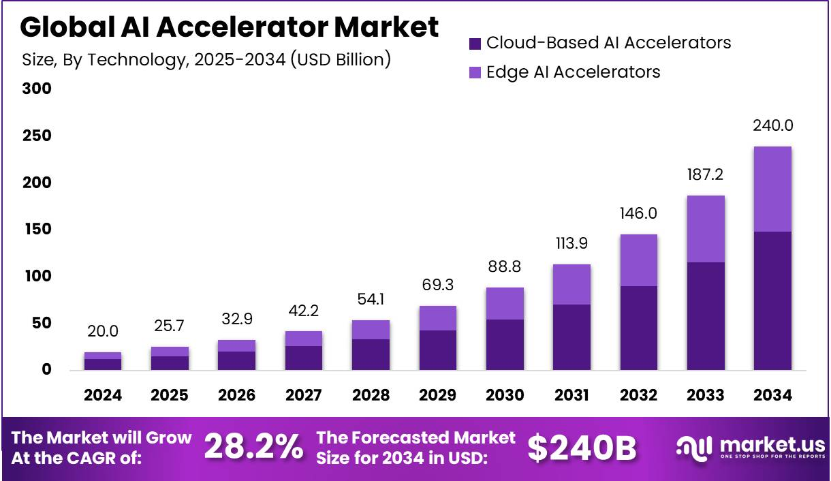
Figure 1: Global AI Accelerator Market Forecast, 2025–2034 (USD Billion); Source: Market.us (2024).
In this context, Nvidia is the first-mover company, using early architectural innovation, CUDA-based system lock-in and hyperscale data-centre customer deep integration (Lieberman and Montgomery, 1988; NVIDIA, 2024). AMD is a strategic follower innovator but vulnerable to scale effects and dependency, and a lack of policy leverage on the ecosystem effects (AMD, 2024; Kerin, Varadarajan and Peterson, 1992). Another indicator of the company’s strength is that Nvidia is heavily dependent on cloud providers, as shown in Figure 2: Nvidia H100 Shipments by Major Customers (Bloomberg, 2024).
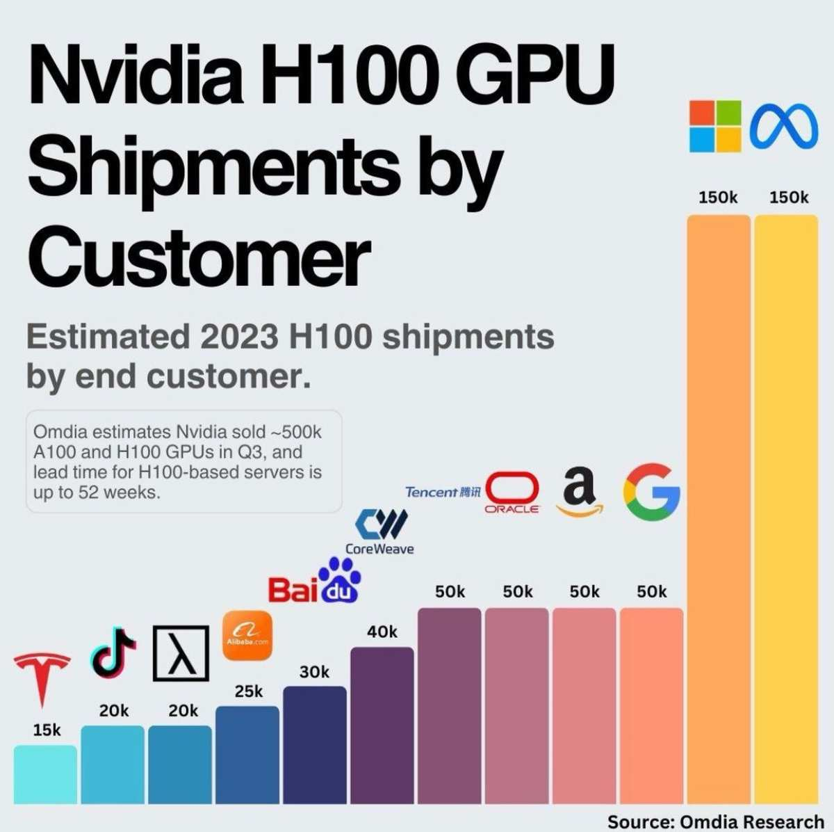
Figure 2: Nvidia H100 GPU Shipments by Major Customers, 2023; Source: Omdia Research (cited in Gandhi, 2024).
This assignment critically evaluates the macro forces that influence the industry of AI accelerators and compares how Nvidia and AMD respond. The discussion indicates that environmental scanning assists in strategic flexibility in an ever-evolving global marketplace.
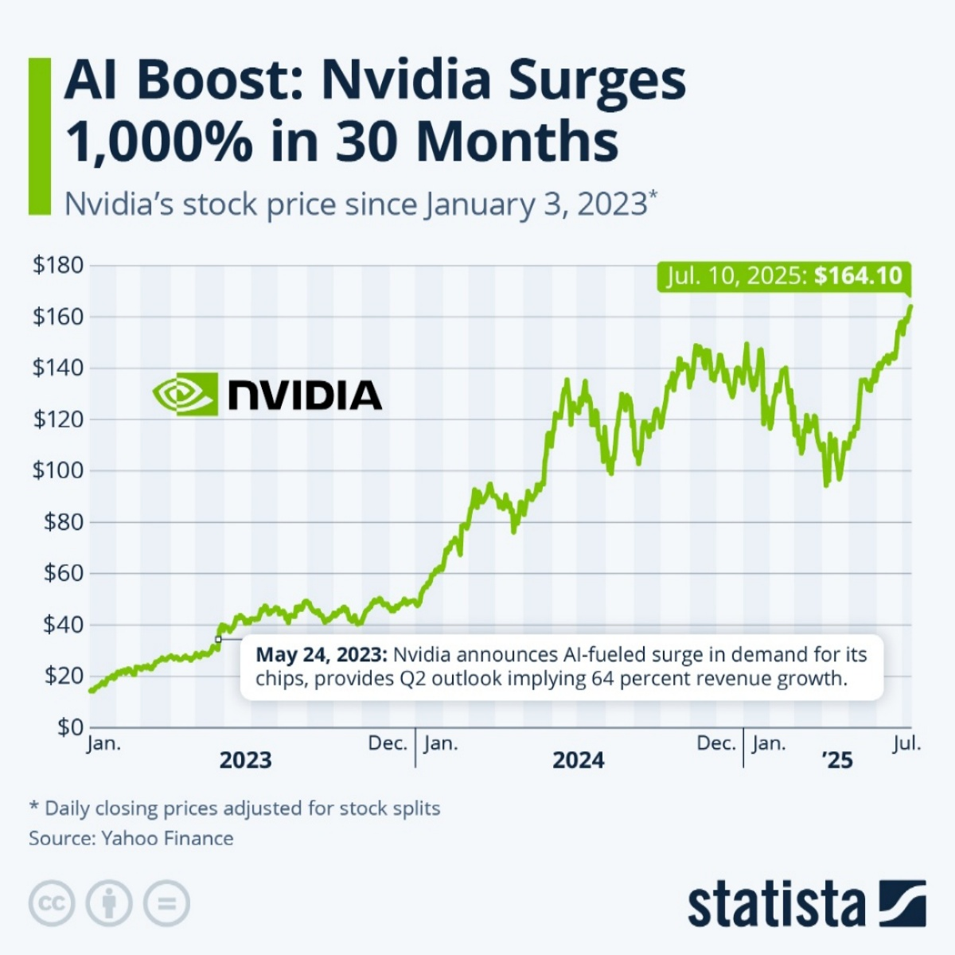
Figure 3: Nvidia Stock Price Surge (2023–2025); Source: Statista (2025).

2. Critical Analysis Of The Macro Marketing Environment

2.1 Overview of the Macro Marketing Environment
The macro marketing environment comprises external and uncontrollable political, economic, social, technological, environmental and legal forces that affect organisational decisions and long-term strategic path (Kotler and Keller, 2016). These forces develop at a fast pace in technology-intensive sectors like AI accelerators and semiconductors, and create high levels of volatility (McKinsey & Company, 2022). The growth in the number of machine learning, generative AI and cloud-based data-centre workloads keeps driving the demand for advanced compute globally, and establishes the conditions of innovation pressure, regulatory intervention, and supply-chain fragility (Statista, 2024; The Business Research Company, 2024). Recent market projections also support long-term multi-year growth in the use of AI chips in the data-centre and edge applications (Next Move Strategy Consulting, 2024).
In the case of AI chip manufacturers, including Nvidia and AMD, the macro forces dictate access to cutting-edge manufacturing nodes, affect investment flows and remodel the cost and performance equation of competition. Policy frameworks and conditions in the supply chain are interacting as breakthroughs, and hence the firms should always keep an eye on the macro environment to remain competitive, and where necessary, change their strategic decisions.

2.2 Selection of Two External Macro Marketing Actors
The technological and geopolitical/regulatory actors are analysed due to their greatest structural influence on the AI accelerator industry. The cost structures, performance differentiation and competitive positioning are directly influenced by technological forces such as the innovation in the architecture of GPUs, the integration of software ecosystems and reliance on the most advanced foundries (NVIDIA, 2024; AMD, 2024). Simultaneously, geopolitical and regulatory drivers, including the U.S.-China conflict on technology, the CHIPs Act subsidies and EU Chips Act interventions, are highly influential on accessibility to the market, resiliency on supply chains and investment incentives (European Commission, 2023; U.S. Government, 2022). These actors have the greatest impact on Nvidia and AMD since they are volatile and strategic.

2.3 Critical Analysis of Each Actor

2.3.1 Technological Actor Analysis
The greatest and most strategically disruptive player in the AI accelerator industry is the technological forces. The shift of the general-purpose GPUs to specialised AI hardware has increased the competitiveness and redefined performance standards (FourWeekMBA, 2024). Figure 4: Nvidia vs AMD Data Centre Revenue (2020-2025) indicates that the two companies are developing a larger gap in revenue, with Nvidia being dominant in training and inference workloads as cloud hyperscalers grow deployments of large-scale AI (Bloomberg, 2024; NVIDIA, 2024).
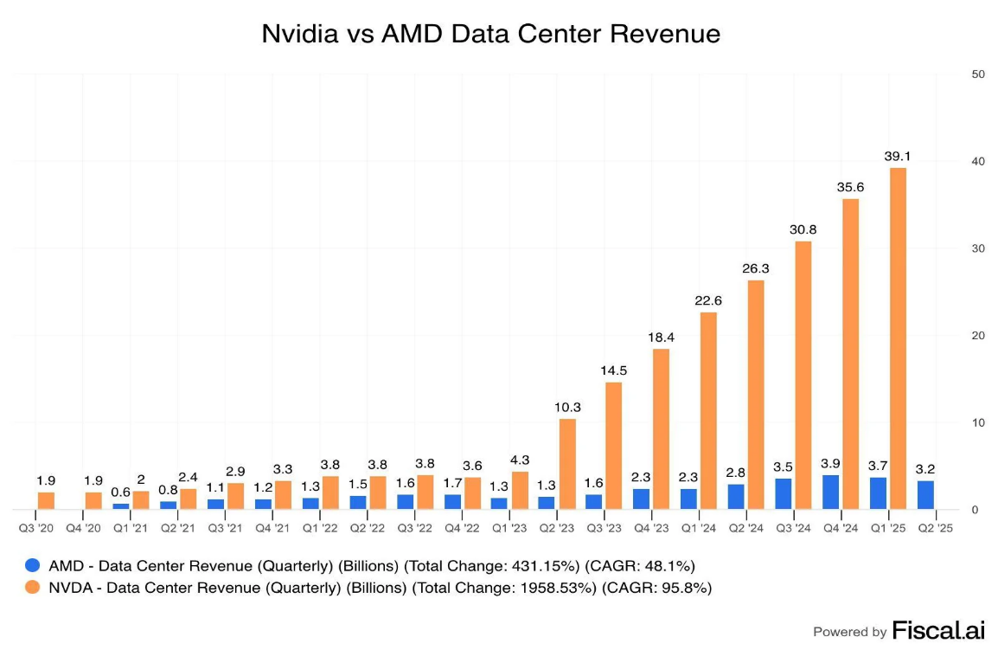
Figure 4: Nvidia vs AMD Data Center Revenue (Quarterly); Source: bl0797 (2024), Reddit r/AMD_Stock.
The groundbreaking nature of Nvidia can be attributed to its CUDA software stack, which serves as a proprietary development platform that is highly integrated into machine learning frameworks (NVIDIA, 2024). The broad library support and optimisation features of CUDA create lock-in within the ecosystem, with developers having high switching costs to other platforms (Lieberman and Montgomery, 1988). AMD’s ROCm platform remains open-source but still lacks full framework coverage and optimisation depth (AMD, 2024; Zhang, Gupta and Li, 2024). These shortcomings make ROCm less appealing to hyperscalers and increase the first-mover advantage of Nvidia.
This asymmetry is enhanced by the technological reliance on state-of-the-art foundries, such as those offered by TSMC 4nm and 5nm. Nvidia takes priority allocation in terms of more significant wafer commitments as well as high-end margins, which allows conducting faster product ramp-ups and enhancing supply reliability (Semiconductor Industry Association, 2024). Being a smaller follower with smaller volume orders, AMD has more limited production scheduling, making it less agile in case of demand spikes.
This is complicated further by the fact that cloud AI accelerators and edge-AI compute are divergent. Nvidia is also present at both levels with its H100/Blackwell data-centre chip and Jetson edge platform to make sure that there is architectural continuity between devices and the cloud (NVIDIA, 2024). The strategy of AMD is more focused on data-centre workloads, and its scope is restricted to diversified compute environments (AMD, 2024).
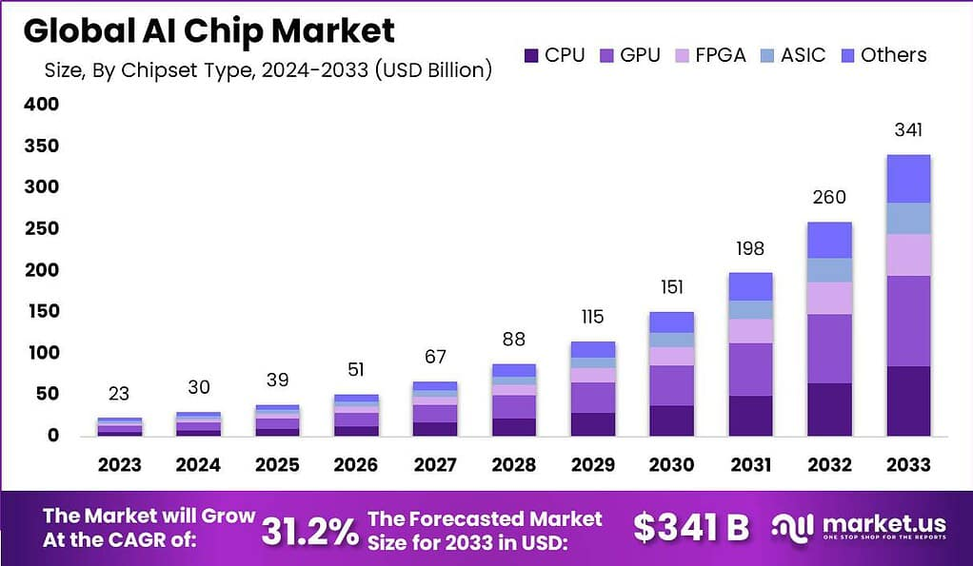
Figure 5: Global AI Chip Market Size by Chipset Type (2024–2033); Source: Market.us (2024)
Critical Evaluation:
The technological forces have disproportionate favours to pioneers due to barriers to entry caused by ecosystem maturity, architecture control, and learning-curve advantages (Grant, 2019). Nvidia enhances its influence in the market by vertical integration and high-speed innovation. As a competitive engineering, AMD faces structural drawbacks due to fragmentation of the ecosystem, limited leverage of the foundry and reduced product breadth. Thus, the technological player exacerbates strategic asymmetry in the long run between the first-mover and first-follower companies.

2.3.2 Geopolitical & Regulatory Actor Analysis
The second key macro player that determines strategic behaviour in the AI accelerator industry is geopolitical and regulatory forces. The technology rivalry between the U.S and China has redesigned the semiconductor flows in the world, investment incentives and market accessibility. Figure 6: Worldwide Semiconductor Revenues and Year-on-Year Change presents this volatility, which depicts players of a cycle of disruptions caused by export restrictions, supply crunch and geopolitical realignment (Semiconductor Industry Association, 2024; CSIS, 2024). These restrictions on exports of high-end GPUs to China have already started to redirect the global semiconductor trade routings (Apricitas Economics (Politano), 2023; CSIS, 2024). Though these limits apply equally to Nvidia and AMD, the implications of this fact in terms of strategy are quite distinct.
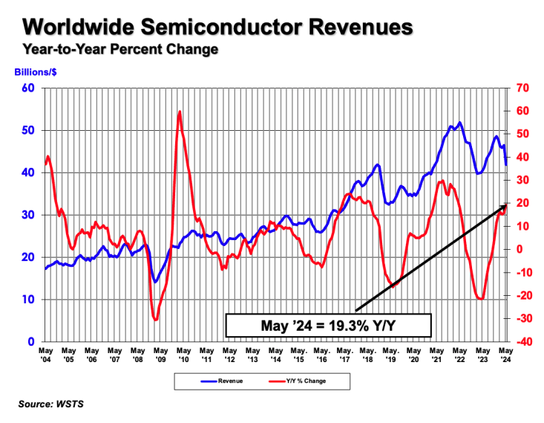
Figure 6: Worldwide Semiconductor Revenues and Year-on-Year Change, 2004–2024; Source: Semiconductor Industry Association (2024)
The wide range of product differentiation enables Nvidia to re-architect export-compliant versions of the GPUs to restricted markets without compromising the high-end market demand in the U.S and Europe (NVIDIA, 2024; FourWeekMBA, 2024). The downgraded designs offer less commercial advantage to AMD, which has a thinner performance ladder and hence less flexibility in the fastest-growing accelerator segments in the world (Statista, 2024). Therefore, export controls hinder the international expansion of AMD more as compared to Nvidia.
Competitive imbalances are also enhanced by regulatory initiatives. Figure 7: CHIPS Act Funding Allocation contains significant U.S. subsidies aimed at strengthening domestic fabrication, R&D and supply-chain resilience (U.S. Department of Commerce, 2024; Dreslinski, 2024). Nvidia has a strong opportunity to gain because of its deep ecosystem of innovation based in the United States and its strategic relationships with federal priorities. Similar structural incentives are given to AMD, but it does not have the same leverage of the ecosystem that Nvidia has, which makes the benefits of these policies less amplified (AMD, 2024).
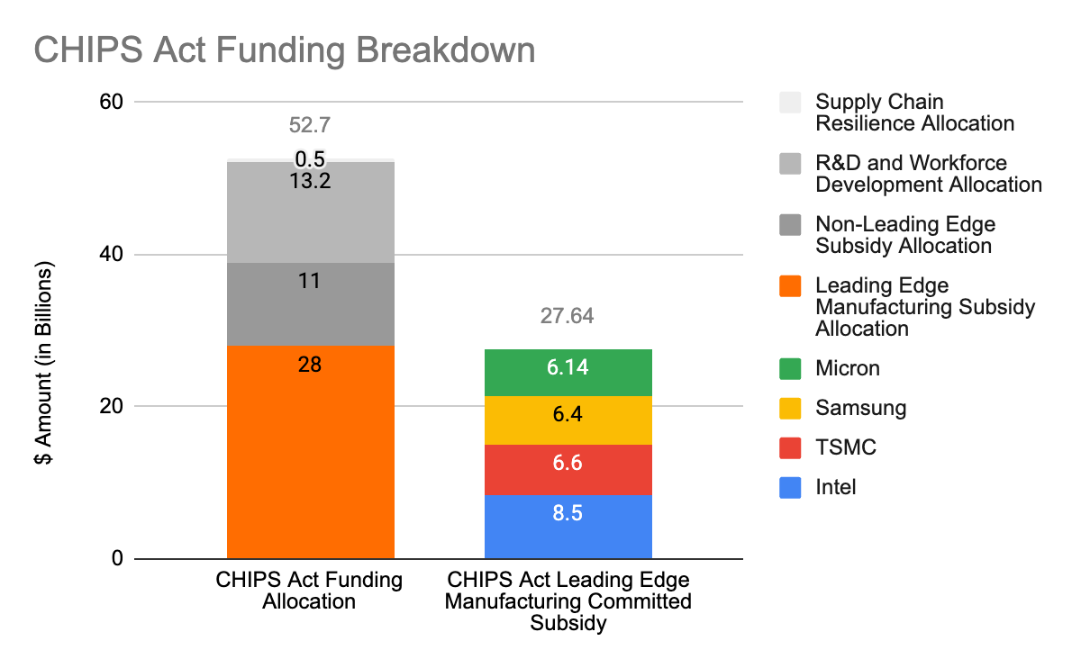
Figure 7: CHIPS Act Funding Breakdown; Source: Dreslinski (2024), SemiWiki.
In the U.S., Europe, through its E.U. Chips Act and Japan, in its METI, are trying to make Semiconductor sovereign and less dependent on external suppliers (European Commission, 2023).
Critical Evaluation:
Existence of geopolitical and regulatory forces increases pioneer advantage by creating access to markets, subsidising firms in alignment and creating competitive barriers with policies. Nvidia has had the benefit of finding shelter in American alignment of policies, widespread ecosystem applicability, and multinational Hyperscaler reliance. AMD encounters more stringent export controls, diminished leverage of policies, and diminished bargaining power in the supply chain. This drives the regulator to enhance strategic asymmetry between first-mover and second-mover companies.

3. Strategic Responses Of Pioneering & Follower Firms

3.1 Pioneering Organisations’ Strategic Responses: Nvidia
NVIDIA's strategic responses are based on its status as the first organisation in the AI accelerator industry. Its activity reflects its dynamic response to macro environmental forces through active adaptation proximate to the control of architecture level, scale benefits and software integration to maintain the leadership. The evaluation of these dynamics can be made through Ansoff, Porter and first-mover theory.

Ansoff’s Growth Matrix
Market Penetration:
The market penetration strategy of Nvidia is guided by active growth in data-centre sectors, which have been the main drivers of AI demand in the world. The H100 and the following-generation Blackwell designs enhance the market share of Nvidia among hyperscalers like Amazon, Microsoft, Google and Meta (Bloomberg, 2024; NVIDIA, 2024). Long-term procurement contracts strengthen switching costs and build platform stickiness.
Product Development:
The iterative architectural innovation is based on the continuous development of products at Nvidia. The history of Ampere, Hopper, and Blackwell features the ongoing strategy of performance scalability and graphical memory improvements and AI-specific acceleration (NVIDIA, 2024). These technologies are directly responding to the technological pressure and performance identified in Task 1.
Market Development:
Nvidia is also developing geographically by enabling sovereign AI deployment in the U.S., EU and Japan, aligning its hardware and software stack with policies of digital infrastructure in countries (European Commission, 2023). High correlation with regulatory agendas improves the qualification of Nvidia for the CHIPs Act and the EU Chips Act incentives.
Diversification:
Nvidia goes beyond silicon value capture through Omniverse (industrial simulation), networking (InfiniBand), and cloud-native AI services, which together reduce dependence on pure GPU sales cycles (NVIDIA, 2024; FourWeekMBA, 2024).

Porter’s Generic Strategies
Nvidia integrates differentiation and cost leadership. Its unique CUDA ecosystem has been the basis of differentiation and allows programmable AI workflows and developer lock-in (Lieberman and Montgomery, 1988). The economies of scale, advanced manufacturing, and alignment of production into 5nm result in cost leadership, which results in the creation of favourable cost-per-watt and cost-per-operation values (Semiconductor Industry Association, 2024).

First-Mover Advantage Theory
The initial investment made by Nvidia in GPGPU technology generated learning-curve advantages, in which the accrual of engineering experience faster innovation in the future (Tellis and Golder, 1996). The high usage of CUDA leads to network effects as developers make more CUDA-reliant models, making switching costs higher. Its ecosystem, hardware, software, networking and cloud platform acts as a moat.

Critical Evaluation
Even though Nvidia has a good strategic position, its strength is not indubitable. The reliance of the firm on TSMC to supply advanced nodes makes the supply vulnerable (Semiconductor Industry Association, 2024). Export controls restrict access to China, which is one of the biggest markets for GPUs (U.S. Government, 2022). Furthermore, the increasing geopolitical disintegration and possible regulatory review of the monopolistic market share of Nvidia present other strategic threats. However, more proactive, innovation-driven reactions, as well as that of ecosystem coherence, remain to enhance the pioneering position of Nvidia and increase competitive distinction.
Table 1: Comparative Strategic Advantages of Nvidia and AMD
Strategic Dimension | Nvidia (Pioneer) | AMD (Follower)
Software Ecosystem | Proprietary CUDA lock-in, extensive optimisation | ROCm open-source ecosystem, narrower optimisation
Foundry Leverage | Priority access to TSMC 4nm/5nm | Lower wafer allocation priority
Data Centre Position | Hyperscaler default choice | Selective hyperscaler adoption
Network Effects | Strong (CUDA + libraries) | Limited network effects
Product Scope | AI accelerators, networking, simulation | GPUs, CPUs, FPGA integration
Source: Compiled from NVIDIA (2024), AMD (2024), Bloomberg (2024), McKinsey & Company (2022) and Semiconductor Industry Association (2024).

3.2 Follower Organisations’ Strategic Responses: AMD
Since the follower organisation, AMD, will take strategies to reduce its performance, ecosystem and market-access gap with Nvidia. Flexibility and fast-follower learning are beneficial to AMD, whereas structural disadvantages in software maturity, foundry prioritisation and regulatory exposure remain in its strategic posture.

Ansoff’s Growth Matrix
Market Penetration:
The Instinct MI200-MI300 series, the cheaper alternative to the H100 and next-generation Blackwell of Nvidia, reinforces its data-centre presence. Relying on the chiplet integration, MI300X is aimed at hyperscalers in need of diversification and better bargaining power (Bloomberg, 2024). Nonetheless, adoption is even less widespread since more performance optimisation requires ROCm compatibility, which is yet to reach the maturity of CUDA (Chen et al., 2024).
Market Development:
AMD offers its market access via clouds, especially Microsoft Azure and Oracle Cloud Infrastructure, in which AMD accelerator allows training, inference, and HPC workloads (IEA, 2024). Such alliances allow large-scale deployments, but adoption is workload-specific because of limitations to optimisation.
Diversification:
The acquisition of Xilinx not only increases the diversification strategy of AMD but also incorporates adaptive computing and FPGA (AMD, 2024). This expands the value proposition of AMD in data-centre networking and embedded systems, which is architecturally flexible and challenging Nvidia to match. However, integration synergies are not fully developed yet, and performance leadership is focused on the wider stack of Nvidia.

Porter’s Generic Strategies
AMD pursues a cost-differentiation hybrid business that is facilitated by chiplet architecture. Chiplets minimise the waste of wafer and enable modular scaling, which is beneficial in promoting the cost-per-compute efficiency in the workloads of choice (MarkLines, 2025). This is in contrast to Nvidia's monolith approach of 5nm and places AMD as a good alternative to organisations that focus on cost or open-ecosystem preference.
Nonetheless, the ability to differentiate is limited since the depth of optimisation and software tools in ROCm is much less than the ones found in CUDA (Zang et al., 2024). Consequently, AMD does not compete with ecosystem dominance, but with value-performance trade-offs.

Follower Strategy Theory
Being a rapid follower, AMD has the advantage of watching the architectural line of Nvidia and matching its roadmap to it (Kerin et al., 1992). The MI300 series represents the same strategy, and it is a direct opposition to Nvidia in its Hopper architecture with high-bandwidth memory scaling and multi-die integration (Bloomberg, 2024). Nonetheless, AMD has long-term lapses in execution: The ROCm compatibility is still not full-fledged on most AI models, especially LLMs; Foundry capacity constraints limit the capabilities of AMD to scale volumes because TSMC favours Nvidia on new nodes; and the availability of high switching costs deters customers from abandoning CUDA-based workflows. These problems limit the capability of AMD to transform rapid follower learning into permanent market share growth.

Critical Evaluation
Despite its agility and architecture advantages, AMD is less competitive than it can be due to the ecosystem maturity, reliance on open-source environments and inferior leverage in subsidy-based or export-restricted markets. The U.S. export restrictions target AMD scaling opportunities in China, where the product differentiation is more substitutable than that of Nvidia (U.S. Government, 2022). Moreover, AMD does not have the same reach in hyperscalers, whose tools and model architectures are still highly CUDA-dependent.
On the whole, the strategy of AMD helps to reduce some of the gaps, but structural drawbacks persist, which supports the pioneer status of Nvidia.
Table 2: AMD’s Strategic Gaps vs Pioneer Capabilities
Strategic Dimension | AMD (Follower) | Nvidia (Pioneer)
Software Ecosystem | ROCm (limited optimisation) | CUDA (industry standard)
Foundry Access | Lower wafer priority | High priority at TSMC
Cloud Adoption | Selective workloads | Broad hyperscaler integration
R&D Leverage | Reactive to Nvidia roadmap | Defines industry roadmap
Market Influence | Moderate | Dominant
Source: Compiled from AMD (2024), NVIDIA (2024), Bloomberg (2024), and U.S. Department of Commerce (2024).

4. Conclusion
It has been shown that the macro marketing environment, in particular, technological, geopolitical and regulatory forces, decisively influence the competitive direction of the global AI-accelerator industry. Task 1 revealed that technology-driven markets develop in a highly volatile environment, in which a high rate of architectural change, changing foundry capacity, export controls and subsidy competition place unequal pressures on companies. These pressures enhance the structural power of first movers like Nvidia, which have early ecosystem-building, software lock-in and network effects that enable it be able to transform environmental shocks into strategic opportunities. In comparison, follower organisations like AMD have greater adaptation costs and reduced strategy space as they need to adapt to conditions mostly determined by pioneers and policy-makers.
Nvidia employs an aggressive, innovation-driven stance, utilising the growth paths and differentiation tactics of Ansoff to further resist market dominance and venture into related areas such as sovereign AI and digital simulation. AMD approaches are more reactive: it relies on fast-follower learning, cloud relationships and chiplet-based efficiencies to fill the essential gaps, but it still has limitations associated with software maturity, foundry prioritisation, and high customer switching costs.
Throughout both companies, one drive stands out clearly, and that is that environmental scanning is not just a planning tool but a strategic defence tool. When firms read macro cues early and transform their capabilities as a result, they will be better placed to respond to technological disruption and intervention of the government. To pioneers, this strengthens their leadership; to followers, it relates to whether they will be able to use external shocks to recover competitively or go into strategic decay.

Reference List
- Advanced Micro Devices Inc. (AMD) (2024) Form 10-K: Annual Report for the Fiscal Year Ended 30 December 2023. Santa Clara, CA: AMD. Available at:
https://ir.amd.com/financial-information/sec-filings/content/0001193125-25-067185/0001193125-25-067185.pdf (Accessed: 19 November 2025).
- Apricitas Economics (Politano, J.) (2023) ‘America & China's Chip Race’. Apricitas Economics Blog. Available at: https://www.apricitas.io/p/america-and-chinas-chip-race (Accessed: 19 November 2025).
- Barney, J.B. and Hesterly, W.S. (2019) Strategic Management and Competitive Advantage. 6th edn. Harlow: Pearson.
- bl0797 (2024) Nvidia vs AMD Data Center Revenue. Reddit – r/AMD_Stock. Available at: https://www.reddit.com/r/AMD_Stock/comments/1mil8mi/nvidia_vs_amd_data_center_revenue/ (Accessed 19 November 2025).
- Chen, H., Park, J. and Srinivasan, R. (2024) ‘Benchmarking next-generation AI accelerators: Nvidia Hopper vs AMD MI300’, IEEE Micro, 44(2), pp. 60–77. IEEE.
- CSIS – Center for Strategic and International Studies (2024) China’s Semiconductor Industry Advances despite U.S. Export Controls. Available at: https://www.csis.org/analysis/chinas-semiconductor-industry-advances-despite-us-export-controls (Accessed: 19 November 2025).
- Dreslinski, R. (2024) ‘The Case for U.S. CHIPS Act 2’, SemiWiki, 26 June. Available at: https://semiwiki.com/semiconductor-services/345889-the-case-for-u-s-chips-act-2/ (Accessed: 19 November 2025).
- FourWeekMBA (2024) ‘AMD business model explained’. Available at:
https://fourweekmba.com/amd-business-model
(Accessed: 19 November 2025).
- FourWeekMBA (2024) ‘How does Nvidia make money? Nvidia business model explained’. Available at:
https://fourweekmba.com/nvidia-business-model
(Accessed: 19 November 2025).
- Gandhi, K.T. (2024) ‘What is NVIDIA’s H100 — A brief look at the AI industry’s new gold’, Medium, 23 January. Available at: https://generativeai.pub/what-is-nvidias-h100-a-brief-look-at-the-ai-industries-new-gold-26a2f1083025 (Accessed 20 November 2025).
- Grant, R.M. (2019) Contemporary Strategy Analysis. 10th edn. Hoboken, NJ: John Wiley & Sons.
- Johnson, G., Whittington, R., Regnér, P., Angwin, D. and Scholes, K. (2020) Exploring Strategy: Text and Cases. 12th edn. Harlow: Pearson.
- Kerin, R.A., Varadarajan, P.R. and Peterson, R.A. (1992) ‘First-mover advantage: A synthesis, conceptual framework, and propositions’, Journal of Marketing, 56(4), pp. 33–52. Available at: https://doi.org/10.2307/1251985 (Accessed: 19 November 2025).
- Kotler, P. and Keller, K.L. (2016) Marketing Management. 15th edn. Harlow: Pearson Education.
- Lieberman, M.B. and Montgomery, D.B. (1988) ‘First-mover advantages’, Strategic Management Journal, 9(S1), pp. 41–58. Available at: https://onlinelibrary.wiley.com/doi/10.1002/smj.4250090706 (Accessed: 19 November 2025).
- MarkLines (2025) China Automotive Semiconductor Development Trends. Available at: https://www.marklines.com/en/report/rep2787_202501 (Accessed: 20 November 2025).
- Market.us (2024) AI Accelerator Market Size 2025–2034. Available at: https://market.us/report/ai-accelerator-market/ (Accessed: 19 November 2025).
- Market.us (2024) Global AI Chip Market Size by Chipset Type, 2024–2033. Available at: https://market.us/report/ai-chip-market/ (Accessed: 19 November 2025).
- McKinsey & Company (2022) The Semiconductor Decade: A Trillion-Dollar Industry. Available at: https://www.mckinsey.com/industries/semiconductors/our-insights/the-semiconductor-decade-a-trillion-dollar-industry (Accessed: 19 November 2025).
- Next Move Strategy Consulting (2024) AI Chip Market Size and Forecast, 2025–2030. Available at: https://www.nextmsc.com/report/artificial-intelligence-chip-market (Accessed: 19 November 2025).
- NVIDIA Corporation (2024) Form 10-K: Annual Report for the Fiscal Year Ended 28 January 2024. Santa Clara, CA: NVIDIA. Available at: https://s201.q4cdn.com/141608511/files/doc_financials/2024/q4/1cbe8fe7-e08a-46e3-8dcc-b429fc06c1a4.pdf (Accessed: 19 November 2025).
- Porter, M.E. (1985) Competitive Advantage. New York: Free Press.
- Semiconductor Industry Association (2024) Global semiconductor sales increase 15.2% year-to-year in January. Available at: https://www.semiconductors.org/global-semiconductor-sales-increase-15-2-year-to-year-in-january/ (Accessed 19 November 2025).
- Statista (2022) ‘Supply chain disruptions make a comeback – index of global supply chain disruptions from 2019 to 2021’. Available at:
https://www.statista.com/chart/25960/supply-chain-disruptions-make-a-comeback (Accessed: 19 November 2025).
- Statista (2024) ‘Data centers almost sole driver of Nvidia’s revenue boom – quarterly revenue by segment FY 2022–FY 2025’. Available at:
https://www.statista.com/chart/25578/data-centers-almost-sole-driver-of-nvidias-revenue-boom (Accessed: 19 November 2025).
- Statista (2025) AI boost: Nvidia surges 1,000% in 30 months – Nvidia’s stock price since January 3, 2023. Available at: https://www.statista.com/chart/32358/nvidia-share-price/ (Accessed 19 November 2025).
- Tellis, G.J. and Golder, P.N. (1996) ‘First to market, first to fail?’, Sloan Management Review, 37(2), pp. 65–75. Available at: https://sloanreview.mit.edu/article/first-to-market-first-to-fail (Accessed: 19 November 2025).
- The Business Research Company (2024) AI Accelerator Global Market Report 2025. Available at: https://www.thebusinessresearchcompany.com/report/ai-accelerator-global-market-report (Accessed: 19 November 2025).
- The Business Research Company (2024) Artificial Intelligence Chip Global Market Report 2025. Available at: https://www.thebusinessresearchcompany.com/report/artificial-intelligence-chip-global-market-report (Accessed: 19 November 2025).
- U.S. Department of Commerce (2024) Public Report on the Use of Mature-Node Chips. Bureau of Industry and Security. Available at:https://www.bis.gov/press-release/bis-publishes-assessment-use-mature-node-chips (Accessed: 19 November 2025).
- World Semiconductor Trade Statistics (WSTS) (2024) Spring 2024 Semiconductor Market Forecast. Available at: https://www.wsts.org/76/103/WSTS-Semiconductor-Market-Forecast-Spring-2024 (Accessed: 19 November 2025).
- Zhang, Y., Gupta, V. and Li, Q. (2024) ‘Performance analysis of CUDA and ROCm frameworks for deep learning workloads’, Journal of Parallel and Distributed Computing, 186, pp. 45–59. Elsevier.

