  Component One:  What are the key skills required when working in the housekeeping team? 750 words (+/- 10%)  Contribution to Overall Module Assessment: 25% | Student No: | 2208277
 | Module Title: | Operating Hotel Facilities
 | Module Code: | BMIH4006
 | Lecturer: | Lola Villard
In my opinion, when working in a housekeeping team, there are several key skills that can contribute to your effectiveness and success in the role. These skills include:
Cleaning and Sanitization: A strong understanding of cleaning techniques, products, and equipment is essential. You should know how to properly clean and sanitize different areas, surfaces, and items in a thorough and efficient manner.
Attention to Detail: Housekeepers need to be meticulous and have an eye for detail. This involves noticing and addressing even the smallest cleanliness issues or maintenance needs to ensure a pristine environment for guests or residents.
Time Management: Housekeeping often involves multiple tasks and tight schedules. Effective time management skills are crucial to complete assignments within designated timeframes while maintaining quality standards. (Raghubalan, G. and Raghubalan, S. 2016)
Organization and Planning: Being organized is vital in housekeeping to keep track of tasks, prioritize work, and manage supplies and inventory. Planning skills help in allocating time and resources effectively and anticipating any potential challenges.
Communication Skills: Effective communication is necessary when working with team members, supervisors, and sometimes guests or residents. Clear and polite communication ensures tasks are understood, feedback is provided, and any issues or concerns are addressed promptly. (Casado, M. , 2012)
Problem-Solving: Housekeepers often encounter unexpected challenges, such as difficult stains, maintenance issues, or special requests. Strong problem-solving skills enable you to find solutions quickly and efficiently, ensuring guest satisfaction.
Professionalism and Discretion: Housekeepers often work in private or sensitive areas, such as hotel rooms or residential spaces. Demonstrating professionalism, respecting privacy, and maintaining confidentiality are essential attributes for this role. (Gebbels,2020, pp.126-147)
Adaptability: Housekeeping teams need to adapt to changing circumstances, such as fluctuating occupancy rates, varying guest preferences, or last-minute requests. Flexibility and the ability to adjust your approach to meet evolving needs are important. (Gebbels,2020, pp.126-147)
Teamwork: Housekeeping is often a collaborative effort. Being a team player, cooperating with colleagues, and assisting others when needed fosters a positive work environment and helps ensure tasks are completed efficiently. For example, from my experience at the hotel as a student it happened once, in my first day at the placement I have forgot to put new towels therefore the quest was angry, and they complained at the front desk. In that situation I took the ownership and I apologies because it was just my first day as housekeeper, and I went and the we have set all they need in bathroom one off the team helped me and encourage me to carry on , never give up , everyone makes mistakes but its important what you learned from it. I have realized how important is to have the ability to work as a team and help each other when they need and don’t let them behind . ( Graham Gibbs reflexion )
Top of Form
When it comes to applying theoretical knowledge in the hospitality industry, it is crucial to bridge the gap between what is learned in theory and how it is practically implemented in real-world scenarios. So therefore, let’s see few examples.
Cleaning Techniques and Products: Understanding different cleaning techniques and products allows housekeeping staff to effectively and safely clean various surfaces and materials. For instance, knowing the appropriate cleaning agents for different types of flooring or understanding how to handle delicate fabrics in hotel rooms ensures proper care and maintenance. (Cottrell, S. 2019)
Safety and Sanitation Regulations: Knowledge of safety and sanitation regulations is essential in maintaining a clean and hygienic environment. Being aware of industry-specific guidelines and best practices ensures compliance and helps prevent the spread of infections or diseases. This includes proper handling and disposal of waste, using personal protective equipment (PPE), and adhering to food safety protocols.
Sustainability Practices: Theoretical knowledge about sustainable practices in housekeeping, such as energy-efficient cleaning methods, waste reduction, and eco-friendly product usage, can be applied in the industry. Implementing these practices not only minimizes the environmental impact but also aligns with the growing demand for sustainable hospitality options. (Cottrell, S. 2019)
Now, let's discuss why these topics are important in the hospitality industry:
Guest Satisfaction: The cleanliness and overall hygiene of a hotel or accommodation greatly impact guest satisfaction. A clean and well-maintained environment creates a positive impression and enhances the guest experience. By applying theoretical knowledge, housekeeping teams can consistently deliver high standards of cleanliness, resulting in increased guest satisfaction and loyalty. (Heppell, M, 2015).
Health and Safety: In the hospitality industry, ensuring the health and safety of guests and staff is of utmost importance. Proper cleaning techniques, sanitation practices, and adherence to regulations help prevent the spread of illnesses, maintain a healthy environment, and mitigate any potential hazards. This is particularly crucial during times like the COVID-19 pandemic, where cleanliness and hygiene have gained even more significance. (Mullins, L. and Dossor, P. 2013)
Reputation and Brand Image: A hotel's reputation and brand image heavily rely on its cleanliness standards. Positive guest reviews and word-of-mouth recommendations often emphasize the cleanliness of accommodations. Applying theoretical knowledge in housekeeping contributes to maintaining a positive reputation, attracting more guests, and building a strong brand image. ( Tesone, V. 2014)
Efficiency and Cost-Effectiveness: Applying theoretical knowledge can help improve the efficiency of housekeeping operations. For instance, understanding proper cleaning techniques and time management strategies allows teams to complete tasks more quickly and effectively. This efficiency leads to cost savings, as it optimizes labour and resource utilization. (Walker, J.R., 2021).
In conclusion, applying theoretical knowledge in the hospitality industry, particularly in housekeeping, is crucial for guest satisfaction, health and safety, reputation management, and operational efficiency. By effectively bridging the gap between theory and practice, housekeeping teams can uphold high cleanliness standards and contribute to the overall success of hospitality establishments. Developing and honing these skills can significantly contribute to your effectiveness and success when working in a housekeeping team. Top of Form

Word Count | 800

Component Two:
Contribution to Overall Module Assessment: 25%
In this scenario – You have just been promoted to team leader for a floor within the hotel. A guest complains that on their arrival, their room had not been properly cleaned. Create an action plan and answer the following questions.

Problem | Why did it happen? | What are you going to do? | How will you prevent this from happening in the future? | What measures would you introduce to improve team effectiveness?
Room not been cleaned. | It happened because not enough training, the supervisor has not checked after the associates, it could happen because they been distracted by someone, not having a quality vacuum. (Bridger, E.(2018) | I am going to do consistent training in the morning and all the supervisors needs to check after the keeper or call when they ready before any companies.  Motivation for team when they are doing great. I will remember to the team we need to help each other and when they need support should always as for it  (Rogers, T. (2008) | I would create posters in the office as everyone can see, any new keeper put it in training with a veteran.  Requesting new vacuum or checking if they damaged before the shift.  Motivation for team every day.  Choosing the cleaning products carefully.  (Quick, L. 2020) | I would recommend to all the housekeeper to have a radio, that will be easy for them calling of any damages or if they need help form supervisor.  I will improve the floor workers trolley carefully. More investment in staff training. Organization every day that’s the key.  (Jones, T. 2010)  (Fallon, M. & Rutherford, D.(2010)

Component Three:
Contribution to Overall Module Assessment: 50%
Your task is to create and prepare a presentation following the detailed scenario provided below.

As the floor housekeeping manager and given the recent guest complaints you need to put together a basic training presentation for your colleagues within the housekeeping team to get the best out of them, ensure that brand standard is being achieved and that Health and Safety procedures are also being followed.

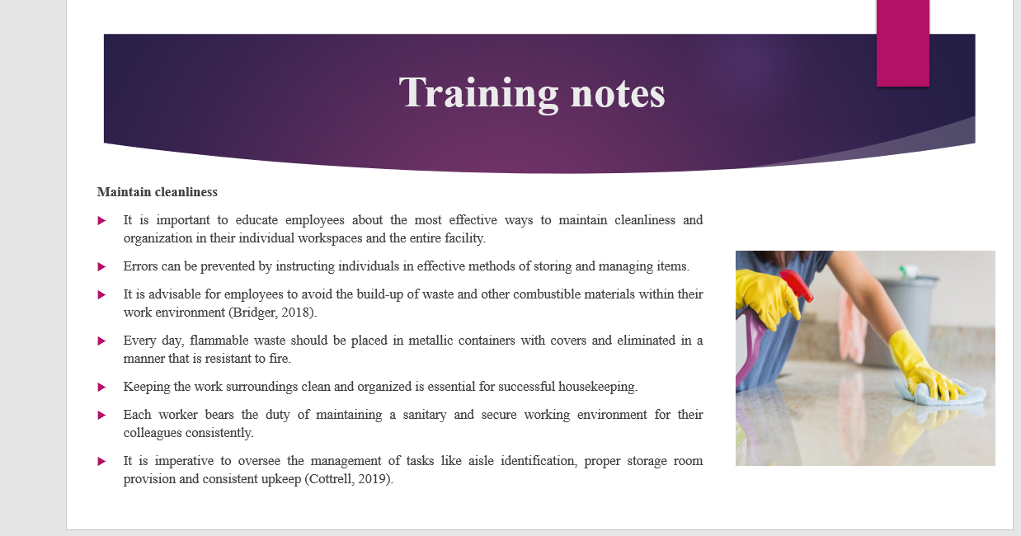

Training Notes:

Maintain cleanliness
It is important to educate employees about the most effective ways to maintain cleanliness and organization in their individual workspaces and the entire facility. Errors can be prevented by instructing individuals in effective methods of storing and managing items. It is advisable for employees to avoid the build-up of waste and other combustible materials within their work environment (Bridger, 2018). Every day, flammable waste should be placed in metallic containers with covers and eliminated in a manner that is resistant to fire. Keeping the work surroundings clean and organized is essential for successful housekeeping. Each worker bears the duty of maintaining a sanitary and secure working environment for their colleagues consistently. It is imperative to oversee the management of tasks like aisle identification, proper storage room provision and consistent upkeep (Cottrell, 2019).

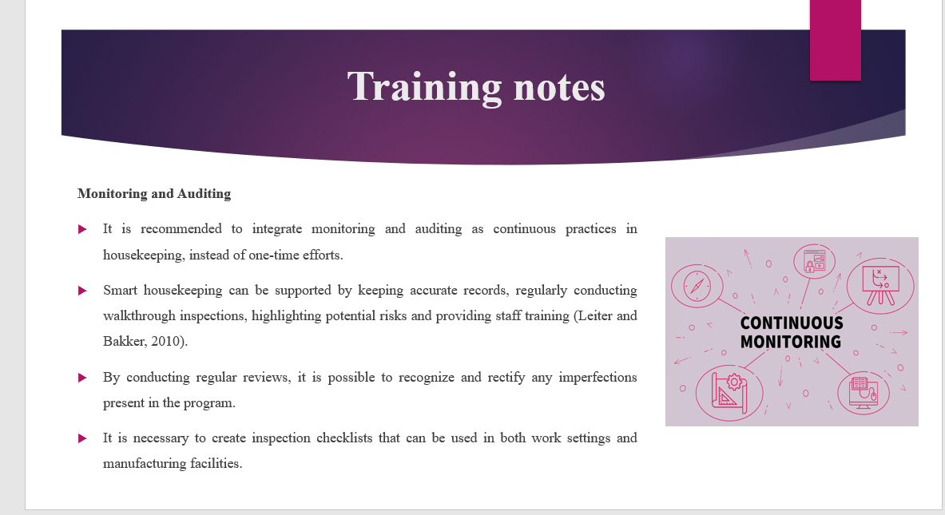

Training Notes:
Monitoring and Auditing
It is recommended to integrate monitoring and auditing as continuous practices in housekeeping, instead of one-time efforts. Smart housekeeping can be supported by keeping accurate records, regularly conducting walkthrough inspections, highlighting potential risks and providing staff training (Leiter and Bakker, 2010). By conducting regular reviews, it is possible to recognize and rectify any imperfections present in the program. It is necessary to create inspection checklists that can be used in both work settings and manufacturing facilities.

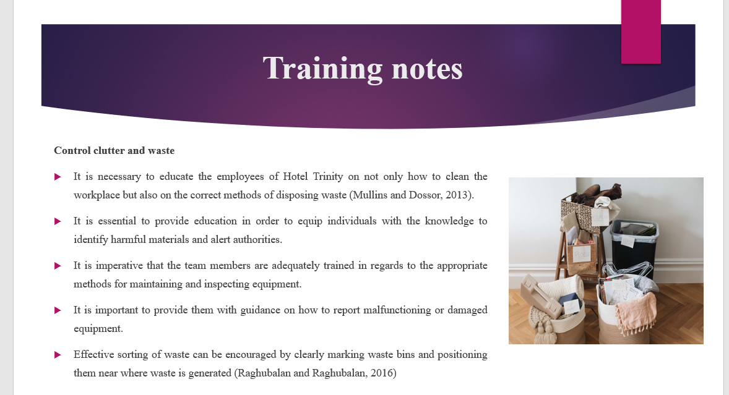

Training Notes:
Control clutter and waste
It is necessary to educate the employees of Hotel Trinity on not only how to clean the workplace but also on the correct methods of disposing waste (Mullins and Dossor, 2013). It is essential to provide education to equip individuals with the knowledge to identify harmful materials and alert authorities. It is imperative that the team members are adequately trained regarding the appropriate methods for maintaining and inspecting equipment. It is important to provide them with guidance on how to report malfunctioning or damaged equipment. Assist in upholding a tidy and systematic establishment by regularly gathering, categorizing, and reusing scrap metal. Effective sorting of waste can be encouraged by clearly marking waste bins and positioning them near where waste is generated (Raghubalan and Raghubalan, 2016).
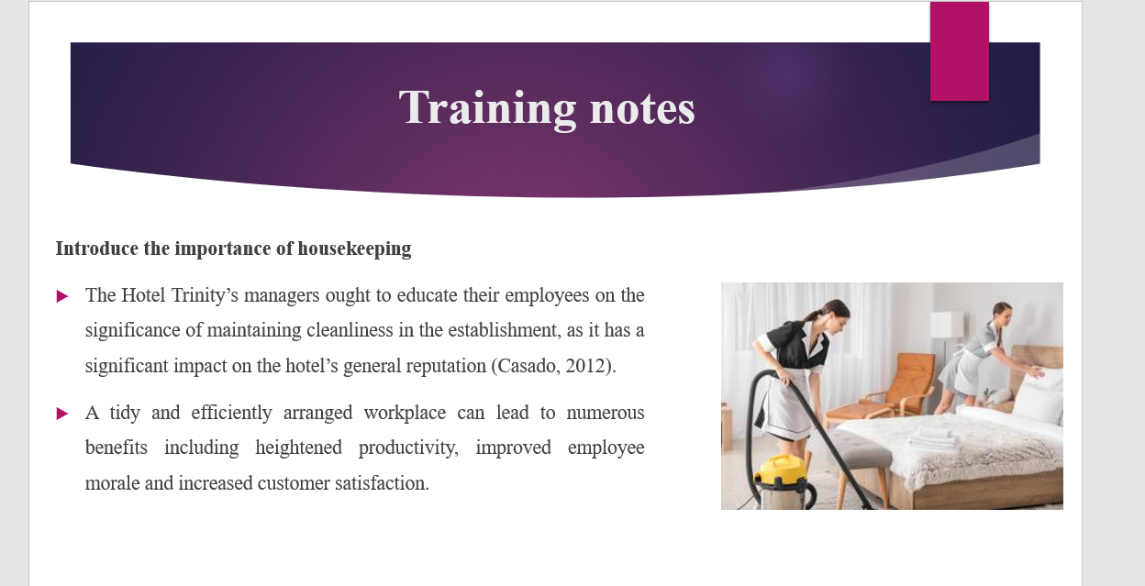

Training Notes:

Introduce the importance of housekeeping
The Hotel Trinity’s managers ought to educate their employees on the significance of maintaining cleanliness in the establishment, as it has a significant impact on the hotel’s general reputation (Casado, 2012). A tidy and efficiently arranged workplace can lead to numerous benefits including heightened productivity, improved employee morale and increased customer satisfaction.

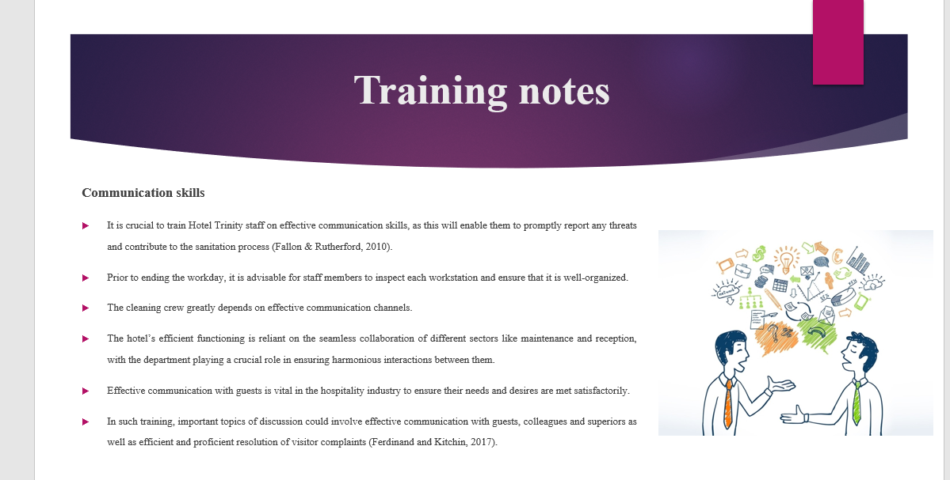

Training Notes:

Communication skills
It is crucial to train Hotel Trinity staff on effective communication skills, as this will enable them to promptly report any threats and contribute to the sanitation process (Fallon & Rutherford, 2010). Prior to ending the workday, it is advisable for staff members to inspect each workstation and ensure that it is well-organized. The cleaning crew greatly depends on effective communication channels. The hotel’s efficient functioning is reliant on the seamless collaboration of different sectors like maintenance and reception, with the department playing a crucial role in ensuring harmonious interactions between them. Effective communication with guests is vital in the hospitality industry to ensure their needs and desires are met satisfactorily. In such training, important topics of discussion could involve effective communication with guests, colleagues and superiors as well as efficient and proficient resolution of visitor complaints (Ferdinand and Kitchin, 2017).

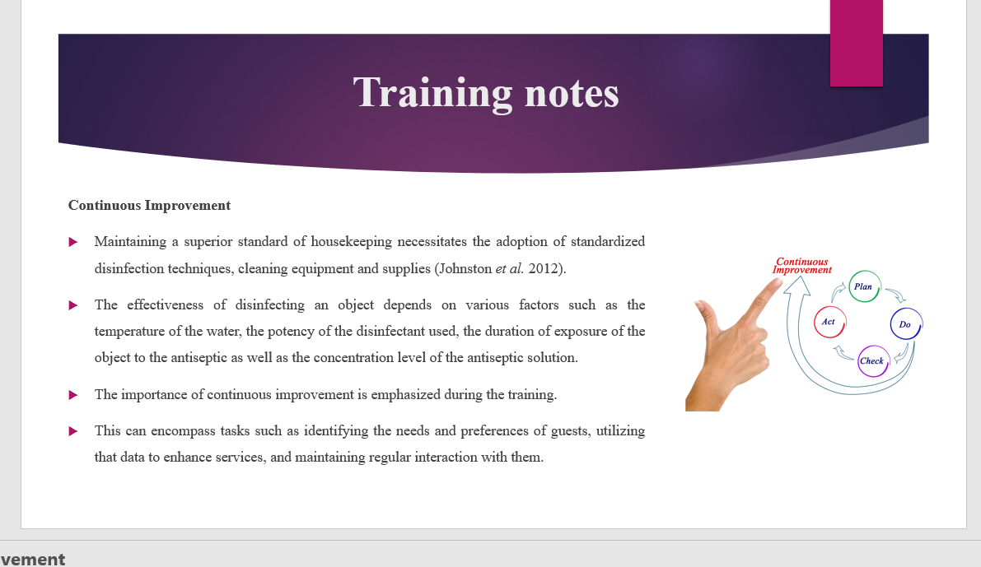

Training Notes: Maintaining a superior standard of housekeeping necessitates the adoption of standardized disinfection techniques, cleaning equipment and supplies (Johnston et al. 2012). The effectiveness of disinfecting an object depends on various factors such as the temperature of the water, the potency of the disinfectant used, the duration of exposure of the object to the antiseptic as well as the concentration level of the antiseptic solution. The importance of continuous improvement is emphasized during the training. This can encompass tasks such as identifying the needs and preferences of guests, utilizing that data to enhance services, and maintaining regular interaction with them.
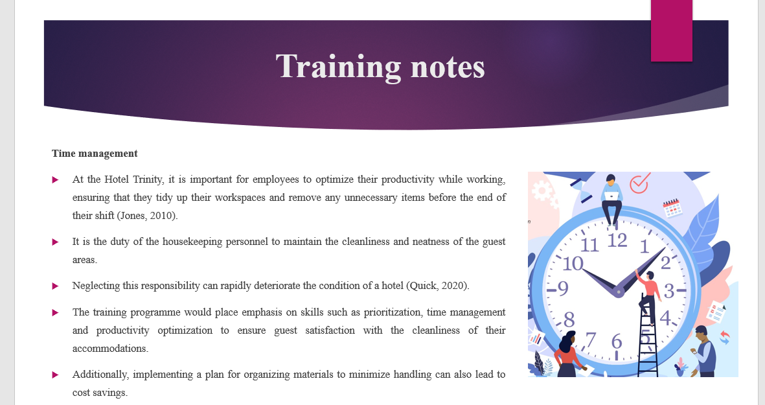

Training Notes:

Time management
At the Hotel Trinity, it is important for employees to optimize their productivity while working, ensuring that they tidy up their workspaces and remove any unnecessary items before the end of their shift (Jones, 2010). It is the duty of the housekeeping personnel to maintain the cleanliness and neatness of the guest areas. Neglecting this responsibility can rapidly deteriorate the condition of a hotel (Quick, 2020). The training programme would place emphasis on skills such as prioritization, time management and productivity optimization to ensure guest satisfaction with the cleanliness of their accommodations. One way to lower expenses is to increase the number of waste containers and dispose of waste more frequently. Additionally, implementing a plan for organizing materials to minimize handling can also lead to cost savings.
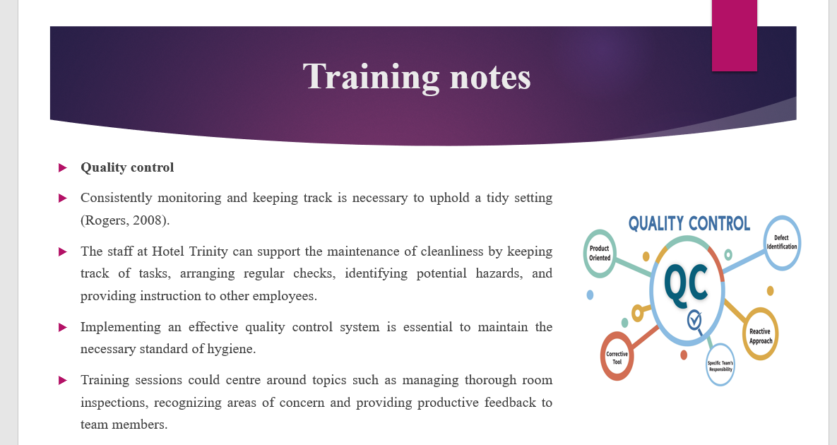

Training Notes:

Quality control
Consistently monitoring and keeping track is necessary to uphold a tidy setting (Rogers, 2008). The staff at Hotel Trinity can support the maintenance of cleanliness by keeping track of tasks, arranging regular checks, identifying potential hazards, and providing instruction to other employees. Implementing an effective quality control system is essential to maintain the necessary standard of hygiene. Training sessions could centre around topics such as managing thorough room inspections, recognizing areas of concern and providing productive feedback to team members.
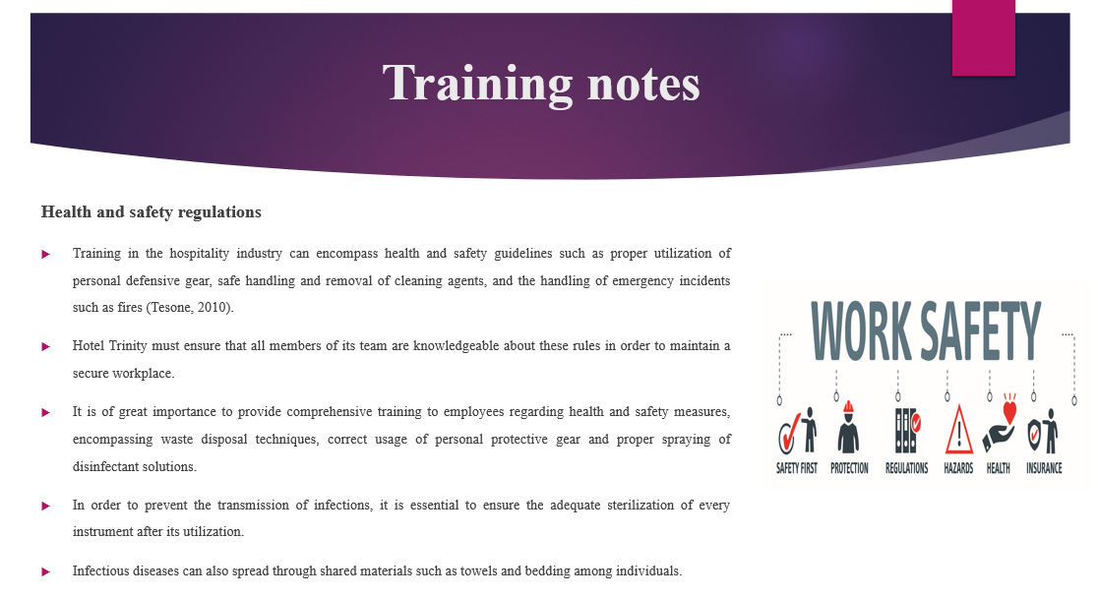
Training Notes: Health and safety regulations
Training in the hospitality industry can encompass health and safety guidelines such as proper utilization of personal defensive gear, safe handling and removal of cleaning agents, and the handling of emergency incidents such as fires (Tesone, 2010). Hotel Trinity must ensure that all members of its team are knowledgeable about these rules in order to maintain a secure workplace. It is of great importance to provide comprehensive training to employees regarding health and safety measures, encompassing waste disposal techniques, correct usage of personal protective gear and proper spraying of disinfectant solutions. In order to prevent the transmission of infections, it is essential to ensure the adequate sterilization of every instrument after its utilization. Infectious diseases can also spread through shared materials such as towels and bedding among individuals.
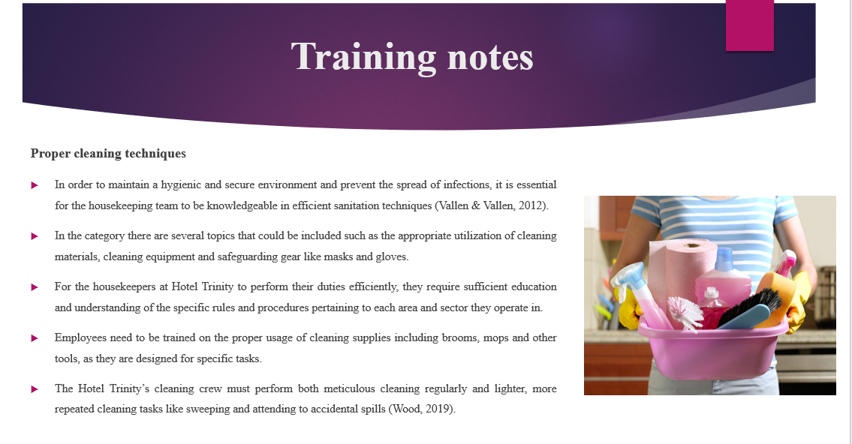

Training Notes:
Proper cleaning techniques
In order to maintain a hygienic and secure environment and prevent the spread of infections, it is essential for the housekeeping team to be knowledgeable in efficient sanitation techniques (Vallen & Vallen, 2012). In the category there are several topics that could be included such as the appropriate utilization of cleaning materials, cleaning equipment and safeguarding gear like masks and gloves. For the housekeepers at Hotel Trinity to perform their duties efficiently, they require sufficient education and understanding of the specific rules and procedures pertaining to each area and sector they operate in. Employees need to be trained on the proper usage of cleaning supplies including brooms, mops and other tools, as they are designed for specific tasks. It is very important to instruct them on how to organize their workspaces and store unnecessary items before their shift concludes. The Hotel Trinity’s cleaning crew must perform both meticulous cleaning regularly and lighter, more repeated cleaning tasks like sweeping and attending to accidental spills (Wood, 2019).

References
(Graham Gibbs reflection)
Bridger, E. (2018) Employee engagement: a practical introduction. 2nd ed. HR Fundamentals. London: CIPD and Kogan Page.
Casado, M. (2012) Housekeeping Management. London: Wiley.
Cottrell, S. (2019) The Study Skills Handbook. 5th ed. London: Red Globe Press.
Fallon, M. & Rutherford, D. (2010) Hotel Management and Operations. London: Pearson.
Ferdinand, N. and Kitchin, P. (2017) Events Management - An International Approach. 2nd ed. London: SAGE Publications Ltd.
Gebbels, M., Pantelidis, I.S. and Goss-Turner, S., (2020). Conceptualising patterns of career commitment: the leaving process in hospitality. International Journal of Contemporary Hospitality Management, 32(1), pp.126-147.
Johnston, R., Clark, G. & Shulver, M. (2012) Service Operations Management. London: Pearson.
Jones, T. (2010) Professional Management of Housekeeping Operations. London: Wiley.
Leiter, M. P. and Bakker, A. B. (2010) Work Engagement : A Handbook of Essential Theory and Research. Hove [England]: Psychology Press.
Mullins, L. and Dossor, P. (2013) Hospitality Management and Organisational Behaviour. 5th ed. Harlow: Pearson.
Quick, L. (2020) Managing Events. Real Challenges, Real Outcomes. London: SAGE Publications Ltd.
Raghubalan, G. and Raghubalan, S. (2016) Hotel Housekeeping - Operations And Management. 3rd ed. India: Oxford University Press.
Rogers, T. (2008) Conferences and conventions a global industry (2nd ed., Events management series). Oxford ; Boston: Butterworth-Heinemann.
Rogers, T. (2008) Conferences and conventions a global industry (2nd ed., Events management series). Oxford ; Boston: Butterworth-Heinemann.
Ruel, H. and Njoku, E., (2021). AI redefines the hospitality industry. Journal of Tourism Futures, 7(1), pp.53-66.
Tesone, D. (2010) Principles Of Management For The Hospitality Industry. 1st ed. London: Routledge.
Vallen, G. & Vallen, J. (2012) Managing Hotel Operations. London: Pearson.
Wood, R. (2013) Key Concepts in Hospitality Management. London: Sage. [Original source: https://studycrumb.com/alphabetize [Original source: https://studycrumb.com/alphabetizer]

