Element 2 Reflective log
Disgrifiad byr o’r gweithgaredd (
Brief description of the activity
The children were put into groups of 3 where I then took them into the role play area. The area was set up as an ice cream van. They had to take turns to be customers and ice cream man or women. They had to pick how many scoops they wanted and if it was in a tub or cone. The price was £1 no matter what and they had 1p, 2p, 5p and 10p coins to use. This linked in to the foundation phase framework because it says that year 2 pupils should be using different combinations of money to pay for items up to £1 (Welsh Government, 2015).

Nod/Amcan y gweithgaredd Aim/Objective of the activity
The aim of the activity was developing the children’s numeracy skills by counting out scoops of ice cream, using money, one more and one less, problem solving (seeing how many scoops filled the cup. To also incorporate literacy in the activity by working on communication skills such as asking questions. Relating to own experiences of going to an ice cream van, writing a menu and taking orders. The activity also worked on their PSD skills allowing them to take leadership roles, building confidence, real life roles (building empathy), shop assistant doing something different to a customer, turn taking, playing cooperatively and dramatic play. The final objective was to use creative skills to make their own ice cream and menus.

Eich rôl chi Your role
My role was to facilitate the learning by modelling the different roles the children had to do and then take a step back and let them try for themselves. I was encouraged by the class teacher to step in when I thought it was necessarily. I was tasked with making sure the children could handle the money correctly and count efficiently, also using the correct terminology. As a practitioner I needed to make sure the children used the equipment safely and didn’t injure themselves, they were using cotton balls as ice cream, so I needed to make them aware that they were not edible. I also needed to limit the number of children that came in the area that were not part of the activity to stop crowding. Set rules for the children to follow and so they knew how to use everything.

Agweddau cadarnhaol – pam? Positive aspects – why?
The positive aspects of this activity were that it was a real-life scenario that the children would have already had experience in or if not will have experience in, in the future. This is because every child loves the ice cream van when they hear it coming with the music on, this activity gives them the confidence in ordering what they would like and not being shy. Another positive of the activity was that were doing a practical activity, on their feet and not sitting down. This was an advantage because children should be encouraged to learn through play and in this scenario, that is exactly what they are doing. Furthermore, children were learning to use correct terminology like ‘can I have…. please, what would you like?’. It gave me the opportunity to assess the children with their numeracy skills of counting and displaying one more or one less. This then allowed me to let the class teacher know which children needed further work with counting and which children were comfortable doing it. The group sizes were appropriate for the activity because it meant one child was working in the shop and two children were the customers, if there were any more children then there would be times were children weren’t doing anything and just hanging around. All the equipment used was plastic which meant it was all safe to use.

Agweddau heriol – pam? Challenging aspects – why?
One part of the activity that seemed challenging was having to deal with disappointment. This was because once the child had ordered what they wanted, they had to wait for the child playing the ice cream man or women to make the ice cream. If that child found counting difficult then the customer would have to wait until they had counted the right number of scoops. Another challenge which appeared during the activity was that there was one task and no differentiation. Children of different abilities took part, and some found it really difficult and others found it simple to complete, when some children found it too difficult, they would get upset. This is when as a practitioner I should have reflected there and then and improvised to change it so those children struggling would be able to complete the task without failure. The role play area was accessible for all children in the class which meant that when I was working with my group of three, other children were wondering in asking to play and can they have a turn which then meant I was talking to them and showing them out of the area and not watching how my group responded to the activity.

Pa wybodaeth arddangoswyd? What knowledge was demonstrated?
Knowledge of the foundation phase outcomes were demonstrated by myself as this is what I was working towards. I wanted to help the children with putting different combinations of money together to pay for their ice cream. I also displayed knowledge of some of the children that I already knew and was able to prepare the area adequality with resources to help them.

Pa sgiliau arddangoswyd? What skills were demonstrated?
Skills that were noticeable during the activity were; counting, using money, problem solving (if there were too many scoops or not enough), asking questions, listening to one another and communicating with each other appropriately. It gave the children a chance to learn simple manners like ‘please’ and ‘thank you’.

Pa werthoedd arddangoswyd? Which values were demonstrated?
Values demonstrated were turn taking, this was when the second customer would wait in line for their chance to buy ice cream. They also had to take turns in the different roles as ice cream man/woman and customer. Another value was playing cooperatively, this was through the children sharing everything and completing the task the way they were showed. It would have been easy for one child to just want to play with everything on their own and not include any of the other children in the task, this would have proved to of been a problem. As a practitioner I developed empathy through understanding why specific children could not do the counting parts of the activity and stepping in to help them by using a number line to guide them in the right direction.

Beth allai cael ei wneud yn wahanol? Pam?
What could have been done differently? Why?
Next time, we could include the use of real money instead of plastic money so children could relate fully to real life experiences. Allowing them to use real ice cream next time so once they had completed the activity they could sit down and have their reward of which they had worked hard for. I could also include prompt cards on the inside and outside of the counter with vocabulary on and phrases for the children to use. This would be used to help with the fluency of the activity to prevent times when a child is unsure of what to say.

What?
Reflection is ‘The ability to think critically and creatively’ (Appleby, 2010:8). It can also be defined as ‘learning through and from experience towards gaining new insights of self and practice’ (Finlay, 2008).
‘Reflecting on practice underpins the work of early years practice’ (Reed and Canning, 2010:1). This is because practitioners are doing this all the time, they are never sitting down and just watching the children. In fact, they are always on their feet being active and getting involved with the children or individuals they are working with. When you reflect you need to consider 3 aspects, these are knowledge, skills and values. Always remembering to follow the SMART tool, which focuses on specificity, meaningfulness, achievable, realistic and timescale.

Gibbs, G. (1988)
Gibbs (1988) developed a reflection cycle based on 6 stages. It ranges from description to considerations for future events. This cycle is a reinterpretation of Kolb’s (1984) model of reflection. Gibbs’ model allows practitioners to think about their own feelings and thoughts. Where Schon’s model was based on both during and after an event, this model only focuses on reflection after the event. He hoped that his cycle would give teachers structure when reflecting.
The 6 stages of this model are; description, feelings, evaluation, analysis, conclusion and action plan. It focuses on learning from experiences by involving feelings and thoughts. The first three stages of this cycle are all about what happened, and the last three sections relate to the practitioner putting meaning to the experiences, feelings and thoughts. Gibbs’s (1988) model of reflection is said to be well-structure and easy to follow (Lawrence, 2008, Powley, 2013). There is no clear guideline to the achievement of better reflection through using this model. (Kihlgren et al., 2014) identified that Gibbs’s cycle does not adopt the deeper thinking reflection.

Schön, D. (1991)
Schön (1991) established an approach to reflection, his approach consisted of ‘reflection in action’ and ‘reflection on action’.
Reflection in action is when the member of staff is thinking on their feet, thinking about what to do next and acting on it straight away. It is seen to be completed during the ‘doing’ stage. For example, a teacher would do this during their lesson. One positive that can be taken from Schön (1991) method is that it allows the practitioner to make changes and adjust the task or event during the time it happens. Also, chances can arise for the staff to deal with events that might not have happened before. This cycle lets teachers be responsible and resourceful through using their knowledge and it allows them to use it in new experiences.
Reflection on action is thinking about something that has happened, thinking about what he or she would do differently next time and taking their time to do this. Schön (1991) recognised the importance of reflecting back ‘in order to discover how our knowing in action may have contributed to an unexpected outcome’ (Schön, 1983). This part of the cycle should inspire teachers to have ideas on what they need to change next time. When reflecting on action it involves you to think deeper, consider causes and options.

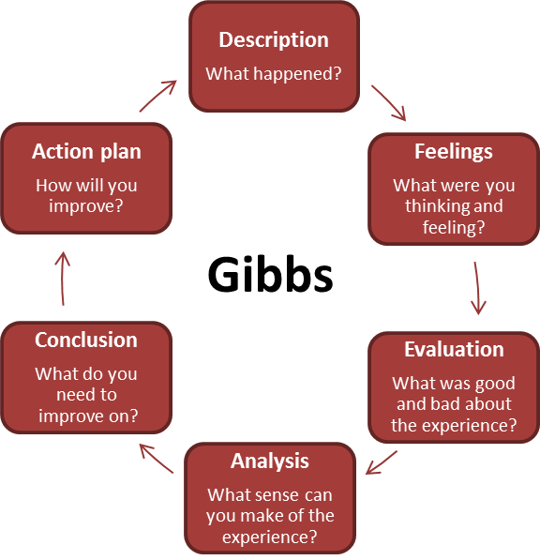
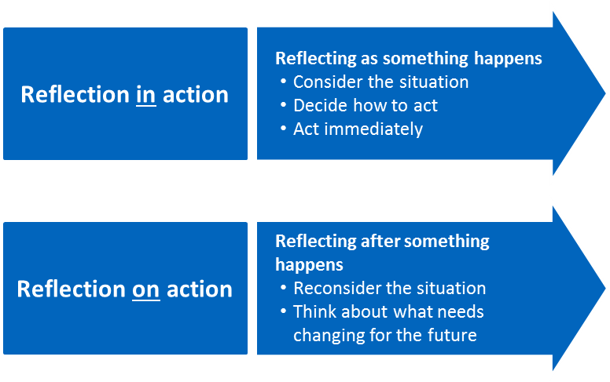

(Cambridge-community.org.uk, 2019)

(Cambridge-community.org.uk, 2019)
Reflection
Why?
Whilst working as a practitioner in the early years, it is important to be reflective. This is because it is seen as beneficial for the children you work with and their parents or carers. It will not only benefit them, but it will it will be a great help to you on maintaining an excellent standard of teaching. If reflection is continued throughout a practitioner’s career then it is possible that they will improve skills, confidence and motivation along with being able to identify professional development needs (Pacey.org.uk, 2019). Through continuing reflection, it then becomes a cycle (Cambridge-community.org.uk, 2019). This is when the practitioner teaches, asses themselves, considers ways of improvement, tries these new ideas out and then repeats the cycle.

(Cambridge-community.org.uk, 2019)

(Cambridge-community.org.uk, 2019)

The link between reflection and excellent practice
Estyn are an organisation who are led by Her Majesty’s Chief Inspector of Education and Training in Wales, it is a crown body, which was established under the Education Act 1992 (Estyn.gov.wales, 2019). They inspect the quality and standards of primary schools and secondary schools along with other establishments where children are present. Estyn’s common inspection framework from 2017 say good practice comes from meeting specific areas of inspection which are; standards, well-being and attitude towards learning, teaching and learning experiences, care, support and guidance and leaderships and management. Within the foundation phase and early years, schools who are dedicated to good practice, have children who are motivated and enjoy learning. The adults in the classroom have an important role to play, ensuring that all children develop skills to become successful learners in the future (Estyn, 2017). Teachers and practitioners must reflect on their own performance to ensure they are delivering the right teaching for the children to gain and improve these skills. (The Independent School Standards (Wales) Regulations 2003) state that schools must draw up and implement a written policy on the curriculum supported by appropriate plans and schemes of work, ensure teachers have well planned lessons, understand pupil needs, use classroom resources effectively and demonstrate that a framework is in place to assess pupils work regularly. The school must also have a framework for pupil performance to be evaluated and lastly delivering effective education for each and every pupil.

What is excellent practice?
Effective practice is all about making sure children get the maximum benefit from their learning experiences whilst in the early years and this can only happen when all adults surrounding the child work alongside one another, getting to know the child so they are then able to support their educational needs (Early Years Matters, 2019). With the link between children outcomes and excellent practice being so strong, a blog was released by William Teager. He said that for children to have the best possible outcomes, teachers need; a degree and specific training, smaller class sizes and more favourable ratios of teachers to children (Teager, 2018).
According to (Hwb Cymru, 2018) excellent practice comes from professional standards which describe skills, knowledge and behaviour. There are five professional standards which teachers need to adhere to, these are pedagogy, leadership, collaboration, innovation and professional learning. New professional standards are linked with reforms in initial teacher education (ITE), an ever-evolving qualifications framework and the national academy for educational leadership.

The link between reflection and excellent practice
Within the foundation phase and early years, reflection plays an important role. This is because it allows teachers to identify any negative aspects of teaching, where they might be going wrong or just a simple improvement in a specific area. It is a tool that is used to help with consistency in teaching and getting the children to where they need to be. The link between reflection and good practice comes from the department of education releasing a report saying, ‘good quality early years settings articulate, establish and sustain good practice that has the potential to improve a child’s outcomes’ (Anon, 2017). This means that through reflection a practitioner can determine what is good practice and what areas need developing or an introduction of new ideas.

Element 4 Personal Development Plan

Area for further development (provide further details) | Why? | How? | Who/Where? | When?
- Knowledge  Completing a degree. To allow me access onto the Graduate Teaching Programme (GTP) to become a teacher. | Having spent the previous three years working in a primary school as a teaching assistant, I have developed a love for the job and helping children to improve basic life skills which they will need when they become young adults and go looking for jobs. The decision to pursue teaching has come through being given the opportunity to cover the class teacher when she is unable to teach or not in class for a reason out of her hands. Through doing this I have identified that I am comfortable in this role and do a good job. Various members of staff within my school advised me that it is something that I should go for. As teaching isn’t something that someone learns, it is natural and a job that only people with specific skills are able to do. | Researching how to become a primary school teacher it appeared that a degree was needed of some sort. This degree does not have to relate to teaching or schooling but is a stepping stone to gaining access on to a PGCE course where there you can specify in primary school teaching or a GTP. A degree that I identified as a possibility for myself to complete was the BA Early Years Education and Care (UWTSD, 2019). This is perfect for me because it is a part time course which means I could complete the degree while still earning a wage through working. With this being a full degree, it meant that the three years is crammed down into two years. | The course is available at the University of Wales Trinity Saint David, at two campuses. One based at Swansea and the other based in Carmarthen. I will study the course at the SA1 campus because the campus and my work place are local. The course fees are £9000 a year totalling £18,000 even though it’s a three years course, it’s all squeezed into two years of studying. | The start date of the course would be June 2018 and expected finish date would be June 2020. After completion of the degree I will then look into a GTP straight away.
- Knowledge  Gaining my Newly Qualified Teaching status through completing a GTP. | After researching how to become a primary school teacher, there are only two routes I could take. The first is a PGCE after my degree which is nine months of full-time study. This would mean that I would have to take time off work, this wouldn’t be practical for myself as I am at the age now where I have responsibilities and bills. Or the other option is a graduate teaching programme which you complete at a workplace and does not require you to attend a university. The GTP is the route I wish to pursue. | I will need to submit an application to the Initial Teacher Education provider (ITE). This will have to be supported with a degree and GCSE grades B and above for Maths and English. (gov.wales, 2019) | I would complete this in a primary school setting, the setting will have to have a place to offer me. The school will receive a grant to help pay for the training and also funding to pay me a non-qualified teachers’ salary. | This training would normally take around 1 year to complete. I would wish to start the course in 2020 and finish it a year later in 2021.
- Skills  Welsh speaking skills. | Through working in a primary school, I have noticed that is an important skill to have. A teacher speaks basic welsh to the children on a day to day basis. Ranging from asking children to line up, sit down, stop talking, close the door and stand behind their chair. Children then learn these phrases and pick them up from hearing them all the time and start to use welsh themselves in class. I would like to improve my awareness and confidence in using Welsh-medium. | I could improve my welsh speaking skills by completing a Welsh Sabbatical course (Wjec.co.uk, 2019). This course is a free course through the Sabbatical Scheme and would mean you would have to take 60 days out of work to complete. | The course is available at Bangor university, Cardiff University and the University of Wales Trinity Saint David. | The course is twelve weeks long which is 60 days.  I would look to do this course whilst I am in work and will apply for it through my school.
- Skills  Cooking skills. | Cooking is important in the foundation phase because children enjoy the experience and they do not know that they are in fact learning numeracy and literacy skills whilst doing it and also putting their five senses to use (Early Years Careers, 2019). | There are cooking classes for nearly everything these days. If there was a particular area which I wasn’t particularly strong in like bread making or food hygiene, then there are courses out there to help with those. | Most cooking classes are held in colleges throughout wales. However, there are some bakery’s for example which offer courses within their shop. | This cooking class would need to be completed before starting work as a teacher.
- Values  Empathy | Empathy is the power to understand perspectives other than my own (TeachHUB, 2019). It is important for children to understand what empathy is. This is because empathy is it helps form relationships with other individuals. It helps children to understand one another’s emotions and feelings. I would need to improve my own understanding of empathy because it is seen as an important set of teaching strategies (TeachHUB, 2019). | To improve my own understanding of empathy, I will inquire to enrolling onto an ‘EmpathyLab’ training day. This will give me a wider knowledge of the topic and allow me to transfer what I know to the children so that they will then become more empathetic towards each other. This course will teach me the triple win framework which has a simultaneous impact on literacy and reading for pleasure, empathy and well-being and finally pro-social attitudes and social activism. | The empathylab training day has passed for 2019, however once I gain my NQT I will enquire about the course with the hope of enrolling onto it. | At some stage in 2020 I would like to complete this training, so I am fully equipped prior to starting a job as a primary school teacher.
- Values  Inclusion | Inclusion is important in the early years of schooling because it gives a child a feeling of belonging, but it also makes them feel comfortable in the setting and a sense of contribution (Maze, 2000). With the desire of being a teacher I wish to be in a position where I am including all children no matter their backgrounds or educational needs. Without a clear understanding of inclusion, I fear that when teaching I will not be focused on inclusion as I should be and won’t understand how to make all children heel included. | Through researching I identified a course called ‘FutureLearn’. This course is a 6-week course which is done online. Its aims are to give teachers an understanding of inclusive education, understanding of what barriers there are to learning and how to challenge them. | This course runs yearly however, it has already started this year. It would not benefit me to the maximum if I was to join the course now. It is free of charge with no implications. | The appropriate time to enrol onto this course would be next year in 2020 when I am able to send an application off in advance and be ready to start on the first start date that they commence on.

Reference List
Appleby, K. (2010) Reflective thinking: reflective practice. In M. Reed and N. Canning (2010) Reflective practice in the early years. London: Sage. pp.7-23.
Cambridge-community.org.uk. (2019). Getting started with Reflective Practice. [online] Available at: https://www.cambridge-community.org.uk/professional-development/gswrp/index.html [Accessed 14 Jun. 2019].
Eraut, M. (1994) Developing Professional Knowledge and Competence, London: Falmer.
Early Years Careers. (2019). Why should cooking be taught in nursery settings? - Early Years Careers. [online] Available at: http://www.earlyyearscareers.com/eyc/latest-news/why-the-early-years-should-teach-cooking/ [Accessed 12 Jun. 2019].
Finlay, L. (2008). Reflecting on 'Reflective practice'. Phd, BA(Hons), DipCOT. The Open University.
Gibbs, G (1988) Learning by doing: a guide to teaching and learning methods. Oxford: Further Education Unit, Oxford Polytechnic.
Gov.wales (2019). Graduate Teacher Programme – policy and priorities statement academic year 2019/20. OGL, pp.2-6.
Husebø, S., O'Regan, S. and Nestel, D. (2015). Reflective Practice and Its Role in Simulation. Clinical Simulation in Nursing, 11(8), pp.368-375.
Hwb Cymru (2018). An introduction to the professional standards for teaching and leadership. OGL, p.2.
Lawrence, P.(2008) Reflecting on events. Emergency Nurse, 15 (9), pp. 16-18.
Maze. (2000). Inclusion in Early Years Settings | A Unique Child | Teach Early Years. [online] Teach Early Years. Available at: https://www.teachearlyyears.com/a-unique-child/view/inclusion-in-early-years-settings [Accessed 14 Jun. 2019].
Pacey.org.uk. (2019). [online] Available at: https://www.pacey.org.uk/Pacey/media/Website files/PACEY%20member%20practice%20guides%20(PDFs)/PG04-self-reflective-practice.pdf [Accessed 14 Jun. 2019].
Reed, M. and Canning, N. (2010) Reflective practice in the early years. London: Sage.
Schon, D.A. (1983) The reflective practitioner. New York: Basic Books.
TeachHUB. (2019). Teaching Strategies: The Importance of Empathy. [online] Available at: https://www.teachhub.com/teaching-strategies-importance-empathy [Accessed 14 Jun. 2019].
Teager, W. (2018). [Blog] Early years education: what does high-quality provision look like?. Available at: https://www.eif.org.uk/blog/early-years-education-what-does-high-quality-provision-look-like [Accessed 15 Jun. 2019].
The Independent School Standards (Wales) Regulations 2003.1. (1), (2), (3), (4), (5).
Usher, R. et al (1997) Adult Education and the Postmodern Challenge, London: Routledge.
UWTSD, W. (2019). Early Years Education and Care (2 Years) (BA) | University of Wales Trinity Saint David. [online] Uwtsd.ac.uk. Available at: https://www.uwtsd.ac.uk/ba-early-years-education-and-care-early-years-practitioner-2-years/ [Accessed 12 Jun. 2019].
Welsh Government (2015). Foundation Phase Framework. OGL, p.33.
Wjec.co.uk. (2019). The Sabbatical Scheme. [online] Available at: https://www.wjec.co.uk/teachers/support-team-for-the-welsh-language-in-education/the-sabbatical-scheme.html [Accessed 12 Jun. 2019].

