1.0 Investigation Report: The Circular Economy and Coca-Cola

  - Introduction – The Circular Economy

With the environment, and socioeconomic conditions getting worse, as a society we became more aware that the economic model we have now, this model is based on the use of fossil fuels, is inherently unsustainable and highly flawed. The limits for such a system are becoming more and more obvious, including frequent economic crisis, global warming and consistently wasted resources and pollution. (Sillanpaa et al, 2020)

In response to such a concerning scenario, a general agreement was reached amongst scientists, environmental activists and governmental bodies that it was necessary to rethink and remodel the way humanity wastes and mismanages resources, and to establish a system that mimics the success of nature, recycles waste and retains its value. The proposed solution is what is now termed the Circular economy (CE)

In 1983, Gro Harlen Brundtland was asked to head a commission, independent of the UN to explore a ‘global agenda for change’ with the purpose of developing ‘long-term’ environmental strategies necessary to achieve sustainable development, by the year 2000 (WCED, 1987)

This was an incredibly ambitious goal, especially as the report corresponded with the period historically where society embraced neo-liberal policies that were adopted by most western governments. Instead of the reduction of consumption, the effect of deregulating the banks, globalization, technological developments in IT and producing more goods offshore, led to increased consumption which was intensified by a lengthy period of uninterrupted growth with low inflation since the crash of the 1920’s (Korhonen et al, 2018)

A linear economy is defined as converting natural resources into waste, via production (Singer, 2017) Such production of waste leads to the degradation of the environment in a number of ways, the two most dominant are by the removal of capital from the environment, and by the reduction of the value of natural capital caused by pollution from waste. (Ibid) Pollution can occur at whilst airing resources. This is a one-way system and an economy based on this system has been referred to as a ‘cowboy economy’ by Boulding (1966)

The circular economy involves much more than just increased recycling or ‘zero-waste-to-landfill’ (Weetman, 2020) it enhances the value-chain to cover the use of products and end-of-life, as well as the stages of supple, processing, manufacturing, distribution and sales. (Ibid) It means the redesign of products, using different raw materials, creating new by-products and recovering value from what was once waste. It could also mean providing a service rather than selling a product, alternatively finding wats to repair or refurbish or even remanufacture the product to be resold.

Below is a diagram that exemplifies the two models. The first is the linear model where we take; make and pollute and in contrast the model on the right represents the circular economy, and like a circle it flows, mimicking nature and limiting waste and pollution.

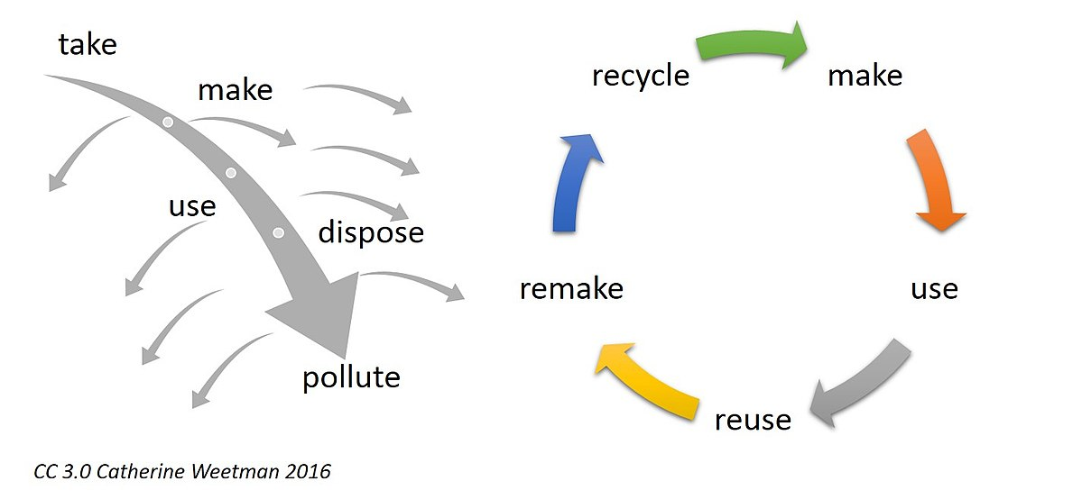

Architect William McDonough and Dr Michael Braungart, an environmental scientist wrote Cradle-to-cradle. They describe how important it is to treat materials as biological or technical nutrients and extending how long those materials can be used. The encourage a way of thinking the reframes the design of products to regenerate themselves and to constantly move from being less bad for the environment to doing better.

The Ellen MacArthur foundation is a charity that is set up by the record-breaking around the world sailor, Ellen MacArthur. The concept is to work with organizations, governments and education to advance the transition to a circular economy. Ellen published a number of books, videos and papers explaining the concept, how it works and what the benefits were to society. The foundation works with consultants McKinsey and also a wide range of other businesses.

The first major report compiled by the foundation which was names ‘Towards the circular Economy series in 2012’ calculated the economic and business opportunities presented for a circular model. the foundations idea of a circular economy is inspired by nature, where one species waste becomes the food of another, and the sun provides much needed energy. A circular economy ‘cycles valuable materials and products and transports them using renewable energy (TU Delft with Ellen MacArthur Foundation, 2016)

Ellen MacArthur Foundation has three principles for the Circular Economy (EMF, 2019)

- Design out waste and pollution
- Keep products and materials in use
- Regenerate natural systems

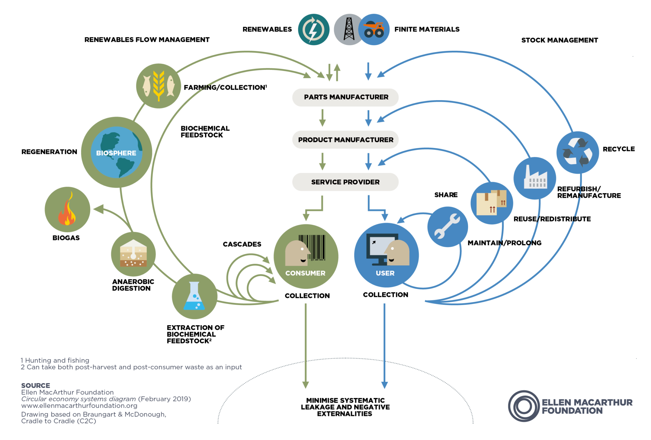

2.0 Coca-Cola and The Circular Economy

2.1. Introduction

Coca-Cola is based in Atlanta, Georgia. In the United States and has a reach globally that has enable d their icon to be one of the most recognizable that exists (ref) They operate in more than 200 countries worldwide, and distribute more than 1.9 billion servings of Coke products a day (ref) The company receives a large amount of their overall revenue from overseas expenditure operated through a bottling system that they franchise (Coca-Cola Annual Report, 2019) The continue to improve and expand their portfolio of over 300 flavours and brands. Although Coca-Cola does not own all the systems, they franchise they still own the stock in most. They run the largest beverage system of distribution worldwide. They also own more than ninety soft-drink and bottled water brands such as Minute Maid; Bacardi Mixers, DASANI, Honest Tea and many more with its varied portfolio of products. It is also worth mentioning that Coke directly owns, markets or licenses more than five hundred global brands, DASANI alone generates a profit of over 4.61 million. (ref)

Coke’s product portfolio is indicative of their ongoing success in the drinks market. In Michael Blandon’s (2010) The Coke Machine: The Dirty Truth Behind the World’s favourite soft drink’ references a 1995 interview with former CEO Roberto Goizueta in Fortune magazine, where Guizueta ‘Envisaged a world where the C on the kitchen faucet stood not for cold but Coke (Blanding, 2010; pg. 64) Considering where the organization was then, and now it is obvious to see how close they actually are at this point to that goal, Coca-Cola is no doubt a household name.

2.2 Coca-Cola: Sustainability and The Circular Economy

According to Salesforce (2020) Bea Perez, SVP & Chief Communications, Public Affairs and Sustainability Officer for Coca-Cola, is committed to their shift towards sustainability. When Cola-Cola built the sustainability office in 2012, Perez lead the initiative and eventually became a partner of the Ellen MacArthur Foundation. Coke is one of the many large multinational corporations that has partnered with the foundation.

Coca-Cola has certainly been making strides to become more sustainable and participate in the drive towards a circular economy, at least on paper. They currently admit to undertaking a number of initiatives designed to improve their impact on the environment and their business functions to become more sustainable.

In 1991, it began using recycled PET plastic in its packaging and constructed the first and only bottle-to-bottle reprocessing plant in 2012, which basically funds the collection of plastic bottles by local authorities. Nick Brown, the head of sustainability European partners limited, pioneered the company’s concept of recycling and deposit schemes (GS1UK.org.uk, 2019)

In 2019, according to GS1UK (2019) Coca-Cola switched the colour of its Sprite bottles from green to clear, making them easier to recycle into new bottles. In early 2020, the organization became the largest user of Recycled PET plastic in Great Britain, with all of its bottle making up at least fifty per cent. As well as the advancements Coke is making relating to its supply chain, the company is also increasing awareness about recycling with a marketing campaign and community projects. In 2017, they introduced the Coca-Cola fountain dispensers, to the University of Reading Campus. The machines work with refillable containers that contain RFID. The students can buy soft drinks in reusable bottles, which Coke can measure by how popular they are and how frequently they are refilled. The system has successfully reduced packaging for producers and consumers. Their ‘round in circles’ campaign, which coincided with recycle week in 2019 educates consumers on the journey that single-plastics take entering the recycling ‘loop’

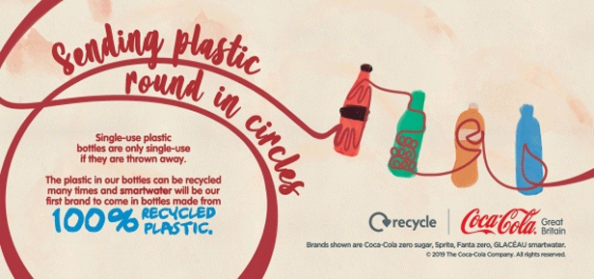

2.3 Coca-Cola PESTEL analysis

Political factors affecting Coke included elements such as the sugar tax, Industrial Safety regulations, political stability and importance of beverages and soft drinks sector in the country’s economy.

Economic Factors again are plentiful but the main factors in relation to the circular economy would be Economic rates; Government intervention in the free market economy, income and inflation rates and of course elements such as COVID-19 which will most certainly have affected many elements of their business, especially distribution to the Pub/restaurant/entertainment and leisure industries who are currently not operating in many countries and societies due to lockdowns etc.

Social Factors include Demographics and skill levels of the population; Attitudes towards health and environment; Leisure interests and culture. People are looking towards more healthy drinks in society, and this affects the sale of a large proportion of coke’s products that are notoriously unhealthy beverages.

Technological

Technology disrupts a variety of industries across the board, transportation has an effect on Coke’s distribution channels and recent developments from Coca-Cola’s competitors as well as the impacts Coca-Cola has used social media to connect with audiences, when they launched their name campaign where they put real names on their bottles, customers lined up to take pictures and they trended on social media, Social media can be a positive thing for the organization but similarly can affect their reputation in that any perceived corporate scandal (such as those that have been mentioned earlier in the report) can have a negative effect on the organization and can go viral quickly.

Environmental factors will be covered throughout the remainder of the report, in more detail.

2.3. Coca-Cola Challenges and Criticisms

The Coca-Cola company and subsidiaries in Western Europe have also announced their intention to eliminate new virgin oil-based plastic in bottle production in Norway and The Netherlands, getting closer to the 100% recycled plastic target they made in 2019. (Industry Europe, 2019)

Despite these and many other strides Coke has seemingly made to becoming a more sustainable organization, they are still criticized as being one of the World’s biggest plastic polluter, voted as such by BreakFreeFromPlastic not once, but twice in a. Row.

BreakFreeFromPlastic is an organization consisting of over 1,500 companies working to tackle plastic pollution. The organization issues a yearly ranking to the World’s biggest polluters where they engage nearly 80,000 volunteers who conduct investigations and brand audits where they analyse plastic they have collected close to home, cataloguing the results in every area of the globe, including remote regions of Indonesia, Philippines, Nigeria and Bhutan (Segran, 2019)

BFFP tracked over 8,000 brands that were responsible for the plastic and from that analysis concluded Coca-Cola, Nestle and PepsiCo as the top polluters. The fact that they have not moved in their ranking in two years, does indicate that not enough is being done to approach this issue.

The report conducted by BreakFreeFromPlastic points out that the manufacture of plastic from fossil fuels causes pollution in the air that is responsible for long-term drastic changes to reproductive, digestive, neurological and respiratory systems. Once products have been made, plastics leak into food and water and cause a whole host of other medical issues, including even cancer. As plastic does not biodegrade, it will exist years after we dispose of it, they plastics break up into microplastics which have been shown to be toxic to the liver. Plastic also contributes to climate change. The manufacturing of plastics and the disposal creates a large expulsion of greenhouse gases. (TheVerge, 2019)

So, the question really is, why do Coca-Cola and other corporate giants continue to use such a damaging material knowing the risks and environmental impacts?

Emma Proestlan BFFP’s global corporate campaigns coordinator said (2019).

‘The world’s top polluting corporations claim to be working hard to solve plastic pollution, but instead are continuing to pump out harmful single-use plastic packaging’

One of the biggest challenges for Coca-Cola and other similar brands is to redesign their packaging, despite initial costs and challenges this will bring, when considering the costs to human and environmental health, it is not a choice but a necessity.

Another huge challenge for Coke is in terms of their proposed contribution towards the advancement of a circular economy, and not the current wasteful linear one is concerning its use and consumption of water, and this is where it gets even more serious. The Water Network (2017) suggests that modern packaging alone puts pressure on water resources in those countries producing the raw materials and manufacturing the packaging (Wheelan, 2020) In addition to water used, it also creates a large grey footprint with plastics and paper being the worst.

Coca-Cola was first criticized for its water practices in the mid 2000s, they kept distribution costs low by using local water sources, something they have continued for many years. However, local people in some of the world’s most water-stressed regions began focusing on companies that used a lot of wate, and Coke found itself the target of public scrutiny. By 2007, US college students called for a nationwide boycott in support of Indian farmers who accused the company of stealing water and impacting their business. It was a threat to the brands image and global strategy. (MacDonald, 2018)

Today, the World Health Organization reports that half of the world’s population will be living in water-stressed areas by 2025; by 2030, the UN predicts water stress will give way to shortages for nearly half of all the people on the planet. In 2007, Hoekstra and other experts began to make people aware of this. Hoekstra thought that Coca-Cola was willing to make the changes necessary to make a difference, but this hasn’t seemed to have happened in reality.(ibid)

There are also several questions relating to many other of Coke’s claims for sustainability. Including the forestry work undertaken by Coca-Cola in Mexico, which includes the digging of infiltration trenches which were meant to ensure sufficient water to saplings. Coke has personally taken credit for financing more than five million tranches in National parks and other forests in and around Mexico. However, these projects have been criticized for causing damage to some of the country’s most iconic national parks.

John Suaven, executive director of Greenpeace UK, disparaged the company’s packaging pledge as a smokescreen. He compared the company’s constant sustainability announcements and public awareness campaigns to an advertising program that ignores what he calls the company’s ‘meagre’ environmental standards and failures to stick to promises they made regarding sustainability. (Suaven, 2019)

2.4. Opportunities for Coca-Cola to advance The Circular Economy

There are several opportunities for Coca-Cola that can enable them to participate and advance the Circular Economy.

The European Commission set up an initiative in 2017 that targets ambitious directives regarding plastic in particular. (Auriault et al, 2017)

- It proposes to decouple plastics from virgin fossil feedstock and reduce its lifecycle GHG impacts.
- Improve the economics, quality and uptake of plastic recycling and reuse
- Reduce plastic leakage into the environment

Firstly, in relation to recycling, where sustainability norms exist, only 35 per cent of recycled packaging is not recycled. Efforts on how to create group norms of recycling and proper disposal are needed, in every country that Coca-Cola operates, there is also an opportunity to connect sustainable packaging to low-income populations. (Coelho et al, 2020)

In terms of its packaging, returnable packaging, refillable bulk dispensers and reusable packaging are examples of initiatives which accomplish more sustainable goals and advancements towards the circular economy. But until Coca-Cola really make the move to abandoning plastics, both its water consumption and environmental damage through packaging will continue to be at odds with the circular economy model. Their refusal to abandon plastic really overshadows all the efforts they make to move towards sustainability. (Coehlo, 2020)

According to Two Sides, (2020) Coca-Cola has aimed to collect and recycle a bottle or can for every one they sell by 2030, while also sustainably reducing their use of virgin packaging materials, and only use materials that are 100% recycling.

As part of this Coke has revealed a prototype for a paper bottle with its partner Paboco. They gave Paboco the challenge of creating a bottle made entirely from renewable materials and one which is biodegradable. This may mean that they finally can participate in achieving their ‘World without waste’ goal. It is the final and necessary step they need to make to really be serious about their participation in the Circular Economy

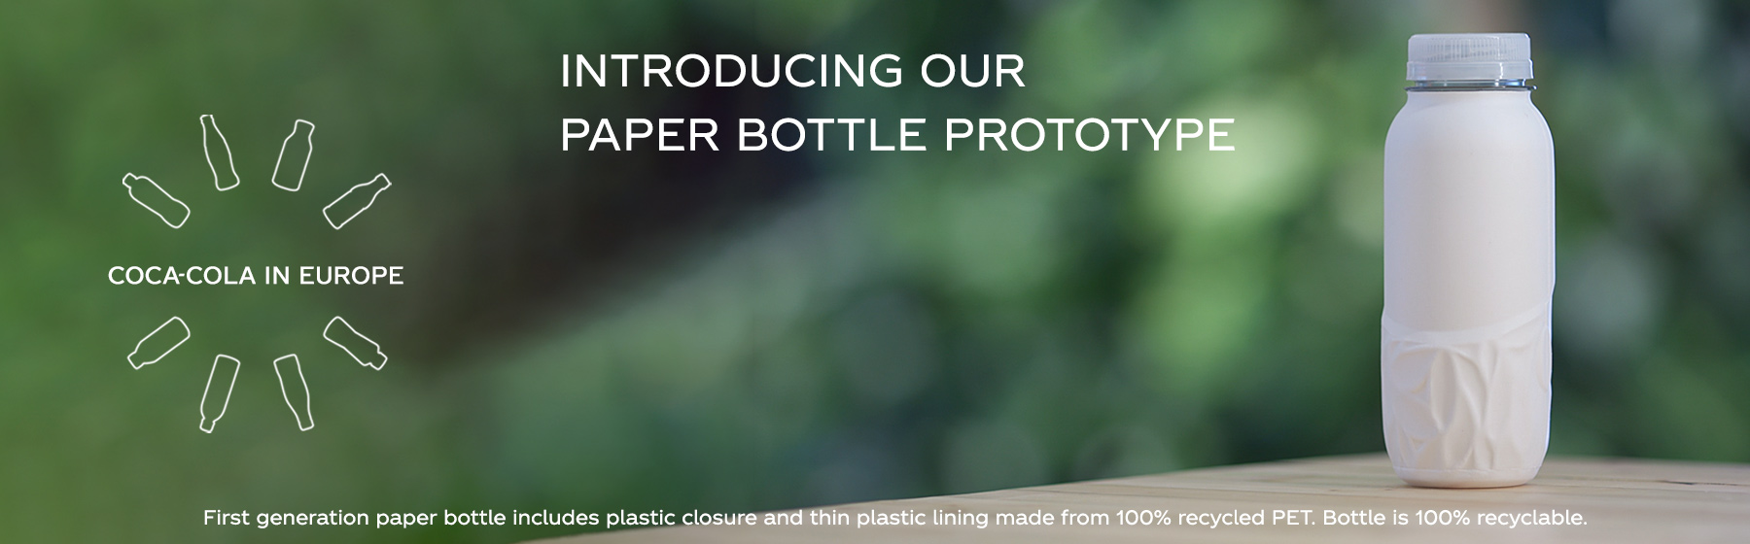

3.0. Conclusion

In conclusion, Coca-Cola seems to have been making a lot of noise relating to becoming sustainable both within their business practices and value chain, from the research and evidence presented it does seem that there are potentially many more pledges than solid results, and often when you look deeper, their publicity tends to make claims that can not always be backed up in reality. This won’t happen until the use of plastic becomes completely redundant, and Coca-Cola truly puts the long-term goal of sustainability in front of short-term financial gains and supposed consumer satisfaction they gain by using single-serving plastic in so many of their products. Further reflection and research is necessary to look at opportunities that Coca-Cola can exploit to do better for the environment and truly embrace the biomimicry so profoundly important to the whole concept.

Bibiliography

Andersen, M.S. An introductory note on the environmental economics of the circular economy. Sustain Sci 2, 133–140 (2007). https://doi.org/10.1007/s11625-006-0013-6

Bawden, T. (2017). Revealed: Coca-Cola sells 3,500 environmentally damaging plastic bottles every second. https://inews.co.uk/news/environment/always-coca-cola-fizzy-drinks-giants-shocking-impact-oceans-57791

Beachum, lateshia. (2020). Coca-Cola will continue making plastic bottles despite environmental concerns, company says. https://www.nationthailand.com/business/30380985

Boyd, O. (2017). Is it fair to blame Coca-Cola and big corporations for our waste crisis? | Guardian sustainable business | The Guardian. https://www.theguardian.com/sustainable-business/2017/aug/02/coca-cola-big-corporations-waste-crisis-plastics-recycling-packaging-circular-economy

Brewer, R. G. (2020). Coca-Cola: Helping the Environment by Using Plastic Plastic isn’t evil, which is why Coca-Cola is working with the material even as it looks to clean up its environmental footprint. https://www.fool.com/investing/2020/10/30/coca-cola-helping-the-environment-by-using-plastic/

Christie, N. (2020). Coca Cola, Pepsi and Nestle named world’s worst plastic polluters in 2020 | The Big Issue. https://www.bigissue.com/latest/environment/worlds-worst-plastic-polluters/

Coca Cola Company 2019 Business & Sustainability Report. (2019). https://d1io3yog0oux5.cloudfront.net/cocacolacompany/files/documents/coca-cola-business-and-sustainability-report-2019+%281%29+%284%29.pdf

COCA-COLA ANNOUNCES INVESTS IN ENHANCED RECYCLING AS PART OF ’WORLD WITHOUT WASTE’ VISION. (2019). https://www.coca-cola.co.uk/sustainability/packaging-and-recycling/coca-cola-announces-new-investments-in-enhanced-recycling-as-part-of-world-without-waste-vision

Coca-Cola European Partners invests in creation of circular economy for PET in Western Europe. (2020). https://www.politicshome.com/members/article/cocacola-european-partners-invests-in-creation-of-circular-economy-for-pet-in-western-europe

Coca-Cola Sweden unveils new labels to “support circular economy for plastic packaging”. (2020). https://www.circularonline.co.uk/news/coca-cola-sweden-unveils-new-labels-to-support-circular-economy-for-plastic-packaging/

Coca-Cola takes two more steps towards 100% recycled plastics in Europe - Industry Europe. (2020). https://industryeurope.com/sectors/consumer-goods/coca-cola-takes-two-more-steps-towards-100-recycled-plastics/

Coelho, P. M., Corona, B., ten Klooster, R., & Worrell, E. (2020). Sustainability of reusable packaging–Current situation and trends. Resources, Conservation & Recycling: X, 6, 100037. doi:https://doi.org/10.1016/j.rcrx.2020.100037

Concept: What is a circular economy? A framework for an economy that is restorative and regenerative by design. https://www.ellenmacarthurfoundation.org/circular-economy/concept

Folk, E. (2020). Is Coca Cola helping the environment? Or hurting? | Red, Green, and Blue. http://redgreenandblue.org/2020/06/02/coca-cola-helping-environment-hurting/

Geissdoerfer, M., Savaget, P., Bocken, N. M. P., & Hultink, E. J. (2017). The circular economy – A new sustainability paradigm? Journal of Cleaner Production, 143, 757-768.

GS1 UK | Deposit return schemes, Coca-Cola and the circular economy. (2019). https://www.gs1uk.org/our-industries/news/2019/12/18/deposit-return-schemes-coca-cola-and-the-circular-economy

Hawa, N. (2016). Coca-Cola Water Replenishment Case Study: Partnerships key ingredient to success. https://www.reutersevents.com/sustainability/coca-cola-water-replenishment-case-study-partnerships-key-ingredient-success

Kopnina, H. (2018). Teaching Circular economy: Overcoming the challenge of green-washing (48th ed.). Handbook of Engaged Sustainability

Korhonen, J., Honkasalo, A., & Seppälä, J. (2018). Circular economy: The concept and its limitations. Ecological Economics, 143, 37-46.

MacDonald, C. (2018). Inside the bad math that lets Coca-Cola say it gives back all the water it uses - The Verge. https://www.theverge.com/2018/5/31/17377964/coca-cola-water-sustainability-recycling-controversy-investigation

McCarthy, N. (2020). The World’s Worst Companies For Plastic Waste Pollution [Infographic]. https://www.forbes.com/sites/niallmccarthy/2020/09/18/the-worlds-worst-companies-for-plastic-waste-pollution-infographic/?sh=20277576f101

Morrison, O. (2020). ‘We are working to ensure packaging doesn’t become waste’: Coca-Cola, Nestlé, PepsiCo and Unilever hit back after damning plastics report. https://www.foodnavigator.com/Article/2020/03/31/We-are-working-to-ensure-packaging-doesn-t-become-waste-Coca-Cola-Nestle-PepsiCo-and-Unilever-hit-back-after-damning-plastics-report

Moving Toward a Circular Economy - Responsibly Managing Plastic Waste. (2018). https://www.coca-colacompany.com/news/moving-toward-a-circular-economy#:~:text=Using%20materials%20that%20are%20100,of%20recycling%20and%20material%20reuse.

Murray, A., Skene, K. & Haynes, K. The Circular Economy: An Interdisciplinary Exploration of the Concept and Application in a Global Context. J Bus Ethics 140, 369–380 (2017). https://doi.org/10.1007/s10551-015-2693-2

Nace, T. (2019). Coca-Cola Named The World’s Most Polluting Brand in Plastic Waste Audit. https://www.forbes.com/sites/trevornace/2019/10/29/coca-cola-named-the-worlds-most-polluting-brand-in-plastic-waste-audit/?sh=41ac4e5a74e0

newsroom, edie. (2019). Redesign, collaborate and collect: Inside Coca-Cola European Partner’s plastics strategy. https://www.edie.net/news/5/Redesign--collaborate-and-collect--Inside-Coca-Cola-European-Partner-s-plastics-strategy/

Pearce, O. (2020). Coca-Cola signs joint statement on circular economy. https://brandingforum.org/featured/coca-cola-signs/

Petter, O. (2019). Coca-Cola named worst plastic polluter for second year in a row by environmental group | The Independent | The Independent. https://www.independent.co.uk/life-style/coca-cola-pollution-plastic-environment-coke-a9168921.html

Pitti, E. (2020). Coca-Cola and Environmental Responibility. https://www.treehugger.com/coca-cola-and-environmental-responibility-4864001

Reiner, T. (2020). Digital Transformation empowers the Circular Economy: Coca-Cola app incentivizes consumers for recycling. https://bp-group.de/en/digital-transformation-empowers-the-circular-economy-coca-cola-app-incentivizes-consumers-for-recycling/

Segran, E. (2019). Coca-Cola, Nestlé, and PepsiCo are the world’s biggest plastic pollute. https://www.fastcompany.com/90425011/coca-cola-nestle-and-pepsico-are-the-worlds-biggest-plastic-polluters-again

Sillanpää, M., & Ncibi, C. (2019). In Sillanpää M., Ncibi C.(Eds.), Chapter one - getting hold of the circular economy concept Academic Press.

Singer, T. (2017). Business Transformation and The Circular Economy: A Candid Look at Risks and Rewards. https://www.stern.nyu.edu/sites/default/files/assets/documents/TCB-Business-Transformation-and-the-Circular-Economy-RR.PDF

Stahel, W. (2016). The Circular Economy. https://www.nature.com/news/the-circular-economy-1.19594

Suaven, J. (2017). If you care so much, Coke, why aren’t your bottles 100% recycled? | Guardian sustainable business | The Guardian. https://www.theguardian.com/sustainable-business/2017/jul/13/coca-cola-plastics-pollution-oceans-bottles-packaging-recycling-pr-fizz-greenpeace-john-sauven

Team, T. (2020). Coca-Cola unveils a prototype for a paper bottle with its partner, Paboco. https://www.twosides.info/uk/coca-cola-paper-bottle

Thomas, D. (2020). Davos 2020: People still want plastic bottles, says Coca-Cola. https://www.bbc.co.uk/news/business-51197463

Towards The Circular Economy: Economic and business rationale for an accelerated transition. (2015). https://www.werktrends.nl/app/uploads/2015/06/Rapport_McKinsey-Towards_A_Circular_Economy.pdf

Waves of Change: How The Circular Economy Can Build a Brighter Future - Salesforce UK Blog. (2020). https://www.salesforce.com/uk/blog/2020/09/how-the-circular-economy-is-shaking-up-business.html

Wheeler, P. (2018). Greenpeace slams Coca-Cola plastic announcement as ‘dodging the main issue’. https://www.greenpeace.org/usa/news/greenpeace-slams-coca-cola-plastic-announcement-as-dodging-the-main-issue/

