

MODULE: MARKETING MANAGEMENT
MODULE CODE: LCMB7001
ASSESSMENT 1

Assignment Title: Marketing Management - Assignment 1
Student Name: Drashti Sorathiya
Student ID: 2240378
Lecturer Name: Tushara Balendran
Submission Date: 30/08/2023

Table of Contents
1. Introduction 4
2. Communication 6
3. Communication Model and Diagram 6
4. Integrated Marketing Communication 8
5. Promotional Strategy Sainsbury Uses to raise awareness 8
5.1 Influencer Collaborations 8
5.2 User-Generated Content Campaigns 9
5.3 Sustainability Initiatives 9
5.4 Interactive Social Media Content 9
5.5 Virtual Events and Webinars 9
5.6 Location-Based Marketing 9
5.7 Social Causes and Charity 10
6. Branding 10
7. Brand Equity 10
8. Aaker’s Brand Equity Model 11
8.1 Aaker's Brand Equity Model and Sainsbury : 11
8.2 Advantages of Aaker's Brand Equity Model: 12
8.3 Disadvantages of Aaker's Brand Equity Model: 12
9. The Customer Journey 13
10. Touchpoints 14
10.1 Understanding Touchpoint Optimization 14
10.2 Pre-Purchase: 15
10.3 Purchase: 15
10.4 Post Purchase: 15
11. Customer Journey Mapping: Unveiling Insights 16
12. Total Engagement Model 20
12.1 Advertising and Marketing 20
12.2 Customer Service 21
12.3 Products and Services 21
12.4 Internal Culture 21
12.5 Innovation 21
12.6 Feedback Loop 22
13. Recommendations 22
• Strategic Partnerships 23
• Experiential Marketing 23
• Virtual Reality (VR) Campaigns 23
Conclusion: 24
References: 25
References 27

List of figures
Figure 1 Sainsbury 4
Figure 2 Linear Communication Model 6
Figure 3 Total Engagement Model 20
Figure 4 Sainsbury Marketing Plan 22

Introduction
Sainsbury, one of the famous United Kingdom's leading supermarket chains has been at the forefront of adapting to these movements to be competitive and relevant in the market. Sainsbury, founded in 1869, has a long-standing history in the retail industry, developing itself as a household name for facilitating quality groceries, household products along with a diverse range of several services. Over the past years, the company has gone through several fluctuations in the business environment, but the past decade has seen a rapid boost in technological advancements and shifting consumer behaviors, presenting both challenges along with opportunities for the company (Adivar et al., 2019).
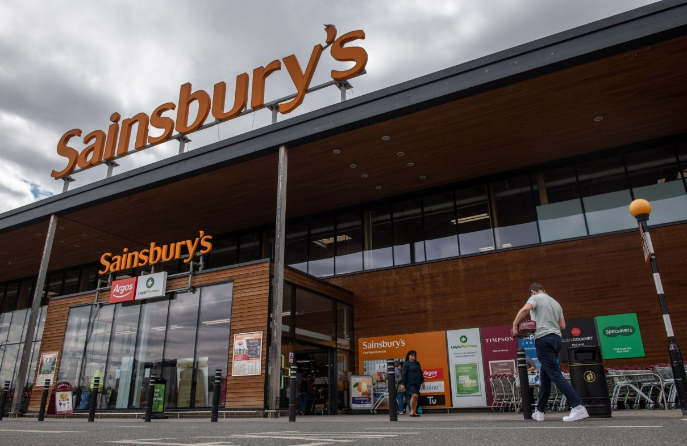
Figure 1 Sainsbury
https://www.bloomberg.com/news/articles/2022-09-21/sainsbury-in-talks-on-500-million-sale-and-leaseback-of-stores?leadSource=uverify%20wall

Companies like Sainsbury have gone through a transformative move for prioritizing customer experiences. As one of the leading supermarket chains in the United Kingdom, Sainsbury has identified the paramount significance of conveying exceptional customer service as well as tailored shopping experiences (Burton et al., 2020). Whereas this intense focus on boosting customer experiences has sometimes led to the diversion of attention from other core main issues which are most critical to the organization's long-term success along with sustainability (Argyropoulou et al., 2023). This overview delves into Sainsbury's overall route through the rise of customer experience as well as its profound effect on the strategic direction of the company. While acknowledging the importance of customer satisfaction in building brand loyalty as well as driving revenue growth it's necessary to explore how this focus may sometimes occasionally detract from other vital core significance internal legal and operational organization matters of Sainsbury's (Burton et al., 2020).
Throughout this examination, we will explore the factors contributing to the increasing focus on customer experience, highlighting how customer expectations have evolved in the digital age. Sainsbury must be focused and not neglect other critical aspects of its core operations. These may include product workforce development as well as operational efficiency along with financial sustainability among others (Dieplinger et al., 2021).
Sainsbury's relentless core focus on customer experience has undoubtedly reshaped how the company connects with its customers as well as devises business strategies. Whereas this customer-centric approach has brought several advantages, it is necessary for Sainsbury to identify as well as rectify core diversion of focus from critical core issues. Effectively managing these dual imperatives, Sainsbury can continue to thrive as a customer-oriented organization while ensuring the overall well-being as well as the success of the company in a rapidly changing retail environment (Argyropoulou et al., 2023).

Communication
Communication is the procedure of transmitting along with exchanging information, ideas, thoughts, feelings either data among individuals, groups or entities utilizing certain means like spoken or written language, gestures, symbols, images, sounds or may be technology. It focuses both verbal along with nonverbal elements which includes tone, body language as well as context, to provide understanding as well as convey meaning (Dieplinger et al., 2021). Effective communication includes the successful encoding as well as decoding of messages, encouraging mutual comprehension and allowing the exchange of knowledge, emotions as well as intentions between participants. It provides as a fundamental pillar of human interaction, collaboration along with the dissemination of information through diverse social, cultural as well as technological contexts (Adivar et al., 2019).

Communication Model and Diagram
A communication model is a framework that facilitates communication works by breaking down the procedure into certain components along with stages. It facilitates insights into the roles of sender, receiver, message, medium, feedback along with noise in the overall communication procedure (Burton et al., 2020). The basic communication models is the "sender-receiver" model which is typically known as the "linear communication model".
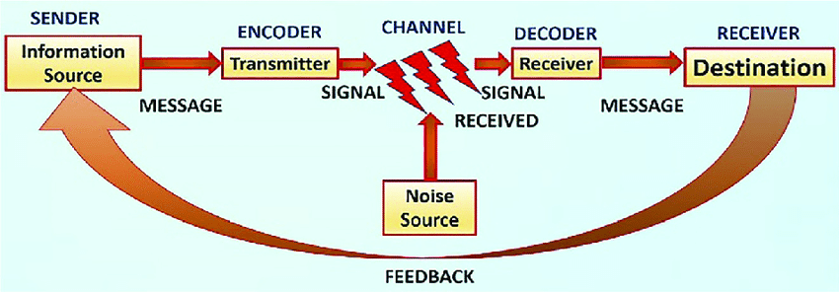
Figure 2 Linear Communication Model

- Sender: Sender refers to the encoder, is the person or entity who starts the communication by developing as well as transmitting a message. The message is what the sender starts to convey to the receiver.
- Message: The message is basically information, idea, emotions may be content that the sender wants to communicate. It might be in the form of words, symbols, images, gestures and any other means of delivering meaning (De Meyer et al., 2023).
- Medium/Channel: The medium or channel is the process through which the message is delivered from the sender to the receiver. It might be a face-to-face conversation, written text, email, phone call, social media, or either any other communication tool (Zweben et al., 2021).
- Receiver: The receiver is known as the decoder which is the person or entity who receives the message. They translate along with decode the message to understand its meaning.
- Feedback: Feedback is the response or the reaction that the receiver gives to the sender's message. It shows whether the message was understood as intended or if clarification is needed. Feedback may be verbal, nonverbal rather written.
- Noise: Noise links to any interference or distortion that affects the transmission or reception of the message. It might be external noise (physical disturbances) or internal noise (psychological factors) that effect effective communication. A simple diagram of the basic communication model (Burton et al., 2020).
Sender --> Message --> Medium --> Receiver
↑
Feedback
↑
Noise
There are very advanced communication models that took these issues into account, like the transactional model which focuses on the reciprocal nature of communication and the constant exchange of roles among the sender as well as receiver.

Integrated Marketing Communication
Integrated Marketing Communication (IMC) links to the strategic as well as cohesive approach of coordinating several marketing communication elements as well as tools to provide a consistent as well as unified message to target audiences. IMC aims to develop a seamless as well as synchronized communication experience for customers by aligning marketing, media relations, promotions for business, direct advertising, and online advertising along with other communication channels. Integrating these diverse methods, IMC targets to boost brand visibility, convey a coherent brand image along with maximizing the effect of marketing efforts across multiple Touchpoints (Dieplinger et al., 2021).

Promotional Strategy Sainsbury Uses to raise awareness
Sainsbury's, as a well-established brand might participate to evolve its promotional strategies to raise awareness as well as engage its target audience.

5.1 Influencer Collaborations
Partnering with relevant social media influencers as well as famous content creators might result Sainsbury's tap into their followers' interests. Influencers may showcase Sainsbury's products, share recipes along with highlighting the brand's values, providing a more relatable as well as personal touch to the promotion.

5.2 User-Generated Content Campaigns
Encourage customers to share their own experiences, recipes as well as creative uses of Sainsbury's products over social media. This will not only boosts engagement but also develops a sense of community around the brand (De Meyer et al., 2023).

5.3 Sustainability Initiatives
Mentioning Sainsbury's commitment to sustainability over campaigns showcasing eco-friendly products, packaging as well as certain initiatives may resonate well with environmentally-conscious consumers along with developing a positive brand image.

5.4 Interactive Social Media Content
Usage of such interactive content which includes polls, quizzes, challenges along with live videos on platforms like Instagram, Tik Tok, as well as Facebook to intact customers as well as encouraging them to actively participate (Zweben et al., 2021).

5.5 Virtual Events and Webinars
Hosting such online events or webinars which are related to cooking, nutrition as well as other topics of interest to your audience. This marks Sainsbury's as a helpful resource along with expert in relevant areas.

5.6 Location-Based Marketing
Using location-based targeting to send promotions as well as provides to customers' smartphones when they are nearby Sainsbury's store. This can drive foot traffic as well as encourage impulse purchases.

5.7 Social Causes and Charity
Align with social such causes that resonate with the targeted audience. Promote initiatives as well as partnerships that shows the brand's commitment to develop a positive effect on society.
Each of these strategies might be tailored to fit Sainsbury's brand identity, target audience along with marketing goals. A combination of these approaches with ongoing market research as well as adaptation helping Sainsbury's effectively raise awareness along with maintaining a strong brand presence in the market (Dieplinger et al., 2021).

Branding
Branding refers to the procedure of developing a distinct as well as recognizable identity for a product, service, company either organization in the minds of consumers. It includes the strategic development as well as management of certain elements like name, logo, design, colors, and messaging as well as overall visual along with emotional representation. A successful branding strategy develops a unique along with consistent image that provides differentiate a brand from competitors as well as communicates its value, values along with promises to consumers (Adivar et al., 2019).

Brand Equity
Brand equity is the intangible value along with perception that a brand holds in the eyes of consumers. It shows the added value a brand brings beyond the functional advantages of its products or services. Brand equity is built over time through positive customer experiences, consistent messaging, effective marketing along with the emotional connection consumers create with the brand (Dieplinger et al., 2021). A strong brand equity sometimes leads to increased customer loyalty, premium pricing, higher market share along with a competitive advantage, as consumers are more likely to select along with remain loyal to brands they trust as well as feel connected to.

Aaker’s Brand Equity Model
Aaker's Brand Equity Model created by David Aaker is one of the framework that helps businesses understand along with managing their brand's value as well as perception in the market. The model based of five core key components that participates to building as well as assessing brand equity: brand awareness, brand loyalty, and brand quality opinion, brand associations as well as other proprietary brand assets (Adivar et al., 2019).

8.1 Aaker's Brand Equity Model and Sainsbury :
- Brand Awareness: This links to the extent to which consumers identifies as well as recall the brand. Sainsbury includes measuring how well customers identifies the Sainsbury's logo, name as well as products. Sainsbury can create surveys or analyze market data to assess its brand awareness level (Burton et al., 2020).
- Brand Loyalty: This component measures how consumers are to select Sainsbury's products over competitors consistently. Sainsbury can trace customer retention rates, repeat purchases, as well as engagement with loyalty programs to gauge brand loyalty.
- Brand Perceived Quality: This links to consumers' assessment of the quality along with value provided by Sainsbury's products along with services. Sainsbury may create conduct customer satisfaction surveys along with comparing its perceived quality against competitors to identify this aspect (De Meyer et al., 2023).
- Brand Associations: These are the thoughts, feelings as well as mental connections consumers have about Sainsbury. This involves associations with attributes, benefits along with emotions. Sainsbury can identify consumer feedback, social media mentions as well as focus groups to understand the associations consumers have with its brand.
- Other Proprietary Brand Assets: The unique elements that set the brand apart which includes patents, trademarks along with brand extensions. Sainsbury's proprietary assets might involve its private-label products along with partnerships with specific suppliers (Zweben et al., 2021).

8.2 Advantages of Aaker's Brand Equity Model:
- Holistic Perspective: The model provides a comprehensive view of brand equity by considering multiple dimensions that participates to a brand's value.
- Measurable Metrics: The model facilitates a framework to measure different aspects of brand equity which helps businesses track their brand's progress over time.
- Strategic Insights: Understanding each component, businesses like Sainsbury can develop informed decisions about marketing strategies, product development as well as customer engagement (Dieplinger et al., 2021).
- Customer-Centric: The model's targets on consumer perceptions along with associations ensures that the brand's efforts align with customer preferences as well as needs.

8.3 Disadvantages of Aaker's Brand Equity Model:
- Complexity: The model's multiple components can be overwhelming to implement fully, particularly for smaller businesses with limited resources.
- Subjectivity: Assessing components like brand associations relies on interpreting qualitative data, which can be subjective and challenging to quantify accurately.
- Resource-Intensive: Gathering data and conducting research to measure each component can require significant time, effort, and resources.
Implementing Aaker's Brand Equity Model might facilitate valuable insights into how consumers perceive the brand, helping Sainsbury make strategic decisions to boost its brand's value as well as competitiveness. It’s significant to identify the potential challenges as well as limitations associated with implementing such a comprehensive model (Argyropoulou et al., 2023).

The Customer Journey
- Definition of customer journey: While touchpoint boost is undoubtedly a core main aspect of making a good as well as better customer experience, it shows a limited perspective that can fall short of occupying the entirety of a customer's interactions with a brand. The customer journey targets the overall sequence of touchpoints, transitions, emotions as well as experiences that a customer undergoes from the initial point of engagement to the final post-interaction process. Zooming out from certain touchpoints to target the wide along with broader journey, organizations like Sainsbury must adopt a deeper understanding that how customers perceive their interactions as well as how these interactions collectively design their overall impression of the brand (Dieplinger et al., 2021).
- 5 component of key points:
- Awareness: In this point, Buyers pick the opportunities and challenges that they wish to pursue.
- Consideration: In this phase, the buyers have committed themselves to reaching the target or challenge and clearly define it.
- Conversion: In this particular stage, the solution categories have been selected by the buyers in advance. (McPherson, n.d.)
- Retention: In this step, the customer journey continues after the moment of sale, and keeping in touch during this time is essential. According to research, a little 5% increase in client retention can result in a startling 25% increase in revenues. Therefore, maintaining contact at this phase of the consumer journey becomes crucial.
- Advocacy: In this phase, Customers who are happy with a product or service become brand ambassadors, promoting it online and through word-of-mouth, which boosts the growth of the company. (Klussmann, 2009)

Touchpoints

10.1 Understanding Touchpoint Optimization
In modern customer experience management, super stores like Sainsbury have harnessed the power of touchpoint boost as a cornerstone of their strategies. The overall concept of touchpoint enhancement circulates around meticulously refining as well as enhancing specific interactions among customers as well as the brand which is the core focus of the business to strengthen the business and this has made the business much more efficient (Adivar et al., 2019). These interactions are sometimes linked to as "touchpoints," which encompass a huge wide range of customer overall engagements, from online interactions as well as in-store experiences to customer service faces along with post-purchase involvement. The underlying principle is that by making each single section touchpoint perfect, companies can develop such impressions that cumulatively contribute to the overall heightened customer satisfaction as well as their experience, loyalty along with advocacy. This will also be going to help a lot in maintaining a successful approach in developing a better customer experience in end to end Journey (Dieplinger et al., 2021).

10.2 Pre-Purchase:
- Internet advertising, covering display ads, pay-per-click PPC, and advertising on social networks
- Web advertising, including blogs, Infographics and Public Relations Videos
- Recommendations from neighbors and relatives are examples of word-of-mouth

10.3 Purchase:
- Discussions that take place in a shop or during an event
- Product information
- Platform feedback and on-page reviews are examples of comments

10.4 Post Purchase:
- Questionnaires for comments
- Pleasant emails and notes written by hand were delivered with the products
- Cross-selling and upselling
https://www.feefo.com/uk/business/resources/customer-acquisition/customer-journey-mapping-guide(No Date)

Customer Journey Mapping: Unveiling Insights
Customer journey mapping deals as a strategic tool for unravelling the typical matters of the customer journey. This technique includes developing a visual representation of each step a customer takes when connecting with a brand. It deals with certain emotional highs as well as lows, pain points along with certain moments of delight that customers faces along the way. Comprehensively identifying the customer journey, organizations like Sainsbury can explore the overall areas of improvements design interventions that can boost customer satisfaction along with ensuring consistency across touchpoints (Burton et al., 2020).

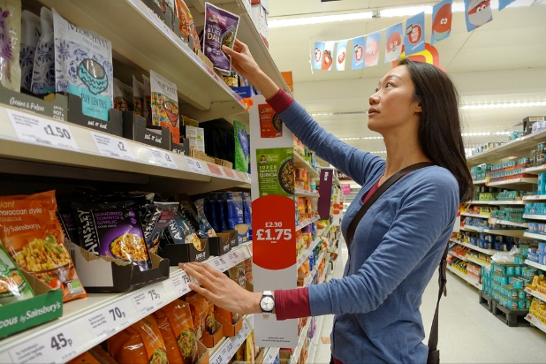
https://www.retailgazette.co.uk/blog/2022/03/sainsburys-expands-world-food-offering/
Details of Person:
Age: 32 year approx.
Gender: Female
Skills: Focus on quality and Negotiate constantly

Product photo:

https://tuclothing.sainsburys.co.uk/product/tuc143285648
Details of Product:
Price: £ 155.00
Material: 60% Wool 20% Polyester 15% Polyamide 5% Cashmere

Care: Dry cleaner only

Style Number: tuc143285411

Customer Journey Map:
Customer Journey Map | Awareness | Discover | Purchase | Use | Bond
Website |  | 3 Check the reviews of the product and cost |  | 6 Review of product and store experience
Store |  | 4 Check availability and material of the product | 5 Purchas the product
Social Media
Web Form
Word of Mouth | 2 Collect feedback on the product from another person |  |  |  | 8 Express positive views to another person
Email |  |  |  |  | 7 Receiving emails of new launching products and offers
prevailing |  |  |  | 1 Existing Customer with the use of product

Describe:
- Customer already purchased that product from Sainsbury and used that in regular wear.
- She happily uses that product and talks to their friend about that. Like their material, colour, size, and comfortability and encourage her to buy the same product.
- She goes to the official company website and surveys the reviews of customers and the cost of the products.
- Then she goes to the store and checks everything about the product and tries to wear that. She likes that and she feels comfortable in that.
- So, she decides to purchase that product from the store.
- Next, she goes to the official website of the company and writes their feedback and experience about their purchasing journey.
- She puts their review on the website that's why she receives every email from the company for new launching products and offers from their stores.
- And, she also expresses their positive reviews to their friends and convinces them to purchase that product.

Total Engagement Model
The Total Engagement Model focuses on aligning all aspects of a company's activities toward a unified plan for customer engagement. Relating this model to Sainsbury's, the retail company, and see how it will be applies to their operations:
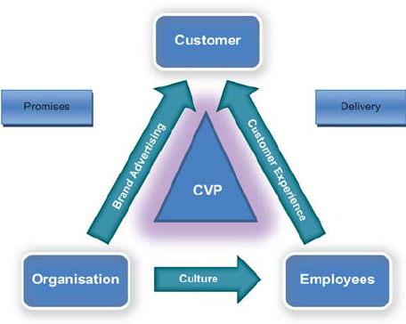
Figure 4 Total Engagement Model
https://www.researchgate.net/figure/The-total-engagement-model_fig2_49513186

12.1 Advertising and Marketing
Sainsbury's can align its advertising efforts with its customer engagement strategy. Advertisements must accurately portray the brand's providing along with values. For example, if Sainsbury's focuses quality products as well as sustainable practices, their advertising must reflect these aspects (Burton et al., 2020).

12.2 Customer Service
Sainsbury's can make sure that its customer service in lines with the promises made in its advertising. Responsive as well as effective customer service no matter in-store or through online channels, participates to a positive overall customer experience.

12.3 Products and Services
Sainsbury's can makes sure that the products along with services they provide match the expectations they set through their advertising along with customer engagement efforts. Providing a wide range of quality products, value-for-money options as well as convenient services which includes online shopping as well as delivery would align with this model (Zweben et al., 2021).

12.4 Internal Culture
The internal culture at Sainsbury's must mirror the external brand image they provide portray to customers. Employees' behaviors as well as interactions must show the values along with promises that Sainsbury's communicates by its advertising as well as customer engagement initiatives (De Meyer et al., 2023).

12.5 Innovation
Sainsbury's might utilize innovation to continually boost up customer engagement. This will be going to involve introducing new products that cater to fluctuating customer preferences, enhancing the online shopping experience, or inducting sustainability initiatives that resonate with eco-conscious customers (Burton et al., 2020).

12.6 Feedback Loop
Sainsbury's can develop a feedback loop by actively seeking customer feedback along with using it to make enhancement through all aspects of the business. Feedback can extract fluctuations in advertising strategies, product offerings, service quality along with more (Dieplinger et al., 2021).

Recommendations
The quote that focus the overall core potential limitations of solely targeting on touchpoints and disregarding the holistic overall customer journey. Rectifying this challenge, Sainsbury needs to adopt several innovative marketing strategies that boost brand awareness whereas effectively managing as well as evaluating the overall customer journey. This overall analysis deals into the complete procedure Sainsbury can move this typical by harnessing diverse communication channels to meet the expectations of present as well as future stakeholders (Kordova et al., 2022).
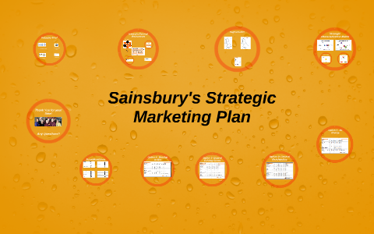
Figure 5 Sainsbury Marketing Plan
https://prezi.com/vvqayu5bsnty/sainsburys-strategic-marketing-plan/

- Strategic Partnerships: Collaborating with aligned brands, local producers either eco-conscious organizations may elevate Sainsbury's brand availability. These partnerships communicate the overall shared values as well as engage socially-conscious consumers who appreciate ethically-driven associations (Kordova et al., 2022).
- Experiential Marketing: Developing immersive brand experiences goes beyond touchpoints, creating lasting emotional connections. Pop-up stores, themed events either interactive installations facilitate customers with memorable interactions. Sainsbury may develop "Farm-to-Fork" events where customers intact in activities like farm visits, cooking classes as well as tastings (Keiningham et al., 2020). These experiences vividly demonstrate the journey of products from sourcing to usage deepening customer understanding as well as attachment.
- Virtual Reality (VR) Campaigns: Developing VR technology might divert customers into Sainsbury's world, encouraging a well deeper connection. Virtual tours of farms, and warehouses, as well as eco-friendly initiatives may provide an educational as well as engaging journey. Sainsbury's "VR Grocery Adventure" might allow customers to virtually shift through aisles, read product stories as well as explore sustainability efforts. This immersive experience boosts brand knowledge along with affinity (Maas et al., 2023).

Conclusion:
Sainsbury for the motive of maximizing customer satisfaction, Sainsbury has totally focused over the significance of touchpoints, identifying their potential to develop positive interactions as well as impressions. Whereas this exclusive focus on touchpoints can inadvertently shift attention from the more critical aspect which includes: the customer's end-to-end journey (Wang et al., 2023). To rectify this, Sainsbury must adopt a comprehensive approach that integrates touchpoint optimization within the broader context of the customer journey (Keiningham et al., 2020). This innovative marketing strategies, Sainsbury may raise brand awareness while effectively managing as well as evaluating the overall customer journey. Strategic partnerships, experiential marketing, virtual reality campaigns along with certain user-generated content contests are avenues that can elevate brand visibility along with developing lasting emotional connections (Maas et al., 2023). These strategies extend beyond individual touchpoints facilitating customers to intact with the brand on a deep level.
Similarly, Sainsbury must incorporate advanced technologies along with certain data-driven approaches to tackle as well as evaluate the customer journey. Unified customer data, AI-powered chatbots, segmented email campaigns, and predictive analytics along with social listening allow Sainsbury to deal with interactions, anticipate certain needs, and rectify concerns throughout the journey (Burton et al., 2020). This makes sure that touchpoints remain aligned with the evolving expectations of both current as well as future stakeholders. Fulfilling stakeholders' expectations necessitates responsive customer service, transparency in ethical practices, interactive tutorials along with robust data privacy assurances. These core elements encourage trust, and engagement along with positive brand perception, reinforcing Sainsbury's commitment to stakeholder satisfaction. Sainsbury's overall success falls in striking a harmonious balance among boosting touchpoints as well as orchestrating a seamless customer journey. By integrating discussed elements, Sainsbury will eventually create a cohesive as well as impactful customer experience that surpasses the expectations of its stakeholders (De Meyer et al., 2023). This holistic approach cements Sainsbury's position as a customer-centric brand that not only delivers exceptional interactions but also understands as well as fulfills the broader aspirations of its customers in an ever-evolving business landscape (Zweben et al., 2021).

References:
https://www.feefo.com/uk/business/resources/customer-acquisition/customer-journey-mapping-guide (No Date) (Accessed: 26 August 2023).
Adivar, B., Hüseyinoğlu, I.Ö.Y. and Christopher, M., 2019. A quantitative performance management framework for assessing omnichannel retail supply chains. Journal of Retailing and Consumer Services, 48, pp.257-269.
Argyropoulou, M., Zissis, D., Korfiatis, N. and Zampou, E., 2023. Horizontal collaboration in the last mile distribution: gauging managerial response to disruption and abnormal demand. Benchmarking: An International Journal, 30(2), pp.460-474.
Burton, J., Gruber, T. and Gustafsson, A., 2020. Fostering collaborative research for customer experience–connecting academic and practitioner worlds. Journal of Business Research, 116, pp.351-355.
De Meyer, A., Ferdows, K. and Vereecke, A., 2023. Putting manufacturing on the offensive. Production and Operations Management, 32(1), pp.227-236.
Dieplinger, L.P., 2021. Omnichannel Touchpoints in the FMCG Industry: An Empirical Study to Evaluate the Importance of Touchpoints in the Omni Shopper Journey. Webster University.
Gualandi, R., Masella, C., Viglione, D. and Tartaglini, D., 2019. Exploring the hospital patient journey: What does the patient experience?. PloS one, 14(12), p.e0224899.
Jones, P. and Comfort, D., 2021. Leading Retailers in the UK and Modern Slavery Statements. International Journal of Sales, Retailing and Marketing, 10(2), pp.18-26.
Jones, P. and Comfort, D., 2022. Modern Slavery Statements and Service Industry Supply Chains: A Commentary on the Leading Hotel and Retail Companies in the UK. Operations and Supply Chain Management, 15(3), pp.386-394.
Keiningham, T., Aksoy, L., Bruce, H.L., Cadet, F., Clennell, N., Hodgkinson, I.R. and Kearney, T., 2020. Customer experience driven business model innovation. Journal of Business Research, 116, pp.431-440.
Klussmann, T. S. a. M., 2009. In: Understanding Customer Journey Stages And Touchpoints. Berlin , Germany: s.n.
Kordova, S., Or, O. and Benis, A., 2022. Intergenerational knowledge management in a cutting-edge Israeli industry: Visions and challenges. Plos one, 17(7), p.e0269945.
Maas, V.K., Dibbets, F.H., Peters, V.J., Meijboom, B.R. and van Bijnen, D., 2023. The never-ending patient journey of chronically ill patients: A qualitative case study on touchpoints in relation to patient-centered care. Plos one, 18(5), p.e0285872.
McPherson, J., n.d. Mapping the Cutomer Journey. [Online]
Available at: https://cdn2.hubspot.net/hubfs/321221/Mapping%20the%20Customer%20Journey%20Whitepaper.pdf [Accessed 15 08 2023].
Paavola, L. and Cuthbertson, R., 2021. Algorithms creating paradoxes of power: Explore, exploit, embed, embalm. Information Systems Management, 38(4), pp.358-371.
Ramadan, Z.B., Farah, M.F. and Daouk, S., 2019. The effect of e-retailers' innovations on shoppers' impulsiveness and addiction in web-based communities: the case of Amazon's Prime Now. International Journal of Web Based Communities, 15(4), pp.327-343.
Romeo-Arroyo, E., Jensen, H., Hunneman, A. and Velasco, C., 2023. Assessing the influence of packaging design symmetry, curvature, and mark on the perception of brand premiumness. International Journal of Gastronomy and Food Science, 31, p.100656.
Wang, Y., 2023. A Model Predicting CRM Resource Effect on Business Performance through CRM Capabilities. Wireless Communications and Mobile Computing, 2023.
Ziliani, C. and Ieva, M., 2019. Loyalty in the omnichannel environment. Loyalty Management: From Loyalty Programs to Omnichannel Customer Experiences, pp.183-201.
Zweben, M. and Sweeney, M., 2021. An Expert Systems Journey—Red Pepper and Blue Martini. IEEE Annals of the History of Computing, 44(1), pp.73-86.

