Tuberculosis: A Public Health Report
Student Name: OKEKE IRENE NJIDEKA
Student ID: 2513507@student.uwtsd.ac.uk
Programme: Certificate of Higher Education Skills for the Workplace (Health and Social Care)
Module: Introduction to Public Health
Module Code: LCHS 4008
Lecturer: Gillian Weaver (Module Lead)
Internal Verifier: Dr Besty Jose

Introduction (150 words)
Tuberculosis (TB) is a contagious bacterial infection caused by Mycobacterium tuberculosis. The disease mainly affects the lungs (pulmonary tuberculosis) but can also spread to other organs such as the brain, spine, kidneys and lymph nodes (World Health Organization, 2024). TB spreads through airborne droplets when an infected individual coughs, sneezes or speaks, allowing the bacteria to be inhaled by others.
Common symptoms of tuberculosis include a persistent cough lasting more than three weeks, chest pain, coughing up blood, fever, night sweats, fatigue, loss of appetite and unexplained weight loss. If untreated, the disease can cause severe lung damage and may lead to death.
Tuberculosis remains one of the world’s leading infectious diseases. Globally, approximately 10.7 million people developed TB in 2024, highlighting the significant global burden of the disease . In the United Kingdom, about 5,490 TB cases were reported in England in 2024, with an incidence rate of around 9.4 cases per 100,000 population, demonstrating that TB remains an important public health concern despite being considered a low-incidence country .

TB Transmission Diagram
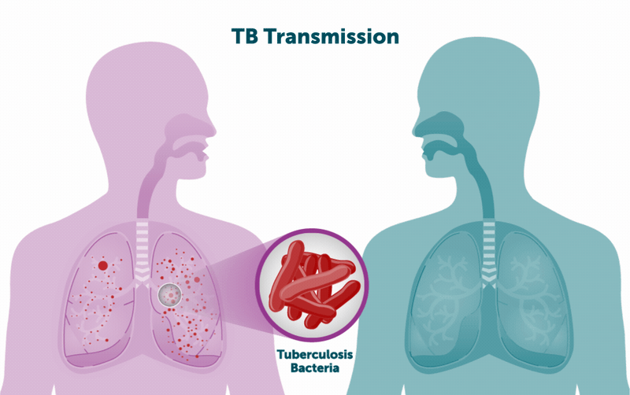
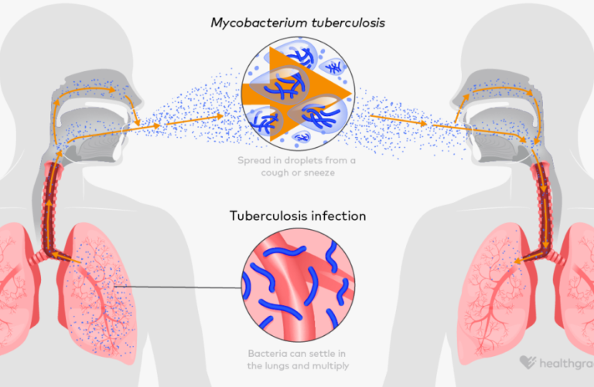

4

Explanation
The diagram above shows how tuberculosis spreads through airborne transmission. When a person with active pulmonary TB coughs or sneezes, microscopic droplets containing TB bacteria are released into the air. These droplets can remain suspended for several hours. When another person inhales the contaminated air, the bacteria enter the lungs and may multiply, causing infection.

Global vs UK TB Incidence Chart
Region | Estimated Cases | Incidence Rate
Global | 10.7 million cases | 131 per 100,000 population
England (UK) | 5,490 cases | 9.4 per 100,000 population
Global TB incidence is significantly higher compared with the UK because many cases occur in low- and middle-income countries where poverty, overcrowding and limited healthcare services increase transmission rates .

Main Body
Measuring and Monitoring Tuberculosis
Monitoring infectious diseases such as tuberculosis is essential for understanding their distribution and developing strategies to control their spread. Public health authorities rely on surveillance systems to monitor TB cases and evaluate the effectiveness of prevention programmes.
One key approach is disease surveillance, which involves the systematic collection, analysis and interpretation of health data. Surveillance allows health organisations to track the number of TB cases, identify high-risk populations and detect outbreaks. Global TB surveillance is coordinated by the World Health Organization, which collects data from countries worldwide through national TB programmes.
Another important monitoring method is case notification systems. Healthcare professionals are legally required to report confirmed TB cases to public health authorities. In the United Kingdom, tuberculosis cases are reported to the UK Health Security Agency (UKHSA). This system helps monitor national trends and enables public health officials to identify areas where TB is increasing.
Laboratory diagnosis also plays a key role in measuring tuberculosis. Diagnostic tests such as sputum smear microscopy, culture tests and molecular testing (for example GeneXpert) are used to detect Mycobacterium tuberculosis in patient samples. These diagnostic tools help confirm infection and monitor treatment outcomes.
In addition, screening programmes are used to detect latent TB infections in high-risk groups. Screening may include chest X-rays, tuberculin skin tests or interferon-gamma release assays. Early detection is essential because individuals with latent TB infection may develop active TB later in life if their immune system becomes weakened.
Public health professionals also use epidemiological research to study the patterns, causes and risk factors associated with tuberculosis. Epidemiological studies analyse demographic factors such as age, gender, socioeconomic status and geographical location to identify vulnerable populations.

Control and Prevention of Tuberculosis
Controlling tuberculosis requires a combination of medical treatment, vaccination, public health interventions and social support.
The primary method of controlling TB is antibiotic treatment. Standard treatment involves a combination of antibiotics such as isoniazid, rifampicin, pyrazinamide and ethambutol for at least six months. Completing the full course of treatment is essential to eliminate the bacteria and prevent drug-resistant tuberculosis.
Another important preventive measure is BCG vaccination. The Bacillus Calmette-Guérin vaccine is widely used to protect children from severe forms of tuberculosis. Although the vaccine does not provide complete protection against pulmonary TB, it significantly reduces the risk of serious complications.
Contact tracing is also an important public health strategy. When a person is diagnosed with TB, healthcare professionals identify individuals who have had close contact with the patient. These contacts are then tested and monitored for infection. Early detection helps prevent further transmission.
Public health initiatives also focus on addressing social determinants of health, such as poverty, overcrowded housing and poor nutrition. Tuberculosis is more common in communities experiencing deprivation and limited access to healthcare services.
The WHO End TB Strategy aims to reduce TB incidence by 90% and TB deaths by 95% by 2035. This strategy focuses on strengthening healthcare systems, improving diagnostic technologies and expanding access to treatment worldwide.

Consequences of Tuberculosis on Individuals and Communities
Tuberculosis has significant consequences for individuals, families and communities.
At the individual level, TB can cause severe physical health problems. Persistent coughing, chest pain, fatigue and weight loss can reduce a person’s quality of life. If the disease spreads beyond the lungs, it may lead to complications such as TB meningitis, spinal TB or kidney damage.
Tuberculosis can also have psychological impacts. Individuals diagnosed with TB may experience anxiety, fear or social stigma. In some communities, TB is associated with poverty and infectiousness, which can lead to discrimination or social isolation.
Economic consequences are also significant. TB patients may be unable to work due to illness, leading to financial difficulties for themselves and their families. The long treatment period may also create additional healthcare costs.
At the community level, tuberculosis places pressure on healthcare systems. Resources are required for diagnosis, treatment and prevention programmes. If TB is not controlled effectively, outbreaks may occur, increasing healthcare costs and threatening public health.
Drug-resistant tuberculosis is an additional challenge. Multidrug-resistant TB occurs when bacteria become resistant to standard antibiotics, making treatment more difficult and expensive.

Health and Social Care Support Services
Individuals affected by tuberculosis require a range of health and social care services to support their recovery and prevent transmission.
Healthcare services provide diagnostic testing, treatment and monitoring for TB patients. Respiratory specialists, doctors and nurses work together to ensure that patients receive appropriate medical care.
Community healthcare services also provide Directly Observed Therapy (DOT) programmes. In these programmes, healthcare workers supervise patients while they take their medication to ensure adherence to treatment. This approach is particularly effective in preventing drug resistance.
Social care services also play an important role. Many individuals affected by TB may experience housing problems, financial difficulties or limited access to healthcare. Social workers help patients access housing support, welfare benefits and community resources.
Mental health support may also be required. Counselling services and support groups can help patients cope with the psychological effects of the disease.
Through coordinated health and social care services, communities can ensure that individuals with tuberculosis receive comprehensive support while reducing the spread of infection.

Conclusion
Tuberculosis remains a major global public health issue despite the availability of effective treatment and prevention strategies. The disease is caused by Mycobacterium tuberculosis and spreads through airborne droplets, primarily affecting the lungs. Symptoms such as persistent cough, fever, night sweats and weight loss highlight the seriousness of the infection.
Global data indicates that millions of people continue to develop tuberculosis each year, while cases in the United Kingdom have also increased in recent years. Monitoring systems such as surveillance programmes, laboratory testing and epidemiological studies are essential for tracking the spread of TB and identifying high-risk populations.
Control strategies including antibiotic treatment, vaccination, contact tracing and health education are essential for reducing TB transmission. However, the disease continues to have serious social, economic and psychological consequences for affected individuals.
Providing comprehensive health and social care support services ensures that patients receive effective treatment and community support. Continued investment in public health strategies is essential to achieve long-term tuberculosis prevention and control.

Harvard Reference List
Care Quality Commission (2023) Fundamental standards. London: CQC.
Naidoo, J. and Wills, J. (2022) Foundations for Health Promotion. 5th edn. London: Elsevier.
NHS (2023) Tuberculosis (TB). Available at: https://www.nhs.uk (Accessed: 15 March 2026).
Public Health England (2023) Tuberculosis in England annual report. London: PHE.
UK Health Security Agency (2025) Tuberculosis in England 2024 report. Available at: https://www.gov.uk
World Health Organization (2024) Global Tuberculosis Report. Geneva: WHO
World Health Organization (2023) End TB Strategy. Geneva: WHO.

