
Faculty of Applied Design and Engineering
Cyfadran Dylunio Cymhwysol a Pheirianneg
School of Applied Computing
Ysgol Cyfrifiadureg Gymhwysol

B.Sc. ASSIGNMENT SPECIFICATION

Student name: |  | Student P number:
Programme: | B.Sc. Computing Portfolio
Module: | Distributed Enterprise Applications | Module Level (4, 5, 6, 7): | 6
Module code: |  | Contribution to Overall  Module Assessment (%):
Lecturer: | Stephen Hole | Internal Verifier: | Mike Dacey
Assignment Title: | Equation Solver Web Service | Assignment No: | 1
Hand Out Date: | 30th December 2009 | Submission deadline: | TBA
Penalties for late submission: Up to one week late, maximum mark of 40%. Over one week late, Refer.
Referencing: | In the main body of your submission you must give credit to authors on whose research your work is based (numeric system of referencing)). Append to your submission a reference list / bibliography that indicates the books, articles, etc. that you have read or quoted in order to complete this assignment (initials of author and surname, title of book/article, edition, publisher: place of publication, date of publication).
Disclosure: | I declare that this assignment is all my own work and that I will acknowledge all materials used from the published or unpublished works of other people.
Student’s Signature: |  | Date:

Learning Outcomes tested  (from module/unit syllabus) | Assessment Criteria To achieve each outcome a student must demonstrate the ability to:

- Please submit the assignment parts in a suitable report folder– not in polypockets.
- The assignment specification (including tasks, marking scheme and coursework feedback form) should be at the front of the submission. Assignments will not be accepted without a specification as it is a requirement that you sign the disclosure regarding referencing convention.

Coursework Feedback to Students

Lecturer’s General Comments:
Final Grade:

Lecturer’s Signature: |  |  | Date:

Second Marker’s Comments:
Second Marker’s Signature: |  | Date:

TASK DESCRIPTION

Students’ Briefing Notes

Equation Solver

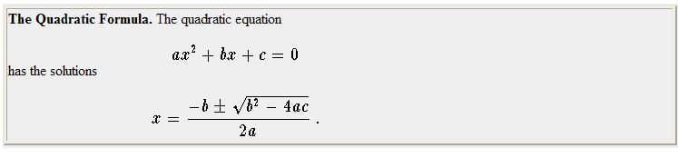
Figure 1 – Quadratic Equation Formula

Sine Rule 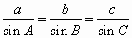 | 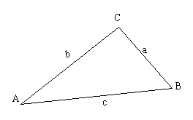

Figure 2 – Sine Rule

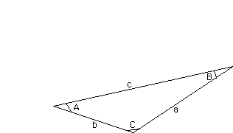
Here's the cosine rule: a²=b²+c²- 2bc*cosA

Figure 3 – Cosine Rule

Equation Solver: Quadratic; Sine Rule & Cosine Rule

- Create a Web Service project to: Find the two possible solutions for x given values of a, b and c using the Quadratic Equation formula (see figure 1).
- Create a second Web Service to calculate an unknown side or angle of a triangle using the Sine Rule (see figure 2).
- Create a third Web Service to calculate an unknown side of a triangle given two side and an angle (see figure 3).
- Create a fourth Web Service to write to a database of your choice the user name, function used, and date accessed.

Marking scheme (and lecturer comments) | Marks available | Marks awarded | 2nd marker
- Create a Web Service project to Quadratic Equation problems | 30%
- Create a Web Service project to Sine Rule problems | 25%
- Create a Web Service project to Cosine Rule problems | 25%
- Write to a database of your choice the user name, function used, and date accessed | 10%
- Report Writing  - What changes (in terms of code and strategy) would be required of the project in order to have it hosted by a Windows Communication Foundation environment  - Format the document correctly  - Include a bibliography  - Reference the bibliography | 10%
TOTAL | 100

Generic Grading Criteria (Degree)
0-35 | A mark in this range is indicative that the work is below the standard required at the current level of your Degree programme. Work falls short of the threshold standards in relation to one or more of knowledge, intellectual, subject based or key skills. Work is based on only minimal understanding, application or effort. It will offer only very limited evidence of familiarity with knowledge or skills appropriate to the field of study or task and/or demonstrate inadequate capability in key skills essential to the task concerned. It may address the assessment task to some extent, or include evidence of successful engagement with some of the subject matter, but such satisfactory characteristics will be clearly outweighed by major deficiencies across remaining areas. Other reasons for failing the coursework may include excessive absenteeism; academic dishonesty (cheating), plagiarism or failure to participate in teamwork.
35-39 | A mark in this range is indicative that the work is below, but at the upper end is approaching the standard required at the current level of your Degree programme. Whilst some points are correctly presented there are serious errors and/or omissions and/or irrelevant material. It indicates work of an insufficient standard. It will show very limited knowledge or understanding of the relevant subject area, and display weak writing and analytical skills and/or poor application of technique. Writing will exhibit weak grammar, very inadequate or absent references and/or bibliography and may contain major factual errors. Quantitative work will contain significant errors and incorrect conclusions.
40-49 | A mark in this range is indicative that the work is of an acceptable standard at the current the level of your Degree programme. Work demonstrates some familiarity with and grasp of a factual/conceptual knowledge base for the field of study and/or ability to employ specialist skills, but only just meeting threshold standards. Work may be characterised by some significant errors, omissions or problems, but there will be sufficient evidence of development and competence. Writing may be poorly presented without properly laid out referencing/bibliography, or in the case of quantitative work, it may not be possible to follow the logic and reasoning leading to the results obtained and the conclusions reached.
50-59 | The work is of a satisfactory to very satisfactory standard at the current level of your Degree programme. Work demonstrates ability to evaluate new information, concepts and evidence from a range of sources and generate ideas through the analysis of concepts at an abstract level. Arguments and issues will be discussed and referenced, but these may not be fully documented or detailed. The work will be mostly accurate and provide some evidence of the ability to analyse, synthesise, evaluate and apply required methods/techniques. There will be no serious omissions or inaccuracies. There will be good evidence of ability to take responsibility for own learning including the selection and use of relevant techniques and applying creative skills. With Quantitative work it should be possible to follow the logical steps leading to the answer obtained and the conclusions reached.
60-69 | A mark in this range is indicative of that the work is of a very good standard for the current level of your Degree programme. Work of commendable quality commanding wide ranging specialised technical, creative and/or conceptual skills. There will be consistent evidence of capability in all relevant subject-based skills, including the ability to self-evaluate and work autonomously and to use effectively specified techniques in appropriate contexts.  Writing work will make excellent use of appropriate, fully referenced, detailed examples and there will be clear evidence of analysis, synthesis and evaluation. Any quantitative work will be clearly presented, the results should be correct and any conclusions clearly and accurately expressed.
70-84 | A mark in this range is indicative that the work is of an excellent standard for the current level of your Degree programme. Work is based on a rigorous and broad knowledge base, demonstrating ability to analyse, synthesise, evaluate concepts and/or interpret and describe the creative expression and the associated workflow process including both the design and development/production considerations.  The work will go beyond that provided on reading lists and include independent work. There will be strong evidence of competence across a range of specialised skills and the capability to operate autonomously. The work will exhibit excellent levels of knowledge and understanding, with elements of originality and flair.
85-100 | A mark in this range is indicative of outstanding work. Marks in this range will be awarded for work that exhibits excellent levels of knowledge and understanding throughout with substantial elements of originality and flair. The work will demonstrate a broad range of critical reading that goes well beyond that provided on reading lists. Marks at the upper end of the range will indicate that the work is of publishable, or near publishable academic standard.

RECEIPT

NAME:

COURSE: | B.Sc. Computing Portfolio |  | YEAR:
ASSIGNMENT
TITLE:

LECTURER: |  | DATE:
DATE STAMP:

RECEIPT

NAME:

COURSE: | B.Sc. Computing Portfolio |  | YEAR:
ASSIGNMENT
TITLE:

LECTURER: |  | DATE:
DATE STAMP:

