Independent Project:
Research Proposal

MODULE | Independent Project (ACCA6020_LON)
STUDENT NAME | Pedro Gaetjens Molongua
STUDENT NUMBER | 2327143
SUPERVISOR | Koushik Modak
LECTURER | Renuga Jayakumar
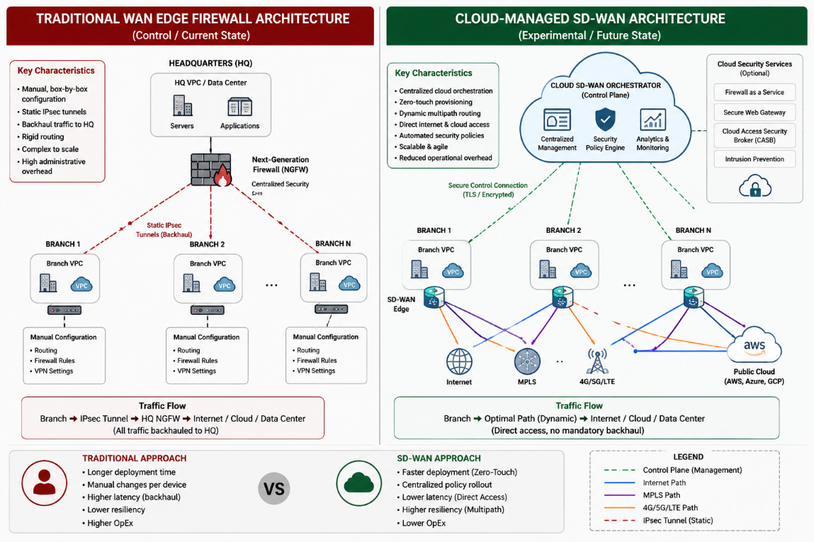
Image generated by ChatGPT
INDEX
BACKGROUND TO MY PROPOSED RESEARCH 3
Subject Area Background 3
Field, Rationale, and Research Gap 4
Research Question & Expected Proposition 4
Research Question (RQ) 4
Expected Proposition 5
Context of Investigation 5
Research Aim & Objectives 5
Expected Outcomes and Deliverables 6
PROJECT DESIGN & METHODOLOGY 6
Research Design and Methodological Justification 6
Network Topology and Architectural Specifications 6
Data Collection and Quantitative Evaluation Metrics 8
Experimental Scenarios 9
Scenario 1: Branch Deployment 9
Scenario 2: Security Policy Deployment 9
Scenario 3: Link Failure 9
Reliability 9
Resources Required 9

BACKGROUND TO MY PROPOSED RESEARCH
Design and Experimental Evaluation of a Cloud-Managed SD-WAN Architecture Compared with Traditional Edge Firewall Networks for Small-to-Medium Enterprises

Subject Area Background
Historically, small-to-medium enterprises (SMEs) have relied on rigid, static, hub-and-spoke Wide Area Networks (WANs). In these traditional architectures, remote branch traffic is backhauled through static IPsec tunnels to a centralized physical or virtual next-generation firewall (NGFW) situated at a primary headquarters centre [1]. While this configuration has served foundational requirements, modern business operations have undergone extensive digitisation, mirroring a macro-level shift towards cloud-hosted applications, digital transformation, and hybrid multi-location workflows [2], [3].
In bandwidth-constrained networks, manual security rules and static routing tables struggle to adapt to the variable quality of service (QoS) and link dynamics introduced by cloud-hosted infrastructures. Security policy changes on traditional edge devices must be managed individually, introducing human administrative latency, configuration drift, and critical security blind spots [4]. This device-centric approach increases administrative overhead, limits scalability, and complicates the adoption of dynamic connectivity solutions such as Starlink, LTE, and multi-cloud networking [1].
Software-Defined Wide Area Networking (SD-WAN) separates the control plane from the data plane, enabling centralised policy management and automated path selection based on latency, jitter and packet loss, thereby improving resilience and scalability [5]-[7]. Recent research has also explored AI-based SD-WAN security techniques [8], [9], although SME deployments continue to face practical challenges in adopting these technologies.
Furthermore, modern network security architectures require strict alignment with international standards and security frameworks. Standardised frameworks such as NIST SP 800-207A establish that multi-location cloud networks must enforce Zero Trust Architecture (ZTA) by discarding implicit trust based on physical location and continually evaluating access policies dynamically [10]. Simultaneously, compliance standards like ISO/IEC 27001:2022 outline strict mandates for automated management, information classification, and secure change control, placing significant emphasis on centralised orchestration to maintain organisational security compliance [11]. Although these studies and frameworks demonstrate the technical advantages of centralised orchestration, most evaluate large-scale enterprise or service-provider environments. Consequently, their findings cannot be directly generalised to SMEs, where budget constraints, limited IT expertise, and simplified network topologies may influence deployment outcomes.

Field, Rationale, and Research Gap
While extensive academic literature exists evaluating global SD-WAN deployments for massive, multinational telecommunications providers [5], [12], there is a noticeable research gap concerning how these technologies translate to resource-constrained SMEs. Existing studies have primarily focused on large-scale enterprise deployments, orchestration frameworks, routing optimisation, or theoretical SD-WAN architectures. Distinct domains of SMEs academic literature frequently explore sophisticated, data-driven frameworks to optimise internal operations and risk assessments [13], yet a profound empirical data gap remains regarding core architectural infrastructure resilience. Comparatively little empirical research evaluates operational efficiency within SME-scale environments by measuring deployment time, configuration effort, policy propagation, and failover performance using reproducible experimental methods. Consequently, organisations considering migration still lack reproducible empirical evidence demonstrating the operational trade-offs between cloud-managed SD-WAN and traditional firewall-centric architectures within SME-scale environments. This research is highly topical and applied because it provides a concrete, empirical comparison to address this evidence gap, offering SMEs a practical, evidence-based migration blueprint.

Research Question & Expected Proposition

Research Question (RQ)
- RQ1: How does a cloud-managed SD-WAN architecture compare with a traditional edge firewall architecture in terms of deployment efficiency, network resilience and centralised security management within an SME environment?
This research adopts an experimental comparative methodology in which two network architectures are implemented under identical conditions to evaluate operational performance using predefined quantitative metrics. Both network environments will be configured using equivalent branch topologies and identical security policies to ensure that any observed differences can be attributed to the management architecture rather than variations in the network design.

Expected Proposition
- P1: A cloud-managed SD-WAN architecture is expected to reduce deployment time, decrease policy propagation latency and improve failover times compared with a traditional edge firewall architecture, despite introducing additional initial orchestration complexity.

Context of Investigation
The investigation focuses on a simulated multi-location SME environment deployed within Amazon Web Services (AWS). AWS networking services will be used to implement and evaluate both a traditional edge firewall architecture and a cloud-managed SD-WAN architecture under identical conditions. It mirrors a realistic corporate infrastructure consisting of:
- A central Headquarters virtual network (VPC) deployed in AWS.
- Multiple simulated branch-office virtual networks simulating dispersed corporate sites utilising diverse virtual WAN transport options (such as hybrid broadband, LTE, or virtual links) [1], [14].
The experimental design will measure how each architecture handles traffic routing, failover and policy changes across these sites.

Research Aim & Objectives
The overarching aim of this research is to design, implement, and experimentally evaluate a cloud-managed SD-WAN architecture against a traditional edge firewall topology within a public cloud environment to assess and compare operational efficiency, security orchestration and network resilience for SME deployments.
To achieve this aim, the study is broken down into the following SMART objectives:
- To critically review existing academic literature, cloud provider reference architectures (AWS and Fortinet), and international standards (NIST ZTA, ISO 27001) to identify optimal security and routing postures for multi-location SME networks.
- To design and develop a comparative public cloud network topology consisting of two distinct testing environments:
ENVIRONMENT | DESCRIPTION
Environment A (Control) | Traditional WAN utilising manually configured routing and edge firewall policies.
Environment B (Experimental) | Cloud-managed SD-WAN utilising centralised orchestration and automated path selection.

- To measure and compare deployment time, policy propagation time, routing behaviour, failover recovery time, and administrative effort between the two architectures under simulated stress scenarios.
- To formulate a set of evidence-based recommendations for SME migration from legacy edge security models to centralised cloud-managed SD-WAN infrastructures.

Expected Outcomes and Deliverables
At the conclusion of this study, the following deliverables will be submitted:
- A Technical Network Artifact: A fully configured, simulated network topology in AWS showing functional routing, high-availability setups, and centralised security templates.
- A 10,000-Word Final Project Report: A comprehensive academic thesis covering the literature review, methodology, implementation, empirical analysis and conclusions.
- Comparative Performance Datasets: Data sets and tracking tables documenting deployment time, latency, packet loss, failover recovery time, and policy propagation time.
- Evidence-Based Recommendations for SME Migration: A practical, step-by-step technical blueprint and decision-making model designed specifically for IT decision-makers in SMEs.
- An A1 Academic Exhibition Poster: A visual research summary highlighting the methodology, key findings, network diagram and comparative metrics of the project.

PROJECT DESIGN & METHODOLOGY

Research Design and Methodological Justification
This study adopts an experimental quantitative methodology because it produces objective and reproducible measurements of deployment time, routing performance and failover behaviour [5], [12]. Both architectures will be deployed within the same AWS region using identical infrastructure so that observed differences are attributable only to the management architecture.

Network Topology and Architectural Specifications
Two AWS environments will be deployed. Environment A represents a traditional WAN using IPsec VPNs, static routing and independently managed virtual firewalls. Environment B implements cloud-managed SD-WAN using identical infrastructure but with centralised orchestration, BGP-based routing and template-driven policy deployment [14], [15]. Infrastructure, workloads and instance types will remain identical to ensure fair comparison.

Data Collection and Quantitative Evaluation Metrics
The research evaluates the architectures using four key metrics, captured during the simulations using automated script timing and active network testing tools.
$$\begin{matrix}Metric & Operational Definition & Measurement Instrument \\ \backslash hline\text{Deployment Time }\left(T_{\text{dep}}\right) & \text{Time taken to provision and securely connect a new branch.} & \text{Stopwatch/CLI deployment script timers.} \\ \backslash hline\text{Policy Propagation }\left(T_{\text{prop}}\right) & \text{Time taken for a security block to apply across all nodes.} & \text{Automated ping/port sweeps via bash scripts.} \\ \backslash hline\text{Failover Time }\left(T_{\text{fail}}\right) & \text{Packet loss duration during a primary link degradation.} & \text{Continuous ICMP stream (ping) at 100ms intervals.} \\ \backslash hline\text{Configuration Effort }\left(C_{\text{eff}}\right) & \text{Number of discrete steps/commands required for an action.} & \text{Quantitative step-audit log.}\end{matrix}$$

The independent variable is the network management architecture, while deployment time, policy propagation, failover recovery and configuration effort are the dependent variables. All other infrastructure characteristics remain constant.
Experimental Scenarios
Three controlled experiments will be conducted under identical network conditions.

Scenario 1: Branch Deployment
A new branch office will be added to each environment. Deployment time ($T_{\text{dep}}$) and configuration effort will be recorded to evaluate provisioning efficiency [14].

Scenario 2: Security Policy Deployment
A security policy blocking SSH (TCP port 22) will be applied across all branch offices. Policy propagation time ($T_{\text{prop}}$) will be measured from deployment until successful enforcement at every site [4].

Scenario 3: Link Failure
Network degradation will be simulated using Linux traffic control (tc) while synthetic traffic is generated with iperf3. Packet loss and failover recovery time ($T_{\text{fail}}$) will be recorded to compare network resilience[7], [14].

Reliability
Identical AWS resources, operating systems and network configurations will be used throughout. Each experiment will be repeated ten times, with mean values, standard deviations and 95% confidence intervals calculated to improve reliability.

Resources Required
Resources required include AWS (Free Tier or AWS Educate credits), EC2, VPCs, Site-to-Site VPN, Fortinet virtual appliances (or equivalent SD-WAN platform), Terraform or AWS CloudFormation, CloudWatch, iperf3, Linux traffic control (tc), Bash scripting, and access to IEEE Xplore, ACM Digital Library and Google Scholar. A personal computer with SSH access is sufficient because all infrastructure is cloud-hosted.
References
[1] H. M. Herrera and Y. D. Granada Mahecha, "Secure Remote Connectivity with Starlink, Lte, and Vpn: Proposal for an Autonomous and Decentralized Architecture," Secure Remote Connectivity with Starlink, Lte, and Vpn: Proposal for an Autonomous and Decentralized Architecture, .
[2] J. Lyu, "AI in Enterprise Networking." M.Sc., Internetworking, University of Alberta, 2022.
[3] S. Kraus et al, "Digital transformation: An overview of the current state of the art of research," Sage Open, vol. 11, (3), pp. 21582440211047576, 2021. .
[4] D. Bringhenti, R. Sisto and F. Valenza, "Security automation for multi-cluster orchestration in Kubernetes," 2023 IEEE 9th International Conference on Network Softwarization (NetSoft) /, pp. 480–485, 2023. . DOI: 10.1109/NetSoft57336.2023.10175419.
[5] A. Leivadeas et al, "Analyzing the Performance of SD-WAN Enabled Service Function Chains Across the Globe with AWS," Proceedings of the 2023 ACM/SPEC International Conference on Performance Engineering /, pp. 125–135, . DOI: 10.1145/3578244.3583722.
[6] R. Perez, A. Zabala and A. Banchs, "Alviu: An intent-based SD-WAN orchestrator of network slices for enterprise networks," in 2021 IEEE 7th International Conference on Network Softwarization (NetSoft), 2021, . DOI: 10.1109/NetSoft51509.2021.9492534.
[7] Y. Zhang et al, "Improving SD-WAN Resilience: From Vertical Handoff to WAN-Aware MPTCP," IEEE Transactions on Network and Service Management, vol. 18, (1), pp. 347–361, 2021. . DOI: 10.1109/TNSM.2021.3052471.
[8] A. M. Abdallah et al, "Cloud Network Anomaly Detection Using Machine and Deep Learning Techniques— Recent Research Advancements," IEEE Access, vol. 12, pp. 56749–56773, 2024. . DOI: 10.1109/ACCESS.2024.3390844.
[9] N. Patel, "Enhanced network security: Real-time malicious traffic detection in SD-WAN using LSTM-GRU hybrid model," in 2024 9th International Conference on Communication and Electronics Systems (ICCES), 2024, . DOI: 10.1109/ICCES63552.2024.10860215.
[10] R. Chandramouli and Z. Butcher, A Zero Trust Architecture Model for Access Control in Cloud-Native Applications in Multi-Location Environments. 2023.
[11] M. Malatji, "Management of enterprise cyber security: A review of ISO/IEC 27001:2022," in 2023 International Conference on Cyber Management and Engineering (CyMaEn), 2023, . DOI: 10.1109/CyMaEn57228.2023.10051114.
[12] Y. Jiang, W. Feng and N. Ge, "Joint Resource Provisioning and Allocation for Service Function Chaining in Software-Defined Wide Area Networks," IEEE Internet of Things Journal, vol. 12, (12), pp. 18732–18749, 2025. . DOI: 10.1109/JIOT.2025.3556460.
[13] B. Liu et al, "Unveiling the potential of graph neural networks in SME credit risk assessment," in 2024 5th International Conference on Intelligent Computing and Human-Computer Interaction (ICHCI), 2024, . DOI: 10.1109/ICHCI63580.2024.10808129.
[14] Fortinet. (27/02). Secure SD-Branch Architecture Guide. Available: https://fortinetweb.s3.amazonaws.com/docs.fortinet.com/v2/attachments/022895df-f2e2-11ef-b13a-ca4255feedd9/Secure_SD-Branch-7.6-Architecture_Guide.pdf.
[15] Amazon Web Services. (06/07). Hybrid Connectivity. Available: https://docs.aws.amazon.com/pdfs/whitepapers/latest/hybrid-connectivity/hybrid-connectivity.pdf.

