Contents
Introduction 2
Reynolds Number 2
Definition 2
Application 3
Wing Profile 4
Properties of the air 4
Velocity 4
Calculation 4
Boundary Flow 5
Material Selection 6
Modelling 6
Physical Testing 7
Scale 8
Scale Model 8
Full Scale 8
Blockage Problem 8
Tunnel Type 8
Open Return 8
Open Return Open Jet 9
Closed Return 9
Floor Treatment 10
Ground Board 10
Porous Suction 10
Moving Floor 10
Fence 10
Test Procedure 10
Bibliography 11

Introduction
In this assignment I will be explaining the effects of airflow on an aerofoil using a rear wing of a car as an example. I will also be discussing the material of the wing, the simulation techniques that could be used to model the airflow over the wing, and the physical testing methods that could be used to practically demonstrate the airflow.
The wing I’ll be using for this assignment can be seen below in figure 1. This is a concept design for a race car rear wing.
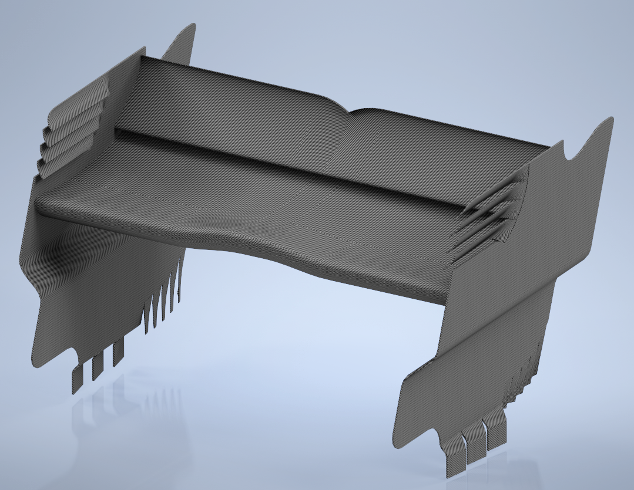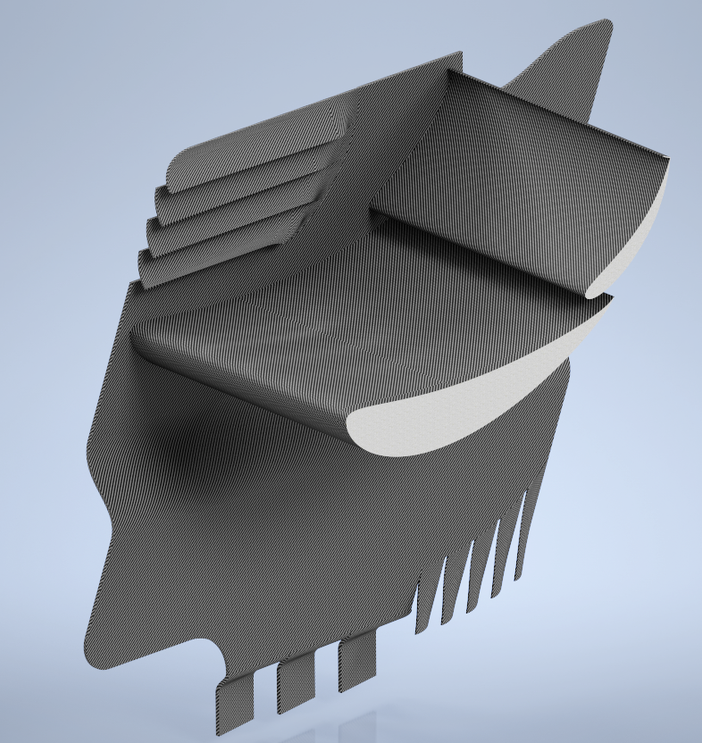
Figure 1 – Race Car Rear Wing
Due to the relatively complex geometry on the wing, any manual calculations will be done on the flat section of the wing, as shown in the cross section in figure 1. This will be representative for basic flow characteristics as the same geometry makes up the majority of the wing.

Reynolds Number

Definition
When working out flow characteristics, Reynolds number can be used to describe the fluid flow in terms of flow formation.
Reynolds number, often expressed as Re, is a dimensionless number. It’s a ratio between inertial forces and viscous forces, which can be used to describe whether fluid flow is Laminar, Transitional, or Turbulent.
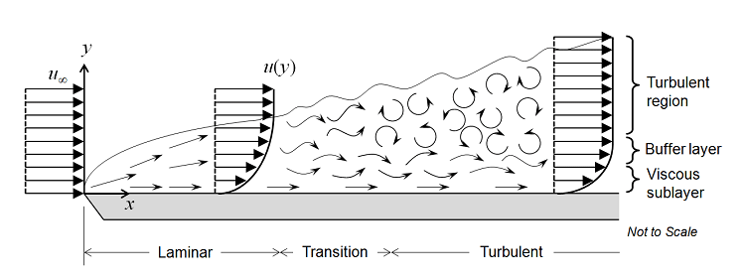Figure 2 – Flow Types (Halila, 2014)
Laminar flow - when the fluid flows in one direction in parallel layers with little to no disruption between the layers.
Turbulent flow - when lateral mixing of the fluid occurs due to variations in pressure and velocity.
Transitional flow - the phase between Laminar and Turbulent flows, where disruption of the flow can be seen, and fluid begins to cross between layers.
Reynolds number can be expressed by the following formula:
$$Re=\frac{ρuL}{μ}$$
Where ρ is the density of the fluid, u is the characteristic velocity of the fluid, L is the characteristic length, and μ is the dynamic viscosity of the fluid.
The critical Reynolds Number (Re_{x}), is a measure of when the flow begins to transition from Laminar to Turbulent. This is dependent on many factors including compressibility, variation in viscosity, and whether the flow is internal or external. However, typically speaking when the fluid is travelling over a flat plate in free stream the critical Re is between 5x10⁵ to 5x10⁶ (Nuclear Power, 2023).
When applying this to the wing, an assumption will be made that the critical Re in free stream over a flat plate of 5x10⁵ will also be relevant to the wing, measuring the characteristic length from the attachment point at the front of the aerofoil.

Application
Turbulent flow on the wing will increase drag and reduce the amount of downforce on the wing. Downforce is a result of a low pressure created underneath the wing when the air passes under it at a high velocity. If the flow becomes turbulent, the velocity decreases, and hence the low-pressure region is lost.
  - 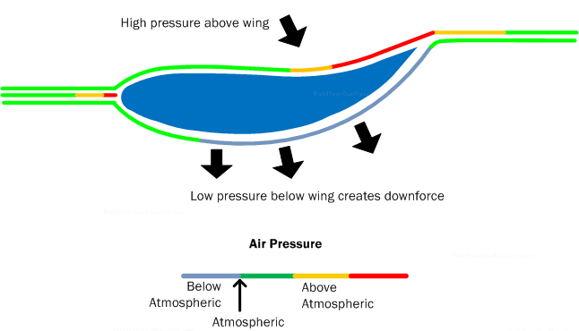
Figure 3 – Downforce (Rangam, 2020)
Knowing the Reynolds Number of the wing will help to determine whether the flow is laminar or turbulent, and hence analyse its effectiveness.
In order to calculate the Reynolds number over the wing, a number of assumptions first need to be made.

Wing Profile
Due to the complex geometry of the wing, flow over a single section must be used. The profile selected makes up the majority of the wing surface and will therefore be a good estimation. Reynolds number will be calculated independently for each element of the wing, although there is a more complex relationship between the elements and how they change each-others flow, assumptions around this will be made later.
The characteristic lengths of the elements are 237.45 mm for the main wing, and 178.138 mm for the second wing. In SI units this is 0.237 m and 0.178 m respectively.
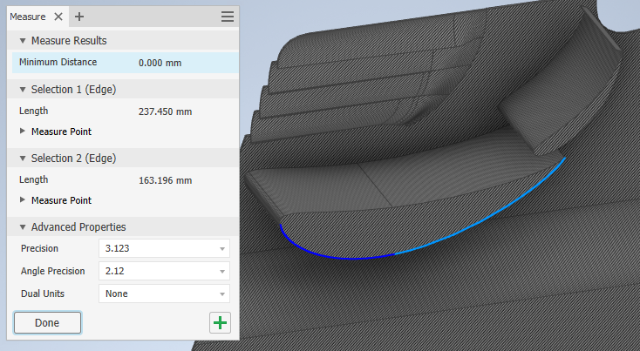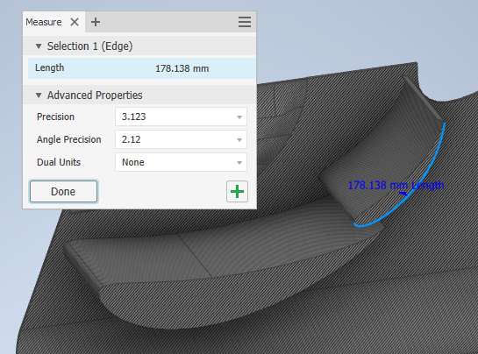
Figure 4 – Characteristic Lengths

Properties of the air
To calculate Reynolds number, fluid viscosity and fluid density both need to be known, and these are both dependent on the temperature and pressure of the air. For this calculation it will be assumed that the air is at 20°C and at standard atmospheric pressure at sea level. Based on these assumptions, a Viscosity of 1.825x10⁻⁵ kg/m-s (Engineers Edge, 2023), and a Density of 1.204 kg/m³ (Engineering Toolbox, 2023). will be used.

Velocity
As only the wing is known, it must be assumed that the velocity of the air as it meets the wing is equal to the speed of the car at a given point in time. It is also assumed that at that point in time, the car is moving directly forward at a consistent speed. Based on information from Mrkonjik (2022), the top speeds for formula racing cars in the different divisions are: Formula 1, 246 mph. Formula 2, 199 mph. Formula 3, 160 mph. Formula E, 174 mph. NASCAR, 216 mph. Rally, 78 mph. These values will need converting to SI units for the sake of the calculation.

Calculation
 |  | Formula 1 | Formula 2 | Formula 3 | Formula E | NASCAR | Rally
Velocity | mph | 246 | 199 | 160 | 174 | 216 | 78
Velocity | m/s | 110 | 89 | 72 | 78 | 97 | 35
Density | kg/m3 | 1.204 | 1.204 | 1.204 | 1.204 | 1.204 | 1.204
Viscosity | kg/m-s | 1.83E-05 | 1.83E-05 | 1.83E-05 | 1.83E-05 | 1.83E-05 | 1.83E-05
Length 1 | m | 0.237 | 0.237 | 0.237 | 0.237 | 0.237 | 0.237
Length 2 | m | 0.178 | 0.178 | 0.178 | 0.178 | 0.178 | 0.178
Re of Element 1 |  | 1,722,681 | 1,393,551 | 1,120,443 | 1,218,482 | 1,512,598 | 546,216
Re of Element 2 |  | 1,292,377 | 1,045,460 | 840,571 | 914,121 | 1,134,770 | 409,778
Re_{x} Length | m | 0.069 | 0.085 | 0.106 | 0.097 | 0.078 | 0.217
  - Figure 5 - Calculations of Reynolds Number
The calculations in the Figure 5 show the Reynolds number of the first wing “Re of Element 1” and the second wing “Re of Element 2” at the various top speeds listed above. From this it is clear to see that in all cases, apart from the second wing on a Rally car, the Reynolds number is above the critical number (Re_{x}) of 500,000 or 5x10⁵ and the flow is therefore turbulent at the end of the wing.
The value in the bottom of Figure 5 “Re_{x} Length” shows the distance along the wing at which the flow has a Reynolds number of 500,000 and therefore when the flow is assumed to become turbulent. If these wings were to maintain laminar flow, they would need to be shorter that that length.
These calculations are making two major assumptions that would affect the flow.
The first is that the critical Reynolds number of 5x10⁵ based on free flow over a flat plate is true for the aerofoil. Aerofoils are designed to decrease the chance of turbulent flow forming, and as such, the critical Reynolds number should be higher. Other factors also need to be considered when designing a wing, such as angle of attack, the angle to which the air hits the wing which will also modify the flow pattern.
The second major assumption is that these two wings are acting as separate components with no relation to each other. Multi element wings are designed to reintroduce air to the flow path to maintain the high velocity, and hence low pressure, reducing the chance of turbulent flow forming towards the back of the first wing, hence increasing the overall downforce. As the air under the second wing is affected by the air under the first wing, the velocity would change and hence the calculation would also change.

Boundary Flow
Due to the frictional forces between the air and the surface of the wing, and the flow paths formed around the wing, the air “sticks” to the surface flowing its shape. Pressure forces between the flow paths, also known as streams, mean they can’t simply separate from each other, and as such will tightly flow around the wing creating what is known as a boundary layer.
Laminar flow in the boundary layer creates very little resistance to flow, with only the small frictional forces at the surface acting against the movement of the wing. Once the velocity in the boundary layer is reduced enough from the frictional forces, the flow in the boundary layer becomes turbulent, and the pressure below the wing increases, reducing downforce.
When the velocity in the boundary layer is reduces to almost zero, there is no longer enough frictional force to maintain the contact between the air and the wing, and separation of the boundary layer will occur. Although the frictional forces are no longer present, the pressure behind the wing will increase and the flow of fluid will become highly turbulent, even reversing the flow, causing what is known as drag. Drag forces are much greater than the frictional forces present in the boundary and will create an effect known as “stalling”, massively reducing downforce, and also acting against the vehicle’s movement, and so flow separation must be avoided.
It is possible to avoid flow separation by reducing the forces pulling away from the wings surface. To show this a comparison can be done between an elongated aerofoil, and a more cylindrical aerofoil.
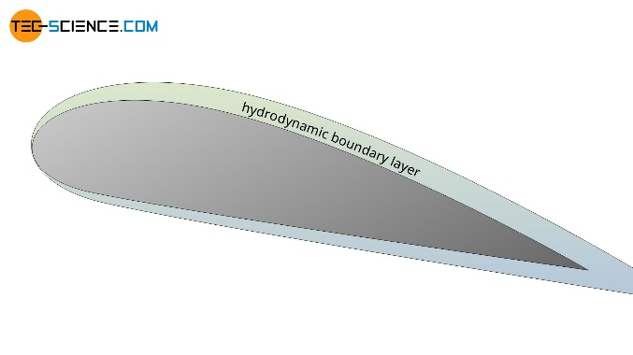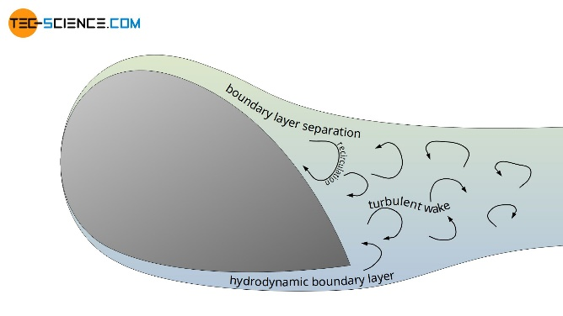
Figure 6 – Flow separation on different aerofoils (Tec-science, 2020)

In Figure 6 two different aerofoil designs are shown. The first elongated design utilises a shallow angle of attack and a smooth transition to reduce the chance of boundary layer separation. In the second design, a much steeper angle of attack is used, and the shape doesn’t follow the normal path of the air, so the directional forces in the same plane as the vehicle’s movement are acting against the surface and causing separation. This can also be described by the pressure gradient between the inside and outside of the boundary. The pressure behind the wing is high, and as such the velocity is too low to maintain the boundary.
The race car rear wing utilises a design much like an upside-down aerofoil, to create the low-pressure region below the wing rather than above, creating downforce instead of lift. The design of the wing sections is similar to the elongated example above, which follows the expected stream path to reduce the chance of separation.
The second wing allows the wing to have a much longer effective length, as if it was one solid wing separation would be likely to occur at the back of the wing, but by reintroducing air into the stream, the velocity is increased, reducing the pressure at the later part of the wing, and increasing downforce while stopping separation.

Material Selection
It is proposed that this wing is to be built from a Carbon fibre reinforced plastic (CFRP). CFRP is a lightweight strong composite material, which according to SGLCarbon (2023) is up to five times less dense than Steel, and only 60% as dense as Aluminium despite having a very similar strength as steel, which makes it a perfect material for applications where weight is important such as in the automotive industry. If a car were made considerably lighter, it would be able to achieve higher top speeds with the same power engine.
Due to the process of making CFRP being well developed, with the modern method of using Polyacrylonitrile (PAN) as the base polymer being developed in the early 1960’s (Dragon Plate, 2019), CFRP has become very easy to form into many different shapes. It can either be made into a thread and wound to the required form known as Filament Winding, or into sheets and laminated known as Moulding (HandWiki, 2023). It can also be machined after forming to achieve the final dimensions, making design work versatile. Due to the restrictions on aerodynamic construction imposed by the Formula race regulations, only woven carbon materials may be used, however this does not limit the form much and is a safety constraint to ensure that the construction method used is stable and consistent (Fédération Internationale de l’Automobile, 2022).
Carbon Fibre was invented in 1860 and was originally used for filament in incandescent lightbulbs become Tungsten became the normal material. The carbon fibre used then only has about 20% carbon, and so it didn’t have the great strength to weight properties of modern Carbon Fibre based materials such as CFRP which have around 55-95% carbon (Dragon Plate, 2019).
Despite their high cost, modern methods of producing Carbon Fibre composites are still a lot cheaper than the old methods. Carbon fibre is still increasing in popularity as an engineering material and is being used in new applications every year including wind turbines, aerospace and the defence sector (Zoltek, 2023). The future of Carbon Fibre composites lays in reducing the production costs further through modern technologies such as 3D printed tooling and advanced chemical technologies.

Modelling
There are a number of different mathematic models used for calculating airflow, but all of them are fundamentally based on the Navier Stokes equations, which describe how velocity, pressure, temperature, and density are related to each other. There are three such formulas; Continuity, Momentum, and Energy shown in respective order in Figure 7.
  - 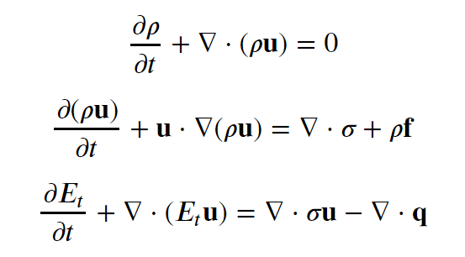
Figure 7 - Navier-Stokes Equations in Simplified Vector Form (Giraldo, 2023)
These equations are often used in static situations looking at one point, but when applying these to more complex real-life scenarios, the maths involved become unwieldy and is prone to errors. This is where computational modelling comes in.
Computational Fluid Dynamics (CFD) is the use of computer simulation for calculating these equations on a much larger scale. A number of points are determined on a model and these derivations of these formulas are applied by using numerical approximations to relate the calculations at each point. Due the ever-increasing power of computers, CFD has become a popular method for testing aerodynamic scenarios, replacing physical testing to some degree and hence speeding up the development process due to the ability to test different designs and scenarios relatively quickly, limited only by the computational power available.
There are many different CFD packages available. Some examples of these are:
- Autodesk CFD
- SOLIDWORKS
- SimScale
- Ansys
- OpenFOAM
- CFD Module
- Simcenter
- Flowsquare
- ParaView
- Altair
Each of these packages offer a different interface and a variety of tools. Some specialised for different types of CFD analysis, but in general they are all based of the same fundamental equations and are used for the same core function of modelling aerodynamics.
Integrated packages like Autodesk CFD and SOLIDWORKS offer inbuilt CAD modelling software to make the models used in the analysis, but generally have more limited CFD functionality than the dedicated packages.
OpenFOAM is an open-source package, so features are added by specialists in the community as well as the developers. This means special modules can be designed for bespoke applications allowing for more specialised usage. But this also means there are many functions and a steeper learning curve for the user.
The other packages are dedicated CFM software each with their own specialist uses, so each package should be evaluated by the user to ensure they are ideal for the functions required.

Physical Testing
If physical testing of the race car needs to be done, a wind tunnel would be required. There are a number of things that need to be considered before deciding what wind tunnel to use.

Scale

Scale Model
A scale model could be used, and hence a smaller wind tunnel. The first problem here is that in order to simulate the effects of a model with a reduced critical length, either the air velocity or density, or a mix of both need to be increase proportionally to make sure the critical Reynolds number is maintained where it should occur.
This means that either the velocity needs to be much greater, so high powered blowers are still needed, and this may have an adverse effect especially if the new velocity approaches the speed of sound. Or the other option would be to pressurise the tunnel, which can only be done on fully enclosed trunnels such as the Closed Return type and is very expensive.
The advantage of a scale model is that if continued development and modifications to the race car are needed, these can be done much quicker and much cheaper on a small-scale model than they can on a full-scale model.

Full Scale
The alternative would be to use a full-scale race car, which makes the design of the wind tunnel considerably easier and cheaper but means any modifications that need to be made require fully modify the full-scale vehicle.
With the continued development and usage of CFD, a lot of the scenarios and modifications can be done before moving to the physical testing phase, meaning this is often the preferred route for modern cars.

Blockage Problem
Regardless of what scale model is being used, once the car is introduced into the tunnel, the volume of the tunnel at the position of the car is reduced, and hence the velocity of the air will increase. This is known as the Blockage Problem and will affect the results making them potentially unrealistic, so something must be done to reduce this effect.
The most common solution to this problem is to simply make the wind tunnel suitably large so the effect of the reduced volume is negligible. This is the most practical option and hence should be used. Other options include removing a section of the ceiling of the tunnel equal to the car being tested, but this means physically modifying the tunnel every time the vehicle being tested changes and is therefore impractical unless incredibly high accuracy is needed.

Tunnel Type

Open Return
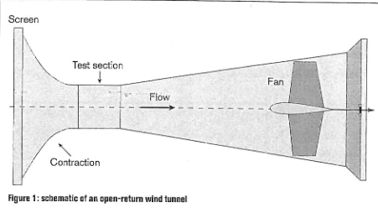
Figure 8 – Open Return Wind Tunnel (Racecar Engineering, 2005)
An Open Return type wind tunnel is shown in Figure 8. This type of wind tunnel draws fresh air from the end of the tunnel past the test area. The biggest downside of this type is the energy required to run it as the fan needs to run equal to the airflow required at all times. There are also potential issues with air quality and flow type of the incoming air, but these are usually controlled with a filtration screen and flow straighteners.

Open Return Open Jet
  - 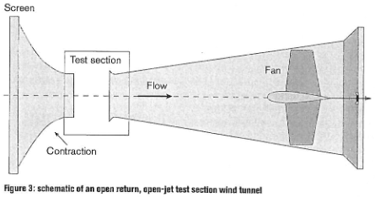
Figure 9 – Open Return Open Jet Wind Tunnel (Racecar Engineering, 2005)
An Open Return Open Jet type wind tunnel is shown in Figure 9. This is similar to the standard Open Return type in Figure 8, but the test section is open to air removing the Blockage Problem entirely and mimicking the open-air racetrack much more closely, however with this tunnel type flow dissipation at the test area can mean even higher energy costs.

Closed Return
  - 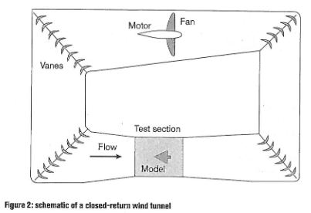
Figure 10 – Closed Return Wind Tunnel (Racecar Engineering, 2005)
A Closed Return type wind tunnel is shown in Figure 10. This type of wind tunnel no longer has the issue of energy losses, air quality, or flow type as it recirculates the same air through flow straighteners. However this type has an issue with the air heating up due to the friction on the walls, and hence the air’s density can reduce affecting the Reynold’s number calculation negatively. This can be controlled by introducing a cooler in the wind tunnel to return the air to it original temperature. This type also has a much larger profile, but if the space is available the consistency gained and reduction in energy costs is beneficial.

Floor Treatment
In a wind tunnel, the air and ground are not both static, so movement of air across the ground will also create a boundary layer which can affect the results, especially when working with vehicles with a very low ground clearance. Because of this a number of floor treatment have been used.

Ground Board
A ground board is a raised platform that the car is placed on. This can help to keep the car out of the built-up boundary layer, only allowing a boundary layer to start forming at the front of the ground board immediately in front of the car. This is ideal for commercial road cars but can still have a negative effect on cars with a low ground clearance.

Porous Suction
The idea of placing the car on a porous ground plate and providing suction through the pores allows the ground boundary layer to be removed but can also affect the airflow around the car body if the suction is too high, so a balance is needed between how much of the boundary layer to remove and how much to disturb the airflow.

Moving Floor
The moving floor idea uses a belt that moves at the same sped as the air to stop a boundary layer from forming. This idea is the most used but has a number of mechanical challenges including how to ensure the belt is flat and that the movement of the belt does not disturb the results by transferring force up through the vehicle. Suction under the belt can hold the belt flat, and often the wheel of the car can be detached, and the body suspended to avoid influencing the car body with any vertical forces.

Fence
The fence idea is similar to the ground board as is only good for commercial cars, but it works by introducing high velocity air onto the ground just before the vehicle to negate the effects of the boundary layer. This has been used as a hybrid with the porous suction method in some cases.

Test Procedure
Based on the information above, a CFD model should be done to get as close as possible to the desired design, then full-scale testing in a closed return wind tunnel with a cooler and a moving floor configuration would give the best results.
Data from this test should be compared with the CFD model to ensure the relationship between both methods is strong. Variations in the results could be due to the restrictions with wind tunnels mentioned above, or due to the CFD not being done at a high enough resolution, so more data points may be needed for a more accurate simulation.

Bibliography
Olichevis Halila, Gustavo Luiz. (2014). A Numerical Study on Transitional Flows by Means of a Correlation-Based Transition Model (M.Eng. thesis, 2014, Instituto Tecnológico de Aeronáutica - ITA).
Kartik Rangam. (2020). Spoiler Alert! Does Your Car Really Need a Spoiler? Available at: https://gomechanic.in/blog/spoiler-and-downforce-explained/ (Accessed 30/06/2023)
Nuclear Power. (2023). Critical Reynolds Number. Available at: https://www.nuclear-power.com/nuclear-engineering/fluid-dynamics/reynolds-number/critical-reynolds-number/. (Accessed 01/07/2023)
Engineers Edge. (2023). Viscosity of Air, Dynamic and Kinematic. Available at: https://www.engineersedge.com/physics/viscosity_of_air_dynamic_and_kinematic_14483.htm (Accessed 01/07/2023)
Engineering Toolbox. (2023). Air - Density, Specific Weight and Thermal Expansion Coefficient vs. Temperature and Pressure. Available at: https://www.engineeringtoolbox.com/air-density-specific-weight-d_600.html (Accessed 01/07/2023)
Elma Mrkonjik. (2022). How Fast Do F1 Cars Go: Velocity of the Pinnacle of Motorsport. Available at: https://seedscientific.com/how-fast-do-f1-cars-go/. (Accessed 01/07/2023)
Tec-science. (2020). Flow separation (boundary layer separation). Available at: https://www.tec-science.com/mechanics/gases-and-liquids/flow-separation-boundary-layer-separation/. (Accessed 02/07/2023)
Dragon Plate. (2019). A Brief History of Carbon Fiber. Available at: https://dragonplate.com/a-brief-history-of-carbon-fiber. (Accessed 02/07/2023)
HandWiki. (2023). Chemistry:Carbon fiber reinforced polymer. Available at: https://handwiki.org/wiki/Chemistry:Carbon_fiber_reinforced_polymer. (Accessed 02/07/2023)
Fédération Internationale de l’Automobile. (2022). 2023 Formula 1 Technical Regulations. Article 15.6 Prescribes Laminates.
Zoltek. (2023). The Future of Carbon Fiber. Available at: https://zoltek.com/carbon-fiber/the-future-of-carbon-fiber/. (Accessed 02/07/2023)
Guillermo Giraldo. (2023). CFD Modeling, Analysis, and Online Simulation For Beginners. Available at: https://www.simscale.com/blog/cfd-analysis-for-beginners/. (Accessed 02/07/2023)
Racecar Engineering. (2005). Tunnel Vision. Page 43.

