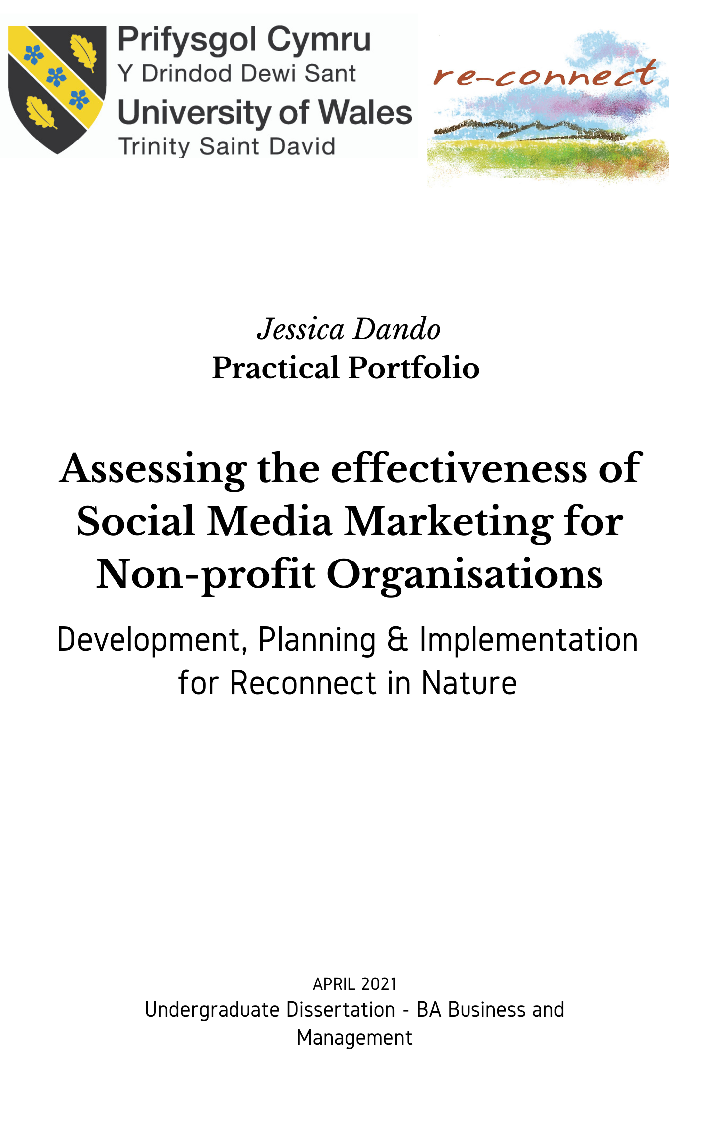

Abstract

As part of the practical portfolio, this dissertation examines the effectiveness of social media marketing on non-profit organisations. By examining secondary research relating to social media strategy, alongside quantitative survey’s themes were discovered relating to the types of content, and themes that were attractive to the target demographic were discovered, and then developed and implemented into a strategy.

The information gathered from primary quantitative surveys and the secondary literature review were then analysed and prioritised in order to implement a strategy that would increase engagement and brand awareness across four of the most popular platforms. This strategy and implementation was then analysed, comparing qualitative data and results from the analytics.

The results showed that by utilising a creative and consistent social media campaign, focusing on created and curated content relevant to the brand and demographic, that brand engagement and awareness can be enhanced organically, but that it is still challenging to generate fast results without using paid for advertising on the platforms. A longer time is needed to analyse the campaign in more detail, and to analyse the strategies most effective more closely when promoting non-profit organisations through social media channels

Acknowledgements

I would like to thank my incredibly patient mentor Glen Behenna, who has always been there day and night to respond to my panic and questions, consistently reassuring me. I would not have been able to do this without you, so thanks for your incredible support. I need to also thank my girls, who have endured the constant ‘Sorry I don’t have time’s’ for the last few weeks, when I haven’t had the time to give them the attention they deserve. Lots of making up to do over the summer. To my mum, who I hope will be proud that I finally got a degree, after not making it the first time. And my patient friends, who I have put off visiting or calling because of lack of spare time. I want to thank the guys from Reconnect in Nature also, for taking the time to explain the intricacies of the organisation and take the time out for endless meetings to make sure we got things spot on for the campaign.

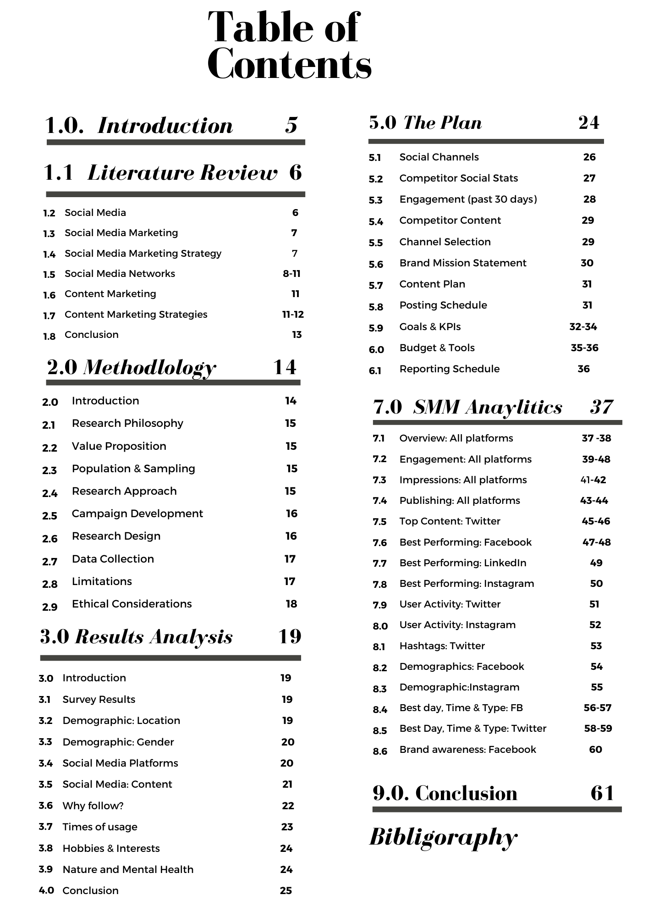

Introduction

The use of social media has transcended from personal daily use, to being utilised as an effective tool for non-profits to promote their organisations and the causes they represent (Chan et al, 2016)

With social media being one of the most useful and effective tools used by organisations to generate brand awareness and attract relevant audiences. Facebook, Twitter, Instagram, and LinkedIn, allow users to share existing content and create their own, profoundly impacting the way that organisations communicate with stakeholders. (Young, 2017; Carville, 2018; Bertow,2020)

Social media has the capacity to replace an extensive range of traditional marketing methods in non-profit and public organizations. It has innovated the way in which non-profit organizations raise money and resources, (Campbell et al, 2014; Axelrad, 2015).

The practical portfolio will involve an application of relevant elements from the literature review to the portfolio, by focusing on the research; development and implementation of an organic social media marketing campaign for Reconnect in Nature.

The primary goal will be the increase of brand awareness, achieved through the development of a visually rich and interactive social media presence. The results that inform the development of the plan will be derived from both primary quantitative research, combined with the secondary sources in the literature, enhanced by qualitative data from intensive software analysis.

Literature Review

This literature review summarises the relevant secondary sources through an analysis of the current research available within the field of study. By considering the range of credible sources and empirical research available, the amount of bias will be reduced overall.

The scope of the literature will consider relevant sources in relation to Social media marketing, strategy and research relating to the use of Social media to promote non-profit organisations. adverts will not feature in the campaign at this stage

The project focuses on the use of social media by non-profit organisations to generate brand awareness. This includes the development and implementation of a digital marketing plan, which will allow an analysis of the research rationale and the opportunity to at least partially implement and record results. The time constraints of the study mean that a full analysis of the development and implementation phase will not be possible, as the real-world project will continue beyond the time limit of the study.

It is within this context that the relevant literature will be reviewed, with the intention of providing an effective overview of the area of study.

Social Media

Social media has grown to an unprecedented level, where it has an impact on every aspect of our lives. Over 3.6 billion people use social media, and that is only predicted to grow over the coming years (Sprout Social, 2021)
Technology, and social networking has the potential to add value to non-profit organisations by increasing their reach, spreading awareness of the causes they represent and driving donations. (Angelou, 2018)

Herant (2011) defines social media marketing as a tool that targets specific customers, engaging them with something direct; memorable and meaningful to them.

Online activities on social media enable organisations to inform the public about their mission, as well as interact with volunteers and donors (Waters et al, 2009) marketing, branding, and raising awareness (Waters & Jones, 2011) enhancing image, and raising funds (Seo et al, 2009) encouraging participation (Kavada, 2012)

Kanter (2012) asserts that social media has transformed the non-profit world, offering a valuable way to engage audience and promote the organisation’s cause.

What makes social networking sites, and microblogs most useful is the communication, collaboration and content sharing that enables organisations to transform one way communication into two-way conversations (Fuchs, 2014)

Social Media marketing

Despite the growth of social media usage, organisations are finding it difficult to cut through the noise and stand out in a saturated market (Villaroel, 2014) Organisations must discover creative ways to stand out against their competitors and become memorable to their audience. (Kemp, 2019; Hollebeek, 2014) Sprout Social (2021) suggests that a socially aware organisation will stand out if they show they share the same values as their audience does. (Williams, 2018)

Listening to the audience; engagement instead of fundraising; sharing relevant; valuable content; honesty, accessibility, as well as using social media as one art of a multi-channel strategy is necessary, as well as being prepared to interact via social media at least once a day (Hersant, 2011: p22)

Social Media Marketing Strategy

According to Fletcher et al (2020) there are several ways to create and implement campaigns and reach objectives, the key to attracting and retaining an audience and following on social media is to maintain a conversation with them, and this can be done was a paced and well considered campaign that endures over time and feels authentic to the audience. Channel, content, and data should work together (Ibid)

Fletcher suggests that there should be a process of categorising, which is described as observing the rules of each channel.

Fletcher (2020) also proposes that organisations respond to other users of the channel, displaying knowledge of a particular area of interest in a way that appeals to the desired audience (Pendley, 2018), building trust for the brand. (Smith, 2012) also highlights the importance of trust, and coming across as authentic, to be successful on social media.

Collaboration is also important according to Fletcher (2020) and (Pawel et al, 2018) building mutually beneficial relationships with key stakeholders is strategically necessary to build community

Social Media Networks

Facebook.

According to Mohsin (2021) Facebook boast a massive user base of 2.80 billion every day. A large proportion of the research regarding Facebook and non-profit organisations centres around revenue and donations. According to Hessekiel (2020) Facebook has transformed peer-to-peer fundraising.

According to (Dunay & Krueger, 2010) Facebook provides a suitable environment for marketers to build their brand, they also provide a platform, allowing companies to establish interaction with their audience, getting valuable views and engagements. (Kotler et al, 2019)

Haydon (2013) suggests that once an organisation has gained a basic understanding of how to utilise social media it is necessary to build a plan, incorporating the following factors and considerations. Considering all the literature reviewed for this project, this plan contained the most detail and seemed more aligned to the type of marketing a non-profit would implement on social media.

Facebook Marketing Plan

Haydon (2010) suggests that the organisation should understand the value proposition; audience; goals; content strategy and measurement components. Organisations should understand the audience and culture to enable them to send the right messages to the right demographic

It is also important to set goals for the marketing, such as building brand awareness, or increasing engagement. (Haydon, 2010; Neti, 2011; Manning, 2014)

Much of the literature reviewed emphasises the need to develop a content strategy -that creates value for the audience. (Haydon, 2010; Fletcher, 2020; Aced, 2010; Weberling, 2012) Sharing blogs and creating videos is an example of effective content creation that is impactful, and the importance of content creation is further highlighted by (Scudder & Mills, 2009; Munar & Jacobsen, 2014; Saxton & Guo, 2014)

Haydon (2010) Kim (2020) and Heinze et al(2020) advise measuring and tracking progress, using analysis software to monitor the progress and results of the campaign.

Twitter

Another social network that has been a phenomenal success in the social networking arena, is Twitter. (Carey, 2019) it generates fully public profiles with status updates that can only be if 280 characters.

According to Brand Watch (2020) There are 330 million active users and 145 million daily users on Twitter. Lui et al (2012) states that microblogging on Twitter allows the opportunity to communicate with the audience and establish a clear understanding of their needs and values.

The use of the hashtag was another moment of innovation and success for the platform, it allows users to categorise subjects into keywords, meaning they can easily find all tweets relating to a certain topic, and streamline the research processes (Carvill, 2018; Holloman, 2013; Butow et al, 2020)

Twitter Marketing Plan

Leaning (2014) offers a few useful suggestions for the type of Tweets to share on the platform, including: Observations; events; Created content; Retweeting other people’s content; direct tweets with other users.

In terms of posting, various advice has been given across the literature, all sharing the same potential frequency. Because Tweets have a short shelf life of ninety minutes, Twitter is the only network where it advised to post more than once a day (Butow et al, 2020)

There are also various third-party twitter apps and platforms such as Cotweet and Agorapulse that can enable an organisation to better manage multiple contributors and scheduling of content. (Mankad, 2020; Sprout Social, 2019)

LinkedIn

Founded in 2003, LinkedIn was predominantly set up to share professional networks and compile an online CV. It has now grown significantly and has over 766 million users. How-to lists tend to perform the best. It is recommended by (Linkedin.com) to use LinkedIn a few times a week, posting relevant content and industry insights with a professional tone.

Instagram

Instagram is a unique photograph sharing app, that enables users to not only share photographs, but also to add filters to improve the look and create a feel to the pictures. (Sharma, 2019; ) According to Kotler et al, (2019) Instagram’s ease of use, along with hashtags and keywords that enable a strong connection with brands on the platform. The platform now boasts over one billion users (Statistica 2021)

Bevins (2014) states that what affords Instagram its success is the application of a visual strategy, and evidence suggests that photographs are usually most effective in generating engagement on social platforms (Johnston, 2019)

Instagram Marketing Plan

People on Instagram do not click on links outside of the network, so people are used to scrolling quite quickly through their feeds. Adverts are advised to be used on the platform as they do not include links. Inspirational quotes products: personal photographs and carousels are popular on this platform (Kemp, 2019; Safko, 2012) as well as short videos created directly by organisations, eliminating the need to share a link which won’t be looked at. (Johnston, 2016)

Content Marketing

In the social media environment, the audience and consumers have more control over the content they engage with than ever. (Cagnon, 2014)

Every organisation now has the facilities and tools to create their own content (Holliman & Rowley, 2014; Haeusermann, 2013) Traditional marketing is now outdated, and organisations must find more innovative ways to stay relevant and market to audiences (Holliman et al, 2014)

Content marketing is a technique that attempts to create and distribute content that is valuable and relevant and to attract and retain a particular demographic (Olin, 2011)

Chiu et al (2012) suggests that one of the best ways of creating content that is engaging is to tell a story, it is effective because it builds on positive emotions, and can also be shared by the audience through channels such as Facebook share, reviews, tweets, Instagram stories and blogs. Feedback on these channels is also important (ibid)

An organisation must know their audience, and with high quality curated or created content, should be able to educate, inform, connect, and entertain (Chui et al, 2012; Fletcher, 2020; Kaplan & Haenlein, 2010)

Content Marketing Strategies

According to Scudder & Mills (2009) and Weberling (2012) in a social media-based context, message strategy may include what to say (richness of content) and how to say it (sentiment and tone)

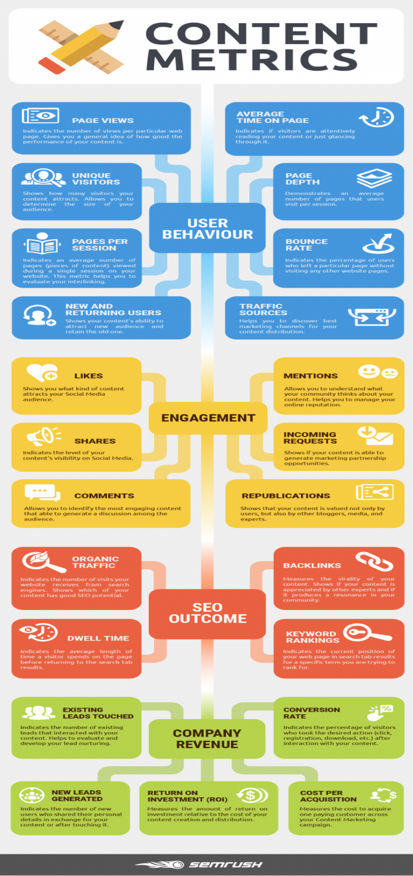

Fig 1.0 Provided by SEMRUSH (2020)

Visual content is particularly effective in building a story or message for an organisation, and findings from the research show that visual content is usually the preferred method ahead of textual content. (Munar and Jacobsen, 2014;)

Informative content is also useful for organisations, it offers value to the audience who will expect organisations to be experts in their field. Psychology literature has found that people are much more likely to notice relevant and informative content above the masses of information on social networks (Ingram, 1984; Cacioppo, 1979)

According to Pullizzi, (2014) An organisation should share a variety of content, including photographs and videos, to engage each audience relevant to the platform used. It is necessary to publish regularly on the platform, and to test and experiment to discover what is effective when it comes to content (Ibid)

Conclusion

There is a wide range of literature available relating to social media marketing, and numerous studies done looking specifically at Non-profit organisations, and what is effective for them in terms of generating a substantial following on social media, as well as engaging audiences and attracting donors and volunteers. The research certainly suggests that social media marketing is beneficial to organisations, if used effectively, despite it being increasingly difficult to get noticed in a busy and over-saturated online marketplace.

Engaging in two-way conversations with audience, knowing your demographic; Sharing the same values (Hyatt, 2012) Listening to the audience sharing good quality created content such as photographs, videos, or blogs or equally as relevant curated content such as informative news articles or relevant videos or photographs from other users,(Schwartz, 2013; Waters et al, 2009) and encouraging user-generated content, such as reviews (Sheikh, 2020; Shevade, 2021)

Even with good quality created content, and a strong marketing plan, there is no doubt that social media marketing in a saturated online marketplace, is a challenge, for smaller organisations. (ref) In order to stand out, organisations must be creative and tell a story to the audience, based on what they want to hear (Du Plessis, 2020; Carey, 2019)

2.0. Methodology

This chapter provides an overview of the selected methodology utilised to the study of Social Media marketing. The methodology seeks to include several research techniques, to support a robust research approach applied to obtain and analyse relevant results. It also explains the scope, benefits, and limits of the chosen research approach. In brief, it offers a definition of how the research will be implemented. The literature review has indicated the context of the study, which the scope of this practice-based portfolio will demonstrate. The literature review also provided useful comparative information to compare with the primary research findings.

The purpose of the practical portfolio is to plan and implement a social media marketing strategy for a non-profit organisation called Reconnect in Nature. The projected goal of the campaign is to: Increase brand awareness; maintain social credibility and to build an interactive presence on several relevant platforms and networks, that can be maintained, resulting in a successful, ongoing, and effective social media presence for the organisation.

This practical portfolio will be conducted using a mixed-method approach. Data will be collected for at least a month beforehand, and then for a month during. The campaign will continue to be implemented for a further six months, but the initial analysis period, for the sake of the timeframe in which this project needs to be completed, there will only be a month of activity recorded in the results. This needs to be considered when analysing results, as (Milla et a., 2018) suggests social media marketing is something that should be developed over time.

Despite their being several tools available for use, the number one publishing and analytics platform will be utilised in the form of a 30-day trial, the platform is effective in analysing various metrics and bringing them together to analyse a before campaign and after campaign scenario.

2.1. Research philosophy

The pragmatic approach has been chosen for this study. This approach is relevant as it does not align itself with either the interpretivist or the positivist approach, but recognises aspects of both as being relevant in the social and physical environment (Wilson, 2013)

2.2. Value Proposition
To assist Reconnect in Nature with increasing brand awareness and interaction, the implementation of an updated study and campaign.

2.3. Population & Sampling

The key demographic is both men and women, aged 30 – 65+ who are interested in the outdoors and nature, as well as mental health professionals who are looking for alternative and natural ways of conducting therapy, and recognise the benefits of alternatives to traditional indoor therapy.

The mixed-method approach uses both quantitative and qualitative elements (Yin, 2018) This method is used so that one method can strengthen the findings of another (Bryman, 2015) The quantitative methods using survey data from selected social media users, will be used to strengthen key analytics collected form the software and combined in turn with the secondary research from the literature review.

2.4. Research approach and Strategy

The phenomenological design is utilised in order to understand a phenomenon through collecting information from people who have lived through an experience (Moustakas, 1994) suggesting that using the lived experience of respondents is not an effective way to identify their knowledge of a subject, and promoting the use of data analysis and observation of how audience reacts to content and strategy, is a more effective way of using the phenomenological design without the weakness and bias associated with relying on people to describe their experience.

To inform and develop a strategy, it was first necessary to finalise the customer segmentation and targeting, taking into consideration the results of the initial survey data to inform the content strategy, and scheduling times of the campaign, as well as solidifying these survey results with research from the review of literature, and aligning this with the organisation’s principles, mission, and goals.

2.5. Campaign Development

The objectives of the research were as follows:

- To increase the number of followers and overall engagement on all social media platforms
- To create and share high quality content to enhance online visibility
- To promote the five principles of Reconnect

2.6. Research Design

Reconnect do currently have a Facebook, Twitter, and Instagram page, where administrator privileges will be granted, to manage the page for the duration of the campaign. LinkedIn is the final consideration, and as the platform is growing exponentially, it was useful to set up a LinkedIn page for the organisation. The lack of activity prior and the timeframe in which is set up will mean it will potentially underperform in comparison to the other networks.

Finally, when the research has been conducted after the survey results are used to formulate the plan and schedule for the platforms, a comparison of quantitative surveys and qualitative observation and data analytics from the campaign will be conducted

To visualise the implementation of the campaign, various techniques which build awareness and audience participation, will be utilised. The distribution will be based on a mix of both curated and created content: Curated will consist of blogs, news articles and relevant studies. The created content will consist of a Blog, video podcast, slideshow of photographs and any creative work Reconnect already have as assets.

Crafting entertaining, high-quality content is key to increasing followers sharing and engagement, stimulating dialogues and the sharing of experiences values. (Carvill, 2019;Chang et al, 2015)

2.7. Data collection

The method of data collection as described above will be an initial survey, where respondents will be selected through random stratified sampling, the demographic being identified as men or women over the age of 30 – 65 and living in the local area. This sampling method was useful for the research, as inferences could be made referring to the results pertaining to the key demographic of Reconnect.

Multiple choice questions will be the most common in the survey, with some open-ended questions that require more detail. As previously stated, a software application will be used to analyse the qualitative data. Agorapulse will be linked directly to the platforms and will be used to inform key data relating to user activity; engagement; and top performing content on the networks both before and after the campaign, this will give a clear indication of the success of the initial few weeks compared to the previous two months prior to the start of it.

A potential drawback of the research, as highlighted below relates to the timeframe not entirely aligning with the needs of the organisation.

2.8. Limitations

The limitations for the data collection are as follows:

In relation to the quantitative methods of analysis, there could potentially be sampling errors due to the small sample size, not being necessarily representative of the demographic. Biases need to be taken into consideration, particularly as the respondents were selected for being known to the researcher.

The software analytics qualitative methods will be able to measure engagement, but not necessarily the real opinions of the audience, such as whether they related to the content, or found the campaign to be attractive or entertaining, in this way it is restrictive in its qualitative results.

Another potential drawback of the qualitative method and the software is the timing, as there will only be a short time frame to measure, it does not give the campaign enough time to demonstrate just how effective the campaign will be on a long-term basis.

2.9. Ethical Considerations.

It is important when conduction research to do so in an ethical manner, which was the case throughout the project. It was particularly important to consider issues relating to questions to do with mental health, as the charity is focused on sensitive issues of this manner, care needed to be taken not to ask intrusive personal questions of the respondents about this matter. So, the decision was made to ask generalised questions about the respondents opinions about the benefits of nature in relation to mental health.

Analysis of results

Introduction

In the following chapter, the results of the survey will be analysed, along with an explanation of how the information from these results, combined with the relevant theory from the literature review that informed the design of the social media marketing plan. There will be a comparison of the data collected through the software before the campaign and after to attempt to identify the strengths and weaknesses, and to see whether the informed strategies were successful in fulfilling the objectives laid out for the campaign.

3.1. Survey Results

The results of the survey are made up of both multiple choice, and open-ended questions, that allow for more in-depth analysis and more information relating to audience social media use.

3.2. Audience Demographic: Location

The initial question in the survey asks age of the respondents, this was one of only two demographic questions asked, and the reason for this being the case was that the respondents had been selected from one specific location (South West Wales) so did not need to be identified in the results

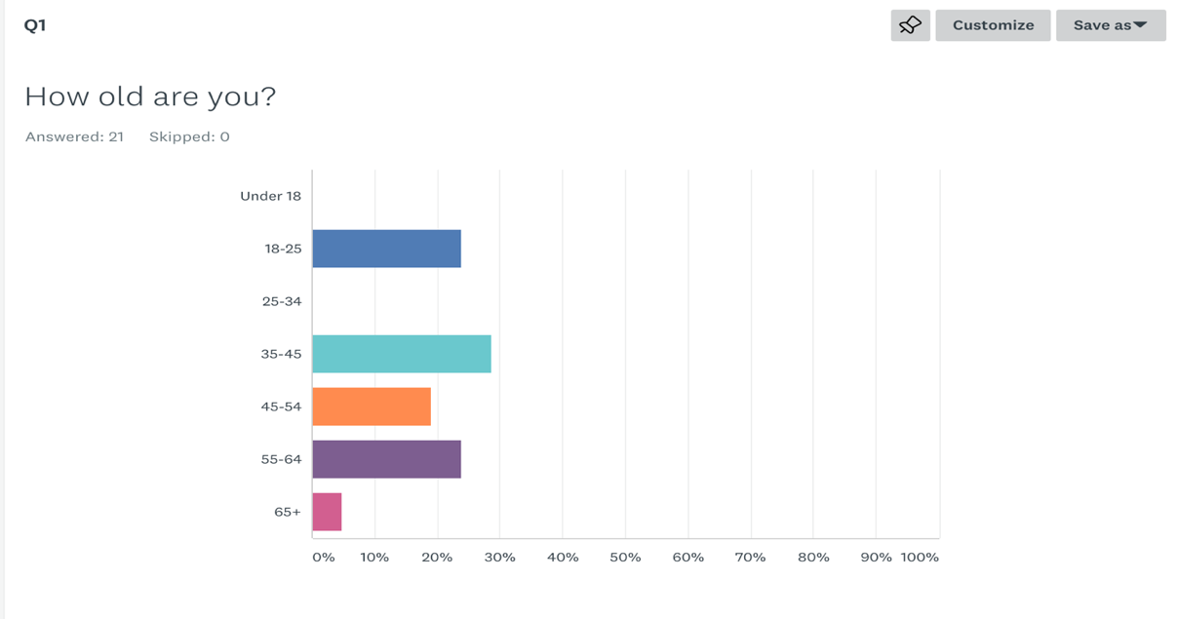

The results show that the respondents contained a large portion of the intended demographic of the organisation. Age ranges between 35-45 are the most prominent at 30% followed by 18-25 at 25 per cent; 25 per cent in the upper age group of 55-64, and 5 per cent being 65 and over. Overall, the respondents were in the age bracket that could be considered suitable for the intended audience of the organisation.

3.3. Demographics: Gender

This question was relevant as it was one of the demographic analytics available in the qualitative data, so it was thought relevant to ask to compare accuracy of both forms of analysis.
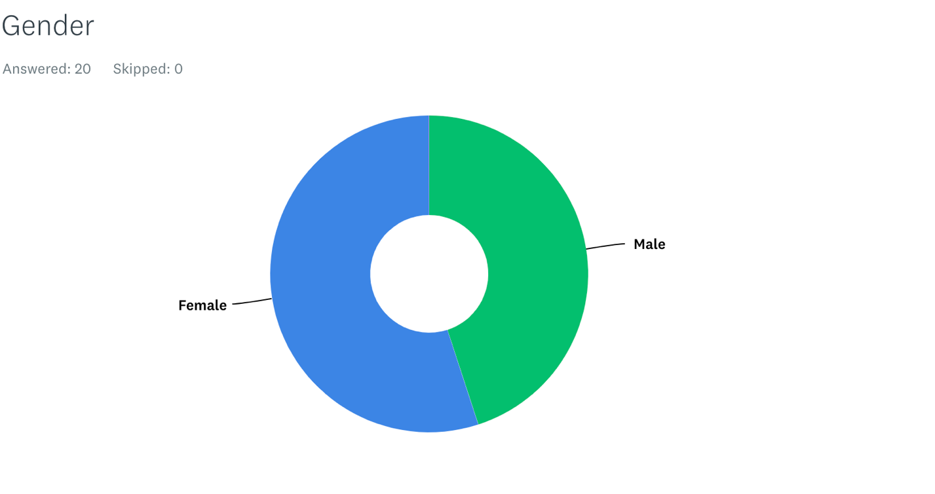

Interestingly, the majority of those who took part in the survey were women, but by a very small margin which allows for a balanced result overall, with 52 per cent of women taking the survey and 42% of men.

3.4. Social Media Platforms

This next question was very important overall for the survey, and in assessing what platforms to choose to attract the target demographic to Reconnect. Answers were expected within the demographic of respondents, with 85 per cent of the respondents using Facebook the most, Instagram at 50 per cent, and Twitter at 40 percent. LinkedIn only got 15 per cent but was still a consideration because of its niche demographic in relation to Reconnect training courses and accessing medical professionals.

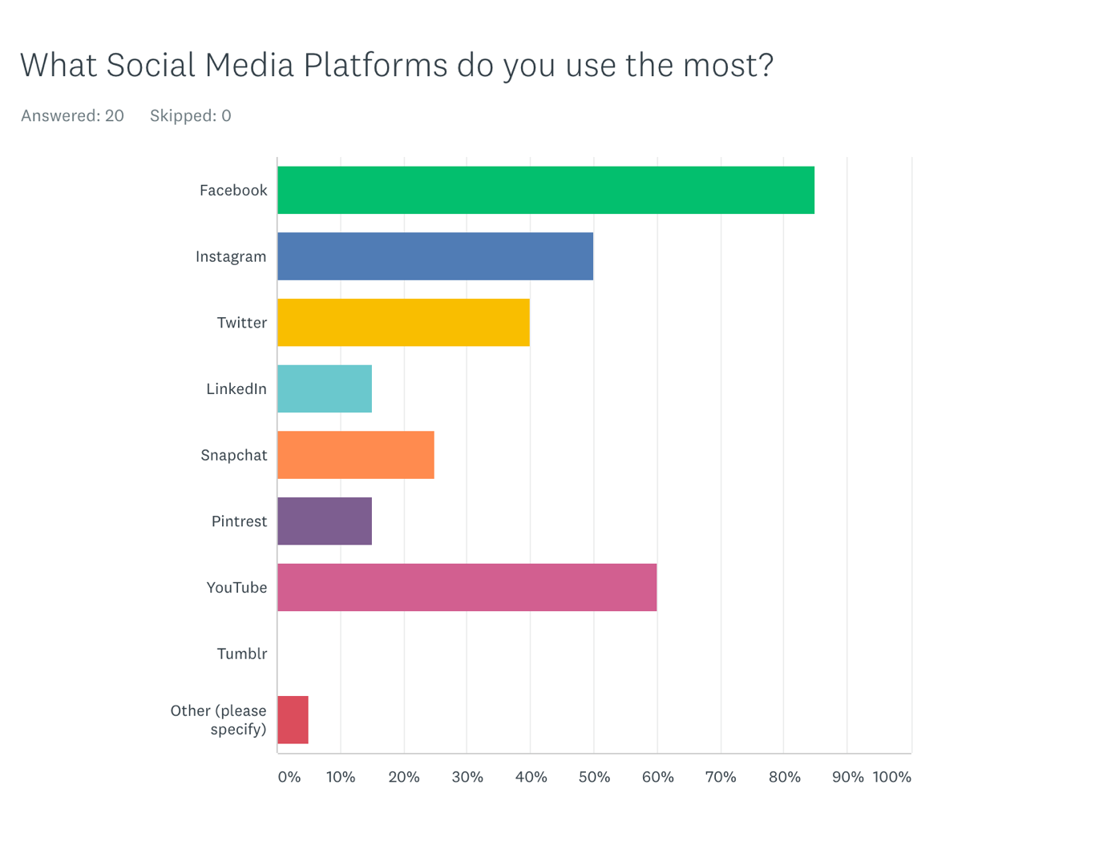

3.5. Best content on Social Platforms

The results of the survey showed that 80 per cent of respondents said they would like to see photographs most on their news feed, which was confirmed in the literature review by De Vries et al, (2012) who suggested that videos and photographs, are the most engaging to audiences, particularly on platforms like Instagram, which is a visual medium

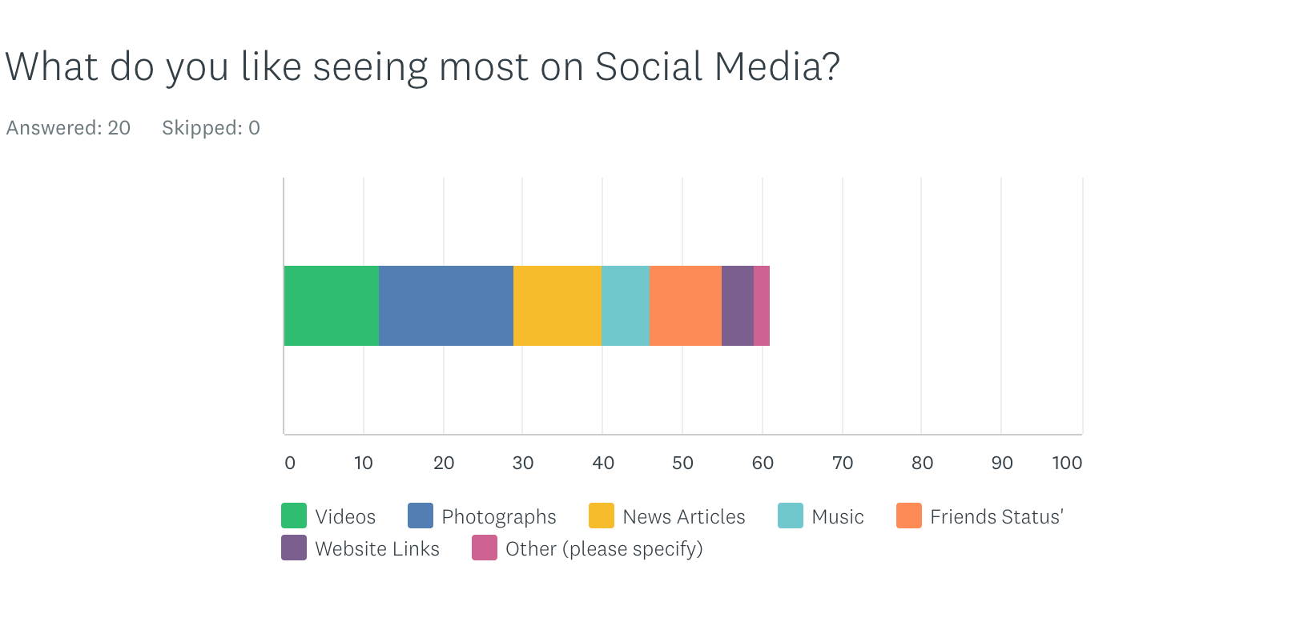
Arthur (2013) Bautista, (2013) and Schneider (2014) also suggested that images, in particular moving images, were likely to drive more action on social media. The results do confirm these views, with Videos coming in second as a favourite thing to be seen on social media 60 per cent saying they like to watch videos on social media, followed by news at 57 per cent, and web links at 24 per cent, the other category of other specified chat, and quizzes.

3.6 Open-ended question, that asked what attracts you to like or follow an organisation on social media?

The answers to this question have been categorised into ten answers, there were some where more than one person had the same answer, and these are listed as x2 or x3 beside the answer.

- Shared interests x3
- Informative articles and videos
- Professional and business-related information x 1
- Being invited by friends x 4
- Similar views x2
- Supporting causes x 2
- Local events x 3
- Informative articles and videos x 4

The answers highlight some relevant theory in the literature by Fuchs (2014) that suggested social networking sites facilitate a two-way form of communication. Further to that, it also coincides with the views of Hyatt (2012) where he surmises that an organisation will stand out if they share the same values as the audience.

3.7. Times of the day most active

When considering what sort of content, the respondents want to see, and looking at what they want from organisations online, the next important question, was to check what times respondents were most active on social media. The night-time scored the highest with the respondents with around 50 per cent of respondents saying they use it most at night, followed be evening at 45 per cent, all day and early morning at 30 per cent, lunch time at 15 percent and late morning.
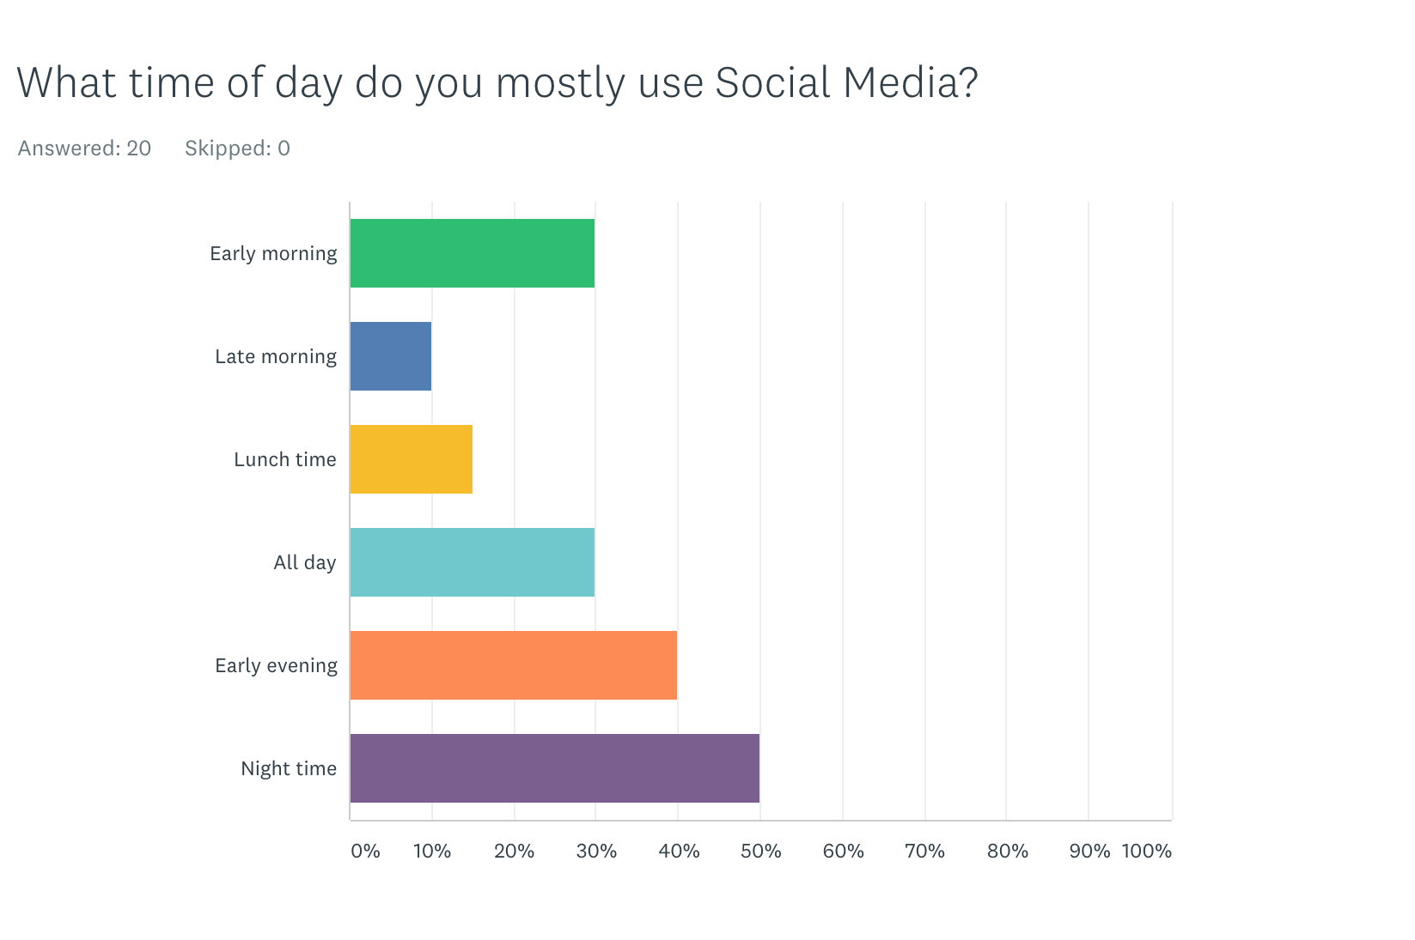

The results allow inferences to be made in terms of the demographic in that the age range of respondents are likely to be most active outside of work commitments. Although there is not much to confirm this in the literature review, apart from (Butow, 2020) suggesting that there should be an element of experimentation when it comes to scheduling.

3.8 Hobbies and interests

The next question was asked to gain a deeper understanding of the demographic chosen for the survey, and to see whether their hobbies and interests were in line with the organisations.
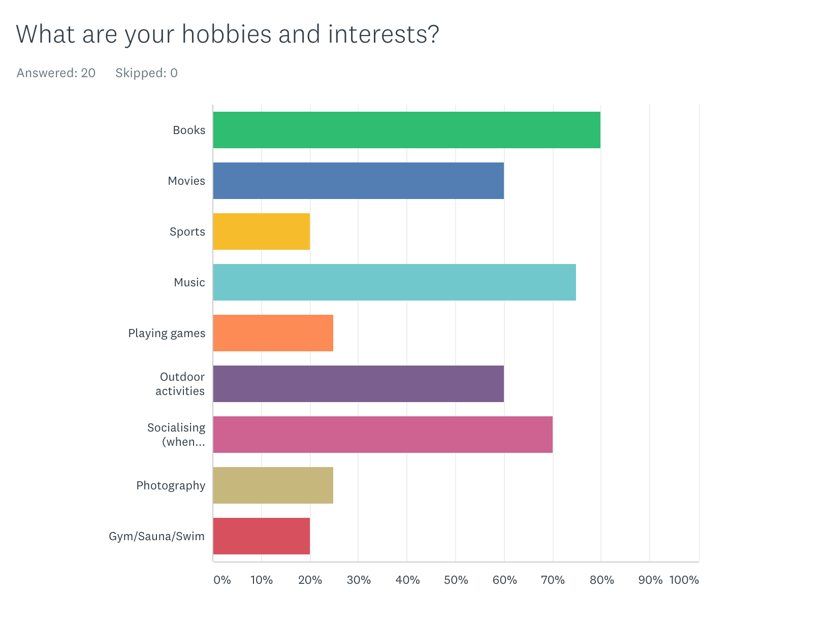
Books came in as the most popular pastime for respondents with over 80 per cents saying they enjoyed that the most. That was followed by music at 75 per cent, socialising at 70 per cent and then outdoor activities and movies at a joint 60 per cent. The results emphasise the respondents need to be social, and consequently their desire to engage with and interact with content.

3.9. Nature and Mental Health

As Reconnect as an organisation is closely related to using nature to help with mental illness, the statements that elicited whether respondents agreed or disagreed with statements and would enable analysis of shared viewpoints related to the mission of the organisation.

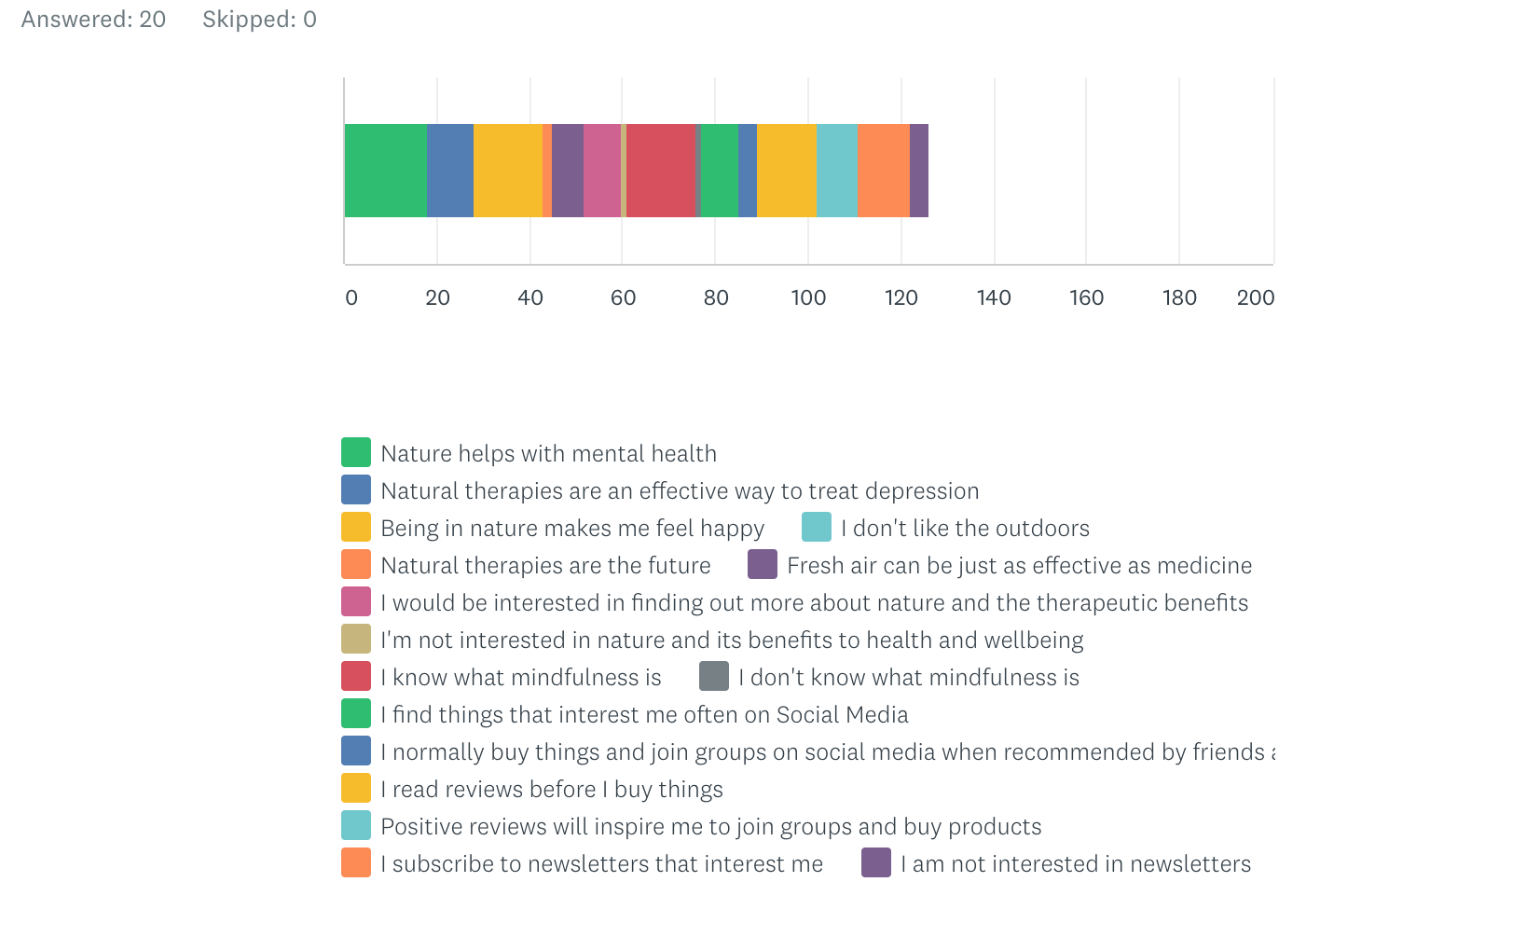

The results demonstrated that the respondents did indeed share the views of the organisation that nature helps with mental health, as well as the fact being in nature makes them feel content. 76 per cent were aware of mindfulness and 66 per cent read reviews, which facilitated the need to generate reviews for the organisation on social media. 38 per cent said they would be interested in finding out more about nature and therapeutic benefits, creating an opening for the social media campaign to share information about the subject and invite respondents to engage.

4.0. Conclusion

In conclusion, the results show that the most popular social media platform is Facebook, which highlights the need for that platform to be focused on and utilised the most. As the most widely used platforms, Facebook was closely followed by Twitter and Instagram, the networks that will also be the focus of the campaign. The respondents expressed clearly what type of content they like to see on the platforms: prioritising photographs, and videos, that was further confirmed by evidence in the literature review. The groups the respondents like to follow include community groups, activism and support and discussion groups, emphasising the need for content planning to incorporate discussion and community.

A huge percentage of respondents agree that nature is beneficial for mental health which demonstrates the necessity for content relating to those benefits and facilitating discussions on those subject areas.

5.0. The plan

Below are infographics showing the Social Media Marketing plan for Reconnect in Nature

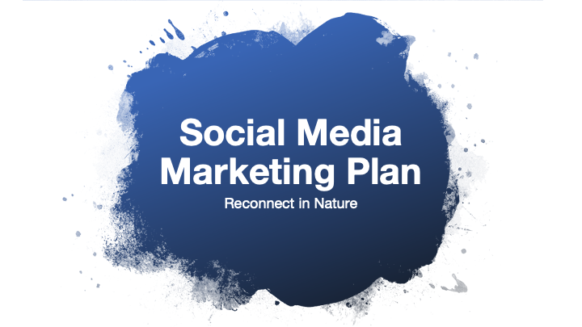

5.1.

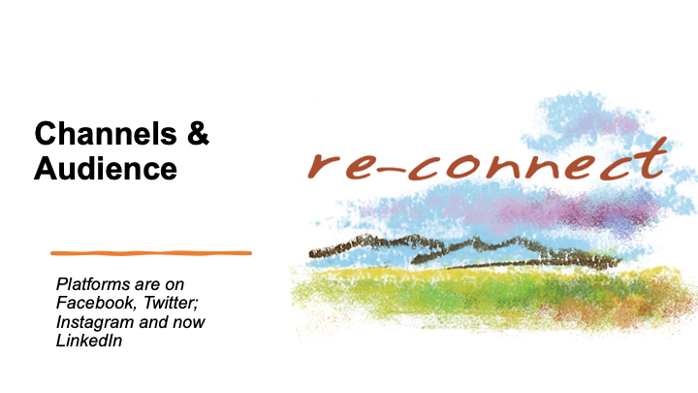

5.2
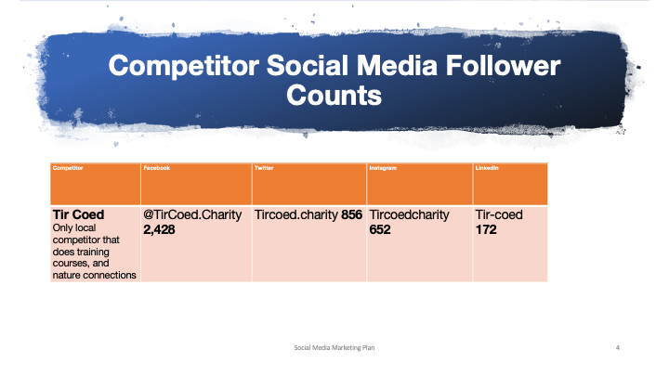

5.3

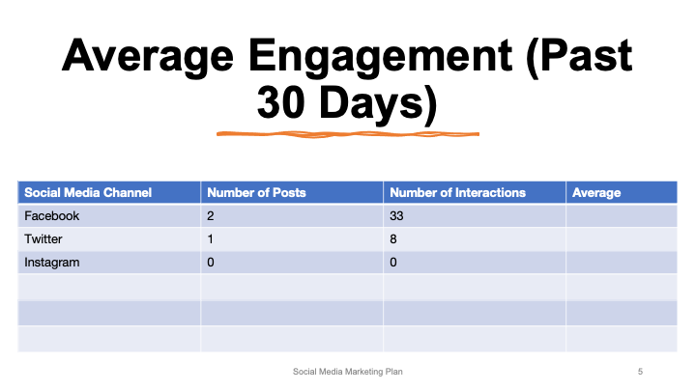

5.4

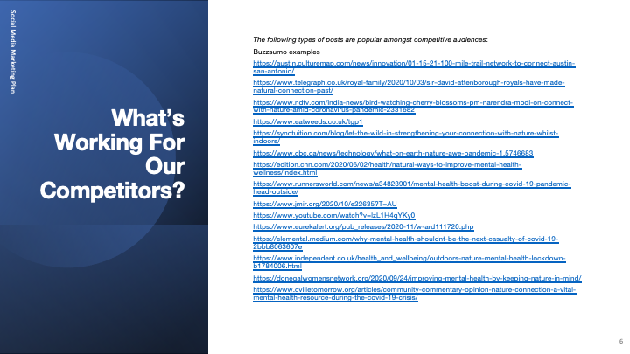

5.5

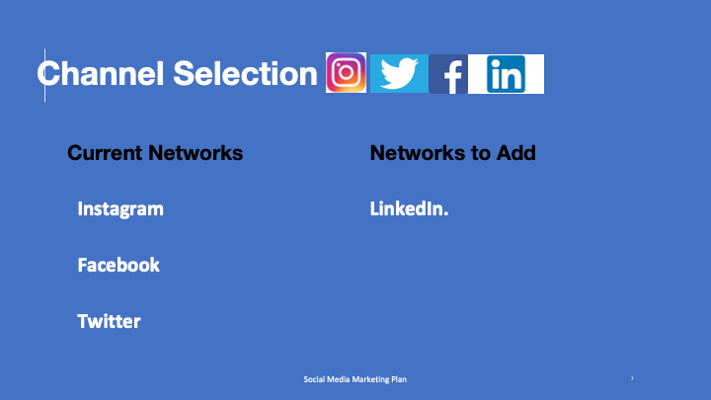

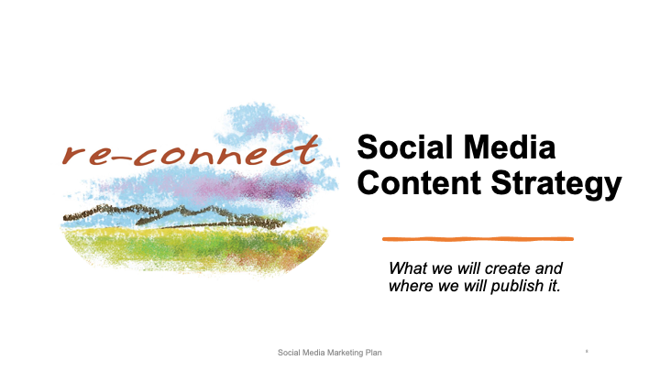

5.6
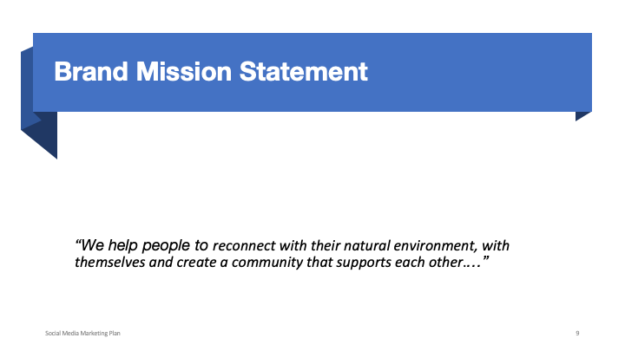

5.7
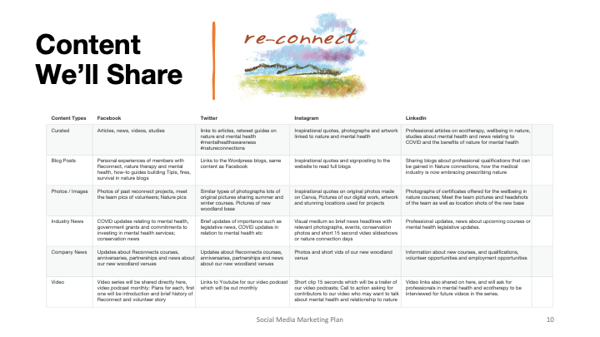

5.8
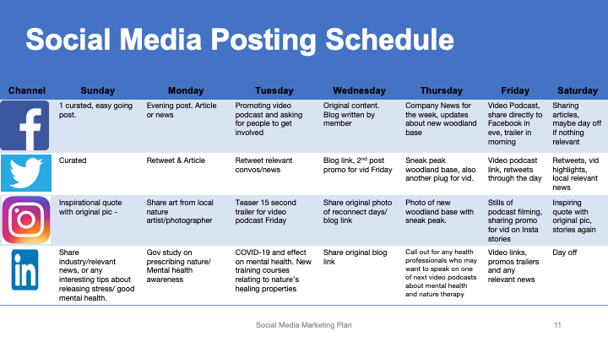

5.9
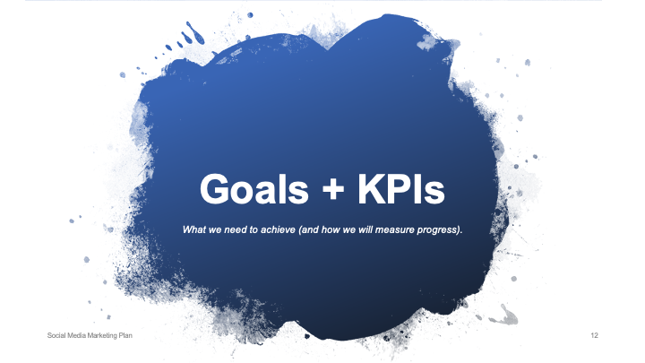

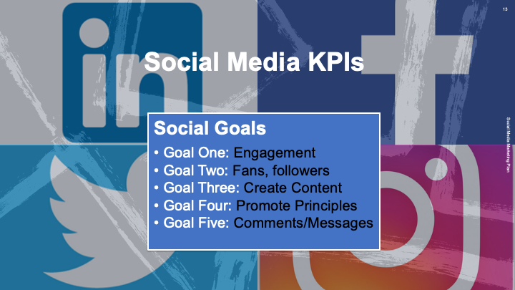

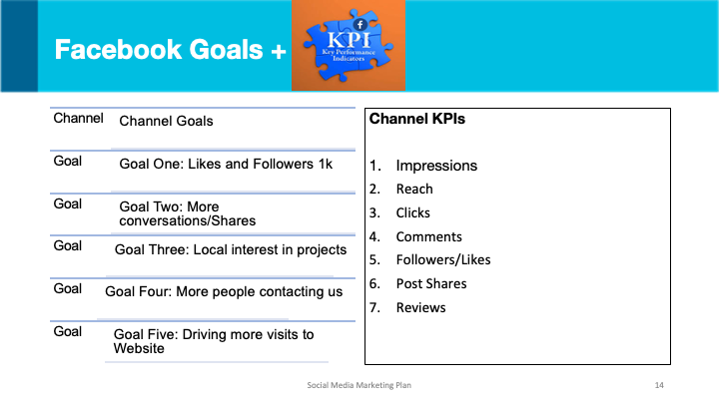

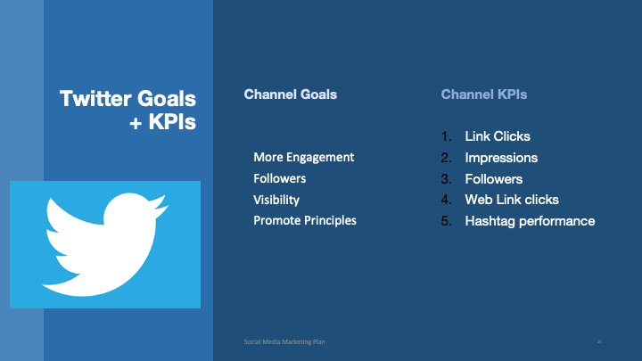

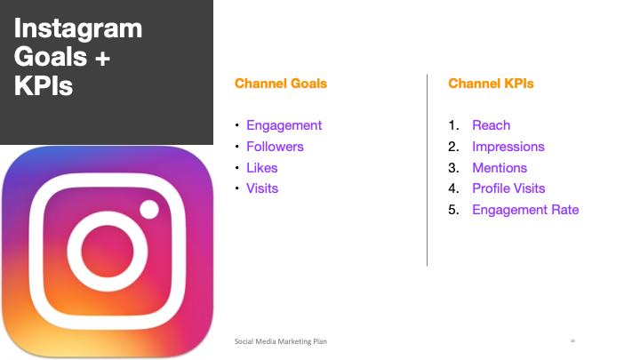

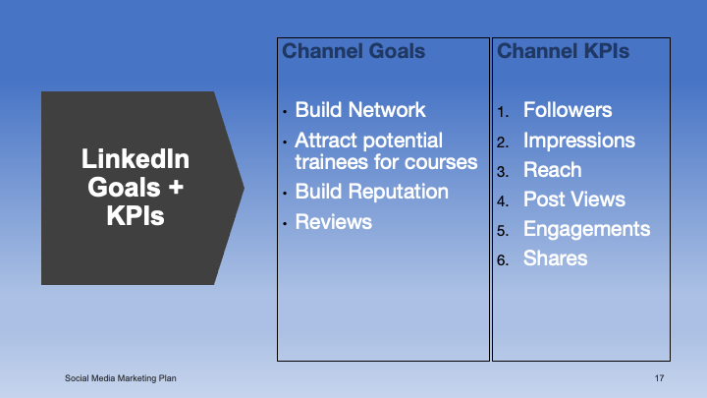

6.0



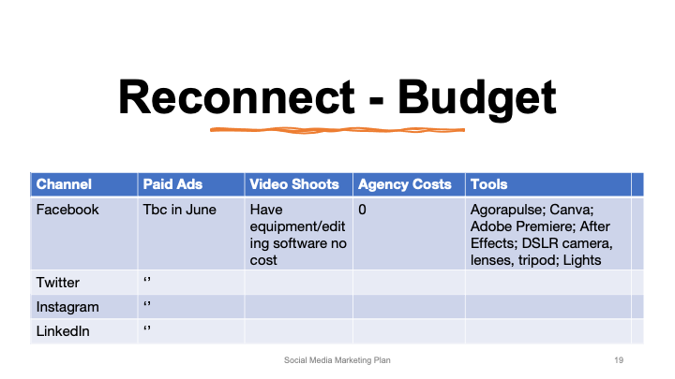

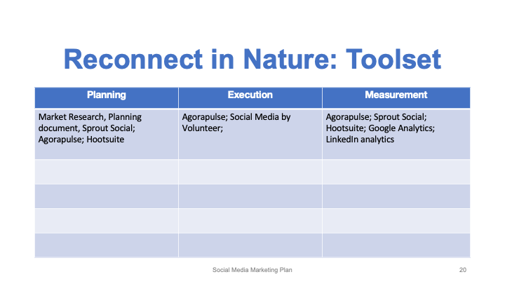

6.1

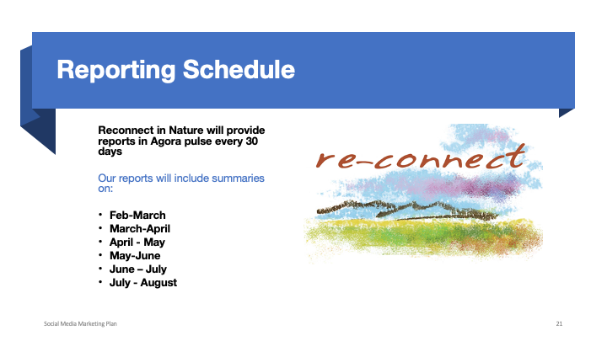

The plan was simple, and easy to read, as the owners of Reconnect in Nature had limited knowledge of metrics, or social media in general so the plan was put together to enable them to understand the key aims, content, and strategy without using complicated wording or industry terminology.

7.0. Social Analytics Results

Agora pulse data for all platforms the month before and during the campaign.

Below, on the next page in Fig 2.0 the first of many aggregated data sets establishes an overview of all the social platforms for the month prior to the campaign.

7.1. February – March: Aggregated data general overview of Facebook, Instagram, and Twitter

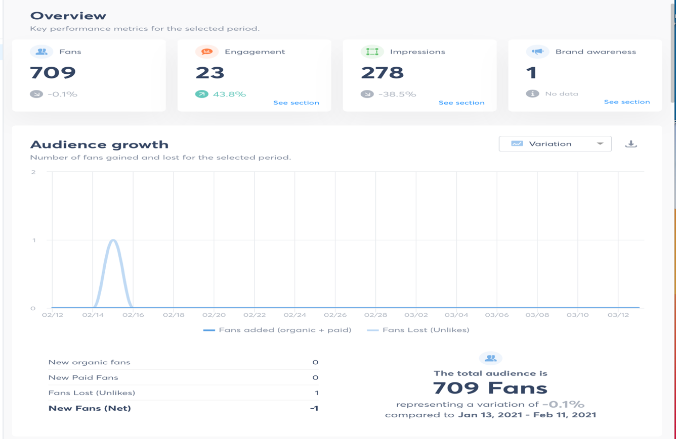

The data from Fig 2.0 shows very little engagement with all social platforms overall during that period, it also generates a comparison for January, showing even the last two months have been very poor in terms of engagement, new fans, and brand awareness.

March-April 2021: Aggregated data for Facebook, Instagram, and Twitter

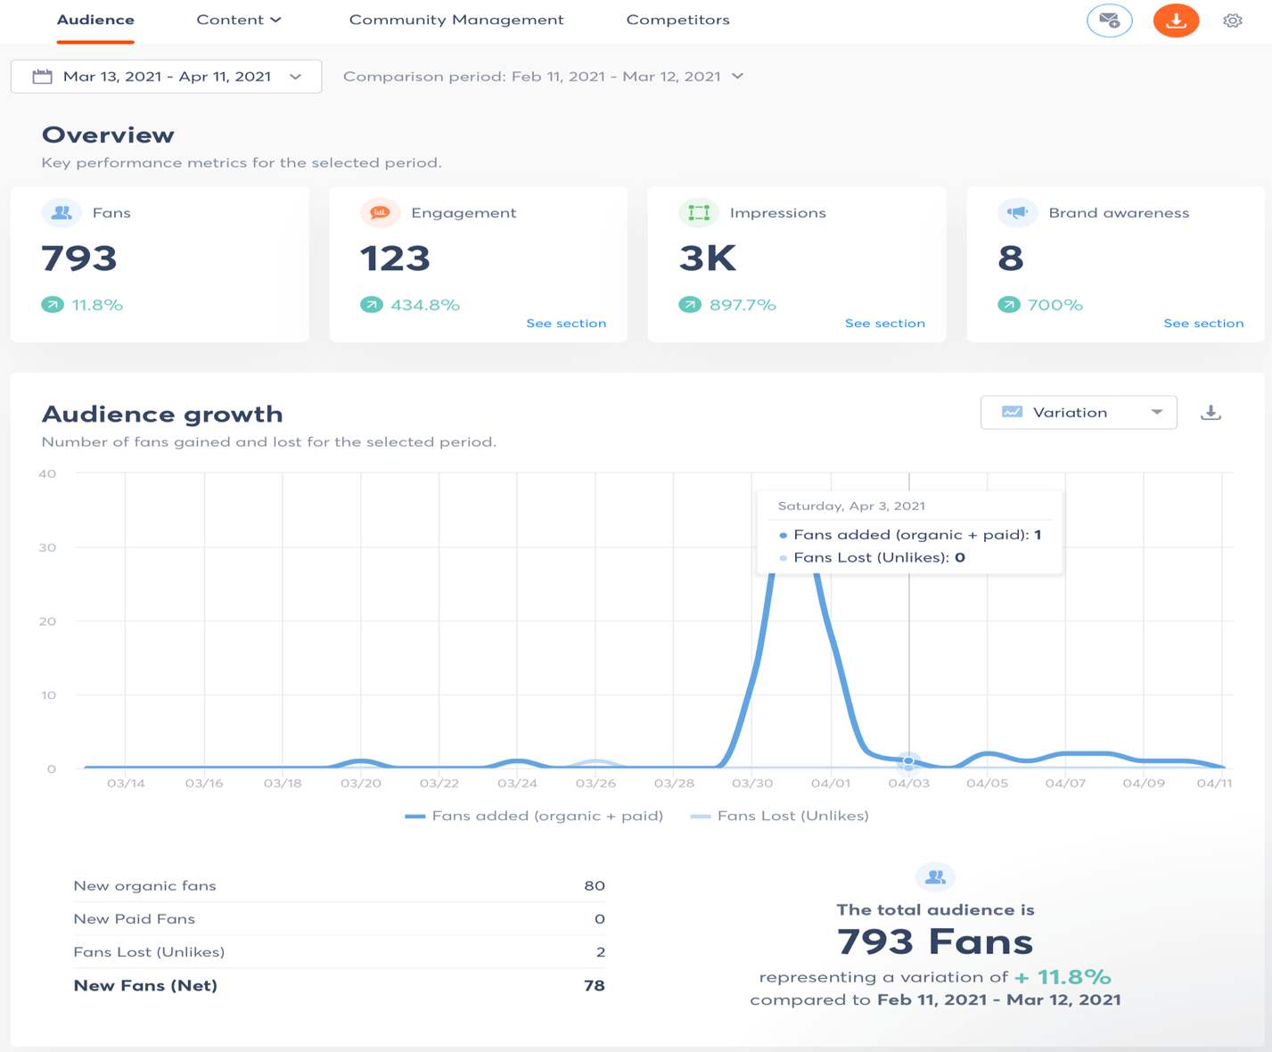

The results of fig 2.1 show that there has been a significant rise of fans and followers as well as engagement, there has been a marked increase in fans, which was down to the posting of more relevant content on a regular basis and the brand awareness score, which is the number of times the organisation was mentioned is and is 7 points higher than the month prior to the campaign. This shows the marked improvement overall across all platforms.

7.2. Feb-March: Aggregated data for Facebook Instagram and Twitter – Engagement

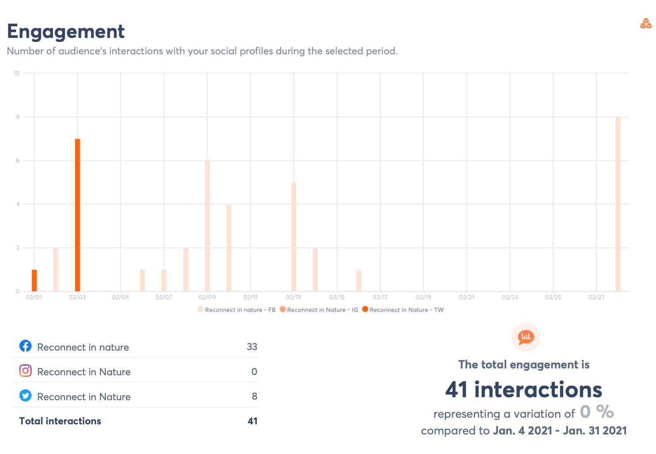

Total engagement is measured in comparison to the previous month, it shows no engagement at all on Instagram and a very low score on Facebook, even lower on Twitter. LinkedIn was not set up at this point, so does not show any results from that network., but the after show the minor results of a short timeframe when the page was set up.

March – April: Aggregated data for Facebook, Instagram, and Twitter – Engagement
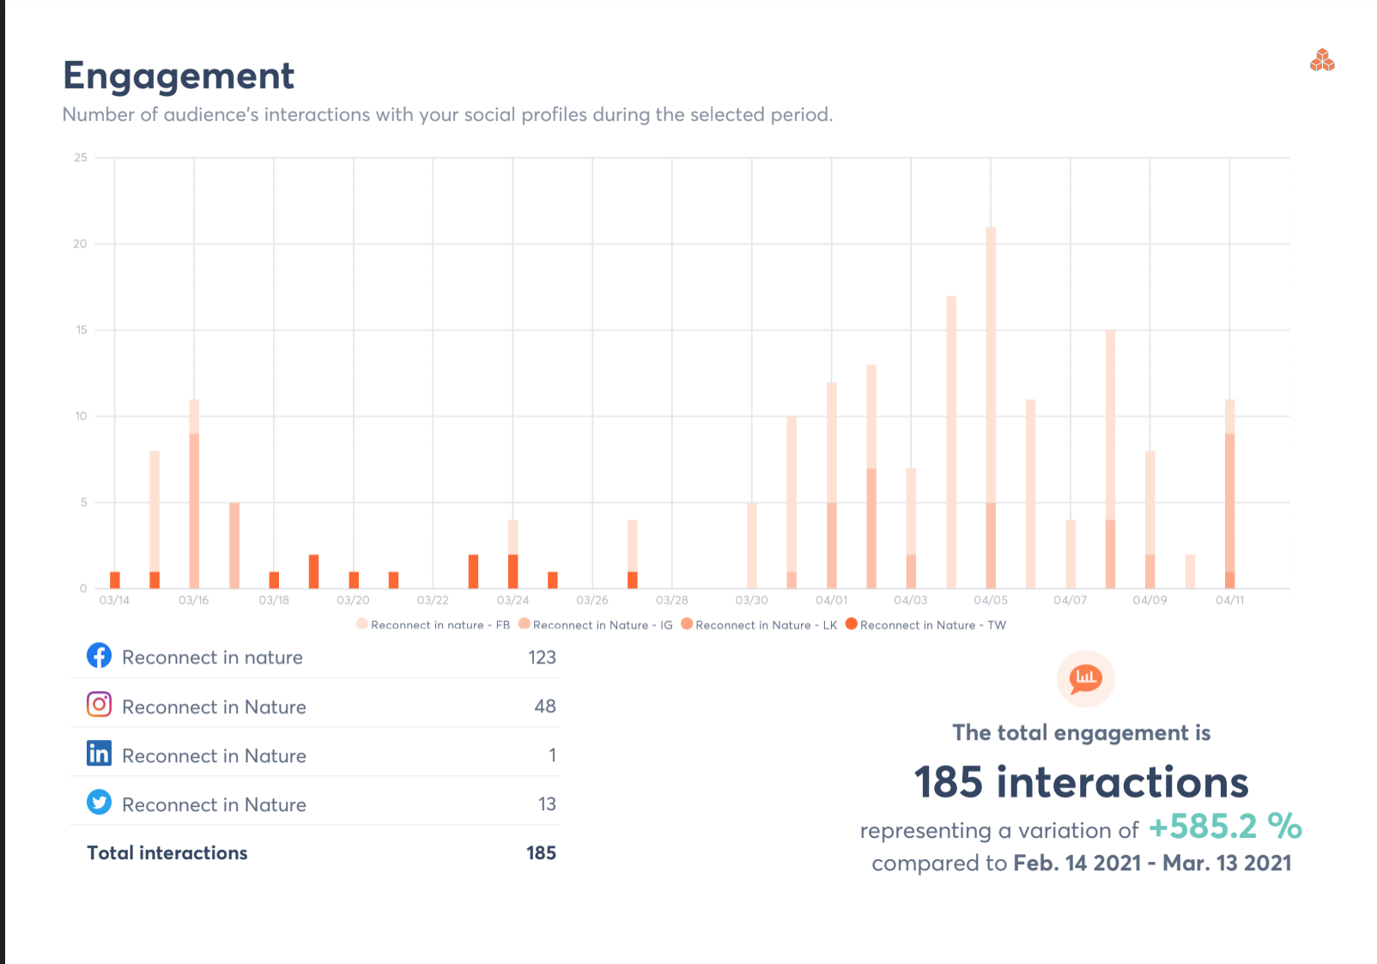

7.3. Feb-March: Aggregated data for Facebook and Instagram – Number of times content is viewed.
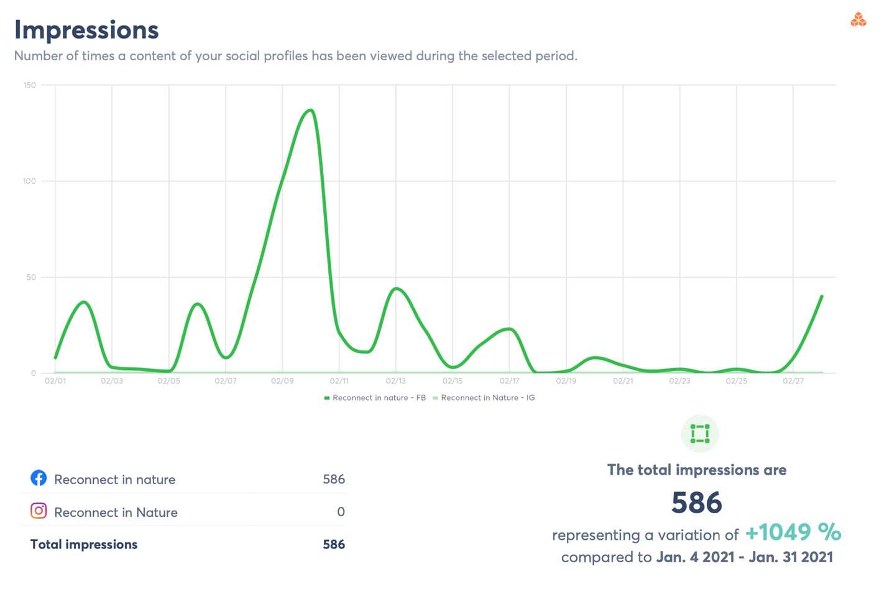
Impressions represent the number of times social profiles are viewed during the specific period. There was a slight variation compared to the previous month, but this was also because of a post that has been shared as an early part of campaign and test of the publishing software.

March-April: Aggregated data across all platforms for impressions

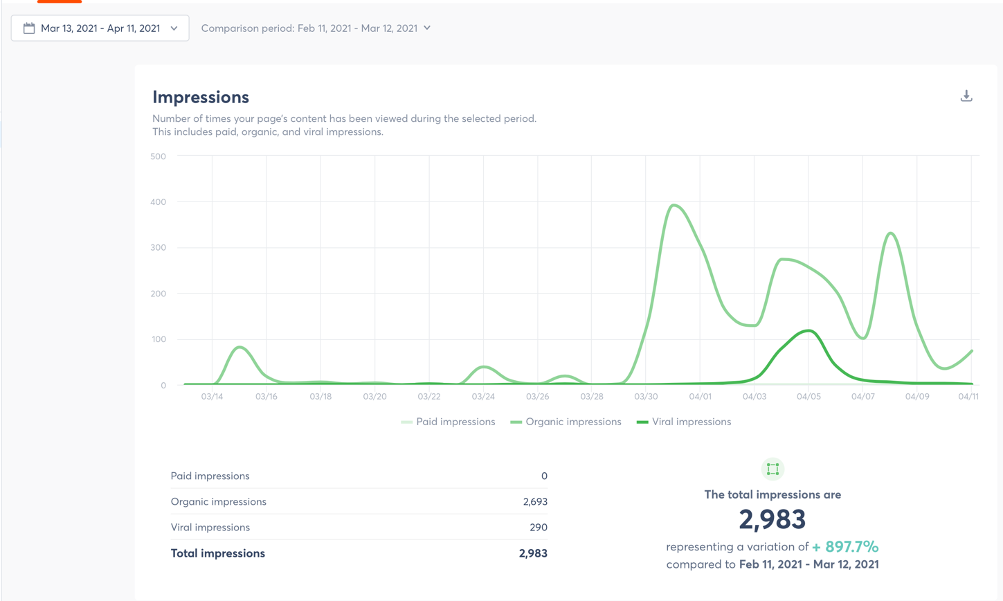

Impressions were much better during the campaign, although the variation doesn’t seem as much, the number of visits to the social sites have gone up significantly.

7.4. Feb-March: Aggregated data for Facebook Instagram and Twitter

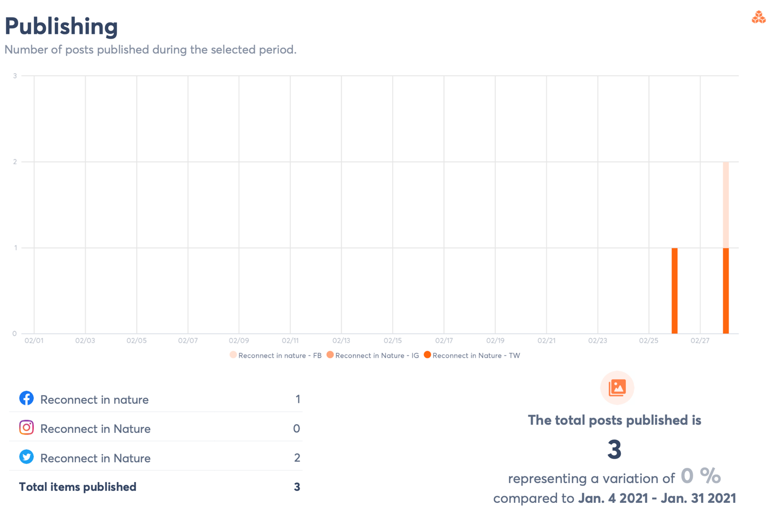
With only 3 posts made across all networks over the last month, there is no wonder why other areas such as engagement and impressions were low. There was no variation from the previous month either, highlighting the fact the organization was posting very little sporadically.

March-April: Aggregated data for Facebook Instagram and Twitter on publishing
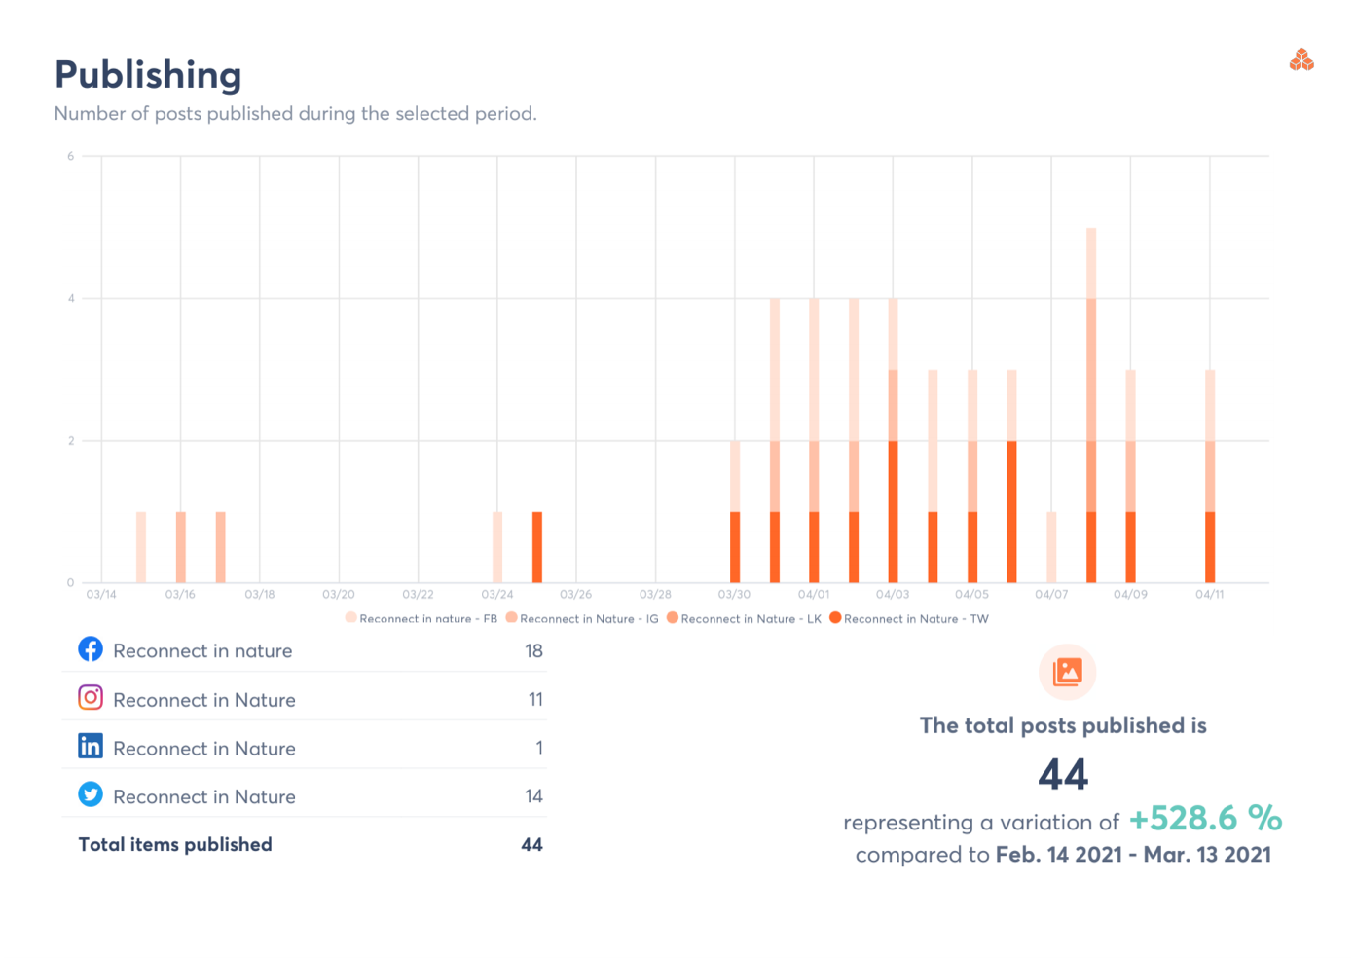
44 posts since the beginning of the campaign meant a much better publishing schedule overall, that includes at least one Facebook post a day and one or two Twitter posts. The number of posts were in line with what the organization wanted to achieve and would have been more if it had suited their timeframe, the idea was to take it slowly then build up to a more intense campaign nearer to when they were selling spaces for training courses and projects, which would be much later in the year.

7.5. Feb-March: Twitter top content

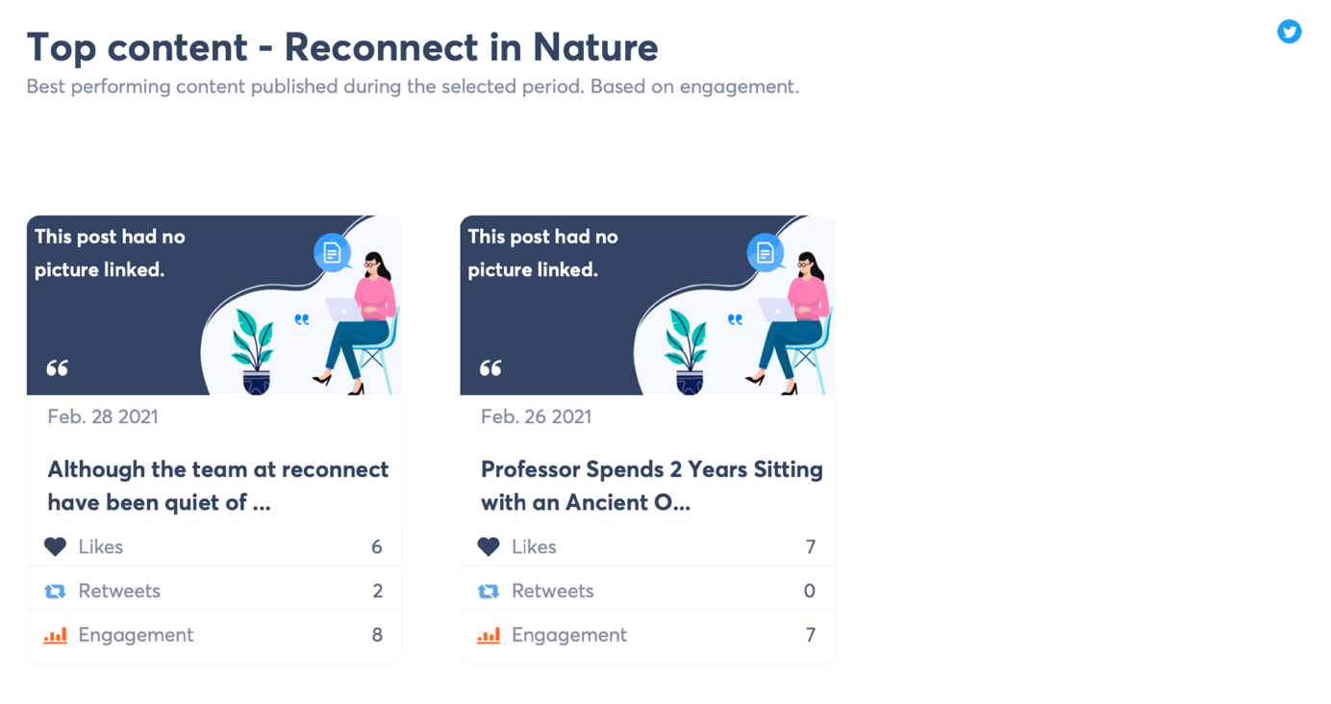

Not much to go on with the top content from Reconnect, the last two months only shows two posts on Twitter, one of them was a post that I made introducing the upcoming events later in the year before the campaign began and testing the publishing tool efficacy.

March - April: Twitter top content

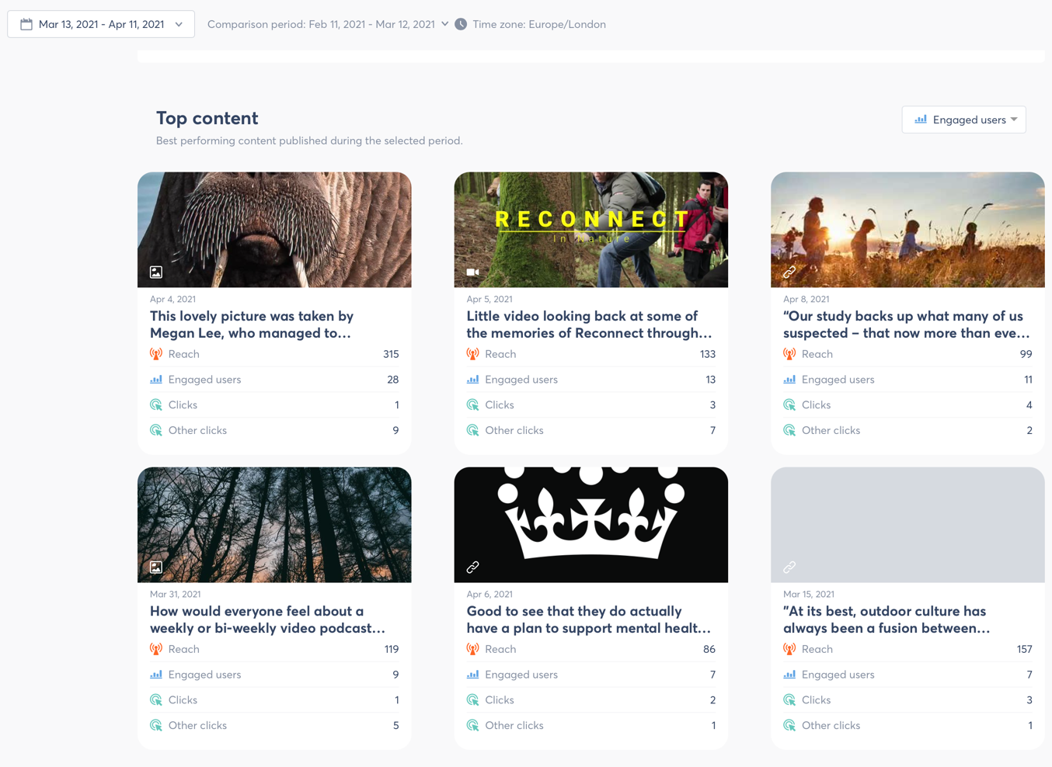

These metrics highlight some of the top posts made during the campaign period.

One of the top performing, was a video created specifically for the platform which incorporated photographs and memories of the best bits of reconnect, this got great engagement and likes. This confirmed the information in the literature that suggested the best engagement came from visual posts, and the survey where respondents said photographs and videos were what they preferred to see on social media. There has also been a rise of fans and followers on all platforms, particularly Facebook, which is still rising.

7.6. February – March: Facebook best performing posts

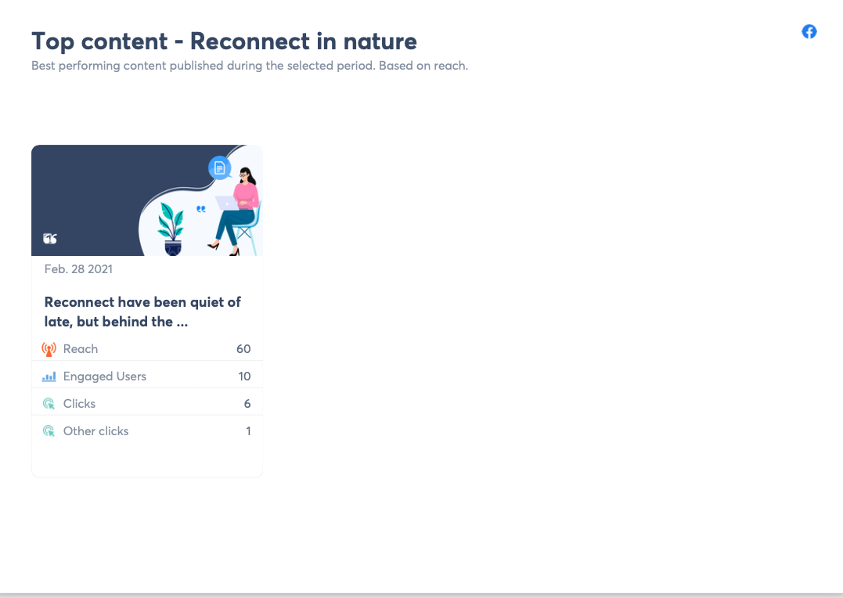
This was the only post that attracted some engagement and a reasonable reach, and as stated before, this was an introduction and software test done more than a week before the regular schedule and campaign.

March – April: Facebook best performing posts

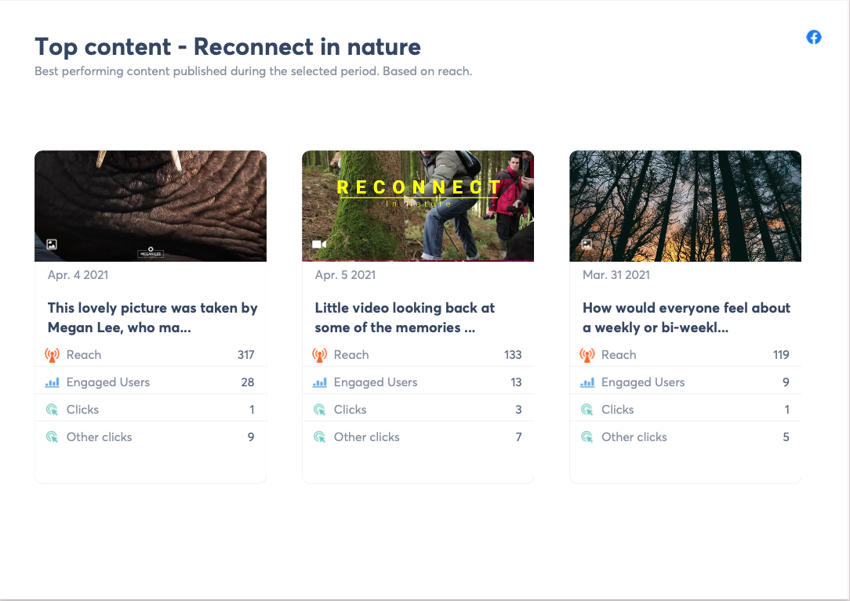
These separate the best posts across the individual networks, and show which ones performed best on each. Facebook audiences seemed to prefer the more personal posts such as the video, speaking directly to the audience asking them to engage and answer a question about potential content and a picture that was deemed irrelevant to the brand. This solidifies the results from the survey and the literature review, both state pictures and videos as content audiences want to see.

7.7. March – April: LinkedIn new page top content
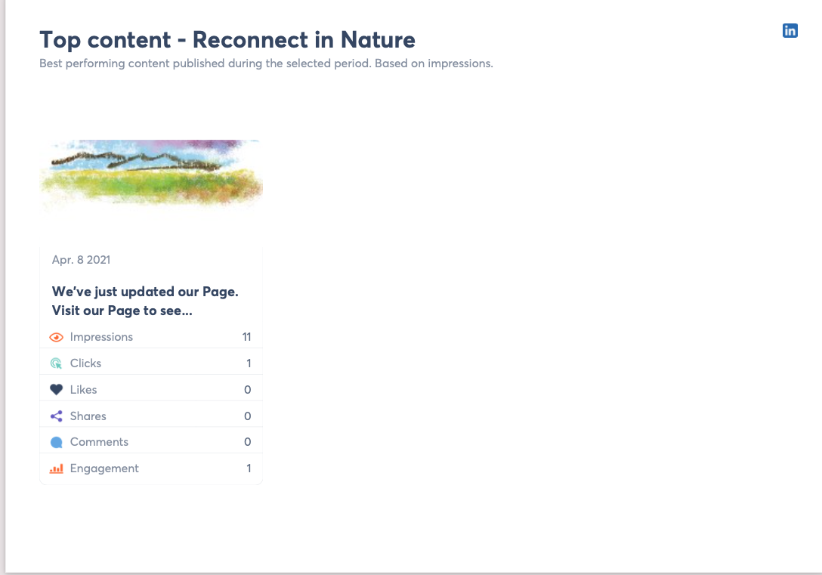

LinkedIn only shows one post as nothing was posted on there until the page was set up in late March, early April. The business page was set up later than this, as there was a realization that there was a need to have a business rather than personal page for the organization after the initial set-up.
7.8. March - April: Instagram top performing posts (not available for Feb-March)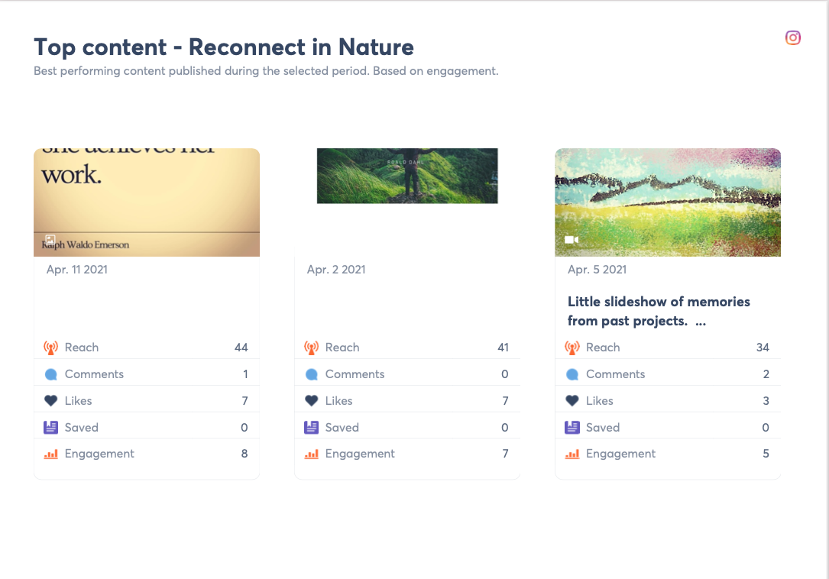
Instagram top posts reflected the survey answers where people prefer to see pictures and videos on social media, the strategy for Instagram was to post relevant and inspirational posts to also attract a younger demographic, and the reach is growing. This interaction and engagement inspired the creation and planning of a video podcast that will be set up and implemented later in the year.

7.9. February – March: Twitter user’s activity times and days
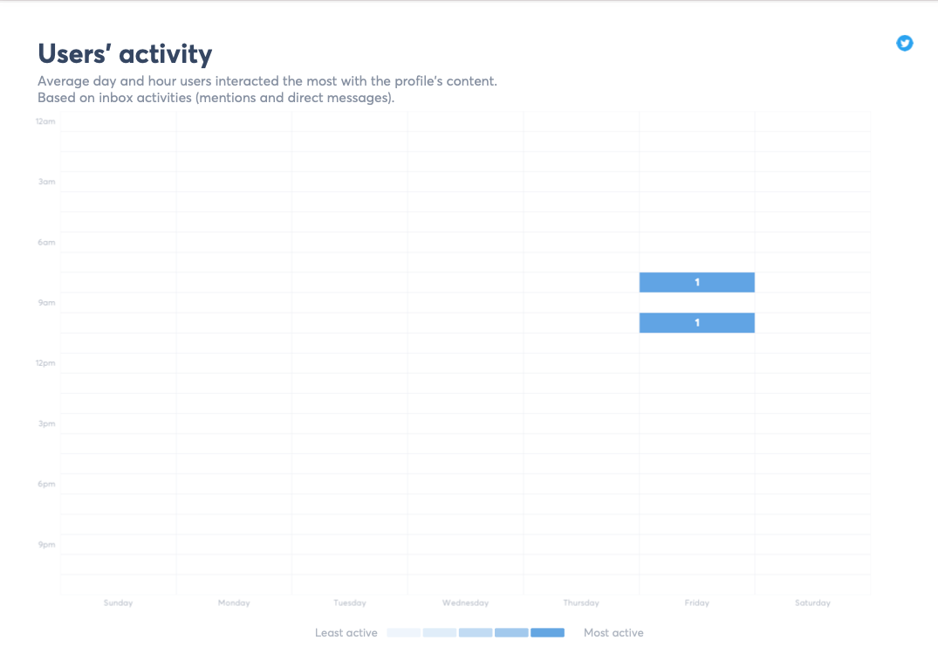
Twitter user activity shows 8am and 10 am as being the best posting times, although the survey results showed that the respondents tended to go on social media more during the evening and night times. Information from the literature review combined with these actual results showed the best time for Twitter was in the morning. According to (Diaz-Ortiz, 2019) more than one post on Twitter was recommended, so a morning and evening post was appropriate for this network to incorporate both times.

8.0. March – April: Instagram user’s activity times and days

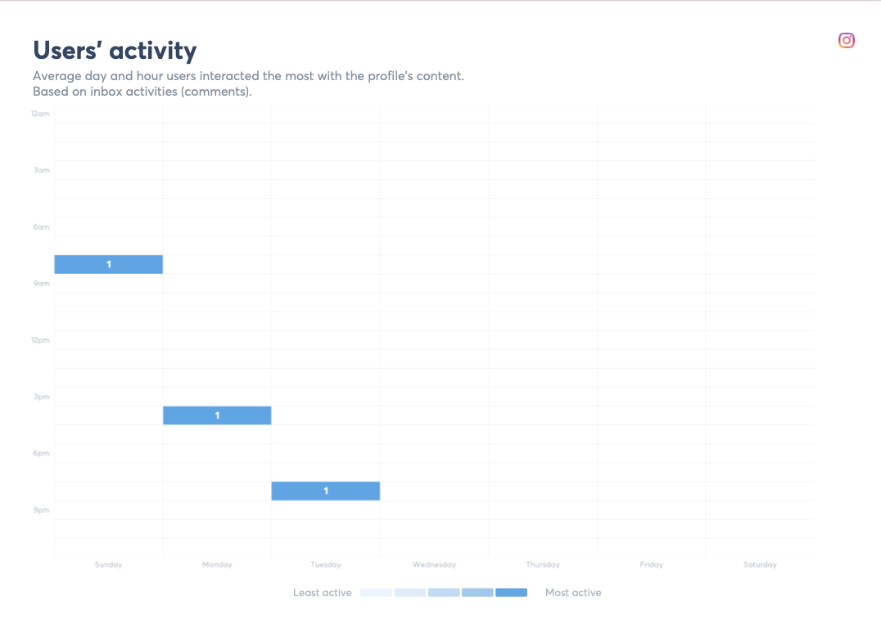

According to (French, 2019) social media marketing is an experimental process, where organisations should try different things, including times and days to post (relevant to the specific platform) so this is going to be done also throughout, using the times highlighted here.

8.1. March – April: Hashtags and interaction on Instagram. (No data for Feb-March)
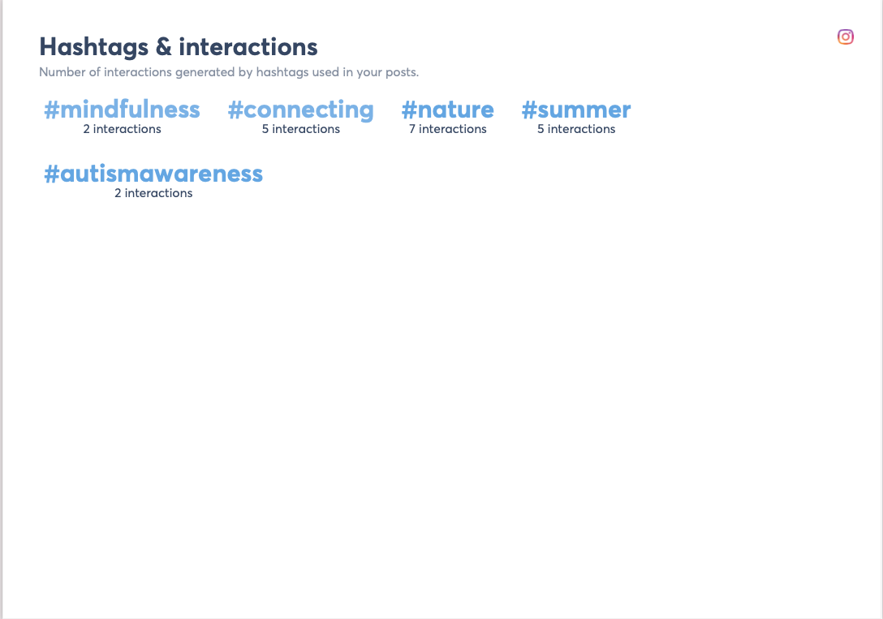

The use of Hashtags on Instagram proved effective in generating better engagement levels, the posts which contained the hashtags generally did better than those without. From the literature reviewed (Macke, 2021) suggests that popular hashtags can mean posts get significantly more engagement, the organization were not utilizing these before.

8.2. Feb – March: Facebook location information

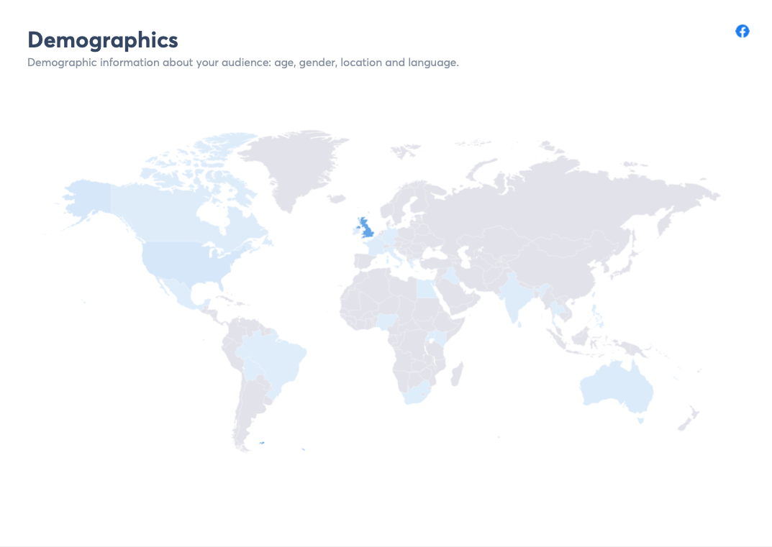

The results show that most users are based in Wales, which is the correct demographic for Reconnect in Nature.

8.3. Before and After campaign averages: Instagram demographics by age

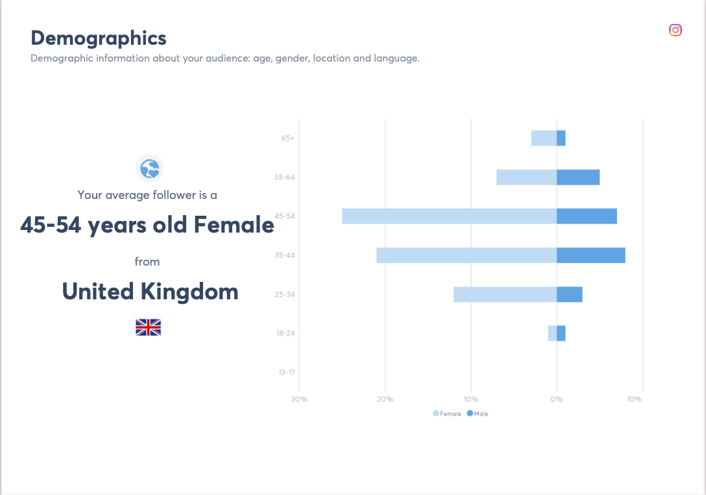

Age demographics highlight the type of age bracket Reconnect in nature want to attract, it does highlight a gap within the 30-45 age group, which will be considered when considering the age range targeted. Instagram and Twitter content will endeavour to attract the younger age bracket.

8.4. February – March: Facebook best time; day and posts.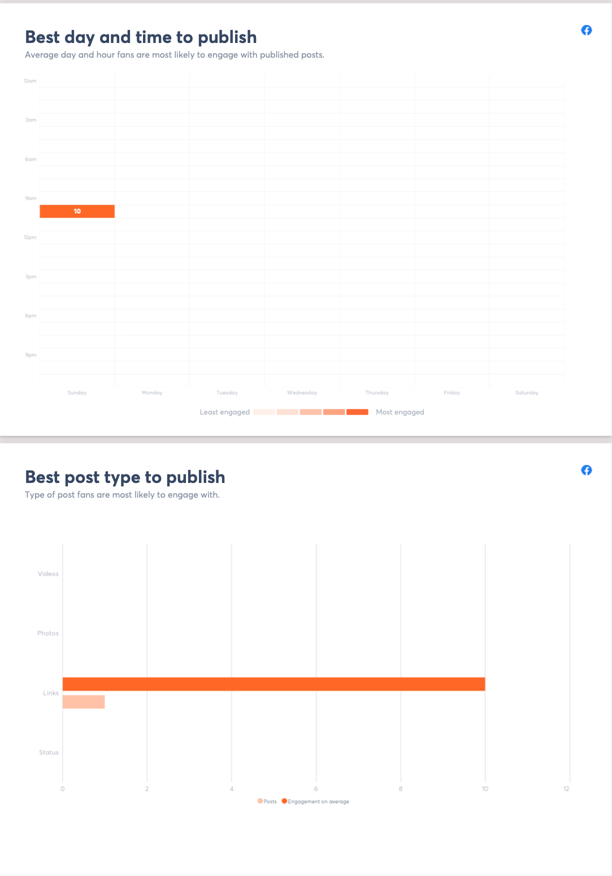
There is much less information before the campaign as to when and what type of post to publish, this is not representative because there are not enough posts to analyse.

March – April: Facebook best time, day, and post type.

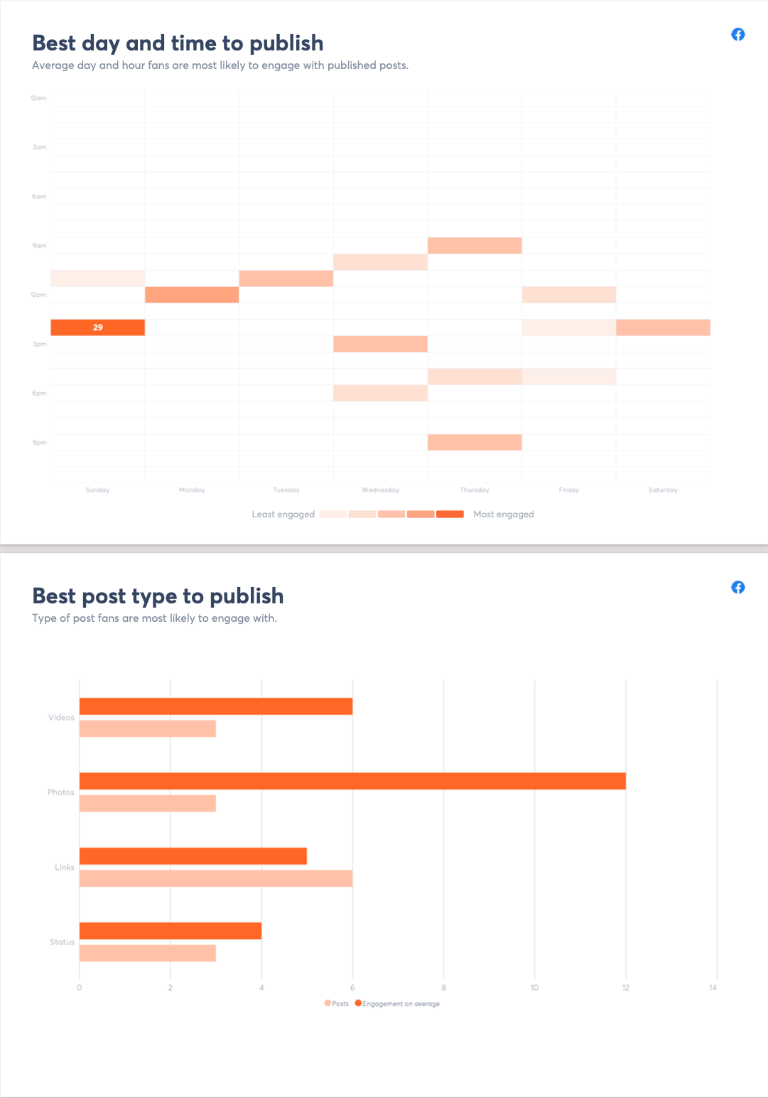

The times of day most popular on Facebook according to the data that was collected at the start of the campaign was between 12 and 3, this does contradict the survey answers that suggested evenings and night-time. To determine the accurate information, both times will be used to post, then the data collected and analysed to determine the ideal time.

Just as the survey data established, photographs are the most popular, followed by videos and then links and finally statuses, which represent that two-way engagement highlighted in the literature review.

8.5. February – March: Twitter best time, day, and post type.

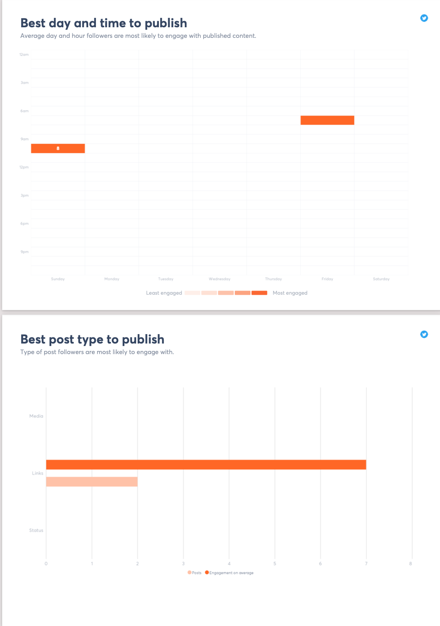
Twitter users before the campaign seem to be more active in the daytime, but this could be unreliable, as the previous posts were so minimal, it could have been the only time that the posts were published, this can be compared to the results during the campaign to see whether this is the case.

March – April: Twitter best time, day, and post type
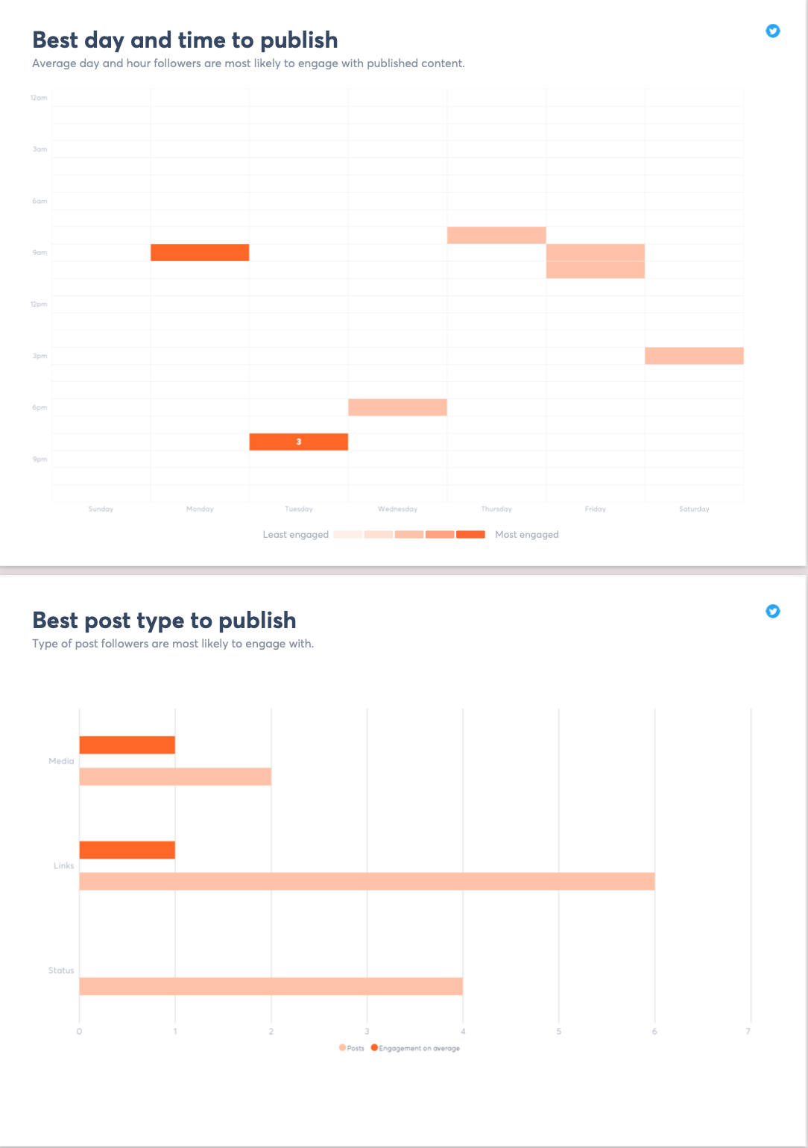
The data here is scattered again, and doesn’t show morning as necessarily the best time to post, with more content and more posts, the dominant time for engagement here is 9am in the morning and 9am at night.

8.6. Brand awareness score Feb – March Facebook
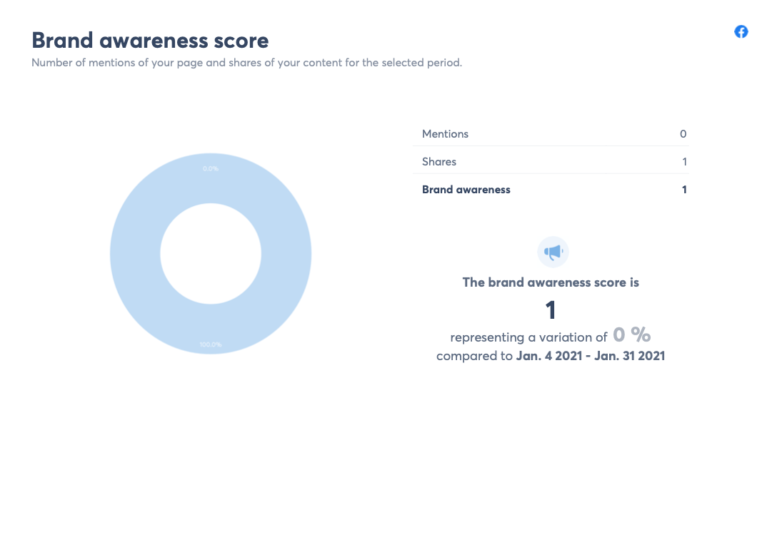
There are not many mentions here unsurprisingly as there has not been much to mention in the months running up to the campaign.

Brand awareness score March – April Facebook
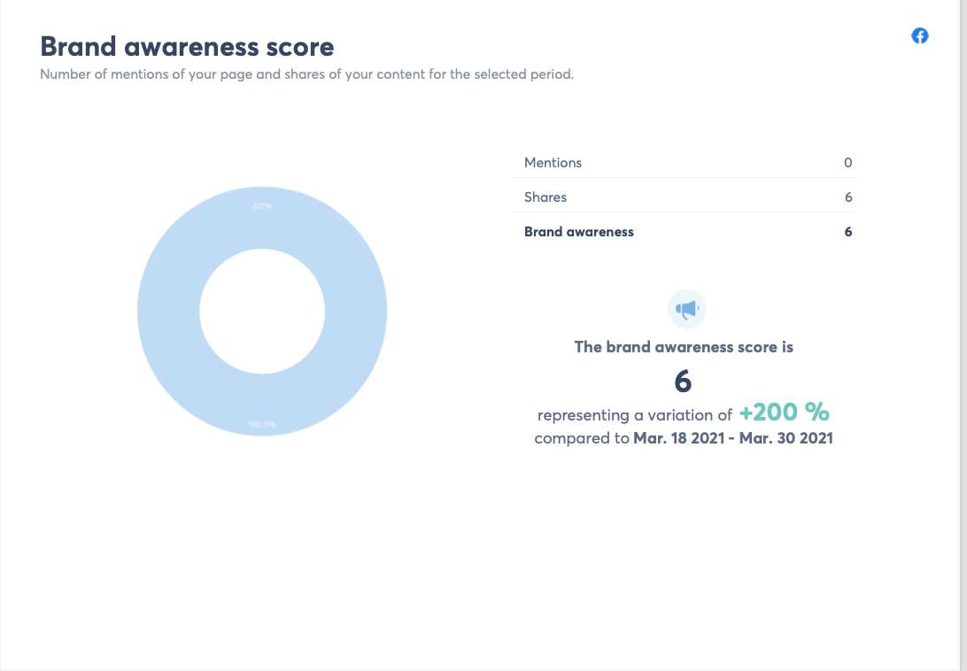

An increase of 200%, which is a good result, (Campbell et al, 2014; Mansfield, 2011 ) say that organic results on Social media are increasingly hard to get, making it difficult to generate real engagement with audiences without paying for advertisements. Increasing posts with created, high quality content and curated informative and entertaining content moving forward, with regular targeted advertising would offer the organisation the best possible results in terms of brand awareness, engagement, and connection with stakeholders.

9.0. Conclusion

The initial literature review and surveys assisted in compiling information relevant to the development of the plan, and an idea of how to structure and schedule the campaign. The following conclusions have been drawn, based on all the evidence provided. Social media is one of the most effective and transforming channels available online and the use of social media for non-profits is no longer a choice, but a necessity.

The results show that even with a very minimal amount of activity, improvements can easily be made in terms of brand awareness, engagement, and new fans/followers/likes. What remains to be a challenge, and will need to be carefully considered over time, is getting that engagement in terms of comments and conversations going. There is a chance that to bring the results the organisation wants and needs, that they will have to invest in paid for advertising rather than just relying on organic marketing. There is no doubt that good quality content, created by the organisation and a steady stream of engaging posts shared from other people, will enable a steady improvement of engagement, audience growth and brand awareness for the organisation.

Bibliography

(Updated 2021) The complete social media analytics guide - Talkwalker. (2019). https://www.talkwalker.com/blog/social-media-analytics-guide

A Digital Marketing Guide for Social Enterprise - Emergent Digital. (2020). https://emergentdigital.com/social-enterprise-digital-marketing/

A., K. (2020). Social Media Strategy. Rowman & Littlefield Publishers.

An, Seongho, "Attention Strategies For Nonprofit Advocacy On Social Media: Results From A National Study Of Homelessness Nonprofits In The United States" (2019). Publicly Accessible Penn Dissertations. 3256.

Appleby, Morgan (2016) "Nonprofit Organizations and the Utilization of Social Media: Maximizing and Measuring Return of Investment," SPNHA Review: Vol. 12: Iss. 1, Article 4. Available at: http://scholarworks.gvsu.edu/spnhareview/vol12/iss1/4

Auger, G. A. (2013). Fostering democracy through social media: Evaluating opposed nonprofit advocacy organizations’ use of Facebook, Twitter, and YouTube. Public Relations Review, 39(1), 369– 376.

Axelrad, C. (2015). 8 routine social media practices of successful nonprofits. Maximizing Social Business. Retrieved from http:// www.maximizesocialbusiness.com

Bernritter, S. F., Verlegh, P. W. J., & Smit, E. G. (2016). Why nonprofits are easier to endorse on social media: The roles of warmth and brand symbolism. Journal of Interactive Marketing, 33, 27-42. doi:https://doi.org/10.1016/j.intmar.2015.10.002

Bortree, and Seltzer, T. (2009). Dialogic strategies and outcomes: An analysis of environmental advocacy groups’ Facebook profiles. Public Relations Review, 35(3), 317-319.

Bowden, Jana Lay-Hwa (2008), “The Process of Customer Engagement: A Conceptual Framework,” The Journal of Marketing Theory and Practice, 17 (1), 63–74.

Briones, R. L, Kuch, B., Liu, B. F. and Jin, Y. (2011). Keeping up with the digital age: How the American Red Cross uses social media to build relationships. Public Relations Review, 37(2), 37–43.

Brodie, R. J., Ilic, A., Juric, B. & Hollebbek, L. (2013). Consumer engagement in a virtual brand community: An exploratory analysis. Journal of Business Research, 66(1), 105– 114

Burt, E. and Taylor, J. (2003). New technologies, embedded values, and strategic change: Evidence from the U.K. voluntary sector. Nonprofit and Voluntary Sector Quarterly, 32(1), 115–127.

Butow, E., Herman, J., Liu, S., Robinson, A., & Allton, M. (2020). Ultimate Guide to Social Media Marketing. Entrepreneur Press. https://www.perlego.com/book/1600716/

Camacho, J. (2020). Campaign Examples SOCIAL MEDIA AND NONPROFITS: USING SOCIAL MEDIA TO DO THE MOST SOCIAL GOOD. https://www.theshelf.com/the-blog/social-media-and-nonprofits

Campbell, D., Lambright, K., & Wells, C. (2014). Looking for friends, fans, and followers? Social media use in public and nonprofit human services. Public Administration Review, 74, 655-663

Carboni, J. L. & Maxwell, S. P. (2015). Effective social media engagement for nonprofits: What matters? Journal of Public and Nonprofit Affairs, 1(1), 18-28. doi:10.20899/jpna.1.1.18-28

Carey, B. (2019). Succeed with Social Media Like a Creative Genius: A Guide for Artists, Entrepreneurs, and Kindred Spirits. Allworth. https://www.perlego.com/book/1032302/

Carvill, M. (2018). Get Social. Kogan Page Publishers

Cazorla Milla, Asli & Mataruna, Leonardo & Runic Ristic, Marija. (2018). Adopting Social Media for Nonprofits as a Main Marketing Tool: Analysis of a Youth Non-Profit Organization. International Journal of Applied Business and Economic Research. 15.

Chaffey, D., & Ellis-Chadwick, F. (2019). Digital Marketing (7th ed.). Pearson. https://www.perlego.com/book/955155/

Chang, Y. T., Yu, H., and Lu, H. P. (2015). Persuasive messages, popularity cohesion, and message diffusion in social media marketing. Journal of Business Research, 68(4), 777-782.

Chin, T. M. (2011). Mobile Technology for Nonprofits: Harnessing the Power of Crowdsourcing (Master’s Thesis). Retrieved from ProQuest Dissertations and Theses. (UMI No. 1506070).

Chu, S. C., and Kim, Y. (2011). Determinants of consumer engagement in electronic word-of-mouth (e-WOM) in social networking sites. International journal of Advertising, 30(1), 47-75.

Constantinides, E., Influencing The Online Consumer’s Behavior: the Web Experience.

Curtis, L., Carrie Edwards, Kristen L. Fraser, Sheryl Gudelsky, Jenny Holmquist, Kristin Thornton, Kaye D. Sweetser. (2010). Adoption of social media for public relations by nonprofit organizations. Public Relations Review, 36(2), 90–92

Curtis, L., Edwards, C., Fraser, K. L., Gudelsky, S., Holmquist, J., Thornton, K., & Sweetser, K. D. (2010). Adoption of social media for public relations by nonprofit organizations. Public Relations Review, 36(1), 90–92. doi.org/10.1016/j.pubrev.2010.003

De Vries, L., Gensler, S., and Leeflang, P. S. (2012). Popularity of brand posts on brand fan pages: An investigation of the effects of social media marketing. Journal of Interactive Marketing, 26(2), 83-91.

Dessart, L., Veloutsou, C., & Morgan-Thomas, A. (2015). Consumer engagement in online brand communities: a social media perspective. Journal of Product & Brand Management, 24(1), 28– 42. doi.org/10.1108/JPBM-06-2014-0635

Dessart, Laurence, Cleopatra Veloutsou, and Anna Morgan-Thomas (2015), “Consumer Engagement in Online Brand Communities: a Social Media Perspective,” Journal of Product & Brand Management, 24 (1), 28-42

Diaz-Ortiz, C. (2019). Social Media Success for Every Brand: The Five StoryBrand Pillars That Turn Posts Into Profits. HarperCollins Leadership. https://www.perlego.com/book/1193135/

Digital Trends (2016). The History of Social Networking. Available at http://www.digitaltrends.com/features/thehistoryofsocialnetworking/
Accessed on 11/04/2021.

Dolnicar, S., & Lazarevski, K. (2009). Marketing in non-profit organizations: An international perspective. International Marketing Review, 26 (3), 275-291. Retrieved March 18, 2021, from ABI/INFORM Global. (Document ID: 1876135181).

Du Plessis, Charmaine. (2017). The role of content marketing in social media content communities. SA Journal of Information Management. 19. 10.4102/sajim.v19i1.866.

Edosomwan, S., Prakasan, S. K., Kouame, D., Watson, J., & Seymour, T. (2011). The history of social media and its impact on business. Journal of Applied Management and Entrepreneurship, 16(3), 79 – 91

Evans, D., & McKee, J. (2010). Social media marketing: The next generation of business engagement. Indianapolis, IN: Wiley Pub.

French, J., & Gordon, R. (2019). Strategic Social Marketing: For Behaviour and Social Change (2nd ed.). SAGE Publications. https://www.perlego.com/book/1431996/

Hansen, D., Shneiderman, B., & Smith, M. A. (2010). Analyzing social media networks with NodeXL: Insights from a connected world. Burlington, MA: Morgan Kaufmann.

Hersant, K. (2011). 9 Best practices of social media marketing. Software World, 42(6), 21+.

Hollebeek, Linda D., Mark S Glynn, and Roderick J Brodie (2014), “Consumer Brand Engagement in Social Media: Conceptualization, Scale Development and Validation,” INTMAR, 28 (2), 149–65.

Holtz, S., & Demopoulos, T. (2006). Blogging for business: Everything you need to know and why you should care. Chicago, IL: Kaplan Pub

Holtzhausen, L. (2014). Non-profit organizations bridging the communication divide in a complex South Africa. Public Relations Review, 40(2), 286-293. doi:10.1016/j.pubrev.2013.10.006

Johnson, R., Onwuegbuzie, A., & Turner, L. (2007). Toward a definition of mixed methods research. Journal of Mixed Methods Research, 1, 112-133. doi:10.1177/1558689806298224

K., H., & Toepler, S. (2020). The Routledge Companion to Nonprofit Management. Routledge.

Kanter, B., Fine, A., The Networked Nonprofit Connecting with Social Media to Drive Change.-San Fransisco: John Wiley.-2010. -29-30

Kaplan, Andreas M. and Michael Haenlein. 2010. “Users of the World, Unite! The Challenges and Opportunities of Social Media.” Business Horizons 53: 59-68.

Kemp, S. (2019). How to create a Digital Marketing Strategy. https://exposureninja.com/blog/how-to-digital-marketing-campaign/

Khan, A., & Khan, R. (2012). Embracing new media in Fiji: The way forward for social network marketing and communication strategies’. Strategic Direction, 28(4), 3- 116 5. doi:10.1108/02580541211212754

Khan, G.; Hoffman, M.; & Misztur, T. (2014). Best Practices in Social Media at Public, Nonprofit, Education, and Health Care Organizations. Social Science Computer Review 32(5), 571-574.

Kietzmann, Jan H., Kristopher Hermkens, Ian P. McCarthy, and Bruno S. Silvestre (2011), “Social Media? Get Serious! Understanding the Functional Building Blocks of Social Media,” Business Horizons, 54 (3), 241–51.

Lee, J., and Hong, I. B. (2016). Predicting positive user responses to social media advertising: The roles of emotional appeal, informativeness, and creativity. International Journal of Information Management, 36(3), 360-373.

K. Lovejoy, G.D. Saxton Information, community, and action: How nonprofit organizations use social media Journal of Computer-Mediated Communication, 17 (2012), pp. 337-353, 10.1111/j.1083-6101.2012.01576.x

Lovejoy, K. & Saxton, G. D. (2012). Information, Community, and Action: How Nonprofit 27 Organizations Use Social Media. Journal of Computer-Mediated Communication, 17(3), 337–353.

Lovejoy, K., Waters, R. D., & Saxton, G. D. (2012). Engaging stakeholders through Twitter: How nonprofit organizations are getting more out of 140 characters or less. Public Relations Review, 38(2), 313-318. doi:10.1016/j.pubrev.2021.03.25

Macke, L. (2021). The Best Social Media Tips For Your Nonprofit. https://www.threegirlsmedia.com/2020/08/31/best-social-media-platforms-for-nonprofits/

Mansfield, H.: Social Media for Social Good: A How-to Guide for Nonprofits. McGraw Hill Professional, New York (2011)

Matthews, B. (2020). Digital Marketing for Charities and Social Causes: A beginner’s guide | Empower Agency. https://empower.agency/digital-marketing-for-charities-and-social-causes-a-beginners-guide/

Maxwell, S. P., & Carboni, J. L. (2016). Social media management. Nonprofit Management & Leadership, 27, 251-260.

McMahon, D., Seaman, S., & Buckingham, J. (2011). Nonprofit adoption of websites and website types. Journal of Marketing Development and Competitiveness, 5(6), 43-50.

Meghan, L., & Tang, T. (2016). Strategic Social Media. John Wiley & Sons.

Milde, Katherine and Yawson, Robert M., Strategies for Social Media Use in Nonprofits (June 30, 2017). Journal of Management Policy and Practice, Volume 18(1), Pages 19–27, Forthcoming , Available at SSRN: https://ssrn.com/abstract=3002552

Miller, K. L. (2010). The nonprofit marketing guide: High-impact, low-cost ways to build support for your good cause. San Francisco, CA: Jossey-Bass.

Munar, A. M., and Jacobsen, J. K. S. (2013). Trust and involvement in tourism social media and web-based travel information sources. Scandinavian Journal of Hospitality and Tourism, 13(1), 1-19

Nah, S. & Saxton, G. D. (2013). Modeling the adoption and use of social media by nonprofit organizations. New Media Society, 15(2), 294–313.

Nisar, T. M., and Whitehead, C. (2016). Brand interactions and social media: Enhancing user loyalty through social networking sites. Computers in Human Behavior, 62, 743-753.

Paquette, Holly, "Social Media as a Marketing Tool: A Literature Review" (2013). Major Papers by Master of Science Students. Paper 2. http://digitalcommons.uri.edu/tmd_major_papers/2

Patterson, M. (2021). How to Perform a Social Media Competitive Analysis (Free Template). https://sproutsocial.com/insights/social-media-competitive-analysis/

Pew Research Center Internet, Science & Tech. (2015). Social Media Usage: 2005-2015. Retrieved March 25th, 2021, from http://www.pewinternet.org/2015/10/08/social-networking-usage-2005-2015/

Pope, J. A., Asamoa-Tutu, F., & Isely, E. S. (2009). Developing a marketing strategy for nonprofit organizations: An exploratory study. Journal of Nonprofit and Public Sector Marketing, 21, 2, 184-201.

Powers, T., Advincula, D., Austin, M. S., Graiko, S., and Snyder, J. (2012). Digital and social media in the purchase decision process. Journal of Advertising Research, 52(4), 479-489

PWC, Charity Finance Group & The Institute of Fundraising (2013). Managing in the ‘new normal’ – adapting to uncertainty [Online]. Retrieved from: http://www.institute-offundraising.org.uk/library/managing-in-a-downturn/

Ramanadhan, S., Mendez, S. R., Rao, M., & Viswanath, K. (2013). Social media use by community-based organizations conducting health promotion: A content analysis. BMC Public Health, 13, Article 1129.

Rathore, A. K., Ilavarasan, P. V., and Dwivedi, Y. (2016). Social media content and product co-creation: an emerging paradigm. Journal of Enterprise Information Management, 29(1), 7-18.

Rowley J, Keegan BJ. An overview of systematic literature reviews in social media marketing. Journal of Information Science. 2020;46(6):725-738. doi:10.1177/0165551519866544

Safko, L. (2012). The Social Media Bible: Tactics, Tools, and Strategies for Business Success (3rd ed.). Hoboken, NJ: John Wiley & Sons, Inc

Sargeant, A., Ford, J., and Hudson, J. (2008). Charity brand personality: The relationship with giving behavior. Nonprofit and Voluntary Sector Quarterly, 37(2), 468-441.

Saxton, G. D. & Waters, R. D. (2014). What do stakeholders like on Facebook? Examining public reactions to nonprofit organizations' informational, promotional, and communitybuilding messages. Journal of Public Relations Research, 26(3), 280. Retrieved from https://search.proquest.com/docview/1538589828

Schmidt, S., & Ralph, D. (2011). Social media: More available marketing tools. The Business Review, Cambridge, 18(2), 37-43. Retrieved March 23, 2021

Schneider, J. A. (2003). Small, minority-based nonprofits in the information age. Nonprofit Management and Leadership, 13(4), 383–399.

Schwartz, S. (2013) The savvy social media guide. Lynchburg, VA: Liberty University Press,

Sharma, M. (2019). Marketing Your Social Enterprise on Social Media. https://csedottawa.ca/marketing-your-social-enterprise-on-social-media/

Sheikh, M. (2020). The Complete Guide to Nonprofit Marketing in 2020. https://visme.co/blog/nonprofit-marketing/

Shevade, P. (2021). Digital Marketing for Charities (2021 Guide). https://socialb.co.uk/blog/digital-marketing-for-charities/

Social Media Marketing: The Ultimate Guide. (2020). https://blog.hubspot.com/marketing/social-media-marketing

Solomon, M. R., & Tuten, T. (2013). Social Media Marketing: Pearson New International Edition. Pearson. https://www.perlego.com/book/811262/

Thomas, R. M. (2003). Blending qualitative & quantitative research methods in theses and dissertations. Thousand Oaks, CA: Corwin Press.

Twitter. (2012). What are hashtags (“#” Symbols)? Retrieved from https://support.twitter.com/articles/49309-what-are-hashtags-symbols

Wang, Y., & Yang, Y. (2020). Dialogic communication on social media: How organizations use twitter to build dialogic relationships with their publics. Computers in Human Behavior, 104, 106183. doi:https://doi.org/10.1016/j.chb.2019.106183

Waters, R. D., Burnett, E., Lamm, A., & Lucas, J. (2009a). Engaging stakeholders through social networking: How nonprofit organizations are using Facebook. Public Relations Review, 35(2), 102-106. doi:10.1016/j.pubrev.2009.01.006

Waters, R.D., Jamal, J.Y.: Tweet, tweet, tweet: a content analysis of nonprofit organizations’ twitter updates. Public Relat. Rev. 37(3), 321–324 (2011)

Watkins, B. A. (2017). Experimenting with dialogue on Twitter: An examination of the influence of the dialogic principles on engagement, interaction, and attitude. Public Relations Review, 43(1), 163-171. doi:10.1016/j.pubrev.2016.0.7.002

Weber, L. (2013). The social enterprise: Building a digital-driven business to gain competitive advantage. Journal of Digital & Social Media Marketing, 1, 6-16. Retrieved from http://henrystewartpublications.com/jdsm

Westcott, S. (2007) Face time: Charities flock to social-networking Web sites to reach out to new people, spark discussion, and help raise money. The Chronicle of Philanthropy. 19(7).

Why Nonprofits Are Easier to Endorse on Social Media: The Roles of Warmth and Brand Symbolism,Journal of Interactive Marketing,Volume 33,2016,Pages 27-42,ISSN 1094-9968,

Why Social Media Matters to Nonprofits - MissionBox. (2020). https://www.missionbox.com/article/118/why-social-media-matters-to-nonprofits

Williams, M., & Buttle, F. (2013). Managing word-of-mouth: A nonprofit case study. Journal of Nonprofit & Public Sector Marketing, 25, 284-308. doi:10.1080/10495142.2013.816191

Xu, W. (Wayne), & Saxton, G. D. (2019). Does Stakeholder Engagement Pay Off on Social Media? A Social Capital Perspective. Nonprofit and Voluntary Sector Quarterly, 48(1), 28–49. https://doi.org/10.1177/0899764018791267

Xu, W.W., Chiu, I.H., Chen, Y., Mukherjee, T.: Twitter hashtags for health: applying network and content analyses to understand the health knowledge sharing in a twitter-based community of practice. Qual. Quant. 49(4), 1361–1380 (2015)

Yin, R.Y. (2009). Case study research: Design and methods. Thousand Oaks, CA: SAGE, Inc

Yorke, D. A. (1984) Marketing and non-profit-making organizations. European Journal of Marketing, Vol. 18 Iss: 2, pp.17 – 22.

Young, J. A. (2012). The Current Status of Social Media uses among Nonprofit Human Service Organizations: An Exploratory Study (Doctoral dissertation). Retrieved from ProQuest Dissertations and Theses. (UMI No. 3507810).

Young, J. A. (2017). Facebook, Twitter, and blogs: The adoption and utilization of social media in nonprofit human service organizations. Human Service Organizations: Management, Leadership & Governance, 41(1), 44-14. doi:10.1080/23303131.2016.1192574

Zhang, Mimi, Bernard J. Jansen, and Abdur Chowdhury. 2011. “Business engagement on Twitter: a path analysis.” Electron Markets 21: 161-175. DOI 10.1007/s12525-011-0065-z.

Zinnbauer, Markus, and Tobias Honer. 2011. “How Brands can Create Social Currency- a Framework for Managing Brands in a New Era.” Marketing Review St. Gallen 28: 50-55.

