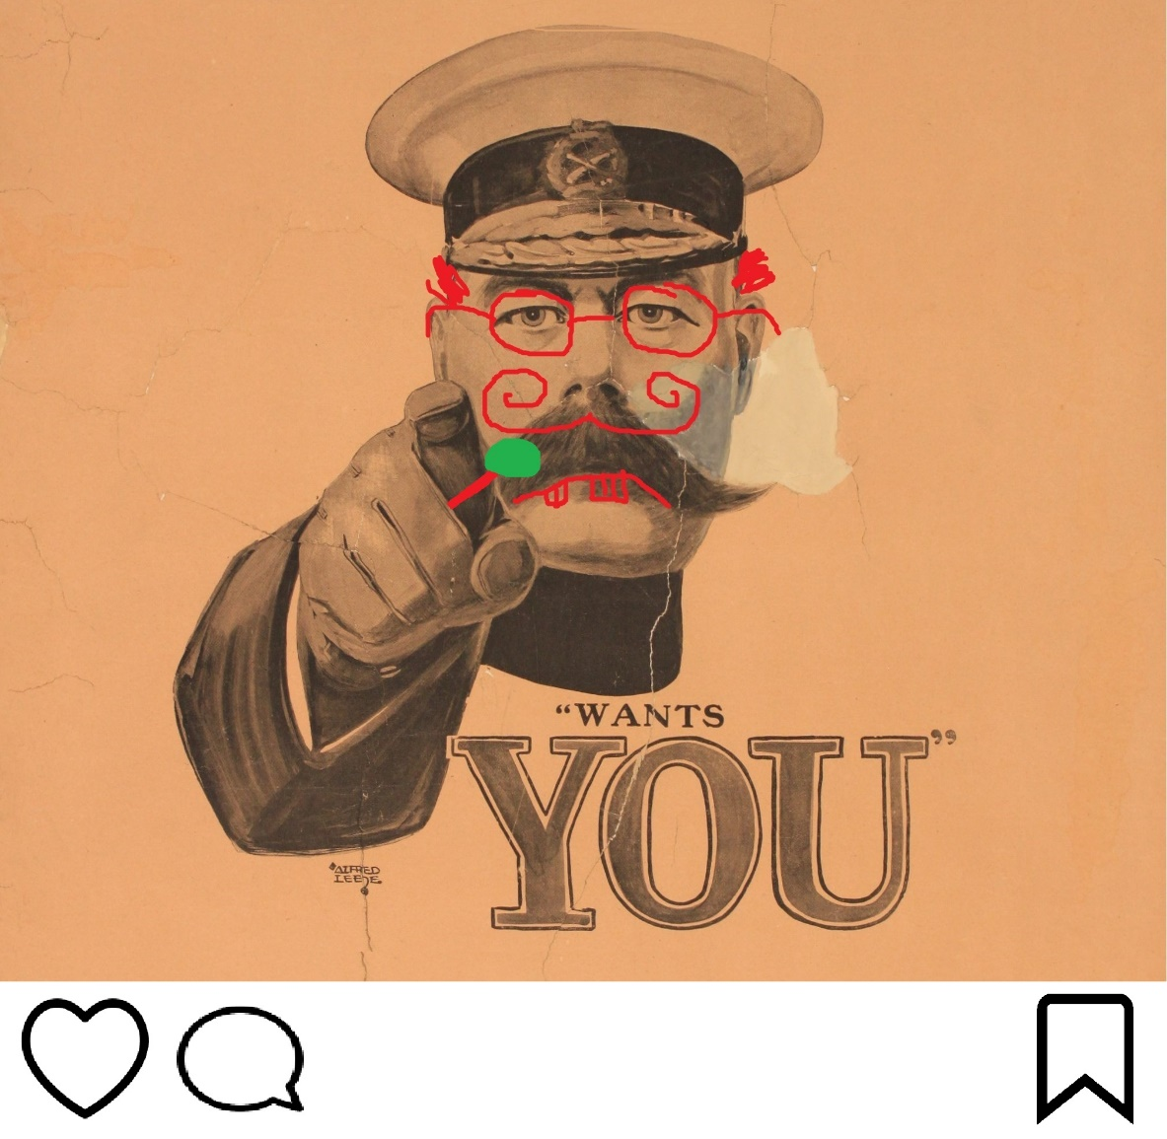
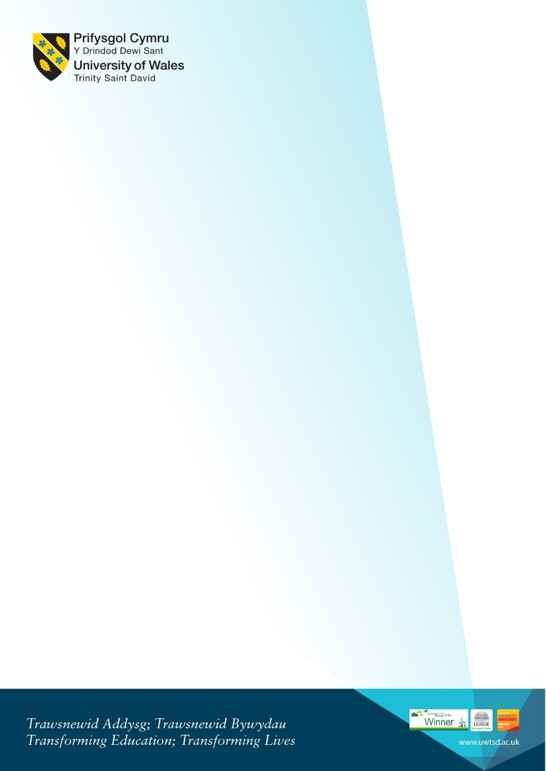
2-5pm, Founders Library. Snacks will be provided
Featuring talks on Religion, Evacuees, Etc Etc Etc Etc and Wargaming
WAR IS FUN

