Engineering Management
Total Engineering Management

Coleg Sir Gar
22/05/20



Contents
List of Figures 2
Task 1 3
(a) 3
(b) 4
(c) 5
Task 2 7
Task 3 9
(a) 9
(b) 11
Task 4 14
(a) 14
(b) 18
(c) 18
Task 5 19
References 21

List of Figures
Figure 1 Table of Averages 4
Figure 2 DOE Graph 5
Figure 3 Kano Model Graph 9
Figure 4 House of Quality Model 12
Figure 5 Machine Capability Results Table……………………………………………………………………………………….14 Figure 6 Tally Chart 14
Figure 7 Tally Histogram 15
Figure 8 Average Control Chart 16
Figure 9 Range Control Chart 16
Figure 10 Table of Control Constants 17
Figure 11 Calculation Results Table 18

Task 1

(a)
What is Taguchi’s Design of Experiments (DOE) and what are the steps involved?
Taguchi’s methods are a set of scientific approaches proposed by Genichi Taguchi in the 1980s on how to improve the quality of manufactured goods by obtained a high standard of performance consistently. These methods and ideas are implemented within the engineering, biotechnology, marketing and advertising industry. To get the optimum design using this method there are four steps that must be followed.
Brainstorming
This step should involve all persons that have relevant knowledge in the topic of the project. All decisions should be made by vote of everyone involved. The brainstorming sessions are used to determine all the criteria of evaluation for the project and how each one will be weighted. This step is also used to identify the external influencing factors, factor levels and noise factor that will be included within the experiment’s evaluation.
Designing Experiments
Using the information for the project gathered in the brainstorming session, the experiment can be designed, and the method instructions can be produced. The necessary orthogonal array must be opted for, assigning factor and interaction to columns is required, trial conditions must be set, and the order must be decided before the experiment begins (Roy, 2001) so the chances of err are reduced.
Running Experiment
The experiment will be completed during this step in random order if and when possible.

Analysing Results
Before analysis can be carried out the data may have to be transferred into another format such as a graph or a chart so that you can properly evaluate the results. The following information is obtained through analysis; the optimum design, effects of the individual factors and the performance when the optimum conditions are met.

(b)
Ā₁ = (20 + 12 + 10) / 3 = 14
Ā₂ = (48 + 28 + 20) / 3 = 32
Ā₃ = (20 + 16 + 8) / 3 = 14.67
B₁ = (20 + 48 + 20) / 3 = 29.33
B₂ = (12 + 28 + 16) / 3 =18.67
B₃ = (10 + 20 + 8) / 3 = 12.67
C₁ = (20 + 20 + 16) / 3 = 18.67
C₂ = (12 + 48 + 8) / 3 = 22.67
C₃ = (10 + 28 + 20) / 3 = 19.33
D₁ = (20 + 28 + 8) / 3 = 18.67
D₂ = (12 + 20 + 20) / 3 = 17.33
D₃ = (10 + 48 + 16) / 3 = 24.67
These averages are then tabulated.

Levels | A | B | C | D
1 | 14 | 29.38 | 18.67 | 18.87
2 | 32 | 18.67 | 22.67 | 17.33
3 | 14.67 | 12.67 | 19.33 | 24.67
Range | 18 | 16.66 | 4 | 7.34
Rank | 1 | 2 | 4 | 3
Figure 1Table of Averages
The conclusion from the table is that the optimum parameter levels are A₁, B₃, C₁ and D₂.
These values can be used to predict the outcome for these settings.
$$Y = \left(A^{1}+ B^{3}+ C^{1}+ D^{2}\right)- 3\overline{T}$$
$$Y=\left(14+12.67+18.67+17.33\right)-\left(3 ×20.22\right)$$
$$Y=2.01$$
A graph was plotted using the ranges of each condition.
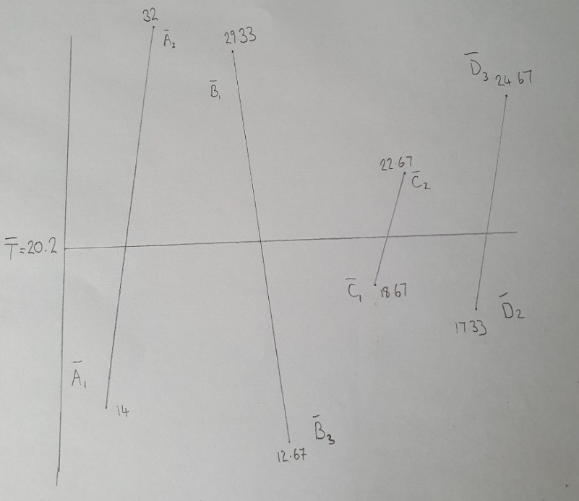

Figure 2 DOE Graph

(c)
The additional information shows that the optimum parameter levels included the most expensive material being used, highest temperature and the longest process time. The parameters could be adjusted so that the money saved on a quicker process, cheaper material and percentage of additive is larger than that of the material wasted on the deteriorated samples.

Task 2
Three main strategic development techniques used by business organisations are SWOT, PESTEL and Porter’s Five Force Analysis. ‘SWOT stands for strengths, weaknesses, opportunities and threats, it is a technique that is used to assess and review company business and strategy’ (SWOT Analysis, 2020). External and internal factors that can affect the company are analysed in the technique. The internal factors involved are the business’ strengths and weaknesses, and the external factors are threats and opportunities. The technique will aid the company into identifying the parts which are performing to a high level. These areas are important for the business to excel and improve on the factors made the company a success. Weaknesses will also be identified so that they can be reduced, improved or even eradicated before they cause any damage. Completing a SWOT analysis can present an opportunity that the company could take advantage of to improve profit margins. Threats are the external factors that could cause problems for your company, for example, new competitors, market changes or changes in government legislations. SWOT analysis will help you determine these threats and ways to resolve them depending on strengths and weaknesses. ‘A PESTEL analysis is an acronym for a tool that is used to identify the macro forces facing an organisation. The initials stand for political, economic, social, technological, environmental and Legal’ (What is a PESTEL analysis?, 2020). The two main applications for a PESTEL analysis is to evaluate the possibility of a new business venture or analysing the macro environment. This technique includes exclusively external factors due to its focus on the macroeconomic market, whereas SWOT analysis focusses on factors in the micro-environment. Political accounts for all the influence that the government has on the business such as policies and tariffs. Economic analyses the effects of the trends of the global market on the company. Social assesses how the company and the social environment can effect each other, for example a business could release an inappropriate or offensive advertisement and it could weaken the business’ image or a particular cultural trend could be the deciding factor of a company’s success in a certain country or city. Technological accounts for the advancement of technology in the business and how it is affecting their stance in the market. Environmental analyses the affect the environment and the company has on each other. The implications of the company on the area is evaluated and the influence the environment can have on the business market such as farming, tourism and fishing. Legal is similar to political, however it focusses more on the direct impacts that the law has on the company, for example, regulatory laws, social laws and standards that need to be adhered to. ‘Porter’s Five Forces is a model that identifies and analyses five things that will determine the company’s strengths and weaknesses, it is often used to decide the industry’s structure and to identify the corporate strategy’ (Porter's Five Forces, 2020). The five forces are named after a professor at Harvard School of Business, Michael E. Porter. This model is applied to all sectors of economy to determine the market of the industry and to increase the long-term profitability of a company. This analysing method identifies all the external factors that can affect the business like PESTEL, however it focusses on the economics. It evaluates all the threats and opportunities that the economic market offers. The five forces are the competition in the industry, potential of new competitors, power of suppliers, power of customers and threat of substitutes. SWOT analyses the way the business can affect the market consisting mainly of internal factors and the five forces look at how the market can affect the business, all external factors.

Task 3

(a)
The Kano Model is a theory created to track the development and the customer reviews of a product, the model was developed by a professor in the 1980’s called Noriaki Kano. It works by classifying customer requirements into five separate categories, which are; basic, performance, indifferent, reverse and excitement. The model describes and displays each category on a set of axis, the y-axis measures the customer satisfaction and the x-axis presents the execution of requirements (Olsen-Landis, 2017). All of the categories are mapped out on the axis like shown below:
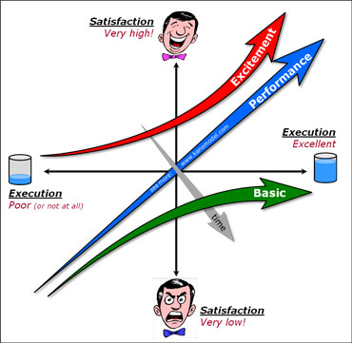
Figure 3 Kano Model Graph
The aim is to understand and communicate the five categories of customer satisfaction with all aspects of product development and services to continue being competitive in the market.
Performance
The performance is the most important requirement for the product. Customer satisfaction
relies heavily on the performance of the product, the worse they perform, the more
dissatisfaction they bring. The performance of a product is the sole purpose of the purchase
of it.

Reverse
These are requirement that cause dissatisfaction, they are rare but are occasionally essential to include.
Basic
These are the ‘basic’ requirements that the customers expect with the product. They are normally not even mentioned and are taken for granted. However, if there was a problem with the feature or it was omitted, there would be serious dissatisfaction from the consumer.
Indifferent
These are features or requirements that would go unnoticed when present or not. The customer satisfaction would not be affected by this.
Excitement
These are requirements that were never expected, they are pleasant surprises when they are included. The customer is not dissatisfied when they are not implemented because they were not expecting them in the first place.

(b)
(i) Why should a company use Quality Function Deployment (QFD)?
There are many reasons a company should be completing a QFD meeting regularly, the first is to keep updated with the customers’ requirements. Every organisation should constantly be updating their products and services to keep up with the advancement of technology and the everchanging demands of the consumers. The QFD clearly displays who the customer is, what they need and how the product could satisfy them.
Another reason is to have a direct comparison between your product and design to your direct competitions. This quick analysis tool could be vital in the planning behind a new product design change that could place you on top of your market (Quality Function Deployment, 2020).
Implementing a QFD in a company will considerably shorten the development time and lower costs. Effective methodology and organisation prevent valuable time and resources from being wasted adding non-valuable features to the product.

(ii) House of Quality
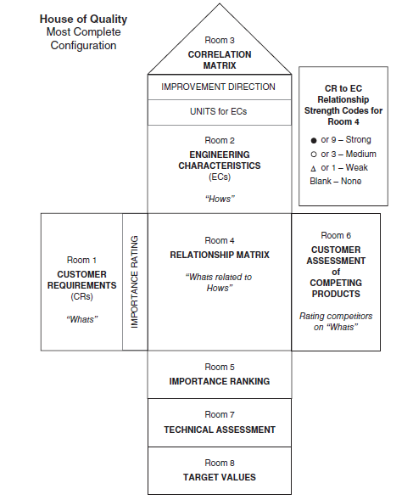
Figure 4 House of Quality Model
The three factors, ‘who’, ‘what’ and ‘why’, are entered into a grid named the ‘house of quality’ which is simply a quality table. The ‘whats’ are recorded in rows and the ‘hows’ are entered in columns.
The construction of the house begins with the customer requirements entered in ‘Room 1’, which are determined by methods such as questionnaires from customers carried out by the market research department. Following that, each customer requirement should be examined in terms of customer assessment, a group of customers should be asked how they perceive the performance of the company and its product. This block is placed on the far right, the other side of the central matrix. The ‘whats’ must now be translated into ‘hows’. These are called the engineering characteristics which is basically the voice of the process, they are placed on the top of the central matrix. Immediately below the central matrix are three rooms, they are named importance ranking, technical assessment and target values. The ranking will help the QFD team to discuss the efficiency of the engineering solutions. The technical assessments will analyse and compare the processes of the company with them of their competitors and the bottom room will display all of the companies target values. The central relationship matrix is the working core of the house of quality diagram. In this area the ‘whats’ and the ‘hows’ will be matched and each of the customer requirements will be evaluated against each development of the engineering characteristics. The type of relationships will be displayed by symbols in the matrix, these will clearly indicate whether the relationship is strong, negative, neutral or other. The roof of the house shows the nature of the relationship after each characteristic of the design requirements are complete. The symbols will be the same as in the central matrix.

Task 4

(a)
The results have been entered into a different table and new columns have been added.
The mean of the samples was calculated by adding all the sample sizes together and dividing that value by the number of samples taken.
The standard deviation was identified by using the formula below.
$$σ= \sqrt{\frac{\sum{(x_{i}-\overline{x})²}}{N}}$$

The sizes were then arranged into groups, tallied and entered into a table.

Figure 5 Machine Capability Results Table Figure 6 Tally Chart
The tallies from the table were then used to plot the results onto a histogram.
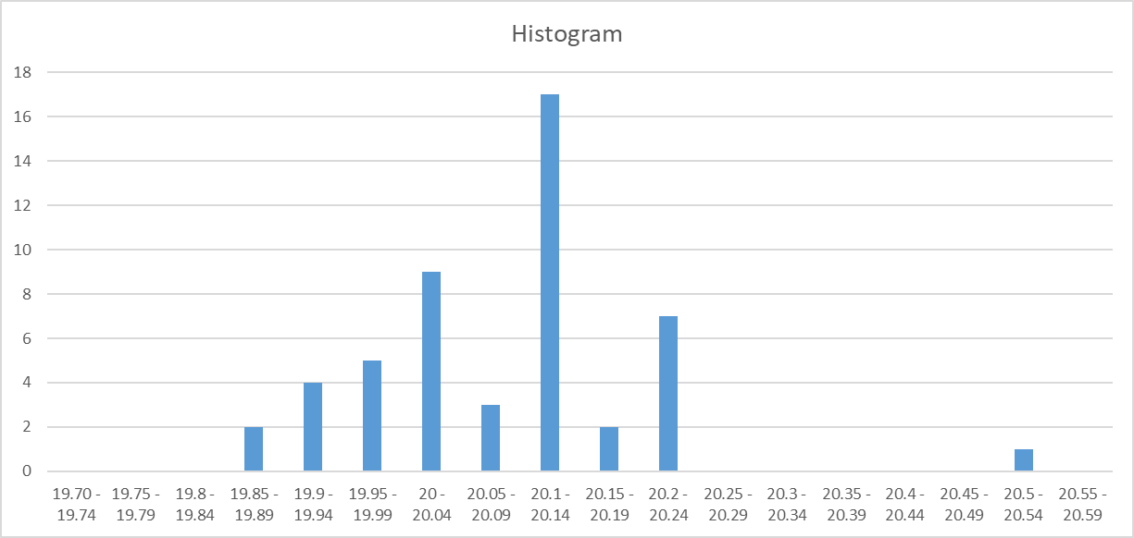
Figure 7 Tally Histogram
Ten sample sizes were taken from five different components therefore the average size and range was calculated for each component.
X1: Average = 20.127 mm Range = 0.26 mm
X2: Average = 20.047 mm Range = 0.17 mm
X3: Average = 20.149 mm Range = 0.53 mm
X4: Average = 20.043 mm Range = 0.21 mm
X5: Average = 19.993 mm Range = 0.34 mm

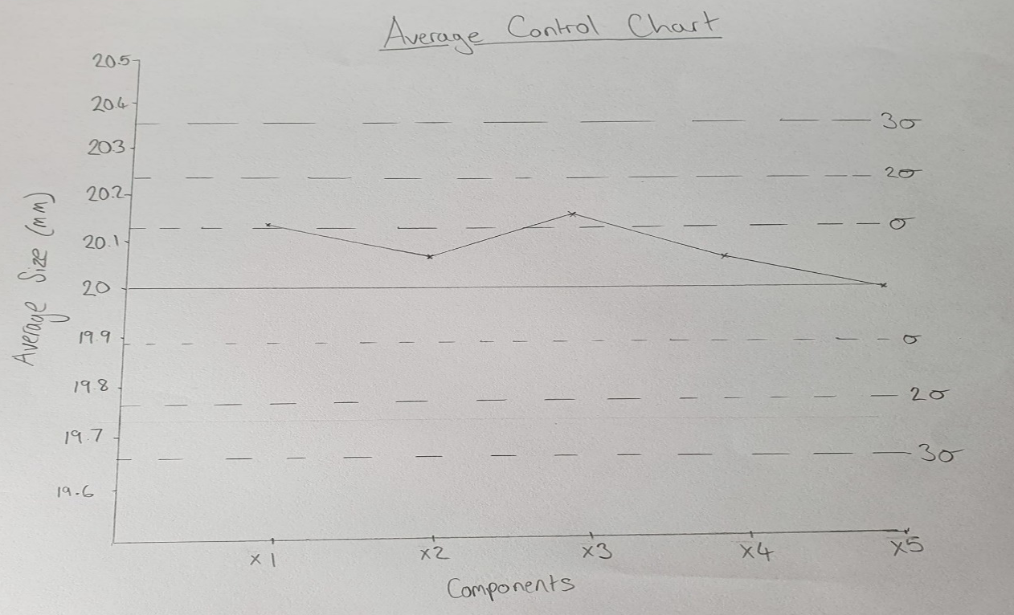
Average and range control charts were constructed with these figures.

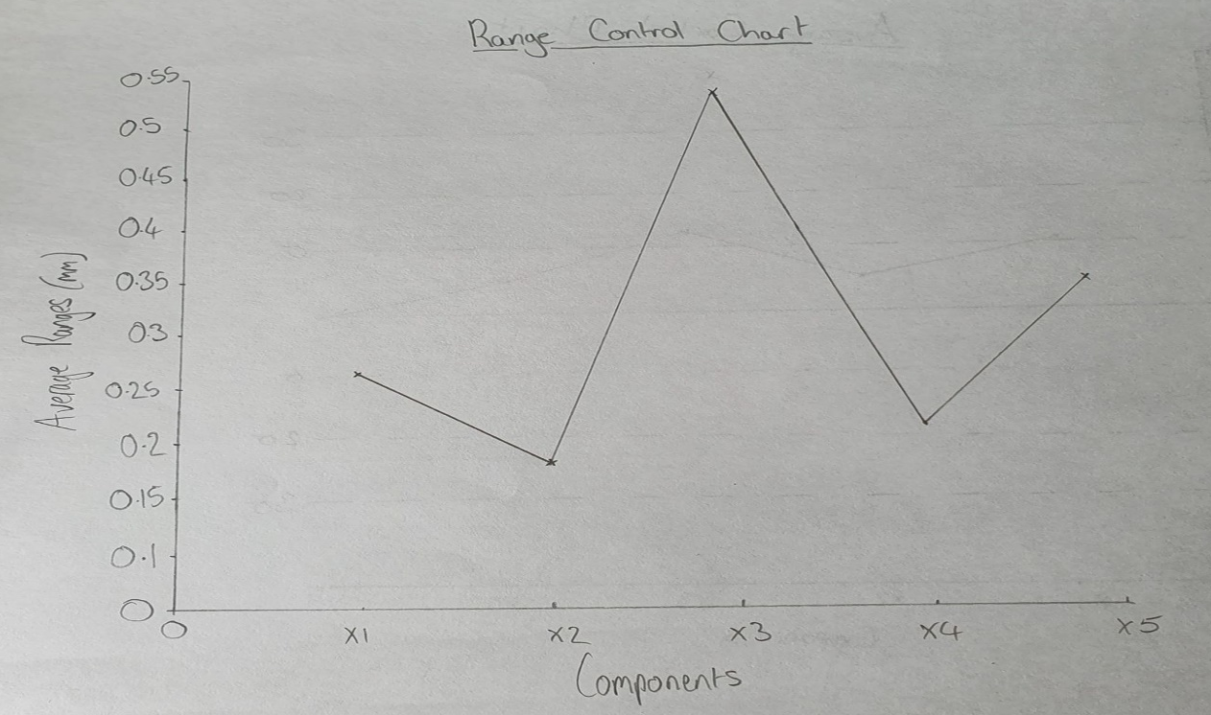
Figure 8 Average Control Chart

Figure 9 Range Control Chart

The formula to calculate the upper and lower control limits are shown below.
$$UCL=\overset{̿}{X}+A_{2}\overline{R}$$
$$LCL= \overset{̿}{X}-A_{2}\overline{R}$$
Before the author can use the formula, they must find $\overset{̿}{X},$ $\overline{R}$and $A_{2}$.
$\overset{̿}{X}$ is the mean of all the sample averages which is 20.07 and $\overline{R}$ is the mean of all the ranges which is 0.302.
$A_{2}$ is a constant which depends on the number of samples you have, in this case, there are five machined component samples therefore the number is 5. The constant can then be identified on the table below.
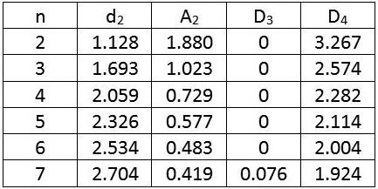
Figure 10 Table of Control Constants
The table clearly states that $A_{2}$ = 0.577
UCL and LCL can now be calculated.
$$UCL=20.07+0.577\left(0.302\right)=20.24 mm$$
$$LCL=20.07-0.577\left(0.302\right)=19.9 mm$$

(b)
Checks are made for special causes of variation on control charts by noticing various patterns in the results. A point beyond either control limit or several values in a row above average are a couple of these patterns detected. They are important to keep track of so that you may understand why something may have gone wrong. If a process is in statistical control, then this means that all the points are close to average. Parameters like standard deviation and mean are constant so the parameters that would need adjusting are factors such as materials and equipment.

(c)
$C_{p}=\frac{Tolerance Range}{6σ}= \frac{0.5}{0.692135}=0.722$
$$C_{pk}=\frac{USL-\overline{X}}{3σ}=\frac{0.42}{0.34607}=1.227$$

Figure 11 Calculation Results Table
The closer the value of $C_{p}$ is to 1 the more capable it is. This process was worked out at 0.722 which is approximately the absolute lowest $C_{p}$ required to deem a process suitable and would often not be enough to satisfy most customers. Generally, a $C_{pk}$ value of at least 1.33 is required and the higher the value is the better. The figure of 1.227 in this project would normally get rejected.

Task 5
Tuckman’s and Belbin’s Theories
Two of the most important team organisation theories are those of Belbin and Tuckman. Belbin’s theory describes team roles at work and Tuckman’s theory describes the stages of team progression. These theories increase the efficiency of work produced within a team. Tuckman’s theory originally only had four stages which are forming, storming, norming and performing. He later added a fifth stage named adjourning and transforming. The forming step involves establishing the teams, planning and collecting data. The next stage is storming, this step involves addressing the task ideas suggested by all team members. This stage can contain a lot of disagreement, so it is essential that it is tackled effectively. The third stage is called norming, as the team moves out of the storming phase ‘they move towards harmonious working practices with teams agreeing on the rules and values by which they will operate’ (Tuckman's Theory, 2020), by this stage the details would have been agreed upon and the team should be pulling in one direction with each member giving vital inputs. Not all teams survive up to the fourth stage, which is performing. This is the phase where the important work is carried out, all members working with high level of independence, motivation, knowledge and competence. The latest and final stage added by Tuckman is adjourning & transforming. This is the phase where the work is ending, and the group splits up. The majority of project members will leave the group sessions with fond memories of each other and may even request to work in the same teams again. This stage could also have a different outcome, for example if there is a change of team members or project goals then the team will have to revert to the forming phase.
Belbin’s theory focusses on the roles of each individual in a team project and the effects that team building exercises can have on the performance of those members. Belbin stated that ‘there are approximately nine main roles, a couple leaders, people who communicate and support others such as team workers, the doers, the innovator that produces most of the good ideas and an expert on the subject of the project to give a depth of knowledge’ (Mackechnie, 2020). The team building exercises can give the individuals experience with their new group members in the roles that they will be filling in the project in a fun and relaxed environment.

References
Porter's Five Forces. (2020, February 22). Retrieved from Investopedia: https://www.investopedia.com/terms/p/porter.asp
Roy, R. K. (2001). Design of Experiments Using the Taguchi Approach. Michigan: John Wiley & Sons.
SWOT Analysis. (2020, March 17). Retrieved from Mind Tools: https://www.mindtools.com/pages/article/newTMC_05.htm
What is a PESTEL analysis? (2020, March 17). Retrieved from Oxford: College of Marketing: https://blog.oxfordcollegeofmarketing.com/2016/06/30/pestel-analysis/

