Effective Teamwork and Communication

Contents
Introduction 3
Team Work and Work Place Communication 3
Team Formulation 4
Tuckman’s Team Development Stages 5
Roles of Team 5
Effective Communication 5
Models of Communication 6
Shannon and Weaver Model of Communication 6
Transactional Model of Communication 6
Communication and Employees performance 7
Conclusion 7
References 7

Introduction
In a recent trend, teamwork and effective communication is the key to organizational success. An effective and skilled team is a greater asset to the organization. When a company faces many problems in the business operation an effective team can help the organization to reduce the risk of business failure. On the other hand, effective communication is the mean that leverage the organization and team to go ahead of the organization. Communication in an organization needs to endure efficiency and to increase the overall productivity of the organization. Every employee in an organization also can be more productive if they can communicate up and down of the organization.

Team Work and Work Place Communication
In the modern economy, most organizations are becoming large and operating their business across the country. This assessment will discuss teamwork and effective communication that Unilever is practiced in the business operation. This organization has faced various ventures in the business operation (Stutzer, 2019). So the organization is going through those situations that force them to work with other people. From this situation, it has been found that teamwork is very important for the organization to ensure effective business operations. Teamwork is important for a successful project and well-being of the organization.
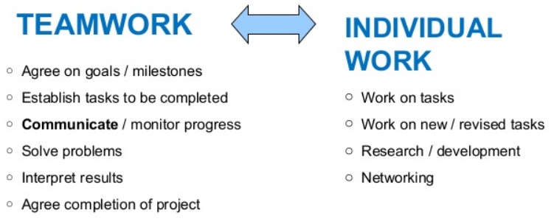
Figure: Different between Team Work and Individual Work
(Source: DiazGranados et al., 2017)

From the above figure, it is clear the teamwork is highly effective than individual works. This facilitates the organization to produce more good output than individual work that also increases the productivity of the organization and also ensures accuracy in decision making (DiazGranados et al, 2017). On the other hand, this team will be more effective if the organization also ensure effective communication and train up the employees to make knowledge sharing process more effective (Motschnig et al, 2016). This also helps the leader and manager to lead the organization properly. The communication also works in a workplace for planning, organizing, and controlling the organization.

Team Formulation
From May empirical research it has been found that teamwork is producing a better result than work individually. Unilever wants to make an effective team that helps them to perform better. But, the manager of Unilever is facing difficulties in to form of an effective team because it needs to perfume more complex tasks (Short et al, 2019). To make an effective team this organization considered many factors such as the capability of the performance, leading capability, and diversity of the organization. Many Theories help the organization to make an effective team. Tuckman’s group development process is discussed below.

Tuckman’s Team Development Stages
This is an effective model of the team making that will helps the organization to become more effective making an effective team for the organization. In this process, the setting of the team divided into five stages that need to make an effective team (Jones, 2019). The five stages are discussed below.

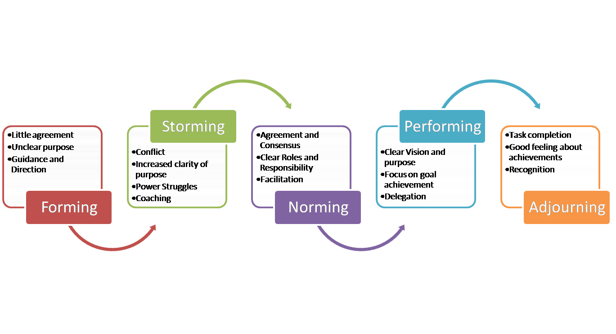
Figure: Tuckman’s Group Development Stages
(Source: Jones, 2019)
Forming
This is the first phase of the team development process where team members can be positive, polite, and anxious and they fail to understand the intention of the organization that the group will do. So in this stage, the leader will dominate the group because the team members are not sure about the activities and roles of them.
Storming
This is a difficult stage for every team because most of the team fails in this stage. This stage is started because members face several conflicts in this stage about their natural working style. During work indifference, process team members can face unwanted situations that can make frustration in the employees (Stratton and Tan, 2019). The organization provides proper support to the team members that strongly dedicated to tasks given to reduce their frustration.
Norming
In the third stage the employees able to understand the difference, cooperate admire colleague strengths, and respect leaders. In this stage team members know each other well and feel free to communicate with each other that helps them to be more effective in the business process. They provide better feedback to the upper level that helps them to make the right decision.

Performing
The team reaches in the performing stage where the team members involve hard working to achieve well-being of the organization and the process structured is effective to reach the goal of the organization (Jovanović et al, 2016). In this stage leader of the organization provide more concentration to the organization to become more effective in the business operation. There are tools for example, KPIs (Key Performance Indicators) that can be used by the leaders to ensure higher performance of the employees within the group.
Adjourning
This is the stage where the team is adjoined. In the case of a project, a team reaches in this stage after finishing the project period and in the case of organization and team can reach in this stage if the organization restructured its business. Team members become frustrating at this stage because they can see the uncertainty in the business operation.

Roles of Team
There are many members of a team who play many responsibilities to reach the goal of the organization. This is necessary for the team to accomplish all the tasks effectively in the business operation (Black et al, 2019). There are many teams in Unilever that play a particular role in the business operation.
Executive bodies: They are responsible for controlling and all the business issues and will take all the decisions of the business. They also work with all the teams to ensure effective communication and synergy.
R & H team: These team members are responsible to collect all the necessary information about the current trend in the market. This information helps the organization to become more innovative in business operations. Unilever conducts continuous customer research that helps them to make such a product that adapts to customer needs
Production and operation team: This team in the organization is responsible to convert ray materials into products that will ensure quality and value for the organization. This team takes all the necessary information from the research team and makes an effective product from the customer.
Sales and Marketing Team: Sales and marketing also help an organization to sell the final product to the customer (Huang et al, 2017). This team responsible for creating effective marketing strategies that help the company to sell more products in the market they also ensure an effective pricing system for the organization.

Effective Communication
Unilever thinks about communication more than merely sharing information. It believes that effective communication is the proper understanding of intention and emotion of the information shared. In the team working the employees not only will able to share information but also they need to be a good listener in the way that gains full meaning of the information about business issues (Ruch et al, 2018). Unilever uses very effective communication means and models to share information. This organization also adopted all the communication platforms of the organization that they can easily use this means when they need to work well about a particular business problem.

Models of Communication

Shannon and Weaver Model of Communication


Figure: Communication Model of Shannon and Weaver
(Source: Gillespie and Schiffman, 2018)
This model is very effective for making communication between senders and receivers. This process also considers all the factors that limit the level of communication like noise. This model made form improve technical communication and Unilever use this model to provide clear information to the receivers. Above figure shows the main four part of the communication that helps the organization to make an effective message and send it to the right person at the right time (Gillespie and Schiffman, 2018). There is also a feedback system in the communication that will help the organization to become more effective to solve any problem in the communication process. They also can help the organization to become more effective and get the necessary information from customers and supervisors. They can design their product according to the customer feedback that helps the organization to make different products and add value to the product.

Transactional Model of Communication
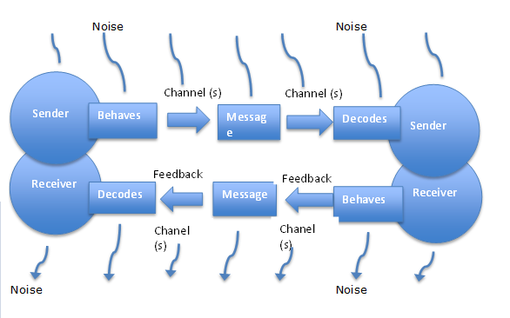
Figure: Transactional Model of Communication
(Source: Barnlund, 2008)

This is also a communication message that will help the organization to communicate between sender and receivers. This is a two-way communication process that helps the organization to send and receive messages at the same time. Both the parties in the communication process is the communicators of the communication process. In this process, both humans and machines can be parties of communication (Barnlund, 2008). Unilever mostly uses this model for interpersonal communication and also called the circular model of communication.
There are many factors, directly and indirectly, that affect the communication process of the organization. This can be noise and other limitation of the communication. There are mainly three types of environmental noise such as physical, psychological nose, and so on. This model also ensures the social reality of the society that helps the organization to become more effective in the business operation (Sriyothin, 2016). The response from the parties can be predicted because that also has different intention and history.

Communication and Employees performance
Unilever can use different means of communication that will help the organization to increase employee’s performance. The First uses of technology in the communication process help and organization to adopt effective means of communication that will increase the performance of the employees and cut costs from the communication process. This organization uses the internet and artificial intelligence that helps the organization ensure automation in the business process.
Up against world communication also needed for the organization because the bottom line employees directly interact with the customers they have actual knowledge about the information of the customer tests and needs. This also helps the employees to perform well in the business operation (Sadia et al, 2016). Two-way communications also increase the interpersonal skill of the organization to become more effective in the business process (Logan et al, 2018). If the employees can share information about each other concurrently this will helps them to become more effective to take any right decision. Two-way communications also save much time from the business process because employees can get and send immediate feedback for any issues.

Conclusion
From the above discussion, it can be said that Unilever practices teamwork processes in the business operation that helps this organization to reduce costs and risks from the business operation. This also helps to become more innovative and develop new ideas for the organization. This organization also ensures effective and tow way communication in the workplace that also facilitates them to become effective in decision making regarding any particular issues in the business operation. In short, two-way communication and participative management are the key issues that help the organization to be more productive and efficient.

References
Barnlund, D.C., 2008. A transactional model of communication. Communication theory, 2, pp.47-57.
Black, S., Gardner, D.G., Pierce, J.L. and Steers, R., 2019. Team Development Over Time. Organizational Behavior.
DiazGranados, D., Shuffler, M.L., Wingate, J.A. and Salas, E., 2017. Team development interventions. The Wiley Blackwell handbook of the psychology of team working and collaborative processes, pp.555-586.
Gillespie, D.J. and Schiffman, R., 2018. A critique of the Shannon-Weaver theory of communication and its implications for nursing. Research and theory for nursing practice, 32(2), pp.216-225.
Huang, C.Y., Huang, J.C. and Chang, Y., 2017. Team goal orientation composition, team efficacy, and team performance: The separate roles of team leader and members. Journal of Management & Organization, 44, pp.1-19.
Jones, D., 2019. The Tuckman’s Model Implementation, Effect, and Analysis & the New Development of Jones LSI Model on a Small Group. Journal of Management, 6(4).
Jovanović, M., Mesquida, A.L., Radaković, N. and Mas, A., 2016. Agile retrospective games for different team development phases. Journal of Universal Computer Science, 22(12), pp.1489-1508.
Logan, T.R. and Michael Malone, D., 2018. Nurses’ perceptions of teamwork and workplace bullying. Journal of nursing management, 26(4), pp.411-419.
Motschnig, R., Ryback, D. and Motschnig, 2016. Transforming Communication in Leadership and Teamwork. Springer.
Ruch, W., Gander, F., Platt, T. and Hofmann, J., 2018. Team roles: Their relationships to character strengths and job satisfaction. The Journal of Positive Psychology, 13(2), pp.190-199.
Sadia, A., Salleh, B.M., Kadir, Z.A. and Sanif, S., 2016. The relationship between organizational communication and employees productivity with new dimensions of effective communication flow. Journal of business and social review in emerging economies, 2(2), pp.93-100.
Short, V., Covey, J.A., Webster, L.A., Wadman, R., Reilly, J., Hay-Gibson, N. and Stain, H.J., 2019. Considering the team in team formulation: a systematic review. Mental Health Review Journal.
Sriyothin, S., 2016. Influence of internal communication on employees’ brand outcomes (Doctoral dissertation, The University of Salford).
Stratton, R. and Tan, R., 2019. Cognitive analytic team formulation: learning and challenges for multidisciplinary inpatient staff. Mental Health Review Journal.
Stutzer, K., 2019. Generational differences and multigenerational teamwork. Critical care nurse, 39(1), pp.78-81.

