Change Management Portfolio

Leading and Implementing Workplace Change

Bmsw6103
Professor Dennis Pepple

By
Nazia Choudhury
Student 1817657

Contents
INTRODUCTION 3
1. CRITICAL EVALUATE HOW POWER IS MANIFESTED IN ORGANISATION CONTEXT TAKING INTO CONSIDERATION THE ROLE OF CULTURE 4
1.1 Types of power: 4
1.2 What is culture? 5
2. REFLECTING ON ANY WORKPLACE CONFLICT OVER THE LAST 12 MONTHS, IDENTIFY THE CAUSE OF THE CONFLICT AND CRITICALLY DISCUSS A CHANGE MANAGEMENT THEORY ASSOCIATED WITH THE CONFLICT 7
2.1 LEWINS 3-STEP THEORY: 8
2.2 LIMITATIONS OF LEWINS 3-STEP THEORY 10
3. REFLECTING ON TING-TOOMEY (1999) CONFLICT RESOLUTION MODEL, CRITICALLY EVALUATE THE DIFFERENT CONFLICT RESOLUTION APPROACHES AND SUGGEST THE APPROPRIATE APPROACH FOR RESOLVING THE CONFLICT 10
3.1 Organisational Conflict 11
3.3 Dispute resolution: 13
3.4 Limitations of Ting-Toomeys theory: 14
3.5 Dealing with conflicts: The Thomas- Kilmann way 14
3.6 Advantages VS limitations of Thomas Kilmann model 15
3.7 Crown Post Office Conflict Resolution- The compromise way 15
4: Conclusion: 16
REFERENCES 16

INTRODUCTION

This report will look at the impact of power and culture at Crown Post Office organisation particularly in terms of management and leadership. power struggles within organizations can create conflicts and is a significant factor that can affect an organization's operations.
To explore these issues, the report will analyse a case study of the Crown Post Office conflict, which resulted in a dispute leading to employees going on strike to demanding a pay rise in line with inflation and influencing other Post Office employees. The report will investigate the types of power employed by both parties, namely the management and the employees. The report will also consider how work culture can impact the style of organizational conflict and identify conflict resolution techniques like Ting-Toomey theory that could be utilized to settle disputes effectively and use Lewins 3-Step theory to implement change.

1. CRITICAL EVALUATE HOW POWER IS MANIFESTED IN ORGANISATION CONTEXT TAKING INTO CONSIDERATION THE ROLE OF CULTURE

The following section aims to analyse the role of power and culture in organizational contexts. In associations, power is crucial for managing the activities of individuals and groups. Individuals use their power to fulfil their needs, while organizations use power to control their members and employees to achieve their goals.
Power is interpreted through the control or influence of people’s behaviour. It is also the medium through which conflicts are resolved, therefore a person would need to become influential in the organisation to have power, ie this can be seen through power struggles between departments. Too much power in amongst few people with little accountability is not a good thing (Godlee, 1994).
Olivié and Pérez (2019) state that power is the ability to influence behaviour, redirect events, overcome resistance, and persuade individuals to do things they wouldn’t usually do. This power is measured by the extent to which a manager can leverage their influence to achieve desired outcomes. It is not inherently good or bad but rather a reflection of the nature of the relationship between the manager and other stakeholders.

1.1 Types of power:
Heap, Black, and Rodgers (2022) state that there are five types of power in an organizational setting.
The first type is formal power, which depends on a person's position in the company and is divided into three subtypes: reward power, coercive power, and legitimate power. The second type is informal or personal power, which stems from a person's exceptional qualities or knowledge and has three subtypes: referent power, expert power, and information power.
In this instance the management at Crown Post Office is using coercive power to enforce a pay freeze (Lunenburg, 2012). Coercive power involves using threats to compel compliance from those being influenced and can be expressed through social, spiritual, physical, political, or economic means. As this is an industrial conflict; third parties are used like the CWU union. The employees use their formal power, represented by the Communication Workers Union (CWU), to fight for their rights and utilizing informal power (Maliwanag, 2019) as it is only 114 out of 11,000 branches striking that are trying to sway public opinion and get sympathy to pressure the Post Office management and ruin their image to agree to a pay rise that matches the increase in the cost of living instead of the original 2% they offered (Timmins, 2022).
The Post Office management's legitimate power arises from being directly owned by the company. The strike will have significant effects on the Post Office, including negative impacts on the local economy, businesses, and workers. It can also strain business relationships, lead to production and economic losses, and damage consumer confidence (Adensamer, Gsenger, and Klausner, 2021).

1.2 What is culture?

Culture also affects power as it affects how different parties approach power and how power is perceived. Culture affects how people behave as it is the shared values, goals and beliefs that effect organisations and employees’ actions and behaviour (Coe et al, 2019).
Some of the main influences of organisational behaviour which effects the output are:
• Organisation climate
• Organisation culture
• Motivation
• Group norms
• External influences
• Management style
• Organisation structure
• Processes

Geert Hofstede developed a theory in 1980 called Hofstede’ cultural dimension which consisted of 4 dimensions that looked at the differences in cultural communication and could analyse the values of each culture through individualism/collectivism, masculinity / feminity, uncertainty avoidance and power distance (Hofstede, 2003). Power distance examines how society yield to the hierarchy of power in their country (see table below). For example, countries like the UK and US are low in their acceptance of unequal power distribution. This is true of the employees at Crown Post Office which is why they are fighting for better pay.

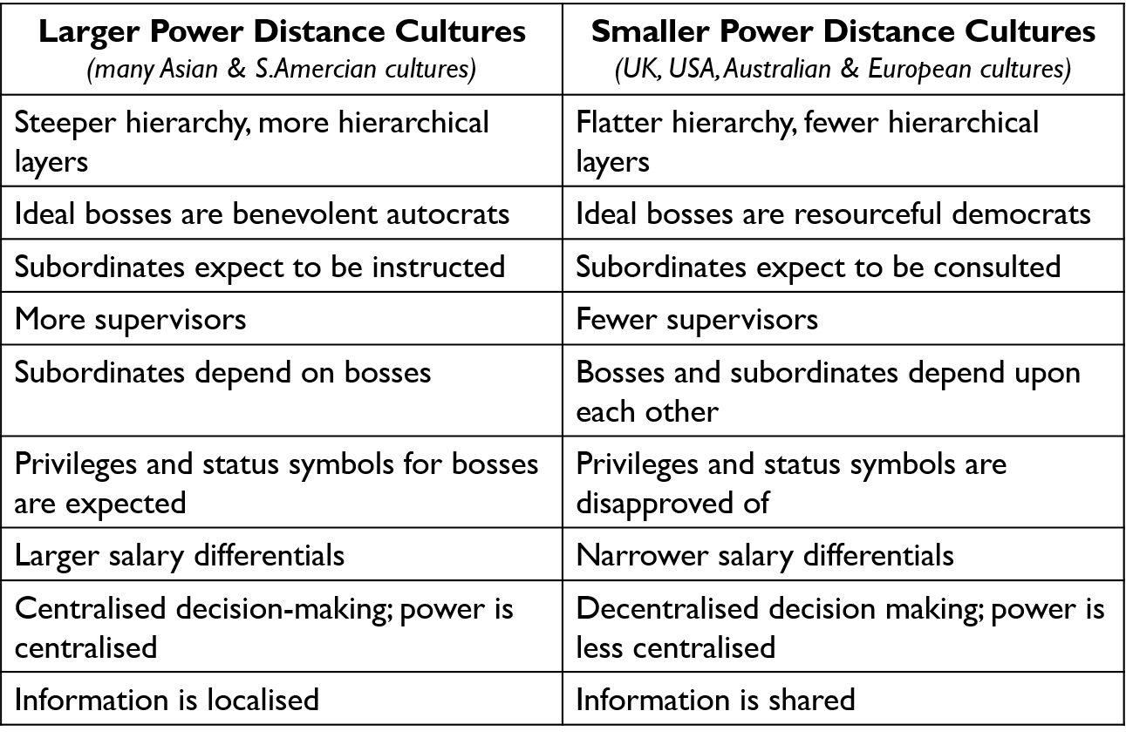
According to Xenikou and Simosi (2006) Cultures differ in how they assign organisational power and status:
Ascription-orientation: Power and status are ascribed according to who a person is, for example, on the basis of age, gender, education or connections.
Achievement-orientation: Power and status are awarded on what people achieve i.e., their knowledge and performance.
In some cultures, power is a big deal therefore there are more hierarchal positions. CEO’s have more power in these type of tall structure cultures, whereas in a flat structure cultures colleagues are seen as equal, therefore the power is less. Cultural structure is important in an organisation as it effects decision making and the overall success and sustainability of the organisation (Manatje and Martins, 2009).
However, there are limitations to Hofstedes theory as stated by Baskerville (2003) who states that this theory is an oversimplified approach and ‘assumes a single static culture’. There can also be sub cultures within cultures and organisations which he does not take into account.
According to Mayer and Louw (2012), conflicts can arise in a culturally diverse workplace when individuals or groups have competing perceptions about power, resources, and similarity. The UK's individualistic work culture plays a significant role in the Crown Post Office work environment, and the employees who are striking take advantage of this culture. In the UK’s individualist the work culture; personal achievement and recognition are highly valued, and competition is the fuel of success (Assmann and Ehrl, 2021). Some may argue that, with or without unions, the employees would still unite and go on strike to get their voices heard, which justifies the unitarist perspective of the Post Office management (Kaufman et al., 2021). However, it may be that the employees are leveraging the benefits of the UK's low-context culture (Nishimura et al., 2008) to achieve their goals for the organisation. In low-context societies, like the US and most Northern European countries, people tend to be direct when communicating and prioritize fulfilling individual needs (Lamb, Cai, and McKenna, 2020). Therefore, the management at Crown Post Office must initiate negotiations with the employees to resolve this serious dispute, in line with the British culture of communication.
In order to enable effective leadership and management, Organisations need to develop good organizational structures and cultures (Tran, 2021).
Leadership development approaches concentrate on recognising and developing people that exhibit truthfulness, integrity and high morals, and use these characteristics to lead people (Akanji et al, 2020).
Organisations can train people to develop leadership skills through training, development and experience. However, some organisations prefer to place people in managerial roles based on their technical abilities rather that their actual leadership skills so they would need formal and informal support to enable them to become good leaders. This can be done through formal training programmes, coaching and mentoring, job rotation, networking, etc.
According to (Cacciattolo, 2014) even when organisations have good leaders in place their leadership behaviour is affected by factors in organisations like hierarchical structures, management policies and practices and performance management systems. However, these organisational factors like a) Hierarchy and bureaucracy weaken the power of leaders (Al-Tameemi and Alshawi, 2014), b) pressure and focus to achieve short-term goals impede achieving quality, c) Individualism in reward and culpability impede collective working as a team and creates apathy, d) ‘Us’ and ‘them’ attitude hinders the advantages of organisational diversity (Wilcoxson and Millett, 2000).

2. REFLECTING ON ANY WORKPLACE CONFLICT OVER THE LAST 12 MONTHS, IDENTIFY THE CAUSE OF THE CONFLICT AND CRITICALLY DISCUSS A CHANGE MANAGEMENT THEORY ASSOCIATED WITH THE CONFLICT

According to CWU.org (2022) Since May 2022, 1,400 post office workers in 114 branches owned by the Government have been striking to increase their pay to align with inflation. Although the other 11,500 branches are not striking, the supply chain and admin staff have involved their union CWU in response to the pay freeze of 2021/22 financial year by the Crown Post Office. Initially they were offered 2% and a £250 lump sum. This was later increased to 3% and £500 lumpsum. After further strikes and conflict it was again increased to only 5%
The management of the 114 branches of the Crown Post Office is the main cause of the current problem as they are more focused on power play. The issue is not affordability, as the Post Office has turned over huge profits of £39 million in 2021/22 with managers receiving bonuses of £2million, according to the Union assistant secretary Andy Furey. The employees were the reason for these profits, especially during the pandemic, when they showed dedication and risked their health to keep the organisation running. However, the management is ignoring this fact and only offering a 5% pay rise and a one-off payment of £500, which is insufficient considering the 12% economic inflation.
The employees are using their power in a different way by striking and using the CWU to pressure the management to meet their demands for a pay increase
Organisations needs to be agile and adapt to change (By, 2005). In the case of crown post office this is the dissatisfaction of employees’ wages not rising with inflation. Depending on the situation there are different approaches that can be used.
Classical theorists of the early 1900’s used a scientific management approach to managing people like Max Weber’s Bureaucracy who looked at how organisations should have clear Structural design, Formal systems, hierarchy and rules to run effectively (Greenwood and Lawrence, 2005).
But the humanistic approaches of the mid 1900’s criticised the scientific approach as it was seen to be too Mechanistic, too concerned with tasks and people were seen as machine parts.
Human relations schools of thought like Elton Mayo focused more on factors like informal systems, group relations, meshing of informal with formal systems and had more of a unitary perspective. Mayo suggested that employees were more productive and worked towards organisational goals when they were recognised and satisfied (Bruce and Nyland, 2011).
Criticism of the earlier approaches:
Systems approach: does not examine the individual and their orientation to work
Human relation approach: generalised theories and suggests that all individuals have common needs
At Crown Post Office the position of the management is of a more scientific management way of thinking of putting structures in place instead of looking at the human needs. Their response is not for the benefit of the employees and what is best for them but they would rather cut down on jobs and pay ie through automation, for them this is more cost efficient and will improve productivity and reduce costs. They think with the right structure people will improve their performance and will do their work well if they are paid well. However, employees don’t just want good structure they want a caring organisation, they want more appreciation of their work and better management relationships (Hoogervorst et al, 2004) this is a social technical theory which highlights on the relationship between the social and psychological requirements of individuals and its structural and technological requirements; organisations need to do more; people must be considered as an equal investment along with technology (Appelbaum, 1997).
So organisational change is needed. The process of organizational change and development is a gradual process: not a static or time restricted. It can be triggered by both external (e.g., PESTEL) and internal factors (e.g., new services and products, new suppliers, new leaders).
This can be done by Planned Change where importance is place on leadership to take action which is seen as the driving force to bring about organizational change. This can be done through Lewin’s 3-Step model.

2.1 LEWINS 3-STEP THEORY:
Lewin’s 3-step theory was developed by Kurt Lewin; a psychologist born in 1890. He Completed his doctoral studies from the University of Berlin and Moved to the US in 1933. There he founded the “Lewin’s Three-Step Model” of Change (Burnes 2020):
- Lewin states that change is achieved through examining all available options to effectively move the organisation from the present state to the desired state
- The possibilities of each route must therefore be carefully analysed before being adopted or abandoned.
- It is unwise to just evaluate the desired future state and adopt the easiest route possible as the easiest route may not necessarily be the best route.

Two kinds of resistance to change – one is from social behaviours and customs and the other is from creation of an inner resistance to change (Harzing and Hofstede, 1996).
Usually employees prefer to keep to their customs and behaviours and increase their resistance to change when they have to move away from their current values.
Resistance can be lowered if management works to reduce the value the employees attach to something or changing their values.

Step 1: unfreeze
This is the first stage in Lewin’s change management process.
During this stage, a way must be found to ensure that employees can let go of any old behaviours that were counterproductive.
The process of finding this must be interactive, transparent and inclusive (Sarayreh et al, 2013).
This is the stage where desire for change can be initiated and implemented.
Individuals will experience and learn from other productive views and in a sense begin to adapt their own views (from counterproductive to productive).
Step 2: change
The stage where the change takes place and feelings of apprehension, transformation and confusion are felt.
Individuals need to adapt to changes in the old processes with a positive mindset and behaviour, to become more productive and the change to be more effective whilst being made fully aware of what is happening to ensure organisational efficiency (Lacey, 1995).
During this stage, the organisation needs to layout clear goals with a gradual change process.
The structure responsible for managing change needs to be developed at this stage and communication between this structure and the employees need to be as transparent.
Step 3: refreeze
During this stage, the changes made are acknowledged as the new standard or status quo.
the refreezing step is essential to ensure that individuals do not change back to the old processes before the implemented change (Hussain et al, 2018).
Leadership must ensure that change is made permanent to the organization's culture and upheld as the new way.
At Crowne Post Office this 3-step process can be used effectively:

FREEZE:
Restraining factors: union, HR policies, inflation
Driving forces: wages / production levels, customer demands

CHANGE:
Reduce hours and keep same pay or give the 5% pay increase but also give a one-time payment of £1000 as bonus which would be continuous to support inflation.

REFREEZE:
Keep watching and monitoring. Can do yearly appraisals to monitor.

2.2 LIMITATIONS OF LEWINS 3-STEP THEORY
Limitations: critically this model is too basic and can be ambiguous. it assumes a linear progression for change and assumes all organisations are the same (Adams and McNicholas, 2007).
However, the advantages of this model is the simplicity allows for it to be applied easily, this is especially useful for small organisations who do not have large resources.

3. REFLECTING ON TING-TOOMEY (1999) CONFLICT RESOLUTION MODEL, CRITICALLY EVALUATE THE DIFFERENT CONFLICT RESOLUTION APPROACHES AND SUGGEST THE APPROPRIATE APPROACH FOR RESOLVING THE CONFLICT

Meyer et al. (2007) suggested that there are a limited number of conflict perspectives that can be observed within organizational environments, including:
• Unitarist perspective: This perspective believes that unions are not necessary in the workplace, as they complicate the situation.
• Pluralist perspective: This perspective assumes that within an organization, there are groups with their own interests, points of view, and authority. These groups frequently conflict with each other and require management.
• Interactionist perspective: This perspective views conflict as a positive effect within a group and asserts that a level of conflict is required for them to function successfully.
• Radical perspective: This perspective considers conflict to be an inevitable aspect of capitalism and endemic in an organization structured around management. It is expressed in terms of power and control, and it is seen as a feature of the conflicting nature of organizational life.

Applying these perspectives to the Crown Post Office case study, the organization's conflict perspective appears to be unitarist, as evidenced by the management's belief that unions are unnecessary and can create a misplaced focus for employees. This attitude has led to inter-group conflict, which involves conflict between opposing forces over goals or shared resources. The strike that occurred due to the pay freeze and the management's refusal to negotiate reflects the clash of power between employees and management, and the employees' decision to strike was a means of demonstrating to the public the unfair treatment they were receiving from the management. According to the CWU, the current salary of less than £24,000 per year is insufficient to keep up with the 12% inflation rate.

3.1 Organisational Conflict

Ting-Toomey states that different cultures handle conflict with different behaviours. She came up with her Face-Negotiation Theory to show how people have different faces which is their self-image which they try to uphold when faced with conflict depending on the type of culture they come from (Oetzel, Garcia and Ting-Toomey, 2008).
Most commonly organisational conflict tends to stem from the variances between Individual and Group orientation cultures (Tng-Toomey, 2010):
- In Individualistic cultures, people tend to recognize the source of conflict as being personal. They believe that resolution can be realised through concentrating on outcomes that will satisfy the individuals as much as possible.
- In Group-oriented collectivist cultures, people see restraint of personal emotions as crucial to protecting face and sustaining long-term relationships. This is seen as more important than achieving specific goals in the resolution of conflict. They may also feel it is important to protecting the face of others in the group as well as their own.

The table below shows the different behaviours associated with different cultures in their assumptions about conflict:

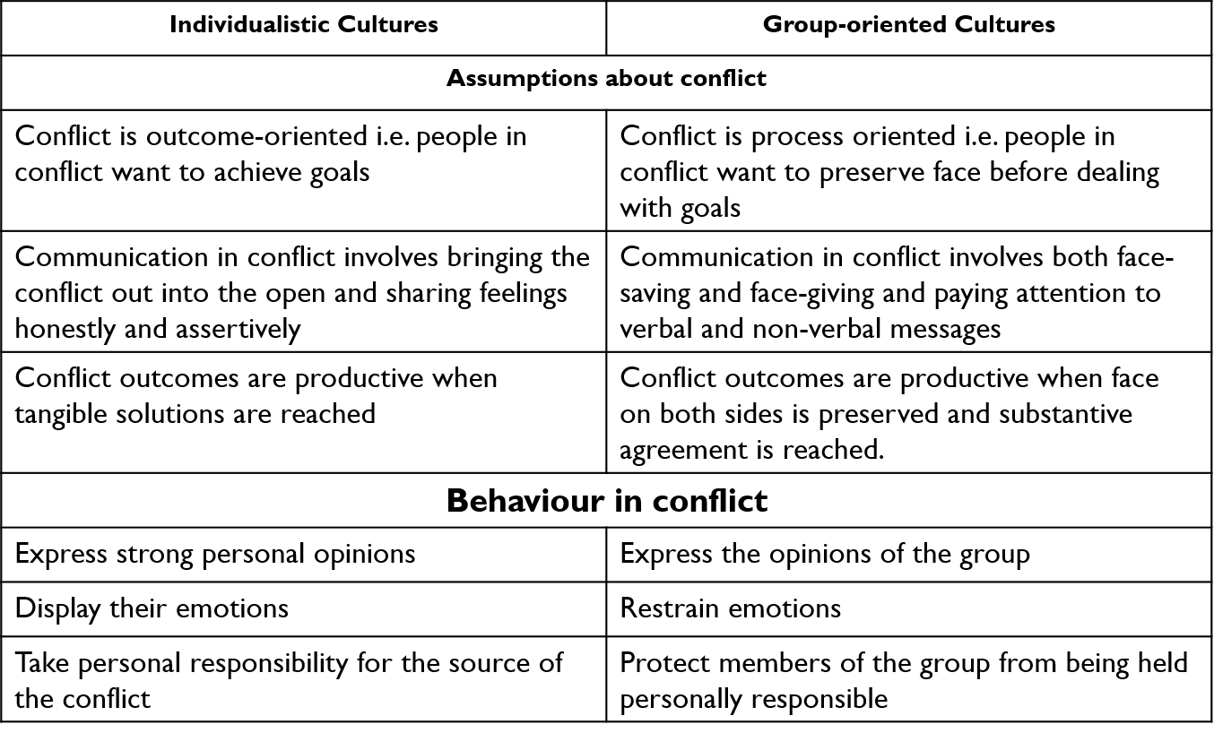

As discussed in Hofstede’s theory and based on the above table we can see that the UK is an individualist culture as they have strong personal opinions and display their emotions especially at the Crown Post Office where the employees are speaking up and fighting for their pay rise. However, as the conflict has gone to strike this has meant that the Post Office has lost face and with the public as they have not tried to resolve the conflict satisfactorily to the employees. The conflict has been bought out into the open and feeling of the employees have been shared assertively by going to strike in order to achieve their goal of better pay.

Ting Toomey theory then suggests different approaches which give solutions to save face and resolve the conflict depending on the type of culture as seen in the table below:

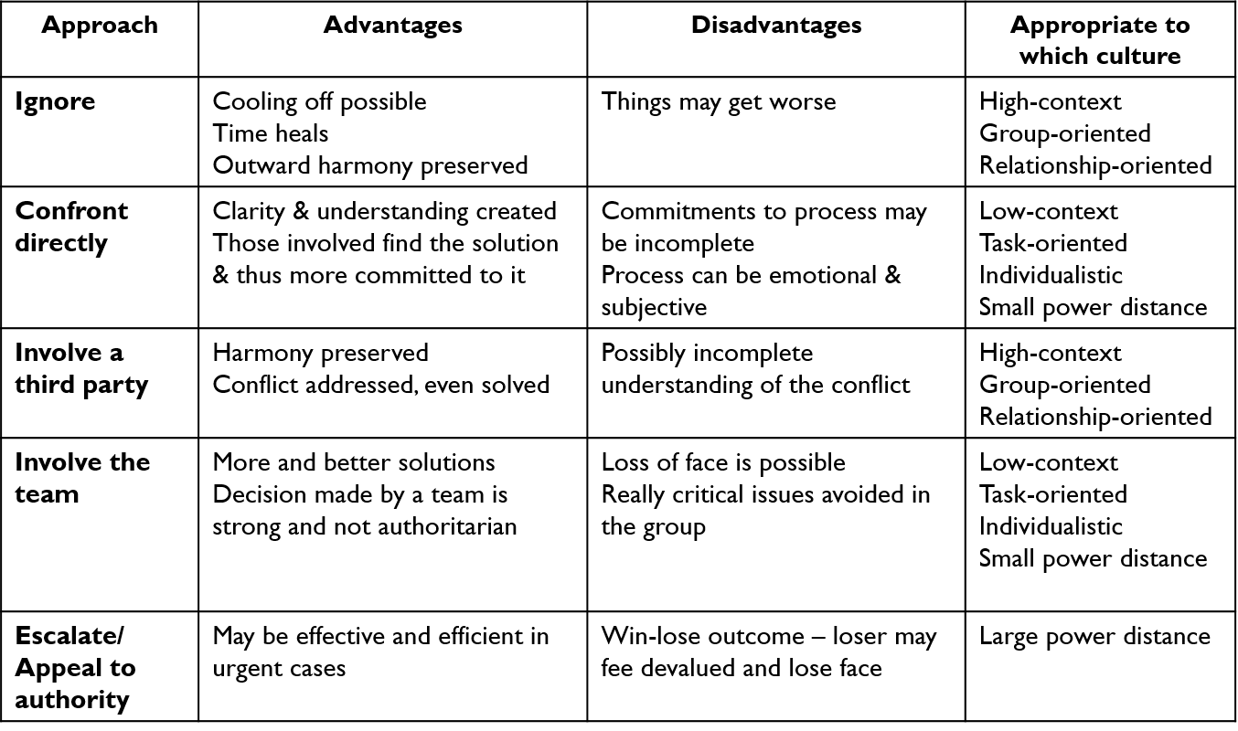

From this table we can see that the UK is a low context / high individualist culture so confrontation is currently taking place in this conflict between the employees and management with the unions being ignored. The problem here is that that escalation is taking place due to the UK culture being confrontational and the employees are being assertive and demanding a pay rise. The employees have decided the best approach for them is to involve a third party which is their union CWU the advantages of which is to keep the harmony, address the conflict on their behalf and negotiate a better pay in accordance with inflation. However, the disadvantage of this according to Ting-Toomey is that it could lead to incomplete understanding of the conflict, which seems to be the case for the employees as the strikes are still ongoing and no resolution has been reached as yet with more strikes forecasted. This could be as this approach is normally for High context, group-orientated and relationship cultures which the Post Office is not. An alternative approach like ‘Involving the team’ which has the advantage of more and better solutions and the decision is made by a team rather than being authoritarian and the decision is being made by the Government as is the case for the Post Office as the 114 workers who are striking are the few Post Offices’ that are still owned by the Government. If these post offices were privately owned the management could negotiate better pay rise but they are unable to negotiate anything above 2.5% due to the Government’s cap. The Government knows that other public sectors would go to strike too if they give in to these employees and agree which is why they are not budging. Another problem for the employees is that as power is in favour of the government, the post office strike isn’t well known and as the government control the media they would be biased towards the government. The disadvantage with the involve the team approach is that loss of face is possible and really critical issues can be avoided in the group.

3.3 Dispute resolution:
Organizational dispute resolution refers to the process of resolving conflicts or disagreements among different groups (Takupiwa and Shelfa, 2019). It can be used as an alternative to going to court. In the Crown Post Office, dispute resolution can involve several phases to reach a resolution before resorting to legal action. The negotiation stage involves discussions between the management and employees to resolve the issue at hand. If negotiation fails, the unions can step in as a mediator during the bargaining stage. Mediation involves using a neutral third party to negotiate a resolution agreeable to both sides. Conciliation and arbitration are other methods that can be used to resolve disputes.
In the case of the Post Office, the negotiation stage has already passed, and the unions are involved in the bargaining stage, with employees going on strike. However, there is still time to resolve the dispute collaboratively by involving the HR manager/s and reaching a solution through conciliation. It is essential to avoid going to the Tribunal or Fair Employment stage, as it can lead to significant financial and moral damage. Therefore, it is better for both to find a solution through dispute resolution before it escalates further and reaches a dead end.
Although the UK culture is assertive the approaching shouldn’t be argumentative in resolving the conflict, although confronting isn’t bad, the environment and situation should be understood and approached carefully, i.e. not publicly or being confrontational. The current situation should be understood and positions clarified. The situation cannot be ignored and trust is important so they need to work together as a team to come up with a conflict resolution.
Conflict resolution is the method through which an agreeable solution is found to solve a disagreement. In organisations, conflict can arise in various forms, including disputes between colleagues or between managers and employees (Wallensteen, 2018).
The resolution in this case could be as mentioned when discussing Lewins 3 step theory to either reduce working hours and keep the same pay or give the 5% pay increase but also give a one-time payment of £1000 as bonus which would be continuous to support inflation.

3.4 Limitations of Ting-Toomeys theory:
This theory does not take into account that cultures in countries do change with each generation and not all people in one culture are the same.

3.5 Dealing with conflicts: The Thomas- Kilmann way

In accordance with Schaubhut's (2007) model, conflict is defined as a situation in which individuals have opposing interests. If two or more parties care about things that are incompatible with one another, conflict arises. The Thomas-Kilmann conflict mode (Thomas, 2008) is an alternative model that can be used to resolve the conflict. It offers five different styles for managing conflicts: avoiding, collaborating, competing, compromising, and accommodating.
The Thomas-Kilmann conflict mode (Thomas, 2008) identifies five different styles of conflict management. These are:
- Avoiding: This style involves avoiding the conflict altogether and delaying resolution. It is characterized by low assertiveness and low cooperativeness, and often leads to an unsuccessful outcome.
- Collaborating: This style is highly assertive and cooperative, and focuses on finding a "win-win" solution that satisfies both parties. It encourages teamwork and collaboration, and can help maintain positive relationships.
- Competing: This style prioritizes an individual's own interests over others, and is highly assertive with minimal cooperativeness. It is useful in situations that require quick action or when unpopular decisions need to be made.
- Compromising: This style involves finding a middle ground and giving up some interests to satisfy others. It is reasonably assertive and cooperative, and aims to find a compromise that both parties can accept.
- Accommodating: This style involves prioritizing the concerns of others over one's own. It is low in assertiveness but high in cooperativeness, and often leads to a "lose-win" outcome. It can be useful in maintaining positive relationships in the workplace.
Each style has its own benefits and drawbacks but selecting the appropriate style should be based on the circumstances at hand.

3.6 Advantages VS limitations of Thomas Kilmann model

According to Hastings et al (2019), people tend to behave assertively when they perceive a threat to their interests, while they tend to act cooperatively when they try to protect the interests of others. These behaviours provide a framework for understanding the five conflict management modes in a workplace. It is important to note that there is no best approach, and managers should adapt their strategies according to the situation.
Additionally, Koley and Rao (2018) highlighted the benefits of Kilmann's approach, which includes a more comprehensive approach to conflict resolution. This method allows for faster conflict resolution and navigation, and promotes a friendly compromise that minimizes harm and reduces future conflicts. However, Garza (2018) pointed out that this approach may lead to counteractions, backlash, or damage to relationships. Moreover, it may not be effective for individuals who are determined or stubborn, particularly in a hierarchical power culture. Finally, this approach may take longer to resolve conflicts than other methods.

3.7 Crown Post Office Conflict Resolution- The compromise way

After analysing the case in order to resolve the situation, a compromise is the best approach to take. Initially, the situation was handled competitively, with employees demanding fair pay to match the 12% inflation while receiving the backing of unions. However, management only offered a 5% pay increase and a £500 one-time payment to settle the dispute, which was a "win-lose" outcome. Employees rejected the offer, firmly stating that it was inadequate and that they deserved more. To satisfy the employees' demands and find a neutral ground, management needs to be accommodating and make concessions. The resolution of maintaining the 5% pay increase while increasing the one-time payment to £1000 to support inflation would please employees and save management billions by not exceeding the 5% pay increase, resulting in a "win-win" situation. The situation has now entered the compromising phase, and all parties must concede to end the conflict and find a resolution, resulting in a "lose-lose" scenario. To reach a resolution, it will require the use of competing, accommodating, and compromising approaches.

4: Conclusion:

Conflicts that arise within a workplace between individuals or groups can have a negative impact on the organization. Differences in social and personal aspects and culture can cause conflicts between people who work together. Resolving and avoiding these conflicts can increase the effectiveness of work and have many positive outcomes for the organization and its employees. The portfolio under consideration highlights a conflict in which 114 Crown Post Office branches were involved over a pay rise, revealing the power play between employees and management. The report emphasizes how British individualistic culture plays a vital role in conflicts and benefits the workforce of organizations. To preserve their reputation, management must avoid letting conflicts go to court by stopping them at the negotiation or mediation phase. The Ting-Toomey model can be used to find the best approach to end conflicts by encouraging management and employees to compromise in order to reach a resolution. Management could then use the Lewin 3-Step model to unfreeze-change-refreeze the conflict and solution of reduced hours with same pay or bonuses in line with inflation.

REFERENCES

- Adams, C.A. and McNicholas, P., 2007. Making a difference: Sustainability reporting, accountability and organisational change. Accounting, Auditing & Accountability Journal, 20(3), pp.382-402.
- Adensamer, A., Gsenger, R. and Klausner, L.D., 2021. “Computer says no”: Algorithmic decision support and organisational responsibility. Journal of Responsible Technology, 7, p.100014.
- Akanji, B., Mordi, C., Ituma, A., Adisa, T.A. and Ajonbadi, H., 2020. The influence of organisational culture on leadership style in higher education institutions. Personnel Review, 49(3), pp.709-732.
- Al-Tameemi, K.S.A. and Alshawi, M., 2014. The impact of organisational culture and leadership on performance improvement in Iraq. The Built and Human Environment Review, 7, pp.1-15.
- Appelbaum, S.H., 1997. Socio‐technical systems theory: an intervention strategy for organizational development. Management decision.
- Assmann, D. and Ehrl, P., 2021. Individualistic culture and entrepreneurial opportunities. Journal of Economic Behavior & Organization, 188, pp.1248-1268.
- Baskerville, R.F., 2003. Hofstede never studied culture. Accounting, organizations and society, 28(1), pp.1-14.
- Bruce, K. and Nyland, C., 2011. Elton Mayo and the deification of human relations. Organization studies, 32(3), pp.383-405.
- Burnes, B., 2020. The origins of Lewin’s three-step model of change. The Journal of Applied Behavioral Science, 56(1), pp.32-59.
- By, R.T., 2005. Organisational change management: A critical review. Journal of change management, 5(4), pp.369-380.
- Cacciattolo, K., 2014. Understanding organisational cultures. European scientific journal.
- Coe, I.R., Wiley, R. and Bekker, L.G., 2019. Organisational best practices towards gender equality in science and medicine. The Lancet, 393(10171), pp.587-593.
- CWU. 2022. Jubilee Crown Post Office strike. [online] Available at: <https://www.cwu.org/news/may-jubilee-crown-post-office-strike/> [Accessed 21 June 2022].
- Garza, O., 2018. The relationship between leadership style and conflict management style of Christian pastors (Doctoral dissertation, Grand Canyon University).
- Godlee, F., 1994. The World Health Organisation: The regions—too much power, too little effect. BMJ, 309(6968), pp.1566-1570.
- Greenwood, R. and Lawrence, T.B., 2005. The iron cage in the information age: The legacy and relevance of Max Weber for organization studies. Editorial. Organization Studies, 26(4), pp.493-499.
- Harzing, A. and Hofstede, G., 1996. Planned change in organizations. Research in the Sociology of Organizations, 14, pp.297-340.
- Hastings, T.J., Kavookjian, J. and Ekong, G., 2019. Associations among student conflict management style and attitudes toward empathy. Currents in Pharmacy Teaching and Learning, 11(1), pp.25-32.
- Heap, V., Black, A. and Rodgers, Z., 2022. Preventive justice: Exploring the coercive power of community protection notices to tackle anti-social behaviour. Punishment & Society, 24(3), pp.305-323.Guðlaugsson, B., Fazeli, R., Gunnarsdóttir, I., Davidsdottir, B. and Stefansson, G., 2020. Classification of stakeholders of sustainable energy development in Iceland: Utilizing a power-interest matrix and fuzzy logic theory. Energy for Sustainable Development, 57, pp.168-188.
- Hofstede, G., 2003. Cultural dimensions. www. geert-hofstede. com.
- Hoogervorst, J., van der Flier, H. and Koopman, P., 2004. Implicit communication in organisations: The impact of culture, structure and management practices on employee behaviour. Journal of managerial psychology.
- Hussain, S.T., Lei, S., Akram, T., Haider, M.J., Hussain, S.H. and Ali, M., 2018. Kurt Lewin's change model: A critical review of the role of leadership and employee involvement in organizational change. Journal of Innovation & Knowledge, 3(3), pp.123-127.
- Kaufman, B.E., Barry, M., Wilkinson, A., Lomas, G. and Gomez, R., 2021. Using unitarist, pluralist, and radical frames to map the cross-section distribution of employment relations across workplaces: A four-country empirical investigation of patterns and determinants. Journal of Industrial Relations, 63(2), pp.204-234
- Koley, G. and Rao, S., 2018, October. Adaptive human-agent multi-issue bilateral negotiation using the Thomas-Kilmann conflict mode instrument. In 2018 IEEE/ACM 22nd International Symposium on Distributed Simulation and Real Time Applications (DS-RT) (pp. 1-5). IEEE.
- Lacey, M.Y., 1995. Internal consulting: perspectives on the process of planned change. Journal of organizational change management, 8(3), pp.75-84.
- Lamb, Y., Cai, W. and McKenna, B., 2020. Exploring the complexity of the individualistic culture through social exchange in online reviews. International Journal of Information Management, 54, p.102198.
- Lunenburg, F.C., 2012. Power and leadership: An influence process. International journal of management, business, and administration, 15(1), pp.1-9.
- Maliwanag, R.J., 2019. The interaction of Filipino time and informal power dynamics in the university of the Philippines school of economics: A case study.
- Manetje, O. and Martins, N., 2009. The relationship between organisational culture and organisational commitment. Southern African Business Review, 13(1), pp.87-111.
- Mayer, C.H. and Louw, L., 2012. Managing cross-cultural conflict in organizations. International Journal of Cross Cultural Management, 12(1), pp.3-8.
- Meyer, E., Ashleigh M., George J.M. and Jones G.R. (2007) Contemporary Management. Maidenhead: McGraw-Hill
- Nishimura, S., Nevgi, A. and Tella, S., 2008. Communication style and cultural features in high/low context communication cultures: A case study of Finland, JapanJapan, and India. Teoksessa A. Kallioniemi (toim.), Uudistuva ja kehittyvä ainedidaktiikka. Ainedidaktinen symposiumi, 8(2008), pp.783-796.
- Oetzel, J., Garcia, A.J. and Ting‐Toomey, S., 2008. An analysis of the relationships among face concerns and facework behaviors in perceived conflict situations: A four‐culture investigation. International Journal of Conflict Management, 19(4), pp.382-403.
- Olivié, I. and Pérez, A. eds., 2019. Aid power and politics. Routledge.
- Sarayreh, B.H., Khudair, H. and Barakat, E.A., 2013. Comparative study: The Kurt Lewin of change management. International Journal of Computer and Information Technology, 2(4), pp.626-629.
- Schaubhut, N.A., 2007. Thomas-Kilmann conflict mode instrument. CPP Research Department.
- Takupiwa, N. and Shelfa, T.C., 2019. Collective bargaining: a catalyst for dispute resolution between employers and employees in the retail industry in urban Mutare. Ushus Journal of Business Management, 18(1), pp.1-13.
- Thomas, K.W., 2008. Thomas-kilmann conflict mode. TKI Profile and Interpretive Report, 1(11).
- Timmins, B., 2022. Post Office strike: Workers to walk out over pay dispute. BBC, [online] Available at: <https://www.bbc.co.uk/news/business-61300417> [Accessed 18 June 2022].
- Ting-Toomey, S., 2010. Intercultural conflict interaction competence: From theory to practice. The intercultural dynamics of multicultural working, 19, p.21.
- Tran, Q.H., 2021. Organisational culture, leadership behaviour and job satisfaction in the Vietnam context. International Journal of Organizational Analysis, 29(1), pp.136-154.
- Wallensteen, P., 2018. Understanding conflict resolution. Sage.
- Willcoxson, L. and Millett, B., 2000. The management of organisational culture. Australian Journal of Management and Organisational Behaviour, 3(2), pp.91-99.
- Xenikou, A. and Simosi, M., 2006. Organizational culture and transformational leadership as predictors of business unit performance. Journal of managerial psychology, 21(6), pp.566-579.

