
APPENDIX GA36c

LEVEL 6ASSESSMENT SPECIFICATION

Student name: | Sara Jayne Griffiths | Student ID number: | 1302902
Programme: | B.A. in Leadership & Management Skills for the Workplace
Module: | Emergent Leadership
Module code: | BMSK6001 | Contribution to Overall Module Assessment (%): | 100%
Lecturer: | Andrew Maund | Internal Verifier: | Andrew Maund
Assignment Title: | Emergent leadership Skills in the Workplace | Word count (or equivalent): | 5,000 Management Report
Submission deadline: | 4th July 2022 DLA student | Return date of provisional marks & written feedback: | Within 20 working days of submission
Submission method: | All written assessments, where practical and possible, must be submitted via Turnitin unless otherwise instructed by the Lecturer. (Please DO NOT put this assessment specification into Turnitin or it will match many similarities with other students’ submissions.)  Alternative submission method (if applicable):  Late submission of the assessment will result in a late penalty mark. Penalties for late submission: Up to one week late, maximum mark of 40%. Over one week late, 0%. Only the Extenuating Circumstances Panel may approve a change to submission dates.
Academic honesty / referencing: | Academic honesty is required. In the main body of your submission you must give credit to authors on whose research and ideas your work is based. Append to your submission a reference list that indicates the books, articles, etc. that you have used, cited or quoted in order to complete this assessment.

Module Learning Outcomes
(from module syllabus)
Upon the successful completion of this module, the student should be able to demonstrate the ability to:

1. Understand the purpose of coaching and mentoring within an organisational context.

2. Critically analyse the skills, behaviours, attitudes, beliefs and values of an effective coach or mentor.

3. Apply strategies to effectively coach or mentor at an appropriate level.

Table of contents

- Abbreviations
- Emergent Leadership Skills for the Workplace - BMSK6001
- What is leadership

- Emergent Leadership

- There are numerous types and styles of leadership in management

- Leadership models and styles.

- Evaluate own ability to use range of leadership styles, in different situations and with different types of people, to fulfil the leadership role

- Ethical Leadership

- Does Gender Impact Leadership

- Assess Your Own Ability To Set Direction, Motivate, Delegate and Empower Others To Bring About Work Place Change!

- Assess Your Own Ability To Set Direction, Motivate, Delegate and Empower Others To Bring About Work Place Change!

- Appendix

- References – Website

- Bibliography, articles. Journals,

Abbreviations

WAG – Welsh Government
BS – Bond Scheme
LHA - Local Housing Allowance
HB- Housing Benefit
DISC- Dominant, Inspiring, Cautious and Supportive
RCT – Social Role Theory

Emergent Leadership Skills for the Workplace - BMSK6001

Introduction
A key focus of this report is to clarify the differences between management and leadership, discuss the range of leadership styles, analyze the skills and traits necessary to become a competent leader, and to self-assess whether one has what it takes.
It is also intended that the author explores how models can be recognized and their impact on workplace performance throughout this discussion.
This report provides an overview of what leadership is. How is emergent leadership different from leadership?
Leadership, management, and ethical leadership are topics covered by the author. While critically assessing her own examples of different styles of theories she uses in her workplace and examples of empowerment and delegation.
The author draws particular interest in whether leaders are made or born and also gender roles in leadership.
The author's profession is a Bond Scheme Project Officer. This role is working with the public who are homeless or potentially homeless and works with several bond teams covering South West Wales. This report will be written with the mindset of a bond worker within the care and support sector, but with overlaps within the housing sector.

What is leadership
The author explains in this report explaining that there are many kinds of leadership and there are several types of leaders.
Leadership style is reflected in behaviour and attitude, but these are in turn the result of interactions between our thinking and feeling.
Leaders in some companies are very task-oriented and want to get their goals accomplished as quickly as possible. While others are highly people-oriented, they wish their employees well. Still, others combine the two. Those who prefer to set and enforce strict schedules are likely to be more production-focused (or task-oriented). Those who prioritize people and strive to accommodate employee needs are typically people oriented.
What is a leader of an organization? A business professional who is a leader develops strategies to make their company successful. (Mindtools 2022).
Getting things done is the goal of leadership. Those who lead have an unclouded vision of where they want to go and can excite their team to share that vision. Therefore, everyone is aiming in the same direction.(Robbins Research International, Inc. 2022)
This quote sums up exactly what the report describes as leadership.: The art of leadership is convincing others to do what you want to be done because they want to do it. - Dwight D. Eisenhower (Dwight D Eisenhower 2022).
The author has provided evidence that anyone can become a leader. There isn't one word to describe a leader. It is a skill that anyone can learn to develop, and it isn't just something that you are born with. As a leader, you enable others to bring out their best attributes and achieve their career goals. (Robbins 2022).
Leadership is not a certain type of personality or trait. However, you must also possess levels of skills and a certain type of psychology. But these skills and psychology can be learned. (Robbins 2022).
Leadership is not a simple formula. One person's ability to lead strengthens the leadership opportunities of others, as opposed to lessening them. In fact, leadership's ultimate definition is empowering others to become effective leaders. It is for this reason that so many legendary leaders credit their success to their mentors. In embracing their role as a leader, one connects with others who have already mastered it. An example would be a student who attains a bachelor’s degree in Leadership and Management who would credit their tutor, Maund! (Robbins 2022).
Exceptional leaders are known for having extraordinary mentors who are credited with their success. Leaders are naturally drawn to others who have already acquired the art of leadership as they begin to accept and develop their responsibilities as a leader. (Robbins 2022).
A company led by a competent leader is imaginative, creative, and adaptable. Moreover, it illustrates a positive company culture characterized by mission and enthusiasm. A company's bottom line benefits from effective leadership by decreasing turnover and encouraging a culture of growth with productivity. (Robbins 2022)

Effective leadership is based upon original and borrowed ideas that are communicated to others effectively enough to engage them so they can act in the manner that the leader wishes. (Dotdash 2022). Leadership is more than merely being in charge! It refers to the authority that comes from a position of power within the organization. Control is derived from punishment or rewards.

Emergent Leadership
Emergent leadership cannot take place with zero followers and includes many factors depending on the circumstances.
An emergent leader who is competent leads a company that is creative, innovative, and adaptable. One of the newest leadership experts to attempt to define styles of leadership is Manfred Kets de Vries a professor and a psychoanalyst, Orat Instead in France. In his book, The Leadership mystique he claims that leadership is a set of behaviour patterns, traits, and characteristics that enable specific people to achieve success. Furthermore, it is a process whereby participants of a team have been seen courage to steer their endeavours to the same goal. .(Dotdash Meredith 2022).
During the same time, a leader makes sure that others act in a way that is directed. In addition to being affable, they should also be able to use critical thinking skills in determining how to use the resources available.(Dotdash Meredith 2022).
A leader who practices emergent leadership creates a collaborative culture that increases performance and revenue.

There are numerous types and styles of leadership in management

Situational leadership
Democratic leadership
Ethical leadership
Distributed leadership
Charismatic leadership
Distributed leadership
Coercive (Situational Leadership)
Authoritative
Afflictive
Coaching

According to William Moulton Marston, people build their self-concept based on one of four factors: dominance, induction, steadiness, or compliance. A DISC evaluation and report is based on Marston's theories. In his study of the DISC model, Dr. Marston (2021) identified four management styles. (Disc Personality Testing 2021).

The influential leader,
The Determined leader,
The servant chief
Systematic leader

His theory that people tend to improve their self-concept based entirely on one of four factors:
Dominance,
Inducement,
Steadiness
Compliance

The acronym DISC represents Dominant, Inspiring, Cautious, and Supportive. The phrases employed in this article are indicative of the psychological traits or tendencies of certain types of leaders. (Disc Personality Testing 2021).

The following are Brian Tracy's lists and unique management styles (2001-2022):

The four pillars are structural, participatory, servant, freedom, and transformational. Although Tracy acknowledges leaders need to be capable of adapting and switching between patterns based on the worker and the scenario in order to build a closer relationship. (Tracy International, 2001-2022).

The first leadership style is Structural.
This allows you to make quick decisions without having to depend on other people's input. It is likely for more transactional activities to occur when by means of the structural leadership style. Team members can be rewarded or punished based on their performance towards your goals, for example. (Tracy International 2001-2022).

Leadership Style 2: The Participative Leader
By putting the team first, the manager makes the team feel truly cared for.
It is the manager's responsibility to practice the "Friendship Factor" with them, which includes three components: time, care, and respect.
Respect, patience, and understanding should also be extended to them. In the same manner by treating those with an understanding and caring way the same you would treat someone close such as a family member. It is evident that you show the employee that you care about them and their problems. The result is an organization that feels bonded, belonging, and owned by its members. (Tracy International 2001-2022). Whilst at the same time the participative leader raises moral in an organisation by including employee’s decisions and options.

Leadership Style 3: The Servant-Leader
In other words, you manage others the way you would like to be managed. It is your responsibility to ensure everyone has the necessary tools and understands their job completely. This report explains the servant leader ensures that everyone understands their job completely and has all the tools they need to do their job well. (Tracy International 2001-2022).
In the event that employees do not understand the task or role, the leader provides ample opportunities for learning, training, and improvement. (Tracy International 2001-2022).
If the team isn’t balanced correctly there could be detrimental effects. As a result, authority may be weakened and vision and direction may be limited. (Tracy International 2001-2022).
It is not merely about leading, but also about excellent leadership, which is known as servant leadership. This type of leadership aims to improve the general welfare of the community or organization. Resolute leaders do not seek short-term results that are only beneficial to themselves. As a result, the goal of servant leadership is to help others. According to them, they serve the greater good. (Robbins 2022).

Leadership Style 5: The Transformational Leader
In order to influence people's emotions, transformational leaders paint a picture of what the future will look like. (Tracy International 2001-2022).
Through the use of optimism, aspirations, and goals, leadership of this kind transforms people. Employees are motivated by their own motivation. As a result of the high level of transparency and communication they ensure, work efficiency is enhanced. (Tracy International 2001-2022).

Leadership models and styles
An explanation of what are the differences between a manager and a leader. In spite of this, one thing is certain - leadership and management is not the same thing, but they both require a close relationship. (Simplilearn June 14 2022).
It is essential that managers imbibe certain leadership skills in order to be effective in their roles. In order to lead successfully, leaders must understand how to manage their followers, employees, peers, and stakeholders so that they feel more motivated, competent, and engaged, and ultimately result in a successful outcome. (Simplilearn June 14 2022).
- Contingency Theory -Besides possessing the right traits, the best leaders are also able to assess their followers' needs, analyze the situation, and take appropriate action.
- Situational Leadership Theory - Contrary to the Contingency Theory, the Situational Theory considers situational variables to be more important and does not consider anyone's leadership style more important than another.
- Transformational Leadership Theory - Leadership theory based on transformational principles is also referred to as relationship theory. Leaders using transformational principles are motivated by their ability to show their followers the importance and purpose of the task at hand. Not only do these leaders focus on the performance of the team, but they also assist individual team members in reaching their full potential
- Transactional Theories - Management theories emphasize supervision, organization, and teamwork. Leadership is based on rewards and punishments. To motivate employees, rewards and punishments are frequently used in this theory.
- Behavioural Theory - The behavioural theory emphasizes the behaviour and actions of leaders rather than their traits or qualities. According to this theory, effective leadership is the result of a variety of learned or acquired skills, in contrast to the Great Man Theory and the trait approach to leadership. Good leaders can be learned. Leadership theories such as this are among the most effective.
- Great Man Theory of Leadership - Based on this theory, a person who is competent at leading has the characteristics of a leader: charisma, confidence, intellect, communication skills, and social competence from birth. Leadership is viewed as a quality that either you possess or do not possess; it is not something that can be learned. It presents an interesting take on leadership that emphasizes some of the characteristics of great leaders, which have largely remained the same over time.
- Trait Theory of Leadership- with the Great Man theory, this theory assumes that leaders are born with characteristics that make them more suited to the role of a leader than those without these natural characteristics. The theory identifies certain qualities, such as intelligence, accountability, sense of responsibility, and creativity, among others, that allow individuals to excel at leadership. (Simplilearn June 14 2022).

What are the key skills / traits of good leadership
Essential leadership skills
Integrity- Leadership at all levels should be characterized by honesty and integrity.
Delegation- A leader's primary responsibility is to delegate, but it can be challenging to do so effectively. Ultimately, you want to be able to clear up time for yourself and your direct reports. This will also allow them to grow, facilitate teamwork, give them independence, and allow them to make better decisions. Trust is essential for a leader to be able to delegate effectively to his or her employees. (Center for Creative Leadership 2022).
Communication - A successful leader is a skilled communicator who is able to communicate in a variety of ways, from conveying information to influencing others to coach their direct reports. In addition, you must be able to listen to and communicate with a wide range of people across roles, geographies, and social identities. (Center for Creative Leadership 2022).

Self-Awareness - In spite of the fact that self-awareness and humility are more inwardly focused traits, they are vital for being a successful leader. Leadership requires an understanding of oneself and an ability to recognize one's strengths and weaknesses.
Gratitude - It is important for leaders to show sincere gratitude in the workplace. Being thankful can increase self-esteem, reduce depression and anxiety, and improve sleep quality. Leadership can even be enhanced by gratitude.
Learning Agility - An individual with learning agility knows what to do when he or she does not know what to do
Influence - Effective leaders possess the ability to persuade others through logical, emotional, or cooperative appeals.
Empathy - As a critical component of emotional intelligence and leadership effectiveness, empathy is associated with job performance.
Courage - Speaking up when an error has been made or presenting a creative idea requires courage. The ability to show courage allows leaders to take action against problems rather than avoiding them or allowing tensions to grow
Respect – Respecting others on a daily basis is one of the most significant characteristics of leadership. Through this approach, tensions and disagreements will be minimized, trust will be established, and performance will be improved.
Emotional intelligence – Understanding others by applying, and directing your own emotions in a positive direction in order to relieve stress, communicate effectively, empathize with others, overcome obstacles, and resolve conflict. (Center for Creative Leadership 2022).

Evaluate own ability to use range of leadership styles, in different situations and with different types of people, to fulfil the leadership role.
Carmarthenshire Bond Scheme provides bond guarantees for potentially homeless or threatened with homelessness individuals or families. The bond guarantee is a way of helping service users who are vulnerable or facing financial difficulties to save for a bond in the private rented sector.
More households in work are living in the private landlord sector and claiming housing benefit —now know as Local Housing Allowance (LHA) for private tenants with the proportion of private renters in employment claiming (HB) increasing from 19% in 2009 to 37% in 2017 (Shelter 2017).
With the increase of energy bills and costs of living the type of service users the bond scheme workers support are at a very low point in their lives due to not having a place they can call home. This can be identified by the theorist Maslow ‘s pyramid “Maslow’s Hierarchy of Needs” as the bond worker assesses the bare necessities, the first action is to make sure the individual or family has access to food, clothing, and rest. A few days after the immediate basic necessities have been satisfied, discussions and planning for the future steps take place with all support providers.

The person might continue in a bed and breakfast and the bond worker would implement other strategies involving many agencies creating a daily schedule that includes work, school, or dealing with mental health or addiction concerns and finding suitable stable accommodation. Moving into the stages from physiological needs with food, water, shelter and sleep raises the service users up Maslow's hierarchy by providing individuals or families with a sense of belonging in accumulation to give them motivation, protection, stability and security .Because of this, the bond scheme helps the service user grow so they can climb Maslow’s Pyramid of Need with confidence and move closer to self-actualization. (Kind, 2010).
According to studies that supported the "individualism model," being homeless or at risk of being homeless carries a stigma (Lund, 2019).
It is so important that the leadership style works with service users because being homeless they are unpredictable due to not having structure in their lives. They do not keep appointments due to being depressed, mental health or they could have been sleeping rough or sofa surfing. The bond worker has to be flexible and able to prioritise things at a quick speed due to continuously changing a calendar to suit the needs of a client. Especially if a service user needs to move within an hour or two as they are street homeless.
Similar to laissez-faire leadership, the area manager within Pobl Bond Scheme places great importance on their co-workers. They do not micromanage, get overly involved, or provide unnecessary supervision or guidance. Laissez-faire leaders, and Pobl Bond Scheme area manager inspire their employees to use their creativity, skills, and knowledge that will further their goals in supporting service users find secure properties that they can call home. This trust given by the area manager gives scope for the bond worker to network with other organisations such as food banks, attend landlord forums, homeless forums, and promote the bond scheme.
However, the bond workers do work in an autocratic way on times. Pobl Bond Scheme is part of Pobl and there are policies and contracts to adhere to. The leadership is partly autocratic leadership due to being structured at what time you start work and what time you finish. The correct mileage has to be inputted in to the Pobl system. The same principle applies to sickness absence in work as there is a sickness policy for the employees and they have to adhere to it or they could be disciplinarians.
The Bond Scheme is funded by the Welsh Government and the bond worker has to complete monthly stats to provide to WAG. This is to show the WAG how often support was provided and how many bonds were given within the community. This again is showing an autocratic way of working within the workplace. Although this style of working is suitable leadership style, autocratic is not a suitable way of working with meeting with clients who need to apply for a bond. Being to autocratic the client would feel undervalued or discriminated against due to their housing situation.
The circumstances cause the author's preferred leadership style to alter. After analysing the many leadership philosophies, it was discovered that situational leadership, developed by Paul Hersey and Kenneth Blanchard, was one of the most popular. The report demonstrates how the author advises her other colleague when a new task occurs when working with co-workers. Supplying encouragement and drive! When looking for a new property, service users receive the same streamlining. Inspiring and motivating them to keep looking increasing the tenant's self-assurance while emphasising emotional support in her relationships with her co-workers and clients.
‘Servant Leadership’ is a compelling vision which the author feels is what is portrait on occasions within the workplace. The author goes more and beyond helping the service users who are homeless by being generous of her time and rebuilding their confidence and becoming competent in them managing their house hold bills and paying their rent.

Ethical Leadership
Ethical leaders' actions can contribute an integral role in fostering an ethical culture and fostering ethical behaviour. As leaders, it is imperative that they set an example based on their own moral values and beliefs that others can follow. It has been demonstrated that effective leaders need to be willing to intervene informally to influence behaviour in their organizations and resolve emerging issues. To accomplish these tasks, these efforts should not be restricted to formal regulatory procedures. A political leader should be someone who commands the trust of the community that leads by example and can oversee the economy.
The author feels that while making decisions based on ethics, leaders should endeavour to do good to society as much as possible. This perspective, which is based on the findings of the theorists John Stuart Mill, Jeremy Bentham, and Peter Singer, provides the clearness needed to cover a broad range of important rulings. It goes beyond a set of clear ethical guidelines “Do not lie” and "Do not cheat!”(Harvard Business Review, 2022).
The author who writes this report feels that it can be devastating if the prime minister lets the country down by not leading by example. We expect a prime minister to be courageous, honest, have integrity, and be honourable. Trustworthiness is based on four characteristics: ability, benevolence, integrity, and predictability (Mayer et al 1995, Dietz and Den Hartog 2006).
According to this argument, the Prime Minister of the United Kingdom, Boris Johnson let the country down by lying and holding parties during the Coronavirus 19 pandemic in 2019 and 2021. It was renowned as Party gate! (Sunday Times, 2022).
This is an example of poor leadership! The Conservative party had a vote of no confidence due to his poor leadership style. (Guardian News & Media Limited 2022).It was proven that it had a detrimental effect due to the regional elections as Boris Johnson’s political party did not hold its Conservative local political seats in most parts of the country. When ineffective leadership is demonstrated, whether within a community or as a team, the effects can snowball. The consequences could include loss of employment, organization, and economic prosperity. The public had lost faith in Johnson. (Guardian News & Media Limited 2022).
Whereas renowned politician Winston Churchill. One of his greatest strengths is his continued involvement in politics. In the end, Churchill had to wait forty years to be become prime minister. Once in charge, he was one of the 20th century's most powerful leaders. Churchill's leadership style was important in his 1951 re-election as prime minister. (Leadership Inspiration Now,2022).
Making the right choices is a leadership obligation. Leaders set objectives, create inspirational visions, and introduce creative ideas. Leadership involves determining what needs to be done with others to win together. Leadership sets the course for the team. As we all know, Prime Ministers pledge to do a variety of things when they become Prime Ministers. It is a challenging, exciting, and inspiring experience to lead a team or an organization. The pledge is to always keep your word.
The company's motto is "Positive, Connected, and considerate." It can be confusing to determine whether the author's organisation is ethical and moral when looking for proof there.
On the Indeed job site, resources discovered that numerous reviews from Pobl employees expressed dissatisfaction and the belief that management had unfairly handled them and provided no help at all. The administration of the organisation was described as lacking in ethical leadership.
However, Pobl does demonstrate an ethical leadership style by establishing rules that everyone must follow. It produces a healthier, more favourable workplace culture, such as equality and diversity. It fosters a culture where every employee is aware that they will be treated respectfully. The atmosphere is supportive and caring, and it places a significant emphasis on forging close bonds between employees and the leadership team. This gradually improves morale, reduces staff turnover, and has a beneficial impact on the employee performance.
The inclusive nature of ethical leadership is apparent. These leaders are receptive to other people's viewpoints. To assist the group, they nudge people to express an idea or an opinion. Because working together across cultures, nationalities, and ethnicities strengthens teams, the workplace for the ethical leader is diverse. The leader must be aware of and accepting of the variations present in today's population in order to produce this benefit. The criticism of this leadership style is directed at the concepts rather than the individuals. (Pobl Group Limited).
One leader who was involved in the bond scheme lacked moral character. She would not permit any bond programme participant in South West Wales to take any initiative. Which in turn, the team had low morale, and a high staff turnover rate. There was a constant need for the human resources department in Pobl having to communicate with the team members to settle disputes between the manager and employees. Many workers believed it was best to avoid being innovative or demonstrating their genuine ability because she perceived those things as a danger to her job. (Future of working 2022).

Does Gender Impact Leadership
Rather than corporate stature, female leaders attribute their success to personal traits like charisma, interpersonal prowess, diligence, or personal contacts.
Queen Elizabeth II. She inspired the creation of the era that bears her name and is noted for its laissez-faire outlook. Independence was fostered during the Victorian era, also known as the Age of Individualism, and individuals were urged to use their abilities and talents to make England a powerful and well-known nation.
Social role theory, which contends that people form descriptive and prescriptive gender role expectations of others' conduct based on an evolutionary sex-based division of labour, was a source of inspiration for the development of RCT (Eagly, 1987; Eagly & Wood, 2012).
According to this system of labour distribution, males have historically held the roles of earners and homemakers, respectively (Eagly & Wood, 2012).
In accordance with these societal roles, women are typically portrayed as an expected to be more social, relational, and caring than males, whilst men are thought of as expected to be more forceful, aggressive, and entrepreneurial than women. The intrinsic motivational traits attributed to men are in line with conventional leadership preconceptions (Schein 1973, 2007).
RCT expands on social role theory by examining how gender roles and leadership roles align and suggesting that
RCT expands on social role theory by looking at how roles of women and leadership roles align, and it indicates that participants tend to retain conflicting viewpoints about the characteristics of leaders who are women and conflicting perspectives about those who are males (Eagly & Karau, 2002).
The theory contends it was because of apparent gender role breaches, women in leadership positions seem to be more likely than males to face scrutiny (Eagly & Karau, 2002). However, Eagly and Karau (2002) also suggested judgments of incongruity may differ depending on the environment of leadership as well as the traits of leaders' evaluators.
Similarly, Eagly et al. (1995) surveyed respondents and found that a leadership role requiring behaviours consistent with supporting participation and open consideration was regarded as feminine, whereas a leadership role requiring behaviours consistent with encouraging participation and public consideration was regarded as masculine.
Margaret Thatcher quoted, "I have a woman's capacity to persevere with a task and continue working on it while everyone else gives up and goes."
The idea contends that because of perceived gender role violations, women in leadership positions probably face greater opposition than men (Eagly & Karau, 2002). However, Eagly and Karau (2002) have made the argument that perceptions of incongruity might differ based on the environment of leadership as well as the traits of the people who are evaluating the leader. In fact, Eagly et al. (1995) questioned respondents and discovered that roles needing the ability to command and control others were assessed as masculine in nature, whereas roles requiring behaviours congruent with encouraging participation and open discussion were judged to be feminine. (Eagly & Karau, 2002).
Women are equipped to make bold decisions as leaders, helping create a team environment that is less authoritative and more cooperative, reflecting a close-knit atmosphere. As a result, collaboration across the organization is strengthened and a new culture is implemented within the organization. They are empathetic, creative and understanding.
Assess Your Own Ability To Set Direction, Motivate, Delegate and Empower Others To Bring About Work Place Change!
Pobl Bond Scheme has a variety of service users from all walks of life. In the first instance of meeting the public it is important to be approachable and none judgemental of how the person has arrived in the situation of becoming potentially homeless or street homeless.
Being empathetic and understanding is paramount. If there is no emotional intelligence by the author to be able to connect in the most appropriate way then the client may feel embarrassed to attend another appointment. The client as a result may be lost in the system and could potentially become a rough sleeper. The author applies the “Contingency Theory “by putting the needs of the client first.
As a company, POBL is constantly changing or introducing new models in order to better serve its customers and employees. In order to motivate her staff to see the benefits of the future, the author changes her leadership style when changes occur. Being friendly and implementing the Participative Leadership style. The interests of her employees are paramount, and she takes care of them.

A PIE model has recently been introduced at Pobl, and as a result of her leadership style, the team has come to value the PIE model despite initially being reluctant to participate. .During this period the author implemented Locke and Latham's Goal Setting Theory as it proposes setting clear goals (Locke and Latham's Goal Setting Theory “Set Better Goals”, The World of Work Project, 2022), and to accomplish this, close relationships must be established, charisma and motivation. Through friendships and motivation, the "Participative Leader" theory encourages the team to succeed.

In order to improve motivation within the team, the author took various measures
after noticing that a colleague seemed increasingly dissatisfied with her job, she spent some time discussing the cause of her dissatisfaction. Following several questions, it was determined that the employee was dissatisfied with her daily routine and desired a change of course in the working day.

As a result of our meeting, a plan was developed with her that entailed progressive integration by means of delegating in additional duties and a greater degree of involvement in decision-making. As a result of the author’s continuous motivation and inspiration to the colleague, the employee has developed by participating in courses within Pobl and is now aspiring to become a manager. Using Locke and Latham's goal-setting theory (Locke and Latham's Goal Setting Theory, Set Better Goals, The World of Work Project, 2022) can encourage people to become motivated and aim for their desired goals.

To find out what the employee’s goals are within the workplace may be varied. One colleague had worked for twenty years within Pobl and was waiting to retire. The job had become mundane and she lacked enthusiasm in team meetings and didn’t make the rest of the team motivated.
The author was aware that the employee had many skills such as speed typing and chairing skills, so the author critically analysed the situation and used three types of leadership styles, contingency theory, transactional Theory and behavioural theory to help the employee find interest in work and Improve creativity. Moreover, provide employees with the necessary resources, instruction, and responsibility to accomplish their goals.

It was discussed and agreed that she would chair the bond scheme meetings and write up the agenda. The employee regained self worth, felt important, valued and she felt needed within workplace. The whole team benefited through the change in her role and everyone bonded as a team as a result of this. The organisation also benefited as the employee could adapt to different roles and therefore the company did not have to re-employ other people to do the tasks.
When the author has given care workers within Pobl more authority over when, where, and how they perform their tasks, it is more likely that they will work harder and find their job more enjoyable. When given the opportunity to demonstrate their capabilities, employees will demonstrate their utmost commitment and feel more fulfilled at the end of the day. According to a meta-analysis published in Harvard Business Review, leaders who empower their employees are more likely to be trusted by their subordinates.
Empowerment, according to the author, empowerment is not meant to imply that employers should assign subordinates tasks they cannot or are not willing to perform. This is contrary to the author's assertion that her staff, who are empowered by her, are encouraged to perform at their highest level and are provided with support along the way. Having been empowered by the author, employees were assured that their leaders would not exploit their efforts, but rather recognize them and celebrate them together.

Leaders should motivate their employees to increase their performance and create innovative methods to overcome obstacles that may hinder the smooth progression of the organization. In order to gain the trust of their team members, the most successful organizational managers employ methods such as communication, problem solving, people management, decision making, and motivation to gain their trust and maximize their organization's performance (James and Burgoyne, 2001).

Critically assess a recognized leadership model or theory in relation to its ability to impact on individual workplace performance
To critically assess a recognized leadership model and theory in relation to its ability to impact on individual workplace performance the report shall compare two different organizations, Pobl Group Ltd (Carmarthenshire Bond Scheme and Virgin Atlantic Airways.
Organizational structure and business culture are shaped by the leadership approach. Therefore, the analysis of Virgin Atlantic Airways' leadership style reflects contemporary leadership transformational theory. (IPL 2022)
The CEO of the company implemented a family atmosphere and a generous reward system that resulted in high employee commitment. Accordingly, Branson expects his employees to provide clients with individualized service. As a powerful influence, the persuasive influencer promotes the innovative spirit within Virgin Airlines at multiple management levels and fosters innovation across the organization. (IPL 2022).
The leadership style has an impact on organizational structure and corporate culture. As a result, the examination of Virgin Atlantic Airways' leadership style amply supports a theory of modern leadership transformation.
Transformational leadership is still widely used in the world today, despite the antagonism between transformational and transactional leadership concepts. Contemporary, present more material, offers a wealth of advantages and disadvantages.
Besides disputes, the compelling leader Richard Branson is crucial to business leadership strategies. Knowing employees and engaging with individuals directly raises the organization and brand. The corporate culture of Virgin includes leaders giving their staff member’s honest criticism.
Virgin Atlantic Airways can offer another few things about transformational leadership, namely reconsidering corporate strategy and treating individuals in a Laissez faire leadership style.
Laissez faire leadership enables managers to offer the necessary facilities required to accomplish objectives, but employees are given relatively little guidance from their manager .This is as a reason to give employees the chance to choose how to reach targets on their own. (Cherry, K, 2019). However giving an employee too much responsibility would have a negative effect and cause serious financial loses to Virgin Atlantic Airways.
You can take standby flights back on the Virgin Atlantic network with Atlantic Airways, which offers one of the best airline employee discounts in the business, so you can get discounted fares for family and friends. You will also get access to special hotel and package holiday bargains with Virgin Holidays. Workers should receive this as appreciation for their hard work and commitment.
The importance of a supportive and inclusive culture at Pobl cannot be overstated, according to the author. Since many of their clients are vulnerable, it is difficult to provide them with the best possible support. I find this aspect of my job to be one of the most challenging. There is no exception to this rule within Pobl. Having an appreciation for everyone in the organization is important. (Indeed 2022).
In addition to being part of the Care and Support umbrella of the company, the organization has a very structured structure. In order to protect the service user, the employee, and the organization, they must conduct daily risk assessments for their clients. All support accommodations must be inspected for health and safety, gas certificates must be re-assessed annually, and electrical safety tests must be performed and signed off on by the employee.
According to the organization's policy, quarterly reviews are conducted to provide feedback on how an employee is performing and if any issues have arisen. Then they attempt to resolve the issue. As a way of showing their appreciation for their contributions, the company provides employees with gift cards worth £100 at Christmas as well as other gifts such as Pobl socks and Pobl bobble hats. It is based on Transactional Theories and Management Theories which emphasize supervision, appraisals, and teamwork. Throughout history, leadership has been exercised using rewards and punishments. It is common to use rewards or punishments as motivational tools in this theory.
Appendix

Mounton-Blake Leadership questionnaire

Questionnaire
Below is a list of statements about leadership behaviour. Read each one carefully, then, using the following scale, decide the extent to which it actually applies to you. For best results, answer as truthfully as possible.

never sometimes always
0 1 2 3 4 5
- 5 I encourage my team to participate when it comes decision making time and I try to implement their ideas and suggestions.
- 3 Nothing is more important than accomplishing a goal or task.
- 3 I closely monitor the schedule to ensure a task or project will be completed in time.
- 3 I enjoy coaching people on new tasks and procedures.
- 2 The more challenging a task is, the more I enjoy it.
- 4 I encourage my employees to be creative about their job.
- 3 When seeing a complex task through to completion, I ensure that every detail is accounted for.
- 3 I find it easy to carry out several complicated tasks at the same time.
- 3 I enjoy reading articles, books, and journals about training, leadership, and psychology; and then putting what I have read into action.
- 2 When correcting mistakes, I do not worry about jeopardizing relationships.
- 2 I manage my time very efficiently.
- 2 I enjoy explaining the intricacies and details of a complex task or project to my employees.
- 2 Breaking large projects into small manageable tasks is second nature to me.
- 4 Nothing is more important than building a great team.
- 2 I enjoy analysing problems.
- 5 I honour other peoples boundaries.
- 3 Counselling my employees to improve their performance or behaviour is second nature to me.
- 2 I enjoy reading articles, books, and trade journals about my profession; and then implementing the new procedures I have learned.

Scoring Section
After completing the Questionnaire, transfer your answers to the spaces below:
People  Question  1.__5_  4.___3___  6.___4__  9.___3___  10.___2___  12.___2___  14.__4____  16.___5___  17._3_____  TOTAL ____31____  X 0.2 = _____6.2___  (multiple the Total by 0.2 to get your final score) | Task  Question  2.___3___  3.___3___  5._ 2_____  7.___3___  8.__3____  11.___2___  13.__2____  15.___2___  18.___2__  TOTAL ___24_____  X 0.2 ___4.8_____  (multiple the Total by 0.2 to get your final score)

Matrix Section
Plot your final scores on the graph below by drawing a horizontal line from the approximate people score (vertical axis) to the right of the matrix, and drawing a vertical line from the approximate task score on the horizontal axis to the top of the matrix. Then, draw two lines from each dot until they intersect. The area of intersection is the leadership dimension that you operate out of.

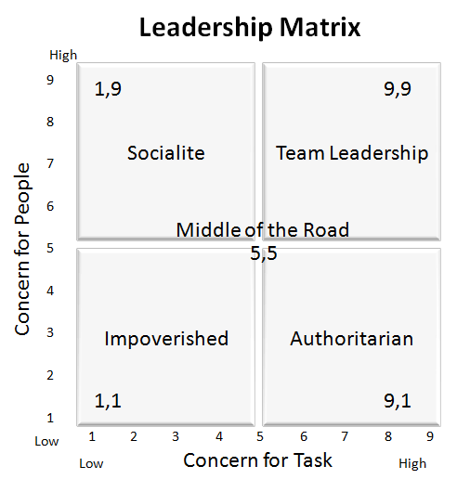

The Results
This chart will give you an idea of your leadership style:
- Impoverished (1,1 to 4,4): weak on both tasks and people skills
- Authoritarian (people - 1 to 4 and task - 5 to 9): strong on tasks, weak on people skills
- Socialite (people - 5 to 9 and task 1-4): strong on people skills, weak on tasks
- Team Leadership (6,6 to 9,9): strong on both tasks and people skills
- Middle-of-the-Road (5,5): in the middle of the chart, but with more experience and skills can display good team leadership

Example

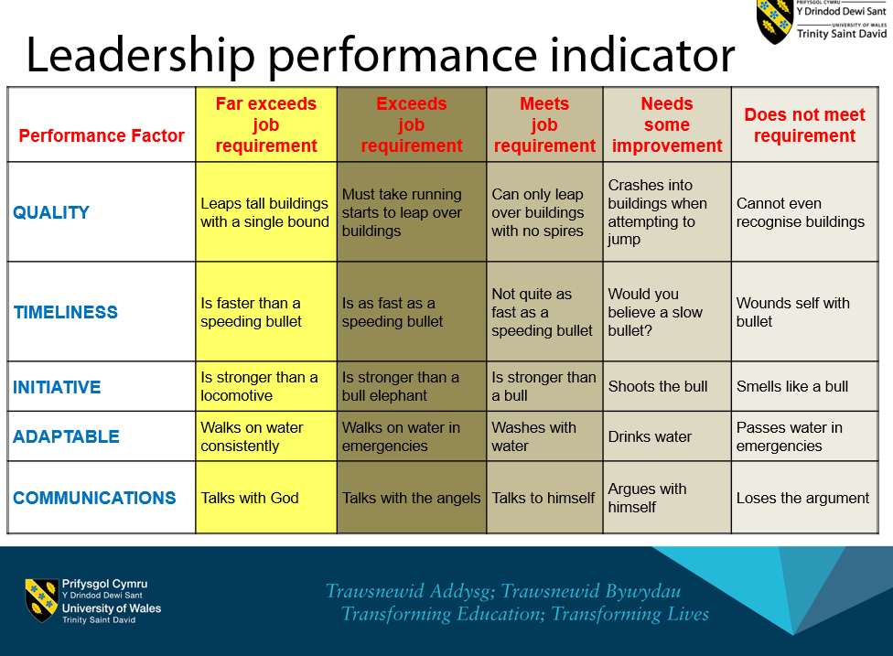

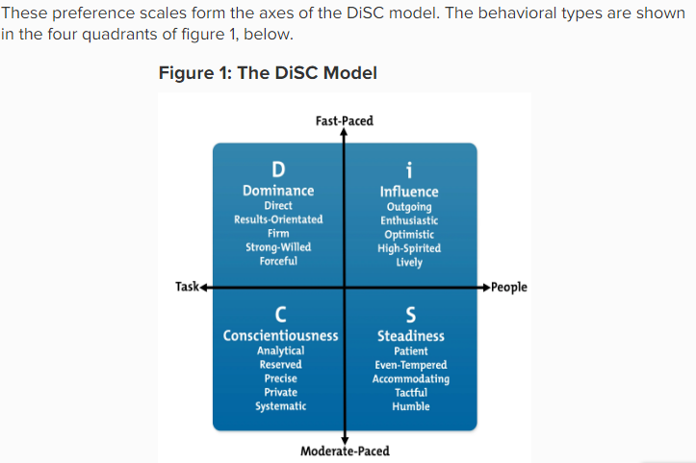

Maslow’s Hierarchy of Needs

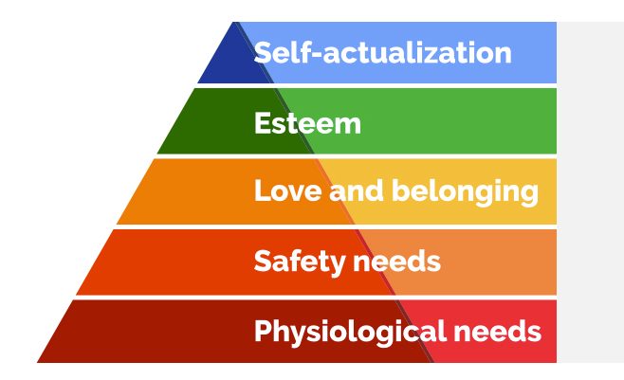
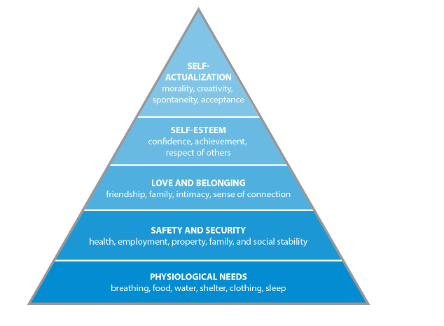

Servant Leadership ( Is the inverted Pyramid )
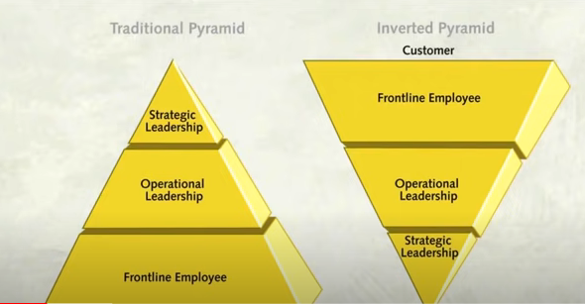

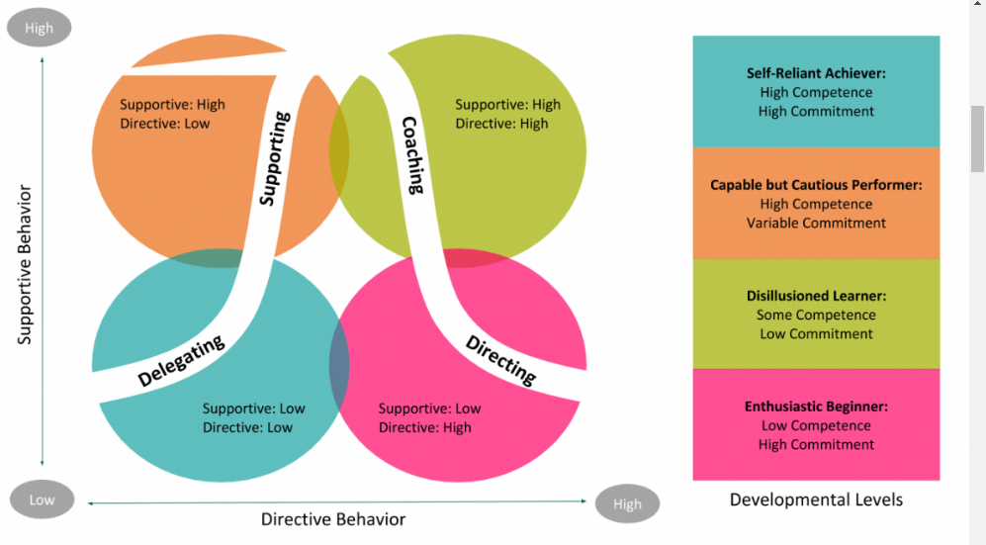

Situational Leadership

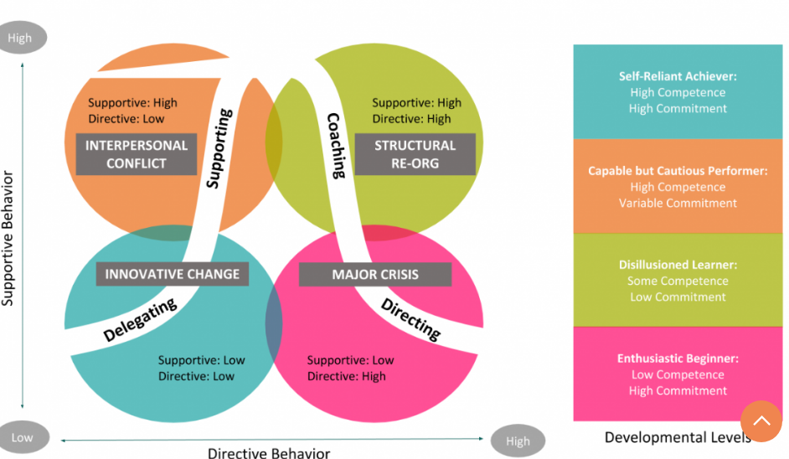
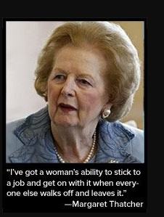

Referencing

Center For Creative Leadership (2022).What Are the Characteristics of a Good Leader? Available at: https://www.ccl.org/articles/leading-effectively articles/characteristics-good-leader/(Accessed July 2022).

Disc Personality Testing (2021).What is the DISC Model?Available at: https://discpersonalitytesting.com/blog/what-is-the-disc-model/ (Accessed July 2022).

Dotdash Meredith, the balance small business (2022) What is Leadership? Definition and Examples Available at: https://www.thebalancesmb.com/leadership-definition-2948275 (Accessed 20th June
2022).

Emerald Group Publishing Limited (2006) Mayer et al 1995, Dietz and Den Hartog Measuring trust inside organisations. Available at:
https://www.emerald.com/insight/content/doi/10.1108/00483480610682299/full/html
(Accessed July 2022).

FOW (2022) 2014 Advantages and Disadvantages of Ethical Leadership Styles Available at: https://futureofworking.com/14-advantages-and-disadvantages-of-ethical-leadership-styles/ (Accessed 3rd July 2022).

Gender and Perceptions of Leadership Effect. Available at: https://www.apa.org/pubs/journals/releases/apl-a0036751.pdf (Accessed July 2022).
Gita de Souza, Howard J. Klein (November 1, 1995). ‘Emergent Leadership in the Group Goal- Setting Process’, Small Group Research , Available at: https://doi.org/10.1177/1046496495264002(Accessed on 25th June 2022).

Guardian News & Media Limited (2022).Boris Johnson wins no-confidence vote despite unexpectedly large rebellion. Available at: https://www.theguardian.com/politics/2022/jun/06/boris-johnson-wins-no-confidence-vote-despite-unexpectedly-large-rebellion. (Accessed 3rd July 2022).

Harvard Business School Publishing, Bazerman (2022) A New Model for Ethical Leadership. Available at: https://hbr.org/2020/09/a-new-model-for-ethical-leadership

(Accessed 3rd July, 2022).
Inspiring Leadership Now (2022) 10 Of The Most Inspiring Leaders Of All Time: Remarkable Stories Of Iconic Trail Blazers Who Went From Adversity To Ext4raordinary & Redefined Leadership Available at: https://www.inspiringleadershipnow.com/most-inspiring-leaders-redefine-leadership/ (Accessed 20th June 2022).

i4 Business Magazine(2022) To Win, Compete at the Top of Maslow’s Hierarchy of Needs. Available at:
https://www.i4biz.com/best-practice/win-compete-top-maslows-hierarchy-needs/ (Accessed 3rd July 2022).
John Adair (1983) Effective Leadership: A Self-development Manual, Gower. Available at: https://books.google.co.uk/books?hl=en&lr=&id=1UMGDAAAQBAJ&oi=fnd&pg=PP1&dq=John+Adair,+Effective+Leadership:+A+Self-development+Manual,+Gower,1983&ots=vwkV1prP19&sig=4Ku2_jdGgbmfpvKVfUIgRRM5UoY#v=onepage&q&f=false .(Accessed July 2022).
Lund (2019). Housing in the United Kingdom, Available at: https://doi.org/10.1007/978-3-030-04128-1_1 (Accessed July 2022).

Mindtools (2022) What is Leadership. Available at: https://www.mindtools.com/pages/article/newLDR_41.htm (Accessed 20th June 2022).
Pobl Group.co.uk (2022) Inclusive By Instinct Available at:https://www.poblgroup.co.uk/wp-content/uploads/2022/04/Inclusive-by-Instinct-2022-25.pdf (Accessed 3rd July 2022).

Robbins (2022), Robbins Research International, Inc. What is Leadership? Available at: https://www.tonyrobbins.com/what-is-leadership/ (Accessed 20th June 2022).

Simplilearn.(June 14 2022) 7 Major Leadership Theories Every Manager Should Master in 2022. Available at:https://www.simplilearn.com/top-leadership-theories-every-manager-should-know-article (Accessed July 2022).

The Economist Educational Foundation (2022) What does it take to be a good Prime Minister? Available at:https://talk.economistfoundation.org/projects/politicians-and-power/the-discussion/what-dose-it-take-to-be-a-good-prime-minister/ (Accessed 20th June 2022).

The Guardian (2022).Local elections 2022: Tories lose hundreds of seats to Labour and Lib Dems – as it happened .Available: https://www.theguardian.com/politics/live/2022/may/05/local-elections-2022-conservatives-labour-boris-johnson-keir-starmer-england-wales-scotland-northern-ireland-live-updates (Accessed at 3rd July 2022).

Tracy B (2022). 5 Leadership Styles In Management You Should Know. Available at:https://www.briantracy.com/blog/leadership-success/5-leadership-styles-to-inspire-peak-performance/ (Accessed 3rd July 2022).

The Sunday Times (Thursday May 26th 2022) Sue Gray report vindicates me over No 10 parties, claims Boris. Available at: https://www.thetimes.co.uk/article/sue-gray-report-vindicates-me-over-no-10-parties-claims-boris-johnson-c90hbrmdj (Accessed 3rd July 2022).

VDOC.PUB (2022) Housing In The United Kingdom: Whose Crisis? Available at: https://vdoc.pub/documents/housing-in-the-united-kingdom-whose-crisis-1k4qhmbi8gug : (Accessed 3rd July 2022).
Weidman, PhD, (2022) Harvard University History of Psychology. Available at :(http://www.apa.org/pubs/journals/hop/) (Accessed July 2022).

Bibliography, Journals & Articles
Adair, J. (1993) The action centred leader. London. The Industrial Society
Alvesson, M. Blom, M. and Sveningsson, S. (2017) Reflexive Leadership organising in an imperfect world. London. Sage Publications.

Avolio, Bruce J., et al. "The moderating effect of gender on leadership intervention impact: An exploratory review." Journal of Leadership & Organizational Studies 15.4 (2009): 325-341.
Bennis, WG. And Thomas, R. J. (2002) Geeks and Geezers: How era, values and defining moments shape leaders. Boston. Harvard Business Press.

Carrol, B. Ford, J. and Taylor, S. (2015) Leadership, contemporary critical perspectives. London, Sage Publications.
De Souza, G. and Klein, H. J. (1995) ‘Emergent Leadership in the Group Goal-Setting Process’, Small Group Research, 26(4), pp. 475–496. doi: 10.1177/1046496495264002

Eagly, A. H., & Carli, L. L. (2003a). The female leadership advantage: An evaluation of the evidence. Leadership Quarterly, 14, 807– 834. doi: 10.1016/j.leaqua.2003.09.004
Eagly, A. H., & Carli, L. L.(2003). Finding gender advantage and disadvantage: Systematic research integration is the solution. Leadership Quarterly, 14,851– 859. doi:10.1016/j.leaqua.2003.09.003
Eagly, A. H., & Carli, L. L. (2007). Through the labyrinth. Boston, MA: Harvard Business School Press. Eagly, A. H., & Johnson, B. T. (1990). Gender and leadership style: A meta-analysis. Psychological Bulletin, 108, 233–256. doi:10.1037/0033- 2909.108.2.233
Eagly, A. H., & Karau, S. J.(2002).Role congruity theory of prejudice toward female leaders. Psychological Review, 109, 573–598. doi: 10.1037/0033-295X.109.3.573 Eagly, A. H., Karau, S. J., & Makhijani, M. G. (1995). Gender and the effectiveness of leaders: A meta-analysis. Psychological Bulletin, 117, 125–145. doi:10.1037/0033-2909.117.1.125
Eagly, A.,Makhijani, M., & Klonsky, B. (1992). Gender and the evaluation of leaders: A meta-analysis. Psychological Bulletin, 111, 3–22. doi: 10.1037/0033-2909.111.1.3
Eagly, A. H., & Wood, W. (2012).Social role theory. In P. van Lange, A. Kruglanski, & E. T. Higgins (Eds.), Handbook of theories in social psychology (pp. 458 – 476). Thousand Oaks, CA: Sage.
Gill, R. (2013) Theory and Practice of Leadership. London Sage Publishing.
Jackson. B and Parry, K.(2013) A very short, fairly interesting and reasonably cheap book about studying Leadership. London Sage Publishing.

Kets De Vries. M. (2006) The Leadership Mystique: Leading Behaviour in the Human Enterprise Harlow. Prentice Hall.

Kouzes, J and Posner, B. (2012) The leadership challenge: How to make extraordinary things happen in organisation. San Francisco. Wiley.
Morrel, M. and Capparell, S. (2002) Shackleton’s Way. London. Nickolas Brealey Publishing.
Northhouse, P.G. (2018) Introduction to Leadership Concepts and Practice. London. Sage Publications.
Western, S. (2014) Leadership a critical text. London Sage Publishing.

