SMARTFLOW
Digital Modernisation of Passenger Flow and Logistics Coordination
Project Management Portfolio
Parts A, B and C
Student Name: Latoya Brown
Student ID: 2428456
Programme: BA (Hons) Leadership and Management Skills in the Workplace
Module: Project Management
Module Code: LCLM5003 – Portfolio Project
Tutor: Dr Kareem Folohunso Sani
Chosen Project: Digital Modernisation of Passenger Flow and Logistics Coordination
Methodology: PRINCE2 / PMBOK Hybrid

Executive Summary
SMARTFLOW is a digital modernisation project designed to improve passenger movement, freight coordination and operational efficiency within a major urban transport interchange undergoing regeneration. Rather than relying solely on physical infrastructure investment, the project introduces an integrated digital platform that enables real-time operational management while regeneration works continue. This approach delivers early public value, reduces disruption and provides the digital foundation required for future transport and net-zero initiatives.
The project is delivered over a twelve-month period with an approved budget of £6.5 million, using a hybrid approach that combines the governance structure of PRINCE2 (OGC, 2017) with the process guidance of the PMBOK Guide (PMI, 2021). The solution comprises four integrated components: a central operational dashboard, passenger information and wayfinding, crowd-flow analytics and freight coordination. Together these provide operators with a single operational view while improving accessibility, reducing congestion and increasing network resilience.
This Project Management Plan defines the governance arrangements, scope, work breakdown structure, schedule, stakeholder engagement strategy, resource allocation and risk management processes required to deliver SMARTFLOW successfully. Particular emphasis is placed on benefits realisation through measurable Key Performance Indicators, ensuring that success is evaluated not only through delivery of outputs but through long-term operational performance. The report concludes that digital modernisation offers the greatest public value at the lowest level of disruption, and recommends approval of SMARTFLOW as the preferred project option.

Contents
Part A – Project Proposal Poster 5
Part B – Critical Reflection on Tutor Feedback 8
Key Strengths 8
Areas for Improvement 8
Conclusion of Reflection 9
Part C – Project Management Plan 10
1. Introduction 10
2. Project Description 10
3. Project Scope 11
4. Work Breakdown Structure (WBS) 13
5. Quad Chart 15
6. Gantt Chart 15
7. Stakeholder Involvement 17
8. Resource Allocation 19
9. Risk Analysis 20
10. Benefits Realisation and Success Measures 22
11. Conclusion 23

List of Figures
SMARTFLOW Project Overview 11
SMARTFLOW Scope Boundary 13
Work Breakdown Structure (WBS) 14
SMARTFLOW Project Quad Chart 15
SMARTFLOW Project Gantt Chart 16
Mendelow’s Power–Interest Matrix 18
SMARTFLOW Communication Plan 19
SMARTFLOW Risk Heat Map 21
SMARTFLOW Change Management Strategy 23

List of Tables
Project Scope Definition 12
Work Package Summary 14
Key Project Milestones 16
Stakeholder Communication Plan 18
RACI Matrix 18
Project Resource Allocation 19
Budget Allocation 20
SMARTFLOW Risk Register 20
Post-Implementation Success Measures 22

Part A – Project Proposal Poster
The project proposal poster is presented below. It was submitted for peer and tutor feedback, and the tutor’s feedback on it forms the basis of the critical reflection in Part B.
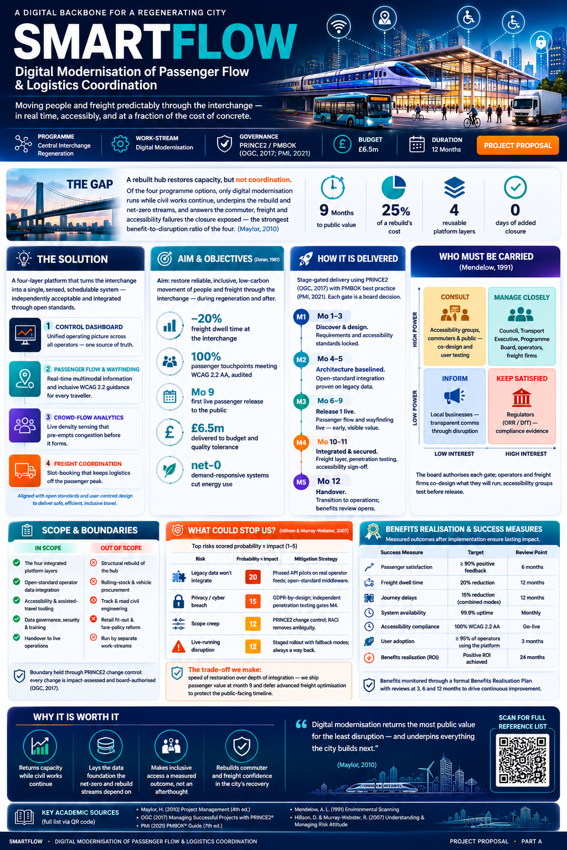
SMARTFLOW Project Proposal Poster (Part A)
Part B – Critical Reflection on Tutor Feedback
This reflection is based on the formal tutor feedback; no peer feedback was received at this stage. The reflection follows Gibbs’ (1988) reflective cycle, moving from the comments received, through evaluation, to a clear action plan. Overall, the tutor confirmed a strong understanding of project management principles presented to a high professional standard. The poster was judged highly professional, visually engaging and logically structured, communicating a complex digital modernisation project effectively to a range of stakeholders. This confirmed that the proposal achieved its aim of presenting a clear, well-justified project management case.

Key Strengths
A principal strength identified was the application of recognised project management tools and methodologies. The tutor highlighted effective use of SMART objectives (Doran, 1981), stakeholder mapping (Mendelow, 1991), scope definition, governance arrangements and risk assessment, demonstrating that theory had been translated into a realistic project environment. On reflection, the strongest aspect was the integration of frameworks rather than their presentation as isolated techniques. Aligning PRINCE2 governance (OGC, 2017) with structured planning, stakeholder engagement and risk management showed how these frameworks collectively support delivery. The positive comments on visual presentation also confirmed that clear communication is fundamental to project management, particularly when conveying technical information to diverse stakeholder groups (Bourne, 2009).

Areas for Improvement
Although the feedback placed the work in the distinction range, two opportunities for improvement were identified. The first was to provide greater detail on post-implementation success measures. Initially, defining objectives, deliverables and implementation stages was assumed sufficient to demonstrate success. The feedback challenged this by emphasising that project management extends beyond delivery and must show how long-term benefits are measured and sustained (Bradley, 2010). This strengthened an understanding of benefits realisation as a critical element rather than a final stage of the lifecycle (Zwikael and Smyrk, 2019).
To address this, the final plan introduces a dedicated benefits realisation and success-measures section with measurable Key Performance Indicators – including at least 90% passenger satisfaction, a 20% reduction in freight dwell time, 99.9% system availability, and formal benefits reviews at three, six and twelve months after implementation. These provide a structured basis for evaluating whether the project delivers its intended outcomes beyond completion.
The second point concerned the visibility of academic evidence. Although the original submission included references within the QR code and reference list, the tutor recommended making the supporting theory more explicit. On reflection, evidence should not only support the work but be immediately visible to the reader. Consequently, concise in-text citations now appear alongside the relevant tools and concepts throughout the plan, including PRINCE2 (OGC, 2017), PMBOK (PMI, 2021), SMART objectives (Doran, 1981), Mendelow’s matrix (Mendelow, 1991) and risk principles (Hillson and Murray-Webster, 2017). These changes strengthen academic rigour and professional credibility.

Conclusion of Reflection
Reflecting on the feedback has reinforced that effective project management concerns not only delivering outputs within scope, time and cost, but also demonstrating measurable organisational value after implementation. The feedback enabled a critical re-evaluation of initial assumptions and confirmed the importance of integrating benefits realisation and visible evidence into project documentation. As a result, the final plan is more comprehensive, evidence-based and aligned with professional practice. The exercise has strengthened an appreciation of reflective practice and will shape future work by ensuring success is judged through long-term outcomes and informed decision-making, not delivery alone (Kolb, 1984).

Part C – Project Management Plan

1. Introduction
Urban transport interchanges are critical components of regional infrastructure, supporting economic activity, social mobility and sustainable transport. Regeneration projects, however, frequently focus on physical capacity while overlooking the operational coordination needed to improve passenger experience and efficiency. Infrastructure investment alone therefore does not guarantee improved performance or user satisfaction.
SMARTFLOW addresses this through an integrated digital modernisation programme. Rather than replacing infrastructure, the project introduces intelligent technologies that coordinate passenger movement, freight operations and transport information in real time. This allows measurable improvements while civil works continue, reducing disruption and delivering earlier public value. The project adopts a hybrid methodology combining the governance of PRINCE2 (OGC, 2017) with the delivery practices of the PMBOK Guide (PMI, 2021), providing robust governance, defined decision gates and flexibility suited to complex public-sector transformation. This plan sets out the governance framework, scope, work packages, schedule, stakeholder strategy, resources and risk arrangements, and defines measurable success criteria so that outcomes continue to generate value after implementation.

2. Project Description
The interchange currently experiences inefficiencies caused by fragmented information systems, inconsistent passenger information, limited operator coordination and inefficient freight scheduling. These contribute to congestion, longer journeys, accessibility barriers and reduced resilience. Regeneration presents an opportunity to modernise the digital systems that support daily operations. Digital transformation is now a key enabler of sustainable transport management, integrating operational data and improving decision-making (Maylor, 2010). SMARTFLOW responds by implementing an intelligent platform that coordinates passenger and freight movements through real-time information and predictive analytics.
The project aim is to improve the reliability, accessibility and operational efficiency of the interchange through an integrated digital management platform. Its objectives are to reduce freight dwell times by 20% within twelve months; achieve 100% compliance with WCAG 2.2 AA accessibility standards across passenger interfaces; deploy the first operational passenger services in a phased release from Month 9, ahead of full go-live; complete implementation within the £6.5 million budget; and establish a scalable platform capable of supporting future regeneration and net-zero initiatives. Principal deliverables comprise an operational control dashboard, a passenger information and wayfinding system, a crowd-flow analytics platform, a freight coordination and slot-booking system, a staff training programme, a cybersecurity and data-governance framework, operational handover documentation and a benefits realisation plan. Figure 1 shows how the platform links current challenges to measurable operational benefits.
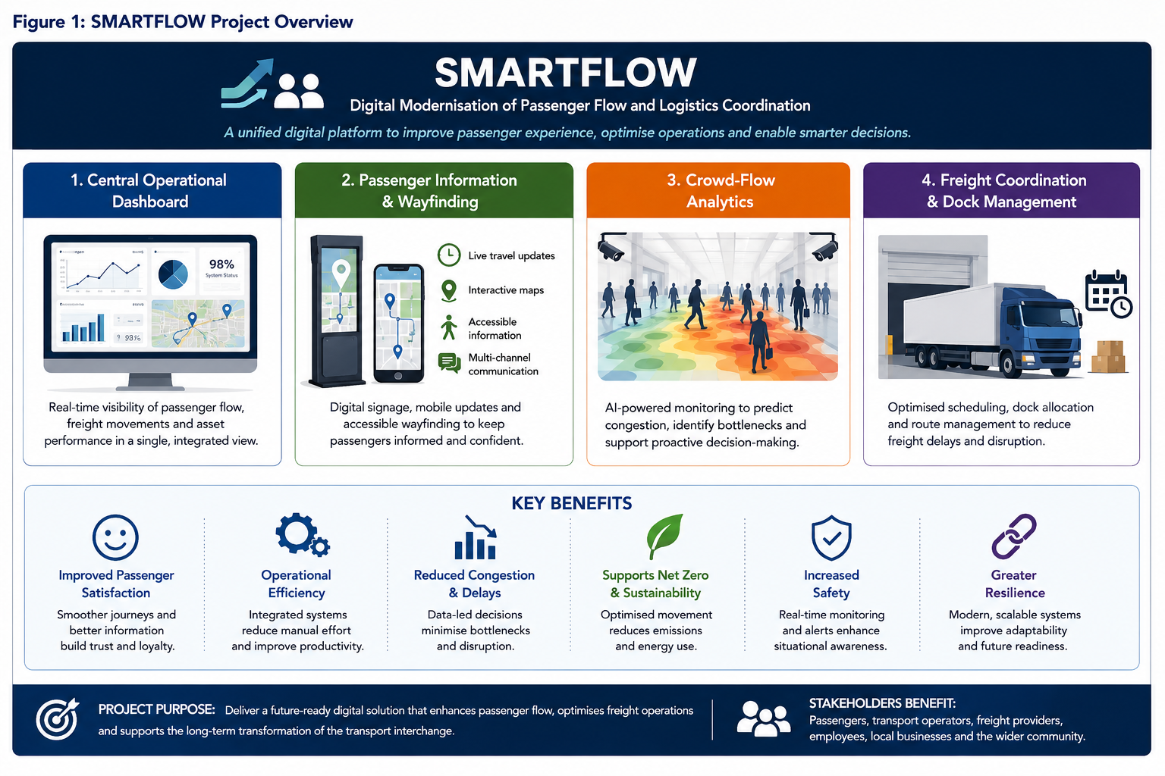
Figure 1: SMARTFLOW Project Overview

3. Project Scope
Effective scope management ensures a shared understanding of objectives, deliverables and boundaries. Poorly defined scope is a leading cause of project failure through scope creep, cost overruns and delay (PMI, 2021). SMARTFLOW therefore adopts the PRINCE2 principle of managing by stages, with all changes subject to formal change control and Project Board approval (OGC, 2017). The scope focuses exclusively on digital technologies that improve passenger movement, freight coordination and operational management; physical works remain outside the project and are delivered through separate construction contracts. Table 1 defines the agreed boundaries.
Table 1: Project Scope Definition
In Scope | Out of Scope
Integrated operational control dashboard | Structural rebuilding of the interchange
Passenger information and wayfinding | Civil engineering and highway works
Crowd-flow analytics platform | Rail infrastructure and signalling
Freight coordination and slot booking | Vehicle and rolling-stock procurement
Open-standard data integration | Retail redevelopment
Accessibility enhancements (WCAG 2.2 AA) | Ticket pricing and fare-policy reform
Cybersecurity and staff training | Commercial tenancy and future expansion
The project assumes that operators provide timely access to operational data, that existing infrastructure supports integration through open-standard APIs, that funding remains available, and that stakeholders participate in governance and user acceptance testing. The project is constrained by a fixed £6.5 million budget, a twelve-month schedule and the need to avoid additional service disruption; compliance with UK GDPR, cybersecurity standards and accessibility legislation is mandatory. Successful delivery depends on operator data, third-party network upgrades, timely procurement of licences and cloud services, stakeholder approval at each stage gate, and completion of penetration testing before deployment. These dependencies are reviewed at each Project Board meeting. Figure 2 illustrates the scope boundary.
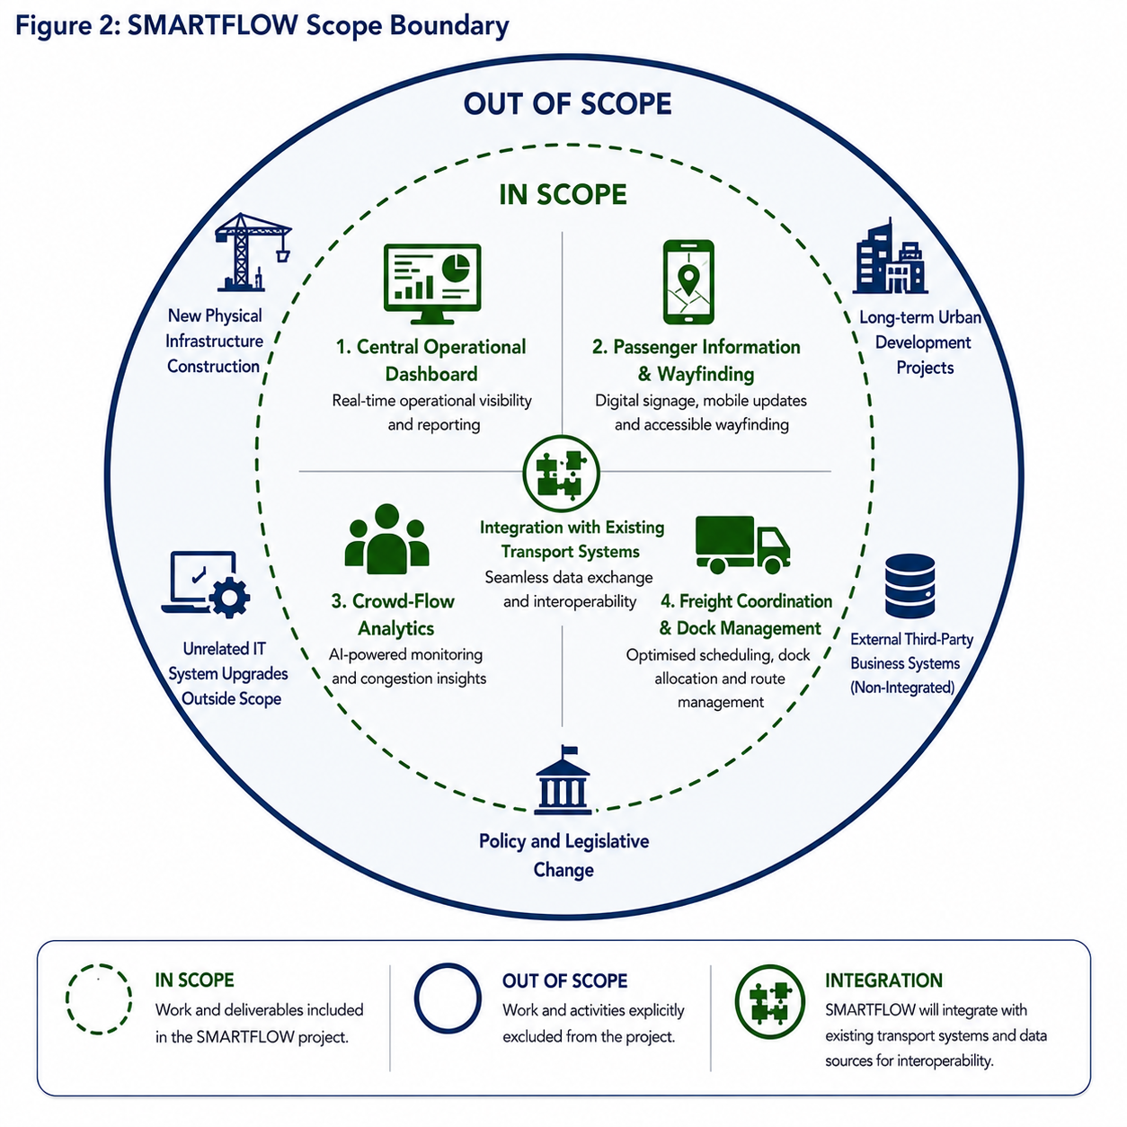
Figure 2: SMARTFLOW Scope Boundary
Acceptance criteria require all four platform components to be operational; 100% WCAG 2.2 AA compliance on passenger-facing services; a 20% reduction in freight dwell time; 99.9% operational availability; successful User Acceptance Testing by all operators; delivery within budget and schedule; and completion of handover and training.

4. Work Breakdown Structure (WBS)
A Work Breakdown Structure decomposes the total scope into manageable work packages that can be planned, monitored and controlled (PMI, 2021). The structure ensures all deliverables are identified, responsibilities are allocated and progress is measured against milestones, reducing scope omissions and supporting accurate estimation. For SMARTFLOW the WBS is organised into five phases – project management, requirements and design, development and integration, testing and quality assurance, and deployment and handover – each decomposed into work packages and activities with defined outputs, acceptance criteria and ownership. This aligns with PRINCE2 product-based planning and supports governance by allowing the Project Board to review deliverables at each stage gate before authorising progression (OGC, 2017). Figure 3 presents the structure and Table 2 summarises work-package ownership.
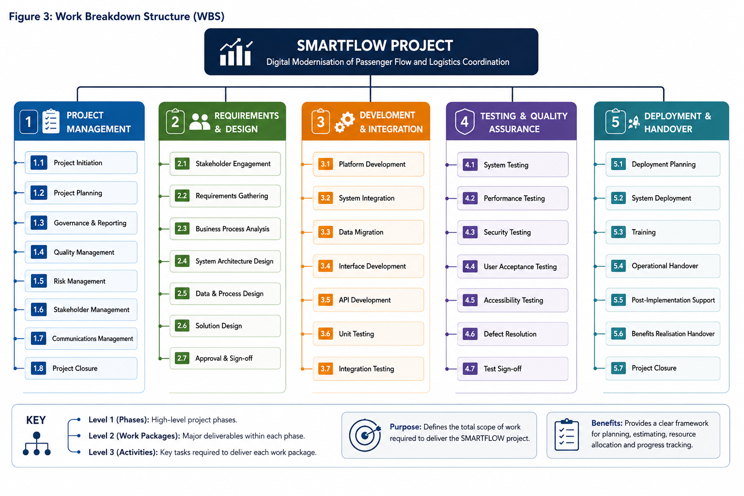
Figure 3: Work Breakdown Structure (WBS)
Table 2: Work Package Summary
Work Package | Primary Deliverable | Project Lead
WP1 – Project Management | Governance, plan and controls baseline | Project Manager
WP2 – Requirements & Design | Approved requirements and solution design | Solution Architect
WP3 – Development & Integration | Configured, integrated platform | Technical Delivery Manager
WP4 – Testing & Quality Assurance | Signed User Acceptance Test | Quality Assurance Manager
WP5 – Deployment & Handover | Operational platform and benefits handover | Implementation Manager
The WBS improves planning accuracy, assigns accountable ownership, links work packages to milestones for monitoring, and reduces scope creep by defining boundaries against which changes are evaluated through formal change control.

5. Quad Chart
A Quad Chart communicates the essential characteristics of a project on a single page, giving senior stakeholders a high-level overview of objectives, deliverables, schedule and resources without detailed technical documentation (Kerzner, 2022). Within SMARTFLOW it supports programme governance by providing the Project Board with a concise summary during stage-gate reviews, aligning strategic objectives with operational delivery and enabling early identification of issues. By presenting complex information visually, it supports communication across technical and non-technical audiences and complements the detailed plan. Figure 4 presents the chart.
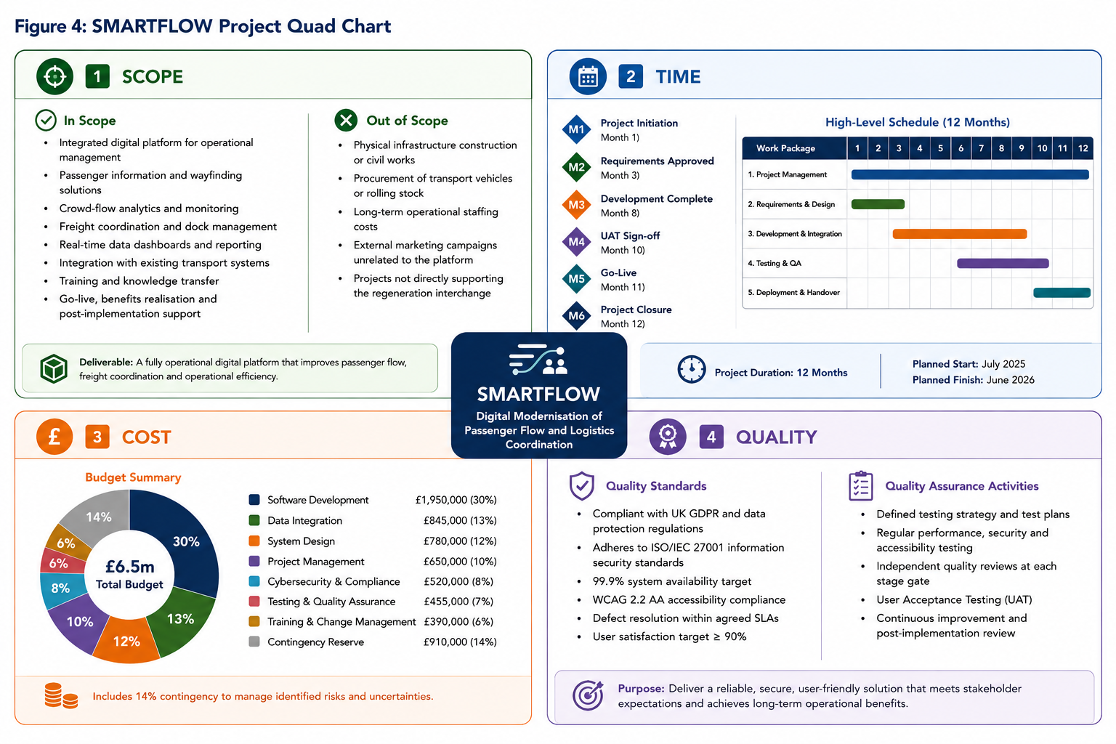
Figure 4: SMARTFLOW Project Quad Chart

6. Gantt Chart
A Gantt Chart illustrates the sequence, duration and interdependencies of activities over time, enabling resource allocation and progress monitoring against milestones (Maylor, 2010). The twelve-month schedule runs from a planned start of July 2025 to completion in June 2026, is developed from the WBS and follows the PRINCE2 stage-gate approach, with each phase concluding in a formal Project Board review before progression. Development completes at Month 8, user acceptance testing concludes at Month 10, the platform goes live at Month 11, and the project closes at Month 12, allowing time for integration, cybersecurity and accessibility testing before deployment. Figure 5 shows the schedule and Table 3 the principal milestones.
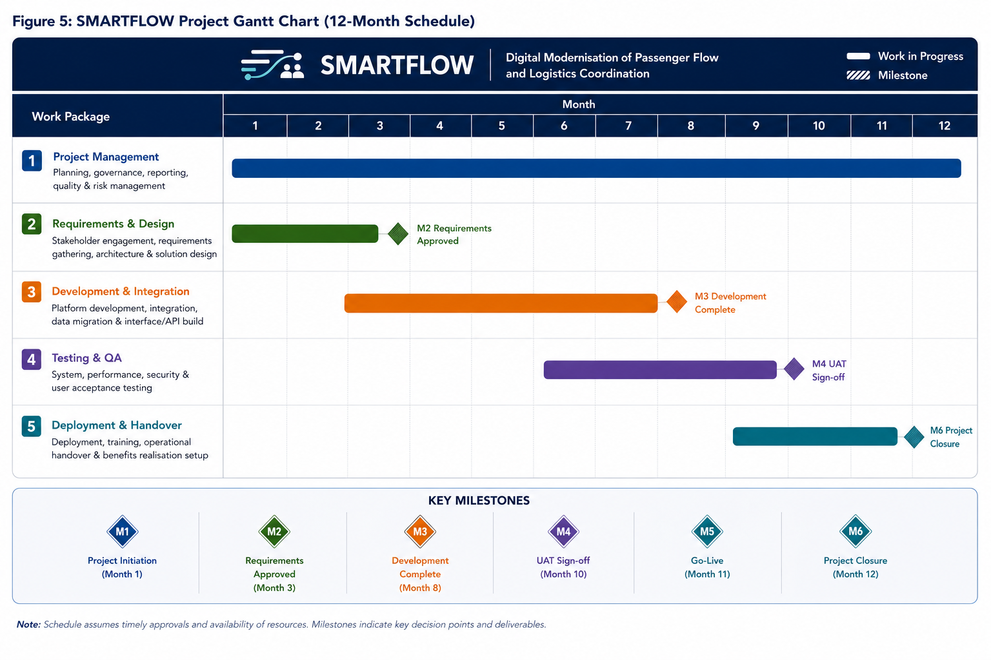
Figure 5: SMARTFLOW Project Gantt Chart
Table 3: Key Project Milestones
Milestone | Description | Target
M1 | Project initiation | Month 1
M2 | Requirements approved | Month 3
M3 | Development complete | Month 8
M4 | UAT sign-off | Month 10
M5 | Go-live | Month 11
M6 | Project closure | Month 12
The critical path comprises requirements analysis, solution design, development, integration, testing and deployment; delay in any of these affects completion unless corrected. Progress is monitored through fortnightly reviews, monthly Project Board meetings and earned-value reporting against the baseline, with variances triggering exception reporting under PRINCE2 governance (OGC, 2017).

7. Stakeholder Involvement
Successful delivery depends on effective stakeholder engagement throughout the lifecycle, since stakeholders influence decisions, provide resources, approve deliverables and determine whether benefits are achieved (Freeman, 1984). SMARTFLOW involves public-sector organisations, transport operators, regulators, suppliers and passengers, each with different expectations and influence. Poor management of these relationships could cause delays, resistance to change and reduced adoption. Engagement therefore uses Mendelow’s Power–Interest Matrix (Mendelow, 1991), shown in Figure 6, supported by a communication plan (Table 4 and Figure 7) and a RACI framework (Table 5).
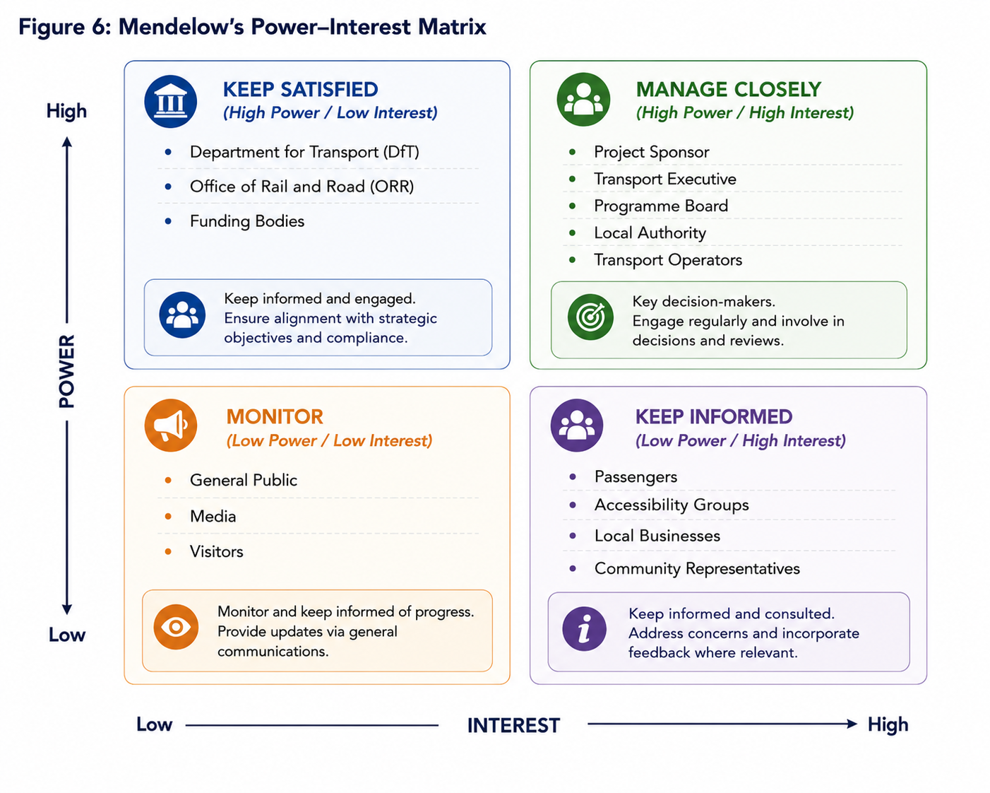
Figure 6: Mendelow’s Power–Interest Matrix
Table 4: Stakeholder Communication Plan
Stakeholder | Information | Method | Frequency | Owner
Project Sponsor | Progress, budget, risks | Project Board | Monthly | PM
Programme Board | Milestones, approvals | Stage-gate review | Monthly | PM
Transport Operators | Integration, testing | Workshops | Fortnightly | Tech Lead
Accessibility Groups | User experience testing | Focus groups | Monthly | BA
Passengers | Service updates | Web, app, social | As required | Comms
Regulators | Compliance evidence | Formal reports | Quarterly | Compliance
Table 5: RACI Matrix
Activity | Sponsor | PM | Tech Lead | BA | QA | Ops
Approve business case | A | R | C | C | I | I
Requirements gathering | I | A | C | R | I | C
Solution design | I | A | R | C | I | C
System development | I | A | R | I | C | I
Testing | I | C | C | I | R/A | I
Deployment | I | A | R | I | C | R
Benefits review | A | R | C | C | I | R
Key: R = Responsible, A = Accountable, C = Consulted, I = Informed. Engagement varies across the lifecycle: initiation secures sponsorship and governance; design and development use workshops so operators and accessibility groups shape requirements; implementation prepares users for change through training and communication; and post-deployment engagement shifts to benefits realisation through performance data and feedback. Figure 7 sets out the full communication plan, defining objectives, key messages, channels, frequency, ownership and feedback mechanisms for each stakeholder group. This continuous approach supports learning, stakeholder confidence and long-term sustainability.
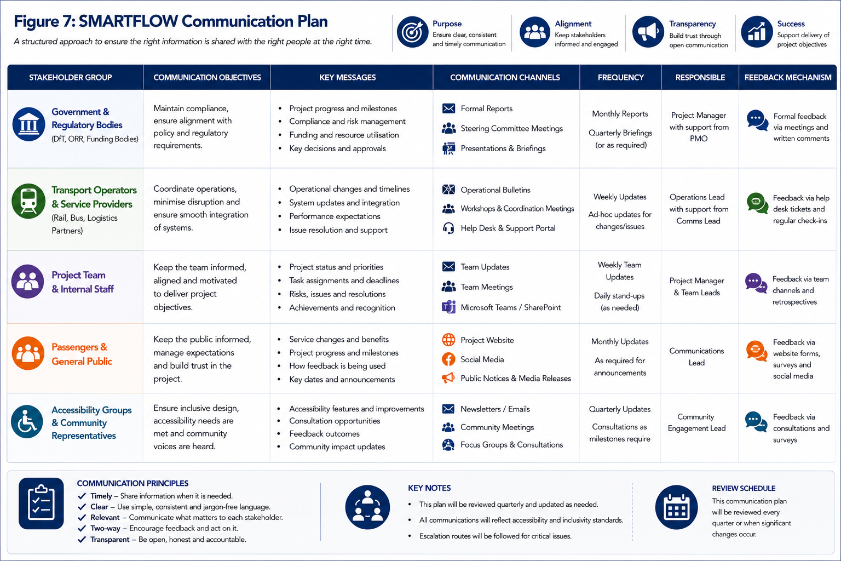
Figure 7: SMARTFLOW Communication Plan

8. Resource Allocation
Effective resource allocation ensures delivery within scope, budget and schedule. Resources include people, technology, finance and organisational support, and effective management improves productivity and ensures skilled personnel are available when required (PMI, 2021). SMARTFLOW adopts resource loading, assigning specialists according to the lifecycle rather than continuously, maximising efficiency and reducing cost. Utilisation is monitored through fortnightly reviews and monthly Project Board reporting. Table 6 sets out responsibilities and Table 7 the budget allocation.
Table 6: Project Resource Allocation
Resource | Primary Responsibility | Phase
Project Sponsor | Strategic direction and funding | Entire project
Project Manager | Delivery and governance | Entire project
Business Analyst | Requirements and engagement | Planning & design
Solution Architect | Architecture and design | Design
Software Developers | Development and integration | Development
Cybersecurity Specialists | Security and penetration testing | Development & testing
Quality Assurance Manager | Testing and UAT | Testing
Change & Training Manager | Training and change | Deployment
Benefits Manager | KPI monitoring and realisation | Closure & post-implementation
Table 7: Budget Allocation
Budget Category | Estimated Cost (£) | Percentage
Software development | 1,950,000 | 30%
Contingency reserve | 910,000 | 14%
Data integration | 845,000 | 13%
System design | 780,000 | 12%
Project management | 650,000 | 10%
Cybersecurity & compliance | 520,000 | 8%
Testing & quality assurance | 455,000 | 7%
Training & change management | 390,000 | 6%
Total | 6,500,000 | 100%
Allocation is reviewed continuously and conflicts managed through prioritisation, workload balancing and, where necessary, external expertise. Expenditure is monitored using monthly budget reports and Earned Value Management (Kerzner, 2022). Knowledge transfer is integral: specialists work alongside operational staff so technical knowledge is retained after closure, reducing supplier dependency and supporting long-term sustainability.

9. Risk Analysis
Risk management is a continuous process enabling teams to identify, assess and respond proactively to uncertainty (PMI, 2021). Digital transformation projects are particularly exposed to technical, organisational, financial and cybersecurity risks. SMARTFLOW adopts a structured process consistent with PRINCE2 and ISO 31000, ensuring risks are identified early and reviewed throughout (ISO, 2018; OGC, 2017). Each risk is assessed using a Likelihood × Impact matrix scored 1 (very low) to 5 (very high); the highest-scoring risks receive priority attention. The register is reviewed fortnightly and reported to the Project Board at each stage gate. Table 8 presents the register and Figure 8 the corresponding heat map, which highlights the high and extreme risks requiring priority action.
Table 8: SMARTFLOW Risk Register
ID | Risk | L | I | Score | Response Strategy | Owner
R1 | Integration complexity with legacy systems | 4 | 4 | 16 | Phased API integration; prototyping; middleware validation | Tech Lead
R2 | Supplier or third-party delivery failure | 3 | 5 | 15 | Contractual milestones; contingency suppliers | Procurement
R3 | Data security breach or cyber-attack | 3 | 5 | 15 | GDPR compliance; encryption; penetration testing | Cyber Manager
R4 | User adoption lower than expected | 3 | 3 | 9 | Change management; training; engagement | Change Manager
R5 | Schedule delay due to dependencies | 4 | 3 | 12 | Critical-path monitoring; buffers; escalation | Project Manager
R6 | Inaccurate or incomplete requirements | 3 | 4 | 12 | Structured elicitation; sign-off; traceability | Business Analyst
R7 | Budget overrun | 3 | 4 | 12 | Earned Value Management; monthly reporting | Project Manager
R8 | Regulatory or compliance changes | 2 | 4 | 8 | Compliance reviews; independent audit | Compliance
R9 | Resource availability constraints | 3 | 3 | 9 | Resource planning; cross-training; succession | HR Manager
R10 | Operational disruption during deployment | 2 | 5 | 10 | Staged rollout; fallback modes; hypercare | Ops Manager
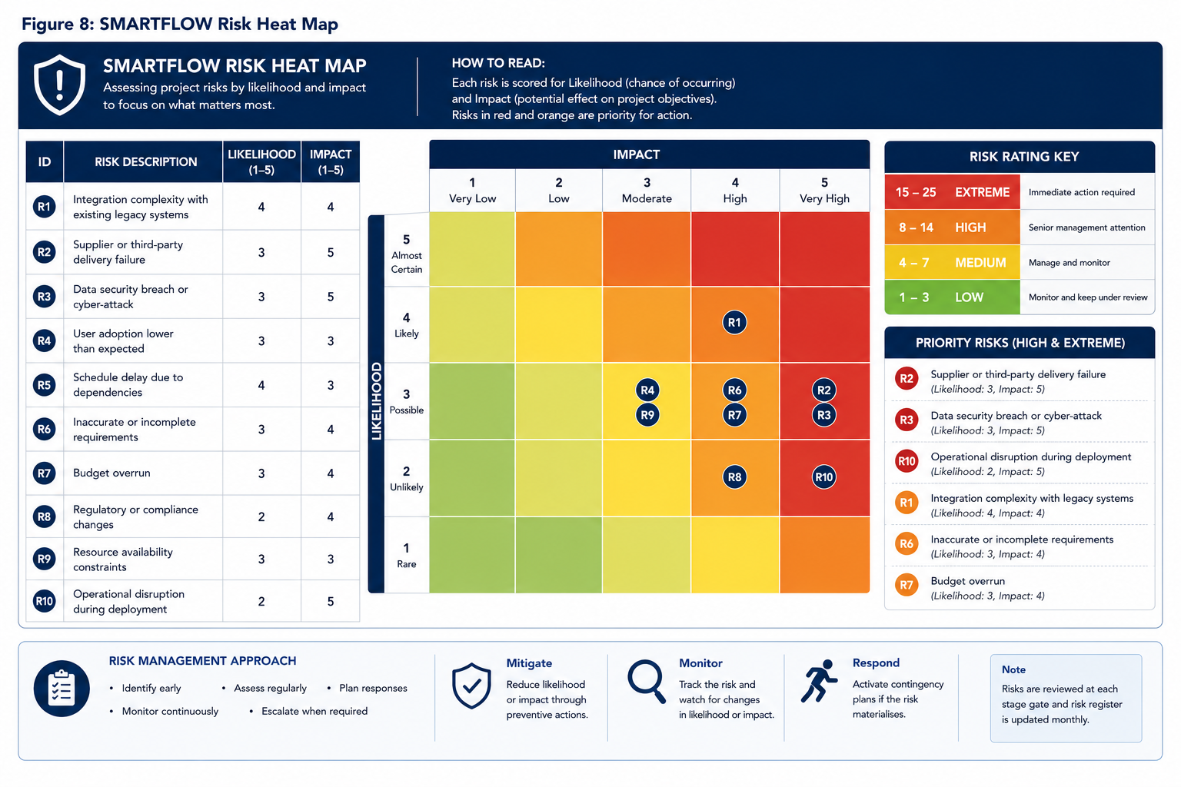
Figure 8: SMARTFLOW Risk Heat Map
SMARTFLOW applies four recognised response strategies: avoid risks through informed design and governance; mitigate through preventative controls, testing and contingency; transfer through contracts, warranties and service-level agreements; and accept low-level risks under regular review (Hillson and Murray-Webster, 2017). Each significant risk has a named owner, and risks exceeding tolerance trigger exception reporting under PRINCE2 governance. Risk management continues beyond deployment: post-implementation monitoring is integrated with benefits realisation so the Board can evaluate whether improvements in passenger satisfaction, freight efficiency and operational performance are achieved, reflecting that success is measured beyond completion (Ward and Chapman, 2003).

10. Benefits Realisation and Success Measures
Responding to tutor feedback, this section defines how success is measured after go-live so that delivery converts into lasting value. Benefits realisation is treated as a managed process extending beyond closure rather than a final stage (Bradley, 2010; Zwikael and Smyrk, 2019). For each objective a baseline is captured before Release 1, performance is monitored during operation, and benefits are confirmed at formal reviews held three, six and twelve months after implementation. Successful adoption is planned as deliberately as the technology, through training, communication and stakeholder engagement. Table 9 defines the principal Key Performance Indicators, each with a target, measurement method, review period and owner, giving the Programme Board an evidence base for confirming benefits and deciding formal closure.
Table 9: Post-Implementation Success Measures
KPI | Target | Measurement | Review | Owner
Passenger satisfaction | ≥ 90% | Passenger survey | 3, 6, 12 months | Benefits Manager
Freight dwell time | − 20% | Operational data | 3, 6, 12 months | Ops Manager
System availability | 99.9% | System monitoring | Monthly | Tech Lead
Accessibility compliance | 100% WCAG 2.2 AA | Independent audit | At go-live; annually | BA
Energy / emissions | Net-zero aligned | Energy reporting | 6, 12 months | Benefits Manager
Realising these benefits depends on people adopting the new systems and ways of working, so change is managed as deliberately as the technology. SMARTFLOW applies a structured change management strategy aligned to the ADKAR model – building Awareness, Desire, Knowledge, Ability and Reinforcement – across five phases from Prepare to Sustain (Hiatt, 2006). Adoption is measured through indicators such as active-user rates, training completion and user-satisfaction scores, complementing the operational KPIs above. Figure 9 presents the change management strategy, linking each phase to its enablers and success measures.
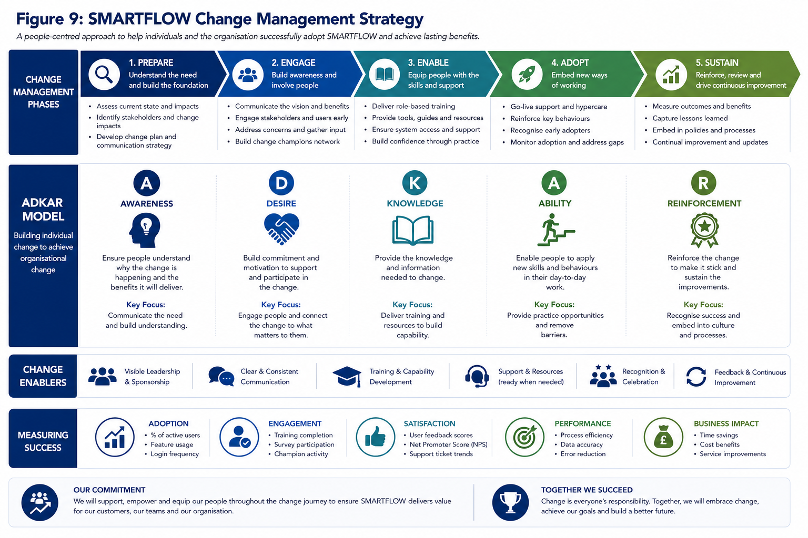
Figure 9: SMARTFLOW Change Management Strategy

11. Conclusion
SMARTFLOW is a strategic digital transformation initiative addressing the operational challenges of managing passenger movement and freight coordination during the regeneration of a major transport interchange. Rather than relying solely on physical improvements, it adopts a technology-enabled approach that delivers measurable benefits while supporting long-term modernisation and sustainability. This plan has demonstrated the application of recognised methodologies through a defined scope, structured WBS, implementation schedule, stakeholder strategy, resource plan and comprehensive risk framework. Integrating PRINCE2 governance with PMBOK delivery practices balances structured decision-making with flexible execution, so performance can be monitored, controlled and adapted throughout the lifecycle. Importantly, the plan extends beyond delivery by incorporating measurable benefits realisation and post-implementation evaluation, ensuring success is judged not only by completion within scope, schedule and budget but by long-term value to passengers, operators and the community. SMARTFLOW therefore offers a realistic, strategically aligned and professionally governed solution, and approval of the plan is recommended to enable implementation and the achievement of its intended benefits.

References
Bourne, L. (2009) Stakeholder Relationship Management: A Maturity Model for Organisational Implementation. Farnham: Gower.
Bradley, G. (2010) Benefit Realisation Management: A Practical Guide to Achieving Benefits Through Change. 2nd edn. Farnham: Gower.
Doran, G.T. (1981) ‘There’s a S.M.A.R.T. way to write management’s goals and objectives’, Management Review, 70(11), pp. 35–36.
Freeman, R.E. (1984) Strategic Management: A Stakeholder Approach. Boston: Pitman.
Gibbs, G. (1988) Learning by Doing: A Guide to Teaching and Learning Methods. Oxford: Further Education Unit.
Hiatt, J.M. (2006) ADKAR: A Model for Change in Business, Government and our Community. Loveland, CO: Prosci Learning Center.
Hillson, D. and Murray-Webster, R. (2017) Understanding and Managing Risk Attitude. 3rd edn. London: Routledge.
International Organization for Standardization (2018) ISO 31000:2018 Risk Management – Guidelines. Geneva: ISO.
Kerzner, H. (2022) Project Management: A Systems Approach to Planning, Scheduling and Controlling. 13th edn. Hoboken: Wiley.
Kolb, D.A. (1984) Experiential Learning: Experience as the Source of Learning and Development. Englewood Cliffs: Prentice Hall.
Maylor, H. (2010) Project Management. 4th edn. Harlow: Pearson.
Mendelow, A.L. (1991) ‘Environmental scanning: the impact of the stakeholder concept’, Proceedings of the 2nd International Conference on Information Systems, Cambridge, MA, pp. 407–417.
Office of Government Commerce (2017) Managing Successful Projects with PRINCE2. 6th edn. London: TSO.
Project Management Institute (2021) A Guide to the Project Management Body of Knowledge (PMBOK Guide). 7th edn. Newtown Square, PA: PMI.
Ward, S. and Chapman, C. (2003) ‘Transforming project risk management into project uncertainty management’, International Journal of Project Management, 21(2), pp. 97–105.
Zwikael, O. and Smyrk, J. (2019) Project Management for the Creation of Organisational Value. London: Springer.

