Effective Team Working & Communication

Presented by
1. Mihai Sibov Medinschi: 1906679
2. George lucian sibov medinschu: 1906678
3. Vlad Vasile Sibov medinschi: 1906680

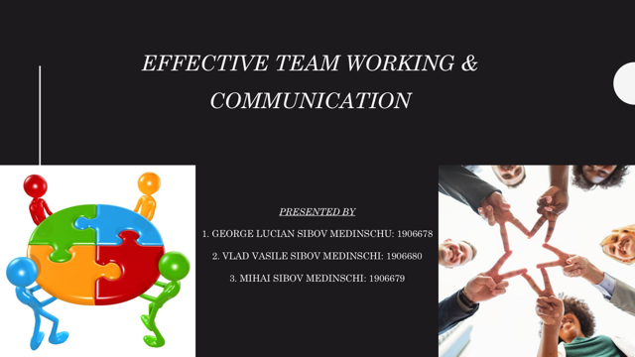

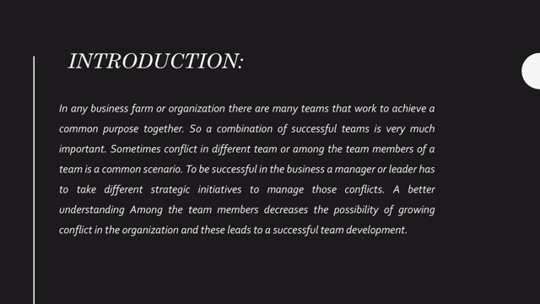
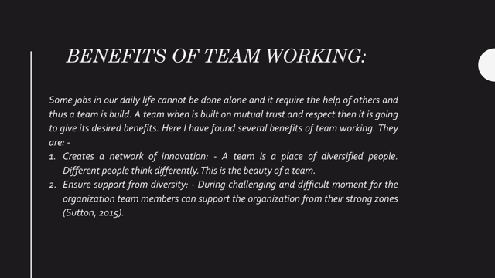

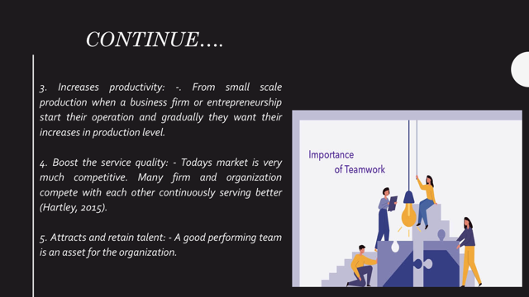

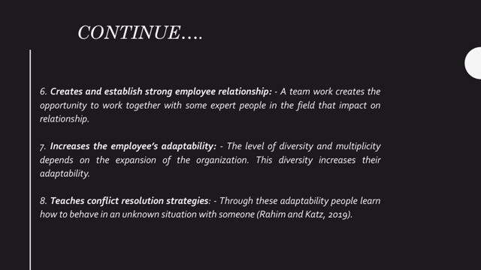

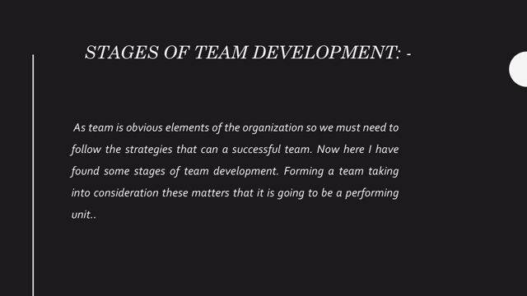
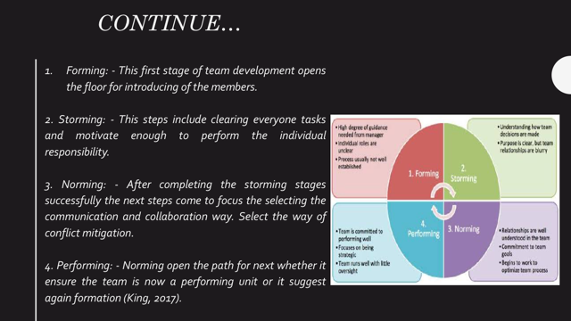

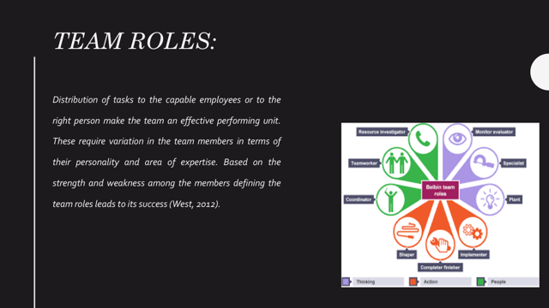
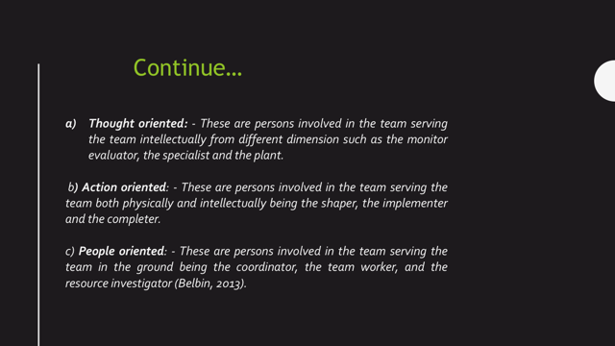

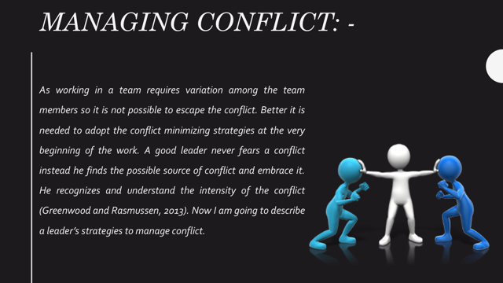
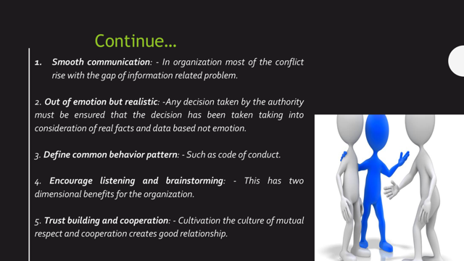

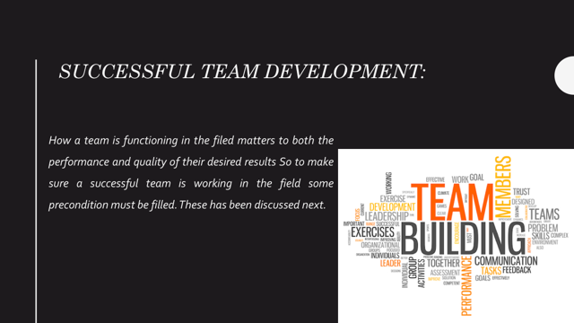

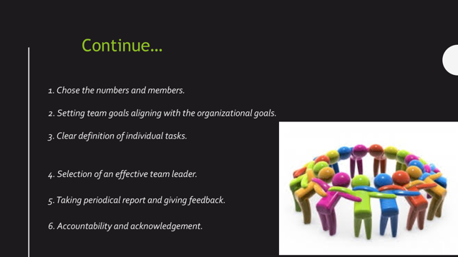

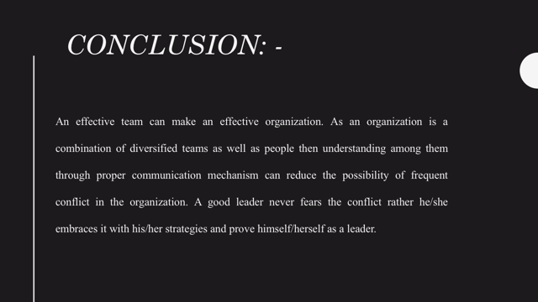
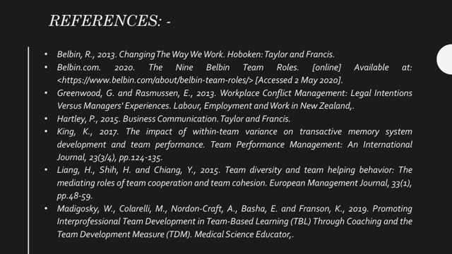

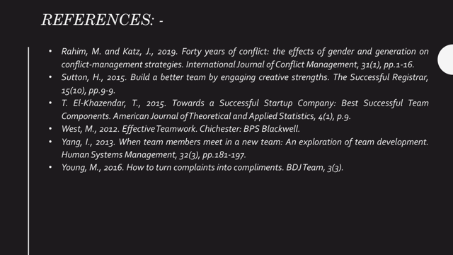

Speaker note:
Introduction
In any business farm or organization there are many teams that work to achieve a common purpose together. So a combination of successful teams is very much important. Sometimes conflict in different team or among the team members of a team is a common scenario. To be successful in the business a manager or leader has to take different strategic initiatives to manage those conflicts. A better understanding among the team members decreases the possibility of growing conflict in the organization and these leads to a successful team development.
Benefit of team working
- These people when singular unit become and work for same things then they share their ideas and obviously these foster innovation and variation in the product and service. Thus it becomes a network of innovation.
- When a person is alone like this situation he/she becomes with overloaded of tasks and mental pressure but when he/she is in a team then the pressure ultimately goes to everyone (T. El-Kasandra, 2015).
- A good performing team working their best in different stages of production must be able to increase the production.
- So in this situation one organization which wants to be dominate in the market then it must be able to bring new update of the product. As a team is a combination of innovation and variation then it can use these merits for upgrading their product or services.
- When they do well in the market then they can also attract others for their firm and able to retain the existing employees who are serving already for the business organization.
- A good leader or a coordinator direct the tasks of all thus a man can observe his/her functions and attitudes how he/she deal with every members and every situation. As finding a good opportunity to meet with some expert people everyone wants to build a good relationship with their mates.
- As much as it becomes expanded the more it’s needed more people from different background. When a person works for this type of firm then it augments the adaptability through flourishing the insights of that person (Madigosky et al., 2019).
- People adopt the quality to face the difficult situation through practical observation. The endurance capability of a person enhances through team work. These all contribute to the limitation of conflicts at work.

