Name. Julie Shehzad
Student id. 2409972
Module. Changemakers: building your personal brand for sustainable Employment
Module code. BMHP5015
Assignment title. Component 1: online portfolio of set exercises

TASK 1. Personal Brand

My personal brand is centred around being compassionate, trustworthy, patient, and supportive when working with children and young people experiencing mental health difficulty’s. I am passionate about helping children feel safe, listened to, and understood, especially those struggling with anxiety, stress, trauma, or emotional challenges. My long-term goal is to build a career within children’s mental health services, potentially as a mental health support worker, councillor, or therapist within the health and social care sector.
Personal branding is important because it allows individuals to present their values, skills, and professional identity to employers (Montoya and Vandehey,2002) In health and social care, employers value individuals who can communicate effectively, show empathy, and remain professional when supporting vulnerable people. According to the (national careers service 2025) careers in mental health and child support require strong communication, teamwork, resilience and emotional intelligence. These are qualities I aim to continue developing throughout my studies and future work experience.
To strengthen my personal brand, I plan to gain practical experience through volunteering with charity’s that support children’s wellbeing. This would improve my confidence and help me understand children’s emotional and social needs more effectively. I also intend to develop my knowledge of safeguarding, mental health awareness through further training.
Research from mind highlights that early mental health support can positively affect children’s wellbeing and future development. This motivates me to pursue a career where I can make a positive difference in a child’s life.

REFERENCES..
Montoya, P, and Vandehey,T. (2002) The personal branding phenomenon. Nashville: Vaughn printing
National careers service (2025)
MIND. (2025)

Task 2.. Network map and rationale
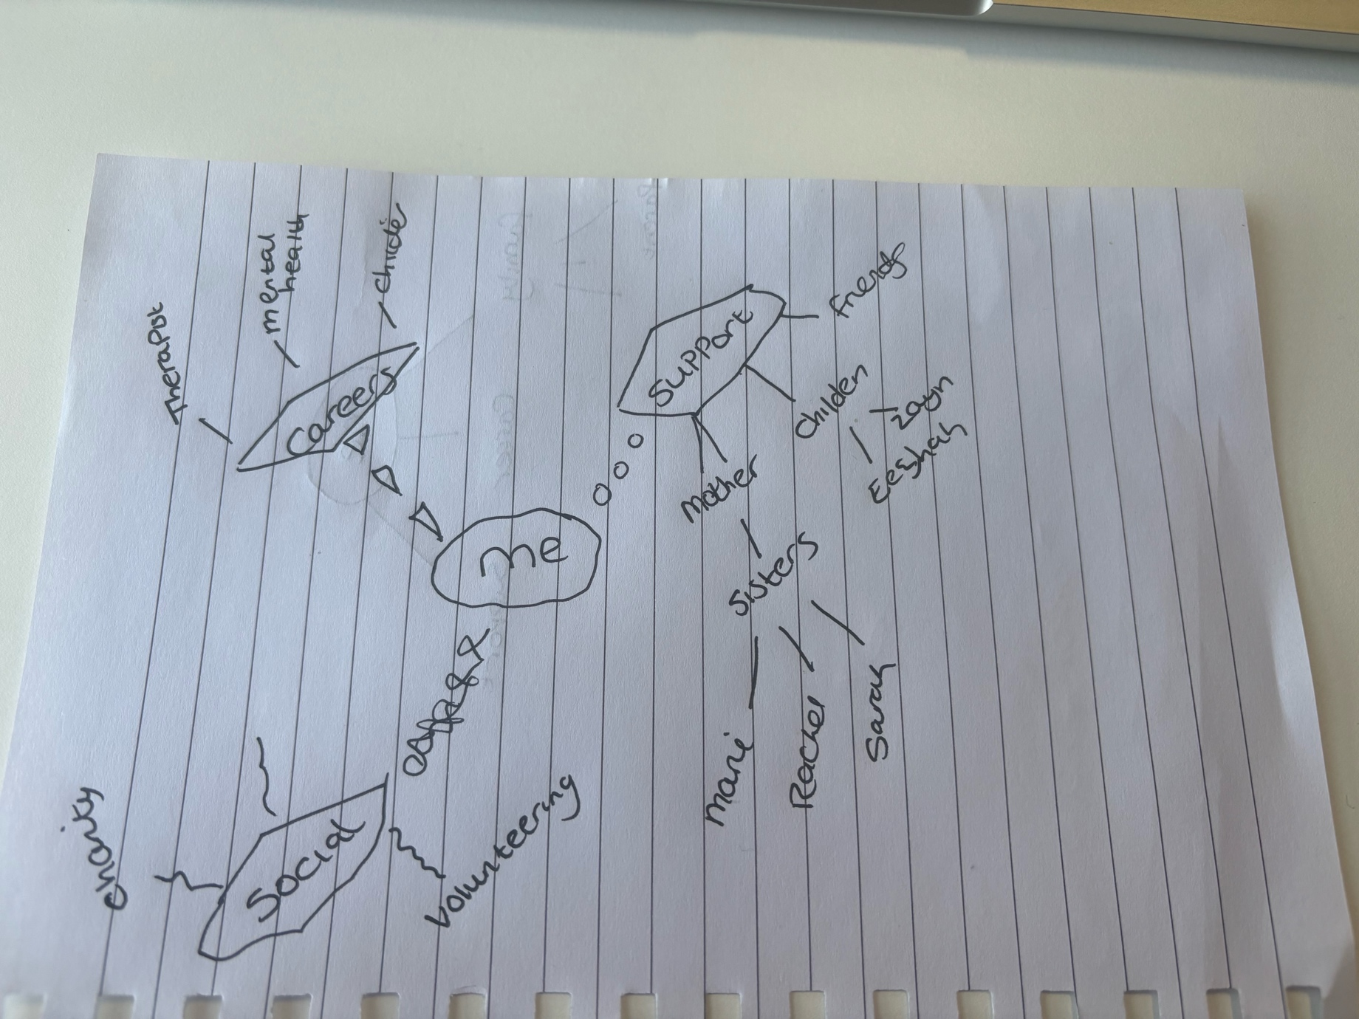

My network, structured as show, is built entirely around my goal to become a children’s mental health practitioner, organised into, careers, support, and social dimensions. This follows Granovetters(1973) theory: Strong ties (family, friends) provide trust and stability, while weak ties (therapists, volunteering contacts) open doors to knowledge and opportunity. Cross and parker (2004) also confirm that networks built with a clear purpose are most effective for learning and progressing in caring professions.
In the careers section, my contacts explain exactly what qualifications I need and what ,y role would involve. Since I do not complete formal placements, their advice and guidance are my main way to learn about the profession.
Support is my foundation. (Wellman and Wortley 1990) highlight that close personal relationships are the most reliable sources of help during challenges. Working with vulnerable children is emotionally demanding as my own personal experience having a son with autism and sensory needs shows. So, my mother, sisters and friends keep me resilient and focused. Importantly, my children Zayn and Eeshah are key here, interacting with them gives me practical understanding of child development and behaviour that I can’t get from studying alone.
My social network- Family, Volunteering and community- build hands on skill. Putnam (2000) describes this as social capital: relationships that let me work directly with young people, practise empathy, and understand local needs. Volunteering proves I can build safe, trusting relationships. The core skill for my dream role.
Overall, my network is strong in experience and support. I only need to grow professional links. It is perfectly aligned to help me learn, practise and succeed in children’s mental health.
References
Cross, R. and parker (2004) The hidden power of social networks: Understanding how work really gets done in organisations. Boston: Harvard business school.
Granovetter, M.S.(1973) The strength of weak ties, American journal of sociology, 78(6), pp 1360-1380.
Putnam, R,D.(2000) Bowling alone: The collapse and revival of American community. New York: Simon and Schuster.
Wellman, B. and Worley, S.(1990) Different strokes from different folks: community ties and social support; American journal of sociology. 96(3) pp 558-588.
Task 3. Blog

Why Children’s Mental Health Needs Our Attention Now

Every child deserves to grow up feeling safe, happy and supported. Yet right across the UK, young people are facing rising pressures that affect their mental health – and the system meant to help them is struggling to keep up. Whether you are a parent, teacher, youth worker or volunteer, understanding what is happening and where support exists is more important than ever.
Recent years have brought big changes. The pandemic disrupted schooling, friendships and daily life, leaving many children feeling lonely, anxious or uncertain about the future. Added to this, the cost-of-living crisis has put stress on families, affecting housing, finances and wellbeing at home. Social media also plays a part: while it connects people, it can also create pressure to fit in, expose children to harmful content or lead to feelings of inadequacy when comparing themselves to others.
According to recent reports, around one in three children and young people now experience a mental health difficulty, including anxiety, low mood, behavioural problems or low self-esteem. Many of these issues start early – often in primary school – but problems can go unnoticed until they become much harder to manage. The main NHS support, Child and Adolescent Mental Health Services (CAMHS), faces long waiting lists, sometimes lasting months, and many children with mild or moderate needs cannot access specialist help at all.
This is why community and early support is so vital. Charities like Place2Be, Barnardo’s and Young Minds, alongside school counsellors and local projects, work to fill the gaps. They offer counselling, safe spaces, wellbeing activities and advice, focusing not just on treating problems but stopping them from getting worse. These services teach young people how to understand their feelings, build resilience and know they are not alone.

Support does not always mean professional treatment. Simple, everyday actions make a big difference: listening without judgement, asking how they really feel, encouraging healthy routines and helping them take breaks from screens. Being able to spot changes in behaviour – such as withdrawal, falling grades or mood swings – can be the first step to getting help.

For me, as someone training to work in this field, this is about giving every child the chance to thrive. There is still a long way to go, but by working together – families, schools, charities and services – we can build a system where every young person gets the right support, at the right time.

References.
Mental Health Foundation (2023) Children and Young People’s Mental Health: State of the Nation Report. London: Mental Health Foundation.
NHS Digital (2023) Mental Health of Children and Young People in England, 2023. Leeds: NHS Digital.
Place2Be (2024) The State of Children’s Mental Health 2024. London: Place2Be.
Young Minds (2024) State of the Nation: Young People’s Mental Health Report. London: Young Minds.

Task 4.
- What is the primary goal of the NHS Equality, Diversity, and Inclusion
Primary goal: To create an NHS where every staff member, patient and service user is treated fairly, valued and respected, regardless of background. It aims to remove barriers, reduce inequality and embed equality, diversity and inclusion into all practices to improve wellbeing, opportunities and care quality.

2. How does the NHS EDI Improvement Plan propose to tackle the gender pay gap?
Gender pays gap: It will publish transparent pay data, conduct regular reviews and take targeted action to close gaps. It also focuses on increasing women in leadership, ensuring fair progression and promoting flexible working to support equal opportunities.
3. What is meant by the term ‘intersectionality’ as used in the NHS EDI Improvement Plan?
intersectionality: This means recognising that people have multiple characteristics such as race, gender, disability or religion, which combine to shape their experiences. It acknowledges overlapping disadvantages, so support and policies address unique, combined needs rather than treating characteristics separately.
4. Why is it important for the NHS to create a psychologically safe work environment?
Psychological safety: It lets staff speak up, share concerns or admit mistakes without fear, building trust and teamwork. This reduces stress, improves safety and leads to better patient care, as people feel safe to contribute and learn openly.
5. How does the NHS EDI Improvement Plan suggest improving the experience of internationally recruited staff?
International staff: It provides better welcome programmes, help with visas, housing and registration, and ensures equal pay and development. It tackles discrimination, values global skills and makes sure they feel fully included and supported.
6. What role does leadership play in advancing EDI objectives according to the NHS Improvement Plan?
Leadership role: Leaders set the culture, prioritise EDI and embed it in all decisions. They model inclusive behaviour, hold others accountable and ensure progress is measured, making equality everyone’s responsibility.
7. Identify one way the NHS EDI Improvement Plan aims to reduce health inequalities within the workforce.
Reduce workforce health inequalities: It offers tailored occupational health and wellbeing support for staff with disabilities, long-term conditions or specific needs. This ensures equal access to care, keeping all employees healthy and able to work.
8. Why does the NHS EDI Improvement Plan emphasise the importance of collecting and analysing data on protected characteristics?
Data importance: Data reveals gaps, disparities or unfair treatment, showing exactly where change is needed. It lets the NHS track progress, prove improvements and make evidence-based decisions to ensure policies work for everyone.
9. Explain how flexible working policies can contribute to equality and inclusion in the NHS workforce.
Flexible working: It supports work–life balance for carers, parents, those with health needs or study commitments. It removes barriers, helps retain diverse talent and ensures people are not excluded by personal circumstances.
10. What is one strategy mentioned in the NHS EDI Improvement Plan to combat bullying and harassment in the workplace?
Combat bullying/harassment: It applies a zero‑tolerance approach, with clear policies, better training and safe reporting routes. It ensures fast, fair investigations and support for victims, making such behaviour unacceptable.

Task 5

Dear Younger Me,
I am writing to you now, looking back at that time when you felt completely overwhelmed, unsure and like you were not doing enough. You were trying to balance college work, helping at home, volunteering, and most of all, supporting your autistic son through his huge challenges – especially his school refusal. You felt tired, stressed, guilty, and often wanted to give up, because every day felt like a battle, and you worried you were failing him and failing yourself, never sure if you were doing the right thing.
Now I understand that what you were missing then was not ability or love, but emotional intelligence and resilience – two things we learned about in this module that make all the difference. Back then, you saw your own feelings of fear, frustration or sadness as weaknesses, so you hid them or blamed yourself. Emotional intelligence would have taught you to recognise those feelings, understand why they were there, and realise that your son’s behaviour was not about you, but his way of showing he was anxious, overwhelmed and struggling to cope. You would have known that his school refusal was not defiance, but his mind and body protecting him from what felt too hard – and that understanding his emotions is the first step to helping him.
You also thought resilience meant staying strong and never giving in, even when you were both exhausted. But resilience is not about being perfect or fighting every battle; it is about how you respond when things go wrong. You tended to take every setback personally and think you were not a good parent or student. If you had known then that resilience is built by facing challenges, learning from them and adapting, you would have seen those hard days as learning, not failure. You would have understood that asking for help, taking time for yourself, and accepting that progress is slow is part of being strong.
Those difficult times shaped you, but knowing what I know now, I wish you had realised that understanding emotions – yours and his – and being kind to yourself would have made everything easier. You were doing so well, even when it felt impossible. These qualities you are building now are not just for you – they are exactly what you will use every day to support him, and what will make you such a caring, understanding children’s mental health practitioner.

You are stronger and more capable than you thought.
From your future self
Task 6
Goal: Become a Children’s Mental Health Practitioner added in my GRANT CHART

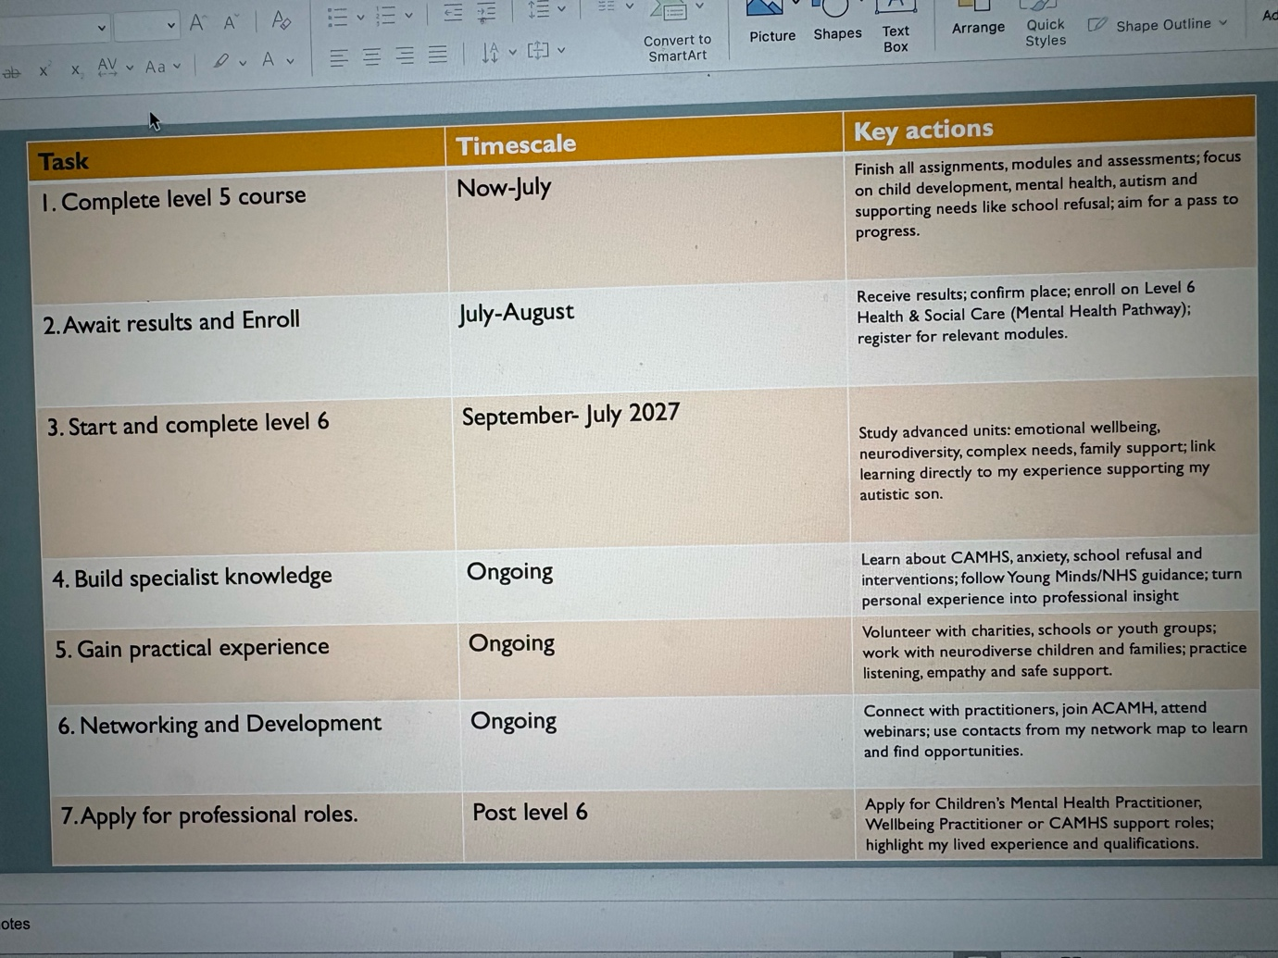
( Sent from my powerpoint)
Explanation
This plan is built around my personal journey and goal: to work as a Children’s Mental Health Practitioner, using my own experience supporting my autistic son through school refusal as both motivation and valuable insight.
The timeline balances learning, experience and qualification, starting with my current studies to build a strong knowledge base. Alongside this, I focus on understanding neurodiversity, anxiety and school avoidance – areas I know from personal experience are critical, and where I can bring real understanding to my future work.
Practical experience is central: volunteering will let me work with a range of children and families, while also helping me apply what I learn. I have planned formal qualifications to meet employer requirements, including specialist mental health training and safeguarding, which are essential for safe practice.
Networking runs throughout, using the contacts I mapped earlier, to learn from those already in the field and stay aware of opportunities. Finally, applying for roles leads to long-term development, ensuring I keep learning and growing, so I can offer the best possible support to every child – especially those facing the same challenges my son did.
Task 7 – Making Changes: Report

Report: Implementing Person‑Centred Mental Health Support

Introduction
As manager of the care home, I propose introducing a structured, person‑centred approach to mental health and wellbeing support for all residents. This change will ensure every resident’s emotional, psychological and social needs are identified, recorded and met, aligning with the Care Quality Commission’s key standards and improving quality of life (CQC, 2023). It builds on my knowledge of supporting vulnerable people, including my personal experience navigating complex needs, and brings consistency to how we respond to anxiety, low mood, loneliness or cognitive changes.
How the change will be achieved
I will use Kotter’s 8‑Step Change Model (1996) as a framework, starting with creating a sense of urgency by sharing feedback and evidence that emotional wellbeing directly impacts physical health and recovery. I will form a small team of interested staff, define clear goals, and communicate the vision to everyone. Training will be delivered in stages, covering emotional awareness, communication techniques, and how to complete wellbeing assessments. We will pilot the new process with one unit, gather feedback, adjust, and roll out fully. Regular reviews will keep progress on track and embed the change into daily practice.
Skills required
Leading this change requires strong leadership and communication skills to explain benefits, listen to concerns and keep morale high (Mullins, 2016). I need emotional intelligence to recognise how change affects staff and residents, and organisational skills to plan training and timetables effectively. All staff will need improved observation, active listening and record‑keeping skills, alongside the confidence to raise concerns and work collaboratively.
Addressing barriers
Common barriers include resistance to new ways of working, time pressures and lack of knowledge. I will overcome this by involving staff in design, offering protected time for training, and providing ongoing coaching and support. Clear guidelines and simple forms will reduce extra workload, while highlighting positive outcomes will build motivation. For residents who find change difficult, we will introduce new activities and support gradually, using familiar routines to reduce anxiety.
Conclusion
This change will make mental health support a core part of care, ensuring residents feel understood, valued and supported. By following a structured model and investing in skills, we can overcome challenges and create a culture where emotional wellbeing is prioritised for everyone.
References
CQC (2023) Key Lines of Enquiry: Regulation 9 – Person‑Centred Care. London: Care Quality Commission.
Kotter, J.P. (1996) Leading Change. Boston: Harvard Business School Press.
Mullins, L.J. (2016) Management and Organisational Behaviour. 11th edn. London: Pearson.

