The Marketing Process: PRIMARK

Group report: Alexandra Maria Cristea – 21109713
Florin Baleanu – 2109714
Vasilica Aurelia Voinea - 2108810
Georgeta Marilena Gheorghe - 2113968
Carmen – Ioana Hodoroaba - 2109656

Module Title – Marketing Fundamentals LCBB4004
Assignment Type – Assignment component 1 – group report
Lecturer Name – Zameer Hussain

Table of Contents

Introduction 3
Segmentation and Targeting 4
Positioning quality and price 5
Competitive Advantage 6
Marketing Mix 7
The 4 Ps of Marketing Definition for Primark company 8
Product 8
Price 8
Place 9
Promotion 9
Conclusion 10
References 11

Introduction

Marketing is the process of promotion of products manufactured by a company to meet the demands available in the open market or a segment of a market (Kartajaya et al., 2021). In this report, the process of market segmentation will be done on behalf of Primark and specific sections of the market will be targeted by proper positioning of products offered by the company. The aspects of maintaining quality and proper pricing of the products will also be discussed. Primark’s strategy for achieving a competitive advantage will be evaluated.
Company background
Arthur Ryan founded Primark in 1969 which operates in the retail industry and offers fast fashion. Its headquarter is in the city of Dublin in the Republic of Ireland and Associated British Foods is its parent company. The company is spread across 14 countries with its US headquarter in Boston, Massachusetts (primark.com, 2022). The current CEO of the company is Paul Marchant and the revenue of the company in 2021 was 5.6 billion British pounds (Smith, 2021).
Marketing strategy and Mission statement
Primark states its mission statement as “to provide customers with high quality, fashion basics at value for money prices”. The company offers low prices to its customers and all its internal and external processes are designed to achieve it (Kraaijenbrink, 2019). Affordable fashion clothing is the main attraction of the company which has made the company successful.

Segmentation and Targeting
It is crucial to choose a segment of the market and target it by offering solutions to its demands to achieve a competitive advantage against competitors. Choosing a section of the market is effectively done with the help of the STP model which includes Segmentation, Targeting and Positioning. Market segmentation is the method of choosing a particular segment in the market to analyse their demands and fulfilling the same for earning profit through a business (Dolnicar et al., 2018). Primark is popular among people who are looking for the latest collection of apparel and accessories at a low price. The company focuses on the requirements and choices of average earning masses and aims to satisfy their needs. It offers clothing, footwear and accessories for men, women and children, but Primark targets female customers primarily. In 2020 alone the company had recorded 11.1 million female consumers, while male consumers were only 10.3 million and children's clothes were sold to only 6.1 million customers (Smith, 2021).
Primark focuses on providing low-priced products to its customers, which sets it apart from the competition. During the Coronavirus pandemic, the company incurred a huge loss, partly because it does not use the online platform for selling its products. In 2018 the company’s revenue was nearly 7.8 million British pounds which fell to below 5.6 million British pounds in 2021 (Smith, 2021). Although online marketing would add to the company’s production cost, it is a powerful marketing channel which would allow the company to grab the attention of more customers.

Positioning quality and price
The last section of the STP model consists positioning of products which refers to the building of perception of the product in the mind of the target customers (Inderst and Martin, 2022). A balance between the quality and pricing of the product must be maintained to build the desired perception in the mind of the customers. For example, if the price is high for a piece of clothing, the automatic perception comes to mind that the product’s quality is higher comparatively. Again, if for the same price three pieces of apparel are offered, then the perception of the quality changes. This psychological fact is followed by companies while pricing their products. Therefore, companies targeting only the well-off segment of customers keep their prices the highest and put maximum effort into providing quality. Primark keeps close monitoring on the balance between quality and pricing of its products.
The pricing strategy followed by Primark is known as the competitive pricing strategy that depends on the perception of customers about the value of the products. The company keeps track of its customers’ choices and formulates strategies to keep the pricing of the products competitive in the market. Primark follows methods to save costs from advertising, packaging and transport (primark.com, 2022). It focuses on delivering exactly the value its customers perceive at a low budget. Compared to Primark, H&M offers better quality products, but its price range is also much higher than Primark. Topshop offers average quality products in exchange for a little higher price than Primark. House of Fraser provides good quality products for a little more than the average price range. Zara demands a much higher price for its products which are comparatively of lower grade than that of House of Fraser. The company refrain from using costly hangers, labels or tags and it even plans to supply its products, so that they can be put on shelves directly.
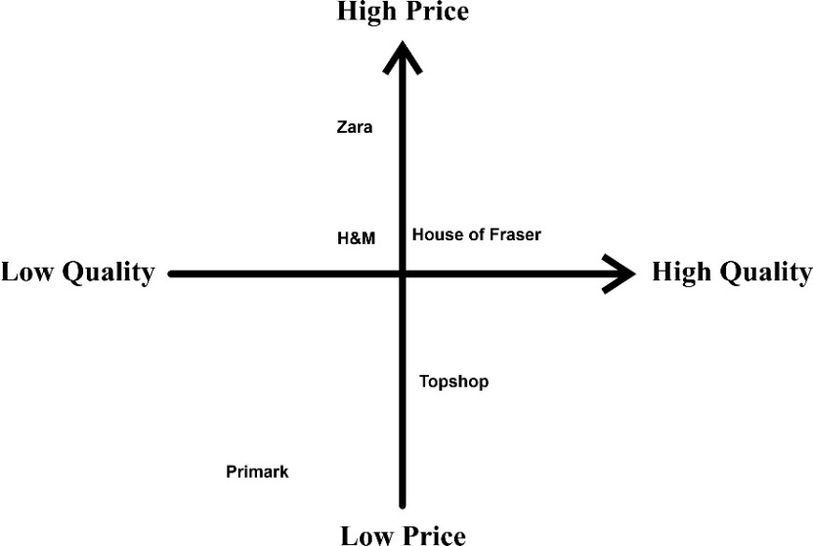
Figure01: Positioning map of Primark
(Source: made by the learner)

Competitive Advantage
The marketing strategy followed by Primark is proved to be successful,l which is displayed in its success. Primark has been successful in achieving a competitive advantage in its market by realising its mission of availing of standard quality products at affordable prices. Competitive advantage is the combination of tools or tactics used by a company to deliver products or services of better quality at a cheaper price compared to its competitors (Ali and Anwar, 2021).
The competitive advantage of Primark can be demonstrated by conducting Porter's generic strategy for the company. The generic strategy model of Porter displays the ability of an organisation to acquire a competitive advantage in a select segment of the market (Islami et al., 2020).
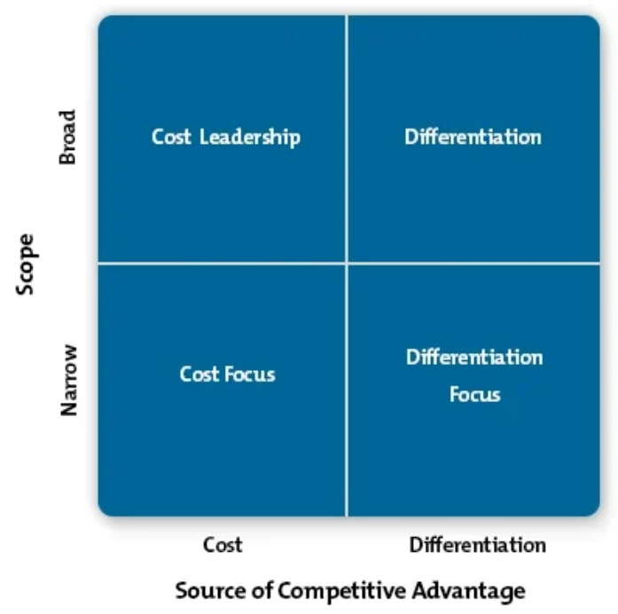
Figure02: Porter’s generic strategy
(Source: inspired by Islami et al., 2020)

Cost Leadership: It is the strategy of leading a wide market area in terms of the cost of products.
Differentiation: It is the strategy of leading a wide market area by making products different or better than competitors.
Cost Focus: In this strategy, a company focuses on a small segment of the market and aims to lead in terms of cost.
Differentiation Focus: This is the strategy of producing unique products for a relatively small segment of the market.
Primark follows the cost focus strategy of marketing where it aims to provide affordable products for consumers who look for low-budget fast fashion clothing and accessories.

Marketing Mix
A marketing mix analysis of the company may reveal the pros and cons of the marketing strategy used by Primark. The various tools combined which are used by a company to reach its marketing target in the market that it has selected is termed the marketing mix (Thabit and Raewf, 2018). It usually comprises four Ps - Product, Price, Placement and Promotion.

The 4 Ps of Marketing Definition for Primark company

Product
Primark distributes fast fashion apparel, footwear and accessories for men, women and children. A fundamental advantage that Primark has over most of its competitors is that it offers a wide range of products. The company offers a full range of women’s clothing collections ranging from regular wear, party wear, swimsuits, innerwear, footwear and sportswear (help.primark.com, 2022). The company’s men’s section includes formal and informal clothes, underwear, leisurewear, shoes and slippers. Primark also has a separate collection for boys, girls and babies in the kid’s section. The company does not produce its products, rather it collects the products from various suppliers.

Price
Primark’s competitive pricing strategy is the main tool that sets the company apart from its competitors. It consistently maintains the price of its products below the range of its competitors by applying various organisational tactics. The company saves costs in every step of its operations to accomplish its mission of availing of fast fashion at an affordable price range. Primark does not own its factories which spare the company of any manufacturing and factory maintenance cost (primark.com, 2022). It does not use expensive hangers, tags or labels on its products which further saves cost. Primark also refrains from mass media advertisement and depends mostly on word of mouth for the spread of its product news. It does not sell its products through online channels although the company maintains a basic website of its own with its product information.

Place
Primark sells its products through physical outlets spread around the UK and the US. At present, there are 398 stores owned by Primark all over the world among which 191 stores are situated in the United Kingdom (Smith, 2021). Although Primark does not offer its services online, some independent dealers resell Primark’s products through online portals of Amazon and Poshmark. Primark guides its customers to their nearest Primark store by providing a store locator on its website.

Promotion
The organisation cuts production costs by confining its advertising strategy mostly to word of mouth. Primark avoids traditional marketing methods but it launched an advertisement stunt in 2019 in the US called the ‘walking billboard’ (adsoftheworld.com, 2022). On the occasion of the reopening of one of its stores, the company put people carrying human-sized versions of their shopping bags in a busy shopping mall.

Conclusion

Through the analysis of the marketing strategy of Primark, it was found that the company strictly adheres to its mission of providing affordable products to its customers. To achieve this, the management of the company applies internal strategies to cut production and supply costs. The success of the company may be credited solely to its focus on the customer demand in its market segment. Primark has achieved success in its sector by the application of simple tactics that it openly reveals on its website. However, the company has limited its communication with customers within its stores which led to the losses it incurred in 2020. If the company used the facilities of internet marketing, it could have covered most of its losses like other retailing companies like Unilever. In the present information era and digital marketing, Primark must catch the current business trend. It needs to digitise its business immediately to achieve sustainable development.

References

Adsoftheworld.com, 2022. Walking Billboards [Online] Available at: https://www.adsoftheworld.com/campaigns/walking-billboards [Accessed 24 June 2022]
Ali, B.J. and Anwar, G., 2021. Business strategy: The influence of Strategic Competitiveness on competitive advantage. International Journal of Electrical, Electronics and Computers, 6(2).
Corporate.primark.com, 2022. HOW WE DO IT [Online] Available at: https://corporate.primark.com/en-us/primark-cares/how-primark-keeps-prices-low [Accessed 24 June 2022]
Dolnicar, S., Grün, B. and Leisch, F., 2018. Market segmentation analysis: Understanding it, doing it, and making it useful (p. 324). Springer Nature.
Help.primark.com, 2022. Product [Online] Available at: https://www.help.primark.com/hc/en-us/categories/115000165369-Product- [Accessed 24 June 2022]
Inderst, R. and Martin, O., 2022. Pricing and product positioning with relative consumer preferences.
Islami, X., Mustafa, N. and Topuzovska Latkovikj, M., 2020. Linking Porter’s generic strategies to firm performance. Future Business Journal, 6(1), pp.1-15.
Kartajaya, H., Setiawan, I. and Kotler, P., 2021. Marketing 5.0: Technology for humanity. John Wiley & Sons.
Kraaijenbrink, J., 2019. Why Is Primark So Successful? The Power Of Alignment [Online] Available at: https://www.forbes.com/sites/jeroenkraaijenbrink/2019/01/22/why-is-primark-so-successful-the-power-of-alignment/?sh=2f0e3331769d [Accessed 24 June 2022]
rimark.com, 2022. About Us [Online] Available at: https://www.primark.com/en-gb/about-us [Accessed 24 June 2022]
Smith, P., 2021. Primark - Statistics & Facts [Online] Available at: https://www.statista.com/topics/4684/primark/#dossierKeyfigures [Accessed 24 June 2022]
Smith, P., 2021. Revenue of the retail division of Associated British Foods worldwide from the financial year 2007 to 2021 [Online] Available at: https://www.statista.com/statistics/383785/primark-revenue-worldwide/ [Accessed 24 June 2022]
Thabit, T. and Raewf, M., 2018. The evaluation of marketing mix elements: A case study. International Journal of Social Sciences & Educational Studies, 4(4).

