MODULE: MARKETING MANAGEMENT

MODULE CODE: LCMB7024

LECTURER’S NAME: Laila Maazouz

STUDENT NAME: Kavya Nareshbhai Kankotiya
STUDENT ID: 2537035

WORD COUNT: 2559

Table of Contents
Task 1: Marketing Environment Analysis 3
1.1 Analysis of two external marketing environment actors 3
Task 2: Strategic Growth and Competitive Positioning 9
2.1 Recommendation of a strategic growth approach 9
2.2 Achieving the competitive edge through the lower-carbon business model 13
Task 3: Critical Reflection on AI Usage 16
a. Tool Disclosure 16
b. Critical Evaluation of AI Output 18
c. Contribution Analysis 18
d. Ethical & Professional Reflection 18
References 20

Task 1: Marketing Environment Analysis

1.1 Analysis of two external marketing environment actors
Natural Environment actor
The natural environment is considered as the most relevant external marketing environment actor that influences the transition of BHP towards the low-carbon products. According to Kotler et al. (2024), the natural environment consists of different factors like climate change, environmental degradation, scarcity of resources, and sustainability pressures, which affect the perception of organisational decision-making. In the case of BHP (Broken Hill Proprietary) Group, which is an Australian multinational mining and metals corporation, increased environmental concerns have reshaped the expectations of stakeholders, consumer demand, and operational strategies.
Climate change seems to be a major issue for the global mining sector, as mining and metals production strongly contributes to the emission of greenhouse gases (GHG). As of 2025, total GHG emissions through all sectors in Australia have been identified as 444.3 Mt CO2-e, and the emission change for the year to June 2025 was a reduction of 27.4% (Dcceew.gov.au, 2025).
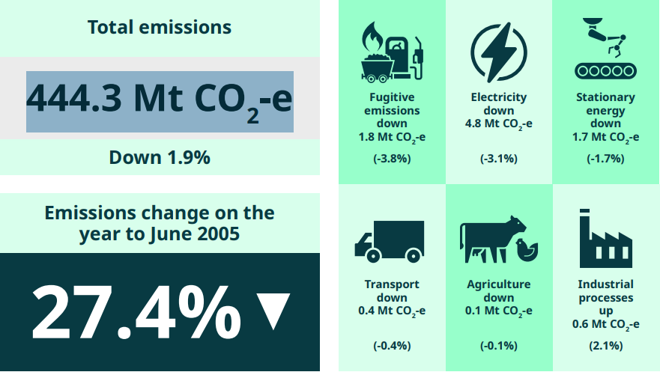
Figure 1: National greenhouse gas inventory
(Source: Dcceew.gov.au, 2025)
Existence of the scientific evidence regarding global warming has raised pressure on the mining firms for reducing their environmental impact and supporting the transition towards a low-carbon economy. By using the MIS (Marketing Information System) method, it has been observed that in the case of BHP, the firm has made a 36% reduction in operational GHG emissions in 2025 from 2020 (Lecture 3, slide 15; BHP, 2025). The firm’s 2030 goals consist of making a reduction of at least 30% in operational GHG emissions and support 40% GHG emissions intensity reduction of the BHP‑chartered shipping of its products (figure below).
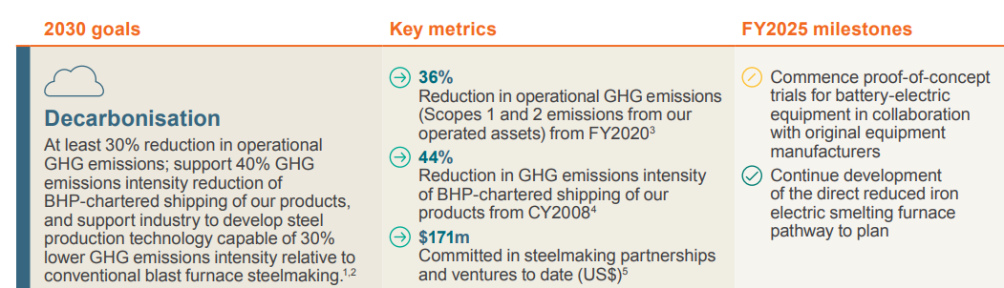
Figure 2: Sustainability performance of BHP in 2025
(Source: BHP, 2025)
In 2025, operational GHG emissions for BHP reached 8.7 MtCO2-e, and it aimed to achieve net-zero operational GHG emissions by 2050 (BHP, 2025). Moreover, the value chain GHG emission was observed as 378.2 MtCO2-e in 2025, which was a sharp increase from 2020 (Figure 3).
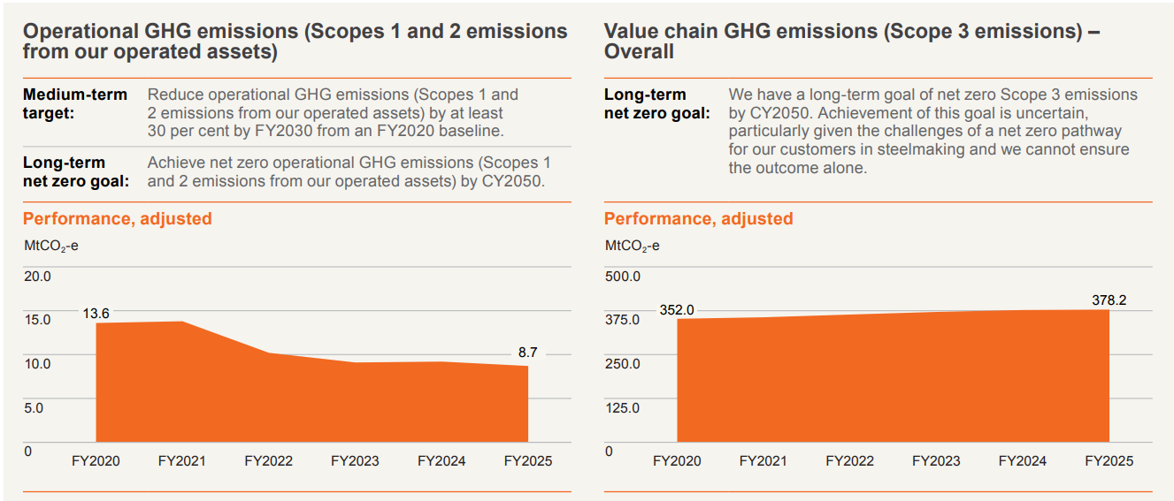
Figure 3: Operational and value chain GHG emissions
(Source: BHP, 2025)
The natural environment has transformed the consumers’ demand, and in the value chain of BHP. Steel production is accountable for a significant proportion of the global carbon emissions, and hence, steel manufacturers are acquiring lower-carbon materials at present for fulfilling the sustainability goals. In order to deal with this crisis, BHP has already made an investment of US$171 million in technologies for supporting the process of clear steelmaking (BHP, 2025). For instance, the firm has aimed to develop steel production technologies in such a way which are able of 30% lower GHG emissions (BHP, 2025). This reflects how external environmental pressure is developing opportunities for the BHP to differentiate itself through the sustainable innovation and lower-carbon products.
Moreover, environmental concerns are also responsible for encouraging BHP to make effective collaboration with the consumers and industry partners for accelerating the decarbonization process. With around US$140 million in funding committed by BHP from 2020 to 2024 and an estimated US$75 million in additional funding planned by the firm from 2025 to 2029, with the major steel producers like POSCO, Baowu, and others to accelerate its decarbonisation (BHP, 2024). Through this partnership, BHP is able to support the development of the “hydrogen-based steelmaking”, “carbon capture technologies”, and “low-carbon iron production” systems suitably. As an impact, there is a possibility to strengthen its market position among the environmentally conscious customers.
Operational changes are also being driven through the natural environment within BHP. Such extreme weather conditions, rising temperatures, scarcity of the water, and biodiversity concerns are raising risks for the mining operations. For dealing with these risks, BHP is investing in the renewable energy, electrification technologies, and battery-powered mining equipment. It has been found out that 70% of total electricity consumption in BHP was drawn from the renewable sources in 2025, and it has made partnerships with battery manufacturers like BYD and CATL for exploring the battery-powered solutions regarding the mining equipment and rail transport (Miningmx, 2026; Reuters, 2025). Through this type of initiative, it has been possible to reduce dependence on the diesel-powered machinery that is a main source of operational emissions.
Political / Regulatory Environment actor
The political and regulatory environment has been identified as another crucial external marketing environment actor that strongly influences the transition of BHP towards the lower-carbon products. The Australian government has integrated stricter policies to deal with climate issues, emissions regulations, and relevant sustainability standards, which affect the mining companies the most (Cer.gov.au, 2026).
The Safeguard Mechanism of the nation has been applied to the industrial facilities that emit more than 100,000 tCO₂-e in a year, which includes mining, oil & gas production, transport, manufacturing, and waste (Cer.gov.au, 2026). It mainly requires that the highest greenhouse gas emitting facilities of Australia reduce their emissions in line with the emission reduction target of the firm of 43% below 2005 levels by 2030 and net zero by 2050. However, the Safeguard Mechanism covers only a fraction of the nation’s GHG emissions, which is a major concern (Figure 4).
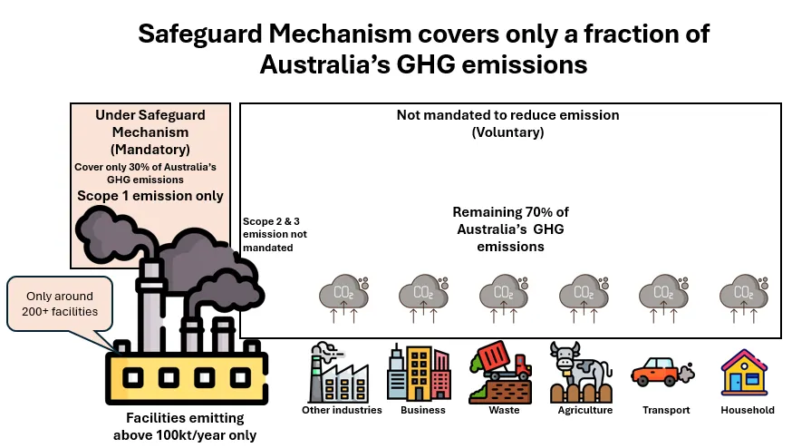
Figure 4: Safeguard Mechanism
(Source: Kusuma, 2025)
The presence of these regulations increases pressure on BHP for investing in the cleaner technologies as well as “low carbon production methods”.
However, in response to these regulations, BHP has aligned its corporate strategies strictly with the global and national climate objectives. The firm has made the commitment to achieve net-zero operational emissions by 2050 and support the reduction of GHG emissions throughout its value chain. The commitment to integrate advanced steel-making technologies for reducing the emission intensity by 30% by 2030 and other commitments showcase how the regulatory expectations strongly influence product developments and investment decisions, along with marketing strategies (BHP, 2025).
However, regulatory environments are also responsible for developing challenges. Here, decarbonisation requires the adequate capital investment in the renewable energy, technologies for carbon reduction, electrification, and emissions monitoring systems (Nekahi et al., 2025). The ability of the BHP to anticipate and respond properly to the regulatory changes can influence its long-term effectiveness quite suitably.

Task 2: Strategic Growth and Competitive Positioning

2.1 Recommendation of a strategic growth approach
The Ansoff Matrix is a strategic framework through which it is possible to identify the growth opportunities quite easily through market penetration, market development, product development, and diversification (Zugay and Zakaria, 2023).
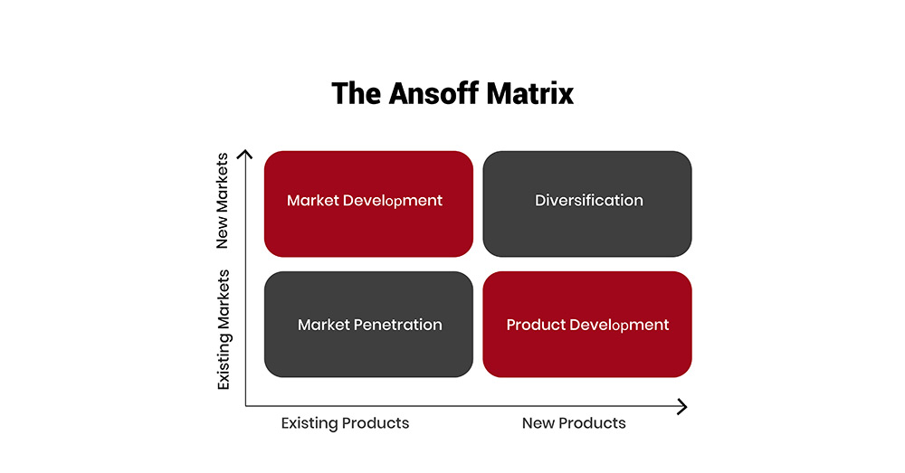
Figure 5: Ansoff matrix
(Source: Thestrategyinstitute.org, 2024)
From the above environmental analysis, it can be stated that product development is the most appropriate growth strategy for BHP, through which it can be possible to allow the organisation for introducing lower-carbon products along with the sustainable resource solutions to the existing consumers while responding to the increased environmental pressure. Rather than entering a new market, the firm must leverage its established position in the mining sector for developing certain products that can support the objectives related to decarbonisation and transition. As per the report, the mining waste management market size has reached US$219.83 billion in 2025 which is expected to reach US$235.39 billion at the end of 2026 and US$307.73 billion by 2030 with a CAGR of 6.9%, indicating the necessity for effective product development for BHP for reducing waste (Thebusinessresearchcompany, 2026).
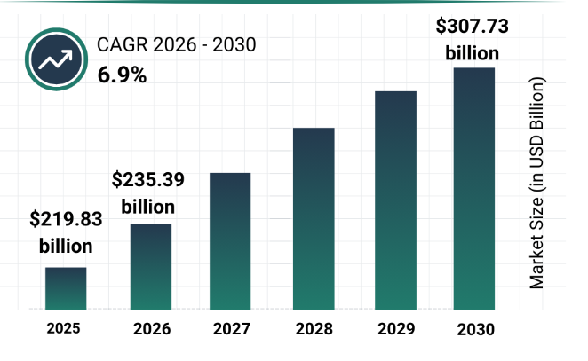
Figure 6: Mining waste management market
(Source: Thebusinessresearchcompany, 2026)
Product development is mostly essential as demand patterns within the mining sectors are mostly transformed by the deployment of the renewable energy, electrification, and adequate digitalisation. The portfolio of BHP is largely focused on the essential commodities for the low-carbon economy, such as copper. In 2025, the copper production of the firm increased by 8% to a record of over 2 million tons, which helped to ensure a net operating cash inflow of US$18.7 billion, decreased by US$2.0 billion from the previous year (figure below). This is developed through “lower average realized prices’, inflationary impacts on the cost base and inventory movements, especially offset by the record copper production as well as foreign exchange movements (BHP, 2025).
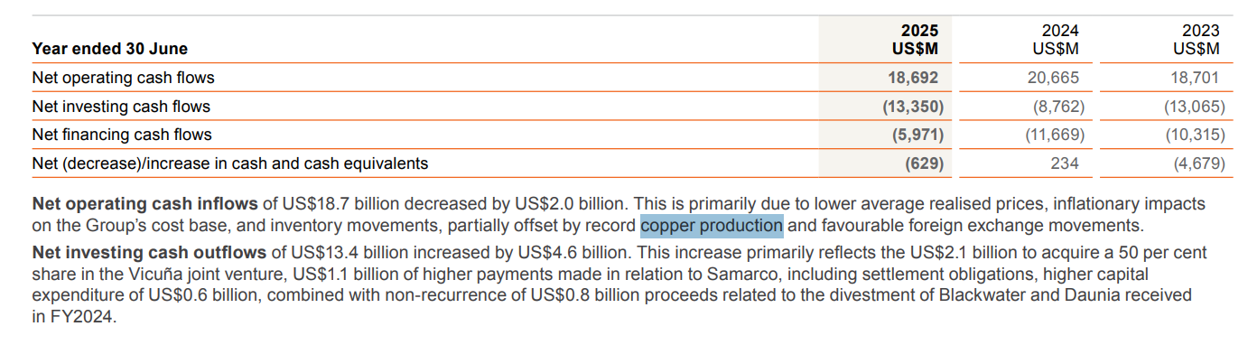
Figure 7: Cash flow statement by BHP in 2025
(Source: BHP, 2025)
This perception reflects the firm’s strategic emphasis on the commodities required for the renewable energy perceptions, EVs and electricity networks.
The rationale for the product development is also strengthened by the existence of long-term opportunities in the market. BHP finds out Copper as the most relevant resource regarding electrification and the “renewable power infrastructure”. The firm also expands its copper portfolio through the greater investments in several projects like the “Vicuña joint venture” and growth initiatives at the Escondida and Copper South Australia. Based on the report, it has been identified that BHP has invested US$800 million (US$1.12 billion) for the Argentinian copper push, which is expected to deliver greater positive outcomes for the long-term (Brown, 2026). Through these projects, it is also expected to enhance the annual production capacity of the firm and strengthen the ability of BHP for supplying materials essential for the low-carbon technologies.
Moreover, through the product development strategy, the firm can be able to move beyond the outputs of traditional mining and create such values through the innovative products consuming low carbon. Partnership with the steel manufacturers also enables the firm for improving the cleaner steelmaking technologies along with raw material solutions with lower emissions. For instance, the “Steel decarbonisation framework” has been designed by BHP for describing the technology pathways to decarbonize the global integrated iron as well as steel industry (BHP, 2026). Across the firm’s partnerships with the POSCO, Tata Steel, JEE, HBIS and Baowu, which are responsible for representing approximately 13% of the global “steel production capacity”, the firm is capable of incentivizing its sustainability perceptions (figure 8).
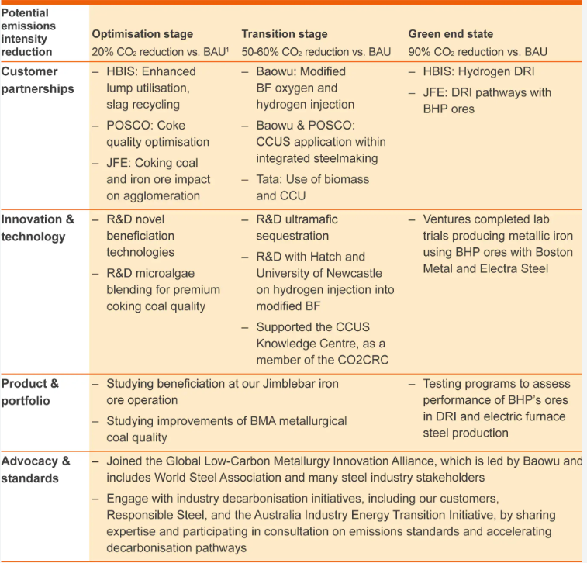
Figure 8: Steel decarbonisation framework by BHP
(Source: BHP, 2026)
This strategy seems to be well aligned with the evolving expectations of the customers, as manufacturers require such sustainable inputs for reducing their carbon footprints. By offering certain products which strongly contribute to the decarbonisation perception throughout the value chain, the BHP can be able to develop greater consumer connections. Moreover, the potential pathway to the firm’s operational GHG emissions long-term net zero goal beyond FY2030 will also require displacement of diesel emissions from mining vehicles and 100% low to zero GHG emissions electricity (figure below).
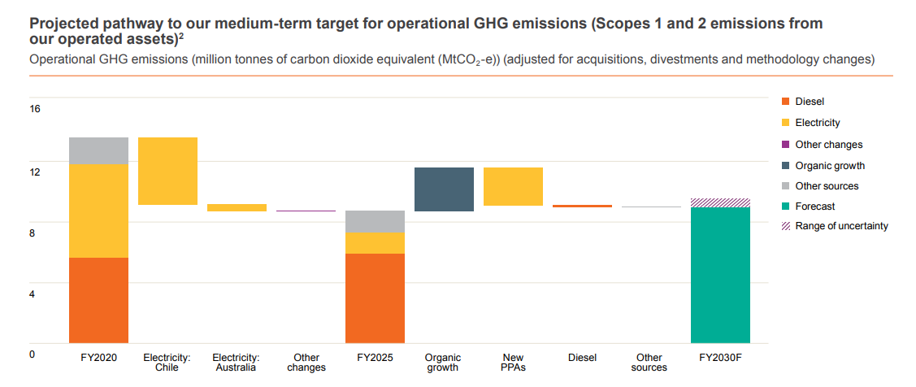
Figure 9: Projected pathway to BHP’s medium-term target for operational GHG emissions
(Source: BHP, 2026)
However, risk areas are also there as product development strategy requires a high investment of the capital and long developmental periods. In this regard, focus can be provided on the BHP’s Jansen potash project as the total investment for Stage 1 of this project would be expected to increase US$8.4 billion (BHP, 2026). Moreover, the first production schedule has reverted to the original schedule of mid-2027.

2.2 Achieving the competitive edge through the lower-carbon business model
BHP can acquire a competitive advantage by deploying sustainability within its business model and positioning itself as the leading supplier of resources essential for the global low-carbon transition. One of the significant advantages for the firm is its core focus on critical minerals like potash and copper that are essential for the renewable energy systems, such as EVs and sustainable agriculture. As per the report, renewable power capacity is projected to increase nearly 4,600 GW between 2025 and 2030, and the PV utility is expected to reach 2,046 GW between these years (IEA, 2025).
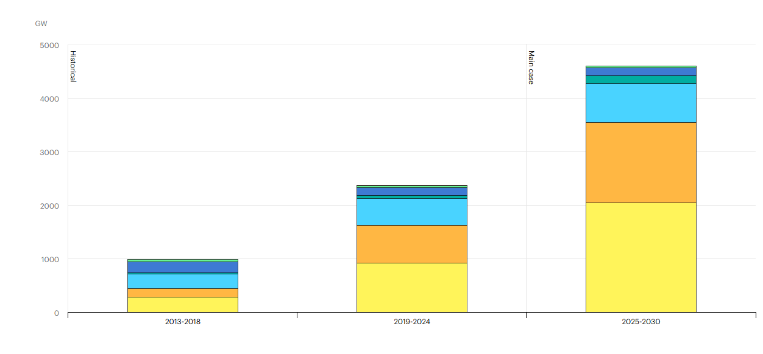
Figure 10: Renewable electricity capacity growth by technology segment from 2013 to 2030
(Source: IEA, 2025)
Moreover, global renewable energy capacity seemed to surge by 700 GW in 2025, showcasing the largest annual increase in history (Gupta, 2026). This type of rapid expansion is expected to facilitate the substantial demand for the minerals, and by increasing production of these resources, BHP can be able to strongly capitalize on the growth market.
BHP can also strengthen its competitive position through the operational efficiency and technical innovation. The firm already invests in electrification, automation and renewable energy projects for reducing the operational emissions and improving the area of productivity (BHP, 2025; Kennedy et al., 2026).
Another major source of competitive advantage for BHP is the greater access to sustainable finance. The report shows that the record global energy investment reached US$3.3 trillion in 2025, reflecting the increased support of the investors to ensure eco-friendly business (World Economic Forum, 2026). If BHP can demonstrate credible decarbonization strategies, then there will be a possibility to attract investment and secure funding for the future projects.

Task 3: Critical Reflection on AI Usage

a. Tool Disclosure
AI was used in a limited as well as supportive capacity at the time of preparing the report, and ChatGPT was taken into focus mainly for identifying the existing grammatical errors in the write-up, improving the structure of the sentences, enhancing the clarity and ensuring the report maintained a proper academic writing style (Mosaiyebzadeh et al., 2023). Apart from that, the tool was also used as the research-support mechanism for exploring the suitability of the strategic frameworks which were relevant for this research. For instance, a consultation with ChatGPT has been conducted to compare the Ansoff Matrix and Porter’s Generic Strategies in order to find out which one best aligns with the requirements of the assessment. The evidence has been provided below:
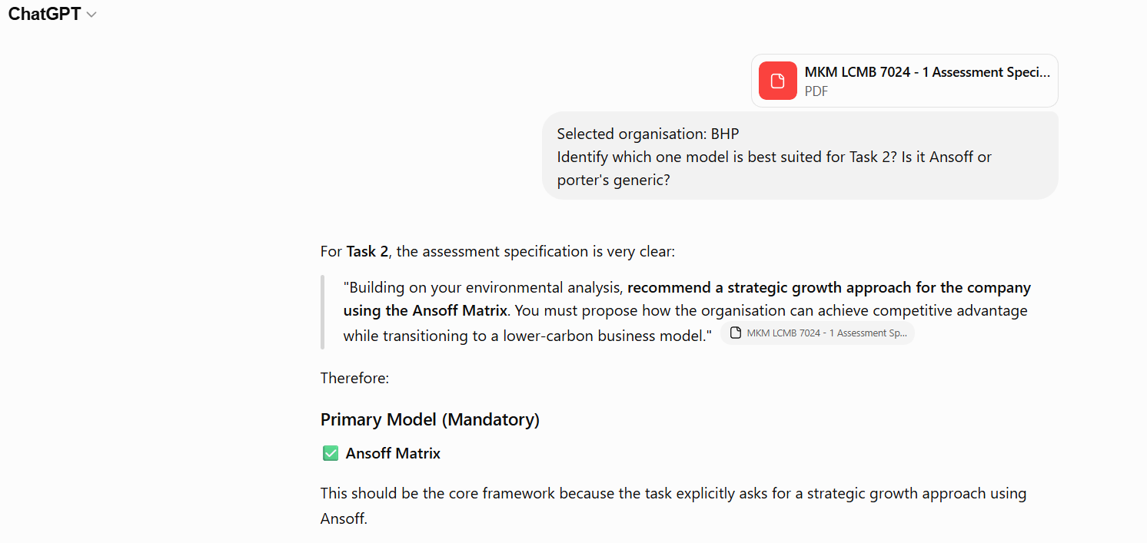
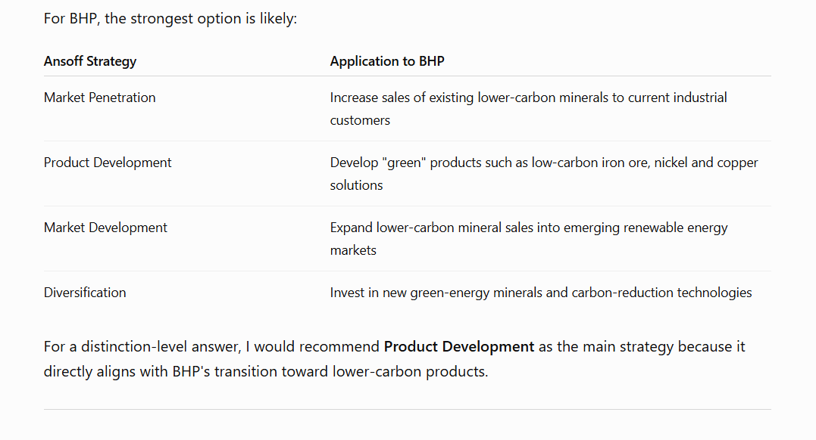
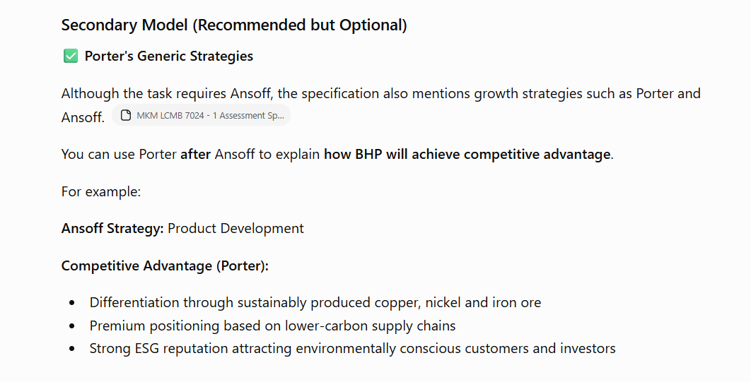
Figure 11: Evidence of research on ChatGPT
(Source: Self-developed)
Above all, it can be stated that the AI was therefore restricted to proofreading, refinement of language, and adequate research support in connection with the guidelines of the AI usage provided in the brief of the assessment.

b. Critical Evaluation of AI Output
Although AI delivered such essential suggestions, but all of the outputs were reviewed carefully and verified properly before using them in the assessment. Information which was generated by ChatGPT was cross-checked properly against the credible academic as well as industry sources, like the annual report of the BHP, its sustainability report, industry reports and the government publications. At the verification process, some of the AI-generated suggestions were taken into focus, and they found them unsuitable after cross-checking in comparison to the assignment requirements. For example, although AI suggested the use of the Ansoff matrix as the primary model and Porter’s generic as the secondary model, after cross-checking the requirements of the assignment, it was determined that the use of the matrix would be relevant only as the second task specifically required the recommendation on a growth strategy. Any unsupported information and unclear recommendations were excluded as well.

c. Contribution Analysis
The final assessment reflected my own work and analysis, as through AI, I only got certain ideas where I faced difficulties. My contribution included the selection of BHP as the main organisation, identifying the core factors like Political/Regulatory actors, along with the environment. I also collected the reliable statistical evidence from reputable websites and reports, demonstrating the environmental influences and evaluating the strategic growth option for BHP. ChatGPT was used only for improving the grammar, readability, and selection of the model for Task 2.

d. Ethical & Professional Reflection
AI can improve the efficiency level by assisting with the proper organisation of data, proofreading, and offering preliminary research. However, such high reliance on the AI can minimise the perception of critical thinking and increase the risk of integrating inaccurate information within the academic as well as professional work. Apart from that, AI-generated content also contains false information and unsupported claims. In this research, AI was employed quite responsibly as a support tool rather than a substitute for the independent analysis.

References
BHP, (2024). Pathways-towards-steelmaking-decarbonisation. Available at: https://www.bhp.com/es/news/bhp-insights/2024/10/pathways-towards-steelmaking-decarbonisation (Accessed: 3 June 2026).
BHP, (2025). Annual Report 2025. Available at: https://www.bhp.com/-/media/documents/investors/annual-reports/2025/250819_bhpannualreport2025.pdf (Accessed: 1 June 2026).
BHP, (2026). Update - Jansen Stage 1 Potash Project. Available at: https://www.bhp.com/news/media-centre/releases/2026/01/jansen-update (Accessed: 6 June 2026).
BHP, (2026). Value chain (Scope 3) greenhouse gas emissions. Available at: https://www.bhp.com/sustainability/climate-change/reducing-our-value-chain-emissions (Accessed: 5 June 2026).
Brown, D., (2026). BHP’s billion-dollar Argentinian copper push. Available at: https://www.australianresourcesandinvestment.com.au/2026/02/10/bhps-billion-dollar-argentinian-copper-push/ (Accessed: 4 June 2026).
Cer.gov.au, (2026). Safeguard Mechanism. Available at: https://cer.gov.au/schemes/safeguard-mechanism (Accessed: 2 June 2026).
Dcceew.gov.au, (2025). National Greenhouse Gas Inventory. Available at: https://www.dcceew.gov.au/sites/default/files/documents/sept-2025-quarterly-update-infographic-full-size.pdf (Accessed: 1 June 2026).
Gupta, S., (2026). Near-700 GW Surge in 2025 Proves Renewable Energy Resilience – EQ. Available at: https://www.eqmagpro.com/near-700-gw-surge-in-2025-proves-renewable-energy-resilience-eq/ (Accessed: 8 June 2026).
IEA, (2025). Renewable electricity. Available at: https://www.iea.org/reports/renewables-2025/renewable-electricity (Accessed: 9 June 2026).
Kennedy, S.M., M, K., P, N. and A, G.B., (2026). ‘Development and analysis of biodegradable PVA biofilms reinforced with Benincasa hispida peel powder for sustainable packaging applications’. Journal of Adhesion Science and Technology, 40(5), pp.849-867. Available at: https://www.tandfonline.com/doi/abs/10.1080/01694243.2025.2569655
Kotler, P., Armstrong, G., Harris, L.C. and He, H. (2024) Principles of marketing. 19th edn. Harlow: Pearson.
Kusuma, D., (2025). Australia’s Carbon Pricing: A Model for Developing Countries? Available at: https://dannykusuma.medium.com/australias-carbon-pricing-a-model-for-developing-countries-caa6d07471d2 (Accessed: 2 June 2026).
Miningmx, (2026). BHP scales back once critical decarbonisation plans. Available at: https://www.miningmx.com/news/markets/65423-bhp-scales-back-once-critical-decarbonisation-plans/ (Accessed: 3 June 2026).
Mosaiyebzadeh, F., Pouriyeh, S., Parizi, R., Dehbozorgi, N., Dorodchi, M. and Macêdo Batista, D., (2023), October. ‘Exploring the role of ChatGPT in education: Applications and challenges’. In Proceedings of the 24th annual conference on information technology education (pp. 84-89). Available at: https://dl.acm.org/doi/pdf/10.1145/3585059.3611445
Nekahi, A., Anil Kumar, M.R., Deng, S., Li, X., Petropoulos, A., Nanda, J. and Zaghib, K., (2025). ‘Toward green renewable energies and energy storage for the sustainable decarbonization and electrification of society’. Electrochemical Energy Reviews, 8(1), p.12. Available at: https://doi.org/10.1007/s41918-025-00247-y
Reuters, (2025). BHP takes steps with CATL, BYD to use more batteries, cut emissions. Available at: https://www.reuters.com/sustainability/climate-energy/bhp-signs-deals-with-catl-byd-use-batteries-mines-vehicles-2025-07-14 (Accessed: 4 June 2026).
Thebusinessresearchcompany, (2026). Mining Waste Management Market Report 2026. Available at: https://www.thebusinessresearchcompany.com/report/mining-waste-management-global-market-report Accessed: 9 June 2026).
Thestrategyinstitute.org, (2024). The Ansoff Matrix: A Powerful Tool for Business Strategy and Growth. Available at: https://www.thestrategyinstitute.org/insights/the-ansoff-matrix-a-powerful-tool-for-business-strategy-and-growth (Accessed: 10 June 2026).
World Economic Forum, (2026). Energy Transition Index 2026. Available at: https://www.weforum.org/publications/energy-transition-index-2026/ (Accessed: 7 June 2026).
Zugay, B. and Zakaria, R., (2023). Ansoff matrix. SAGE Publications, Inc..

