Assessment 1: Compare and contrast two approaches to the development of sustainable communities and critique these using a sustainability theory of your choice.
This submission will compare two approaches to the development of sustainable communities. Approach 1 [A1] will explore the concept of the 20-minute neighbourhood, using The Abbey Estate in Thetford as an example, where this approach is currently awaiting planning permission. Approach 2 [A2] will explore the concept of an eco-village, drawing upon the example of The Beddington Zero Energy Development [BedZED] community in South London. Through an eco-socialist lens, this submission will highlight the complexities involved in redeveloping an existing community [A1] alongside a purpose-built community where the motivation is to live more sustainably [A2]. It will conclude that in this instance, both approaches towards creating a sustainable community are remarkably different. While eco-socialism can be applied to highlight the social and environmental factors in each approach, meeting social needs are a necessity in A1, whereas the environmental factors are more prominent in A2.
Multiple components are required to create a sustainable community (Egan, 2004, p.19, fig. 1). The Institute for Sustainable Communities (2025, np) states that for a sustainable community to thrive, it must consider a plethora of human needs alongside a variety of perspectives, ensuring that all feel safe and welcome. Rodriguez (2015, np) adds that the impetus for sustainable communities is based upon the premise that when economic growth, prosperity and sustainability are prioritised and invested into communities, poverty can be reduced through better employment opportunities, people are naturally healthier, and individuals generally lead much happier lives.
Löwy (2005, p.18) defines eco-socialism as a sequence of thoughts and actions surrounding ecology that ‘appropriates the fundamental gains of Marxism’. In essence, Löwy (2005, p.15) asserts that socialism and ecology bear similarities in the quest to create a fairer world. From a socialist perspective, emphasis is placed upon people’s needs and the desire for social equality; for ecologists, the protection of the natural environment and ecological balance takes precedence (Lowy, 2005, p.15). Thus, when the two are combined, eco-socialism jointly places the needs of society and the environment at the forefront to allow both to exist and thrive in harmony.

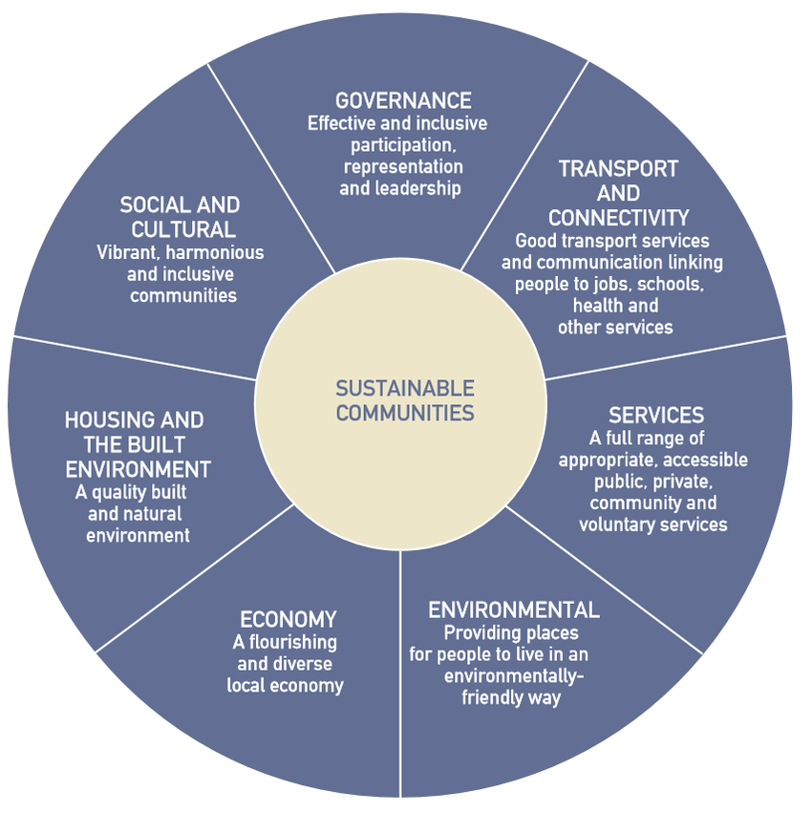
Figure 1: Components of Sustainable Communities

(Egan, 2004, p.19)
The 20-minute neighbourhood model is a proposition that is attracting growing interest from local and national governments worldwide (Olsen et al., 2022, p.1). The key objective of this approach is to mitigate inequality together with meeting net zero carbon emission targets by providing individuals with a desirable place to live, work and enjoy leisure activities; all within 20-minutes by foot, bicycle or public transport (Improvement Service, 2021, p.3; Town and Country Planning Association [TCPA], 2025, np). To succeed, Haugen (2011, p.373) highlights the importance of the proximity of essential services, such as schools and medical centres alongside grocery stores and community spaces.
The second approach towards achieving a sustainable community is through the creation of ecovillages. Gilman (1991, para 2) defines an ecovillage as:
A human-scale, full-featured settlement, in which human activities are harmlessly integrated into the natural world in a way that is supportive of healthy human development and can be successfully continued into the indefinite future (Gilman, 1991, para 2).

Xue (2014, p.132) adds that while the concept of an eco-village is largely based upon societal degrowth, capacity remains to develop social, economic and political activities through the promotion of localism; the ‘micro aspects’ of the political system and how groups interact and support one another (Harmes, 2021, p.1). Comparatively, both approaches aim to mitigate the effects of climate change on par with fulfilling human needs which is advantageous within eco-socialism.
The 20-minute neighbourhood model (A1) intends to be implemented in a neighbourhood in Thetford known as The Abbey Estate. Built in the 1960’s to safely separate cars from pedestrians, the Radburn design has resulted in ‘convoluted, confusing streets’ which are mostly ‘unobserved and unsafe’ (TCPA, 2023, np). Using the Indices of Multiple Deprivation [IMD] (Ministry of Housing, Communities and Local Government [MHCLG], 2019, np), Figure 2 shows that The Abbey Estate falls within the top 10 per cent of the most deprived regions in the UK, with high levels of anti-social behaviour, poor public transportation and a lack of suitable employment (Breckland Council, no date, pp. 21-27). By way of resolution and to generate regrowth into the estate, the Flagship Group, who own 60 per cent of the housing, have long-term plans to implement the 20-minute neighbourhood model (TCPA, 2023, np). In short, this radical redevelopment would allow for additional greener spaces inclusive of cycling paths and safer walking routes, a community centre as well as improved transport connections to the main town (Flagship Group, 2024a, p.6). Research by Haugen (2011, p.384) has shown that adequate access to services, like the ones in this proposal, can be linked to heightened satisfaction surrounding quality of life and general ease in fulfilling daily routines while living more sustainably. As a social landlord, the Flagship Group (2024b, np) has been clear that this regeneration project will not profit from the development and any surplus funds will be injected back into the community. This is relevant from an eco-socialist perspective given that Somerville (2021, p.44) argues that eco-socialism holds capitalism in contempt. Thus, the suggested proposal of a fully funded regeneration project that will invest in the community is desirable as it could assist in improving the lives of the residents as well as the environment around them.
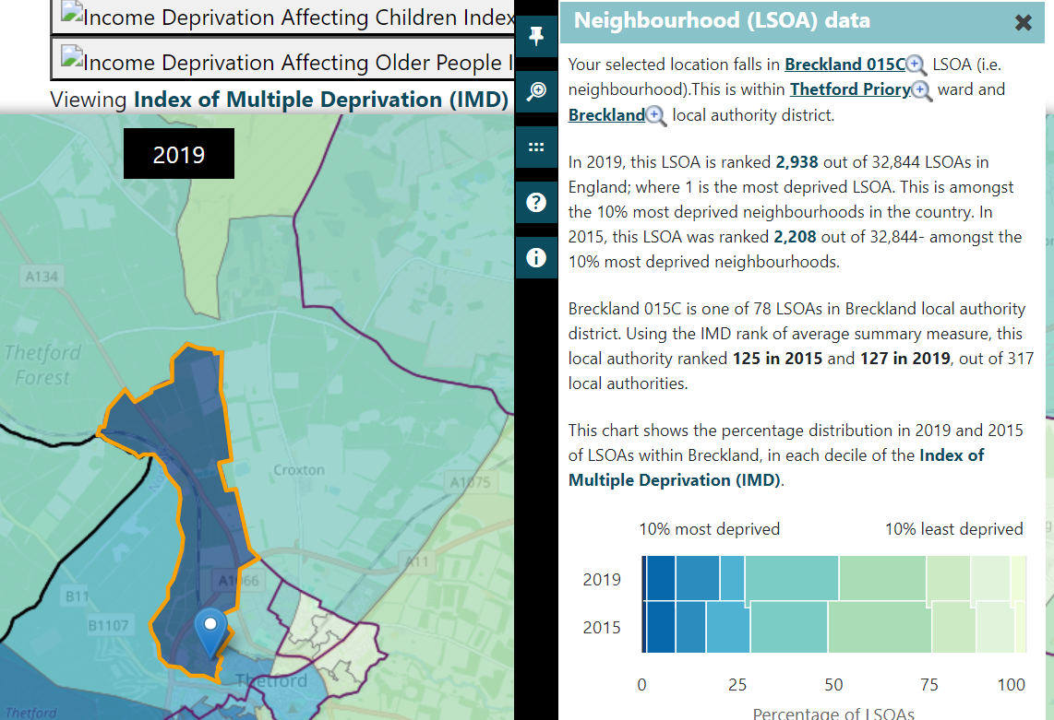
Figure 2: Indices of Deprivation: 2019 and 2015

(MHCLG, 2019, np)

One example of an eco-village can be found in South London. BedZED (A2) is the UK’s first large-scale sustainable community known for its environmentally friendly and low-carbon housing development (Bioregional, 2016, p.2). Completed in 2002 with sustainability and the environment at its core, residents can make use of incentives to reduce the need for travel as well as making significant savings on living costs such as their water usage and energy consumption (Bioregional, 2009, pp.21-26). This has proved successful with quantitative data from 2015 showing that energy bills were 68 per cent less than the average home in London (Bioregional, 2016, p.17). Moreover, Bioregional (2016, p.17) claim that further savings are made through BedZED’s city car club membership, where the cost of running a car was reduced by 13 percent, equating to an estimated saving of £297 a year. These figures assist in demonstrating that when the correct infrastructure is applied, savings can be made whilst reducing one’s carbon footprint. Similarly in A1, the Flagship Group’s (2022, p.7) redevelopment plan is to make it more viable to travel within and around The Abbey through several initiatives such as car club schemes and improved cycle networks. As it has been established that unemployment is a contributing factor of the communities’ high level of deprivation (Breckland Council, no date), providing better access to the main town via improved public transport networks could result in more employment opportunities whilst reducing the need for car ownership. This is supported by Capasso Da Silva, King and Shea (2020, p.2) who state that typically, it is easier for those seeking employment if they can access the place offering the greatest number of jobs. In addition, more employment could also help facilitate a more progressive local economy.
In principle, the proposition in A1 could be incredibly beneficial to the community in the long term. However, it is facing challenges and criticisms from members of the community. Cognetti (2023, p.20) stresses that public participation in the regeneration of social housing estates can ‘educate the stakeholders’ and guide them throughout the redevelopment process. In this instance, some residents of The Abbey have rejected the proposed plans with fears that the redevelopment of existing homes alongside the creation of new ones will leave some disadvantaged financially (Issimdar and Goreham, 2024). Others report that they will lose access to their green spaces (Thetford Town Council, 2024, np). Although the Flagship Group (2024b, np) have made assurances that this will not be the case, this criticism highlights the complexity of a large-scale redevelopment, even when the intention seems well placed. Eco-socialism can be used here to highlight the importance of ensuring social security to individuals. In essence, if the immediate needs of the community are not met and there are underlaying uncertainties, there is a risk that the subject of sustainability will be a second thought and the components of what makes a sustainable community will not be met, as seen in Figure 1 (Egan, 2004, p.19). This is supported in the work of Neef (1991, p.32) and his theory of ‘Matrix of Needs and Satisfiers’. In short, Neef (1991, p.32) classes protection as one of the nine essential human needs, grouping autonomy, social security and solidarity, to name a few, as fundamentals in the development of human beings. This underlines the importance of gaining the trust of the community before the restoration can begin. In contrast to A2, the story of life in a purposed built eco village is entirely different.
Given BedZED’s eco-friendly nature, Bioregional (2016, p.13) suggests that this development attracts a particular demographic of people who are keen to live environmentally friendly lifestyles. This relates to what Wagner (2012, p.60) refers to as the ‘culture of sustainability’ whereby one assesses how humans not only treat themselves and others, but also the environment around them. Together, this mutual like-mindedness amongst inhabitants surrounding sustainability allows their community to flourish. This is referenced in one study by Bioregional (2009, p.9) who documented that the sense of community was what residents liked most about BedZED, supporting the overall quality of resident’s lives and wellbeing. From an eco-socialist perspective, this approach is favourable as it fulfils people’s social needs alongside maintaining the natural environment. This is remarkably different to A1, because although a strong community spirit does exist (TCPA, 2025, np), the prospect of creating a 20-minute neighbourhood is a contentious issue (Issimdar and Goreham, 2024; Thetford Town Council, 2024). Here in lies the contrast, as those living in BedZED have the means to make the choice to live there, whereas those in The Abbey may not have the same freedoms due to the levels of deprivation. This is supported with data from the IMD (MHCLG, 2019, np) which shows that the area where BedZED is located is amongst the top 40 per cent least deprived neighbourhoods in the UK, meaning domains such as employment, income and education are higher in comparison to other places in the country, including Thetford. This underlines an imbalance between the two approaches, particularly surrounding the social elements which are integral in a sustainable community (Egan, 2004, p.19). Moreover, the sheer scale of the redevelopment in A1 means that the lives of the habitants are likely to experience disruption over a span of approximately fifteen to twenty years (Flagship Group, 2024a, p.4). This is a level of endurance that purpose built, eco villages like BedZED have not had to endure.
To conclude, this submission has established that in principle, both approaches consider the needs of the environment and human beings (Improvement Service, 2021; TCPA, 2025; Gilman, 1991; Xue, 2014), of which both are key in the makeup of sustainable communities (Egan, 2004; The Institute for Sustainable Communities, 2025). Based on the literature surrounding eco-socialism (Löwy, 2005; Somerville, 2021), the fact that there are considerations for social and environmental factors in the two approaches is positive. This similarity between the two is evident amongst both examples used in this submission, especially regarding the environmental aspect of each design (TCPA, 2023; Bioregional, 2016; Flagship Group, 2024a). Having said this, the differences between the two approaches are distinctive. At this stage, A1 is merely a design, while A2 is an active example of a sustainable community. In A1, the level of deprivation means implementing a 20-minute neighbourhood seems entirely plausible (MHCLG, 2019, Breckland Council, no date; Haugen, 2011). However, this submission has established that there are several complexities largely relating to the social factors of the community (TCPA, 2023; Issimdar and Goreham, 2024; Thetford Town Council, 2024). Hence, if communities are to be truly sustainable, ensuring that residents are included in the planning process of redevelopments, regardless of criticism, is of the upmost importance to ensure that their needs are met (Cognetti, 2023; Neef, 1991). In contrast, BedZED is an example of what a sustainable community can be when the correct infrastructure is invested in (Bioregional, 2009, 2016), proving that it is possible for eco-villages to succeed on a large scale, even in urban environments. In essence, these examples have highlighted a disparity between the culture of sustainability (Wagner, 2012). A1 shows that when implementing these initiatives into real life, especially into a deprived area, the future of the natural environment is synonymous with improving the lives of residents. In contrast, the main ethos of an eco-village, as seen in A2, is to make a progressive stance in living sustainably, often with likeminded people (Bioregional, 2009; 2016). Thus, the eco-village is a strong contender against the 20-minute neighbourhood given that it fulfils more components of a sustainable community (Egan, 2004). However, the challenges and time involved in modifying long standing neighbourhoods like The Abbey Estate should not be underestimated and must be done with support from the community if it is to be viable.

.
,

Reference List
Bioregional. (2009) ‘BedZED seven years on: The impact of the UK’s best known eco-village and its residents’. Available at: BedZED-7-years-on_Bioregional_Peabody_2009.pdf. (Accessed: 16 January 2025).
Bioregional. (2016) ‘The BedZED Story: The UK’s first large-scale, mixed-use eco-village’. Available at: The-BedZED-Story_Bioregional_2017.pdf. (Accessed: 15 January 2025).
Breckland Town Council. (no date) ‘Thetford’s Town Delivery Plan: 2021-2030’. Available at: Thetford Town Delivery Plan. (Accessed: 13 January 2025).
Capasso Da Silva, D., King, D.A. and Lemar, S. (2020) ‘Accessibility in Practice: 20-Minute City as a Sustainability Planning Goal’, Sustainability, 12(1), pp.1-20. Available at: Accessibility in Practice: 20-Minute City as a Sustainability Planning Goal - ProQuest. (Accessed: 14 January 2025).
Cognetti, F. (2022) ‘Beyond a Buzzword: Situated Participation Through Socially Oriented Urban Living Lives’, in Aernouts, N., Cognetti, F. and Maranghi, E (eds) Urban Living Lab for Local Regeneration: Beyond Participation in Large-scale Social Housing Estates. Switzerland: Springer, pp. 19 – 37. Available at: Urban Living Lab for Local Regeneration : Beyond Participation in Large-scale Social Housing Estates. (Accessed: 20 January 2025).
Egan, J. (2004) ‘The Egan Review: Skills for Sustainable Communities’. 04UPU1892. Available at: Egan Review Skills for sustainable Communities.pdf. (Accessed: 10 January 2025).
Flagship Group. (2022) ‘Streets and Parking’. Available at: 221005_streets-and-parking-brochure_print.pdf. (Accessed: 21 January 2025).
Flagship Group. (2024a) ‘The Abbey: A Guide to Planning’. Available at: abbey-planning-2024.pdf. (Accessed: 14 January 2025).
Flagship Group. (2024b) ‘Your questions, answered’. Available at: Your questions, answered - Flagship Group. (Accessed: 17 January 2025).
Gilman, R. (1991) ‘The Eco-village Challenge: The challenge of developing a community living in balanced harmony - with itself as well as nature - is tough, but attainable’, Living Together. Available at: The Eco-village Challenge. (Accessed: 15 January 2025).
Harmes, R. (2021) Localism and the design of political systems. 1st ed. London: Routledge, Taylor & Francis Group. Available at: Localism and the Design of Political Systems‬‎ - Record details‬‎ - EBSCOhost Research Databases‬‎‬‬‬. (Accessed: 20 January 2025).
Haugen, K. (2011) ‘The advantage of 'near': Which accessibilities matter to whom?’, European Journal of Transport and Infrastructure Research, 11(4), pp. 368-388. Available at: The advantage of 'near' : Which accessibilities matter to whom?. (Accessed: 10 January 2025).
Improvement Service. (2021) ‘Elected Member Briefing Note: 20 Minute Neighbourhoods’. Available at: Elected Member Briefing Note: 20 Minute Neighbourhoods. (Accessed: 11 January 2025).
Institute for Sustainable Communities. (2025) ‘What is a Sustainable Community?’. Available at: What is a Sustainable Community? - Institute for Sustainable Communities. (Accessed: 10 January 2025).
Issimdar, M and Goreham, C. (2024) ‘Thetford Abbey Estate plans criticised by landlord and councillor’. BBC. Available at: Thetford Abbey Estate plans criticised by landlord and councillor - BBC News. (Accessed: 17 January 2025).
Löwy, M. (2005) ‘What is ecosocialism?’, Capitalism Nature Socialism, 16(2), pp. 15–24. Available at: Full article: What is ecosocialism?. (Accessed: 11 January 2025).
Ministry of Housing, Communities and Local Government. (2019) ‘Indices of Deprivation: 2019 and 2015’. Available at: Indices of Deprivation 2015 and 2019. (Accessed: 12 January 2025).
Neef, M. (1991) Human Scale Development: Conception, Application and Further Reflections. New York: The Apex Press. Available at: Full page fax print. (Accessed: 22 January 2025).
Olsen, J.R., Thornton, L., Tregonning, G. and Mitchell, R. (2022) ‘Nationwide equity assessment of the 20-min neighbourhood in the Scottish context: A socio-spatial proximity analysis of residential locations’, Social Science & Medicine, 315, pp.1-12. Available at: Nationwide equity assessment of the 20-min neighbourhood in the scottish context: A socio-spatial proximity analysis of residential locations. (Accessed: 11 January 2025).
Rodriguez, L. (2015) ‘How sustainable cities can improve lives’. World Economic Forum. Available at: How sustainable cities can improve lives | World Economic Forum. (Accessed: 10 January 2025).
Somerville, P. (2021) ‘Revisiting Connections between Capital and Nature II: The Case of Climate Change’, Capitalism Nature Socialism, 32(2), pp.40-55. Available at: Full article: Revisiting Connections between Capital and Nature II: The Case of Climate Change. (Accessed: 15 January 2025).
Thetford Town Council. (2024) ‘Thetford Town Council vote to support objection letter regarding the redevelopment plans of Thetford’s Abbey Estate’. Available at: Press Release: Thetford Town Council vote to support objection letter regarding the redevelopment plans of Thetford’s Abbey Estate. | Thetford Town Council. (Accessed: 17 January 2025).
Town and Country Planning Association. (2023) ‘Regenerating a post war housing estate’. Available at: Regenerating a post war housing estate - Town and Country Planning Association. (Accessed: 13 January 2025).
Town and Country Planning Association. (2025) ‘The 20-minute neighbourhood’. Available at: The 20-minute neighbourhood - Town and Country Planning Association. (Accessed: 11 January 2025).
Wagner, F. (2012) ‘Toward the Future’, in Andreas, M. and Wagner, F (eds) Realizing Utopia: Ecovillage Endeavors and Academic Approaches. Munich: Rachel Carson Centre, pp.57-72. Available at: rachel_layout_issue8_2013.indd. (Accessed: 17 January 2025).
Xue, J. (2014) ‘Is eco-village/urban village the future of a degrowth society? An urban planner's perspective’, Ecological Economics, 105, pp.130-138. Available at: Is eco-village/urban village the future of a degrowth society? An urban planner's perspective - ScienceDirect. (Accessed: 14 January 2025).

