Module Code: BMHP5015
Module Title: Changemakers: Building your Personal Brand for Sustainable Employment
Assessment: Component 1 – Online Portfolio
Student Name: Ishrat Hussain
Student Number: 2318968
Lecturer name: Danielle Dunne

(Professional Focus: Health and Wellbeing Practitioner (UK Health and Social Care Sector)
Task 1 – Personal Brand
My personal brand as an aspiring Health and Wellbeing Practitioner focuses on compassion, professionalism, and empowerment. I aim to support individuals in improving their physical, mental, and emotional wellbeing through holistic and person-centred approaches. My brand values are empathy, reliability, and continuous learning. These values align closely with the NHS Constitution (NHS England, 2023), which emphasises respect, dignity, and quality of care.
To strengthen my personal brand, I plan to develop stronger communication and digital health skills. According to Skills for Care (2023), effective self-promotion, digital literacy, and reflective practice are essential employability skills within modern health and social care settings. I will use LinkedIn to showcase my experience, join professional forums, and participate in Continuing Professional Development (CPD) opportunities. By adopting a growth mindset and seeking feedback from mentors, I can enhance my credibility and demonstrate readiness for professional roles.
Building a visible, authentic personal brand will help me connect with employers who share my values of inclusivity and holistic care. Furthermore, I plan to demonstrate my brand through volunteering in community wellbeing projects, showcasing reliability and integrity. Reflecting regularly using models such as Gibbs’ cycle will help me align my actions with my values and refine my personal narrative as a practitioner.
References:
NHS England (2023) The NHS Constitution for England. London: Department of Health and Social Care.
Skills for Care (2023) Developing Your Personal Brand in Social Care. Leeds: Skills for Care.

Task 2 – Network Map showing “Career”, “Support”, “Social”, and Community” connections]

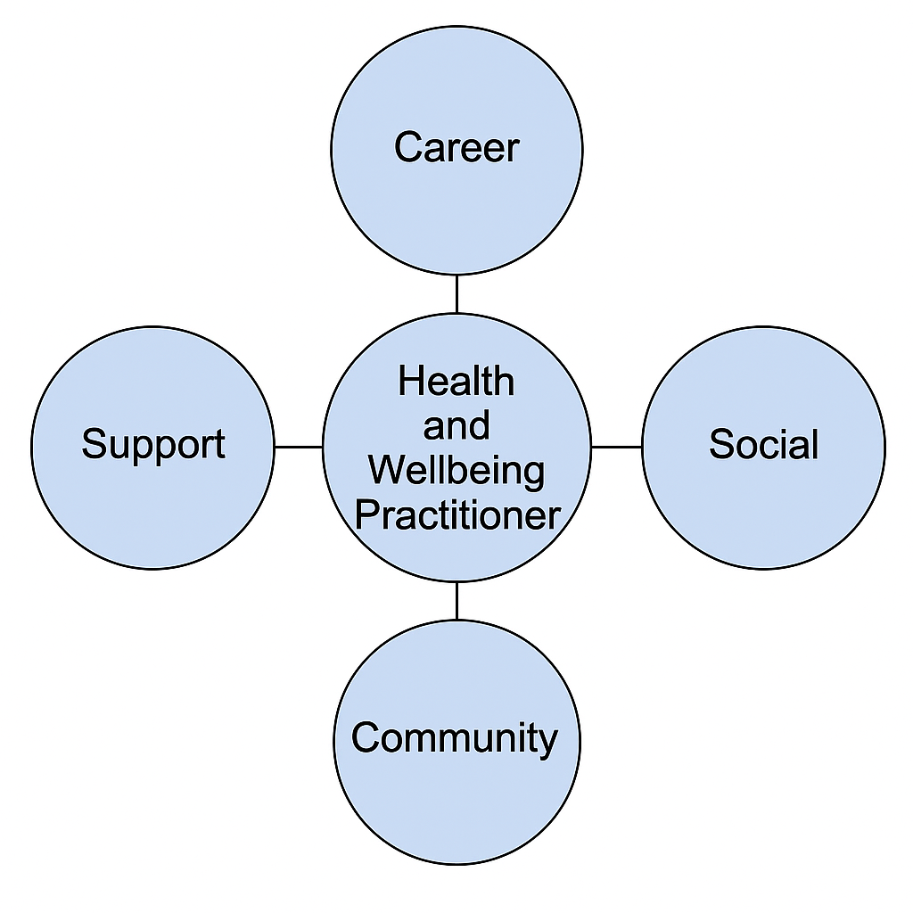Figure 1. Network Map of my Professional Connections as a Health and Wellbeing Practitioner
(Source: Created by the author, 2025)

My professional network consists of four interconnected areas: Career, Support, Social, and Community. The career dimension includes mentors, academic tutors, and professionals I connect with through LinkedIn and university placements. The support network involves family and close friends who provide emotional stability and motivation. My social network includes peers studying health and social care who share experiences and knowledge. The community network includes volunteering connections with local wellbeing charities and public health campaigns.
According to Granovetter (1973), the “strength of weak ties” theory suggests that weak social connections can create opportunities for employment and innovation by linking us to new information. Building a hybrid network that balances strong personal ties and weak professional ties strengthens employability and resilience. Kolb’s (1984) experiential learning model also highlights that reflection on these interactions helps transform experiences into personal growth.
To improve my network, I plan to engage more with community health projects and attend NHS career events, thereby expanding my exposure to multidisciplinary collaboration and professional development.
References:
Granovetter, M. (1973) ‘The Strength of Weak Ties’, American Journal of Sociology, 78(6), pp. 1360–1380.
Kolb, D. (1984) Experiential Learning: Experience as the Source of Learning and Development. Englewood Cliffs: Prentice Hall.
(Figure 1 illustrates my current professional network.)

Task 3 -Blog: Addressing the Growing Mental Health Crisis Among Young People – A Call to Action for HSC Professionals
Target Audience: Health and Social Care Professionals
The mental health needs of children and young people in the UK have reached a critical point, placing increasing pressure on health, education, and social care services. Recent data from NHS Digital (2023) indicates that 1 in 5 children and young people aged 8 to 25 have a probable mental health disorder, reflecting a significant rise since the COVID-19 pandemic. This increased demand is exposing gaps in early intervention, accessibility, and multi-agency collaboration that must be urgently addressed to prevent long-term negative outcomes (Public Health England, 2021).
Health and Social Care professionals play a vital role in recognising early signs of mental distress and ensuring young people receive timely support. However, long waiting lists for Child and Adolescent Mental Health Services (CAMHS), reduced school-based provision, and stigma often prevent young people from accessing help at an early stage (NHS England, 2022). Consequently, many reach crisis point before intervention occurs.
Digital mental health platforms—such as Kooth, Young Minds, and NHS-endorsed apps—have emerged as valuable tools to complement face-to-face services. They provide early, confidential support and encourage help-seeking behaviour in young people who may be reluctant to approach professionals directly (Young Minds, 2023). While digital platforms should not replace specialist services, they can enhance preventative support and offer safe signposting options while young people await further intervention.
To create sustainable change, a coordinated approach is essential. Increased investment in early intervention, strengthened partnerships between education, social care and voluntary services, and improved mental health training for professionals are key priorities (Department of Health and Social Care, 2023). Integrating digital resources into care pathways can reduce barriers and promote earlier access to support.
Young people deserve a system that is proactive, inclusive, and collaborative. The time for action is now.

Reference List (UWTSD Harvard)
Department of Health and Social Care (2023) Transforming children and young people’s mental health provision. London: DHSC.
NHS Digital (2023) Mental Health of Children and Young People in England 2023. Available at: https://digital.nhs.uk/ (Accessed: 1 November 2025).
NHS England (2022) Children and Young People’s Mental Health Services: Workforce and Access Report. London: NHS England.
Public Health England (2021) Improving young people’s health and wellbeing: A framework for public health. London: PHE.
Young Minds (2023) Annual Impact Report 2023. London: Young Minds.

Task 4 – NHS Equality, Diversity and Inclusion Quiz
- The primary goal of the NHS Equality, Diversity, and Inclusion (EDI) Improvement Plan is to create a fair, inclusive workplace that reflects the diversity of the communities it serves and reduces health inequalities (NHS England, 2023).
- It addresses the gender pay gap by promoting transparent recruitment, flexible working, and equal progression opportunities.
- Intersectionality recognises that individuals can experience overlapping forms of discrimination, such as race, gender, and disability, requiring targeted approaches.
- A psychologically safe environment allows staff to speak openly without fear, improving wellbeing and patient safety.
- The plan supports internationally recruited staff through mentoring, inclusive onboarding, and anti-racism training.
- Leadership plays a key role by modelling inclusive behaviours and holding teams accountable for EDI goals.
- It seeks to reduce health inequalities through fair representation, targeted leadership development, and equitable access to training.
- Collecting and analysing protected characteristics data helps identify disparities and monitor progress.
- Flexible working fosters equality by accommodating diverse needs and improving retention.
- To combat bullying and harassment, the plan promotes restorative practices, education, and zero-tolerance policies.

- Reference:
NHS England (2023) Equality, Diversity and Inclusion Improvement Plan. London: NHS England.

Task 5 – A Letter to Myself
Dear Younger me,
I know you are facing challenges that feel overwhelming. You worry about balancing study, work, and your sense of purpose. If only you knew then what I know now: resilience and emotional intelligence are your greatest strengths. Developing self-awareness, empathy, and self-regulation (Goleman, 1998) would have helped you manage stress and maintain balance.
When faced with criticism, try to pause before reacting—reflect instead of retreating. Understanding emotions allows you to communicate calmly and build better relationships. Resilience isn’t about avoiding failure but learning from it, adapting, and continuing forward. Each setback is shaping the practitioner you are becoming.
Remember that caring for yourself is not selfish—it enables you to care for others. The challenges you face now are laying the foundation for your compassion, patience, and professionalism in health and social care. In the future, these experiences will give your insight and empathy when supporting individuals through similar struggles.
Always believe that perseverance is stronger than perfection. Take time to celebrate progress, however small, and recognise that mistakes are vital learning opportunities. Continue nurturing kindness toward yourself and others. The ability to reflect, grow, and stay hopeful will guide you through every challenge in both your personal and professional journey.
Keep learning, reflecting, and believing in your ability to grow.
With kindness and courage,
Your Future Self
Reference:
Goleman, D. (1998) Working with Emotional Intelligence. New York: Bantam Books.

Task 6 – Gantt Chart
Gantt Chart showing 6-month timeline toward employment goal as Health and Wellbeing Practitioner

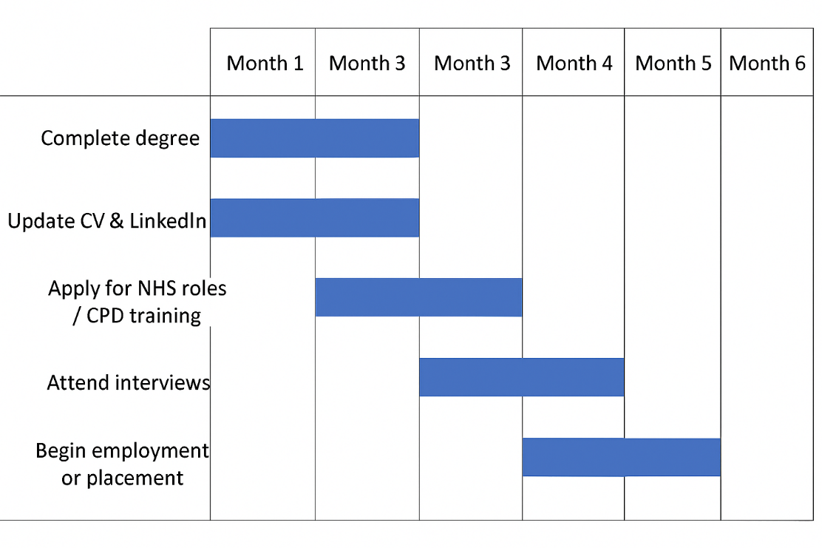
Figure 2. Six-Month Gantt Chart Showing Professional Development Timeline
(Source: Created by the author, 2025) My Gantt chart outlines the six-month plan to reach my employment goal. The tasks include:
- Completing my degree (Month 1–3)
- Updating CV and LinkedIn profile (Month 2)
- Completing NHS application and CPD training (Month 3–4)
- Attending interviews (Month 4–5)
- Starting placement or role (Month 6)
According to Project Management Institute (2021), Gantt charts help visualise tasks, set realistic deadlines, and track progress. Each task is interdependent—academic achievement enhances employability, while networking supports interview success.
I will review progress monthly, seek mentor feedback, and adjust plans as necessary. Maintaining flexibility is essential, as health and social care roles often evolve with policy and workforce demands. The Gantt chart serves as both a motivator and accountability tool, ensuring I manage time effectively and remain focused on professional growth.
Reference:
Project Management Institute (2021) A Guide to the Project Management Body of Knowledge (PMBOK Guide). 7th edn. Newtown Square: PMI.
As shown in Figure 2, my six-month Gantt chart demonstrates the sequential steps I plan to take toward achieving employment in the health and social care sector.

Task 7 – Making Changes Report
As a care home manager, I will implement a digital medication management system (eMAR) to reduce errors and improve resident safety. The change objective is to cut medication administration errors by 30% within six months and improve on-time administration compliance to 95%.
Following Lewin’s (1951) model, I will first unfreeze by presenting baseline audit data on current MAR errors, sharing incident trends at team briefings, and listening to staff concerns. I will identify change champions from each shift and involve a resident/family representative to keep the work person-centred. During the change phase, we will run short, hands-on training, provide quick-reference cards, and pilot the eMAR on one unit for four weeks before scaling up. Policies (medication rounds, error reporting, escalation) will be updated and aligned to the DSP Toolkit requirements for information governance. In the refreeze stage, we will embed the new workflow into induction, add eMAR competencies to supervision, and display monthly safety dashboards on the staff board.
To strengthen adoption, I will also apply Kotter’s (1996) steps: create urgency (audit data), build a guiding coalition (RN lead, senior carer, pharmacist), form and communicate a clear vision (“right medicine, right time, every time”), empower staff by removing barriers (protected training time; IT support), generate short-term wins (pilot unit results), and anchor gains in culture (celebrate zero-error weeks).
Risks and mitigations: resistance (co-design and extra coaching), digital downtime (paper contingency), and data privacy (role-based access, two-factor log-in). Evaluation will track error rates, late/omitted doses, staff confidence, and resident/family feedback at weeks 4, 12 and 24.
References:
Lewin, K. (1951) Field Theory in Social Science. New York: Harper & Row.
Kotter, J.P. (1996) Leading Change. Boston, MA: Harvard Business School Press.

Task 8 – Self-Reflection
Using Gibbs’ (1988) Reflective Cycle, I have reflected on how this module has developed my self-awareness, communication, and leadership skills.
Initially, I underestimated the importance of building a personal brand and engaging with professional networks. Through completing the tasks, I realised that self-reflection is crucial for identifying strengths and areas for growth. The Gibbs model encouraged me to evaluate my actions and emotions, draw conclusions, and plan for future improvement.
I learned that effective communication and emotional intelligence enhance teamwork and service delivery in health and social care. The portfolio tasks—especially the letter and personal brand reflection—helped me articulate my professional identity and recognise my resilience.
Furthermore, this module highlighted that reflective practice is not just an academic activity, but a professional behaviour embedded in high-quality, person-centred care. It has increased my confidence to discuss practice challenges openly, seek feedback constructively, and support colleagues through reflective dialogue. Applying Gibbs’ framework will allow me to continue developing my leadership skills, fostering self-awareness and adaptability in fast-changing health and social care environments.
In the future, I intend to use reflection to inform my Continuing Professional Development (CPD) goals, such as attending resilience workshops, undertaking NHS digital literacy training, and seeking mentorship in wellbeing promotion. Reflection will continue to shape my decision-making, emotional regulation, and capacity to deliver compassionate care. Ultimately, this process has strengthened my professional identity and motivation to become an empathetic, evidence-informed Health and Wellbeing Practitioner.

Reference List
Age UK (2022) Digital Inclusion and Older People. London: Age UK.
Gibbs, G. (1988) Learning by Doing: A Guide to Teaching and Learning Methods. Oxford: Oxford Polytechnic.
Goleman, D. (1998) Working with Emotional Intelligence. New York: Bantam Books.
Granovetter, M. (1973) ‘The Strength of Weak Ties’, American Journal of Sociology, 78(6), pp. 1360–1380.
Kolb, D. (1984) Experiential Learning: Experience as the Source of Learning and Development. Englewood Cliffs: Prentice Hall.
Kotter, J.P. (1996) Leading Change. Boston, MA: Harvard Business School Press.
Lewin, K. (1951) Field Theory in Social Science. New York: Harper & Row.
NHS Digital (2022) Data Security and Protection Toolkit. London: NHS Digital.
NHS England (2019) The NHS Long Term Plan. London: NHS England.
NHS England (2023) Equality, Diversity and Inclusion Improvement Plan. London: NHS England.
Skills for Care (2023) Developing Your Personal Brand in Social Care. Leeds: Skills for Care.
Author (2025) Figure 1. Network Map of my Professional Connections as a Health and Wellbeing Practitioner. Created by the author.
Author (2025) Figure 2. Six-Month Gantt Chart Showing Professional Development Timeline. Created by the author.

