University of Wales Trinity Saint David

Title: Wonderland Winter Party Event at The Great Victoria Hotel

Student Name: Shahd Omer (2130010)
International Meeting Management for the Hotel Industry
BMIH 6007
Lecturer: Chris Wilkin

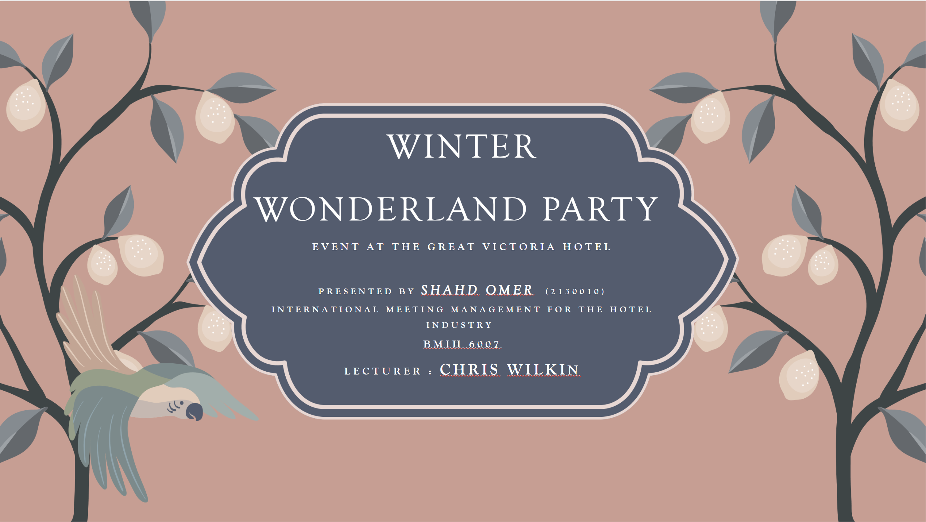

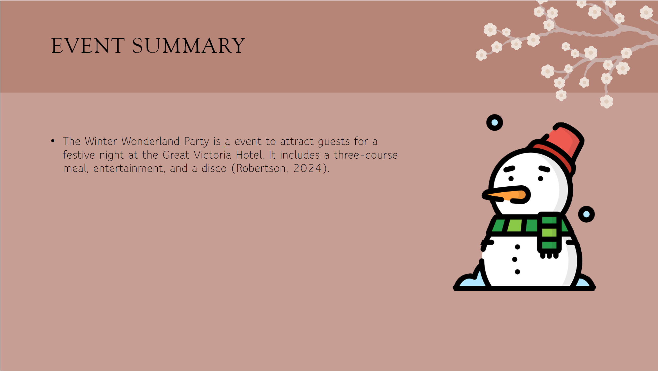

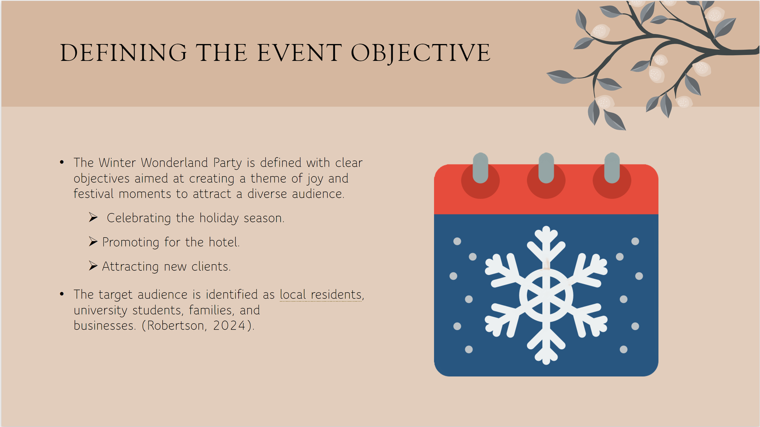

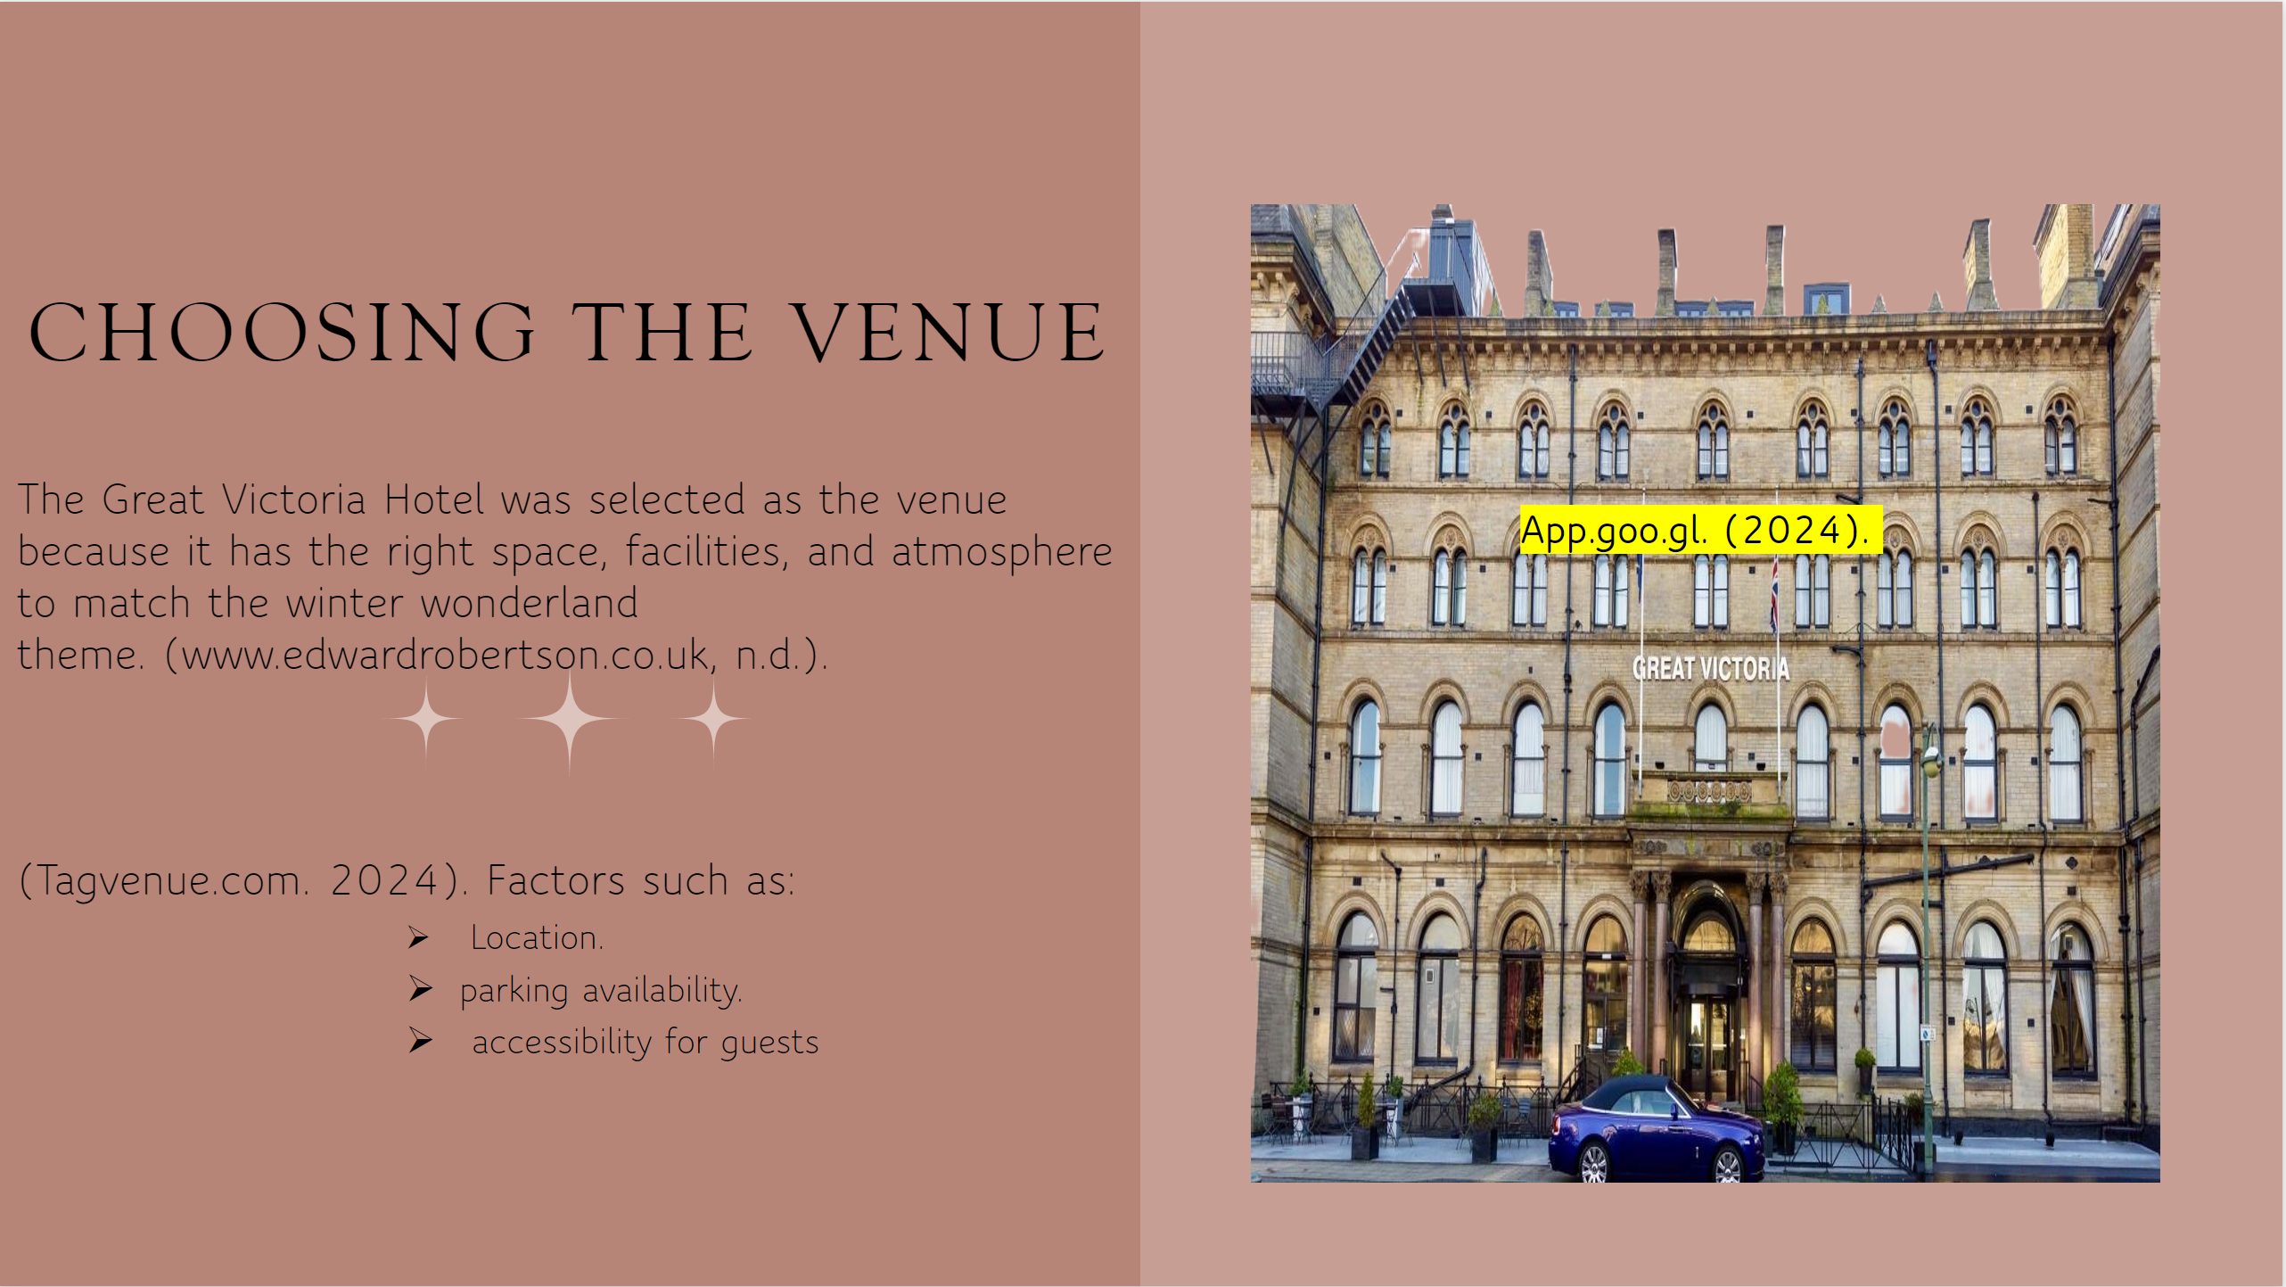

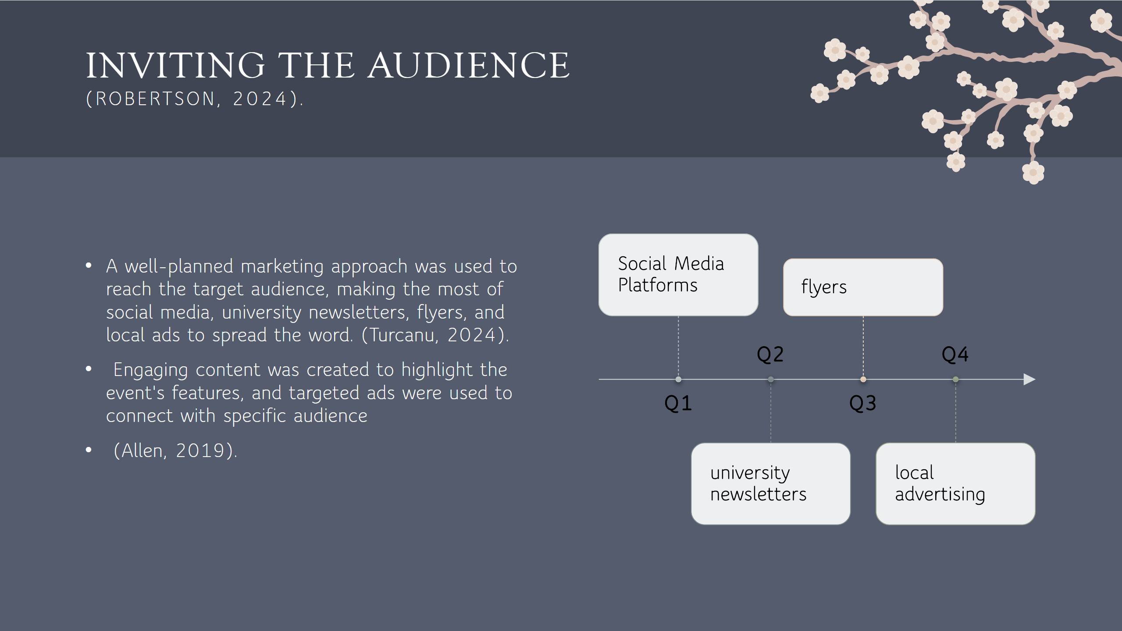

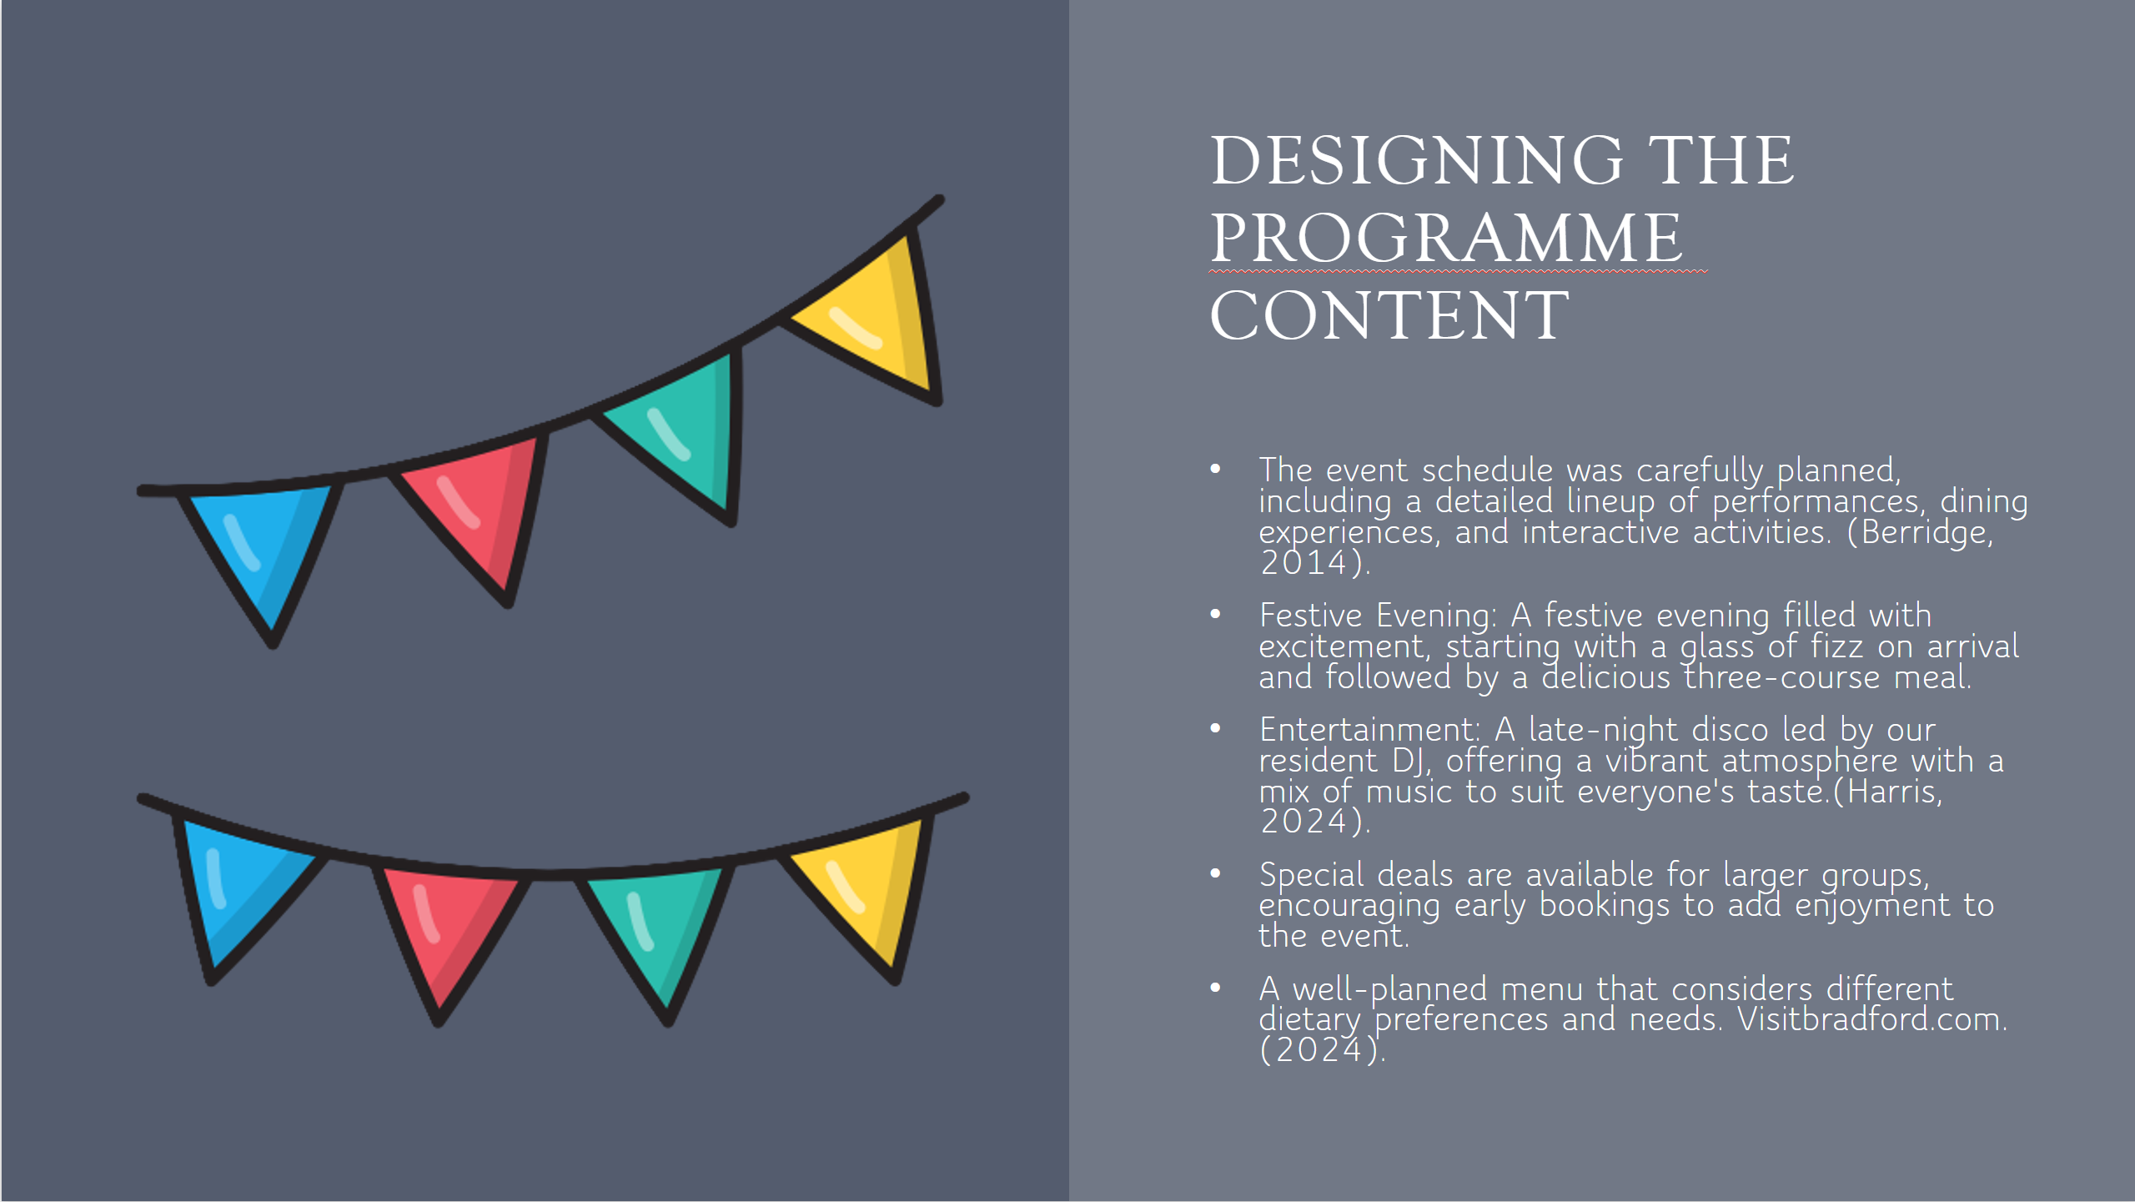

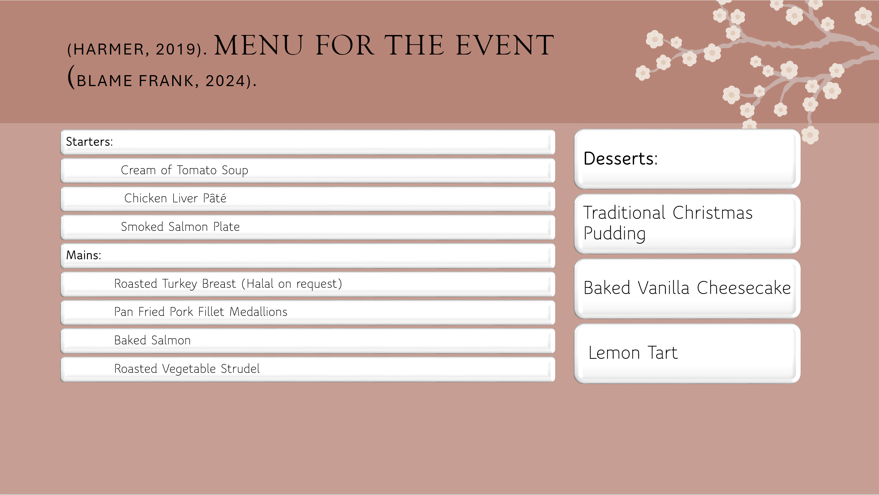

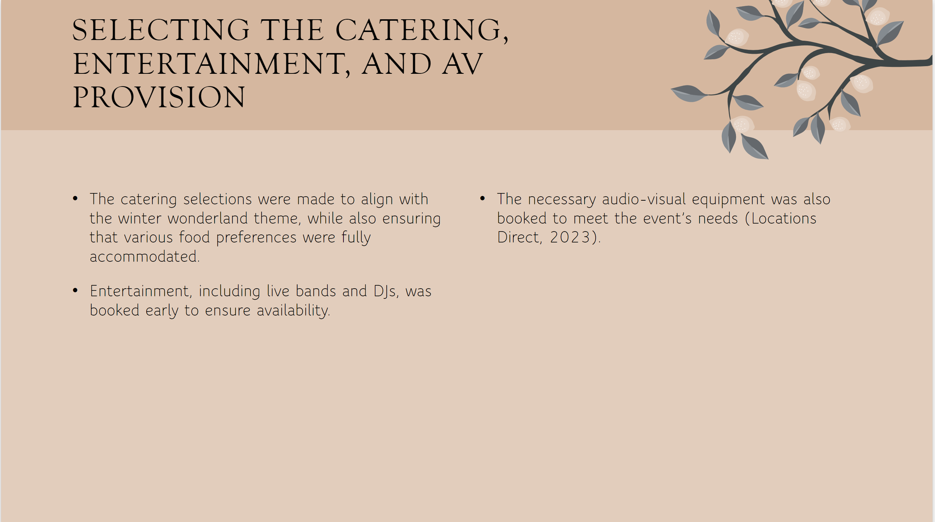

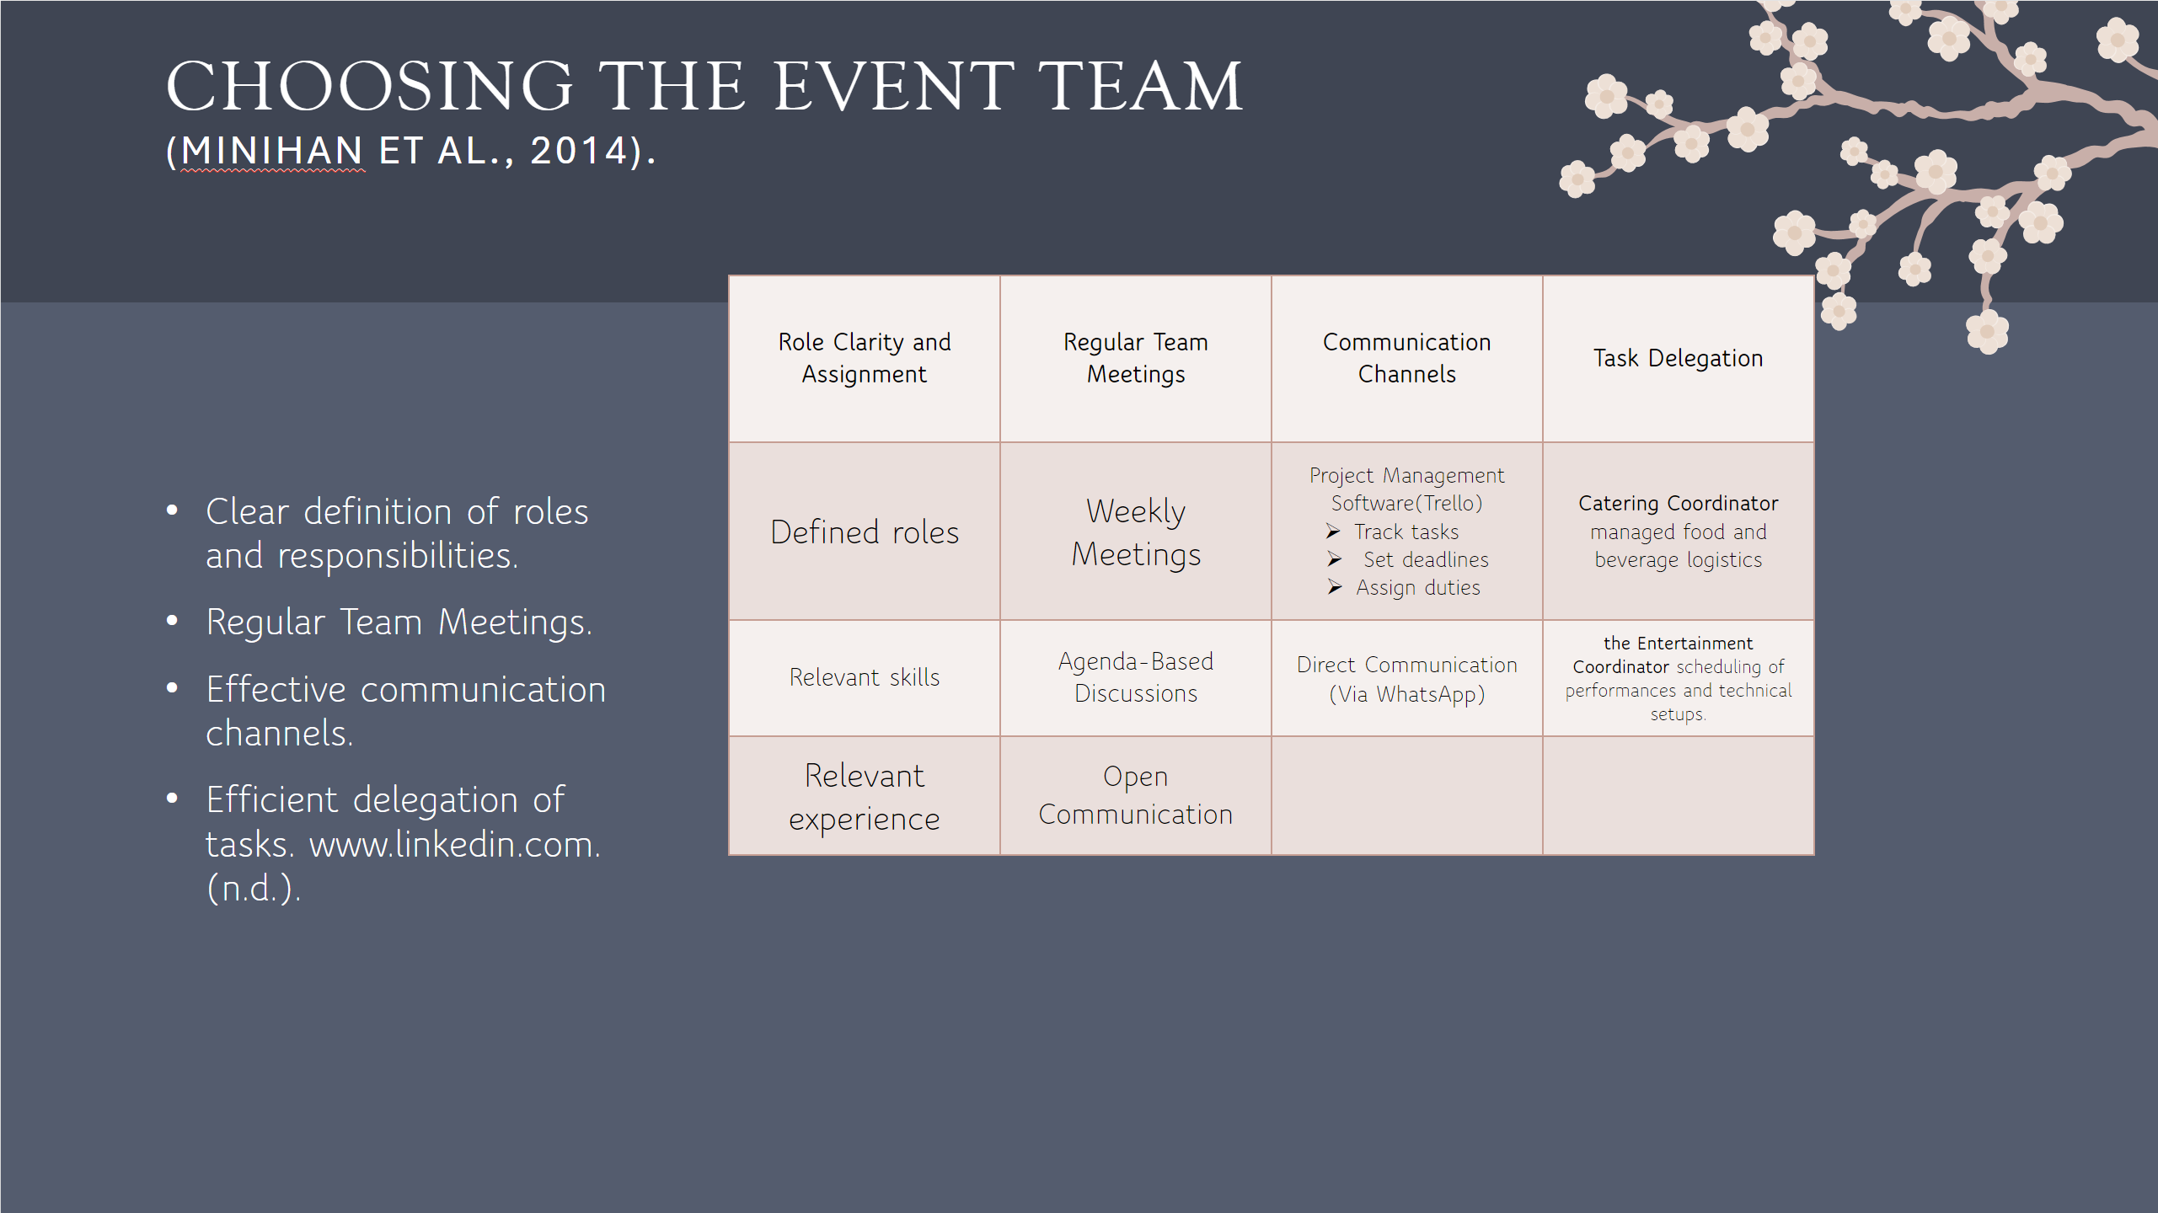

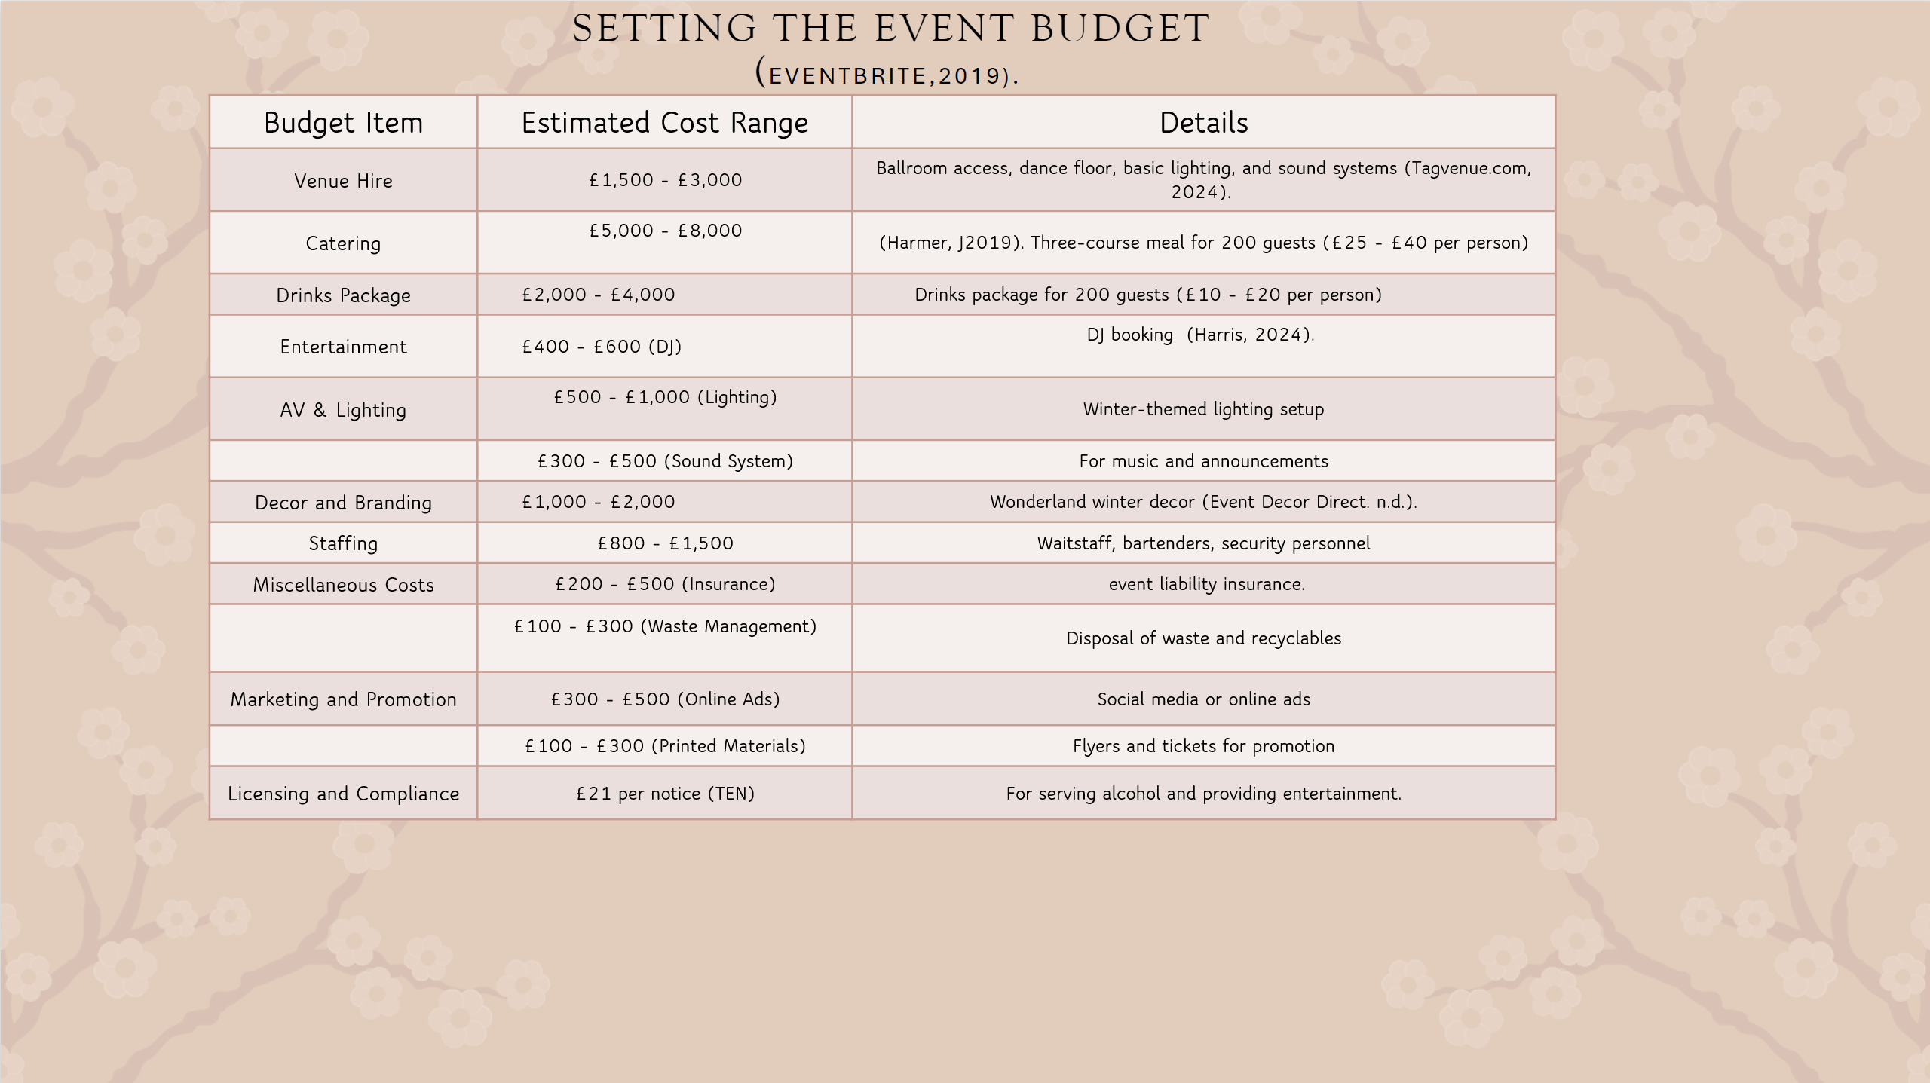

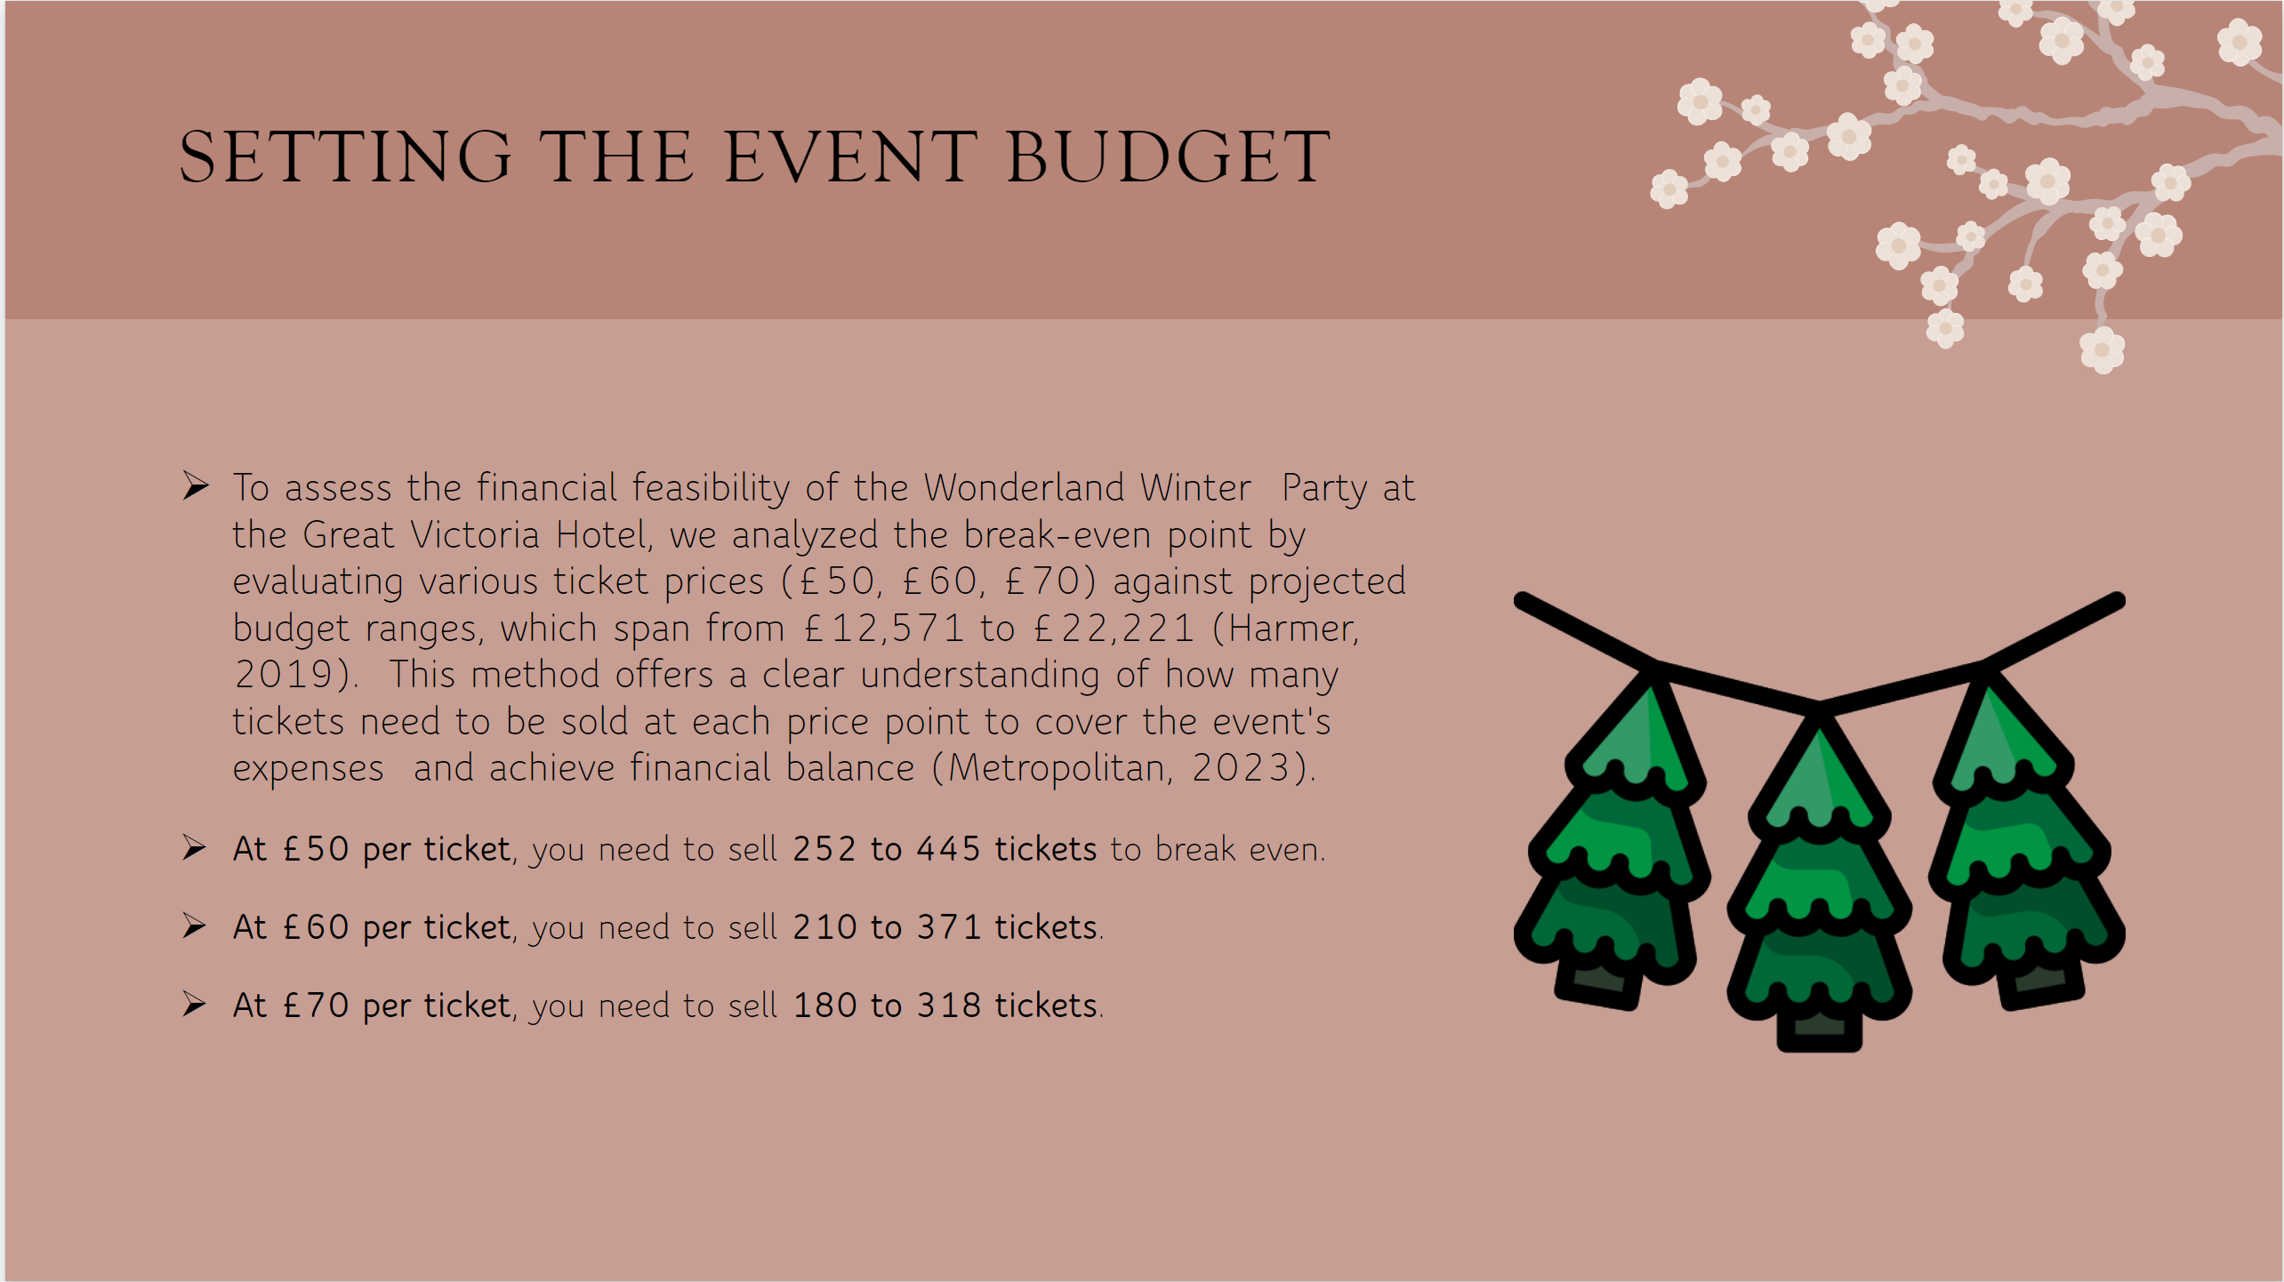

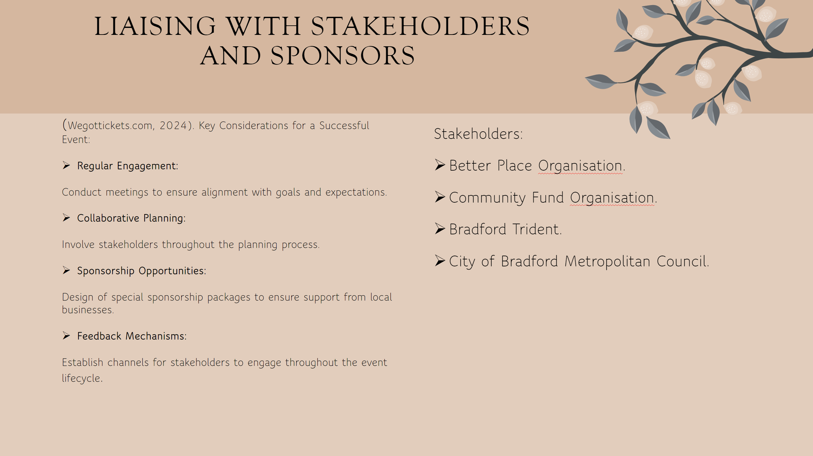

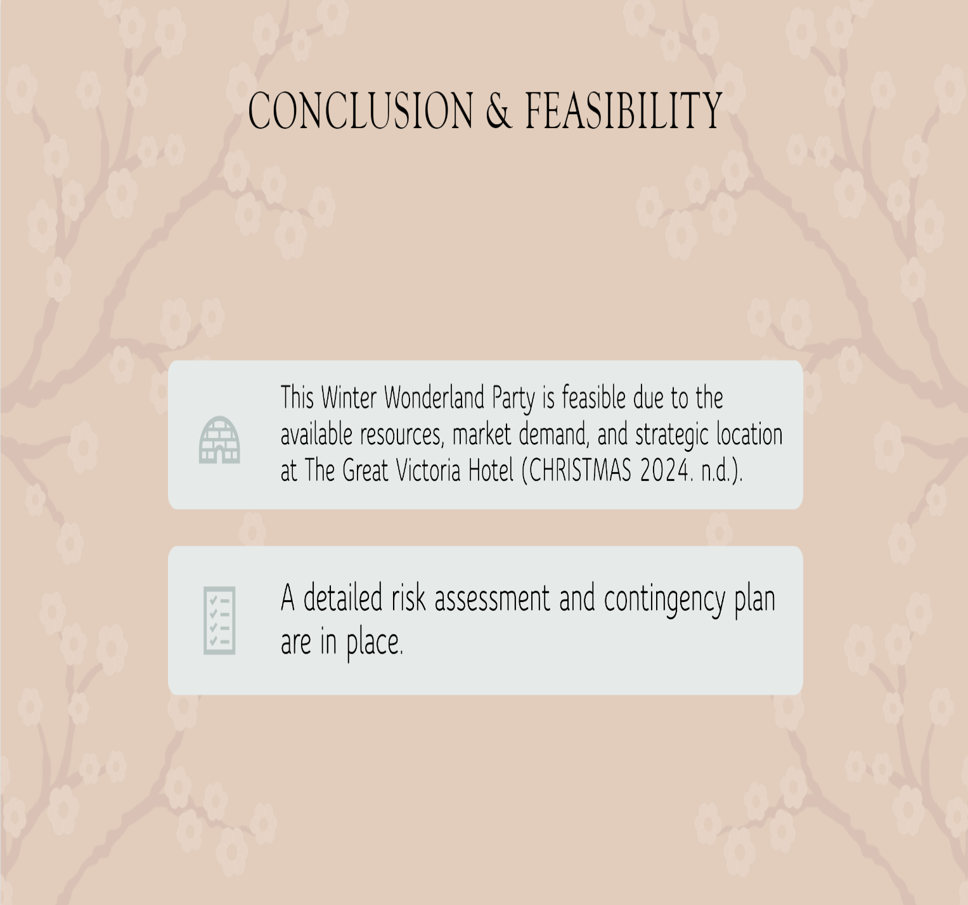

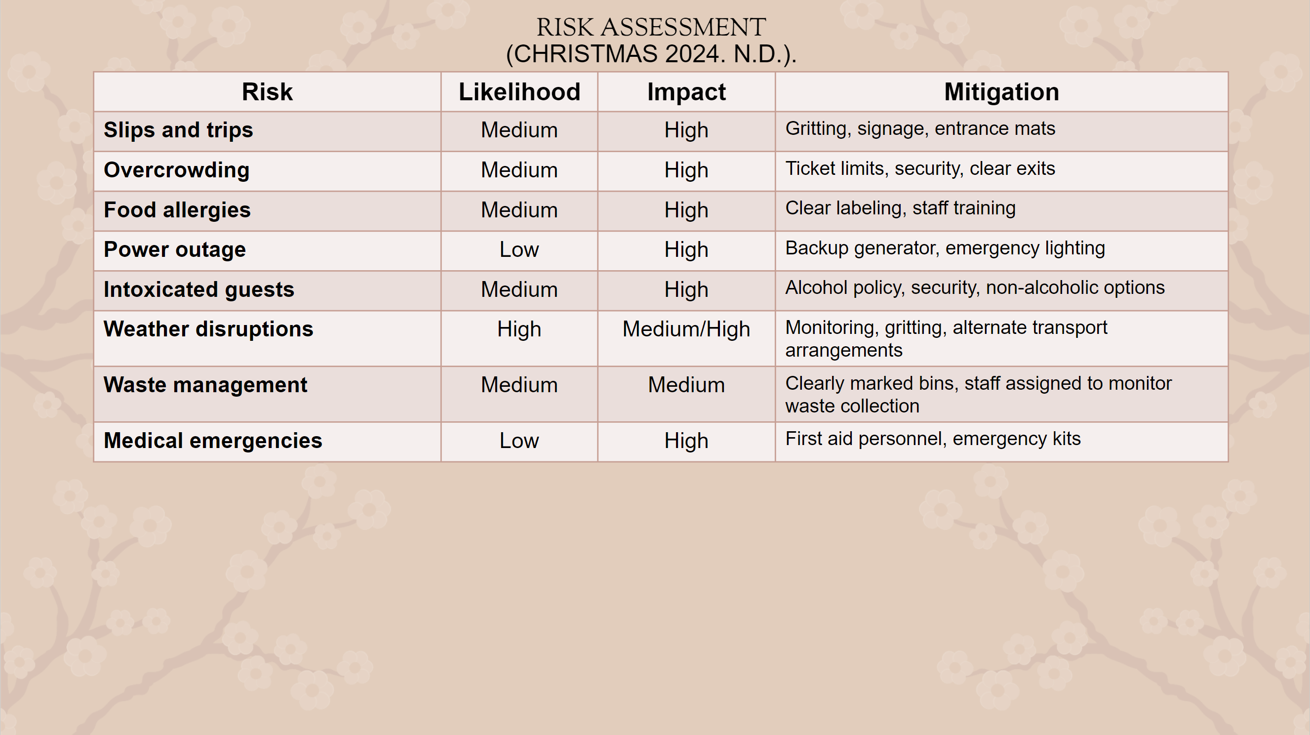

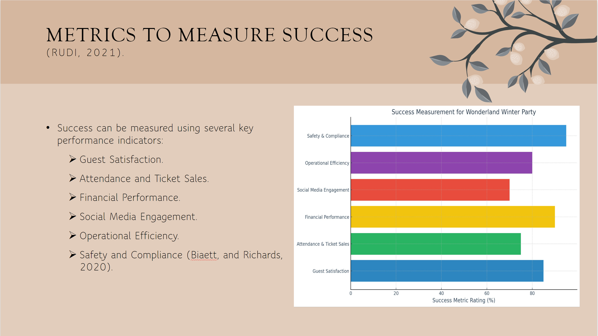

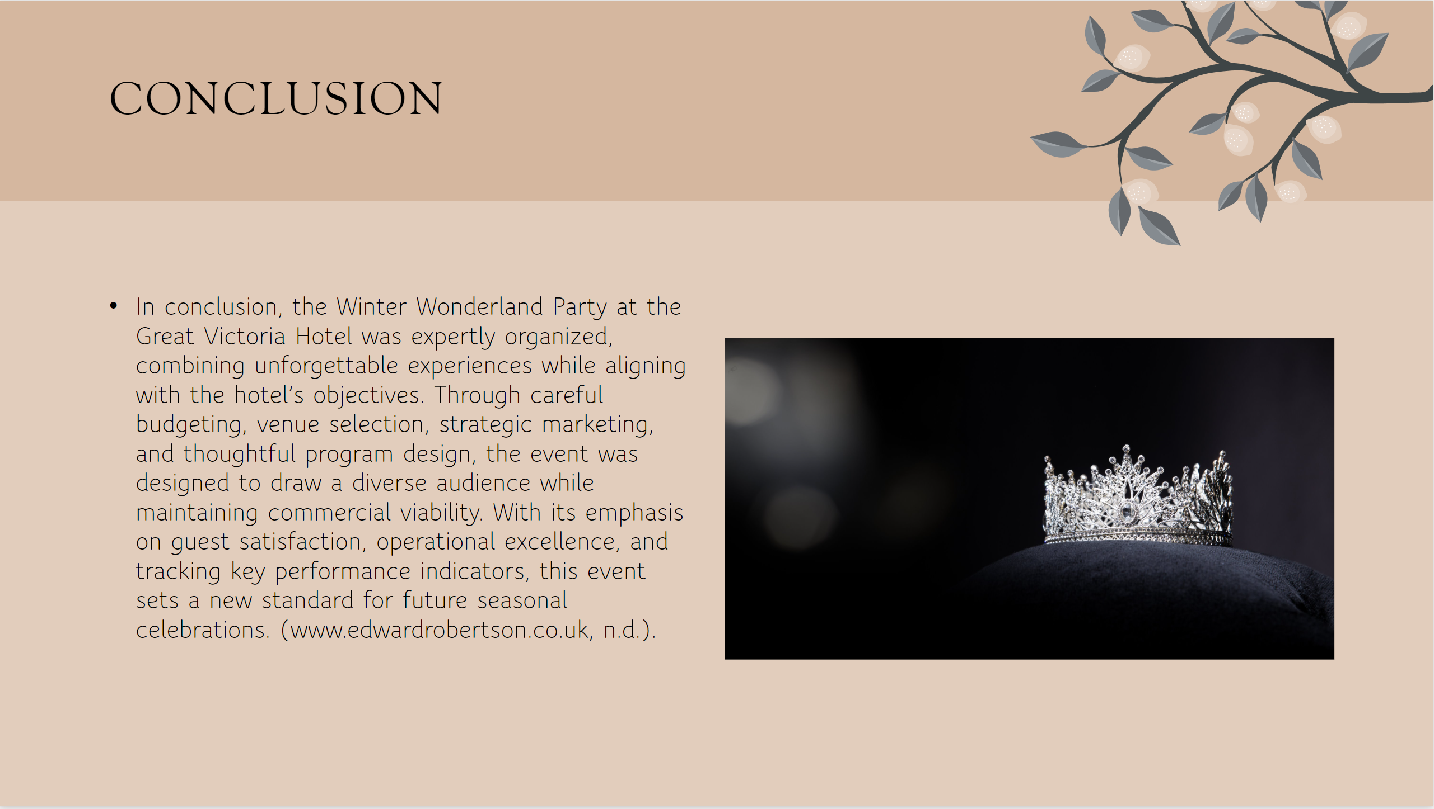

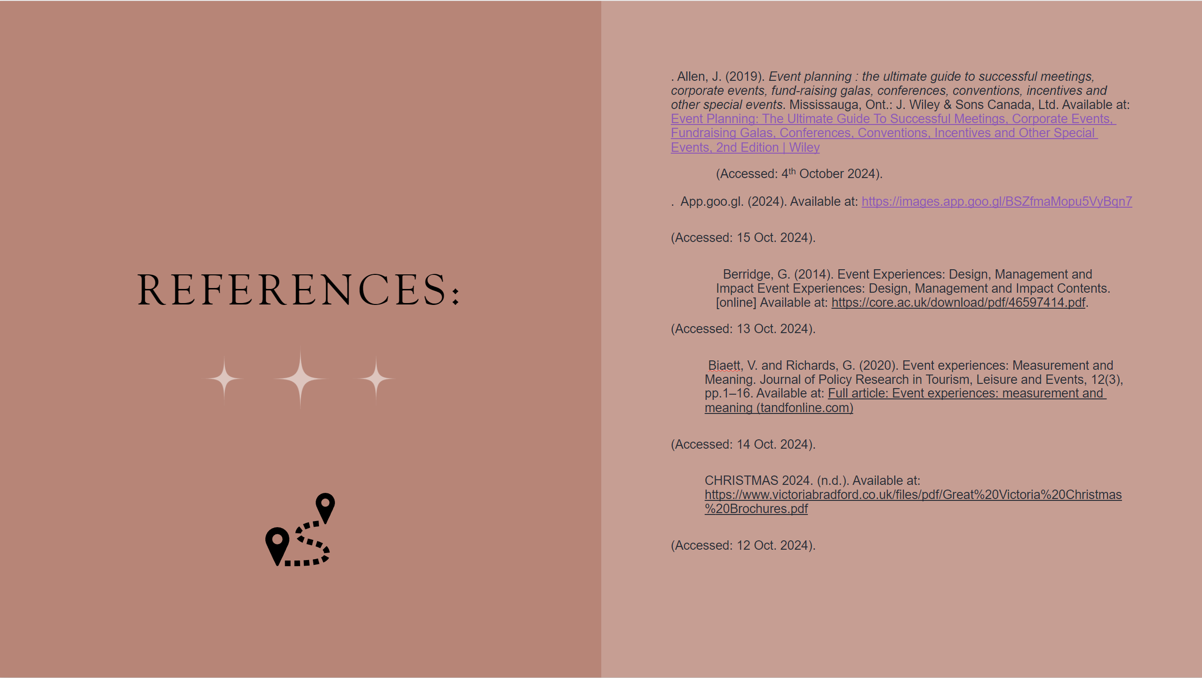

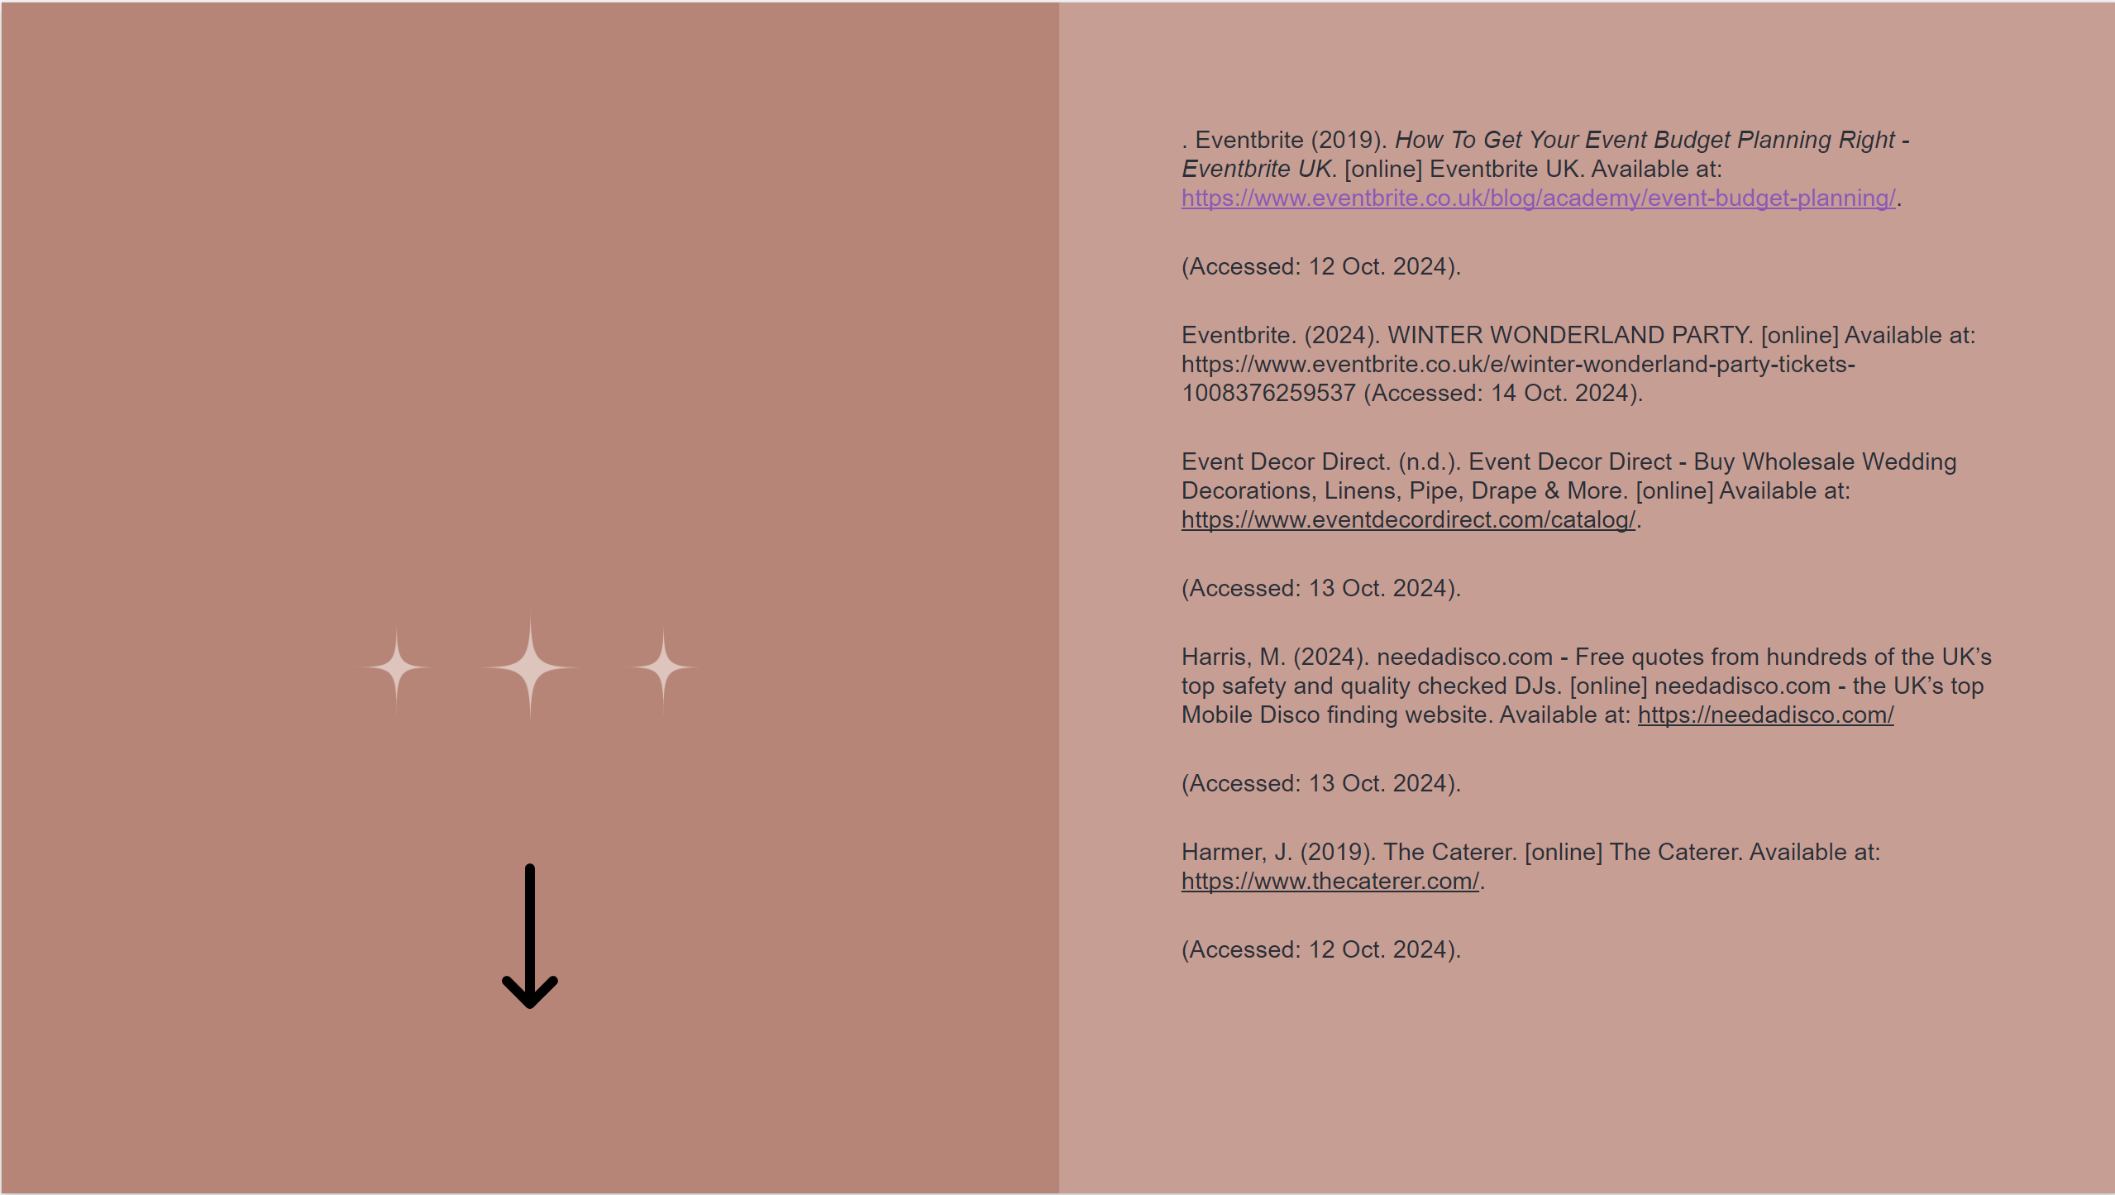

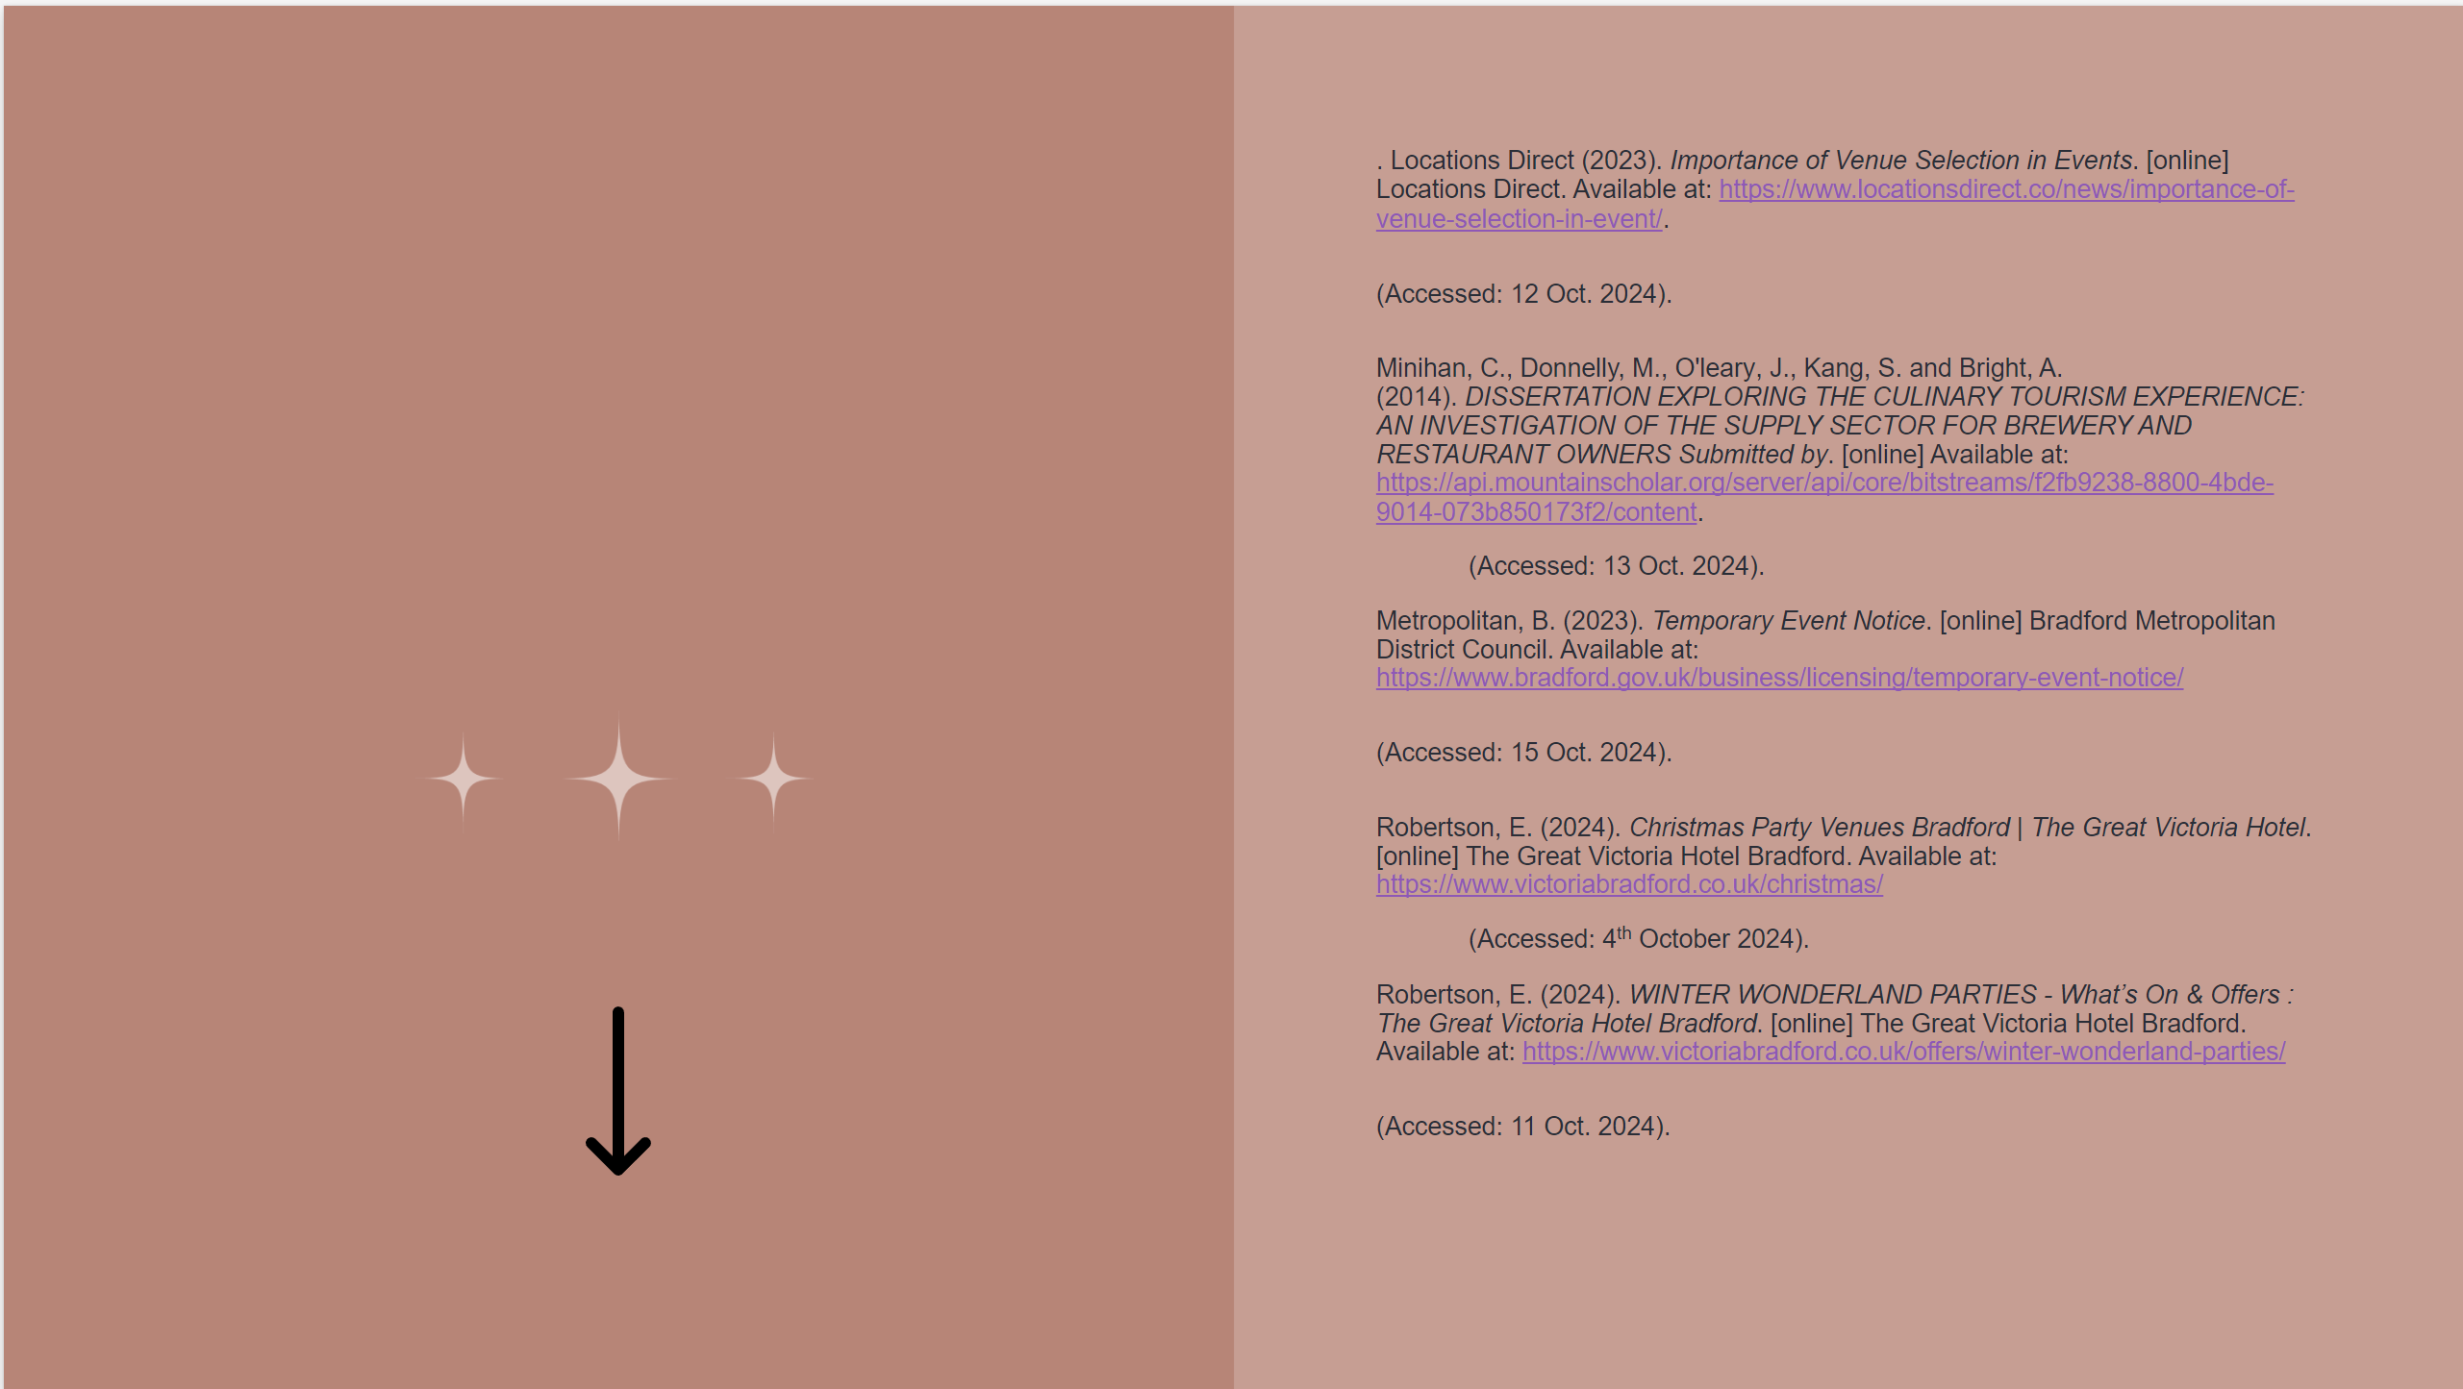

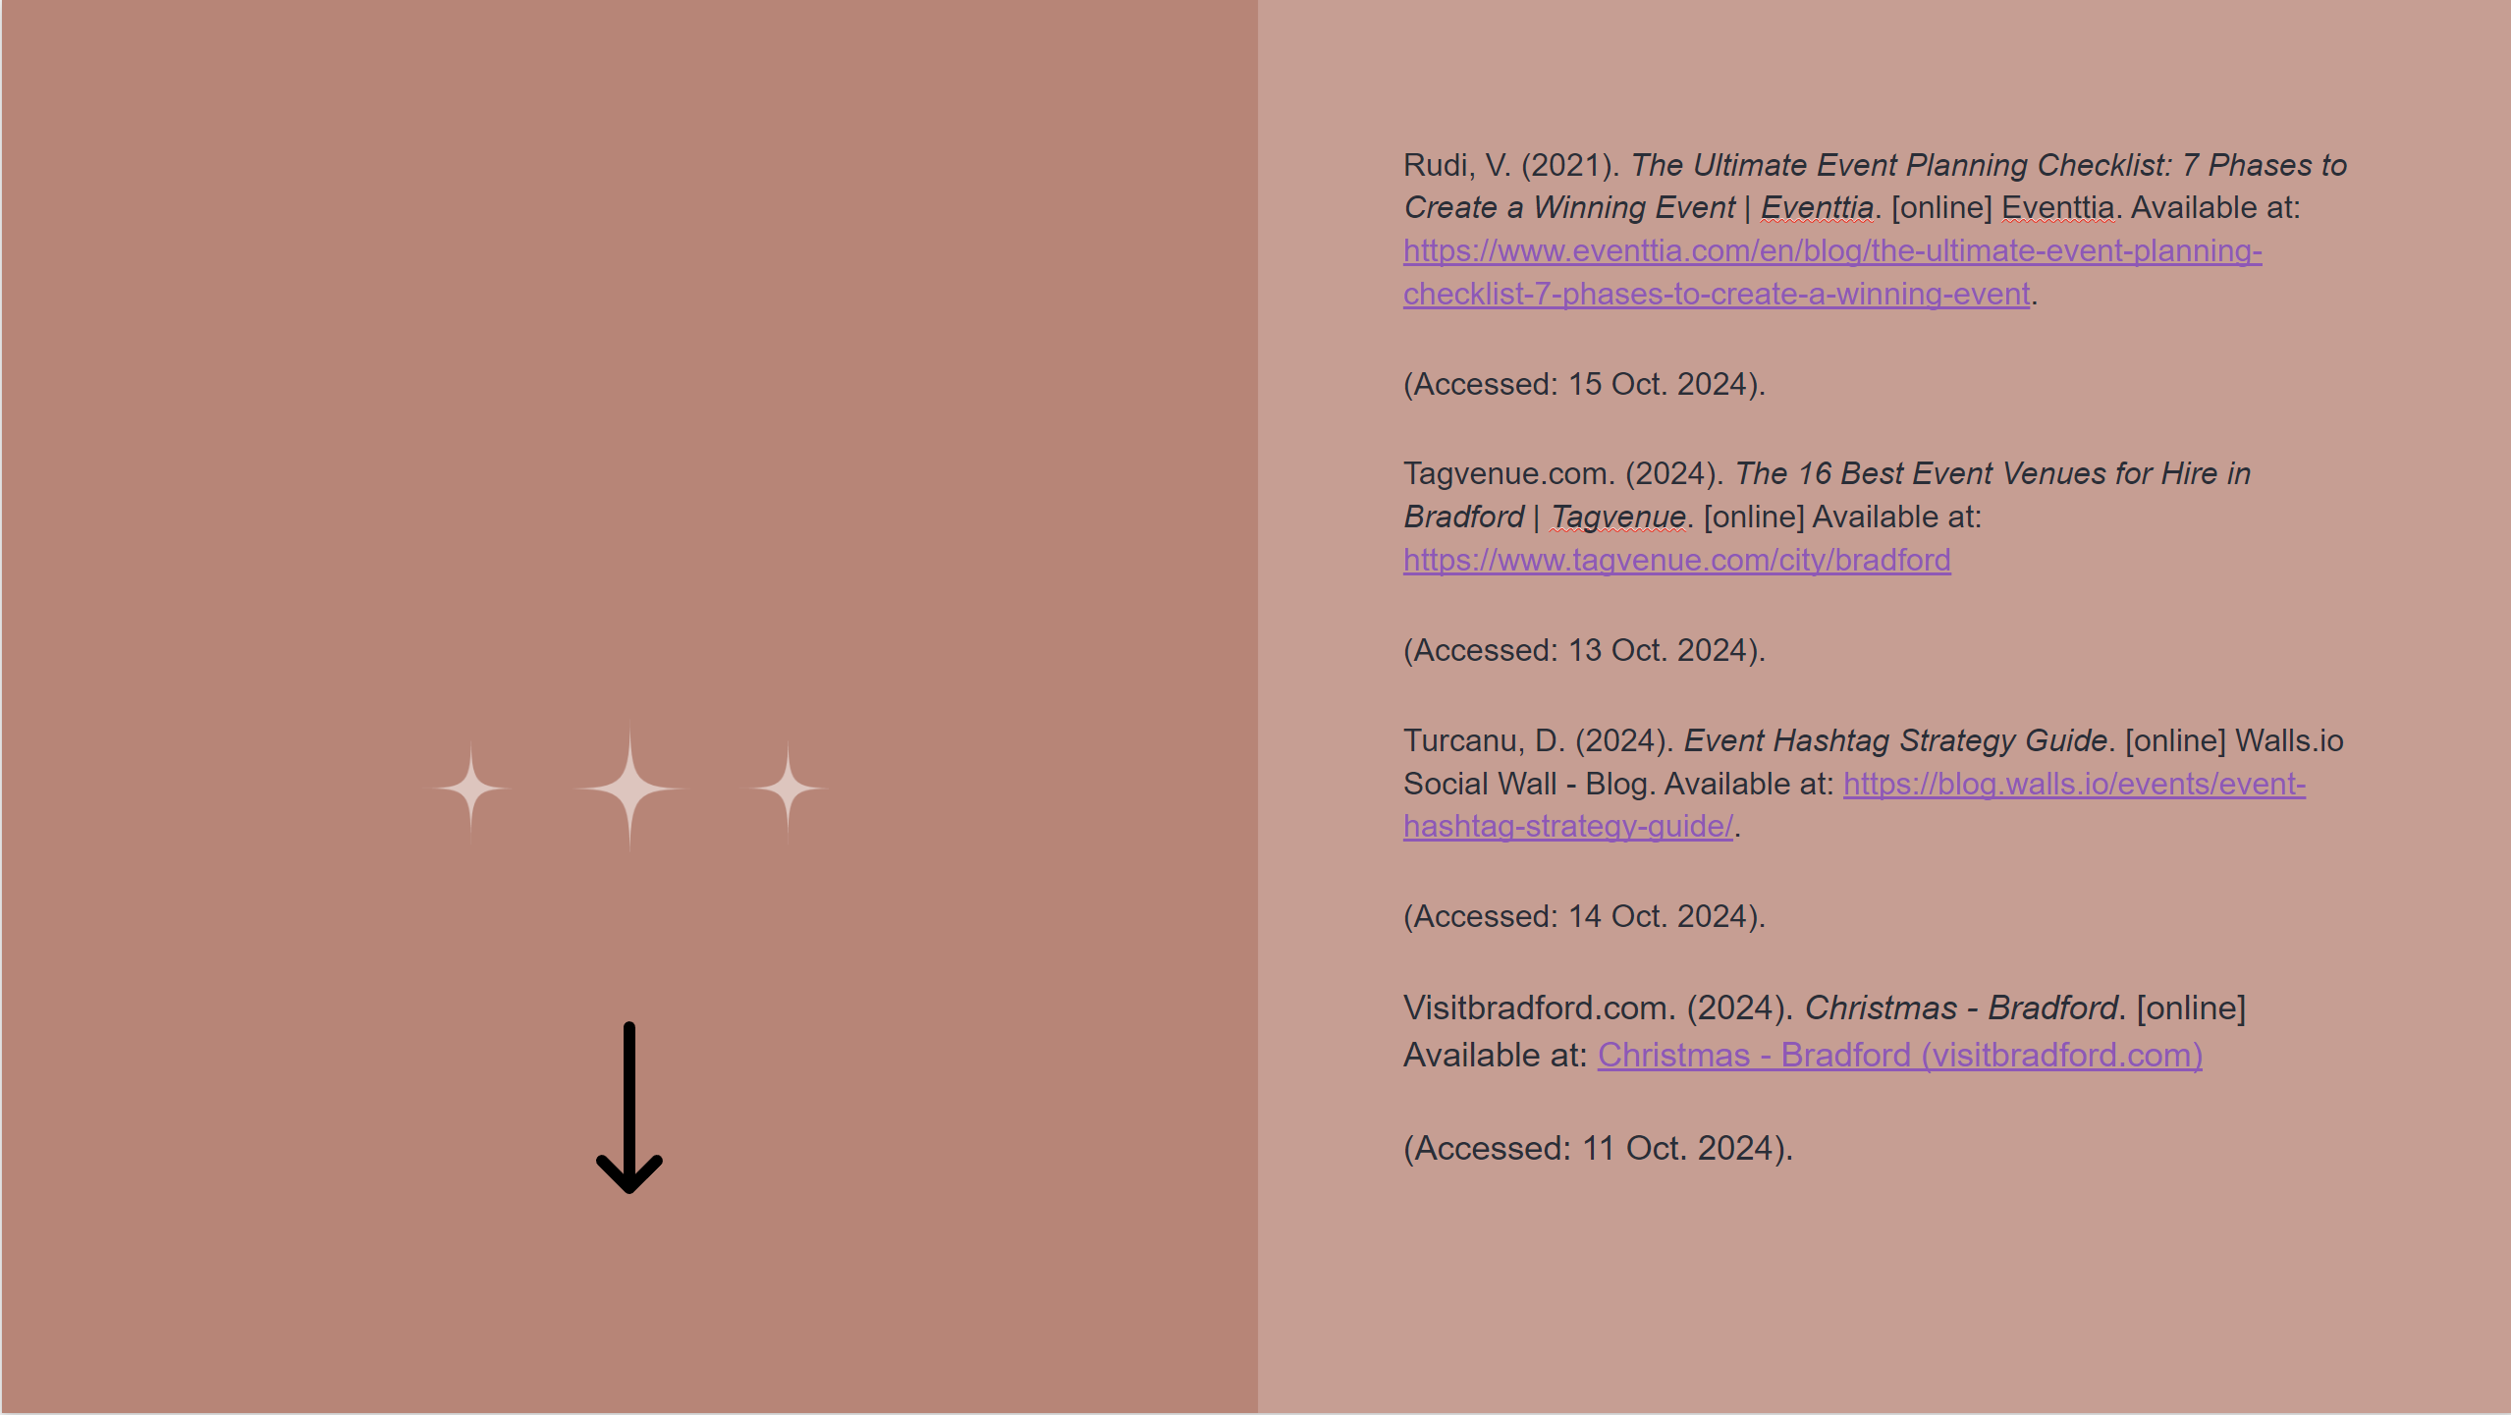

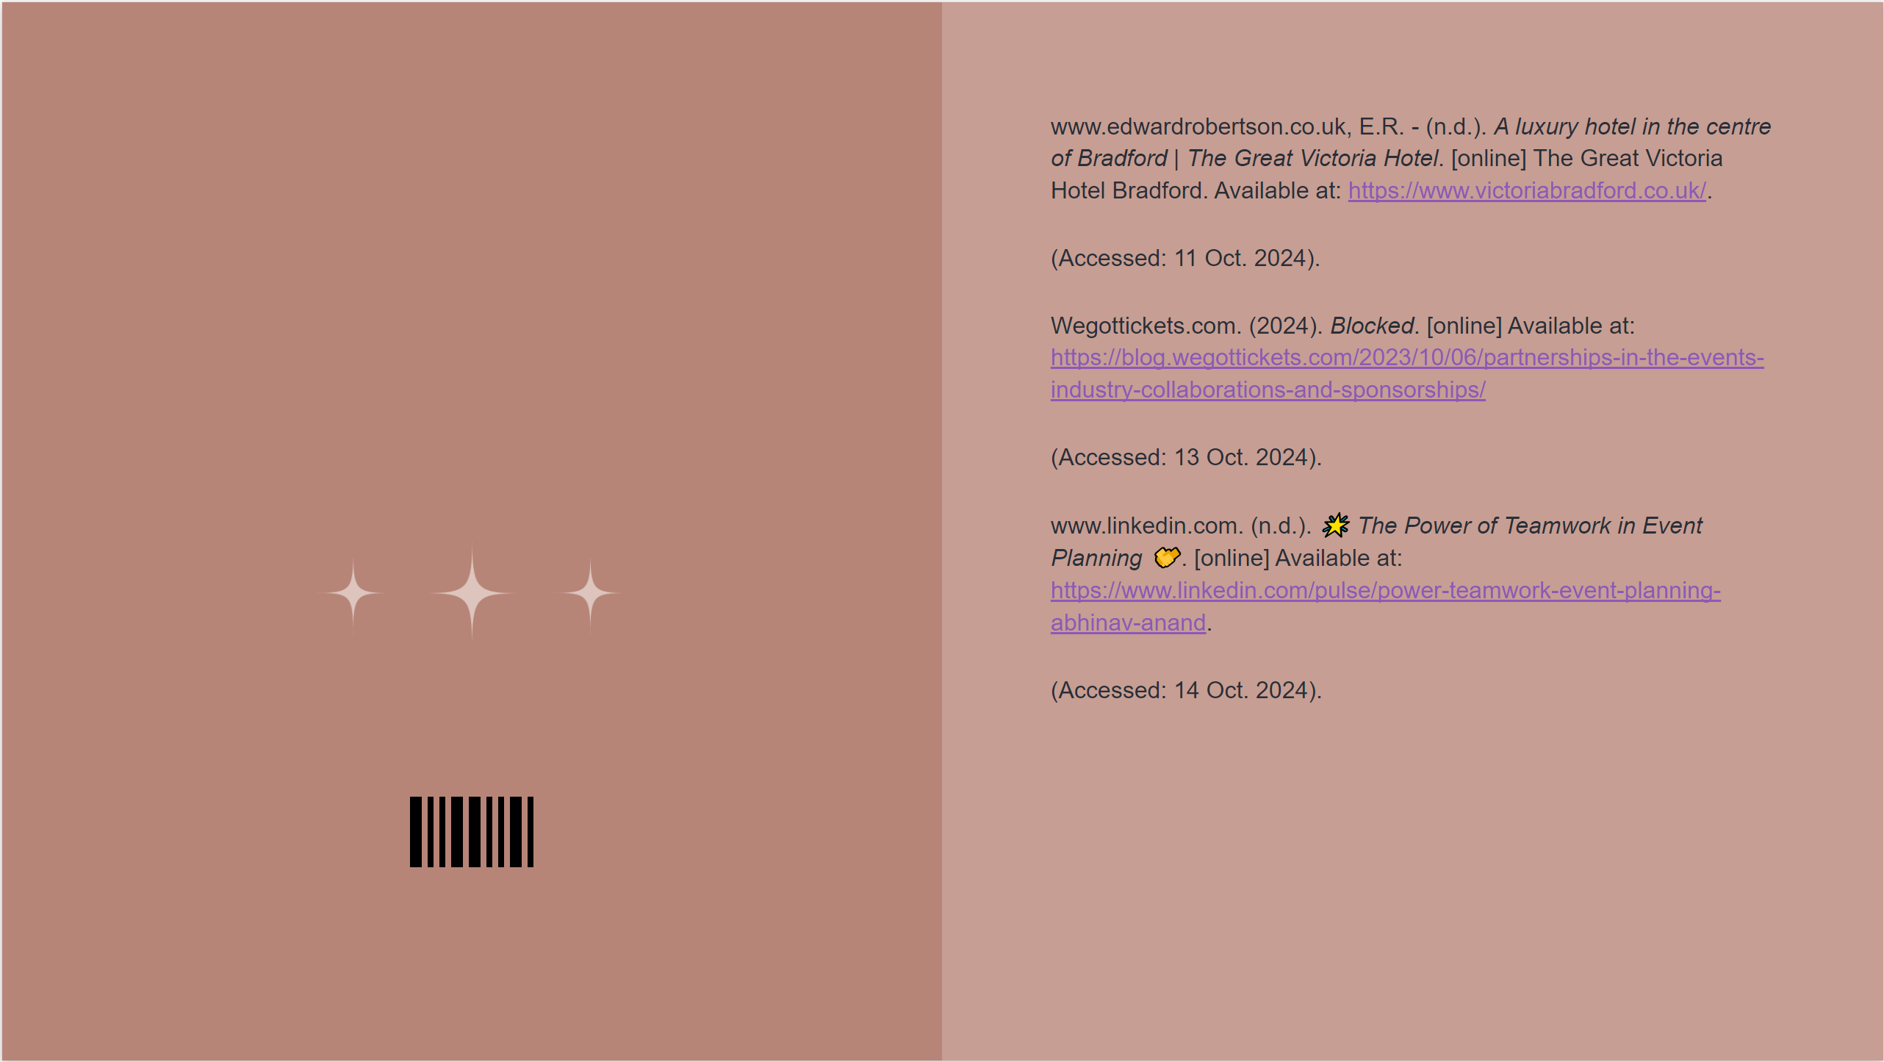

References:
- Allen, J. (2019). Event planning : the ultimate guide to successful meetings, corporate events, fund-raising galas, conferences, conventions, incentives and other special events. Mississauga, Ont.: J. Wiley & Sons Canada, Ltd. Available at: Event Planning: The Ultimate Guide To Successful Meetings, Corporate Events, Fundraising Galas, Conferences, Conventions, Incentives and Other Special Events, 2nd Edition | Wiley
(Accessed: 4th October 2024).
- App.goo.gl. (2024). Available at: https://images.app.goo.gl/BSZfmaMopu5VyBqn7
(Accessed: 15 Oct. 2024).
- Berridge, G. (2014). Event Experiences: Design, Management and Impact Event Experiences: Design, Management and Impact Contents. [online] Available at: https://core.ac.uk/download/pdf/46597414.pdf.
(Accessed: 13 Oct. 2024).
- Biaett, V. and Richards, G. (2020). Event experiences: Measurement and Meaning. Journal of Policy Research in Tourism, Leisure and Events, 12(3), pp.1–16. Available at: Full article: Event experiences: measurement and meaning (tandfonline.com)
(Accessed: 14 Oct. 2024).
- CHRISTMAS 2024. (n.d.). Available at: https://www.victoriabradford.co.uk/files/pdf/Great%20Victoria%20Christmas%20Brochures.pdf
(Accessed: 12 Oct. 2024).
- Eventbrite (2019). How To Get Your Event Budget Planning Right - Eventbrite UK. [online] Eventbrite UK. Available at: https://www.eventbrite.co.uk/blog/academy/event-budget-planning/.
(Accessed: 12 Oct. 2024).
- Eventbrite. (2024). WINTER WONDERLAND PARTY. [online] Available at: https://www.eventbrite.co.uk/e/winter-wonderland-party-tickets-1008376259537 (Accessed: 14 Oct. 2024).
- Event Decor Direct. (n.d.). Event Decor Direct - Buy Wholesale Wedding Decorations, Linens, Pipe, Drape & More. [online] Available at: https://www.eventdecordirect.com/catalog/.
(Accessed: 13 Oct. 2024).
- Harris, M. (2024). needadisco.com - Free quotes from hundreds of the UK’s top safety and quality checked DJs. [online] needadisco.com - the UK’s top Mobile Disco finding website. Available at: https://needadisco.com/
(Accessed: 13 Oct. 2024).
- Harmer, J. (2019). The Caterer. [online] The Caterer. Available at: https://www.thecaterer.com/.
(Accessed: 12 Oct. 2024).
- Locations Direct (2023). Importance of Venue Selection in Events. [online] Locations Direct. Available at: https://www.locationsdirect.co/news/importance-of-venue-selection-in-event/.
(Accessed: 12 Oct. 2024).
- Minihan, C., Donnelly, M., O'leary, J., Kang, S. and Bright, A. (2014). DISSERTATION EXPLORING THE CULINARY TOURISM EXPERIENCE: AN INVESTIGATION OF THE SUPPLY SECTOR FOR BREWERY AND RESTAURANT OWNERS Submitted by. [online] Available at: https://api.mountainscholar.org/server/api/core/bitstreams/f2fb9238-8800-4bde-9014-073b850173f2/content.
(Accessed: 13 Oct. 2024).
- Metropolitan, B. (2023). Temporary Event Notice. [online] Bradford Metropolitan District Council. Available at: https://www.bradford.gov.uk/business/licensing/temporary-event-notice/
(Accessed: 15 Oct. 2024).
- Robertson, E. (2024). Christmas Party Venues Bradford | The Great Victoria Hotel. [online] The Great Victoria Hotel Bradford. Available at: https://www.victoriabradford.co.uk/christmas/
(Accessed: 4th October 2024).
- Robertson, E. (2024). WINTER WONDERLAND PARTIES - What’s On & Offers : The Great Victoria Hotel Bradford. [online] The Great Victoria Hotel Bradford. Available at: https://www.victoriabradford.co.uk/offers/winter-wonderland-parties/
(Accessed: 11 Oct. 2024).
- Rudi, V. (2021). The Ultimate Event Planning Checklist: 7 Phases to Create a Winning Event | Eventtia. [online] Eventtia. Available at: https://www.eventtia.com/en/blog/the-ultimate-event-planning-checklist-7-phases-to-create-a-winning-event.
(Accessed: 15 Oct. 2024).
- Tagvenue.com. (2024). The 16 Best Event Venues for Hire in Bradford | Tagvenue. [online] Available at: https://www.tagvenue.com/city/bradford
(Accessed: 13 Oct. 2024).
- Turcanu, D. (2024). Event Hashtag Strategy Guide. [online] Walls.io Social Wall - Blog. Available at: https://blog.walls.io/events/event-hashtag-strategy-guide/.
(Accessed: 14 Oct. 2024).
- Visitbradford.com. (2024). Christmas - Bradford. [online] Available at: Christmas - Bradford (visitbradford.com)
(Accessed: 11 Oct. 2024).
- www.edwardrobertson.co.uk, E.R. - (n.d.). A luxury hotel in the centre of Bradford | The Great Victoria Hotel. [online] The Great Victoria Hotel Bradford. Available at: https://www.victoriabradford.co.uk/.
(Accessed: 11 Oct. 2024).
- Wegottickets.com. (2024). Blocked. [online] Available at: https://blog.wegottickets.com/2023/10/06/partnerships-in-the-events-industry-collaborations-and-sponsorships/
(Accessed: 13 Oct. 2024).
- www.linkedin.com. (n.d.). 🌟 The Power of Teamwork in Event Planning 🤝. [online] Available at: https://www.linkedin.com/pulse/power-teamwork-event-planning-abhinav-anand.
(Accessed: 14 Oct. 2024).

