Daniel Bridgewater (2218703)
[Email address]

Designing an Automatic Traffic Light Controller for a T-Junction Road
ACDB5002 (2023)

Contents
Introduction 1
Background research 1
Circuit Design 2
System Operation Flowchart 3
Simulation screen-captures 4
Testing method and results 5
Conclusion & recommendations on future work 5
References 6
Appendix 1: Circuit diagram 7
Appendix 2: Spreadsheet demonstrating light sequence 7
Appendix 3: Complete software listings 8

Introduction
This report aims to document my work on designing an embedded traffic light control system, assisted by use of the Proteus circuit simulation software.
The system requirements are as follows: 1) to manage three traffic light sets; 2) each light set having pedestrian crossing signals that include a 40 second countdown display; 3) that in a complete rotation, each set of lights has 10 seconds; 4) ensuring the pedestrian lights do not conflict with the traffic light signals.
As there is no specification in the requirements for how long the lights should be illuminated, I decided to follow UK legislation stating the order and duration for the behaviour of each set of lights.
The system is built using the PIC chip … for this exercise we used the proteus simulator {to aid development} and wrote the software using C. I used a “Top Down” development approach as described below:
- I reviewed the requirements and identified missing information
- Created a flowchart to describe the operating principle
- Produced a circuit simulation so I could test the software
- Developed the PIC code
- Cyclically tested and evaluated the PIC code using the proteus simulator

Background research
A suitable microcontroller needed to have a few different traits; it needed to be supported by the simulator, to be currently in production so the circuit design will not become outdated, and ideally be cheap to reduce manufacturing costs. Manually searching for a suitable candidate would have taken an excessive amount of time, so I wrote some software to identify which simulator chips were currently in production. If this was not done, then it is conceivable that the design would be using obsolete components and therefore could not be manufactured.
After the software produced a list of potential PIC chips, I searched for one which only contained features I knew the design would use, such as a smaller memory capacity and the lack of capacitive-touch sensing support. This was done to reduce cost and led me to choose the PIC16F1784 as the best option.
As the requirements had not specified what the exact timings for the lights should be, I inferred they should comply with UK road standards. I therefore followed The Traffic Signs Regulations and General Directions (2016) [2, Schedule 14, Part 1, Paragraph 4], which defines the order and durations for a traffic light change sequence.
For the sake of simplicity, my simulation treats the traffic lights as low-power LEDs, but in practice it would be necessary to use relays with flyback diodes to switch the mains power needed for a commercial traffic lightbulb.

Circuit Design
As I am controlling 7-segment displays with a microcontroller, current limiting resistors are needed to prevent damage to the circuit. I have chosen 220Ω to safely drive the 7-segment red LEDs, because ohms law states that R=V/I and they have need to have a forward current of 20mA when provided 5V.
In the circuit design, I decided to use a NOT gate to reduce the I/O requirements of the chip in the hope of being able to use a lower specification device. I also used transistors acting as relays because the PIC device would not be able to supply sufficient current to power the pedestrian lights [1, 30.1]. Doing this eliminated the use of the PORTA I/O group in my design, which makes it easy to use for future expansion.
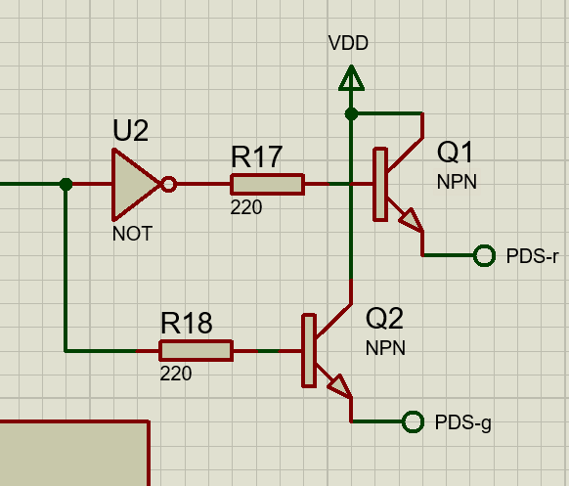
Figure 1: NOT gate & transistor arrangement
The full circuit diagram is provided in Appendix 1.

System Operation Flowchart
There are two flowchart sections; The first is a high-level process describing the overall behaviour of the system which calls a procedure to operate the lights. The second chart is a sequence diagram detailing how an individual traffic light is controlled. Having this separation reflects how the code is scalable for different situations, as it has been designed to be adaptable for different hardware configurations.
The sequence diagram is a generic flowchart that encapsulates the timing behaviour for any single traffic light. The higher-level process calls the single traffic light sequence for each instance of the traffic lights in the simulation, this design makes the solution scalable so that lights could be added or removed with only very minor changes to the code.
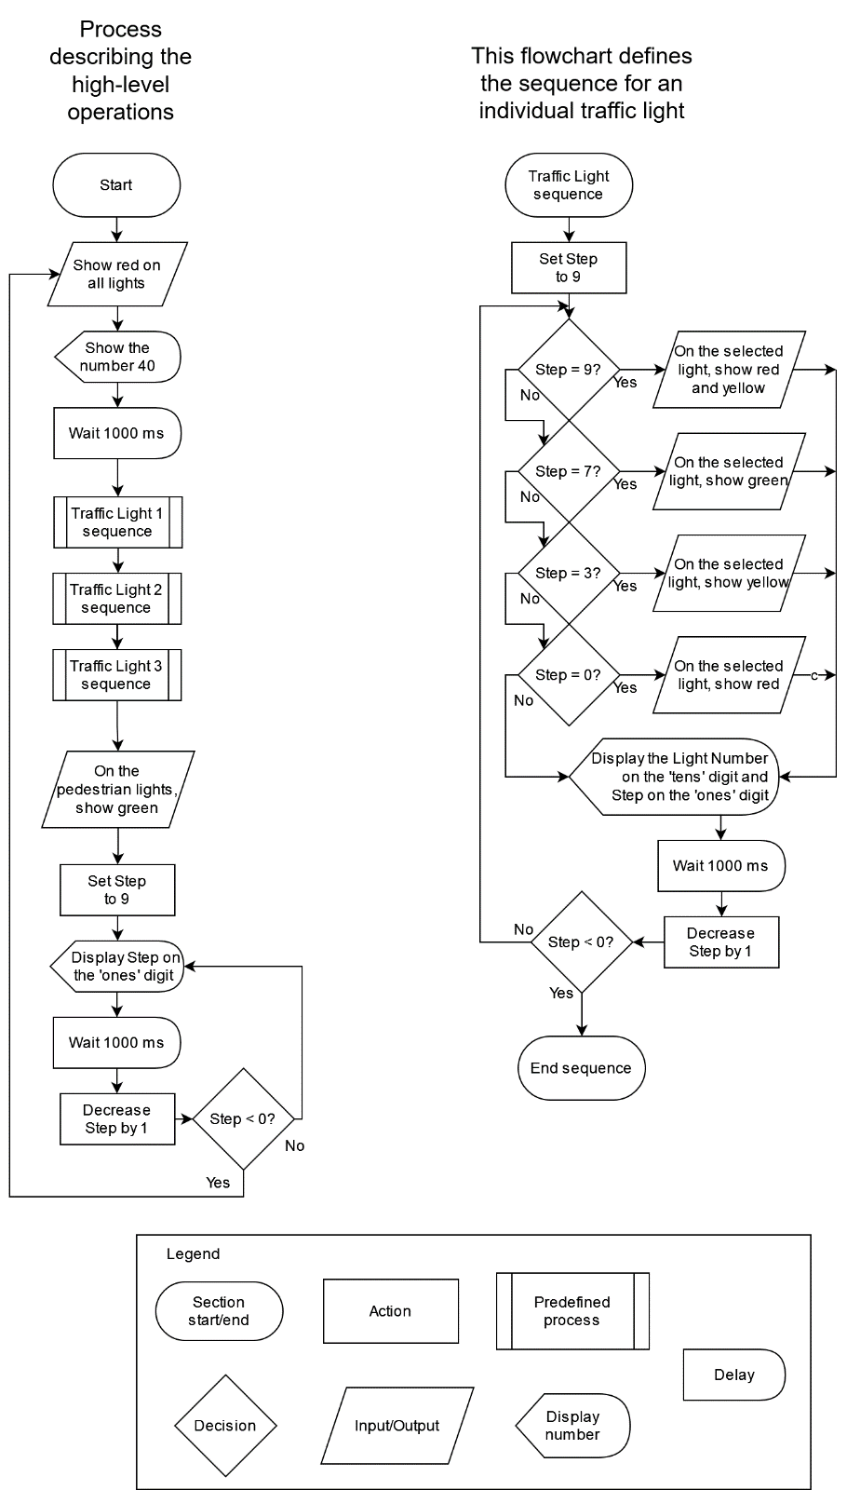
I have used informal symbols in my flowcharts for the delay and numeric output functions, so a legend has been included to define their meaning.
Figure 2: System operation flowchart

Simulation screen-captures
The first set of tests I did were to get a full rotation working on a single traffic light, as defined in [1].
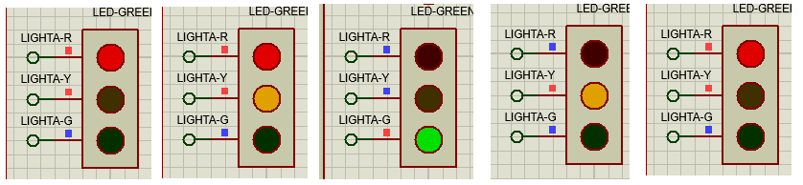
Figure 3: Full rotation of an individual traffic light
At any given point in time, the system will only have one set of traffic lights allowing drivers or pedestrians to move. This is done to minimise the chance of an accident as traffic flows should never intersect each other.
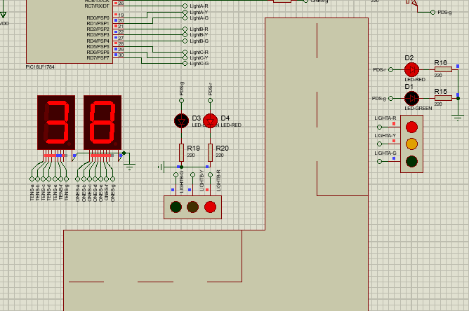
At this point in time, at the 38 second mark, traffic lights 2 and 3 are showing red indicating those drivers should not move, while traffic light 1 is showing the red and amber signals to indicate those drivers should prepare to move.
The pedestrian lights are also red, as there should not be any people on the road while drivers are preparing to move.

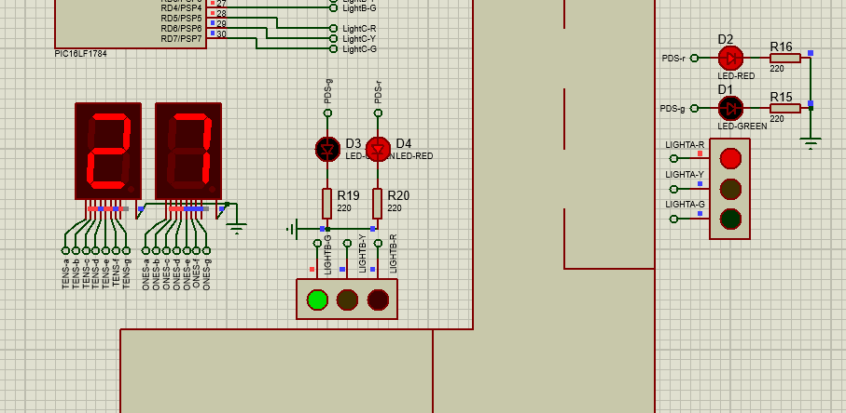
Following a full rotation of traffic light 1, it transfers control to the next set, going in an anti-clockwise circle. After this set finishes, it will again transfer control onto light 3

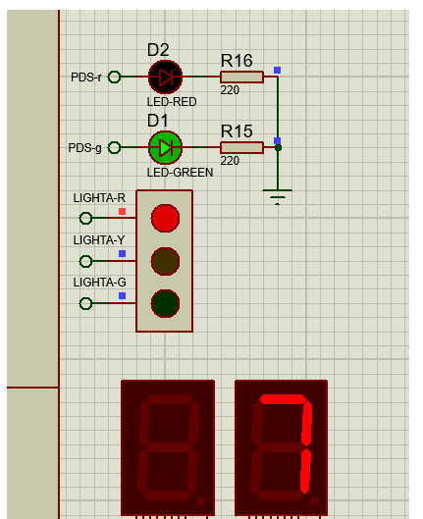
After the final set of traffic lights concludes its rotation, there is 10 seconds allocated to allow any pedestrians to cross the road. Once the countdown reaches 0, it resets to 40 and the entire sequence repeats.

Testing method and results
Traffic lights are used to manage the safe traffic flow at road junctions and provide safe crossing signals for pedestrians. Because of the safety implications, it is imperative that the system does not malfunction in any circumstance. During development, I discovered that the timing and sequencing of events was critical. To aid in the design of a safe system, I developed the sequencing spreadsheet shown in Appendix 2, which describes how each light should appear for all points in time. This was a valuable resource while writing the code responsible for governing behaviour of the lights.
The testing method was a cycle of making a change, testing that change in the simulator, and iteratively adjusting it until the behaviour was correct. I first created an abstraction for the traffic light states to isolate the complexity of controlling a light, so later code could focus on how the lights should behave. I tested this with a simple but inaccurate pattern, then extended the abstraction code for multiple lights once it worked with the first one. This development method allowed me to rely on stable code and to focus on small problems individually, instead of spending time on identifying where a problem had occurred. During testing, I discovered that the green and red lights were mistakenly swapped, which would have been much harder to discover if I also had to consider the possibility of the sequence logic being faulty. Once the abstraction code had been fully tested under all conditions, I moved on to developing the sequence controller and implementing pedestrian light support.
When I came to test the code, the simulator revealed a fault in the logic that enabled the pedestrian light to show green while traffic was still flowing. I fixed the underlying issue and additionally installed a safety guard to prevent the pedestrian light showing green while any of the traffic lights were also green.

Conclusion & recommendations on future work
All four of the initial design criteria have been successfully met: i.e. managing the three traffic light sets, with pedestrian crossing signals that include a 40 second countdown display, and in a complete rotation each set of lights has 10 seconds whilst ensuring the pedestrian lights do not conflict with the traffic light signals. In addition to the requirements, I followed UK regulations that set the rules for order and duration of traffic light rotations in the UK, so the system can be deployed across the country.
This exercise has taught me how to develop software for an embedded environment, making use of simulator software to expedite the process without access to physical hardware for testing. It also taught me how to write concise and efficient code, as the microcontroller has very limited processing and storage capacity.
I found the Top-down approach to handling the problem to be very useful. In this case: I took time to first understand the requirements, then I created a sequence model of how the traffic lights should be illuminated in a spreadsheet (Appendix 2), allowing me to create a flowchart of how the behaviour should be implemented. Both of these resources were crucial to ensuring the code I wrote would be clean, perform correctly, and be easy to debug.
Future options to further develop this system could include:
- A provision for pedestrians to signal they want to cross, i.e. a button. This might require a more sophisticated software design using interrupts, as the current software is not checking any external conditions.
- The visible countdown timer could only be illuminated when the pedestrians are crossing, to indicate how long they have left. At present, it could be confusing to show the time left in the overall sequence when it does not apply to them.
- For accessibility purposes, adding a loud beeper to announce the pedestrian light turning green would assist those who have partial or no eyesight. If this is done, the volume should be adjusted depending on how close the traffic lights are to houses.
- Further work could be done to build interlocks into the code to detect malfunctions. This will certainly be necessary if a pedestrian button is added, as the scope for failure increases. For instance, checks could include:
  - Checking that there is never more than one green light active at a time
  - Implementation of the Watchdog Timer so the system safely restarts in the event of a software crash

References
[1] | Microchip, “28-Pin 8-Bit Advanced Analog Flash Microcontroller,”  PIC16F1784 Datasheet, Jun. 2012 [Revised Aug. 2014]  https://www.mouser.co.uk/datasheet/2/268/40001637C-1066570.pdf  Accessed: 5th January 2024 @ 12:11
[2] | Great Britain, Parliament. (16th March 2016, “The Traffic Signs Regulations and General Directions (2016)”  https://www.legislation.gov.uk/uksi/2016/362/schedule/14/made  Accessed: 8th November 2023 @ 16:53

Appendix 1: Circuit diagram
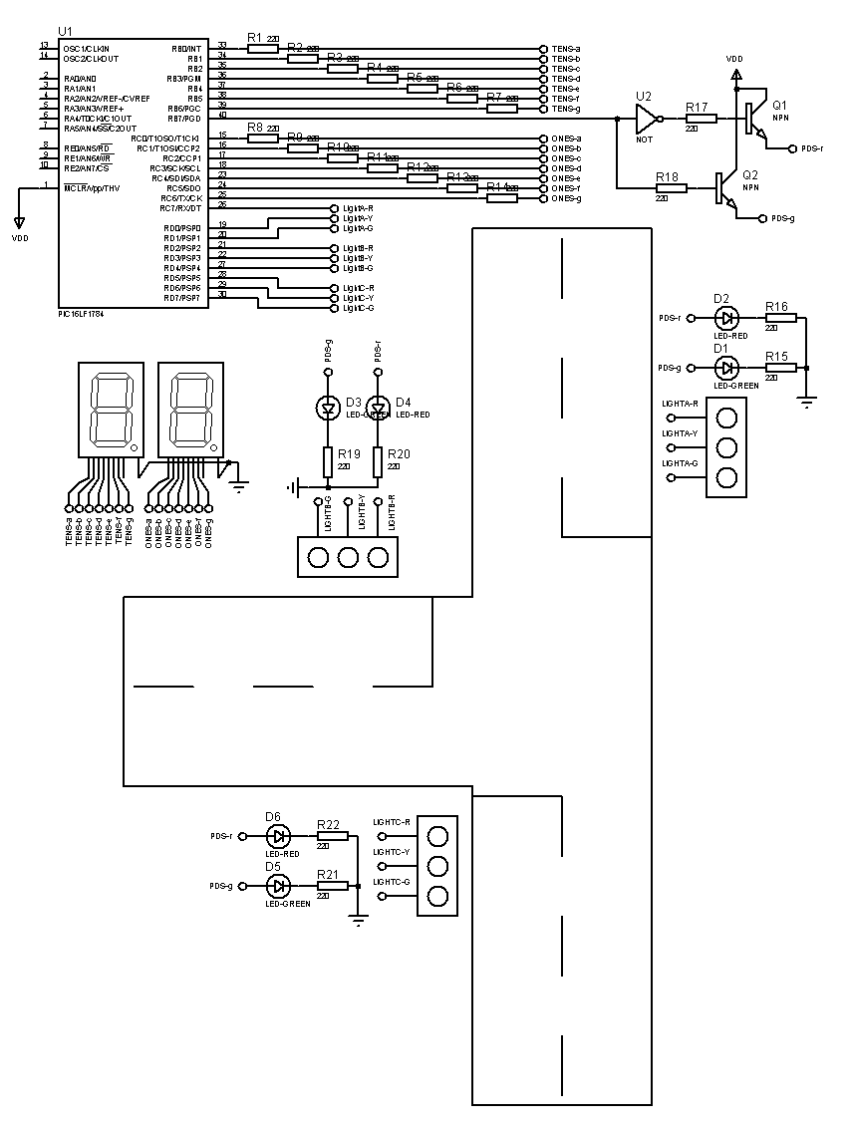

Appendix 2: Spreadsheet demonstrating light sequence
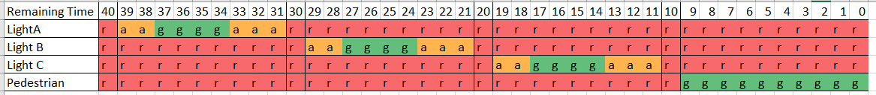

Appendix 3: Complete software listing
/* Author: Daniel Bridgewater
* Created: Tue Nov 7 2023
* Processor: PIC16F1784
* Compiler: MPLAB XC8
*/

#define _XTAL_FREQ 4e6 // 4 MHz clock
#define delay_ms __delay_ms
#include <xc.h>

// C#-style shorthands for signed and unsigned char types
#define sbyte signed char // -128 to 127
#define byte unsigned char // 0 to 255

// Traffic light state definitions
typedef enum TrafficLightStates {
STOP = (byte)0,
GET_READY,
PROCEED,
SLOW_DOWN
} TrafficLightStates;
TrafficLightStates lights[3];
byte pedestrianCross = 0;

// Function declarations
void update_lights(void);
void show_number(sbyte tens, sbyte ones);

// Entry point
void main() {
TRISB = TRISC = TRISD = 0; // All pins are outputs, PORTA,E unused

// Infinite loop
while (1) {
// Initial state at 40 second mark
lights[0] = lights[1] = lights[2] = STOP;
pedestrianCross = 0;
update_lights();
show_number(4,0);
delay_ms(1000);

// For each light...
for (sbyte sequence=0; sequence<3; sequence++) {
TrafficLightStates *light = &lights[sequence];

// ... count through the 10 second sequence.
for (sbyte step=9; step>=0; step--) {
// Select new traffic light colour according to UK legislation:
// The Traffic Signs Regulations and General Directions (2016),
// Schedule 14, Part 1, Paragraph 4.
switch (step) {
case 9:
*light = GET_READY;
break;
case 7:
*light = PROCEED;
break;
case 3:
*light = SLOW_DOWN;
break;
case 0:
*light = STOP;
break;
default:
// Do nothing in all other steps
break;
}
// Apply the new state onto the hardware
update_lights();

// Show number of seconds remaining and pause
show_number(3-sequence, step);
delay_ms(1000);
}
}

// Final part, let pedestrians cross
pedestrianCross = 1;
update_lights();
// Count down from 9 to 0
for (sbyte step=9; step>=0; step--) {
show_number(-1, step); // -1 turns Tens digit off
delay_ms(1000);
}
}
}

// Output traffic light states
void update_lights() {
/* Pin mappings:
RB<7>: Pedestrian Red/Green
RC<7>,RD<0-1>: Traffic light A
RD<2-4>: Traffic light B
RD<5-7>: Traffic light C
*/

// Light A
switch (lights[0]) {
case STOP:
PORTC |= 0b10000000; // Red ON
PORTD &= 0b11111100; // Yellow,Green OFF
break;
case GET_READY:
PORTC |= 0b10000000; // Red ON
PORTD |= 0b00000001; // Yellow ON
PORTD &= 0b11111101; // Green OFF
break;
case PROCEED:
PORTC &= 0b01111111; // Red OFF
PORTD &= 0b11111110; // Yellow OFF
PORTD |= 0b00000010; // Green ON
break;
case SLOW_DOWN:
PORTC &= 0b01111111; // Red OFF
PORTD |= 0b00000001; // Yellow ON
PORTD &= 0b11111101; // Green OFF
break;
default:
// Obvious failure state
PORTC |= 0b10000000; // Red ON
PORTD |= 0b00000011; // Yellow,Green ON
}

// Light B
switch (lights[1]) {
case STOP:
PORTD |= 0b00000100; // Red ON
PORTD &= 0b11100111; // Yellow,Green OFF
break;
case GET_READY:
PORTD |= 0b00001100; // Red,Yellow ON
PORTD &= 0b11101111; // Green OFF
break;
case PROCEED:
PORTD &= 0b11110011; // Red,Yellow OFF
PORTD |= 0b00010000; // Green ON
break;
case SLOW_DOWN:
PORTD &= 0b11101011; // Red,Green OFF
PORTD |= 0b00001000; // Yellow ON
break;
default:
// Obvious failure state
PORTD |= 0b00011100; // Red,Yellow,Green ON
}

// Light C
switch (lights[2]) {
case STOP:
PORTD |= 0b00100000; // Red ON
PORTD &= 0b00111111; // Yellow,Green OFF
break;
case GET_READY:
PORTD |= 0b01100000; // Red,Yellow ON
PORTD &= 0b01111111; // Green OFF
break;
case PROCEED:
PORTD &= 0b10011111; // Red,Yellow OFF
PORTD |= 0b10000000; // Green ON
break;
case SLOW_DOWN:
PORTD &= 0b01011111; // Red,Green OFF
PORTD |= 0b01000000; // Yellow ON
break;
default:
// Obvious failure state
PORTD |= 0b11100000; // Red,Yellow,Green ON
}

// Pedestrian lights, with checks to ensure it cannot be green while unsafe to cross
if (lights[0] == STOP &&
lights[1] == STOP &&
lights[2] == STOP &&
pedestrianCross)
{ PORTB |= 0x80; } // Show green
else { PORTB &= 0x7f; } // Show red
}

const byte segment_lookup[10] = {
//0 1 2 3 4 5 6 7 8 9
0x3f, 0x06, 0x5b, 0x4f, 0x66, 0x6d, 0x7d, 0x07, 0x7f, 0x67
};
// Output numeric digits
void show_number(sbyte tens, sbyte ones) {
/* To make things simpler in the outer logic, the two digits are separate parameters.
Pin mappings:
RB<0-6>: Tens Digit
RB<7>: Pedestrian Light (mask this out!)
RC<0-6>: Ones Digit
RC<7>: Light A Red (mask this out!)
*/

// Clamp values to not exceed 9
if (tens > 9) tens = 9;
if (ones > 9) ones = 9;

// Turn off Tens segment if less than 0
if (tens < 0) {
// Clear Tens
PORTB &= 0x80;
} else {
// Tens digit lookup, with mask to avoid altering Pedestrian Light
PORTB = (PORTB & 0x80) | segment_lookup[tens];
}

// Ones digit lookup, with mask to avoid altering Light A
PORTC = (PORTC & 0x80) | segment_lookup[ones];
}

