MARKETING MANAGEMENT – ASSESSMENT 1
CASE STUDY – PRIMARK

Executive Summary
Marketing activities are helpful for organisations by which companies attract more customers to their business and they try to retain their customers with high-quality products and services. Recently, the issues in brand management and brand awareness are increasing for the higher competition level in the market and Primark company also has faced challenges in managing their sales and revenue for their lack of innovative focus on digitisation. Assessment 1 of the report focuses on critically appraising Primark. Thus, the background of the company reflects that Primark is a well-known fashion retailer in the UK. However, during Covid-19 times, the stated firm has suffered a loss in its revenue. Hence, concerning this, the stated firm for branding follows Barnlund's transactional model of communication. As the company has started their online store as per the demand of its customers, the customer journey map has been developed differently for the online and offline stores Primark. The total engagement model has been applied to the business activities of Primark and new promotional strategies have been recommended for the business to develop their sales and revenue with innovative and digital marketing activities.

Table of Contents
Assessment 1: Report 4
Introduction 4
Background information about the company 4
Definition of communication 6
Briefly explanation of a communication model with a diagram 6
Definition of Integrated Marketing Communications 8
Recommendations of promotional strategies the company can use to raise awareness of the brand 9
Definition of branding and brand equity 11
Explanation of either Keller’s Brand Equity model with relation to Primark 12
Discussion on the customer journey and customer touchpoints for Primark 13
Explanation of consumer touchpoints 14
Customer journey map of Primark with diagram 16
Strengths and weaknesses of customer journey map of Primark 18
Explanation of the Total Engagement Model by relating it to Primark 18
Recommendations for new touchpoints 20
Conclusion 20
Reference list 21

Assessment 1: Report

Introduction
Marketing management is the process of controlling the various marketing operations of the companies with the help of human resources to interact with customers and to have business growth by attracting more customers towards the business. Challenges in the marketplace are increasing day by day for which the companies are facing issues in their brand management and customer management effectively (Poplavskaya et al. 2021). The trends among customers have changed to having digitised services from the companies since the pandemic situation. Primark is known as a fast fashion retailer, headquartered in Dublin, Ireland and its stores are in various places in Europe and the US and other countries (Primark, 2023). The company is having issues in managing its sales since the covid-19 situation and in the post-pandemic situation as well as the lack of digitisation in their business (The Guardian, 2020). In this section of this study, the importance of communication in marketing activities and the new promotional strategies which Primark can use in their business has been discussed. Along with this, the application of the brand equity model has been done in addition to the analysis of the customer journey map of Primark. The total engagement model has also been discussed with the alignment of the Primark company by which innovative marketing strategies can be developed to fulfil the stakeholders' expectations.

Background information about the company
Primark is a well-renowned fashion retailer company that is situated in Dublin in the UK. It is mainly owned by Associated British Foods plc, (ABF). It has overall 380 stores in 12 different countries including the UK and USA. However, the main objective of the enterprise is to provide varieties of products at an affordable cost offering to all genders and ages (Adams et al., 2019). Further Primark has also adopted the effective business model that allowed them to achieve success by skillfully managing its supply chain and leveraging economies of scale to maintain low costs. The company does not invest in advertising or online sales and relies solely on its physical stores to generate sales.
Additionally, as per Bob et al., (2020), Primark has taken initiatives to enhance its sustainability and ethical practices in recent years, such as incorporating more eco-friendly materials and enforcing fair labour standards across its supply chain. However, in the context of the study, Primark has to face losses due to the Covid-19 pandemic and due to less digitalisation. The below figure reflects the revenue generation of Primark between 2007 and 2022. In observing the figure, it can be stated that every consecutive year the enterprise has improved sales and growth with its effective strategy and business framework (Rust, 2020). As comparing the years from 2019 to 2022 it shows that in 2020 and 2021 the sales were critically low due to the pandemic situation and less emphasis on digitalisation in the market. However, from the revenue and sales of 2022, it can be stated that after the pandemic as the old traditional marketing shifted toward the digitalisation process (Statista.com, 2023). It provided a positive output for Primark Company as it increased its sales and revenue and contributed to the success of the company by implementing digitalisation processes.
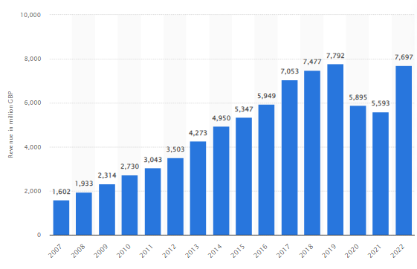
Figure 1: Revenue of Primark worldwide from 2007 to 2022
(Source: Statista.com, 2023)
Mission statement
The mission statement of the Primark Company is “to make more sustainable fashion affordable for everyone”.

Definition of communication
Communication in basic terms can be stated as the transmission of information from the sender to the receiver (Aceto et al. 2019). Communication in the marketing process is known as the message and media that marketers use to communicate with their target market. Companies can communicate directly with their customers or they can use their marketing activities to communicate with their customers as well. Both verbal and non-verbal communication can be done by the companies to manage their marketing activities (Kurniadi and Mahaputra, 2021). Advertisements in the printed media and the use of billboards can be considered as the written communication process in marketing activities. On the other hand, communicating in the stores with the customers directly can be stated as one kind of verbal communication in marketing.

Briefly explanation of a communication model with a diagram
Nowadays, a tendency of giant organisations towards implementing various communication models has seen growth across the international markets to provide a wholesome understanding of the industry. According to Kharouf et al., (2020), implementing an effective communication model can aid both organisational managers and employees to understand similar business patterns or changes in organisational structure by facilitating effective communication. However, Bui et al., (2019), on the other hand, pinpointed one key benefit of using communication models in organisations as it helps in understanding and identifying the main components and relationships of the entire communication process throughout the organisational structure. Therefore, from analysing various real-life evidence, it can be evaluated that applying the right communication model can simplify the overall business procedure by offering the organisation a visual representation of the different aspects employees encounter while facilitating active communication with stakeholders, suppliers and customers.
Organisations while conducting global business operations mainly focus on implementing the proper communication model through a pictorial representation. Based on the image, the entire communication process can be understood simply with the help of unique ideas, innovative thoughts, or interesting concepts through. Koren and Pető (2020), by supporting this argument, have stated that by developing a diagram of the applied communication model, global organisations, such as Primark, can access systematic representations of the overall communication process. In such a way, this communication model can help the companies to comprehend how effective communication can be formulated to deal with the challenges of limited reducing sales due to poor digitalisation process.
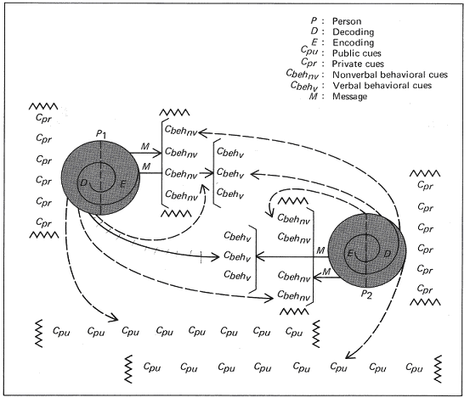
Figure 2: Barnlund's transactional model of communication
(Source: Cerrone and Mäekivi, 2021)
Based on real-life evidence and applications, various communication models can be identified which represent simplified representations of the communication process throughout the organisational structure. According to Cerrone and Mäekivi, (2021), between Barnlund’s Transactional Model and Dance’s Helical Model, the former is the most effective model of communication an organisation can implement across its business dealings. However, Lu et al., (2022) pinpointed that one of the reasons behind selecting Barnlund’s Transactional Model is that the model describes both non-verbal and verbal communication as an exchange of organisational inputs. On the other hand, Cerrone and Mäekivi, (2021) have determined Barnlund’s Transactional Model as one of the major Transactional Models, through which the entire process of organisational communication can be carried out with the facility of receiving immediate two-way feedback. Moreover, another interesting function of this communication model is that it can offer a compact and complete overview of the entire process of complex communication by comparing its facilities based on immediate feedback.
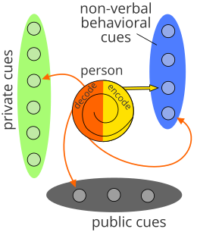
Figure 3: Way brands follow Barnlund's transactional model of communication
(Source: Lu et al., 2022)
Primark, as a result, may focus on implementing and investing more in bringing Barnlund's transactional model of communication into action to facilitate an active mode of organisational communication. Primark, with the help of this model of communication, can highlight the complex process of interaction within the organisational structure (primark.com, 2023). At the same time, this communication model can also help Primark to identify and determine many complex factors, which influence the entire process of how communication is interpreted and perceived (primark.com, 2023). Moreover, this model also emphasises the importance of developing an active communication process by considering all the physical and psychological influences over communication and feedback towards shaping the meaning of organisational messages.

Definition of Integrated Marketing Communications
Integrated marketing communications (IMC) refers to the marketing approach that involves the fusion of different communication channels to deliver a unified message to the intended and valuable audience. IMC helps brands to understand that efficient communication is indispensable in today's cut-throat business environment. In the context of the words, Herhausen et al., (2020) denote that brands nowadays focus on synchronising communication channels, including advertising, public relations, personal selling, and sales promotion, to publicise their low-priced yet trendy clothing products.
However, by aligning these channels, they ensure that the message is communicated and is unambiguous, uniform, and effective across all contact points. Moreover, for instance, the integrated marketing system intends to incorporate social media promotions, in-store campaigns, and targeted advertisements aimed at reaching its target market.
Moreover, IMC helps enterprises establish a robust brand identity while maintaining consistency across all channels. This ensures that customers have a clear comprehension of the brands and their principles (Bob et al., 2020). The IMC also focuses on delivering affordable yet stylish clothing as an integral component of its brand identity, and the company takes advantage of IMC to disseminate this unique value proposition efficiently.

Recommendations of promotional strategies the company can use to raise awareness of the brand
Brand awareness is considered a marketing term by which consumers recognize products based on their name, logo, and others. According to this study, it can be analyzed that due to less digitalization, Primark has lost its brand value negatively along with reducing business assets. During pandemic situations, majorities of people depend on online shopping, and due to enhancing technological Integration, social media is a major pathway to raise brand awareness of this retail sector. To sum up, it can be said that high brand awareness is linked with high sales and large customer reach. Nowadays, it is necessary to mention that 79% of consumers like to buy from those brands, which are popular. Therefore, with respect to this study, some recommendations in terms of promotional strategies have been mentioned in order to raise the brand awareness of Primark, a fashion retail organization.
Recommendation 2: Proper logo and tagline in social media
Building an effective brand value, logo, and tactic is very important as well as the first step to developing brand awareness. As per the suggestion of Masiello et al., (2020), brand value in social media should be light-hearted and fun also, which helps brands to become recognizable. As an example, it can be said that M&S, a very popular brand, has made its brand aesthetic by using proper colour, and keywords, and targeting consumers demographically. It has allowed the company to enhance sales and revenues ultimately compared to the previous year. This chosen company, Primark, needs to increase its social media presence, including setting clear brand value, brand tagline, and logo, which will help to improve brand awareness positively. As per the suggestion of 60% of the audience advocates brands based on their values and beliefs. Therefore, this company needs to make an eye-soothing brand logo to attract people and increase brand awareness to a high level.
Recommendation 3: Tell a brand story through blogging
Every company has a brand story; however, the critical fact is the right way to tell the story. It can be recommended that the brand story of Primark should be narrative and highlight its success through blogging in the social media channel, which will help to increase brand awareness properly. As per the research of Malik et al., (2023), every brand needs to build brand awareness beyond the product. Therefore, this company should focus on this promotional strategy to improve the level of brand awareness.
Recommendation 4: Run awareness ads and social media contests
According to social media networks, brand awareness is a key success to meeting business goals. This company needs to make awareness advertisements on social media so people can recall them. Besides that, this company can arrange social media contests to engage people and enhance awareness levels about the brand (Ardiansyah and Sarwoko, 2020). For example, the Matalan retail sector has established a "tag-a-friend" entry model to enhance consumers' engagement in social accounts and leads to high brand awareness. This company can prioritize this promotional strategy not only to enhance brand awareness but also to increase audience sizes.
Recommendation 5: Created shareable content and offer a freebie
It can be advised that Primark needs to create shareable content, which can go viral. It will help followers to share content and reach a large number of people very easily. Nowadays, hashtag is very popular; this company can use a hashtag during sharing contests, which will help to stay one step earlier to improve brand awareness.
Alternatively, everyone prefers freebies, which means offering free products to customers with offers will help to create traffic in social media about the brand. For instance, M&S has implemented a "freemium business model" to offer products free with an aim to upgrade paid plans and improve brand awareness also. The company may focus on this type of promotional strategy to improve and raise its brand awareness.

Definition of branding and brand equity
Branding is considered about feeling consumers' good as well as establishing an emotional relationship with them. As argued by Olanipekun and Adelekan (2022), branding helps to create consumer loyalty in the long term by creating a good impression. In comparison to this study, Primark usually uses Facebook marketing as a branding strategy by posting various videos, photos, and blogs and providing brand-related advice to customers. It helps this company to aware consumers of the latest trends and improves their loyalty.
Brand equity is about brand value, which is usually determined by consumers' perceptions of this brand based on product quality and desirability. As per the research Forbes, this company always tries to provide high-quality sustainable products to its customers at comparatively low prices. However, according to the statistical analysis, it can be analyzed that the brand value has been reduced in the last two years during covid-19 pandemic due to lacking digitalization.
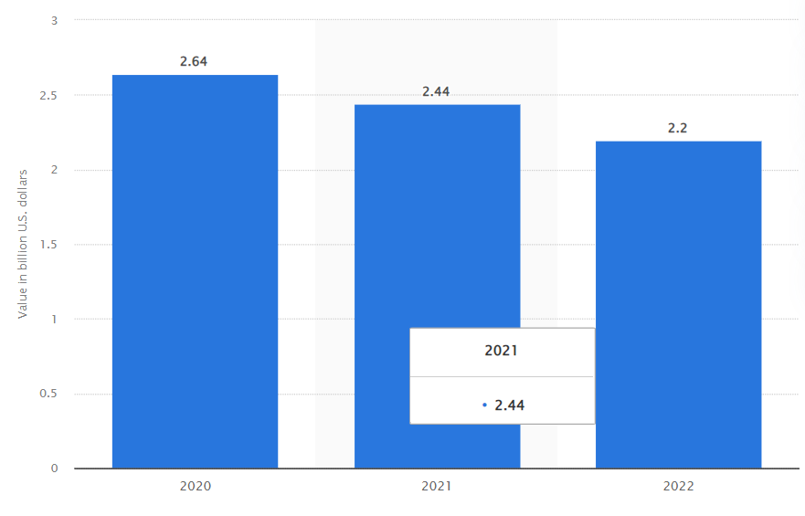
Figure 4: The brand value of Primark
(Source: Statista.com, 2022)
The above picture has mentioned that the brand value has been reduced to 2.2 billion US dollars in 2022 from 2.64 billion USD in 2020. However, this company is trying to improve brand value by creating new fashion-related content, blogging, and others (Primark, 2023).

Explanation of either Keller’s Brand Equity model with relation to Primark
Keller's brand equity model, known as the CBBE model (customer-based brand equity) is simple and helps to create a strong brand image by creating effective and ideal brand experiences. It consists of four important stages: "salience", "performance and imagery", "judgments and feelings” and "Resonance". In contrast to Primark, the first stage "salience" will help to understand its identity and improve its thinking capacity at a high level. The second stage "performance and imaginary" will help understand customers' needs and fulfill their needs easily. As per the research of Jadhav et al., (2021), the Keller model has broken performance at 5 specific key features: "characteristics of the product", product "reliability and durability", "service effectiveness", "style", and price. All of these specifications will help to develop the company's products and features and ultimately improve business performance. On the contrary, imaginary is related to brand currency, which will help to set proper target customers and construct messaging for them.
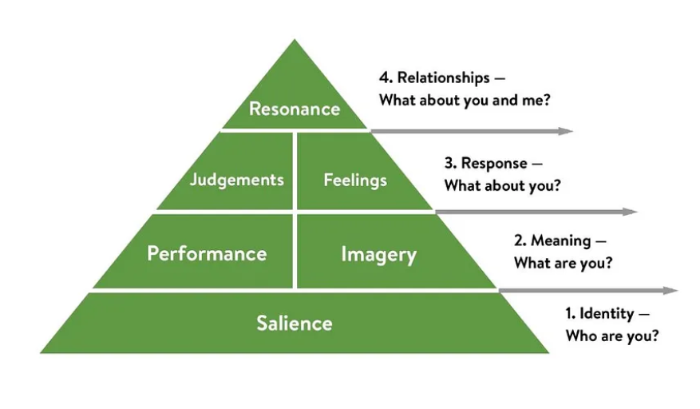
Figure 5: Keller’s CBBE pyramid
(Source: Created by the researcher)
The third stage is relapsed to judging the brand. With the help of the third stage, the company can create its own brand message by which people can associate with this brand (Jiménez-Marín et al., 2021). Lastly, resonance will help to identify customers and create strong relationships with them through great tactics.
To sum up, the application of the CBBE model will improve brand performance by improving brand identity to customers. Besides that, it will help to improve behavioural loyalty by implementing various schemes like "customers loyalty card scheme", "purchasing scheme", and others. Usually, it will help to improve community sense including improving their active engagement through joining clubs, online chats, and others. Alternatively, applications of this model will help to improve brand performance and service effectiveness in a high manner.

Discussion on the customer journey and customer touchpoints for Primark
Consumer persona
PERSONA NAME | Amyra John
BACKGROUND | Education: MBA in HR  Job title: HR manager in a private company with a responsibility to hire IT people  Work experience: More than 12 years
DEMOGRAPHICS | Age: 34  Sex: Female  Location: Dublin, Ireland  Income: 4000 pounds/ month  Marital status: Married  Children: 2 children
IDENTIFIERS | Motivation to use this brand: This brand is very sustainable and provides high-quality products at very affordable prices.  Goals to use this brand: It is a very comfortable product and extends long days.
Table 1: Consumer persona
(Source: Created by the researcher)

Explanation of consumer touchpoints
Consumer touch points are considered as points related to the brand regarding customer contact from start to finish. In this case, the consumer touch point has been described based on above mentioned consumer persona.
Touchpoints | Before purchase | During purchase | After purchase
Awareness | Awareness was created from social media posts regarding brand sustainability. | During purchasing, the quality of the product has ensured that "the brand is sustainable" and its online specifications helped to create awareness. | The knowledge-based forum of Primark has enabled customers to sustain awareness.
Consideration and decisions | The company's blogging has helped make decisions. | Customer reviews have enabled the customer to make decisions smartly. | Feedback surveys have helped the company to evaluate customers' experiences.
Action and purchase | Facebook posts and Video has helped to take action. | Social media presence has allowed taking action. | Primark provides huge offers to loyal customers, which motivates them to engage with this brand.
Retention | Social media daily posts regarding trending and sustainability allow the customer to engage with this brand and enhance retention. | Social media content and various offers from Primark allow the customer to engage with this brand and enhance loyalty. | This company responds by sharing and replying to content, which is a great motivation to retain this brand.
Table 2: Touchpoints of the customer
(Source: Created by the researcher)

Customer journey map of Primark with diagram
A customer journey map can be stated in accordance with a diagram which shows the process and stages which customers go through at the time of interacting with any company for buying products as well as for availing customer service. In with Siebert et al. (2020), the stages for the customer journey map are awareness, search, decision, service and retention and advocacy. Customers' actions are different for these five different stages and their experiences are also different. Primark is an Irish fast fashion company and the company has a presence more in the offline markets rather than having effective brand positioning on online sites. The customer journey map has been developed for both the online and offline stores of Primark company by which customers can easily have trendy fast fashion products from online business activities as well as from the offline stores.
 | Awareness | Consideration | Decision | Service and Retention | Advocacy
For online stores | Customers can increase awareness with online advertisement | Customers used to search for the product in online search engines and on the website of Primark. | After watching the products, customers can compare the products with the other fashion brands online and after that customers make the decision to purchase the fast fashion products. | Customers can have the online delivery service of the product to their house and they can have support from customer services for any kind of issue. | After having satisfaction services and fashion products from the end of Primark, customers can develop their loyalty to the brand.
For offline stores | Customers can increase their awareness from the advertisements of printing media and online media both. | They can reach the stores of Primark and they can touch and feel the products on their own and they can do the trial also. | Customers can show excitement to buy the products from the offline stores after the trial of the fast fashion products. | They can get the store services at the time of billing of the products and in the exchange process of the products. | Having high-quality fast fashion products and effective offline store customer services can increase the loyalty and trust of the customers for Primark.
Table 1: Customer journey map for Primark
(Source: Created by author)

Figure 6: Customer journey map in Primark
(Source: Created by author)

Strengths and weaknesses of customer journey map of Primark
In the context of online selling, the online advertisement of Primark works well as one of the touchpoints. In many cases, this touchpoint works well for the customers if the company use attractive content and in many cases, these touchpoints can have a low impact on the customers. Furthermore, in case of consideration, the customers are required to search for the products of Primark and this can have a low effective on the customers' behaviour. Different options can be provided by Primark to them by which the consideration for buying the products from Primark can be done. The touchpoint of the service and retention of Primark is effective for the customers. They can have customer services for their products and services easily from the company (Primark, 2023). On the other hand, for the offline stores, the touchpoints in the awareness stage are again the advertisements, promotions, and others. These touchpoints are used to work well for the customers and they can increase their awareness of the products and they can increase their willingness to buy the products from the offline stores.
Moreover, in the case of the offline selling process, customers are able to touch and try the products in their stores in the consideration stage. This touchpoint is having a more positive impact on the behaviour of the customers and experiencing the products physically is having a higher effect on changing the buying decision of the customers (Roggeveen et al. 2020). Moreover, the buying process is technically advanced in the stores of Primark and this also works well to change the behaviour of the customers to buy the products positively. The exchange of the products from the offline stores of Primark and having the support from the customer service staff are well managed in the business and these touchpoints also work well in managing the customer journey in the business.

Explanation of the Total Engagement Model by relating it to Primark
The total engagement model focus on the four different factors of brands which are advertisement, customer experience, customer, and customer value propositions. This is one of the valuable tools of the business by which companies can grow their brands and have more customer bases (Iankova et al. 2019). Organisations maintained the culture of the business and they maintained the brand advertisement as well. Brad advertising affects customers and the culture of the organisation affects the employees of the business. Moreover, customer experience can impact the customers from the end of the employees if they have the facilities to work in a positive organisational culture. The promises and the delivery of the promises are also related to the total engagement model (Arora et al. 2019).
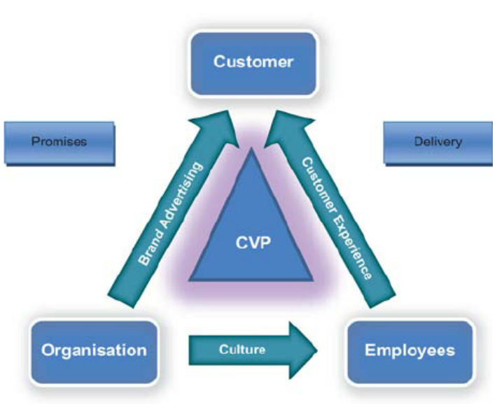
Figure 7: Total engagement model
(Source: Researchgate, 2023)
In the context of Primark company, the company is doing brand advertisement with different online and offline channels and they are trying to satisfy their customers with trendy fast fashion products by which they are having a positive impact on their customers. Along with this, the company is trying to maintain a positive culture in their business. In accordance with Paais and Pattiruhu (2020), employees can have more motivation when they work in a workplace with a positive culture. This helps in increasing the customer experience when they get effective customer service from the employees of the companies. Primark was lacking in digitisation, but now they have also launched their online website from where people can buy fashion products. This facilitates the company managing their promises to their customers and they are delivering their fast fashion products to the customers by which they can increase their sales and retain their customers.

Recommendations for new touchpoints
In the pre-purchase period, Primark can increase consumer touch points by increasing their communication with their customers through social media sites. Similar to this, in the stores of Primark, customer service staff can help the customers to get their needed fashion clothes and they can start to sell the customised products as well. On the other hand, at the time of purchasing the touch points can be increased by providing them offers on different products and providing them coupons for having the offers on their next purchase. This can help them in developing the impact of the touchpoints during the post-purchase period also.

Conclusion
This can be concluded from this section that innovative marketing approaches are needed from the end of the companies by which they can engage their customers to their brands and change the customer journey positively. Companies which are communicating with their customers frequently with different innovative activities can position their brand in the mind of customers more precisely and this is effective for the attraction of the customers and retention of customers. Primark had its presence as an offline store at the time of the pandemic and they were having a lack of focus on digitalisation. For this reason, they have experienced a lack of sales in their business and have an issue with brand management in front of customers. However, the brand has started its online stores from where customers can buy their fast fashion products as per the trend in the industry. New promotional strategies for Primark have been highlighted and the customer journey of Primark has been pointed out in the customer journey map as well.

Reference list
Aceto, G., Persico, V. and Pescapé, A., (2019). A survey on information and communication technologies for industry 4.0: State-of-the-art, taxonomies, perspectives, and challenges. IEEE Communications Surveys & Tutorials, 21(4), pp.3467-3501.
Adams, P., Freitas, I.M.B. and Fontana, R., (2019). Strategic orientation, innovation performance and the moderating influence of marketing management. Journal of Business Research, 97, pp.129-140.
Ardiansyah, F. and Sarwoko, E., (2020). How social media marketing influences consumers purchase decision: A mediation analysis of brand awareness. JEMA: Jurnal Ilmiah Bidang Akuntansi Dan Manajemen, 17(2), pp.156-168.
Arora, A., Bansal, S., Kandpal, C., Aswani, R. and Dwivedi, Y., (2019). Measuring social media influencer index-insights from Facebook, Twitter and Instagram. Journal of retailing and consumer services, 49, pp.86-101.
Bob, F., Jumadil, S. and Marlena, G., (2020). Communication strategy planning in influencing the intention to visit: An implication to marketing management. Polish Journal of Management Studies, 22(1), pp.117-133.
Bonetti, E. and Izzo, F., (2020). Multiple identities of a festival: Intended, communicated and perceived brand personality in the social media environment. International Journal of Contemporary Hospitality Management.
Bui, H., Chau, V.S., Degl'Innocenti, M., Leone, L. and Vicentini, F., (2019). The resilient organisation: A meta‐analysis of the effect of communication on team diversity and team performance. Applied Psychology, 68(4), pp.621-657.
Cerrone, M. and Mäekivi, N., (2021). A zoosemiotic approach to the transactional model of communication. Semiotica, 2021(242), pp.39-62.
Herhausen, D., Miočević, D., Morgan, R.E. and Kleijnen, M.H., (2020). The digital marketing capabilities gap. Industrial Marketing Management, 90, pp.276-290.
Iankova, S., Davies, I., Archer-Brown, C., Marder, B. and Yau, A., (2019). A comparison of social media marketing between B2B, B2C and mixed business models. Industrial Marketing Management, 81, pp.169-179.
Jadhav, D.S., Upadhyay, N. and Bhatt, V., (2021). Applying the Customer Based Brand Equity Model in examining Brand Loyalty of Consumers towards Johnson & Johnson Baby Care Products: A PLS-SEM Approach. ADBU Journal of Engineering Technology, 10(2).
Jiménez-Marín, G., Sanz-Marcos, P. and Tobar-Pesantez, L.B., (2021). Keller's resonance model in the context of fashion branding: persuasive impact through the figure of the influencer. Academy of Strategic Management Journal, 20 (6).
Kharouf, H., Biscaia, R., Garcia-Perez, A. and Hickman, E., (2020). Understanding online event experience: The importance of communication, engagement and interaction. Journal of Business Research, 121, pp.735-746.
Koren, M. and Pető, R., (2020). Business disruptions from social distancing. Plos one, 15(9), p.e0239113.
Kurniadi, W. and Mahaputra, M.R., (2021). Determination of Communication in the Organization: Non Verbal, Oral and Written (Literature Review). Journal of Law, Politic and Humanities, 1(4), pp.164-172.
Lu, W., Tingey, S., Preusser, D. and Zoghi, B., (2022), August. Design of An Interactive Scenario-Based Technical Management Communication Course-A Unique Addition to Future Engineering Leaders’ Toolbox. In 2022 ASEE Annual Conference & Exposition.
Malik, A.Z., Thapa, S. and Paswan, A.K., (2023). Social media influencer (SMI) as a human brand–a need fulfillment perspective. Journal of Product & Brand Management, 32(2), pp.173-190.
Olanipekun, O.J. and Adelekan, S.A., (2022). Why I Buy What I Buy? The Dynamics of Brand Awareness on Consumers' Choice. In Entrepreneurship and Post-Pandemic Future. Emerald Publishing Limited.
Paais, M. and Pattiruhu, J.R., (2020). Effect of motivation, leadership, and organizational culture on satisfaction and employee performance. The Journal of Asian Finance, Economics and Business, 7(8), pp.577-588.
Poplavskaya, K., Lago, J., Strömer, S. and De Vries, L., (2021). Making the most of short-term flexibility in the balancing market: Opportunities and challenges of voluntary bids in the new balancing market design. Energy Policy, 158, p.112522.
Primark, (2023). Who We Are. Available from: https://corporate.primark.com/en-gb/a/about-us/who-we-are [Accessed on: 17th April 2023]
primark.com, (2023): Homepage, available at: https://www.primark.com/en-gb [Accessed on 18/04/2023]
Researchgate, (2023). The total engagement model. Available from: https://www.researchgate.net/figure/The-total-engagement-model_fig2_49513186 [Accessed on: 17th April 2023]
Rust, R.T., (2020). The future of marketing. International Journal of Research in Marketing, 37(1), pp.15-26.
Siebert, A., Gopaldas, A., Lindridge, A. and Simões, C., (2020). Customer experience journeys: Loyalty loops versus involvement spirals. Journal of Marketing, 84(4), pp.45-66.
Statista.com, (2023). Revenue of Primark worldwide from financial year 2007 to 2022 Available at: https://www.statista.com/statistics/383785/primark-revenue-worldwide/ [Accessed on 18/04/2023]
The Guardian, (2020). Primark loses £800m in Covid-19 lockdowns. Available from: https://www.theguardian.com/business/2020/jul/02/primark-loses-800m-amid-covid-19-lockdowns [Accessed on: 17th April 2023]
Primark, (2023). Contact Us. Available from: https://www.primark.com/en-gb/help/contact-us [Accessed on: 26th April 2023]
Roggeveen, A.L., Grewal, D. and Schweiger, E.B., (2020). The DAST framework for retail atmospherics: The impact of in-and out-of-store retail journey touchpoints on the customer experience. Journal of Retailing, 96(1), pp.128-137.

