M3X9083
Dissertation: Business

Chloe Morgan
P147949

Gender Differences in Leadership Styles: A look into male leaders and female leaders within the Police Sector and Engineering Industry.

Supervisor: Dr Sandra Dettmer

20/11/2017

Contents

- Introduction……………………………………………………………………………….3
  - Literature Review…………………………………………………………………3
- Research Question and Aims………………………………………………………….4
- Research Rationale………………………………………………………………………….5
- Research Design and Methodology…………………………………………………..6
  - Data Collection and Analysis………………………………………………..6
  - Philosophy……………………………………………………………………………. 6
  - Strategy…………………………………………………………………………………7
  - Choice of Method…………………………………………………………………..7
  - Time Horizon………………………………………………………………………….7
  - Resources Needed…………………………………………………………………..7
5.0 References…………………………………………………………………………………………8

1 .Introduction
This dissertation project has been designed to evaluate the difference in leadership styles between males and females. The project will focus specifically on two key areas: the engineering industry and the police sector, looking in depth at different types of leadership style adopted by both men and women who have achieved top positions in these fields to analyse the balance of masculine vs. feminine leadership traits demonstrated by these individual.

  - Literature Review
Leadership can be defined as:
“an attempt to use non coercive influence to motivate individuals to accomplish some goal” (Bertocci, 1984).
Much research exists, in regards to gender and leadership styles, however, the research has mostly supported the theory that each gender behaves stereotypically (Sargent, 1981).
Loden (1985) maintained that there is a “masculine mode of management characterized by qualities such as competitiveness, hierarchical authority, high control for the leader and unemotional and analytic problem solving” (Eagly, 1989). There have been some theorists who disagree with Sargent’s theory such as Nieva & Gutek, who argue that “women leaders appear to behave in a similar fashion to their male colleagues” (Eagly, 1989). An example that supports Nieva & Gutek is women in politics. Recently we have seen women break through the glass ceiling in politics, such as Theresa May and Hilary Clinton. However, Kanter (1977) argues that “women or more often in positions of little power or opportunity for advancement, they behave in ways that reflect their lack of power” (Eagly, 1989).
Play like a Man, Win like a Women states the six things a man can do in the workplace that women can’t:
- They can cry. You can’t,
- They can have sex. You can’t
- They can fidget. You can’t
- They can yell. You can’t
- They can have bad manners. You can’t
- They can be Ugly. You can’t.
(Evans, 2000).
The theory behind this book is that “women do not understand how to behave in the leadership world because they were not socialized as children in the same way as men through sports and competitive games” (Clisbee, 2005 ).

2. Research Question and Aim
The main questions this project will be looking into are:
- How have women progressed within their career in the engineering industry and police sector?
- How women leaders in the specific fields differ from male leaders?
- What leadership styles do male leaders follow and women leaders?
Aims
The overall aim of this project is to find out if there is really a difference between leadership styles, when comparing male and females. The project also aims to investigate whether there is a gender difference, this affects progress within typically male – dominated sectors.
Research Objectives
To achieve the aims set above, the objectives of this study will be:
- Review leadership theories and how they are applied within the workplace.
The reasoning behind this research is to expand and understand the different leadership styles and how they are applied to the everyday workplace.
- Based on primary research, identify the most commonly adopted leadership style in traditionally male-dominated industries.
Information will be gathered through questionnaires and interviews conducted with employees from each sector. This is a crucial element to this project as it will allow a greater understanding of specific sector and will allow a greater insight, into how each gender operates with everyday tasks.
- Analyse the career progression of females and males in management.
By gathering further information on this particular element, statistics will be able to show if there is equality between the genders and highlight any discrepancies.
- Recommendations for the chosen industries in order to increase diversity in senior roles, which has been demonstrated.
This will be done to provide some guidelines for both the engineering industry and the police sector.

3. Research Rationale
Over the years, women have become more successful in the workplace. They have stepped out of the “stereotype” of a stay at home mother and are now some of the world’s most powerful entrepreneurs e.g. Sara Blakely who founded ‘Spanx’ (Forbes, 2017).
Even though women are well established in the workplace, “women represent just a sixth of senior executives at the largest listed British Companies” (Gordon, 2016). It has also been estimated that women in senior roles in the UK has fallen from “21% in 2016 to 19% in 2017” (Thorton, 2017). So with women now making up X% of the overall workforce, why is there still gender inequality when it comes to these top roles?
Recent reports have enlightened the public to just exactly what happens behind closed doors in the workplace. For example, currently in the media there is an ongoing case involving Harvey Weinstein abusing his position of power within the film industry. Even though this project does not look specifically at sexual harassment in the workplace, this is an example of something that can affect the way women (and sometimes men) progress within the workplace.
This project has been designed to look into the leadership differences between men and women. The report will be going into detail, analysing the difference in how each gender manages their team and whether leadership style is down to the lack of women in senior positions or if there is still a divide between men and women. The study will focus on two typically male-dominated areas: engineering and the police. This report focuses on men and women, however, future reports will also look into the Transgender community in management.

  - Research Design and Methodology
Research can simply be defined as “a process of enquiry and investigation and increases knowledge” (Hussey, 2009).
Saunders et al (2007), created the research onion which allows theorists to look at the philosophy, approach, strategies, time horizon and techniques/procedures. These sections are all applied to the model in layers. Figure 4.1 shows the research onion:
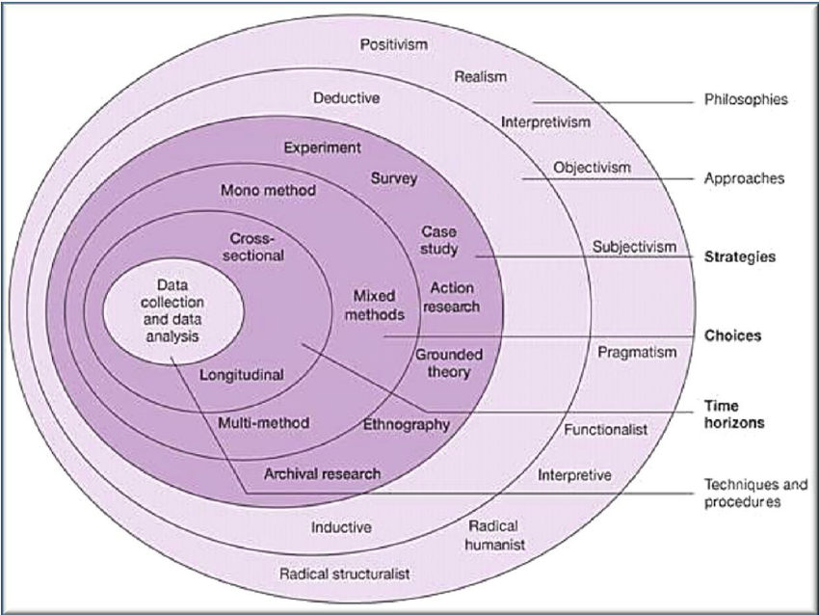
Figure 4.1 – The Research Onion
4.1 Data Collection and Data Analysis
The researcher for this particular study will be collecting and analysing the data using a quantitative approach. “The quantitative approach can be most effectively used for situations where there are a large number of respondents available” (UKEssays, 2017). This research will include face to face interviews with employees from both the Police Force and Engineering industry, as well as questionnaires and surveys. These will be distributed over a wide sample, allowing the researcher to analyse trends and responses.
4.2 Philosophy
An interpretivist approach will be applied by the researcher, this will allow the researcher to “understand differences between humans in our role as social actors” (Saunders, 2009). This approach will consist of research carried out among people rather than objects, the researcher in this case will be carrying out face to face interviews with employees within each industry.
4.3 Strategy
A strategy can be defined as:
“…a plan of action designed to achieve a specific goal. Strategy is all about gaining or at least attempting to gain, a position of advantage over adversaries or competitors” (SSP, 2017).
This study will conduct a survey, which will be carried out within each industry. The questions of this survey will be about the background of the managers, how they got their position, any hurdles they have accomplished to get to the level they are at now. The survey will also be given to employees below the leader. The survey will be worked with the researcher and the researcher Supervisor to design the research, in a way that will best achieve the goals. This survey will look at how they believe they are managed and what their leaders are like.
The sample size of the surveys will look at covering 20 – 25 people, this will include a mixture of employees and managers. Carrying out the survey will “allow the collection of a large amount of data from a sizeable population in a highly economical way” (Saunders, 2009). Interviews will also be conducted with both managers and employees of each industry.
4.4 Choice of Method
For the first objective, desk research will be carried out to understand the theories behind leadership styles. Objective 2 will be achieved by desk research and surveys and the third objective will be surveys and interviews with managers and employees.
4.5 Time Horizon
This particular study will require a cross-sectional study. Cross-sectional study simply means “research tool used to capture information based on data gathered for a specific point in time. The date gathered is from a pool of participants with varied characteristics and demographics known as variables” (Rivers, 2017).
4.6 Resources Needed
The following are needed to complete the study:
Computer.
Microsoft Word to complete dissertation and create surveys, interviews etc.
Microsoft Excel to translate findings into charts and tables.
The internet and access to the library to carry out research on theories.

4.7 Gantt Chart



5.0. References

al, S. e., 2009. The Research Onion. [Online]
Available at: https://www.researchgate.net/figure/282912642_fig2_Figure-2-The-research-onion-Saunders-et-al-2012
[Accessed 16 November 2017].
Bertocci, D., 1984. Defintions of Leadership . In: Leadership in Organisation: There is a difference between Manager and Leaders. Maryland : s.n., p. 6.
Clisbee, M., 2005 . Gender Differences in Leadership Styles: A literature Analysis , Nebraska: s.n.
Eagly, A. H. P. U. W. L. J. B. T., 1989. Gender and Leadership Style: A meta - analysis. Gender and Leadership Style, 1(1), p. 2.
Evans, G., 2000. Play like a Man, Win like a Women. New York : Broadway Books.
Forbes, 2017. The World's Most Powerful Female Entrepreneurs. [Online]
Available at: https://www.forbes.com/pictures/lml45effkg/sara-blakely-founder-spanx/#154279626102
[Accessed 16 November 2017].
Gordon, S., 2016. Women hold just a sixth of senior roles at top UK companies. [Online]
Available at: https://www.ft.com/content/0713fe70-18f8-11e6-bb7d-ee563a5a1cc1
[Accessed 16 November 2017].
Hussey, J. C. &. R., 2009. Business Research: A pratical guide for Undergraduate & Postgraduate Students. 3rd ed. London: Palgrave MacMillian.
Rivers, J., 2017. Cross Sectional Study defined. [Online]
Available at: http://study.com/academy/lesson/cross-sectional-study-definition-advantages-disadvantages-example.html
[Accessed 16 November 2017].
Saunders, M., 2009. The Purpose of your Research . In: Research Methods for Business Students. Harlow: s.n., p. 144.
Saunders, M., 2009. Understanding your Research Philosophy . In: Research Methods for Business . Harlow: Pitman Publisher, p. 116.
SSP, 2017. What is Strategy. [Online]
Available at: http://www.simply-strategic-planning.com/what-is-strategy.html
[Accessed 17 November 2017].
Thorton, G., 2017. Number of Women in senior business roles declining. [Online]
Available at: http://economia.icaew.com/en/news/march-2017/number-of-women-in-senior-business-roles-declining
[Accessed 16 November 2017].
UKEssays, 2017. Research Onion - Explanation explained. [Online]
Available at: https://www.ukessays.com/essays/psychology/explanation-of-the-concept-of-research-onion-psychology-essay.php
[Accessed 16 November 2017].

