University of Wales Trinity Saint David
Circuit Build Assignment
OME L4 Fundamentals of Electrical and Electronic Systems
Hayden George Gibbs (2021185)
January 2023

Table of Contents
Abstract 1
1. Introduction 1
2. Equipment 2
3. The Circuit 2
3.1. Description 2
3.2. Operation 2
4. Diagram and Simulations 2
4.1. Given diagram 2
4.2. Proteus build 3
4.3. Simulation 4
4. The Calculations 4
5.1. Resistance 4
5.2. On/Off 4
5.3. Period and Frequency 5
5. Tables and Graphs 5
7. The Build 7
7.1. Planning 7
7.2. The physical circuit 8
8. Testing 10
9. Conclusions 10
References 11

Abstract
The purpose of this activity was to virtually build a 555 timer circuit on Proteus, simulate its operation and record the results. Once this has been complete, the circuit was then ‘real life’ designed on paper and built from components on an electronics breadboard. The circuit was then tested using a digital power supply to operate the circuit, the lights flashing in turn proved the correct operation of the electronic circuit.

Introduction
The main aim of this activity was to virtually build, simulate, design, build and test an astable 555 timer that results in the alternating activation of two light emitting diodes. The circuit is designed and simulated on the Proteus electronic simulation software and built from components on electronic breadboard, used for prototyping and testing before committing to soldering.

Equipment
There was an array of equipment used over the stages of the set task, this included:
- A computer and peripherals
- Proteus electronic design and simulation software
- Virtual charts and tables
- Planning paper
- Pen
- Electronic prototyping bread board
- Electrical components consisting of:
555 Timer integrated circuit
1000 ohm resistor
10,000 ohm resistor
2x 350 ohm resistors
Green light emitting diode
Red light emitting diode
100 micro-farad capacitor
100 nano-farad capacitor
Insulated ‘jumper’ wires
- Digital DC power supply
- Test leads with crocodile clips

The Circuit

Description
The tasked circuit to build is an astable timer circuit using a 555 timer integrated circuit chip. Both virtually and physically. The astable multi-vibrator mode can also been referred to as self-triggering or free running mode. An astable multi-vibrator operated as an oscillator circuit meaning the output oscillates at a frequency determined by other components. This oscillation generates a square waveform output. [1]

Operation
When the circuit is supplied with the correct power requirements, in the case of this circuit 9 volts, the two light emitting diodes (LEDs) will start turning on and off in turn. Both LEDs will not be on or off at the same time. This is the result of the square wave output from the 555 timer with the output voltage of the timer going high and low.

4. Diagram and Simulations

4.1. Given diagram
The engineer was supplied with the below diagram, as can been seen, not all the information was supplied to allow the building of the circuit. Some calculations had to be performed before the simulation and production could start.
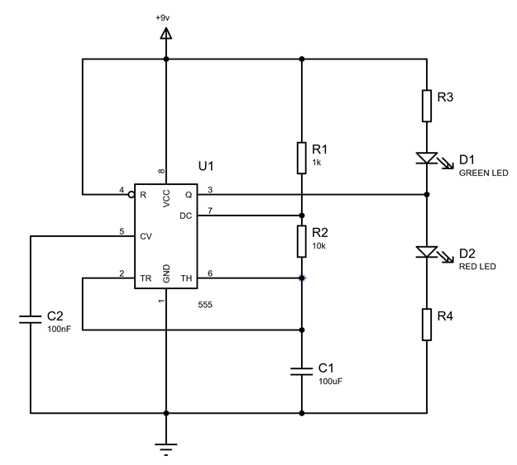
Figure 1, the supplied brief diagram

4.2. Proteus build
On the Proteus electronic planning and simulation software the brief diagram had to be constructed using the example and performed calculations to obtain the correct values. All components have to be added to a build list in the software, before adding them to the build screen and connecting. Each component dialog box was opened to adjust the value of each.
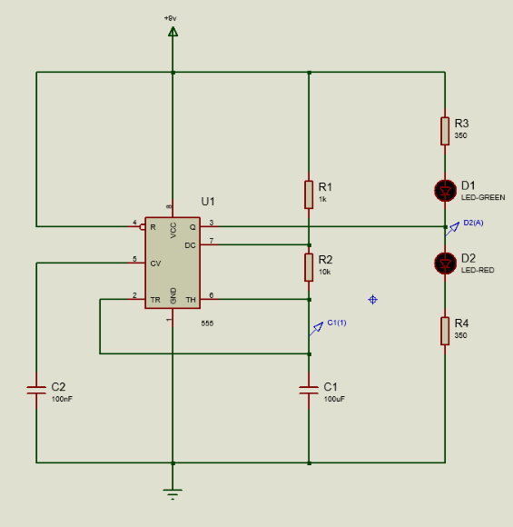
Figure 2, Proteus build of the circuit

4.3. Simulation
Once the circuit was complete on Proteus, a voltage probe was added to monitor the charge of C1, and an amp meter added between the LEDs to monitor the on/off period. A chart was also added to monitor these probes.
The circuit simulation was then ran for a set amount of time, 10 seconds. This was used to confirm the LEDs were activating on and off in turn. The table was also populated with the results from the simulation.

The Calculations
A few calculations had to be made to have an operating circuit, some calculations are used to show the ideal results for the circuit.

5.1. Resistance
One of the most fundamental equations in electronics is the relationship between voltage, resistance and current. The equation is:
$$Voltage \left(V\right)=Current \left(I\right)×Resistance (R)$$
This equation was used, with information about the LEDs used in the circuit to calculate the required resistance for R3 and R4 in the circuit.
To find the correct value, the specifications from the data sheet of the LED was used. The specifications showed the requirement of 2 volts and 20 milli-amps.
The supply voltage for the circuit was 9 volts, therefore:
$$9V-2V=7V$$
The remaining voltage was divided by the required current, resulting in the needed resistance value. [2]
$$R=\frac{V}{R}=\frac{7}{0.02}=350Ω$$

5.2. On/Off
Due to the nature of the circuit the on and off periods are different lengths of time, the ‘on’ time will always be longer than the ‘off’ time in this configuration. The below graph shows an example of the charge and discharge of the capacitor, resulting in the square wave on/off phase output. [3]
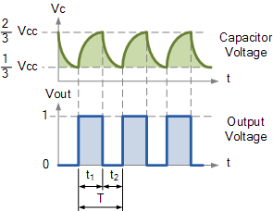
Figure 3, Chart showing the charge of a capacitor and the square wave output voltage [3]
The time that the output is high was calculated using the value of R1 and R2 as well as the capacitor value in the equation below
$$t_{1 }High (On)=ln2×(R_{1}+R_{2})×C$$
$$=ln2\left(1000×10,000\right)×100µf=0.7624 seconds$$
The time that the output is low was calculated using the value of R2 and the capacitor. Calculation below.
$$t_{2 }Low \left(Off\right)=ln2×R_{2}×C$$
$$=ln2\left(10,000\right)×100μf=0.6932 seconds$$

5.3. Period and Frequency
Once the time on and off for the output had been calculated these two figures were used to calculate the period of the output from the circuit.
$$Period= t_{High}+t_{Low}$$
$$=0.7624+0.6932=1.4556 seconds$$
Once the period is obtained, the frequency can be calculated. Frequency is defined as ‘the number of periods or regularly occurring events of any given kind in unit of time, usually in one second.’ [4]
Given this, the frequency of the circuit can be calculated.
$$Frequency=1/{t_{High}+t_{Low}}$$
$$=1/{1.4556}=0.68699 Hz$$

Tables and Graphs
The expected values have been calculated, and the circuit operation simulated, values can be taken from the simulation result charts.
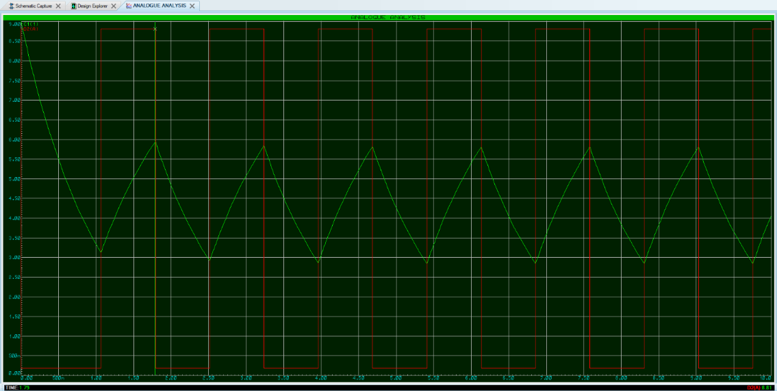
Figure 4, beginning of 'off' period
The chart above shows the time of the start of the ‘off’ period at 1.79 seconds, the graph below shows the end of the ‘off’ period at 2.52 seconds. The time difference between these two values is the lengths of time the output is low, ‘t₂’.
$$2.52-1.79=0.73$$
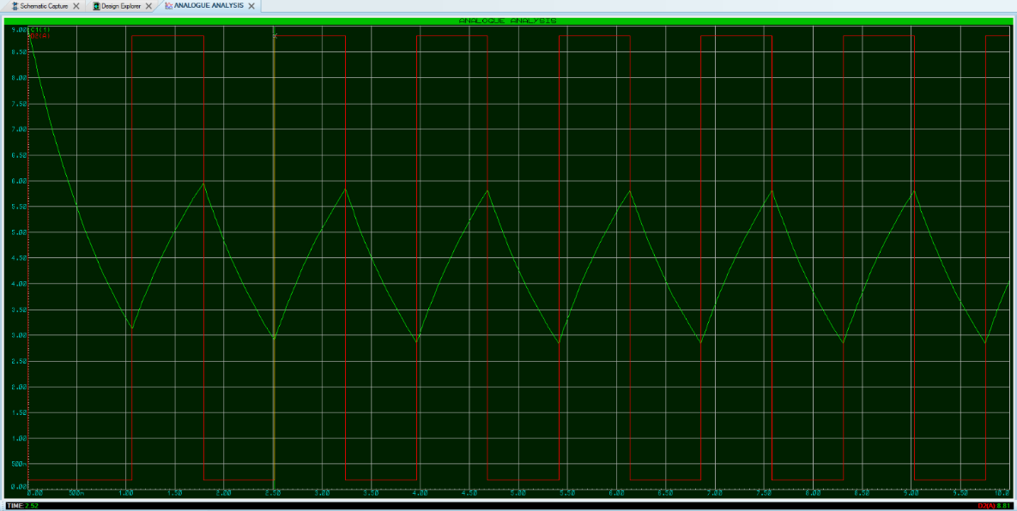
Figure 5, end of 'off' period and beginning of an ‘on’ period

The time shown in the graph above is 2.52 seconds, the graph below shows 3.24 seconds. The time difference between these two values is the lengths of time the output is high, ‘t₁’.
$$3.24-2.52=0.72 seconds$$

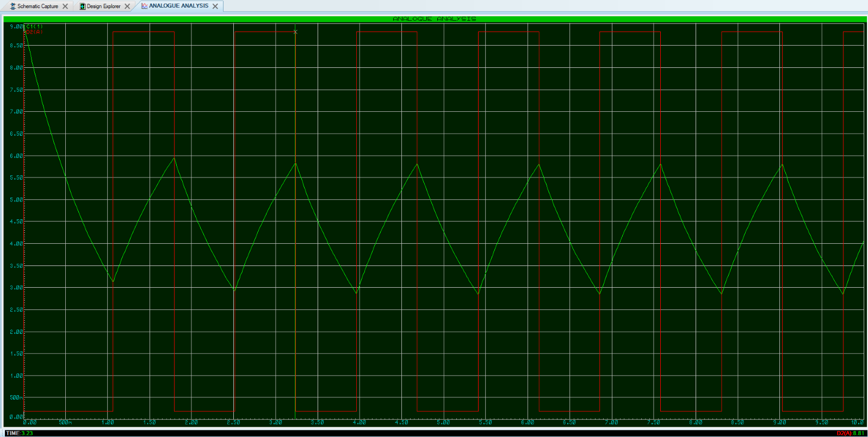
Figure 6, the end of an ‘on’ period
These are simulated values, and also rely on the operator placing measurement cursors on the traces on the chart, introducing potential errors.

7. The Build
Once the calculations had been made and the simulations had been completed, the physical circuit could be built.

7.1. Planning
A circuit diagram cannot be matched in bread board, stripboard or on a printed circuit board like for like. Therefore the circuit diagram was drawn in a compatible version to allow it to work on bread board.

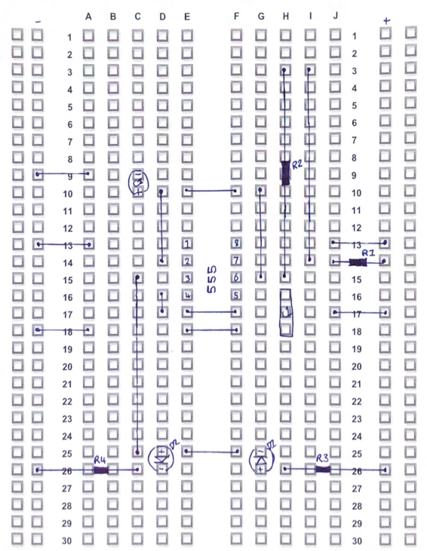
Figure 7, the paper plan for the 555 circuit timer circuit

7.2. The physical circuit
With the paper plan complete, building with physical components into electrical bread board could start. The 555 timer integrated circuit was added first, followed by the next larger components, C1, C2, the LEDs and resistors.
Once these were in place according to the plan, plain insulated wire jumpers could be put in place, making all necessary connections between components and power rails.
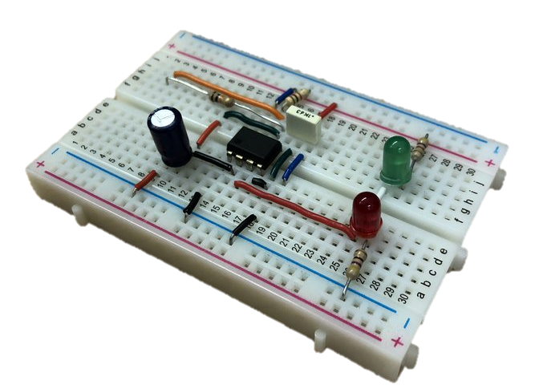
Figure 8, isometric view of a stable timer circuit
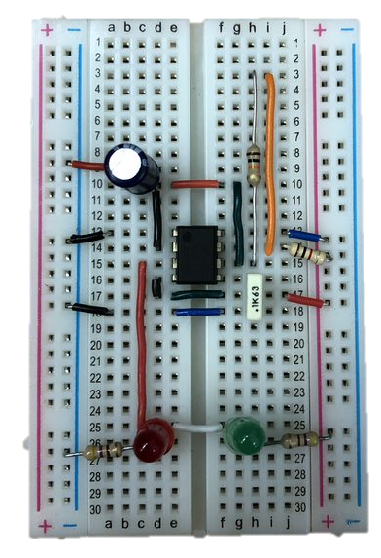
Figure 9, plan view of the astable 555 timer circuit
It was important in building that the jumping wires are straight and flat, as much as reasonably possible and that all the components weren’t squashed or looking untidy.

8. Testing
To test the astable 555 timer circuit, power was applied to the power rails on the bread board using jumping wires into the power rails, connected to a variable digital power supply using test leads with crocodile clips.
The power supply was set to 9 volts and the output was powered on. The LEDs on the circuit started powering on and oscillating in turn, as the simulation did. Confirming the circuit was working as intended.

9. Conclusions
If able to carry out more testing, it may have been found the original calculations figures differ from the physical circuit results. This may be of a result of the component tolerances, the simulated component will have perfect values, and 100 ohms will be 100 ohms. In real life, the 100 ohm resistor will have an accepted tolerance, so could be higher or lower than the stated value. Across the circuit, this compounding of tolerances could change the output readings of the circuit. [5]
This was a successful design and build of an astable 555 timer circuit, from design and simulation, to planning, building and operating as intended.

References

[1] | Jayant, “555 Timer Astable Multivibrator Circuit,” Circuit Digest, 29 September 2015. [Online]. Available: https://circuitdigest.com/electronic-circuits/555-timer-astable-multivibrator-circuit-diagram#:~:text=Astable%20mode%20works%20as%20a,very%20popular%20and%20versatile%20IC.. [Accessed 04 January 2023].
[2] | R. S. Coutinho, “Finding the right resistor for your circuit,” Medium, 16 Febuary 2017. [Online]. Available: https://medium.com/arduino-playground/finding-the-right-resistor-for-your-circuit-ecdf4b4c8f97. [Accessed 04 January 2023].
[3] | “555 Oscillator Tutorial,” Electronics Tutorial, [Online]. Available: https://www.electronics-tutorials.ws/waveforms/555_oscillator.html. [Accessed 04 January 2023].
[4] | “Frequency,” Dictionary.com, [Online]. Available: https://www.dictionary.com/browse/frequency. [Accessed 04 January 2023].
[5] | B. Griffiths, “COMPONENT TOLERANCE,” The University of Sheffield, Sheffield.

