Name: Nazia Kousar Rafiq
Student number: 2030249
Module code: BMSW4003
Module title: Digital Skills And Research Methods
Lecturer’s name: Akinseye Aluko
Assignment title: DSR Assessment 2 Individual report

Impact of virtual learning environment on student’s learning experience at the University of Wales Trinity Saint David London Campus

Introduction

Due to the current Covid-19 pandemic, students in the United Kingdom have been restricted from going onsite learning. Therefore, all universities in Britain such as the University of Wales Trinity Saint David London campus have been taking lectures, workshops and seminars online through Moodle. This leads to an impact on students learning experience. Students which have been affected negatively due to virtual learning are those who have just started university as it is all new to them which makes it harder for them to learn. Final year students have also been affected negatively as their final exams are online and it is hard to accurately grade them. Virtual learning has also had a positive impact on university students learning experience as it gave good experience on technology and boosted confidence on being independent. The two main virtual learning environment used within the United kingdom is Moodle and Blackboard. Mood is a free virtual learning environment to download which doesn’t take into account the cost of hosting and managing platforms more effectively.

Positive impact

Virtual learning environment have many positive impacts on student’s learning experience at the university. An example to this is that when studying online, this can have a cost saving benefit on students and teachers as students won’t need to travel to the university using public transport which can save money on oysters and petrol. There will be no need for expensive travel or accommodations. Virtual learning environment decreases student’s carbon footprint in regards to gas and fuel. Students are able to learn at their own pace from the comfort of their home environment with pre-recorded virtual lessons. This allows students to be flexible and learn at their own time during the day. Furthermore, virtual learning environment allows students to immediately gain feedback on their learning which allows student progress to speed up then it will if learning was onsite at the university. This has been stated by 80% of student at the university through virtual learning feedback and surveys.

Virtual learning is a way to improve student’s technical skills by studying on a computer during virtual lessons. This can allow students to learn new skills and become capable of using the keyboard and application such as Microsoft word, excel and PowerPoint. Businesses around the world have moved to virtual teams in order to have the knowledge of how to communicate and learn remotely. Having online sessions can help stop the spread of any illnesses such as the corona virus. This indicates that virtual learning environment is made in order to protect students wellbeing as well as their mental health. Although virtual classes prevent students from meeting and collaborating face to face, it still gives them an opportunity to expand world view as student’s attending virtual learning often get to meet other students from around the world, from different cultures and backgrounds. Therefore, virtual learning can save time on students hand by not travelling to the university or miss out any important task due to traffic or being late.

In addition to this, virtual learning environment has strengthened community and relationships at the university of Wales Trinity Saint David London campus by sharing interests with other students in my class. Having teamwork during classrooms, I have gathered secondary data from students on how they find virtual learning. They have stated that the virtual learning environment has led them to collaborate on projects and has gave them an opportunity for to interact through ideas which had developed their ability to gain teamworking skills. Improved accessibility is also a positive impact of virtual learning environment on student’s learning experience at the university as the virtual classrooms are accessible to any student who have access to a laptop or any device with internet connection. This makes a comfortable environment for students to learn at their own location. (FunTech Blog, 2020) In addition to this, virtual learning environment enhances assessments for learning through offering instant feedback and feed-forward to SEN students who take responsibility for their own learning experience alongside motivated all students to correct their work at the best of their ability.

Negative impact

On the other hand, there are many negative impacts of virtual learning environment on student’s learning experience at university. Example to this is infrastructural challenges as students at the university of Westminster have experienced a lot of expenditure to set up their online classes due to buying laptops and making a desk environment at home to study. Students may struggle to use technology therefore, virtual learning is new to them. This can make them struggle to set up their classes online. Technical issues are a blockage between students and their learning. This will result in late submissions and exams. Furthermore, due to virtual learning environment placed over the internet, there is a reduced number of interactions face to face communication between students. This can have a huge effect on students ability to work in a team and to reach out for help. Which shows that there is a loss of social as well as emotional skills within students. Some students may not be able to afford the internet or any devices which can cause stress and depression as not being able to succeed through virtual learning.

At the university, students move around, attend sessions, societies and make friends which keeps students healthy and emotionally stable. Whereas, virtual learning has prevented them to do so. Students can be affected by the excess of screen time as staring at the screen for too long can damage their eyes and could lead to other problems. Although students get support from teachers virtually, it is not as effective as it would be face to face. Virtual interactions are not instant and students will not get an instant reply which may take a few working days to get their answer. This can be an issue as students may leave their work to last minute and not get the help they need on time. In some cases, students have sent emails to the wrong email or the teacher don’t receive it. (School,2020) Virtual learning environment can result in hackers hacking accounts which can block students from accessing their virtual learning sources. Looking at it from another point of view, some students don’t focus online then face to face as students may not be sitting behind the screen or not listening. This is a major impact on students learning experience. Having background noises from family members such as kids and elderly people can cause disturbance and effect students ability to learn. (HR Daily Advisor, 2018) from asking students questions, I have identified that students are feeling lazy due to online learning as they are not as active as they should be. This can cause physical damage alongside effect their mental health.

Questionnaire on ‘Impact of virtual learning environment on student’s learning experience at the University of Wales Trinity Saint David London Campus’
To gather up information on the impacts of virtual learning environment on student’s learning experience at the University of Wales Trinity Saint David London Campus, I created a questionnaire using University of Wales Trinity Saint David’s 0365 apps which involved 10 multiple choice questions in relation to impacts of virtual learning environment on student’s learning. Then I sent the questionnaire to the University of Wales Trinity Saint David London Campus’s students to fill out in order to gather data using primary data collection tools which can be used to identify students opinion on their learning experience. After receiving 15 responses, I converted the questionnaire survey answers into graphs using excel. This made is easier to see an overall view on students learning experience at the University of Wales Trinity Saint David London Campus. Examples of graphs are shown below:
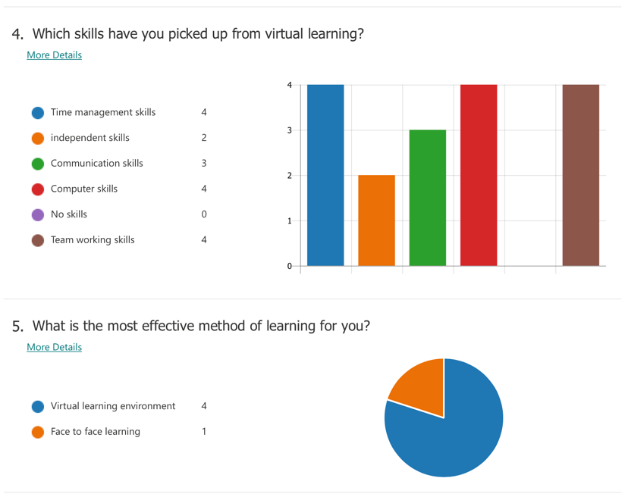
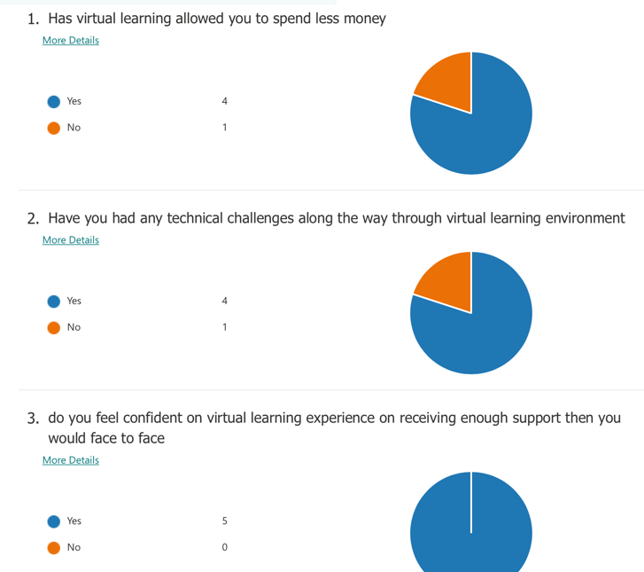
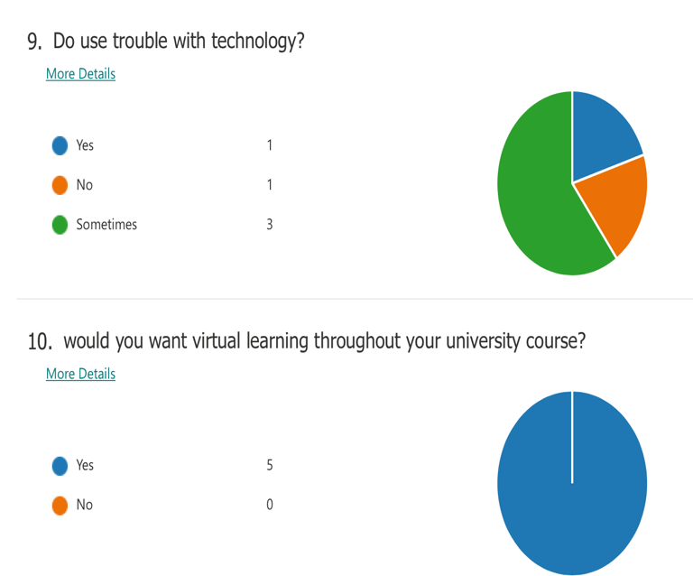
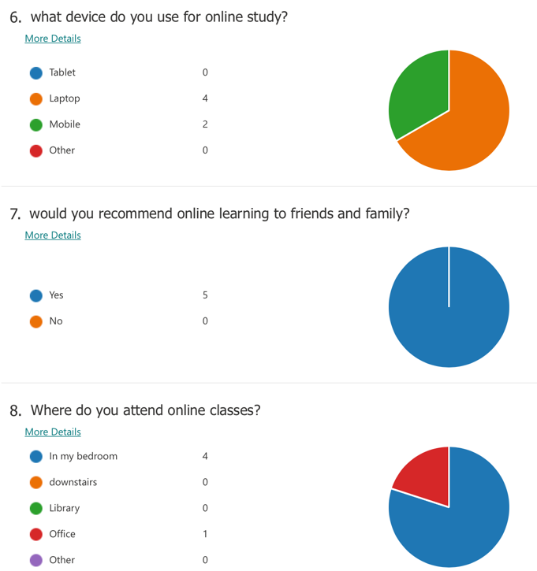

(www.microsoft.com, n.d.)

Looking at the graphs of data collected from current students at the university, you can see that students prefer virtual learning environment compared to face to face teaching. This is due to less expenses, development of skills, being more comfortable and more effective way of learning. This indicates that virtual learning environment has a huge positive impact on students learning experience, compared to having a negative experience. Using secondary data collection methods such as questionnaires and surveys allows students to feel heard and also allows teachers to know where their students are at their learning. This helps teachers make a plan to solve any issues preventing students from having an effective learning experience as well as identify what best suits their learning such as using specific resources like online library and Moodle.

Conclusion
In conclusion to this, virtual learning environment started taking place in early 2020 due to the COVID 19 pandemic where students were forced to stay home and attend classes online to avoid face to face contact which leads to the spread of the corona virus. At first when virtual learning was invented, it was very difficult for schools to come up with online activities and make accounts for every student at the university. Then students at the university struggled due to rapid technology growth. This effected students learning to have a gap along the way. However, now in 2021 there has been an upgrade of sources which students are given to use which have drove them to great practice on using technology and allowed them to gain many skills without going onsite. There are many negative and positive impacts of virtual learning environment on students learning experience. Weighing both sides of the categories, there are more positivity than there is of negativity. This has been proven by asking students their opinions by creating surveys and questionnaires.
Virtual learning has improved students satisfaction, engagement and recall in their learning experience. Virtual learning allows more then 100 students to attend the session without any clashes on the website. However, in some universities, there is a limit of students which can attend a session. This stops students from being able to learn effectively. Furthermore, during virtual learning, there were around 35 students which attended and the student group taught using virtual learning environment on Moodle and Microsoft teams which had a higher mean score for retention than the didactic groups. This was not a as significant. (Ryan and Poole, 2019)Students learning styles had seemed to have no effect on their engagement or ease of their learning. There are 3 main themes which have emerged from the qualitative data which are the visuals shown are better and helpful, the talks are informative and more details and visuals are required. Although skills are picked up from virtual learning, there are many things which teachers had to fulfil to get students where they are with good learning experience. Example to this is having an introduction of advanced technology. Virtual learning environment has allowed students to become active learners from being passive learners. Active learners promote critical thinking skills.

References:
- FunTech Blog. (2020). 8 Benefits of Virtual Learning Environments (Importance of Virtual Classrooms). [online] Available at: https://funtech.co.uk/latest/benefits-virtual-learning-environments-classrooms.
- HR Daily Advisor. (2018). 5 Potential Disadvantages to Virtual Training You Should Consider. [online] Available at: https://hrdailyadvisor.blr.com/2018/06/25/5-potential-disadvantages-virtual-training-consider/.
- Ryan, E. and Poole, C. (2019). Impact of Virtual Learning Environment on Students’ Satisfaction, Engagement, Recall, and Retention. Journal of Medical Imaging and Radiation Sciences, [online] 50(3), pp.408–415. Available at: https://www.jmirs.org/article/S1939-8654(18)30463-6/fulltext.
- ‌School, M.I. (2020). Advantages & Disadvantages Of Virtual Classroom» Meru International School. [online] Meru International School. Available at: https://www.meruinternationalschool.com/advantages-disadvantages-of-virtual-classroom/.
- ‌www.microsoft.com. (n.d.). Microsoft Forms - Easily create surveys, quizzes, and polls. [online] Available at: https://forms.office.com/Pages/DesignPage.aspx?lang=en-GB&origin=OfficeDotCom&route=Start#Analysis=true&FormId=-REPTm4EBUWcuNshUjEeIZOJu_fu4O9FvMvThDtOiGJUODlWSU1NRkMxM0FMMElMMjNZRFBUU1NRTy4u [Accessed 5 Sep. 2021].

‌

