Programme: MSc Public Health and Social Care in Practice

Module Code: LCHS7000

Module: Social Epidemiology and Public Health Development

Student Name: Salomiben Rasikbhai Khristi

Student ID number: 2433236

Table of Contents
Task 1: Social Epidemiological Analysis 4
Title 4
Introduction: 4
Contextual background and underlying factor: 4
Higher rates of mental illness 4
Low rates of access to healthcare 4
Mortality rates among the elderly group 4
(Source: Gregory, 2021) 5
Social isolation and loneliness 5
Poverty 5
Housing issues 6
National Response to reduce health inequalities in chosen group: 6
Organisations that support the chosen group: 7
Conclusion: 7
Task 2: Epidemiological Analysis 8
Introduction 8
Definition of the health problem 8
Social, cultural and health consequences 8
Main Body 9
Public health measures drawing on the 3 P’s 9
key determinants/risk factors of the chosen disease/health issue 10
key determinants/risk factors 10
Epidemiological studies and a health needs assessment; identify those affected or/are at risk in a specific, defined population 11
Main public health approaches and strategies used to monitor the incidence of Type 2 Diabetes in the London Borough of Tower Hamlets for the older age (65and above) population, drawing on all the types of monitoring/surveillance system available/have been used in the specific, defined population 11
Epidemiology to determine the public health impact/short- and long-term consequences/effect of the disease on the specified population. 11
Health intervention programme 12
Strengths and weaknesses of the epidemiological approach 12
References 13

Task 1: Social Epidemiological Analysis

Title
Age and Health Inequalities among the elderly population (age 65 and above) in UK

Introduction:
According to WHO (2018) health inequalities are systematic differences that impact the health status of different populations. In the UK, there will be 12.7 million aged people over 65 in 2022 (Barton et al., 2024). It is estimated that around 33 people aged 65 or over are for 100 people aged 20-64 in the UK (Barton et al., 2024). The elderly population in the UK aged 65 and above is the chosen targeted group.

Contextual background and underlying factor:
3 diseases/illnesses

Higher rates of mental illness
Mental health problems have become common in the old age population as around 22% of men and 28% of women aged 65 and above face chronic depression and bipolar disorder (Age UK, 2022). In the UK’s 10th anniversary State of Health and Social Care of old people it is revealed that the old age population aged 65 and above faces mental health issues like anxiety, depression and panic disorder. Around 14% of people aged 65 to 74 have depressive symptoms and around 67% of people of this age group with clinically significant symptoms did not receive proper treatment (Care Management Matters, 2025). Around 28% of people aged 65 + have experienced disappointment in their GP appointment. Around 85% of older people facing depression did not receive help from the NHS (Care Management Matters, 2025). Only 5% of people who are above 65 have taken therapies (Age UK, 2022). The mental health inequalities exist among older people due to a lack of awareness among healthcare professionals and lack of targeted screening for physical illness to treat the mental health of old age people (Lowther-Payne et al., 2023: (Reynolds et al., 2022). To overcome these challenges, it is required to foster mandatory mental health screening for adults.

Low rates of access to healthcare
Older adults in the UK have challenges in accessing healthcare due to the difficulty in getting appointments, which includes prolonged waiting times for emergency units (Thorlby et al., 2025). The workforce shortage in the NHS and social care systems impacts the accessibility of healthcare. Proactive and preventive care can help in identifying the required Healthcare needs of older people. Enhancing digital inclusion through age-friendly digital literacy programs can also serve the purpose.

Mortality rates among the elderly group
Old-aged hospitalized patients in England have the highest death rates in the Western world in comparison to other countries. In 2022-2023, around 28655 old people over 65 + had died (Gregory, 2021). This shows health inequality as these people have died without receiving social care. Sometimes lack of public money restricts local authorities from providing support to older people which results in insufficient care for the growing older population. To prevent this issue, a comprehensive plan to reform social care support to older people can be effective. Assisting immediate payment to Healthcare professionals for providing Healthcare services to older people can help in preventing these deaths (New Age UK, 2024).
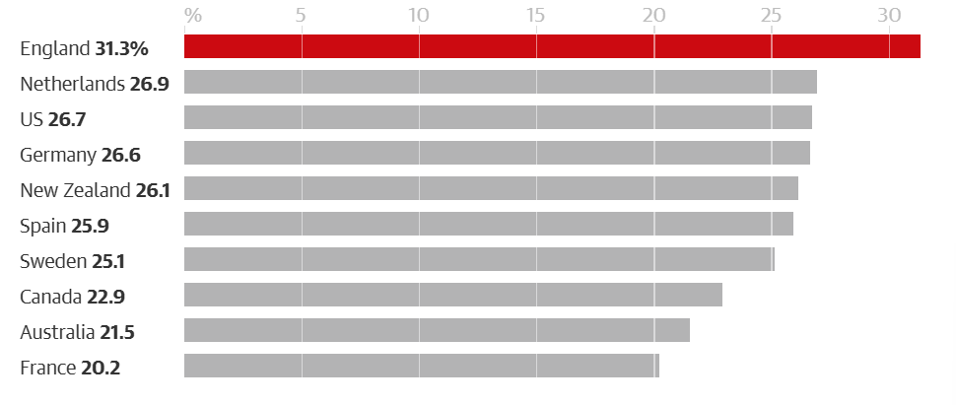
Figure 1: higher mortality rates in England

(Source: Gregory, 2021)
3 social issues:

Social isolation and loneliness
Loneliness and social isolation are common phenomena among older people. According to the report of Age UK (2024), 7% people (1 in 14) aged 65 and above in the UK suffer from loneliness, which equates to around 930,000 individuals. Around 270,000 old people in England Spencer a week without any communication with friends or family (Age UK, 2024). It is estimated that by 2034, 1.2 million people aged 65 will suffer from loneliness and face severe consequences. It is estimated that around 2 million people aged 65 and above require care and support; however, very less old people are receiving support and care, which shows increasing health inequalities (Age UK, 2024). This loneliness can occur due to major life changes like retirement, aging, lack of effective Physical health, which limits maintaining communication and social circle. This can be prevented through effective community-based interventions that assist older people's social support, which helps in preventing loneliness.

Poverty
Poverty is one of the key drivers of health inequalities among older people as it can reduce the accessibility of quality health care services, medications and nutrition. Around 2 million UK pensioners are living in poverty (Centre for Ageing Better, 2025). The limited pension and cost-of-living crisis in the UK causes this inequality. Assisting the state to ensure pension support and delivering proper financial advisory support to the poor elderly people can help combat these challenges.

Housing issues
In the UK, Old age people face housing issues due to poor quality and unsuitable housing issues which lead to health problems like respiratory disease and cardiovascular disease. Leaks, dampness and poor insulation in the house can lead to physical conditions like asthma, arthritis and heart disease in older people. Socio-economic deprivations and systematic failure contributed to causing health inequalities, as the housing issue is proportionately impacting the health and well-being of older adults. Comprehensive development of a natural strategy to tackle the poor housing issues of old-age people can help in addressing the issue.
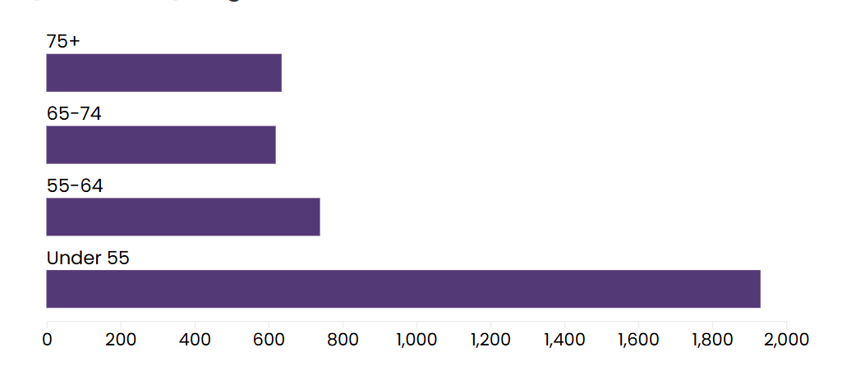
Figure 2: Number of non-decent homes
(Source: Centre for Ageing Better,2025b)

National Response to reduce health inequalities in the chosen group:
The NHS long-term plan and aging well program aims to shift hospital-based care to community-based support for elderly people, with an effective community response anticipatory care model and enhanced health in care homes that help support the complex needs of elderly people (The Grove Medical Group, 2022). The Core20plus5 Approach Accelerates effective improvement in reducing healthcare inequalities for specific populations of deprived areas, including older adults facing multiple long-term conditions through addressing wider social determinants by assisting positive equitable access to healthcare (Brennan, 2024).

Organisations that support the chosen group:
Age UK is a prominent charity that supports older people by raising awareness of health equality. This charity advocates policy changes and campaigns against social exclusion and loneliness among older people (Age UK, 2024). It takes initiative for underfunded social care, digital inclusion to support old age 65+. Age UK aims to assist with financial security, good health and social support to older people. It assists the elderly in fighting poverty. The Silver Line, run by Age UK, a charity, also assists the elderly through friendship and support.

Conclusion:

It can be concluded that the chosen targeted group, older people aged 65 and above, is the most vulnerable population who are at high risk of health inequalities due to multifaceted factors like chronic illness, deprivation, inadequate housing, comorbidity, social exclusion, increased social dependency and other functional barriers. Health inequality for old age people aged 65+ is rooted in socioeconomic disadvantages like isolation, discrimination and loneliness. Increasing mental health awareness and support by the state and charity can help in preventing mental illness among elderly people.

Task 2: Epidemiological Analysis
Topic- Epidemiological Management Plan for Type 2 Diabetes in the London Borough of Tower Hamlets for the older age (65and above) population

Introduction

Definition of the health problem
As a regional epidemiologist, this report encapsulates a developing epidemiological management plan for Type 2 Diabetes in the London Borough of Newham for the older age (65and above) population. Type 2 Diabetes is a chronic metabolic condition where the body does not produce enough insulin or produces high levels of insulin with increased blood glucose levels of the body (Smith and Matters 2018).

Social, cultural and health consequences
The social consequences of this disease include a reduction in the quality of life and increased social isolation, compounded by the complications of vision loss. The cultural practice that impacts diet, lifestyle, and exercise often becomes a cause of the disease. The cultural dietary practices of certain ethnic groups can contribute to the increase of the disease. For instance, the cultural practices of diverse Borough Newham can impact in management of the disease. As a health consequence of this disease, patients can face complications like kidney failure, neuropathic complications like ulcer, blindness, cardiovascular complications like heart attack (WHO, 2024).
In 2024, 589 million adults were living with diabetes, and it is estimated that by 2050, around 853 million people will be living with diabetes (International diabetes Federation, 2024). Globally, 1 in 5 people suffer from Diabetes (Sinclair et al., 2020). In the UK, almost 4.6 million people have diabetes (Diabetes UK, 2024). Almost 90% of people living with diabetes have type 2 diabetes (Diabetes UK, 2024). Around 6.3 million people in the UK are at risk of type 2 diabetes. In the UK, 21% of adults aged 65 and over have diabetes

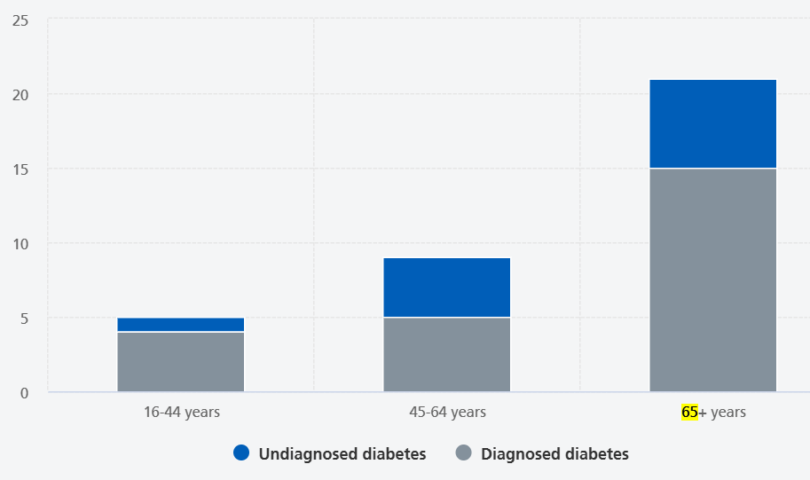
Figure 3: Prevalence of diagnosed and diagnosed diabetes of the age group 65 and above
(Source: NHS Digital, 2021)
The London Borough of Tower Hamlets has shown concerning statistics for type 2 diabetes, as it is the second highest rate of type 2 diabetes facing old age people 65 and above in London (Tower Hamlets Council, 2024).

Main Body

Public health measures drawing on the 3 P’s
Prevention
The primary prevention for Tower Hamlet considers preventing type 2 diabetes in older adults through several health checkups. The initiative of the NHS Diabetes prevention program, NHS health check-up, social prescribing, and community-specific resources for identifying type 2 Diabetes for older people. Additionally, a culturally competent diabetes prevention program that assists the ethnic community of Tower Hamlets also helps in preventing diabetes. A community engagement program for older adults that includes promoting diabetes related awareness, also acts as very hard in preventing diabetes for older people.
Besides this, the secondary prevention emphasizes detecting diabetes through routine screening tests and developing programs to assist in preventing diabetes. The diabetes prevention program for patients aged 65 years requires a confirmed diagnosis of Black Asian minority and ethnic origin. The prevention program emphasizes on changing lifestyle through a 12-month program. The NHS diabetes prevention program available for people aged 18 to 80 can be accessed by people of Tower Hamlets. Good moves program promotes diabetes prevention by promoting awareness in preventing kidney disease, cardiovascular disease and hypertension (Diabetes Prevention/Programmes, 2025)
Protection
Protection considered protecting people from complications of diabetes through measures like effective blood pressure management, annual diabetes review. All this can prevent the catastrophic impacts of type 2 diabetes among older people.
promotion
Tower Hamlets GP care group produced educational materials in diverse languages, including English, Somali, and Sylheti, to ensure information can be accessible to all the ethnic groups of Tower Hamlets (NHS Diabetes awareness, 2025)

key determinants/risk factors of the chosen disease/health issue

key determinants/risk factors | Risk factor in Tower hamlets
Non-modifiable risk factors like age, ethnicity and genetics play a key role in diabetes | Diabetes significantly increases in old age. Family history and genetics, when interacting with Lifestyle, influence the diabetes risk. Tower Hamlets has a large Bangladeshi community who are 6 times higher risk of developing type to diabetes in comparison to other ethnic groups in the UK
Modifiable risk factors like physical inactivity, poor diet, obesity, hypertension and smoking have a severe impact in causing type to diabetes | A sedentary lifestyle in older adults causes diabetes. Diet plays a significant role in diabetes. The demographic profile of Tower Hamlet suggests a propensity to diabetes, as the majority of the old age population has low-income opportunities that restrict healthy living and having a proper diet. High blood pressure creates a comorbid condition for older adults that leads to diabetes.
Socio-economic factor | Tower Hamlet is socio economic deprived urban area in the London borough Socio Socio-economic deprivation impacts the lifestyle can be a detrimental factor to diabetes. Moreover, the BMI of the large Bangladeshi population of Tower Hamlets is prone to type 2 diabetes

Epidemiological studies and a health needs assessment; identify those affected or/are at risk in a specific, defined population
Studies and health needs assessment in the Tower Hamlets of the London Borough. The primary population at risk of type 2 diabetes is the South Asian Bangladeshi community due to genetic factors. Old age people over 65 years of age have a higher risk of diabetes, belonging to the large Bangladeshi community, due to the BMI. The borough has faced social deprivation, which makes it vulnerable to type 2 diabetes. Conditions like high blood pressure, cardiovascular disease high levels of cholesterol cause type 2 diabetes. HNA is needed for an assessment of Tower Hamlets, highlighting there is requirement for culturally sensitive targeted programs, prevalence of type 2 diabetes in the Bangladeshi community (Shamsutdinova et al., 2023). Crafting local programs in local languages can help provide proper social support. Early intervention strategies that help in identifying and diagnosing cases can help in combating diabetes. Integrated care support given to the older population can help in addressing the Challenges of type to diabetes.

Main public health approaches and strategies used to monitor the incidence of Type 2 Diabetes in the London Borough of Tower Hamlets for the older age (65and above) population, drawing on all the types of monitoring/surveillance system available/have been used in the specific, defined population
The main Public Health approach in Tower Hamlet includes strategies for targeting individuals vulnerable to type to diabetes. Environmental and Lifestyle interventions can be important for addressing type to diabetes in ethnically diverse communities. Strategies and monitoring. The valley and system that can include systematic collection of data from electronic health records, hospitals general practices can act as a critical source of analyzing standardized data to systematically understand the vulnerable people who are at the verge of type 2 diabetes. The statistical information can help in addressing mortality rates caused by type 2 diabetes.
Public Health screening, like the NHS health checkup program, can benefit the elderly people of Tower Hamlet who are at risk of diabetes (NHS health checks, 2024). The behaviour respected surveillance can be a standardized methodology for conducting a population survey to track diet, physical activity, smoking and obesity, which are the major causes of type 2 diabetes in Tower Hamlets.
Indicated based Surveillance can help in assessing the clinical effectiveness of Tower Hamlet through auditing blood pressure, cardiovascular effects, cholesterol, etc, of people of Tower Hamlet.

Epidemiology to determine the public health impact/short- and long-term consequences/effect of the disease on the specified population.
Clear epidemiological targets can be determined through establishing long-term and short-term consequences. For short-term consequences, at least 5 to 7% of weight reduction can be considered for the elderly people of Tower Hamlet facing type 2 diabetes. As a long-term consequence, at least 15 to 20% of weight management can be considered, along with focusing on reducing the chances of blood pressure and stroke.

Health intervention programme
The HNA can be developed true considered in a community-based Lifestyle intervention program. At least a 14 Week program that combines culturally sensitive dietary preferences and physical activities sessions can be considered for addressing type 2 diabetes in Tower Hamlet. Developing an evaluation to monitor attendance rates of the people taking part in the intervention can be effective (Ronaldson et al.,2022). Participation satisfaction can be monitored. The primary outcome can be and the secondary outcome can be controlling high blood pressure, cholesterol levels and physical activity (Calderón-Larrañaga et al., 2021)

Strengths and weaknesses of the epidemiological approach
The strength lies in developing effective surveillance systems focusing on culturally specific factors using several data sources. The weakness lies in the lack of abundance of data, which can be determined epidemiologically. The complex interplay of social, environmental and genetic factors might not be fully included, which can cause difficulty in addressing the deep-rooted type 2 diabetes.

References
Age UK (2022) ‘Large numbers of older people could do with some mental health support - but are less likely than younger groups to receive it’, 16 May Available at: https://www.ageuk.org.uk/latest-press/articles/2022/large-numbers-of-older-people-could-do-with-some-mental-health-support---but-are-less-likely-than-younger-groups-to-receive-it/ (Accessed: 12 December 2026)
Age UK (2024) ‘Parliamentary Briefing: Loneliness in later life November 2024’ Available at:https://www.ageuk.org.uk/siteassets/documents/reports-and-publications/reports-and-briefings/loneliness/you-are-not-alone-in-feeling-lonely---parliamentary-briefing-.pdf (Accessed: 12 December 2026)
Age UK (2024) ‘We won’t let older people face winter alone. Plummetting temperatures and rising costs are a crisis for many older people. But through benefits advice, practical support and essential local services, we'll be there to help.’Available at:https://www.ageuk.org.uk/ (Accessed: 12 December 2026)
Barton, c. Sturge g., andHarker R. (2024) ‘The UK’s changing population’, House of Commons Liberary, 16th July Available at: https://commonslibrary.parliament.uk/the-uks-changing-population/ (Accessed: 12 December 2026)
Brennan, A., (2024). Applying the CORE20PLUS5 to Address Health Inequalities for Patients Under the Rehabilitation and Recovery Service in the London Borough of Hackney. BJPsych Open, 10(S1), pp.S223-S223. Available at:https://doi.org/10.1192/bjo.2024.548
Calderón-Larrañaga, S., Clinch, M., Greenhalgh, T. and Finer, S., (2021). Could social prescribing contribute to type 2 diabetes prevention in people at high risk? Protocol for a realist, multilevel, mixed methods review and evaluation, BMJ open, 11(4), p.e042303. Available at:https://doi.org/10.1136/bmjopen-2020-042303
Care Management Matters (2025) ‘Older people’s health inequalities revealed in anniversary report’, 30 September Available at:https://www.caremanagementmatters.co.uk/older-peoples-health-inequalities-revealed-in-anniversary-report/ (Accessed: 12 December 2026)
Centre For Ageing Better (2025a) ‘Financial Security | The State of Ageing 2023-24’ Available at:https://ageing-better.org.uk/financial-security-state-ageing-2023-4 (Accessed: 12 December 2026)
Centre For Ageing Better (2025b) ‘Housing | The State of Ageing 2022’, Available at:https://ageing-better.org.uk/housing-state-ageing-2022 (Accessed: 12 December 2026)
Diabetes Prevention/Programmes (2025) ‘Service Details for Diabetes Prevention/Programmes for Patients with Diabetes’ Available at:https://www.towerhamletstogether.com/files/Final-Service-Details-for-Diabetes-Prevention-March-2025.pdf (Accessed: 12 December 2026)
Diabetes UK (2024) ‘How many people in the UK have diabetes?’Available at:https://www.diabetes.org.uk/about-us/about-the-charity/our-strategy/statistics (Accessed: 12 December 2026)
Gregory A. (2021) ‘England has highest death rates of older patients in western world, study finds’, The Guardian, 10th November.Available at:https://www.theguardian.com/society/2021/nov/10/england-has-highest-death-rates-of-older-patients-in-western-world-study-finds (Accessed: 12 December 2026)
International diabetes Federation (2024) ‘Facts & figures’ Available at:https://idf.org/about-diabetes/diabetes-facts-figures/ (Accessed: 12 December 2026)
Lowther-Payne, H.J., Ushakova, A., Beckwith, A., Liberty, C., Edge, R. and Lobban, F., (2023). Understanding inequalities in access to adult mental health services in the UK: a systematic mapping review. BMC health services research, 23(1), p.1042. Available at:https://doi.org/10.17605/OSF.IO/RQ5U7
New Age UK (2024) ‘New Age UK analysis finds that 28,655 older people died waiting for social care in the most recent year’ 20 May Available at:https://www.ageuk.org.uk/latest-press/articles/2024/new-age-uk-analysis-finds-that-28655-older-people-died-waiting-for-social-care-in-the-most-recent-year-for-which-figures-are-available/ (Accessed: 12 December 2026)
NHS Diabetes awareness (2025). ’New diabetes awareness video campaign for Tower Hamlets’, 13th May Available at:https://www.gpcaregroup.org/news/new-diabetes-awareness-video-campaign-for-tower-hamlets/ (Accessed: 12 December 2026)
NHS Digital (2021) ‘Health Survey for England, 2021 part 2’, NHS 16 May Available at:https://digital.nhs.uk/data-and-information/publications/statistical/health-survey-for-england/2021-part-2/adult-health-diabetes (Accessed: 12 December 2026)
NHS health checks (2024) ‘NHS health checks’ Available at:https://www.towerhamletsconnect.org/information-and-advice/gps-and-health-services/health-services/nhs-health-checks/ (Accessed: 12 December 2026)
Reynolds 3rd, C.F., Jeste, D.V., Sachdev, P.S. and Blazer, D.G., (2022). ‘Mental health care for older adults: recent advances and new directions in clinical practice and research’. World Psychiatry, 21(3), pp.336-363.Available at:https://doi.org/10.1002/wps.20996
Ronaldson, A., Freestone, M., Zhang, H., Marsh, W. and Bhui, K., (2022). ‘Using Structural Equation Modelling in Routine Clinical Data on Diabetes and Depression: Observational Cohort Study’’ JMIRx Med, 3(2), p.e22912. Available at:https://doi.org/10.2196/22912
Shamsutdinova, D., Das-Munshi, J., Ashworth, M., Roberts, A. and Stahl, D., (2023). ‘Predicting type 2 diabetes prevalence for people with severe mental illness in a multi-ethnic East London population’, International Journal of Medical Informatics, 172, p.105019. Available at: https://doi.org/10.1016/j.ijmedinf.2023.105019
Sinclair, A., Saeedi, P., Kaundal, A., Karuranga, S., Malanda, B. and Williams, R., (2020). ‘Diabetes and global ageing among 65–99-year-old adults: Findings from the International Diabetes Federation Diabetes Atlas’, Diabetes research and clinical practice, 162, p.108078.Available at:https://doi.org/10.1016/j.diabres.2020.108078
Smith J. and Matters H. (2018) ‘Health Matters: Preventing Type 2 diabetes’ , 24 May. Available at:https://ukhsa.blog.gov.uk/2018/05/24/health-matters-preventing-type-2-diabetes/ (Accessed: 12 December 2026)
The Grove Medical Group (2022) ‘Ageing well: How the NHS cares for the frail and elderly’, 8 April. Available at:https://thegrovemedicalgroup.nhs.uk/2022/04/08/2696/ (Accessed: 12 December 2026)
Thorlby R., Tracey F., Philmore S., Rostas Z., and Mendelsohn E. (2025) ‘Health care for older adults’ The Health Foundation, August Available at:https://www.health.org.uk/reports-and-analysis/briefings/health-care-for-older-adults#:~:text=The%20NHS%20is%20in%20a,waiting%20for%20planned%20hospital%20care (Accessed: 12 December 2026)
Tower Hamlets Council (2024) ‘Living with Type 2 diabetes in Tower Hamlets’, November 14 Available at:https://towerhamlets.moderngov.co.uk/documents/s154120/Appendix%201%20Living%20with%20Type%202%20Diabetes.pdf . (Accessed: 12 December 2026)
WHO (2024) ‘Diabetes’14 November Available at:https://www.who.int/news-room/fact-sheets/detail/diabetes#:~:text=it%20are%20known.-,Type%202%20diabetes,Gestational%20diabetes (Accessed: 12 December 2026)
WHO (2028) ‘Health inequities and their causes’, World Health Organization’, 22 February. Available at:https://www.who.int/news-room/facts-in-pictures/detail/health-inequities-and-their-causes (Accessed: 12 December 2026)

