Research Project Proposal
What are the current challenges that the industry is
facing that is affecting employee recruitment and retention

Student name : Cristina- Florentina Patanghel
Student I.D -2118920
Module : Personnel Resourcing and Development
Lecturer: Lisa Knight

Table of Contents

COVER PAGE………………………………………………………………………….pg.1
INTRODUCTION ………………………………………………………………….pg. 2-3
MAIN FINDINGS…………………………………………………………………...pg.3-6
PESTLE ANALYSIS………………………………………………………………..pg.7-8
SWOT ANALYSIS…………………………………………………………………..pg.8-9
HOSPITALITY INDUSTRY EXAMPLE…………………………………………..pg.9-10
RECOMMENDATIONS ………………………………………………………..pg. 10-11
CONCLUSION………………………………………………………………………pg.11
REFERENCES LIST……………………………………………………………..pg.12-14

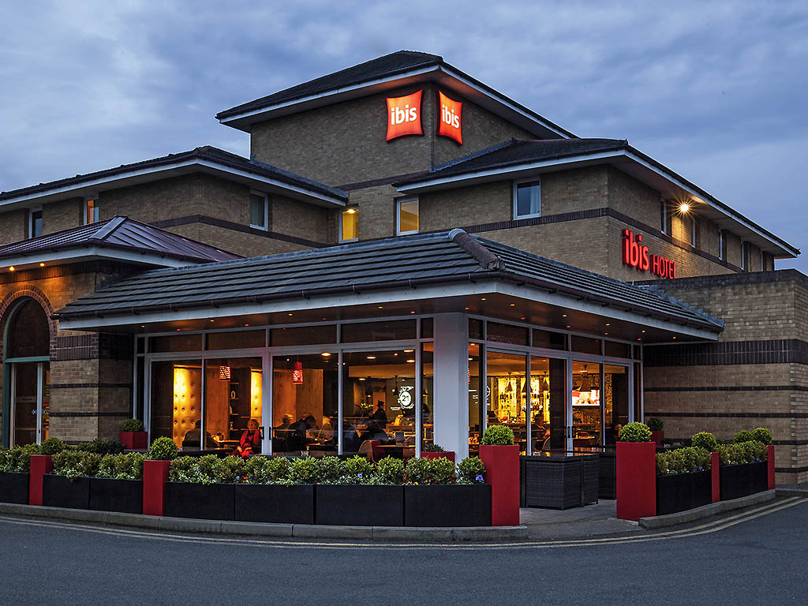
IBIS LONDON BARKING

Introduction

Ibis London Barking is a 3* bed and breakfast hotel, located in Barking, London , and an important member of Accor Hotel Group brand since 1974.
With 86 double rooms, a parking lot, restaurant, and amenities like a bar and full English breakfast, the hotel is always ready to offer top-notch services and ensure that every visitor has a wonderful stay. (Ibis,2023).
The Heartists® (staff members) who welcome and look out for their guests while offering the greatest service are crucial to Accor Hospitality's success. The human race is expanding its concern for its citizens, and this civilization celebrates individuality and welcomes everyone with open arms (Accor, 2023).
The main issues Ibis hotel is facing at the moment due to Brexit and Covid are retention, staff shortages ,continued with lack of training or the poor management itself, ,therefore solutions are critical to be found.
The primary causes of both temporary and permanent roles' low retention rates are poor working conditions, which include long hours, low compensation, and inadequate benefits, are considered the most prevalent factors. Lack of job satisfaction or opportunity for progress may also be contributing elements (Headway,2021).
Staff turnover in the hospitality industry is still substantial; in June 2022, 5.7% of the overall workforce quit. This reflects the rate for the entire year of 2022, which had highs of 6.4% and lows of 5.4% (Fourth,2022).
Taking into consideration that Brexit & Covid-19, hit really hard on Hospitality Industry especially in UK, business need to evaluate the situation and take action as soon as possible ,and comprehend the issues they are facing with their staff .
Accor Hotel Group felt really hard the catastrophic consequences of the pandemic era , losing more than 1000 employees worldwide, closing down multiple locations around the world and losing even more on revenue and retention rates regarding customers and employees(Thiessen,2020).
As a result of Covid crisis, UK Hospitality lost 115bn in just 2 years , businesses of all sizes have been left with depleted cash reserves, severe debt, and a yawning hole of 400,000 job openings. More than 80% of hospitality enterprises report having positions to fill (Thomsen,2022).
According to UKHospitality, shortages are reducing the economy by £22 billion in the hospitality sector alone. The pandemic hangover and Brexit have made it increasingly harder to locate skilled, and sometimes even unskilled, workers.
Consequently, Covid and Brexit made the UK hospitality sector's staffing and retention problems worse than they already were (Hughes,2022).

Main Findings
1.Internal factors
Poor management and lack of training are considered the internal factors that could lead to staff shortages and low retention rates.
Poor Management
Poor management can have an effect on the budget of the firm, employee disengagement, and overall profits. Last but not least, a decline in productivity and morale can be a sign that staff members are unhappy with the direction being given. If the team is led by a capable individual, employee task performance will continue to improve.
A company's reputation is harmed by high employee turnover in addition to the cost of doing so. The benefit of keeping the employees is greater because it takes less time and money to train, onboard, outfit, and get new personnel up to full output (ClueHR, 2022).
Negative effects of poor management
- low spirit. It can be challenging for employees to maintain high energy or passion for their work when nothing seems to satisfy the leader, which can contribute to significant staff turnover rates.
- high incidence of illness and stress.
- Bad hiring choices, situation, and outcome (PeepsHR, 2018)
Lack of training
Unsuccessful job performance and increased levels of stress at work are more common in people that have not obtained appropriate training. If workers feel undervalued and unhappy at work, they are more motivated to turn elsewhere for opportunities for career progression and development (Martinelli,2018).
Effects of employees lack of training
- unsafe workplace conditions
- Happy and dissatisfied Employees
- decrease in productivity
- Absence of interest in consumers
- a dramatic change regarding retention and staff recruitment.
Every business and sector has been affected by the general labour crisis, but the hotel industry has been hardest hit, with an estimated 100,000 people needed in this field alone (Yun,2022).
People are less willing to enter the sector because of how unpredictable and risky it is .
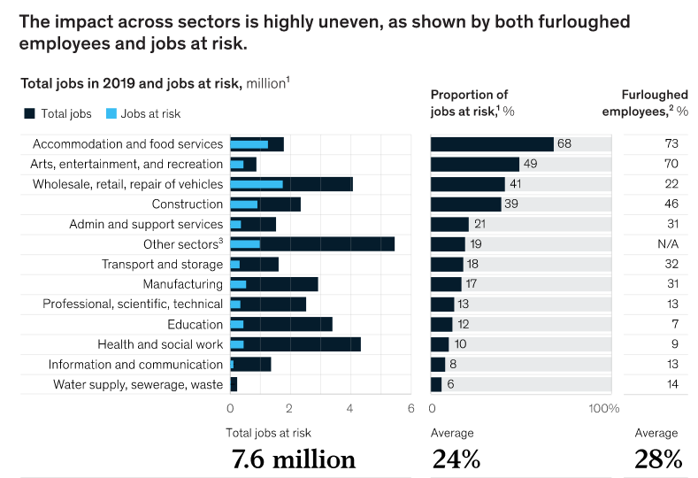
2.External Causes:
- Brexit
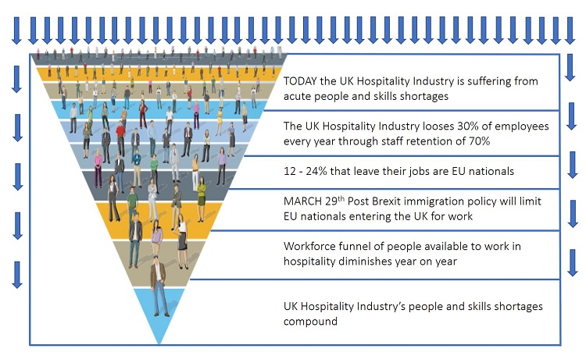
According to data from a recent online YouGov survey of more than 1,000 GB hospitality workers, the UK hospitality industry's personnel retention rate is only 70%, which is significantly lower than the country's average for all industries, which is 85%. Hence, almost 30% of the 400–700 thousand EU citizens employed in the hotel industry will need to be replaced over the course of the following year. It ranges from 90 to 210 thousand individuals. Barriers to entry into the UK are being pushed up as a result of Brexit and the immigration white paper; everyone wonders where 90–210 thousand additional workers for the hotel industry will come from Sheehan,2019).

B- Covid-19

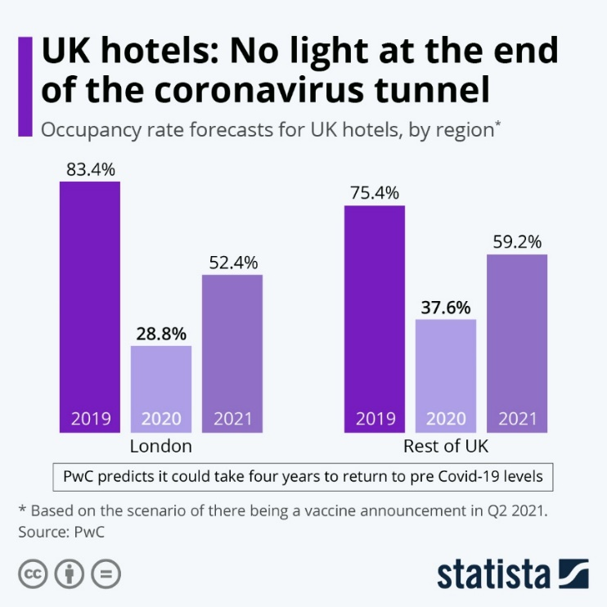
Employers and the UK economy both suffered greatly as a result of the Covid-19 pandemic's ability to close hotels, bars, restaurants, and other businesses.
A 42% decrease from 2019 to 2020 in the total economic output of the hospitality industry. Hospitality industry output fell by 21% in 2021 compared to 2019. From 3% in 2019 to 2% in 2020 and 2021, the UK's hospitality sector's economic contribution decreased (Parliament,2022).

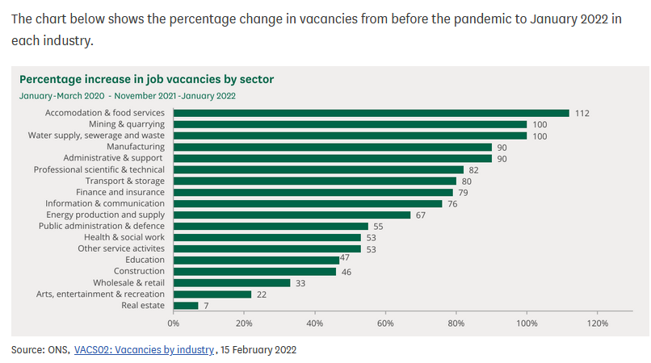

Given these factors, a PESTEL ANALYSIS is essential in order to conduct a deeper examination and gain a complete understanding on how this are affecting retention rates within Hospitality.
A mechanism for getting a comprehensive picture of the business environment is a PESTLE analysis. PESTLE stands for political, economic, social, technological, legal, and environmental factors (Sydney,2022).
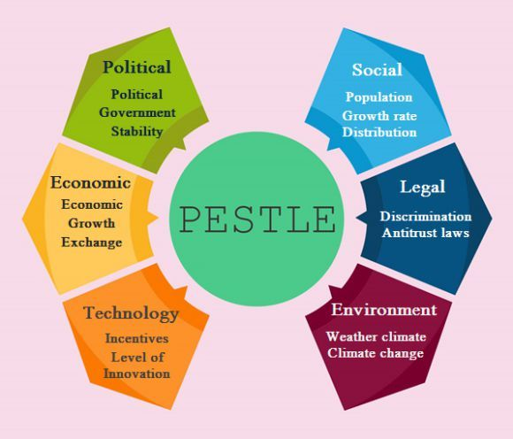

Political concerns like Brexit and Social and Economic factors like Covid are the main causes of the staff shortage and low retention rate.
POLITICAL
The political stability of the country becomes essential since hotels must deal with the political atmosphere in the numerous countries where they operate. If the country is unstable, visitors will be unwilling to travel on vacation or for company, which would reduce the number of customers and have a negative effect on the hotel's profits. The UK just exited the European Union, which decreased the number of tourists coming to the country and consequently decreased hotel profits in the country and also employees retention rates. Adding, the current trade conflict between many nations and lockdowns will affect the operations and profitability of the hostel (MBA, 2021).
This is a significant setback for the hotel sector, which depends significantly on EU immigrants—before Brexit, employment in the hospitality sector was made up of about 25% non-UK workers. It is predicted that fewer EU nationals would move to the UK for employment in the years to come because of the ongoing travel bans
According to Radley (2022) in his report, many UK employees have not returned from their leave.
During pandemic 60% of Hospitality Industry staff had changed jobs or left the UK due to lockdowns rules for businesses (Radley,2022).
SOCIAL
After COVID-19 struck the UK, consumer habits surrounding their lifestyle, spending habits, values, and beliefs altered. As a result, even after the pandemic phase, customers still considered AIRBNBs to be more convenient than hotels and takeout or fast-food delivery alternatives to be superior to restaurants. Since people are leaving their positions owing to poor pay rates, all these changes have a direct impact on the hospitality sector's revenue and staff retention (Kasi,2022).
ECONOMICAL
Most hospitality workers struggled under COVID, receiving only 80% of their monthly salary and shifting from underpaid to furlough. The UK's "Job Retention Programme" was developed to provide businesses with relief from the financial burden of the pandemic and a mechanism to retain their staff until the situation improves. Due to this decline many workers resign and changed their jobs (Brighthr,2018).

Finding solutions is a crucial step, taking into account all of these elements and their implications.
To find prospective possibilities and strengths that could address the employee retention issue, a SWOT analysis can be performed.

SWOT ANALYSIS FOR IBIS HOTEL
STRENGTHS | OPPORTUNYTIES
- Global brand recognition  - ‘’AllSafe’’ cleaning program for COVID-19  - Knowing customers needs  - Online booking engine  - Great customer service delivered  - Attractive hotel design  - Great location  - Well trained staff  - Membership reward  - Presence on social media platforms  - ‘’Day use only’’ unsold rooms option are saving revenue | - Customer data base for personalised services  - Build online engagement with the brand  - Build stronger customer relationship  - Accessible accommodation and services prices  - Accor memberships discounts  - advertise on comparison websites online  - generating more interesting content for social media  - ‘’Good to Go’’ app for environment sustainability and food waste avoidance
THREATHS | WEAKNESSES
- important rivals acquiring market share  - opponents offering greater "value add"  - deteriorating financial situation  - Terrorism's effects  - substantial modification of consumer behaviour | - strong existing rivals  - only a few opportunities exist for loyalty programmes  - rivalry in the private rental sector  - unfavourable economic conditions  - health crisis  - substantial staff turnover  - Low star rating
(Ladman,2018)
Hospitality Industry example for low staff retention rates
Intercontinental Hotel Groups updates employee benefits to improve recruiting and retaining top personnel.
The business has implemented a new staff rewards programme and revised its policies surrounding employee leave entitlements to account for various personal circumstances. The new initiative, known as "IHG myBenefits," includes paid parental leave for adoption, paternity, and maternal needs, as well as the possibility for staff to use personal leave time for proactive wellbeing or even to take a short break to work on a passion project. Even more paid time off is available for employees to celebrate their birthdays.
IHG provides a sizable discount for its employees' friends and family to stay at IHG locations, similar to Marriott's Employee Rate and Hilton Go Program.
The company has also altered its Domestic Violence Leave for Staff policy to paid time off rather than unpaid time off in an effort to encourage team members who are experiencing violence or abuse from an intimate partner to seek help without endangering their ability to do their jobs. (IHG, 2023).

RECOMMENDATIONS

Human Resources Department and General Manager would agree on a "Rescue Plan" for the hotel's crisis in order to quickly overcome this phase, as it is proved that the negative impacts of poor management and lack of training on a company's profitability are important problems.
Every team leaders must establish a relationship between the team and management department, as well as emphasise the value of effective management and crew training. Given that employee involvement is the primary determinant of a company's performance, it is imperative to give the team with all the resources they require to cooperate and advance the company's objectives. It is necessary to adhere to the health safety standards because of the influence of COVID-19 updating cleanness programme "AllSafe."
Furthermore take into account offering discounts, points, and awards through loyalty programmes to recognise good staff. Employee work needs to be encouraged, supported, and valued.
Regarding Brexit and staff shortage issue, management team could :
- offer competitive salary
- fostering a culture of positivity at work
- streamline the hiring procedure
- Improve the training process
- re-evaluate the company management approach
- promote development and provide chances for growth
- enhance the working atmosphere and provide better perks
- automate where it's possible
- offer staff shift patterns and hours flexibility

CONCLUSION

The hospitality industry is dealing with serious difficulties like a lack of staff, low employee retention rate, inadequate management, and lack of training. COVID-19 and Brexit implications are also making commercial efforts even more difficult. PESTEL and SWOT analysis offered important valuable information regarding this concerns .The solutions offered in this report are tailored to the demands and specifications of the organisation.

References

Accor(2023) ‘’About Accor’’ Available at : https://group.accor.com/en/group/who-we-are/about-us (Accessed 01/03/2023)
Armstrong (2020) Chart Covid ‘’ UK hotels: No light at the end of the coronavirus tunnel’’ Available at : https://www.statista.com/chart/23338/uk-hotel-occupancy-forecasts/ Accessed 02/03/2023)
Allas (2022) Chart ‘’ COVID-19 in the United Kingdom: Assessing jobs at risk and the impact on people and places’’ Available at : https://www.mckinsey.com/industries/public-and-social-sector/our-insights/covid-19-in-the-united-kingdom-assessing-jobs-at-risk-and-the-impact-on-people-and-places (Accessed 05/03/2023)
Brighthr (2018) ‘’ Furlough guide for employers
Can you claim your employees' wages through the Job Retention Scheme? ‘’ Available at : https://www.brighthr.com/articles/leave-and-absence/furlough-leave/ (Accessed 04/03/2023)
ClueHR (2022) ‘’ What are the consequences of poor management to employees?’’ Available at : https://www.cluerhr.co.uk/consequences-poor-management-employees/ (Accessed 05/03/2023)
Fourth (2022) ‘’ Hospitality Headcount Hits Two Year High – but Leaver Rate Remains Major Cause for Concern’’ Available at: https://www.fourth.com/press-release/hospitality-headcount-hits-two-year-high-but-leaver-rate-remains-major-cause-for-concern (Accessed 03/03/2023)
Hughes (2022) ‘’ Is Brexit the cause of recruitment issues in the hospitality industry? Available at : https://www.dailypost.co.uk/news/north-wales-news/brexit-cause-recruitment-issues-hospitality-24197063 (Accessed 02/03/2023)
House of Commons Library (2022) ‘’Hospitality Industry and COVID-19’’ Available at : https://commonslibrary.parliament.uk/research-briefings/cbp-9111/ (Accessed 02/03/2023)
Headway (2021) ‘’
What Causes Low Retention Rates In Temporary And Permanent Roles? ‘’ Available at : https://www.headwayrecruitment.co.uk/blog/2022/05/what-causes-low-retention-rates-in-temporary-and-permanent-roles/238 (Accessed 05/03/2023)

Ibis (20230 ‘’Ibis London Barking’’ Available at : https://all.accor.com/hotel/2042/index.en.shtml (Accessed 01/-3/2023)
IHG(2023) ‘’ IHG revamps staff benefits to boost talent attraction and retention’’ Available at : https://www.hotelmanagement.com.au/2021/09/21/ihg-revamps-staff-benefits-to-boost-talent-retention/ (Accessed 05/03/2023)
Kasi (2022) ‘’Pestel analysis of the Hospitality Industry’’ Available at : https://freepestelanalysis.com/pestel-analysis-of-hospitality-industry/ (Accessed 03/03/2023)
Ladman (2018) ‘’ What is Hotel SWOT Analysis?’’ Available at : https://www.xotels.com/en/revenue-management/revenue-management-book/competitor-analysis (Accessed 05/03/2023)
Martinelli (2018) ‘’ The Consequences of a Lack of Training in the Workplace’’ Available at : https://www.highspeedtraining.co.uk/hub/lack-of-training-in-the-workplace/ (Accessed 05/03/2023)
MBA Skool (2021) ‘‘Hilton PESTLE Analysis’’ Available at : https://www.mbaskool.com/pestle-analysis/companies/18162-hilton.html (Accessed 02/03/2023)
ONS (2022) Chart ‘’ How has the pandemic affected industries and labour in the UK?’’ Available at : https://commonslibrary.parliament.uk/how-has-the-pandemic-affected-industries-and-labour-in-the-uk/ (Accessed 05/03/2023)
PeepsHR (2018) ‘’ The impact of bad managers’’ Available at : https://www.peepshr.co.uk/resource-centre/the-impact-of-bad-managers/ (Accessed 05/03/2023)
Rahman (2023) ‘’ PESTEL analysis of the hospitality industry’’ Available at : https://www.howandwhat.net/pestel-analysis-hospitality-industry/ (Accessed 02/03/2023)
Radley (2022)’ The impact of Brexit on the Hospitality Industry and what business can do’ Available at: https://trailapp.com/blog/impact-brexit-hospitality
(Accessed :03 March)
Sheehan(2019) ‘’ Brexit numbers already impacting and pointing to worse to come for hospitality’’ Available at : https://www.hospitalityandcateringnews.com/2019/02/brexit-numbers-already-impacting-pointing-worse-come-hospitality/ (Accessed 02/03/2023)

Thiessen (2020) ‘’ Hotel Group Accor Cut 1000 Jobs Worldwide After Covid Losses’’ Available at: https://www.forbes.com/sites/tamarathiessen/2020/08/06/hotel-group-accor-cuts-1000-jobs-after-covid-losses/?sh=1c9800926885 (Accessed 28/02/2023)
Thomsen (2022) ‘’ Two years of Covid does £115bn damage to hospitality industry’’ Available at : https://www.ukhospitality.org.uk/news/596042/Two-years-of-Covid-does-115bn-damage-to-hospitality-industry-.htm (Accessed : 01/03/2023)
The University of Sydney (2022) ‘’ Marketing: PESTLE Analysis’’ Available at : https://libguides.library.usyd.edu.au/c.php?g=508107&p=5994242 (Accessed 02/03/2023)

Yun (2022) ‘’ ‘Turning point’: Is the hospitality worker shortage starting to ease?’’ Available at : https://www.smh.com.au/business/the-economy/turning-point-is-the-hospitality-worker-shortage-starting-to-ease-20221012-p5bp93.html (Accessed 05/03/2022)

