The importance of early child attachment!

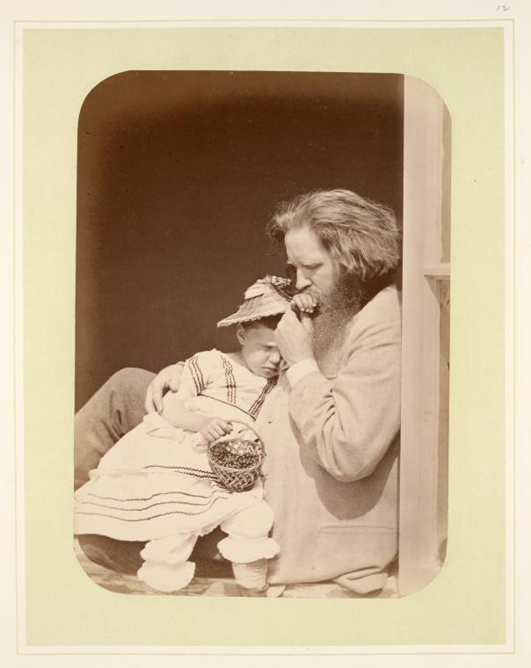

Hold me tight & keep me safe
Gemma Vaughan 2203490

What is attachment?
According to (Heale 1998-2023) attachment is the emotional bonds that develop between an infant and those who provide the majority of the child's care are referred to as attachments. It gives the child a reassuring sense of protection and security. (Heale 1998-2023) suggests the development of a child's personality, ability to have deep, passionate relationships, ability to handle emotional stress, and many other factors are all accounted for by the complex and detailed theory of attachment.
Children can develop attachments to multiple people, but the relationship with those who have given them close care since they were very little is the most significant and everlasting (Bowlby, 1997). (Bowlby, 1997) believed that individuals inherited the five attachment behaviours—sucking, holding, obeying, crying, and smiling—through natural selection. These actions make up an attachment behavioural system designed to safeguard an early offspring and improve the child's survival chances. When a child is in discomfort, they signal for the caregiver's attention so that they can comfort and protect them (Bowlby 1997).

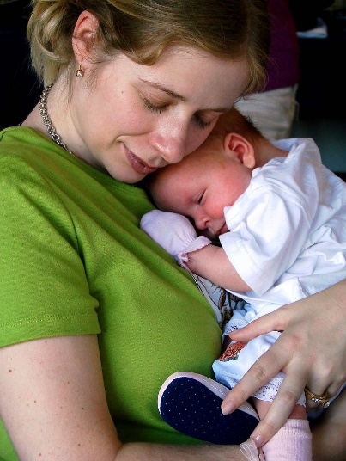

A child's first two years of life are the most crucial for establishing attachments. During this time, children create an "internal working model" that influences how they view relationships and behave in social environments.
The Mental Health Foundation defines a child who is firmly attached as someone who: Feels deserving of affection, Feels deserving of consolation, Is capable of managing their own emotions, is capable of controlling their own behaviour and the capacity to establish and maintain relationships. A child's mental health and "good sense of wellbeing" are aided by a secure bond, consistency, and sensitivity with a parent or carer (Mental Health Foundation, 2016).
(Verywellhealth 2023) argued that attachment allows children to feel safe. There are two key distinctions that need to be made. First, bonding should not be mistaken with attachment. Second, although it happens frequently, the mother is not always the carer; other options include the father, a grandparent, or a carer who is not a part of the same family (Verywellhealth 2023).
Five phases of a child's development can be identified:
Newborn
According to rise 2018 New-borns respond automatically to outside stimuli throughout the first month of life. In other words, if you massage a baby's cheek or place a finger in their hand, the baby will turn to look at one's hand. A new born is able to move their head from side to side, see objects up close, identify specific smells, and smile or scream when they need something (rise 2018).
Infant
Rise 2018 suggests In the first year of life, infants swiftly acquire new skills. An infant can regulate his head motions and put his hands together between the ages of three and six months. A baby can sit alone, chatter, and react to his name by the time he is six to nine months old (rise 2018).
Toddler
From research, Rise 2018 stated, Toddlers start to learn how to walk independently, climb stairs, and leap in place when they are between the ages of one and three years old. They are able to utilize brief words, wield a crayon, draw circles, stack blocks on top of one another, and even follow straightforward instructions (rise 2018).
Age of preschool
Children develop their motor skills between the ages of three and five. They are able to clothe themselves, throw a ball overhand, skip and jump, stand on one foot for at least ten seconds, and draw faces (rise 2018).
School age
Children six to twelve years old are considered school age. Rise 2018 suggested they are competent, self-assured, autonomous, and accountable. For youngsters of school age, peer interactions are crucial, especially those with peers of the same species. Children who are older and in school start to acquire their biological features. In youngsters of school age, symptoms of ADHD, such as difficulty focusing and being easily distracted, may manifest (rise 2018).
Children experience several milestones during all of these ages (also known as "stage characteristics").
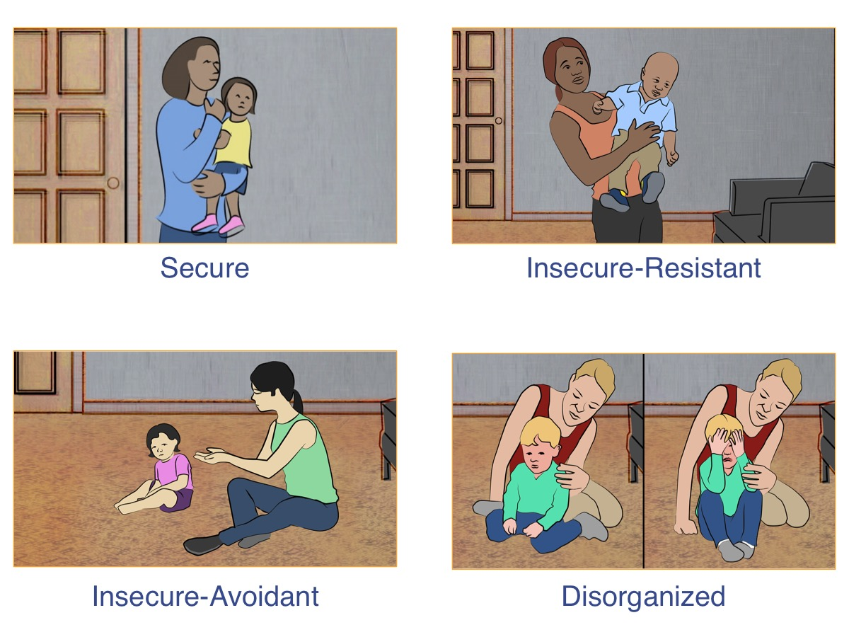
The manner in which an individual interacts with people in their life is determined by their attachment style. Childhood is when attachment styles, often referred to as attachment patterns, form and persist throughout adulthood. Secure and insecure attachments are, in general, the two major types.
According to help guide 1999-2022, The behaviour displayed inside a relationship, particularly when that relationship is endangered, characterizes attachment styles or types. When faced with relationship issues, a person with a secure attachment type might be able to express their emotions honestly and seek support. On the other hand, those with insecure attachment styles could have a tendency to act needy or clinging in their closest relationships, act selfishly or deceitfully when they feel vulnerable, or just avoid connection entirely (helpguide 1999-2022).

Secure attachment
According to (Pittman 2020) The most beneficial type of attachment is secure attachment. It depicts a connection in which a child finds solace in the caregiver's presence. Children who are closely bonded feel safe and like they can rely on someone. Therefore (Pittman 2020) suggested children that have a solid connection value their career over others, turn to them for solace, and feel safe exploring their surroundings while their career is nearby. Because it has long-lasting effects on a person, secure attachment is regarded as essential to healthy development. Children who have a strong degree of stability and care in their upbringing find it simpler to explore and engage with their environment (Pittman 2020). Healthy attachments depend on the degree to which parents and carers are dependable, responsive, and attentive to a child's basic needs, providing a sense of safety and providing children with a solid foundation for world exploration (Pittman 2020).

Insecure attachments
If a child and their caregivers have early interactions that are unfavourable, inconsistent, inappropriate, neglectful, or abusive, insecure attachments may arise. According to (Bottaro 2022), There are three types of insecure attachment. Each category describes a collection of distinct behavioural patterns that influence how people interact with one another. It is believed that children that exhibit a "avoidant" attachment pattern 'down-regulate' their attachment behaviour, appearing to manage their own suffering rather than expressing a significant need for consolation (Bottaro 2022). Ambivalent and Disorganised also play a big part in attachment but please note some children may differ with an illness such as autism, ADHD and much more (Bottaro 2022). Having an illness such as ADHD it makes it very hard for one to communicate and focus. Most of us wouldn't often link issues like attachment theory and ADHD together. ADHD and attachment difficulties, however, are closely related.

Seeking help for insecure attachments
Help guide 1999-2022 stated that It's vital to know that you don't have to accept the same attitudes, expectations, or behavioural patterns for the rest of your life if you or your love partner exhibits an insecure attachment style. As an adult, you are capable of changing and acquiring a more stable attachment pattern (helpguide 1999-2022). Please note: There are many things you can do on your own to develop a more secure attachment style if you don't have access to suitable therapy. Find out as much as you can about your insecure attachment style to begin with (helpguide 1999-2022). Your ability to identify and change the reflexive attitudes and behaviours of insecure attachment that might be a factor in your relationship issues will improve as you gain more understanding (helpguide 1999-2022).

Reference list:
Help guide, 1999-2022. Relationships communication. Attachment and adult relationships. Retrieved from: ://www.helpguide.org/articles/relationships-communication/attachment-and-adult-relationships.htm
Rise, (2018), Five stages of child development. https://riseservicesinc.org/news/5-stages-child-development/
Bowlby, John (1997) Attachment and loss. Volume 1: attachment. London: Pimlico. Retrieved from: https://learning.nspcc.org.uk/child-health-development/attachment-early-years#article-top

Father and child. Photo. Wikipedia. Retrieved from: https://commons.m.wikimedia.org/wiki/File:Father_and_child.jpg#mw-jump-to-license
Mental Health Foundation. (2016). Why relationships are so important for children and young people. Retrieved from: https:// www.mentalhealth.org.uk/blog/why-relationships-are-so-important-children-and-young-people
Lady dragonfly world, 2008. Image. Flickr. Retrieved from: https://www.flickr.com/photos/ladydragonflyherworld/4121739977

Attachment behaviours. Institute for learning and brain sciences. Retrieved from: Attachment Behaviours | Institute for Learning and Brain Sciences (I-LABS) (uw.edu)
Bottaro, Angelica. (2022). Verywellhealth. Insecure attachment, signs, causes and how to overcome. Very well health. Retrieved from: Insecure Attachment: Signs, Causes, and How to Overcome (verywellhealth.com)
Heale, Sarah. (1998-2023). Teach early years. Understanding attachment. Retrieved from: https://www.teachearlyyears.com/a-unique-child/view/understanding-attachment-part-1
Pittman, Darcey. (2020). Talk space. Parenting secure attachment. What is attachment? Secure attachment is the healthiest. Retrieved from: https://www.talkspace.com/blog/parenting-secure-attachment-what-is/#:~:text=Secure%20attachment%20is%20the%20healthiest,have%20someone%20to%20rely%20on.
Bibliography

Parenting for brain. Attachment theory retrieved from: https://www.parentingforbrain.com/attachment-theory/

