A COMPARISON OF THE MARKETING METHODS OF TWO MULTINATIONAL HOTEL BRANDS SIX SENSES AND MOXY

STUDENT NAME: ADRIANA BALICA
STUDENT ID:2232252
THE MODULE TITLE: MARKETING ESSENTIALS BMIH4005
LECTURER NAME: CHRISTOPHER WILKINS
WORD COUNT: 1436

The hospitality industry is highly competitive, and for hotels to succeed, effective marketing strategies are essential (Cherapanukorn,2017). In this essay, a comparison is made between the marketing strategies of Six Senses and Moxy, two hotel chains with vastly different target markets and positioning strategies. Six Senses is a luxury hotel brand that positions itself as a leader in sustainable hospitality (Tarlton,2022), while Moxy is a budget- friendly hotel chain catering to young and social-savvy travellers (Monk,2015).
The essay begins with an overview of the importance of marketing in the hospitality industry, examining the various marketing channels used by hotels to reach their target audience. Next, a comparison is made between the marketing strategies of Six Senses and Moxy, highlighting their similarities and differences. By analysing their branding, messaging, promotions, and other marketing initiatives, we can gain a comprehensive understanding of their marketing approaches (Lane Keller,2001). Through this comparison, we can shed light on the significance of effective marketing in the hospitality industry and demonstrate how hotels can differentiate themselves, build brand loyalty, and create a unique guest experience. This essay offers valuable insights into how hotels can stay competitive in a crowded marketplace by implementing effective marketing strategies.
Six Sense and Moxy are two successful hospitality brands that have employed unique marketing strategies to cater to their target audience. A SWOT analysis reveals the Six Senses’ comprehensive approach to showcasing its brand values, sustainability initiatives, and distinct guest experience has been a significant strength for the brand (Carizzo,2019). Utilising e-mail marketing and experiential marketing has also enabled the brand to keep its guests informed and engaged (Le,2011). Meanwhile, Moxy has positioned itself as a brand for budget-conscious, young, and tech-savvy travellers. This positioning has also allowed Moxy to cater to a specific target market, which has been a significant opportunity for the brand. Moxy’s heavy reliance on digital marketing, social media, and influencer marketing has been another strength for the brand (Gretzel,2017).
A PESTLE analysis highlights some external factors that have impacted both brands. For instance, the COVID-19 pandemic has been a significant threat to the hospitality industry (Fu,2020), causing Six Senses and Moxy to rethink their operations and marketing strategies. Changing consumer preferences, increased competition, and economic fluctuations are other external factors that pose challenges to both brands (He,2020). Despite these challenges, both Six Senses and Moxy have identified unique opportunities to differentiate themselves from their competitors, such as showcasing luxury offerings and wellness experiences for Six Senses and creating a fun and social experience for Moxy’s guests on Instagram and TikTok. Both brands continue to adapt and innovate to meet the evolving needs and expectations of their customers.
Six Senses and Moxy have distinct marketing strategies that align with their brand positioning. Six Senses focuses on offering high-end luxury accommodations that promote wellness, sustainability, and unique experiences through a comprehensive marketing approach that includes email and experiential marketing. Moxy, on the other hand, caters to young, tech-savvy, and budget-conscious travellers with affordable accommodations, utilizing digital and social media marketing to create brand awareness. This is reflected in their pricing strategies, where Six Senses positions itself as a luxury brand with higher prices (Appendix 1), while Moxy offers budget-friendly prices to its target audience (Appendix 2).
Their place strategy is also different, as Six Senses has hotels in select locations around the world, often in remote, natural settings (Appendix 3), while Moxy’s hotels are in urban areas (Appendix 4) and near transportation hubs. In terms of promotion, Six Senses uses email marketing, experiential marketing, and social media to promote its brand, while Moxy relies heavily on digital marketing, social media, and influencer marketing.
Both brands have well-trained staff who are knowledgeable about their brand values and offerings. However, Six Senses places a greater emphasis on personalized service, with staff going above and beyond to make each guest feel welcomed and care for (Rebelo Vieira,2020). In contrast, Moxy focuses on creating a fun and social atmosphere for its guests, with staff often acting as hosts to encourage guest interaction and engagement (Wangelin,2015).
Six Senses is committed to providing a seamless and stress-free guest experience (Nicklin,2018). This is achieved through a range of initiatives, including streamlined check-in and check-out processes, proactive problem-solving by staff, and attention to detail throughout the guest’s stay. On the other hand, Moxy emphasizes a more casual approach, with a focus on creating a fun and social environment for guests (Brammer,2018).
The physical evidence strategy of Six Senses and Moxy also differs significantly. Six Senses places a strong emphasis on sustainability, using environmentally friendly materials and practices throughout their hotels. This includes everything from the use of organic linens and toiletries to solar panels, and rainwater harvesting systems (Villa-Clarke,2019). In contrast, Moxy’s hotels are designed to be playful and modern, with unique design elements and attention-grabbing details, that create a memorable guest experience (Megson,2016). The marketing mixes of Six Senses and Moxy, reflect their different brand strategies and target markets. These differences suggest that the two brands are targeting different market segments, each with their unique needs and preferences.
Using the SimilarWeb tool, it can be seen that Six Senses and Moxy have different customer segments that they target through their marketing strategies. Six Senses targets a more affluent and older audience, with a higher percentage of users from Asia and the Middle East. Meanwhile, Moxy targets a younger and more budget-conscious audience, with a higher percentage of users from North America and Europe. In terms of targeting strategies, Six Senses focuses on targeting luxury travellers who are interested in wellness and sustainability. The brand position itself as a high-end, exclusive experience with personalised service, unique accommodations, and high-end amenities. In contrast, Moxy targets younger, tech-savvy travellers who value affordability, social interaction, and modern design. The brand position itself as a fun, social experience with a trendy and playful atmosphere.
To determine where these brands sit compared to each other and other brands, we can use positioning tools such as Bowman’s strategy clock and perceptual maps. Based on Bowman’s clock, Six Senses is positioned as a differentiator with a focus on high-quality products and a premium price point (Appendix5). Moxy, on the other hand, is positioned as a hybrid with a focus on low prices and moderate quality (Appendix 6).
The different customer segments and targeting strategies of Six Senses and Moxy are reflected in their positioning strategies. Six Senses is positioned as a high-end, exclusive experience for affluent travellers, while Moxy is positioned as a trendy and affordable option for younger, tech-savvy travellers. These findings can be linked back to the marketing mix and situational analysis, as the brand’s product, price, place, promotion, people, process, and physical evidence strategies are all designed to appeal to their respective target audience and differentiate themselves from competitors.
In conclusion, Six Senses and Moxy hotel chains are two very different brands that have implemented marketing strategies to reach their target audience and create brand awareness. While Six Senses has positioned itself as a luxury and sustainable hotel chain that offers unique guest experience, Moxy has positions itself aa a budget-friendly, technology-driven brand that caters to young and social-savvy travellers. In terms of marketing, Six Senses has relied on a holistic approach that emphasizes sustainability, wellness, and community, using high-quality visuals, interactive content, and experiential marketing to showcase their brand values and create a luxury image. On the other hand, Moxy has focused on social media, influencer marketing, and experiential marketing to build a fun, engaging, and affordable brand that resonates with its target audience. Despite the differences in marketing approaches, both brands have successfully built brand awareness, engaged with their target audience, and differentiated themselves from their competitors. Six Senses has built a loyal following of guests who appreciate their luxury and sustainable experiences, while Moxy has become a popular choice for young and social-savvy travellers who seek affordable and vibrant accommodation. Looking at the broader hospitality industry, the comparison between Six Senses and Moxy highlights the importance of understanding the target audience and creating a unique and compelling brand image. In a highly competitive industry, hotels need to differentiate themselves by offering unique experiences and showcasing their brand values to build brand awareness and loyalty. The comparison of Six Senses and Moxy’s marketing strategies shows that different brands have different target audience and positioning, and that successful marketing requires a deep understanding of the audience, brand values, and industry trends.

Brammer, M. (2018). Japan’s Two New Moxy Hotels Aim for Laid-Back Hospitality. [online]
Metropolis. Available at: https://metropolismag.com/projects/moxy-hotel-design-japan/
[Accessed 6 May 2023].

Carrizzo, B. (2019). Six Senses Kicks Off Sustainability Initiative. [online] Luxury Travel Advisor.
Available at: https://www.luxurytraveladvisor.com/hotels/six-senses-kicks-off-sustainability-
initiative [Accessed 5 May 2023].

Cherapanukorn, V., 2017. Development of eCRM success: A case study of hotel industry.
International Journal of Trade, Economics, and Finance, 8(2), pp.90-95.

Fu, Y.K., 2020. The impact and recovering strategies of the COVID-19 pandemic: Lessons from
Taiwan’s hospitality industry. Cogent Social Sciences, 6(1), p.1829806.

Gretzel, U., 2017. Influencer marketing in travel and tourism. In Advances in social media for
travel, tourism and hospitality (pp. 147-156). Routledge.

He, H. and Harris, L., 2020. The impact of Covid-19 pandemic on corporate social responsibility
and marketing philosophy. Journal of business research, 116, pp.176-182.

Hotel News Scotland (2019). Moxy Edinburgh Airport is Now Open. [online] Hotel News
Scotland. Available at: https://www.hotelnews.scot/news/marriott-international-expands-uk-
portfolio-opening-moxy-edinburgh-airport [Accessed 6 May 2023].

Lane Keller, K., 2001. Mastering the marketing communications mix: Micro and macro
perspectives on integrated marketing communication programs.

Le, P. (2011). How to market service packages to European customers. Case study: Evason Ana
Mandara &amp; Six Senses Spa-Nhatrang Resort. [online] www.theseus.fi. Available at:
https://www.theseus.fi/handle/10024/28631 [Accessed 10 Feb. 2023].

Megson, K. (2016). Moxy Berlin hotel brings ‘fun, impromptu and playful’ experiences to
German capital. [online] cladglobal.com. Available at:
https://www.cladglobal.com/news.cfm?codeid=328183 [Accessed 7 May 2023].
Monk, Z. (2015). Plans Revealed for Moxy Hotel York. [online] BOUTIQUE HOTELIER. Available
at: https://www.boutiquehotelier.com/plans-revealed-for-moxy-hotel-york/ [Accessed 4 May
2023]. The three-star tier Moxy brand is targeted at social and millennial travellers, with buzzy
lobbies, tech-savvy guest rooms and 24-hour bars.

Nicklin, M.W. (2018). After Renovation, Six Senses Kaplankaya Reopens. [online] Luxury Travel
Advisor. Available at: https://www.luxurytraveladvisor.com/hotels/after-renovation-six-
senses-kaplankaya-reopens-may [Accessed 6 May 2023].

Rebelo Vieira, J., 2020. The impact of Instagram campaign in the Six Senses Group in Douro
valley (Doctoral dissertation, Haute Ecole de Gestion &amp; Tourisme).

Tarlton, S. (2022). Six Senses Grand Bahama to Offer Hotel, Villas, and Branded Residences
with a Focus on Sustainability and Regeneration. [online] Weller Development Partners.
Available at: https://www.wellerdevelopment.com/newsroom/six-senses-grand-bahama-to-
offer-hotel-villas-and-branded-residences-with-a-focus-on-sustainability-and-regeneration/
[Accessed 2 May 2023].

Villa-Clarke, A. (2019). Spa Focus: How The New Six Senses Uluwatu Promises A Different Kind
Of Spiritual Experience. [online] Forbes. Available at:
https://www.forbes.com/sites/angelinavillaclarke/2019/01/15/spa-focus-how-the-new-six-
senses-uluwatu-promises-a-different-kind-of-spiritual-experience/ [Accessed 7 May 2023].

Wangelin, J. (2015). Case Study: Moxy Hotel Guest Experience. [online] Medium. Available at:
https://medium.com/@jack.w/case-study-moxy-hotel-guest-experience-8943880d5b2f
[Accessed 7 May 2023].

Appendix 1-Six Senses room price at Rome
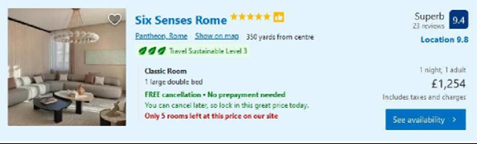

(Source: booking.com)

Appendix2-Moxy room price at Milan
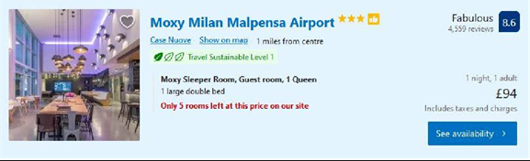

(Source: booking.com)

Appendix 3-Six Senses hotel locations

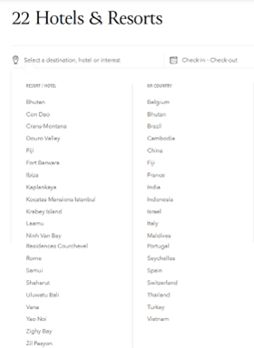
(Source: sixsenses.com)

Appendix 4 -Moxy hotel locations
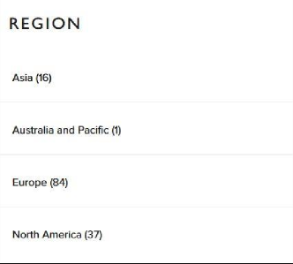
(Source: moxy-hotels.marriott.com)

Appendix 5 -Six Senses hotel Bowman Strategy Clock
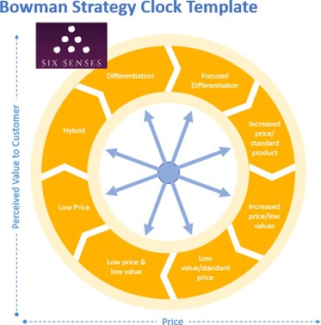
(Source:Adriana Balica)

Appendix 6 -Moxy hotel Bowman Strategy Clock
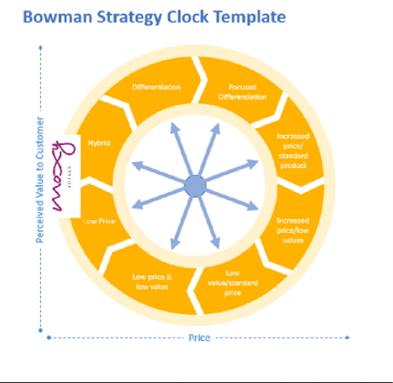
(Source:Adriana Balica)

