In up to 1000 words explain how sex and gender beliefs shape social life?
Introduction: Within this essay I intend to explore how sex and Gender beliefs shape social life. I shall clearly define the difference between sex and gender and investigate the ways in which different societies beliefs shape what is expected socially of different sexes and genders.
This paper has been divided into four parts. The first part will define the difference between sex and gender roles, examining which beliefs and expectations surrounding sex and gender roles shape lives socially. Part two will explore Indian anthropologist Valentina Pakynteins study of the Khasi society and their matriarchal social structure (Pakynteins 2017). In the third section I will review and support Peter Wades theories linking sex and gender beliefs to racial stereotypes (Wade 2009), using Judith Okelys ethnography of the Gypsy community (Okely 1983) to validate Wades theory. I shall conclude that the sex and gender beliefs held within a smaller community shape social life as much as the beliefs and expectations society has in general of their sex and gender roles within the wider community.
What is the difference between sex and gender? 
This Photo by Unknown Author is licensed under CC BY
Our sex is determined by our physicality. The sex of a man’s body with male genitalia is male and the sex of a woman’s body with female genitalia is female. Gender is defined by what roles society chooses to place on these sexes. In some society’s women are expected to stay at home, have babies and do the housework while the men take on board the gender role of hunter gatherer. If a man or woman steps outside these clearly defined roles they are identifying as a different gender to what is expected socially. A person in a man’s body may prefer to engage in activities or dress codes that are typical of women, so his sex is male, but he identifies as female gender. Some people completely disregard societies expectations and beliefs, preferring instead to identify as non-binary; allowing them to flow between both male and female stereotypes without question. However, I will go on to explain in my conclusion why this individualistic approach is only possible in larger consumerist societies.
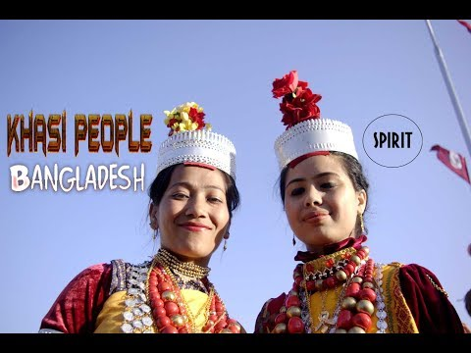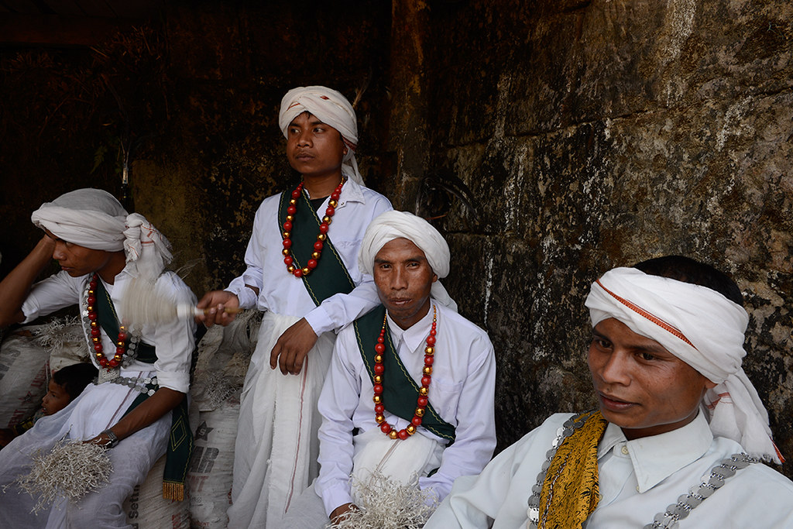
Pictured on the left are two Khasi women.
Below is an image of Khasi men at a fertility ritual
The Khasi People of Bangladesh. The Khasi tribe are a matrilineal society. They are in the Khasi and Jaintia Hill district of Meghalaya, located in north eastern India. The gender role of the male is in politics, women are not permitted to participate in politics. The gender role of the female is head of the household and all wealth and lineage is passed down through the females via the youngest daughter.
In her journal article, Indian anthropologist Valentina Pakyntien, explains that the youngest daughter and maternal uncle make all the decisions relating to the household and the youngest daughter is the family member that inherits the wealth. If a family has no female children, it is regarded as ‘extinct’ and if a man has no sisters, he is considered an inauspicious husband. These sex and gender beliefs have shaped young people’s social lives when choosing a potential spouse for example. Pakyntein also highlighted the outside influence beyond this community that is shaping social lives, ‘factors such as mass – conversion to Christianity. Changing economy. Education and modernisation.’ (Pakyntein. 2017). One of the changes she noted was, ‘male members of an extinct family are no longer burdened with guilt or avoided by the neighbours.’ The sex and gender beliefs of these outside influences are changing the beliefs and expectations of different gender roles within the Khasi culture.
1 2 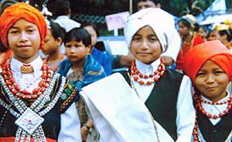 3 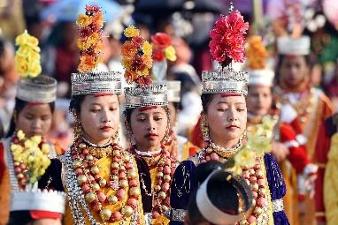 4 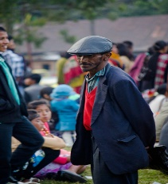
Above from left to right: 1 Khasi woman socialising. 2 Khasi boys in traditional dress. 3 Khasi girls in traditional dress. 4 Khasi man socialising.

Latin America and the Gypsy community.
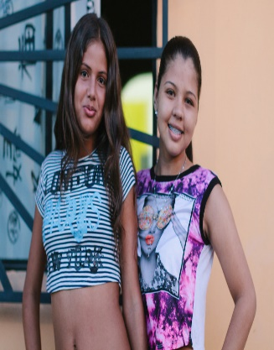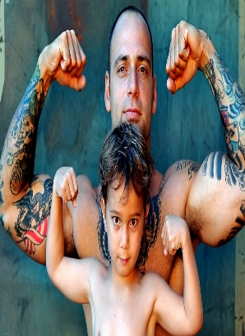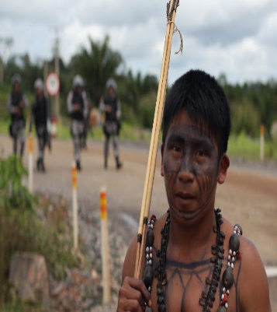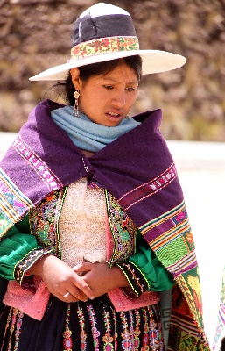
Left: Boys and girls in modern Latin America.
Right: Indigenous Latin Americans.
In his study ‘Race and sex in Latin America’ Peter Wade asks the question are the gender roles assigned to men and women in Latin America intrinsincly linked with racial stereotypes? Wade acknowledges the different portrayals of gender roles according to the ethnicity of the individual. The black man is sexualised and placed in strong athletic roles for example, reminding us of the slave era these stereotypes originated from.
He notes that the cultural stereotypes placed upon people shapes both gender roles and social lives . However, the indigenous American gender roles around the time of the ‘Portuguese conquests’ were far more egalitarian with gender parallelism allowing equal rights to use community resources.
Judith Okely also highlighted this point in her ethnography of the Gypsy/Traveler community (203,213). The Georgies (towns people) veiw gypsy women as seductive whores and gypsy men as violent thieves. Gypsy girls are expected by their own community to never be alone in the company of a man because her chastity is directly linked to family honour. The community believes a male gender role is to be expert at fighting and working in order to protect his family and home. These gender roles of protection and chastity could easily be influenced by the racial stereotypes placed on Gypsies.
These beliefs shape their social lives by dictating how and when male and female members of the same family are allocated sexual and social freedom. 1  2 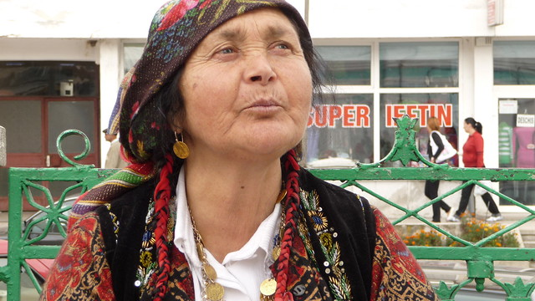 3 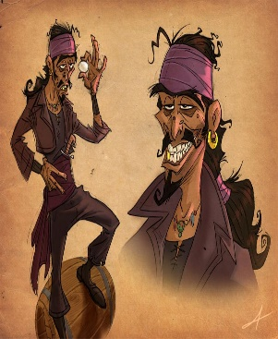 4 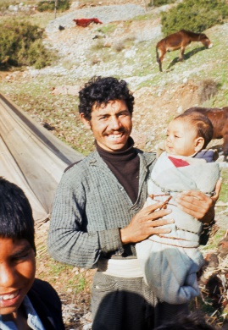
From left to right: 1 Media portrayal of a Gypsy woman. 2 A Gypsy woman.
3 Media portrayal of a Gypsy man. 4 A Gypsy man.
Conclusion.
In conclusion gender roles are clearly defined by racial and gender stereotypes that are culturally, economically and socially driven. The driving force can be the indigenous community or an outside influence such as mass consumerism, racism education and modernisation.As we see with the khasi people modernisation redefines what gender roles are and sexuality and gender beliefs clearly shape the social lives of any community.
Living as an individual that chooses to define their own gender roles is realistically only possible in larger consumerist societies as harsh living environments force tribes and societies to move as one unit with clearly defined gender roles that shape social lives and maintain the social structure. Choosing to move as an individual would be detrimental to personal survival.
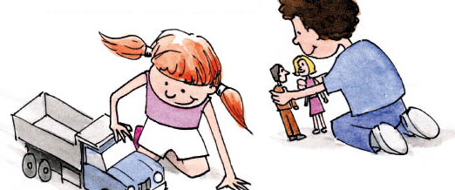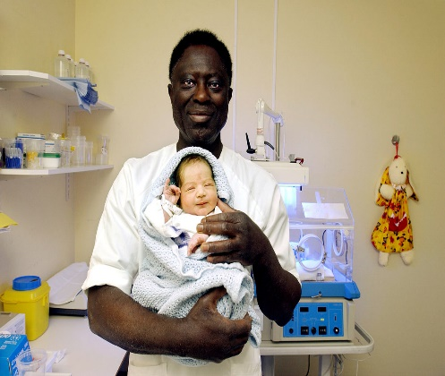
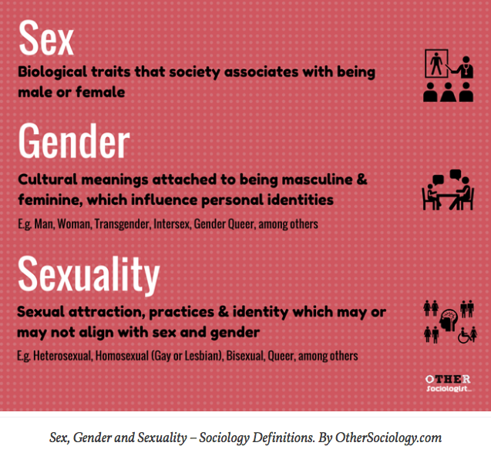
REFERENCES:
Pakyntein, V. (2017). Gender Relations in Khasi–Pnar Matrilineal Kinship. Asian Man (The) - An International Journal, 11(1), p.50.
Wade, P. (2009). Race and sex in Latin America. London: Pluto Press.
Okely, J. (1984). The traveller-gypsies. Cambridge: Cambridge University Press.

