TASK DESCRIPTION

1.0 - Aims & Objectives

City and County of Swansea have chosen to enter into a joint agreement with Marriot Hotels to create a new restaurant and ice-cream parlour (with manager’s apartment) on Swansea foreshore, in the position indicated. The site is located between County Hall and the Marriot Hotel and is illustrated on the attached images. The building, which is to share parts of the car park of both of the existing adjacent facilities, is to have a GIA (Gross Internal Area) at ground floor level of approximately 300 square metres.
The building is to contain the restaurant, café bar, ice-cream parlour, kitchen, food-stores etc. At second floor level, there is to be a self-contained manager’s apartment and staff welfare facilities. This project is procured via a Design and Build contract.

You are to assume that you work as a junior construction professional, employed by a local company tendering for the work, requested to initiate a full site investigation as part of the feasibility study.

TASKS:

- Describe the historical background of the site via a preliminary desktop study, drawing upon archival material. Your study should include plans and photographs, with full referencing of both illustration and archival information gained.
- Describe, given the historic background, your recommendations for the contents of a detailed site investigation, which is to be undertaken by others. You must advise them of which elements of the site investigation you consider being most significant and applicable to this particular site, given its historic background.
- State the Building Regulations / Codes of Practice from which your recommendations are derived.
- With the aid of sketches, describe a suitable foundation detail for the building, based on your preliminary observations.

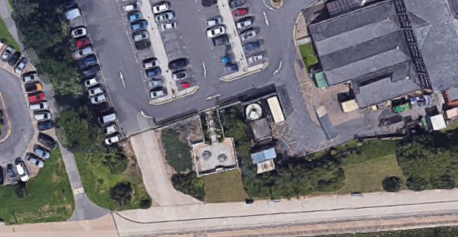
2.0 – Location

This is the location of site that overlooks the Swansea marina in SA1. It is situated only one mile away from the ruins of the medieval Swansea castle which was built in 1107 and attracts a large population of tourists, the M4 motorway, golf courses and the Gower Peninsula are also nearby. The red box shows where the actual site is, it is neighbouring the Marriott Hotel which was built in 1989 and was last renovated in 2007.

Below is a site location plan for the Marriott hotel that I found at - https://property.swansea.gov.uk/online-applications/files/1818E9200D8DB8A875485CDFADC2BAF9/2007_1609-SITE_LOCATION_PLAN-529.jpg
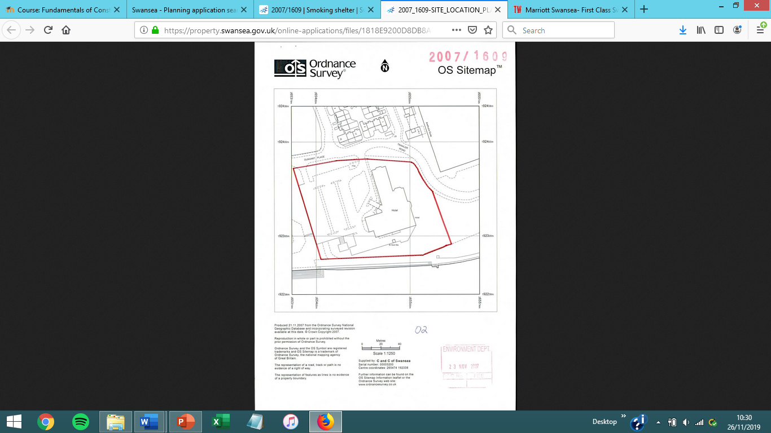

The Gower peninsula
Gower peninsula is quite close to the site and it is a huge tourist attraction, it was designated as the UK’s first Area of Outstanding Natural Beauty back in 1956. The area of it is also huge at around 70 square miles (180 km²), one of its most attractive features is the number of beaches there is around 25 or more of them which is incredible compared to other attractions similar in the UK.

“It’s no surprise that walking in Gower is so popular, its home to some of the most beautiful sections of the Wales Coast Path . Grab your boots and be prepared for a spectacular waterfront walk. It’s not all about sea and sand either – you’ll encounter lush woodlands and stunning countryside views along the way.” - https://www.visitswanseabay.com/destinations/gower-peninsula/

Swansea Bay
The Swansea bay is situated very close to the site, Swansea Bay has the second highest tidal range in the world at 10.4m.

As the site overlooks the Swansea marina which is shoulder to shoulder with the coastline, this can come an advantage and a disadvantage for the site here are a few examples: -

Advantages

- It can strengthen the immune system of workers and guests – studies show that being staying close to the coastline’s air increases relaxation and decreases stress. It’s studies like this that attract more guests to come.

- Owners of the ice cream parlour can use the coastline or beach in their propaganda or whilst their promoting their product.

Disadvantages

- Higher risks of floods

- Waste materials from the coast being brought closer to the site

Swansea Civic Centre
Swansea civic centre which used to be called the county hall is the centre of the county of Swansea council. Following the local government act 1972, which split Glamorgan county council and west Glamorgan county council, the new county council met at Swansea guildhall. A new facility was commissioned as the new home of the county council, it was opened as County Hall in July of 1982. The building was renamed the civic centre in 2008, and Swansea central library was moved.

Swansea Castle
Swansea castle that neighbours the BT building was originally built made of wood, but then later got destroyed by the Welsh back in 1106. The castle was then rebuilt in the late 12th century but this time it was built made up of stone, it was then remarkably destroyed again 1217. The castle was then slighted by parliament in the year of 1647. The castle was then later used as a police station up to around the 19th century and now stands as more of a tourist attraction.

Swansea Marina

The Swansea marina inhabits the former south dock, which was opened in 1859. Swansea’s coal trade also got too large for the basic riverside dock services. A North Dock was produced, followed by the south dock, it was designed by the Scottish engineer called James Abernethy. These docks were uplifted by the introduction of the south wales railway at Swansea high street station.
More port facilities have been made further east of the marina, and the south dock formally designed by James Abernethy was closed down in 1969. It stayed there in terrible conditions until the authority locals refurbished the area. The older dock was then actually reopened being called the Marina in 1982. To this current date that very Marina has around 550 berths, 185 of that 550 were added in 2006 when the Marina was extended to the dock’s western end, close to the Marriott Hotel.

3.0 – Desktop Study

- Site History – after looking on the national library of Scotland website I matched up a map from 1952 and from present day and it shows that there is an old line running through the site. The line looks to be the Mumbles line, which was closed down in 1960 after being bought, it was also seen as the first passenger service in the world.

I got this information and the map below from –“https://maps.nls.uk/geo/find/#zoom=13&lat=51.6295&lon=-3.9214&layers=102&b=1&z=1&point=51.6286,-3.9174”
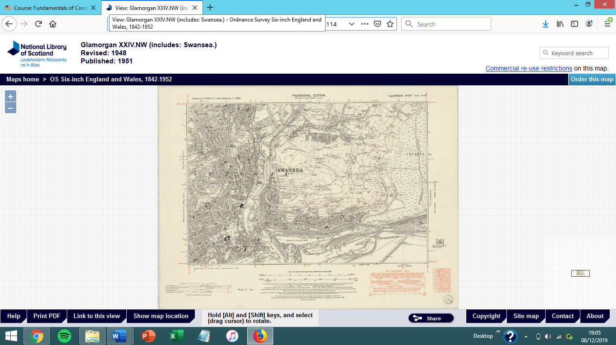

“The Mumbles Railway was built under an Act of Parliament in 1804, authorising the removal and carriage of limestone from the quarries at Mumbles to the docks area of nearby Swansea. From there the limestone would be sent to all corners of the world. Construction was completed in 1806 and services began. There was no formal opening ceremony and, to begin with at least, it was industrial product rather than people that was the important factor.” - https://www.bbc.co.uk/blogs/wales/entries/9301805e-7330-35bc-8701-ebbea7ec945c

- Materials
Having a look on the British Geological Survey (BGS) website I found a map showing what the sites materials are made up of these include mudstone, siltstone and sandstone. Sedimentary bedrock was also listed which is believed to have been formed 318 million years ago. Also, the local environment of the site was previously full of swamps, deltas and estuaries.

British Geological Survey Website - http://mapapps.bgs.ac.uk/geologyofbritain/home.html
“Sedimentary rocks are formed from the broken remains of other rocks that become joined together. A river carries, or transports, pieces of broken rock as it flows along. When the river reaches a lake or the sea, its load of transported rocks settles to the bottom. We say that the rocks are deposited. The deposited rocks build up in layers, called sediments. This process is called sedimentation. The weight of the sediments on top squashes the sediments at the bottom. This is called compaction. The water is squeezed out from between the pieces of rock and crystals of different salts form. The crystals stick the pieces of rock together. This process is called cementation.” - https://www.bbc.co.uk/bitesize/guides/zgb9kqt/revision/3

- Buildings nearby
There are a lot of buildings nearby the site. The two most noticeable developments are the Marriott Hotel (Built in 1989) and the County Hall which is now known as the Swansea civic centre (Built in 1982). These 2 buildings have been refurbished and extended upon since they were built, which obviously means the owners of the buildings would have had planning applications accepted for the works they wanted to carry out. There were re-developments for the Marriot Hotel in 2007 to preserve two storage containers to last for at least the next two years, the Marriot Hotel also had a handful of planning restraints. These included an airport safety zone, flooding zones, cycle paths and a mining area. Because the site is in almost the same location as the Marriot Hotel, these exact same restraints will be relevant to the ice-cream parlours planning application.

- Soil contamination?
As previously stated, some of the areas surrounding the site are used as a car park, this means there’s a possibility of cars leaking petrol into the soil which when contaminated can affect soil health.
Information acquired from “https://www.soils.org/discover-soils/soils-in-the-city/soil-contaminants/petroleum-products”

- Planned Development
The planned development includes a restaurant and an ice-cream parlour which will include an apartment for the manager. The building will include also food stores, a kitchen area, café area and staff welfare facilities. The proposed restaurant will be at ground floor level. The kitchen will be on the ground floor and will be one storey high, the main section of the building, which will include the restaurant and managers apartment will be three storeys high instead.

4.0- Foundations

The foundations that are suitable for this structure would be piled raft foundations. I would use this type of foundation as the raft foundations would extend the weight of the structure over a big area, and the end bearing piles will hand over the weight of the structure through the soil that is soft to a proper bearing level of ground which is then hard. It would contain concrete slabs, which is then hardened by the beams combined into the pile foundations. A raft would be supported on a compacted base and would have an edge. I would choose a block and beam floor for the ground floor; this would be great as it is constructed faster, and it makes sure that the floor stays away from wet or contaminated soil. For this method, the ground has to have no vegetation and cannot be anywhere near below ground level. The floor would have to consist of precast concrete beams, which would then be re-in forced with steel. Insulation would be inserted, and the floor would be finished with floor screed. It would be important that the floor be ventilated.

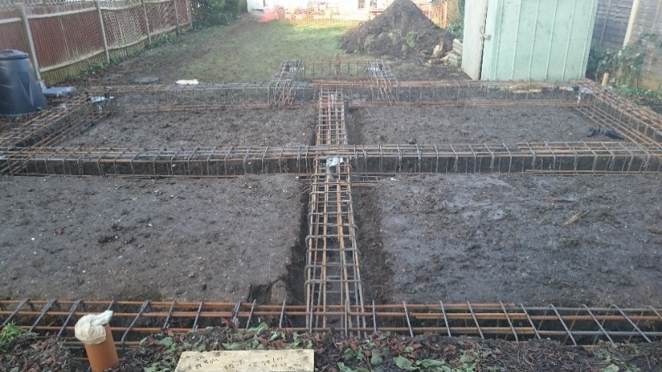

Desk Study
This is my desk study on the site which will have
create a new restaurant and ice-cream parlour (with manager’s apartment). The site’s boundaries are next to the Marriott Hotel and the coast path behind it. The coast path has a slope leading to the coastline this provides a small but necessary drainage feature. In this sight area as it is by the sea there are no transmission lines or aircraft movements that obstruct sight lines, but there are ships which sail by that may obstruct that view. The only way of any obstructions being below ground of this site would be related to the coal mines, because of this observation I looked on the coal authority website to see if there was any history of coal mines or mine openings in that area. Luckily the website shows that there has been no history of work in that specific area, the closest area I could find to the site that had work previously had was in mount pleasant which is a 23-minute walk away.
The coal authority website where I found this information – “http://mapapps2.bgs.ac.uk/coalauthority/home.html”

There are no records I’ve found of an unexploded ordnance or an “XO” within a 3.9-mile radius as the last spotted “XO” was in Kilvey Hill which is a 20-minute walk from site. There was however a Lunt waffle target around 0.5 miles away from site, and the Swansea area in general was one of the biggest towns with the highest bomb risk.
I gathered this information from – “https://zeticauxo.com/downloads-and-resources/risk-maps/”

Where the site is the mumbles railway used to have a line through and most of the services and utilities from that line can still be used to this day. Meteorologically the site is no in the best of positions as Swansea is officially the wettest city in the UK and gets an average annual rainfall of 1,360.8mm or 582.4 metres. It’s weather like this that can cause major delays in development and in the actual construction of the building as most groundworks and bricklaying sections of the job are difficult or not appropriate to be done in such bad conditions.
The statistics used are from – “https://www.walesonline.co.uk/news/wales-news/soggiest-city-britain-pays-high-2440570”

