The first 1000 Days
The first 1000 days in life are from conception up to the age of 2. During this stage of their lives, it is vital for us to ensure that their brains and bodies are developing well in order to improve their chances at life. it is important that during this stage, the mother takes care of herself ensuring that she has a healthy diet and is looking after her body. For example, by lowering stress levels or adhering away from adversity, there is a higher possibility of the child becoming healthier physically. The is key when the baby is in the womb as they will have all the nutrients from the mother. After the baby is born, the environment in which they are raised plays a big role in their development. It is vital that they get the best nutrition and care and support after birth as well as in the womb as they are the most influential within development at that age and therefore by receiving the nutrition that is needed and the care, there is a higher probability of the child’s health being at its best.

Within the first 1000 days of a child’s life, The Children’s Nutrition (2020), indicates that the first 1000 days are fundamental for the development of multiple systems within the body such as the immune system which is developed to fight off diseases.
It is the parents’ role to ensure that the child is developing healthily and receiving everything necessary. The baby is fully dependent on the adult to nourish, care, protect and aid them into reaching their full potential.

Conception and Pregnancy

During conception and pregnancy, is it very important for the mother to be healthy and active as the baby will be growing and developing rapidly in her womb for the next 9 months. Winchester Hospital (2023) states that during the early stages of pregnancy, the fetus develops at a fast pace. It will be developing its’ spinal chord, brain, lungs and heart during this stage. There are many changes that take place within the first trimester such as hearing the baby’s heart beat which can be heard from around 6 weeks but sometime can take longer reaching the 10-12 week mark. Also around the 10 week mark, the ears, mouth and nose will also begin to develop. Attaching the baby to mother is the umbilical chord which helps nourish the baby, passing the food that the mother consumes and feeds it to the baby. The umbilical chord also plays another role which is to dispose of the waste from the baby.
As the pregnancy reaches the second trimester, the baby will continue to grow with more body parts forming which include their muscles and bones while also their hair will be developing including their eyebrows and eyelashes. As their ears developed in the last trimester, Winchester Hospital (2023) indicates that the baby will be able to hear the mother heartbeat by 18 weeks. During the second trimester, the baby tends to develop quickly, putting pressure on the mother’s body in areas such as the lungs, stomach, bladder. After reaching the end of the second trimester, the baby’s will have developed but will not open during this stage until they start to blink during the third trimester. The baby tends to weigh around two pounds when they reach the end of week 23.
The third trimester is the final stretch before the baby arrives where they do their final part of growing and developing. During this stage, Winchester Hospital (2023) imply that the mother should feel lots of movement from the baby as they develop and they’ll begin to recognise the parent voices. Also, during this final stage, the baby should begin to practise breathing within the womb and therefore the mother should be able to feel a type of hiccup motion from the baby. By reaching the end of week 37, many babies are considered full-term by this stage but the baby will continue to grow and develop until they are born and will be fully dependant on the mother until then.

Current Challenges

The National Centre for Children and Families (2021) set out a survey to reveal how nursery staff were under pressure and what challenges they face daily. One of the main challenges that occurred was mental health issues within the early years. It was found that in England, 1 in every 20 children were found to have been suffering with a form of mental health issue.
It is stated by The National Centre for Children and Families (2021) that a majority of mental health issues in children under the age of 5 tend to go un-noticed or un-identified meaning they are not receiving the initial support they need from that young age and therefore leading to a struggle in later life.
During this survey, The National Centre for Children and Families (2021) implied that numerous people that were questioned in the survey had indicated that they had a role of guiding and helping the children with the mental health issues and they were one of the key people who needed to look after them.
The UK Government (2022) implied that there was a clear and significant impact on children in nursery settings and in early years after the Covid 19 pandemic. It is stated that the pandemic not only affected the children’s speech and language development but also had a big impact on the children’s social and emotional development as well.

Activity Ideas
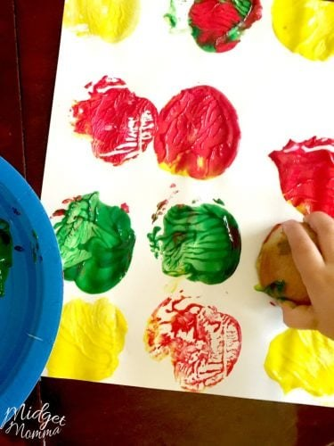
Raising Children Net (2023) have implied that play during the first 1000 days of life is crucial as it has multiple benefits. These benefits include helping children learn, develop, gain confidence and can help their well being. Within the aspect of play, there is an array of types of play which are all beneficial. From birth, babies begin their journey of exploration and further along begin to play and as they grow and develop, the type of play that they engage in will also change with them. For example, there is a variety of structured play and there is a variety of unstructured play. Unstructured play is when is was not planned and the children are forming their own play using their own imaginations and developing their own ideas. Structured play is the complete opposite where all the play will be planned and the children will have to follow the lead of an adult who had the idea where they can not express themselves fully within the game and can not make it their own.
Action for Children (2023) imply that sensory play is an important aspect of a child’s life from the moment they are born. This is because when a baby is born, they can not talk or walk or tell us how they are feeling and can only use their action and their senses. When babies and children engage in sensory play, it is helping them accelerate their senses which are touch, taste, smell, hearing and sight. Action for Children (2023) have shown that sensory play can aid in assisting brain development in early years, creating a better memory and is also important as it encourages the young children to engage in independent thinking.
School House (no date) suggested that messy play was also another good activity idea for young babies and children. Messy play can help these young children as generates creative minds and allows the children to have the freedom to explore. Messy play is known as a sociable activity where it can help develop a baby or a child’s communication and language skills. School House (no date) highlights that messy play can assist children with their physical development along side the mental development. It will give the children the opportunity to learn all about themselves as well as special awareness meaning their own and other peoples special boundaries. Alongside this, the children will benefit as they will be learning all about muscle control within their own body as messy play can include activities such as shoveling sand or soil.

There are multiple activities which come into the bracket of messy play. These activities include:
- Being outside and making the most of nature such as jumping in puddles
- Being at home, in the bath with bubbles
- Shaving foam
- Jelly
And there are many other objects or items that can be used to make the most of the time spent doing messy play activities with the children. Below, there is a short clip explaining why messy plays a key role in a child's development.

The Importance of Messy Play

Environment
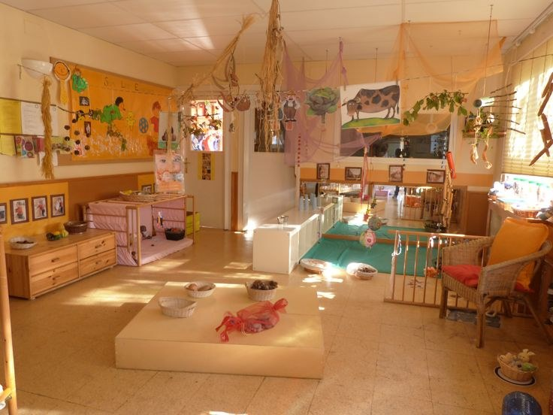
The Welsh Government (2022) advises that the environment in which the early years setting surrounds, should be focused on the children’s likes and experiences. It is suggested that in order for the children to continue to grow and develop happily within their setting, it is important for the setting to have consistent monitoring therefore being able to see clearly what is working, what is stimulating the children’s minds and what is not useful at all and will need changing. While stated that the setting will benefit the babies and children with their development, it is vital that the setting is also a place where the child feels comfortable, relaxed and safe (Welsh Government 2022). If a child is beginning to feel secure, they should be able to express themselves freely and imaginatively where we can learn what they find interesting. Ensuring that a setting offers a safe, healthy and happy environment will offer the children a space where they can explore their curiosity, solve problems and develop their thinking skills.

Children will learn a variety of skills and attributes from their environment alone therefore it is important that the setting they are in are open to valuing and learning all about diversity and should be supportive regarding inclusivity. Welsh Government (2022) implies that with inclusivity, it is important for the children to learn about recognising and respecting other families and cultures. By raising awareness to diversity and allowing the children to learn, it creates a safe space for all the children attending the setting making them feel comfortable and willing to engage. This allows the staff in that setting to understand the needs of all the children and are then able to help them progress further with the understanding of how. It is known that children learn from their surroundings and environments such as seeing how the adults around them behave and imitating what they see them do and hear them say. It is the adult’s role to demonstrate a positive role model for the children as they are easily influenced and this can be done by showing inclusion and celebrating all the children individually. For the positive role modelling to be effective, the adult must show that the setting is accessible for all children but if it is not then they should make appropriate changes in order to aid for the others necessary. It is also important to have resources that are not specific to a certain gender and can show diversity (Welsh Government 2022).
Relationships with parents
Early Years Alliance (2019) conveys that working alongside parents and guardians in an early years setting is fundamental to the child’s experience as it enables effective understanding of the child and therefore will produce operative learning for the child as well. It is important for the setting to open to all influences from the parents such as taking part in discussions, sharing interests and welcoming the parents in to the setting for the to fully understand where their child will be learning and developing. This way, the parents can offer their input on how aspects of the setting will benefit their child more than other aspects as well as describing what previous, at-home interests their child has been showing and developing. By working side-by-side with the parents, it creates the opportunity to push the learning further beyond the nursery setting with the young children and allowing the parents to have the opportunity to expand on what has already been taught and leant in the nursery to see if the skills can be developed further at home. Early Years Alliance (2019) suggests there are a few benefits to working coincide with parents such as improved educational outcomes for young children, improved communication skills between practitioner and parent and improved relationships between parent and child.

Bronfenbrenner
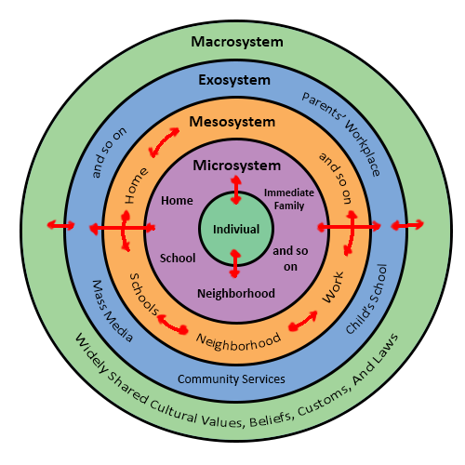
First Discoverers (2022) discuss Bronfenbrenner and his ecological system. The system is made up of 4 layers which include:
- The microsystem
- The mesosystem
- The exosystem
- The macrosystem
Within this system, Bronfenbrenner was highlighting that the child is at the centre of the social system and then progress through each layer. It begins with the microsystem where the child is creating bonds with their closest relatives including their parents and/or siblings. Also, within this layer of the system, it is possible for the children to create interactions within their school or nursery surroundings. The second layer of the system is the mesosystem where it focuses on the differences between everyone which is involved in the microsystem. For example, it is in this layer the relationship between an early years practitioner and a child’s parent would come under. The third layer would be the exosystem where non-direct obstructions come under such as a parents losing their job. This will obstruct the child’s learning and education due to parental stress but will not have a direct impact on them. The final layer of the system is the macrosystem. Within this layer comes beliefs, religion, and cultural aspects. For example, a religious belief may play a role in decided whether an early years setting is suitable for the child’s early education or not.
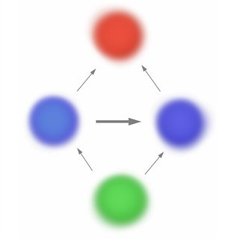
1 - Bronfenbrenner's Ecological System

International Approaches
Te Whariki
In Wales and England, early years settings follow the national curriculum which is different to some countries such as New Zealand. In New Zealand, they follow a different approach to learning which is known as Te Whariki. The meaning of Te Whariki is a ‘woven mat’ which symbolises the process of learning and developing from a young age. New Zealand Government (2017) indicates that is form of curriculum represents new life and potential in the children. Within Te whariki, there are five stands which are other known as principles.
The first stand is called ‘mana atua’ which means wellbeing. This is where they promote the wellbeing of all children and allow them the right to express how they are feeling and are encouraging a safe space for them.
The second strand is called ‘mana whenua’ which means belonging. This is where the children should feel secure within their settings and all the children should be treated with respect. Also under this strand, diversity should also be appreciated.
The third strand is called ‘mana tangta’ which means contribution. This is where the children should develop by actively engaging with activities and opportunities that are open to them. During this strand, the children often partake in activities that include other adults as well as other children.
The fourth strand is called ‘mana reo’ which means communication. This is where language skills are focus upon and it is important to acknowledge the way the children are developing through language and how they communicate with one another.
The fifth and final stand is called ‘mana aotũroa’ which means exploration. This is where the children are being supported to explore and learn to understand the world around them in their own way.
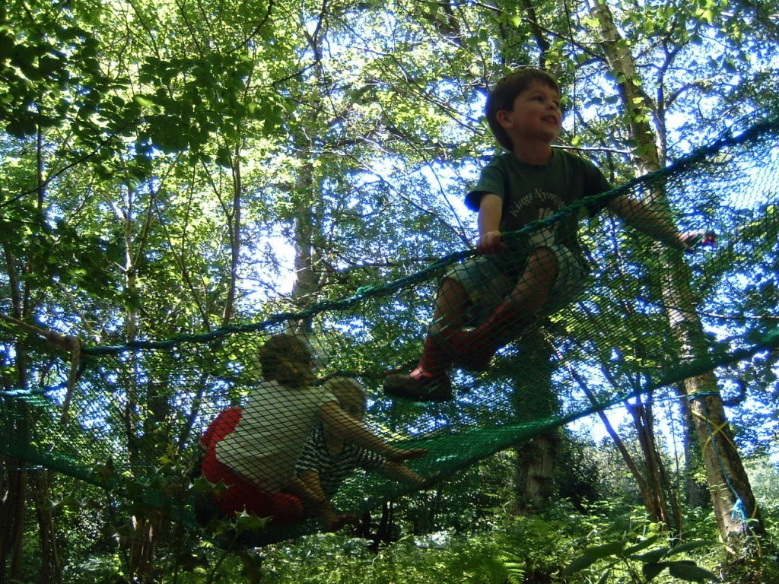
Forest Schools
Forest schools were developed in Denmark originally and are a child-centred process which is there to support the children’s learning within a holistic approach. Forest Schools Association (No date) highlights that it can help young children develop confidence and self-esteem within natural surroundings. The meaning behind forest schools is to aid children in developing their skills which include:
- Social
- Physical
- Emotional
- Intellectual
Within the forest school, their aim to create spaces for children to learn how to solve problems on their own while carrying out their own risk assessment and learning from previous mistakes on how to better themselves and not repeating that mistake again. Please find below a video of an in-depth explanation of forests school and their many benefits.
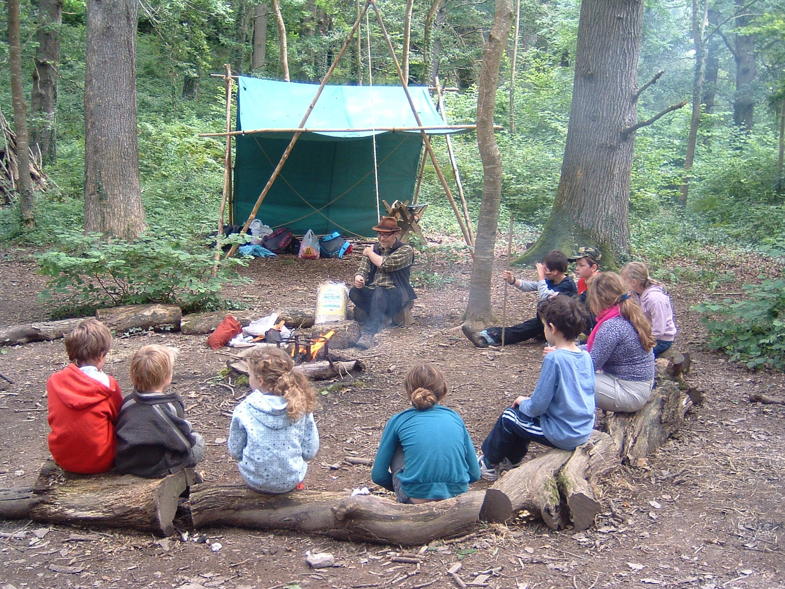
2 - What is a Forest school?

Reference list


Action for Children. (2023) What is sensory play and why is it important? Available at: https://www.actionforchildren.org.uk/blog/what-is-sensory-play-and-why-is-it-important/#:~:text=Sensory%20play%20is%20any%20activity,the%20world%20that%20surrounds%20them (Accessed: 20 March 2023).
Early Years Alliance. (2019) Involving parents in their children’s learning. Available at: https://www.eyalliance.org.uk/involving-parents-their-children%E2%80%99s-learning#:~:text=Working%20in%20partnership%20with%20parents,children's%20learning%20development%20at%20home (Accessed: 14 April 2023).
First Discoverers (2022) Child Development Theories: Urie Bronfenbrenner. Available at: https://www.firstdiscoverers.co.uk/child-development-theories-urie-bronfenbrenner/ (Accessed: 17 April 2023).
Forest School Association. (No date) What is Forest School? Available at: https://forestschoolassociation.org/what-is-forest-school/ (Accessed: 18 April 2023).
House of Commons. (2019) First 1000 Days of Life. Available at: https://publications.parliament.uk/pa/cm201719/cmselect/cmhealth/1496/1496.pdf (Accessed: 16 February 2023).
National Library of Medicine. (2022) Importance of Maternal Nutrition in the First 1,000 Days of Life and Its Effects on Child Development: A Narrative Review. Available at: https://www.ncbi.nlm.nih.gov/pmc/articles/PMC9640361/#:~:text=A%20person's%20first%201%2C000%20days,and%20impaired%20growth%20%5B3%5D (Accessed: 16 February 2023).
New Zealand Government. (2017) Te Whariki. Available at: https://www.education.govt.nz/assets/Documents/Early-Childhood/ELS-Te-Whariki-Early-Childhood-Curriculum-ENG-Web.pdf Accessed: 17 April 2023).
Nursery World. (2002) The Practitioner Role. Available at: https://www.nurseryworld.co.uk/news/article/the-practitioner-role (Accessed: 11 April 2023).
Playful Childhoods. (No date) How to deal with messy play. Available at: https://www.playfulchildhoods.wales/how-to-deal-with-messy-play?gclid=EAIaIQobChMIzZKU_6a2_gIVGODtCh3YhwuyEAAYASAAEgLw_vD_BwE (Accessed: 2 April 2023).
Raising Children Net. (2023) Why play is important. Available at: https://raisingchildren.net.au/guides/first-1000-days/play/why-play-is-important (Accessed: 12 March 2023).
School House. (No date) 5 Reasons Why Messy Play Is Important and Benefits Children. Available at: https://schoolhouse-daycare.co.uk/news/why-messy-play-benefits-children/ (Accessed: 20 March 2023).
The Children’s Nutritionist. (2020) Why you should pay close attention to the first 1000 days of your baby’s life. Available at: https://childrensnutrition.co.uk/full-blog/first-1000-days/ (Accessed: 27 February 2023).
The National Centre for Children and Families. (2021) Their challenges are our challenges. Available at: https://www.annafreud.org/media/13013/their-challenges-are-our-challenges-survey-report.pdf (Accessed: 7 March 2023).
UK Government. (2022) Education recovery in early years providers: spring 2022. Available at: https://www.gov.uk/government/publications/education-recovery-in-early-years-providers-spring-2022/education-recovery-in-early-years-providers-spring-2022 (Accessed: 12 March 2023).
Welsh Government. (2022) A Curriculum for funded non-maintained nursery settings. Available at: https://hwb.gov.wales/api/storage/b1801d78-38c3-4320-9818-d9996c21aef8/220914-a-curriculum-for-funded-non-maintained-nursery-settings.pdf (Accessed: 11 April 2023).
Winchester Hospital. (2023) Fetal Development by Trimester. Available at: https://www.winchesterhospital.org/health-library/article?id=101070#:~:text=The%20spinal%20cord%2C%20brain%2C%20heart,until%20around%20week%2010%2D12 (Accessed: 4 March 2023).

