Shangri-La -Dubai

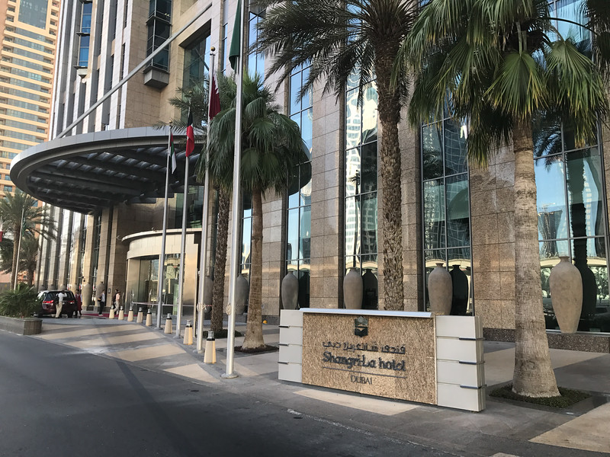
Hotel Handbook for Intercultural competence

Name: Alexandra Gabriela Atofanei
Module: BMIH 5003
Lecturer: Michael Davies

- Introduction:

Shangri-La -Dubai is a hotel in Dubai opened in 8 July 2003. The hotel has 302 guest rooms and suites, two floors of elegant Horizon club accommodations and 126 services apartments furnished. The hotel is located along Sheikh Zayed Road, 15 minutes from Dubai International Airport and 5 minutes from the Dubai Convention Centre. It’s also close to the famous Dubai Mall, shopping malls and popular beaches.
Shangri-La -Dubai is an ideal starting point of discover the city energy, modern architecture stands, along with the traditional souk markets. (Shangri-La-Dubai , nd)

This report uses Hofstede theory to understand the culture between two countries. The tourists visited the hotel came from Germany. The Hofstede theory will help to understand and train the staff to interact with German guests.

According to Hofstede (1980) cultural dimension, Forsyth et al. expected that the construct of idealism would be closely associated with the masculinity dimension, while the construct of relativism would be closely related to uncertainty avoidance and individualism. Hofstede (1980) cite that, cultures that have a low score in masculinity will develop values which are consistent with relationships with friends and family.

Schwarts mention that culture consist of the derivates of experience, more or less organized, learn or created by the individuals of s population, including those images or encodement’s and their interpretation transmitted from past generations , from contemporaries or formed by individuals themselves. ( in Schwarts et al., 1991:324)

- About German culture:

As every country, Germans are quite different then emirates people and this can be a disadvantage when the hotel try to understand their needs and train their staff to deal with their preferences. Their culture combines most Christian values with art, literature, logic, philosophy, reason and a love of sausages and beer. One of their stereotypes is a testament to their dedication to good planning and time keeping. Some of the characteristic of Germans be sensible, thrifty, respect other privacy, respect the law of society and structure. They love good beer, delicious sausages, hiking, traditional.They have strong family values, they are quite unneighborly and they create a sense of community. They like to travel, especially international travel, sport and gardening.
As food and drink they have traditional dishes as : roulade, German noodles, schnitzel and their special drink is beer. Also, they have as tradition Kaffee and Kuchen which is like English afternoon tea. ( German culture people, tradition , customs and facts, nd)

- Country Analysis using Hofstede comparison between Germans and Emirates:

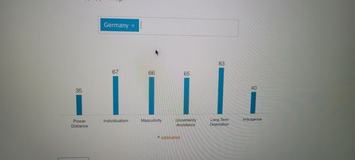

From the power distance point Germany is not surprising among the lower power distant countries’-determination rights are extends life and needs to be taken into accont.Regarding individualism, Germans are truly one of them. Loyalty is based on personal preferences for people as well as a sense of duty and responsibility. A high score in masculinity relate that the society will be follow by the competition, achievement and success. The uncertainty avoidance presented a high percentage which means that is a strong preference for reductive rather than inductive approaches.The long-term orientation presents Germany as a pragmatic country, where people believe that truth depends very much on situation, context and time. Indulgence is seen as a tendency to cynicism and pessimism.

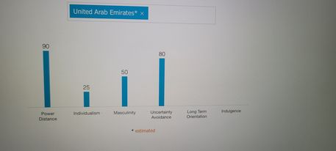

Power distance shows that people accept a hierarchical order where everybody has a place, and which is no need of further justification. From the individualism side, emirates are considered a collectivistic society. Regarding masculinity side can be understand that emirates can be neither masculine or feminine. Uncertainty avoidance shows that in this cultures there is an emotional need for rules, time is money.Lond term orientation and indulgence is missing from the emirates Hofstede score .

These two graphs shown that these two countries are quite different, and this helps the staff of the hotel to understand and improve their attributes to deal with guests from Germany.

How to greet German people:

German’s people like to greet using handshake with direct eye contact. Usually, the men’s greet women first and wait for them to extend their hand. They say: Guten Tag ( Good day) or Hallo ( Hello), these are the most common greetings in Germany. (German culture, nd)
This is very essential for the staff working in Shangri- La -Dubai, to give the best welcome to the guests when they arrived.

Hotel handbook: Do and Don’t advice for staff:

When staff interact with German people, they must follow the do and don’t advice. The following table will show some useful information for staff working at the hotel for each department.

Do for all departments | Don’t for all departments
Reception -provide sincere answers to serious questions.  -smile to them and greet them with shake hands ( this is possible obviously post COVID). | -avoid cancelling them at the last minute or being late.
Housekeeping- ask them permission before you do something related with them, as eg: taking a picture or video with them or just clean their room. | -do not press them to revise their decision if they have already given you their response.
Kitchen-try to not take personal offence if a German informs you of a mistake you made. | -avoid shouting across rooms or drawing attention to yourself in public;
Food and beverage- expect a German to be open and honest when they disagree with you. | -avoid involve in the conflicts, try to be patient and understand what they want to tell you and their preferences.

(German culture, nd.)

Germans’ stereotypes:

The staff in the hotel should be aware also with German stereotypes can understand better their preferences, They are direct, known as straight shooters, they have the organization rules and structure. To try to impress the Germans, the kitchen staff can prepare some traditional dishes from their country in the hotel restaurant on their arrival.

However, the staff must know what general etiquette is and what to avoid. In their opinion is rude to chew gum or keep one’s hands in one’s pockets when talking with someone. Also, putting the legs over knee over the other. (German culture, etiquette, nd)

Stereotypes are defined as boras generalizations made about a group of people. ( Fiske, 1998; Reyna , 2000,; Taifel, 1981, 1892)

Another way to understand better the German people is to know exactly how they are as persons. Some examples of their personality traits: they are hardworking, humorous, they are well organized, they respect punctuality, traditions are very important for them and they are very creative. ( Six distinct stereotypical German personality traits, nd)

How to understand better Germans:

In relation with communication German people appreciate straight forward and direct speech. They have a formal way of communication, and they are polite. For non-verbal communication and they are polite,they like to shake hand, when greeting, good eye contact is important and to smile to them as well. They are pragmatic, they preferer responses that are precise. (Communicating effectively with Germans, nd)

Some superstitions about general culture for Germans are the following: they believe that windows open will cause illness, they consider bad luck to celebrate birthday’s early, rather than wave to them greet them by knocking on the table. (Fun facts about Germany, you didn’t know, nd)

Staff from the hotel should know some of the German culture facts. Their official language is German, their culture has produced many famous classical composers which include Bach, Beethoven, Johan’s Strauss, which can help the staff to create a great ambient to them when they eat at the restaurant to assist them with a good music. Also, they like culture Rammstein, Tokyo Hotel and Scorpions. ( Facts and culture, nd)

Conclusion:

To conclude this report as presented the needs of the guest came to the Shangri-Le- Dubai will help the staff to understand better the guests needs, their preferences. This will help them to provide the best accommodation and a perfect place to stay for them.

Executive summary:

This report will examine the country where the visitors came in to stay during their accommodation which is Dubai, and the hotel is Shangri-La Dubai. The guest will come from Germany, which is a different cultural country with different rules, opinions, communication, language and tradition. For the staff in the hotel will be a good experience to have guests from Germany and to try to learn how people like to live and to develop more knowledges and maybe learn possible a new language. This report uses Hosfede comparison to make the staff understand some of the differences between the two cultures and see how to understand their preferences also.

It is extremely important to understand the culture of a country to have success within the hotel operation and guest hospitality experience. This is the way to show to the guests that you care about them, their culture and you are happy because they make the choice to be in your hospitality environment. This report present also and the way to greet Germans , which is very essential and is one of the most important thing when you interact with new people. Also, this report shows some of the Germans stereotypes, way of communication and culture facts. The hotel handbook with do and don’t is very important for the staff to know exactly what is good and not advisable in contact with the guests.

This report is one of the best ways to help the staff to know the person before is coming to the hotel and avoid also to upset the guests or do something which for them is wrong. This will affect the hotel reputation and may be a bad experience for the guests.

References:

- Fiske, S.T . (1998) , Stereotypping , prejudice and discrimination . In D.T. Gilbert, S.T . Fiske, and L. Gardner, The handbook of Social psychology (pp357-411) , New York: McGraw-Hill;
- https: //www.shangri-la.com/dubai/shangrila/press-room/fast-facts/, Informations about Shangri-la-Hotel Dubai, accessed on 7.03.2022;
- https://www.hofstede-insights.com/country-comparision/the-united-arab-emirates accessed on 13.03.2022.
- Hofsteade, G.(1980)- Culture’s Consequences: International Differences in Work-Related- Values. Sge, Newbury Park, CA;
- Https://www.expectrio.com/living-germany/german-culture, German culture, people tradition , customs and facts, accessed on 7.03.2022;
- https://www.hofstede-insights.com/country-comparision/germany, accessed on 13.03.2022;
- https://culturalatlas.sbs.com.au/germans-culture/german-culture-greetings, German culture, accessed on 09.03.2021;
- https: www.fluentu.com/blog/german-sterotypes, 9 German stereotypes that are straight up , accessed on 10.03.2022;
- https://culturalatlas.sbs.com.au/ger,ans-culture/german-culture-do-s-and-don-ts, German culture, accessed on 10.03.2022;
- https://culturalatlas.sbs.com.au/german-culture/german-culture-etiquette, German culture etiquette, accessed on 10.03.2022;
- https://dammann-german-english-translation.com.au/six-distinct-sterotypical-german-personality-traits/ , Six distinct stereotypical german personality traits, accessed on 12.03.2022;
- https://www.international-excellence.com/articles-tips/171-communicating-effectively-with-germans, Communicating effectively with germans, accesed on 12.03.2022;
- https://takelessons.com/blog/fun-facts-about-germany , Fun facts about Germany you didn’t known, accessed on 12.03.2022;
- https://www.softschools.com/facts/cultures/german-culture-facts/3255/;
- Schwarts, T., White , G. and Lutz, C. (eds), new Directions in Psychologcal Anthropolpgy, , Cambridge ; Cambridge University Press, 1992,)

