
Date: 10 January 2022
Module name: Living with Care: The Older Person
Module code: BMHP009
Student name: Ana Maria Elena Stanciu
Student ID: 1909953
Lecturer: Edward Goka

Assessment 1
Written report

Table of Contents
Introduction 2
Discussion 2
Evaluation 5
Figure 1. 7
Figure 2. 9
Recommendations 10
Conclusion 11
Reference list: 11

Introduction

All nations around the world are affected by the 21st Century greatly substantial demographic and social tendency, the ageing population. Although the growth of life expectancy is the greatest achievement of advancement and health care, it presents challenges because elders will represent the biggest percentage of the population in the future. Yet that will represent social, economic, and cultural challenges to people, families, public health, and society (CEB, 2014).
CEB (2014) suggests that from 2010 to 2060, 65 years old and over individuals will double reaching 160 million in the county’s members of the Council of Europe.

Immunisation of parasitic and infectious diseases, such as smallpox, polio, measles, and healthy diets, cleaner waters have decreased the number of diseases and prevented death among children, are the biggest accomplishments of public health. Moreover, life expectancy among women at birth was increased because children were reaching the age of 15 years old not because people were living longer, from 1850 to 1900 (WHO, 2011).
The following report is a comparative report on the strategies that United Kingdom (UK), and Romania will or have adopted to provide and take care of their growing aging population. Further, in this report will be discussed, the meaning of elderly individuals in the UK and Romania, provide statistics regarding the topic, discuss the impact of loneliness in care settings for the elders as well as examine regulator bodies meant to tackle the concept of loneliness, further, it will look at local, national, and international strategies designed to help, support, and protect the elderly.

Discussion

Ageing terminology has several meanings in various contexts, it can be referred to as a chronological viewpoint but also a physical cycle whereby molecular proliferation and cellular destruction head to an incremental erosion of normal functionality over the years of an individual life (BMA, 2016).
NHS (2015) however, defines ‘an older person’ as someone who has passed the age of 65 years regardless of the biological differences.

Yet in Romania, an older individual is described as a ‘vulnerable category’ inside the society, having the highest exposure, and a quickened probability of functional deterioration and that comprise people over de age of 65 just as the UK (Urzeala, C. et al., 2021).

Further, the notion of the older individuals in the UK means people who are in substantial need of public health care services because in general, an individual over the age of 65 is more likely to be in poor health conditions than a younger individual (Abdi, A. et al., 2019).
On the other hand, the Department of Health (2001), suggests that elderly individuals are not a ‘costume community’ having a broad spectrum of necessities, but they can perhaps be people that have completed careers and paid taxes, people that are in transition from a healthy life to a frail one or people that have had strokes and dementia, therefore, becoming vulnerable.

Whereas in Romania being an elderly person it is someone needy, incapable, and marginalized from the rest of the society due to poverty and social inequalities (Bodgai, S. I. and Cutler, S.J., 2013).

Regardless of how, older people are described, whether they have been taxpayers or suffered dementia and strokes, the ageing population although it is the result of substantial development in health care, technology, and demographic changes, they need medical and social support (BMA, 2016).

In both countries, the ageing population is not necessarily a motive for celebrating life expectancy because frequently those extra years are spent in poor health and social isolation putting pressure on both health and social care but also on the doctors because the elderly health is frail. Therefore, facing considerably prolonged time health situations and multiple comorbidities (BMA, 2016).

The theory of social breakdown is characterised by psychological dysfunction due to social rejection and society view of the elderly, as needy individuals (Kuypers, J.A. and Bengtson, V.L., 1973), it is very much applicable in Romania.
The older generations of Romania’s mental health are much poor than other countries in Europe not only because of social exclusion but from material and economic help, assistance, communities’ establishments, and health benefits that is why elders are seen as needy individuals (Precupetu, I., Aartsen, M. and Vasile, M., 2019).
In the UK however, the most applicable theory of ageing is modernisation theory that although the world has evolved rapidly, older people are still perceived as wise and important for the society, still carrying out important tasks in communities (voluntary work, childminder, involvement in politics and much more), they are perceived to have a better knowledge at workplaces due to life experiences (Vauclair, C.M. and Rudnev, M., 2019).

Furthermore, Rabontu, C.I. and Todorut, A.V. (2018) suggest that currently, one in seven people in Romania are over 65 years old and over, due to low birth rate. It is estimated that in 2030 people over 65 will be one in five and by 2060 one third of the country will be older than 65 years. This means that older people must be protected and provided with a better quality of life.

The UK on the other hand is confronting the same situation when it comes to the rapidity of the population ageing.

UK Parliament (2021), reports that in 2019 approximately 19 % of people (12.3 million) were 65 years old and over with an increase of 23% since 2009 and this group of age are estimated to grow up to 24% by 2043. Additionally, those aged 75 and more are estimated to increase from 8% in 2008 to 13% in 2043.
Growing older comes with a higher risk of developing many comorbidities but not only. They are more likely to develop loneliness which many people experience at some point in their lives (Age UK, 1018).
Nevertheless, the risks are higher among elders because they are more likely to be widowed or more often have no one to talk to (Age UK, 2018).

According to McGarrigle, L. (2017), the association between loneliness and social isolation which is the total or partial deficiency of social interactions and connection, can increase one's likelihood to develop illnesses and enhance mortality.
Yet a study that was done by Koning, J. et al. (2021) implies that loneliness can affect one’s wellbeing even if one stay physically active throughout their life. Consequently, people that live in rural areas which are more active than those who live in urban areas, can be affected by loneliness too, therefore, their physical and mental well-being (Koning, J. et al. 2021).
In the UK approximately ten million people are suffering from loneliness although not all acknowledged because loneliness is an extremely personal occurrence therefore a complex issue (Mann, R. et al., 2020)
Yet regarding care homes, loneliness is an acute problem. According to Mann, R. et al. (2020) residents of between 22 and 42% of home cares in the UK are suffering loneliness that restricts older people in ordinary activities of day-to-day living, inadequate self-reported conditions, disabilities, difficulties with mobility, decreased mental function, depressions, needy psychological wellbeing, and higher mortality chances.
Romania's health care system in comparison to the UK has substantial drawbacks in the expenditure of either medical or social care, consequently the main carers of the elderly are their families. However, the majority of those who are living in care homes are either mentally ill to the point of not being capable of remembering or recognizing people and things or physically disabled, therefore, it is extremely difficult to find out the impact of loneliness and social isolation in Romania’s care homes (Bajenaru, L. et al., 2020).
But this is not the only difference between the two countries (UK and Romania). The major difference between the two countries is the fact that although the ageing population affect both countries, the elderly are seen differently in the UK, they are not marginalised they have rights are those are respected both in society and health and social care whereas in Romania they are almost ‘disposable’ having the Europe’s littlest pensions and they are forced to live in overcrowded houses because of that, even if they also worked and paid taxes (Precupetu, I., Aartsen, M. and Vasile, M., 2019).

Evaluation

As has been mentioned above Romanian health services are a continuous reorganisation since the fall of communism in 1989. Yet there are, however, legislative acts meant to support the dependent elderly:
- Social Assistance for Older People 17/2000 legislates the assistance delivered for older individuals at personal residence and home cares
- Decrees 318/2003 and 246/2006 assure the least aspect of supervision within the organisations. It is mainly focused on the functioning standards of the organisations, not on the quality of care provided
- Framework Law of Decentralisation 195/2006 facilities the organization's planning and expenditure to react in a reasonable way to social necessities
- Social Assistance Framework 292/2011 supports the minimum requirements regarding long term supervision (WHO, 2021).
Regardless of the improvements in Romania's health care, it is a constant failure to deliver long term care because of overwhelming budgetary and human reserves limitations (WHO, 2021).
Likewise, the strategies for loneliness and social isolation are inexistent but a study done by Schiau, I. (2016), suggests that Romanians aged between 45 and 80 tend to use humour to tackle social isolation and loneliness and that is more predominant among men whereas women utilize humour in interpersonal relationships circumstances.

Exactly as Romania UK must provide care and protection for the elderly and the best way to do that is through policies and regulations. The following regulations are some of the UK’s strategies to protect the older population:
- Care Act 2014 requires all institutions and care providers to facilitate well-being when caring for an elder as well as when scheming supervision (Department of Health and Social Care, 2021)
- Mental Capacity Act 2005 empowers families to act on behalf of patients lacking cognitive ability, but it also provides a ‘code of practice’ that explains the way to care for and work with an individual that possible lacks cognitive abilities (Department of Constitutional Affairs, 2007)

Furthermore, according to Age UK (2019), they are approximately two million people 65 and over that suffer loneliness in the UK that can affect drastically their quality of life and makes them more likely to develop Alzheimer's. Yet in 2005-2006 Age UK developed a report with a variety of interventions to better understand the concept of loneliness and support communities with different activities helping the elderly find enjoyment and motives but also working with different local agencies setting up a framework for individuals who suffer loneliness.
The government protects the older population from loneliness as well by legislation such as:
- Equally, Act 2010, protects people from discrimination at the workplace and anywhere in society (GOV.UK, 2015)
- Age Discrimination Act 2004 protects older people if discrimination regarding their age in various situations (GOV.UK, 2015)

Similarly, 51.5 % of the elderly population of the world receive a pension after retirement age. As it can be seen in Figure 1 there are a substantial number of inequalities in Sub-Saharan Africa where only 16.9% of the older population of the country receives a pension, Middle East, 29.5%, North Africa 36.7%, Asia and Pacific 47%, and Latin America and Caribbean 56.1% whereas North America and Europe the ratio coverage is 90% or more (International Labour Office, 2014).

Figure 1.
Demographic economic statistics.
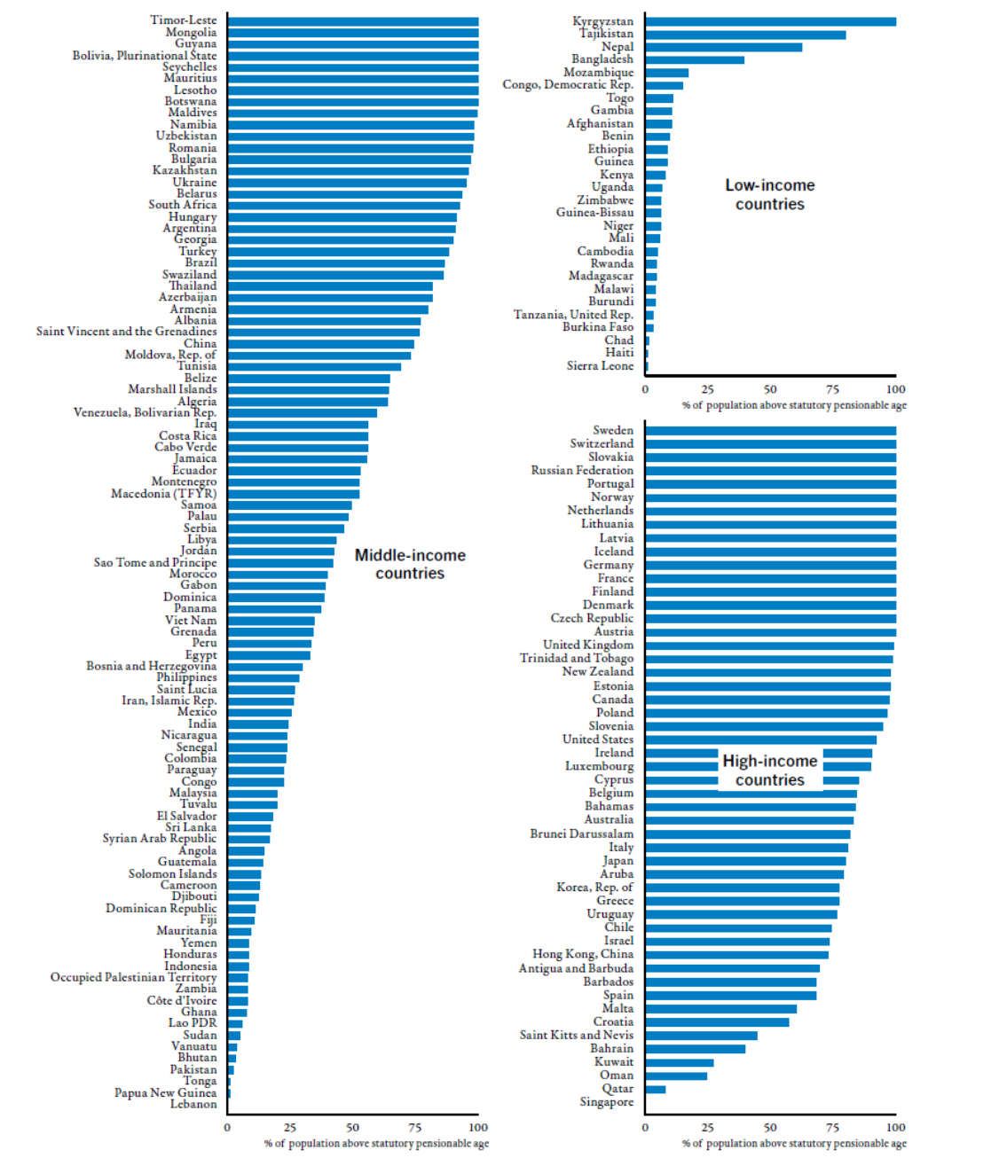

Source: https://www.ilo.org/wcmsp5/groups/public/---dgreports/---dcomm/documents/publication/wcms_310211.pdf.

Unfortunately, the situation of territories with very little pension coverage is due to the small percentage of the working population taking into consideration the fact that the percentage of pension coverage is higher in the counties with higher rates of employment. In addition, the employees who contribute to pension funds in low-income countries are very low (5.7%) compared to the contribution in high-income countries (90.7%), upper-middle-class salary counties (50.7%) and middle-class salary countries (15.2%) (International Labour Office, 2014).
Yet between 2010-2012 actions were taken to tackle those necessary pension funds by introducing non-contributory pensions and extending the contributory plans in a bigger number of nations. Subsequently, 45 nations have reached to provide high-income pensions compared to 34 in 2000 (International Labour Office, 2014).
Likewise, that is considerable progress worldwide regarding the social safety of an ageing population.

Furthermore, the existing strategy in the UK regarding health care does not deliver assistance until individuals come to the crisis point whereas the new system will improve wellbeing and independence at all levels to decrease the chances of individuals getting to the crisis level (HM Government, 2012).
Everyone will have access to information and guidance to schedule early their maintenance requirements and have a decent relationship with those around them, to retain independence. There will be additional assistance within societies, better accommodation alternatives and increased assistance for carers (HM Government, 2012).
Yet regarding the future of the health care system that will have to deal with a greater number of aged individuals, artificial intelligence will be of great assistance in heart failure (Barrett, M. et al., 2019).
Barrett, M. et al. (2019) estimate that by 2025 Western Europe will confront a heart failure preponderance rising by 3% of the society because of life expectancy. In the current time's heart failure, it is by far the most important case of hospitalisation in patients over the age of 65 having an enormous social influence and expenses.
As it can be seen in Figure 2 the current approach to treating heart failure is not the best way because it implies numerous health assessments, therefore, not always accurate (Barrett, M. et al., 2019).

Figure 2.
Health Assessment and management for a patient with heart failure.
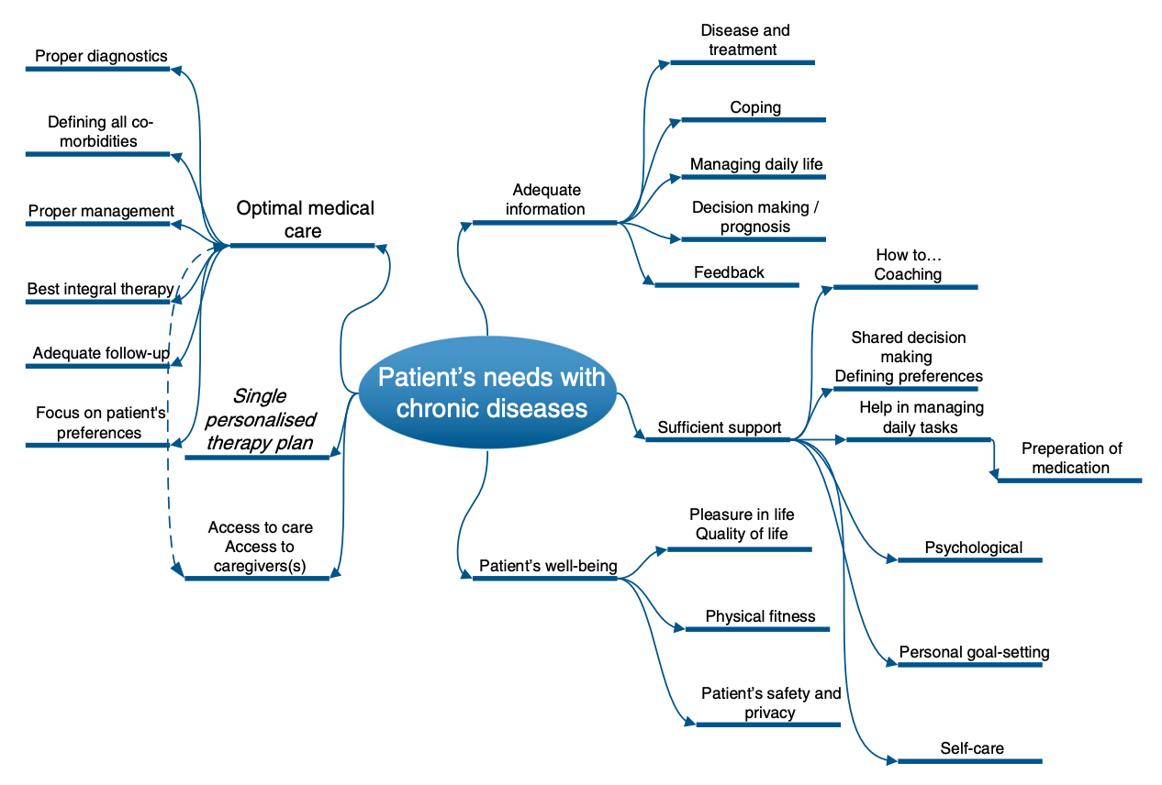
Source: https://pubmed.ncbi.nlm.nih.gov/31832118/.

Consequently, in the best medical heart failure management and treatment, artificial intelligence will help considerably eliminate all time-consuming health assessments instead given more time to specialists in treating the illness (Barrett, M. et al., 2019).

During the lockdown of the COVID-19 pandemic, some of the councils have started to try Amazon Alexa’s to support the health and well-being of elders that must isolate themselves from others. Also, NHSX provided ten thousand tables for those in social care settings helping them connect with family and friends through video calls, Microsoft Team's was provided free for the NHS and social care institutions but just during the lockdown (Institute of Public Care, 2021)
Yet Institute of Public Care (2021), reported that at the beginning of December 2020, 232.901 residents within the UK social care institutions were using technological platforms provided whereas 60.937 users on March 31st same year which means that older people can manage to use technology successfully.
Furthermore, according to the Appello Foundation (2017), family’s assumption that loneliness can be combated by moving older people into care homes is wrong because homes inhabitants still recorded feeling lonely in the proportion of 9% whereas 26% recorded feeling partiality lonely and that is due to mobility and health conditions.
However, permanent implementation of video calls in care homes is beneficial for people who have problems with mobility, and comorbidities that stop them move a lot. Seeing, hearing and being able to talk to their loved ones will diminish feeling lonely, but it can also help them build up relationships with other residents within the care home (Appello Foundation, 2017).
Yet another important benefit of video calls is the possibility of staff being able to maintain visual contact with patients without being invasive and patients’ peace of mind knowing that they can call anytime they need assistance (Appello Foundation, 2017).

Recommendations

The first and most important suggestion is for Romanian governments regarding legislation and strategies. As it can be noticed Romania needs and should make policies to reduce the amount of discrimination against the elderly.
Secondly, both countries should adopt a holistic approach in the attempt of implementing procedures to combat loneliness among older residents of care homes, residential homes across both countries should organise meetings with the residents where they can ask them what activities, technology, or other methods to tackle loneliness will be suitable and preferred by them.
Further, they should carry out activities such as entertainment, recreations programs, dancing, karaoke, arts and crafts, social festivities, and some types of parties within the care home that can help people interact with each other.
Thirdly, health and social care should implement technology and artificial intelligence that will help monitor and boost the health and well-being of the nation, also in the UK for example is too much bureaucracy. Before anyone is sent to see a socialist must go through all sorts of speaking and complete paper forms and that takes so much unnecessary time and of course GP practitioners. Reducing paperwork and replacing it with a simple phone call health assessment and eventually sending patients straight to see a specialist for what they show symptoms will be more efficient but a more importantly quicker way of diagnosis, consequently, more time for treatment.
Finally, the sense of purpose as well as feeling useful can make one desire to do things to be productive, hence, both above-mentioned countries should encourage people to remain to work for as long as they are in good health conditions.

Conclusion

The future of the world according to public literature and government statistics it looks like the prevalence of older people will be higher than younger at some point in the future and that will indeed bring challenges to society and national health. Nevertheless, it has been mentioned throughout the report that life expectancy is the greatest achievement of development and health care and that was possible by the hard work and dedication of the individuals that nowadays are old and represent challenges. Older people should have taught and assisted the younger generation to get where they are right now and they continue to do so, therefore, they must be respected, cherished, and taken care of by society and national health and social care

Reference list:

- Age UK (2018) All the Lonely People: Loneliness in Later Life. Available at: https://www.ageuk.org.uk/globalassets/age-uk/documents/reports-and-publications/reports-and-briefings/loneliness/loneliness-report.pdf. (Accessed: 2 January 2022).

Age UK (2019) Loneliness. Available at: https://www.ageuk.org.uk/globalassets/age-uk/documents/policy-positions/health-and-wellbeing/ppp_loneliness_and_isolation_uk.pdf. (Accessed: 4 January 2022).

Abdi, A. et al. (2019) ‘Understanding the care and support needs of older people: a scoping review and categorisation using the WHO international classification of functioning, disability and health framework (ICF)’, BMC Geriatrics, 19(159).

Appello Foundation (2017) The Role of Technology in Combating Loneliness and Social Isolation: A Guide for Housing Providers. Available at: https://www.housinglin.org.uk/_assets/Resources/Housing/OtherOrganisation/appello-the-role-of-technology-in-combating-loneliness-and-social-isolation-amongst-older-people_v6.pdf. (Accessed: 5 January 2022).
- Bajenaru, L. et al. (2020) Identifying the Needs of Older People for Personalized Assistive Solutions in Romanian Healthcare System, Studies in Informatics and Control, 29(3), pp. 363-372.
- Barrett, M. et al. (2019) ‘Artificial intelligence supported patient self-care in chronic heart failure: a paradigm shift from reactive to predictive, preventive and personalised care’, Queen's University Belfast, https://doi.org/10.1007/s13167-019-00188-9.

Bodgai, S. I. and Cutler, S.J. (2013) ‘Aging in Romania: Research and Public Policy’, The Gerontolist, 54 (2).

BMA (2016) Growing older in the UK. Available at: https://www.bma.org.uk/media/2105/supporting-healthy-ageing-briefings-final.pdf. (Accessed: 29 December 2021).
- CEB (2014) Aging population in Europe: Challenges and Opportunities for the CEB. Available at: https://coebank.org/media/documents/Study_Ageing.pdf. (Accessed: 29 December 2021).
- Department of Constitutional Affairs (2007) Mental Capacity Act Code of Practice. Available at: https://assets.publishing.service.gov.uk/government/uploads/system/uploads/attachment_data/file/921428/Mental-capacity-act-code-of-practice.pdf. (Accessed: 5 January 2022).

Department of Health and Social Care (2021) Using the Care Act guidance. Available at: https://www.gov.uk/government/publications/care-act-statutory-guidance/care-and-support-statutory-guidance. (Accessed: 6 January 2022).
- GOV.UK (2015) Equality Act 2010: guidance. Available at: https://www.gov.uk/guidance/equality-act-2010-guidance. (Accessed 4 January 2022).
- HM Government (2012) Caring for our future: reforming care and support. Available at: https://assets.publishing.service.gov.uk/government/uploads/system/uploads/attachment_data/file/136422/White-Paper-Caring-for-our-future-reforming-care-and-support-PDF-1580K.pdf. (Accessed: 30 December 2021).
- International Labour Office (2014) Social protection for older persons: Key policy trends and statistics. Available at: https://www.ilo.org/wcmsp5/groups/public/---dgreports/---dcomm/documents/publication/wcms_310211.pdf. (Accessed: 4 January 2022).
- Institute of Public Care (2021) Adoption and Scalability of Technology Innovation in the Adult Social Care Sector. Available at: https://ipc.brookes.ac.uk/files/publications/Digital-tech-rapid-research-review-Feb-2021.pdf. (Accessed: 5 January 2022).

Kuypers, J.A. and Bengtson, V.L. (1973) ‘Social Breakdown and Competence’, Human Development, 16(3), pp. 181-201.
- Koning, J. et al. (2021) ‘Profiles of Loneliness and Social Isolation in Physically Active and Inactive Older Adults in Rural England’, International Journal of Environmental Research and Public Health, 18 (3971). https://doi.org/10.3390/ ijerph18083971.
- McGarrigle, L. (2017) The adverse effects of social isolation and loneliness on psychological and physical health outcomes in care home residents during Covid-19. Availableat:https://assets.publishing.service.gov.uk/government/uploads/system/uploads/attachment_data/file/1012417/S0584_Adverse_effects_of_social_isolation_and_loneliness_in_care_homes_during_COVID-19.pdf. (Accessed: 30 December 2021).
- Mann, R. et al. (2020) ‘Identifying Loneliness and Social Isolation in Care Home Residents with Sight Loss: Lessons from Using the De Jong Gierveld Scale, JOURNAL OF LONG-TERM CARE, pp.167–173. DOI: http://doi.org/10.31389/jltc.39
- NHS (2015) Improving care for older people. Available at: https://www.england.nhs.uk/ourwork/clinical-policy/older-people/improving-care-for-older-people/. (Accessed: 30 December 2021).
- Precupetu, I., Aartsen, M. and Vasile, M. (2019) ‘Social Exclusion and Mental Wellbeing in Older Romanians’, COGITATIO, 7(3), pp.4-16.

Rabontu, C.I. and Todorut, A.V. (2018) ‘The Effects of Ageing Population on the Economy and on Service Activities in Romania’, International conference KNOWLEDGE- BASED ORGANIZATION, 24(2), pp. 88-97.

Schiau, I. (2016) ‘Humor, Loneliness and Interpersonal Communication: A Quantitative Study of Romanian Older Adults’, Journal of Communication and Public Relations, 18(37), pp. 89-106.
- Urzeala, C. et al. (2021) ‘Barriers and Facilitators for the Romanian Older Adults in Enjoying Physical Activity Health-Related Benefits’, Sustainability, 13, 12511. https://doi.org/ 10.3390/su132212511.

UK Parliament (2021) Housing an aging population: a reading list. Available at: https://commonslibrary.parliament.uk/research-briefings/cbp-9239/. (Accessed: 4 January 2022).
- Vauclair, C.M. and Rudnev, M. (2019) ‘Modernization Theory’, Encyclopaedia of Gerontology and Population Aging, DOI: https://doi.org/10.1007/978-3-319-69892-2_750-1.
- WHO (2011) Global Health and Aging. Available at: https://www.who.int/ageing/publications/global_health.pdf. (Accessed: 4 January 2022).
- WHO (2021) ROMANIA Country case study on the integrated delivery of long-term care. Available at: https://www.euro.who.int/__data/assets/pdf_file/0008/426383/LTC-Romania.pdf. (Accessed: 4 January 2022).

